 |  | 
United Nations Development Programme
Project Document for projects financed by the various GEF Trust Funds

Project title: Green Sharm El Sheikh
Country: Egypt | Implementing Partner (GEF Executing Entity): Ministry of Environment |  | Execution Modality: National Implementation (Full NIM)
Contributing Outcome (UNDAF/CPD, RPD, GPD):
Outcome 1: Advance poverty eradication in all its forms and dimensions
Outcome 2: Accelerate structural transformations for sustainable development
UNDP Social and Environmental Screening Category: High |  | UNDP Gender Marker: GEN 2
Atlas Project ID (formerly Award ID): 00123342 |  | Atlas Output ID (formerly Project ID): 00118606
UNDP-GEF PIMS ID number: 6249 |  | GEF Project ID number: 10117
LPAC meeting date: 05 January 2022
Project duration in months: 72 months
Planned start date:  01 March 2022 |  | Planned end date:  28 February 2028
Expected date of posting of Mid-Term Review to ERC:  01 September 2024 |  | Expected date of posting Terminal evaluation report to ERC: 30 November 2027
Brief project description:
The Project objective is to turn Sharm El Sheikh into a model integrated and ecologically sustainable tourism city of national and international importance through the adoption of further low-carbon technologies, good waste management practices and a further-enhanced protection of its natural capital basis.
This will be achieved by developing an integrated Sharm El-Sheikh Sustainable Development Strategy (SESSDS) and Action Plan, with a focus on technical assistance, capacity building and demonstration of good practice for climate change mitigation, chemicals and waste prevention and management, through a series of pilot investments, organization and development of an integrated sustainable development strategy and its implementation plans, and promotion of behavioural change, in conjunction with national priorities and needs articulated by the Government.
Successful implementation of the SESSDS will require multi-stakeholder processes (MSP), where political, technical, financial, and organizational capacities as well as citizen engagement and stakeholder processes are leveraged to achieve the city’s sustainability goals. The measures introduced by the Project will showcase the City as a model for replication elsewhere in Egypt, defining a new paradigm of how tourist destinations can successfully address the challenges of development growth.

Financing Plan
GEF Trust Fund Grant |  | USD 6,212,694
UNDP TRAC Resources |  | USD 90,000
(1) Total budget administered by UNDP |  | USD 6,302,694
(2) Total confirmed co-financing to this project not administered by UNDP |  | USD 56,600,000
(3) Grand total project financing (1)+(2) |  | USD 62,902,694
Signatures
Agreed by Government Development Coordination Authority: | Signature:  print name |  | Date/Month/Year:
Agreed by Implementing Partner: | Signature:  print name |  | Date/Month/Year:
Agreed by UNDP: | Signature:  Alessandro Fracassetti, Resident Representative, UNDP Egypt |  | Date/Month/Year:

Table of Contents
I. Development Challenge 6
1.1 Overall development context and challenge (socio-economic, sustainable development) 6
1.2 Environmental context and specific threats 9
1.3 Root causes 14
II. Strategy 16
2.1 The long-term solution 16
2.2 The baseline scenario 17
2.3 Barriers, theory of change and assumptions 24
III. Results and Partnerships 28
3.1 Project Area 28
3.2 Project Description and Expected Results 28
3.3 Alignment with GEF focal area strategy 51
3.4 Global Environmental Benefits and Incremental Cost Analysis (Baseline vs Alternative Scenario) 52
3.5 Local and national project beneficiaries and benefits 54
3.6 Consistency with national convention strategies/plans/reports/assessments 55
3.7 Relevance to SDGs 56
3.8 Stakeholder engagement 57
3.9 Coordination and partnerships 58
3.10 Gender equality and empowering women 62
3.11 Risks to the project and social/environmental safeguards 62
3.12 Innovativeness, sustainability and potential for scaling up 63
3.13 Knowledge Management 64
3.14 South-South and Triangular Cooperation 65
IV. Project Results Framework 66
V. Monitoring and Evaluation (M&E) Plan 74
VI. Governance and Management Arrangements 77
VII. Financial Planning and Management 82
VIII. Total Budget and Work Plan 85
IX. Legal Context 90
X. Risk Management 90
XI. Annexes 93
Annex 1: Geospatial coordinates and maps of the project area 93
Annex 2: Multi-Year Work Plan 96
Annex 3: Monitoring Plan 98
Annex 4: Stakeholders Consulted during project development and Stakeholder Engagement Plan 107
Annex 5: UNDP Risk Register 119
Annex 6: GEF PA Management Effectiveness Tracking Tool 127
Annex 7: Project Team and Terms of References 170
Annex 8: Summary of the GEF Cost-Sharing Mechanism for Pilot Investments under Component 2 178
Annex 9: Theory of Change 184
Annex 10: Details on the GHG Emissions Reduction calculations 186
Annex 11: Environmental & Social Management Framework (ESMF) 193
Annex 12: UNDP Social and Environmental Screening Procedure (SESP) 194
Annex 13: Gender Analysis and Gender Action Plan 210
Annex 14: Co-financing letters 223
Annex 15: GEF OFP Endorsement Letter for PIF 227
Annex 17: GEF Core Indicators at Baseline 228
Annex 18: GEF 7 Taxonomy 232
Annex 19: UNDP Capacity Development Scorecard 239
Annex 20: Ranking Environmental Sensitivity of Marine Habitats 243
Annex 21: Knowledge Management Strategy 268
Annex 22: Initial Project Procurement Plan (Year 1) 274
Annex 24: Background Report: Biodiversity and Protected Areas 277
Annex 25: Background Report: Tourism and Energy 364
Annex 26: Background Report: Waste 399
Annex 27: TBWP in GEF Budget Template 463

Tables
Table 1: GHG Emissions Reductions Summary 53
Table 2: Monitoring and Evaluation Plan and Budget 76
Table 3: Key institutions involved in project components 79

Figures
Figure 1: Urban population trend in Egypt 6
Figure 2: Largest cities 7
Figure 3: Population density 7
Figure 4: Tourism overnight stays – Egypt and Sharm El-Sheikh 8
Figure 5: Sharm El-Sheikh area 8
Figure 6: Sharm El Sheikh area with Ras Mohamed National Park 28
Figure 7: Enhanced planning process leading to the Sustainable Development Strategy in Sharm El-Sheikh 31
Figure 8: Current and future desired waste management scheme in Sharm El-Sheikh 35
Figure 9: Waste management flow diagram 43
Figure 10: Project Organisation Structure 77

Acronyms
CEPSD ETF Committee on Environmental Protection and Sustainable Development
EEAA Egyptian Environmental Affairs Agency
ETF Egyptian Tourism Federation
FSP Full Sized Project
GEF Global Environment Facility
GEFSEC Global Environment Facility Secretariat
GHG Greenhouse Gas(es)
GOPP General Organization for Physical Planning
GTU Green Tourism Unit at MOTA, recently renamed Sustainable Tourism Unit
MLD Ministry of Local Development
MOE Ministry of Environment
MOTA Ministry of Tourism and Antiquities
MPED Ministry of Planning and Economic Development
MSP Medium Sized Project
MSW Municipal solid waste
NCE UNDP Nature Climate and Energy
NCS Nature Conservation Sector, under MOE/EEAA
NCW National Council for Women
NUCA New Urban Communities Authority
PIF Project Identification Form
PIR GEF Project Implementation Report
POP Persistent Organic Pollutants
POPP Programme and Operations Policies and Procedures
PPG Project Preparation Grant
STAP GEF Scientific Technical Advisory Panel
STU Sustainable Tourism Unit at MOTA
TA Technical Assistance
TVET TVET project
UNDP-GEF UNDP Global Environmental Finance Unit
UPOP Unintended Persistent Organic Pollutants
WMRA Waste Management Regulatory Agency

Development Challenge

1.1 Overall development context and challenge (socio-economic, sustainable development)
Overview and Economy
- Egypt lies at the north-eastern corner of Africa, bordering the Mediterranean and Red Seas. Its total area is 1,001,450 km2, including 995,450 km2 of land area, and 6,000 km2 of water area. Egypt shares borders with the Gaza Strip (13 km) and Israel (208 km) to the north-east, Libya (1,115 km) to the west and Sudan (1,276 km) to the south. Its coastline is 2,450 km and its highest point Mount Catherine on the Sinai at 2,629 m. The country can be divided into four physiographic regions: the Western Desert, Nile Valley, Eastern Desert and Sinai. While 4% of the country are agricultural lands, 96% are hyper-arid, arid and semi-arid deserts.
- In 2017, Egypt had a GDP of USD 237 billion, GDP/capita (PPP) of USD 12,700, GDP growth of 4.2%, with public budget revenues of USD 38 billion and public budget expenditures of USD 59 billion, and an average budget deficit of 9.7% of GDP (2002 -2017). However, a high 28% (2016 est.) of the population lives below the poverty line. Unemployment rate lies at 12%.
- Egypt’s economic activity is relatively diverse, and driven by agriculture (cotton, rice, corn, wheat, beans, fruits, vegetables; cattle, water buffalo, sheep, goats), industry (textiles, food processing, chemicals, pharmaceuticals, hydrocarbons, construction, cement, metals, light manufactures) and services, such as tourism.
Urbanisation
- Egypt’s rapidly growing population was 97 million in 2017, the largest in the Arab world. Most economic activity takes place in the fertile Nile valley and delta, where about 95% of the population is concentrated in about 5% of the country’s land area, while other areas of the country remain sparsely populated or uninhabited. Urbanisation is growing rapidly. With an annual national population growth rate of 2-3% over the past decades, Egypt has approximately 1 million new citizens to house every 8 months. Population growth combined with rural-urban migration has resulted in rates of population increase of almost 4% annually in Egypt’s urban centers. In 2017 the urban population in Egypt was reported at c. 42 million, of which the Greater Cairo area hosts about 20 million. Alexandria is the second-largest urban concentration with c. 5 million, followed by Port Said with c. 700,000, Suez with c. 600,000 and Luxor with c. 500,000.
Figure 1: Urban population trend in Egypt
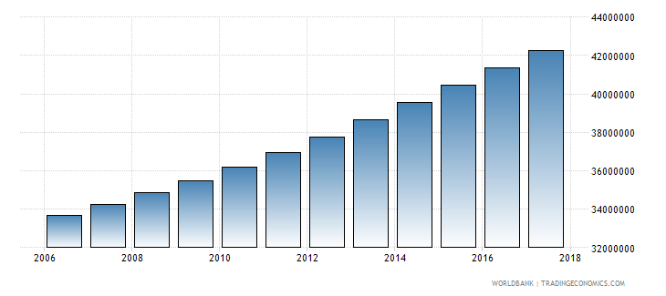

- During the 1970, there was a major interest in new planned urban communities in Egypt, aiming to decrease the high population density of existing urban areas. At that time the Government helped create a number of new cities by expanding out to the desert. For this purpose, the New Urban Communities Authority was established by virtue of Law 59/1979 to serve as the responsible body for creating, administering, selecting sites, and preparing master and detailed plans of new cities. A development and construction map was prepared for Egypt including assignment of 24 new cities reflecting the establishment of new urban communities aimed at absorbing 12 million people by 2017. These cities – although much smaller in size than Cairo and Alexandra – are in varying development phases as regards making future investments and choosing the pathway for their future urban concept, expansion and sustainability.
Figure 2: Largest cities | Figure 3: Population density
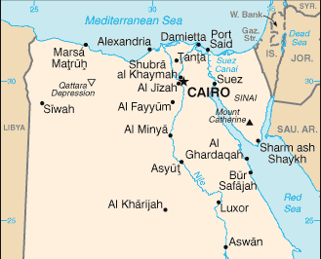 | 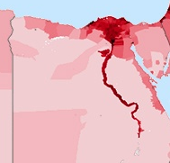
- Unfortunately, at present a large proportion of planning, investment, operation and maintenance of cities in Egypt (as in the rest of the MENA region) is unsustainable and sub-optimal in terms of their environmental footprint (GHG emissions, pollution, resource consumption, etc.). Moreover, due to the longevity of most urban systems, any decisions taken today will lock in emissions and vulnerability profiles for many decades to come and they will determine the competitiveness, quality of life and environmental sustainability of cities and the surrounding habitat.
- The above is particularly relevant for urban developments in the context of tourism. Tourism development potential is a major criterion behind the selection of new and expanded urban development areas in Egypt, because the sector is prioritised by the Government to provide employment and economic growth for its growing population and act as attractant for resettlement.
The Tourism Sector in Egypt
- Egypt’s tourism industry has been one of the most important and fastest growing components of Egypt’s economy, and was for long among the most diverse and vibrant in the world. In 2010 it contributed about 11.3 % of the Egyptian GDP, employing some 2.6 million Egyptians directly and 3.5 million indirectly (about 12 % of Egypt's workforce), when international tourist arrivals in Egypt reached 12.8 million generating some USD 12.5 billion annually; travel receipts constituted around 21.4 % of foreign currency earnings in 2010, ranked second only after petroleum exports. Government-driven investments and the resulting continuing construction and development boom are mirrored in the growth of hotel establishments and holiday home complexes. The total number of hotels and tourist villages in Egypt reached 1,490 in 2008 up from 1,207 hotels in 2004, a 23.4% increase. Lodging capacity has increased considerably in the past years. Most of this growth has taken place along Egypt’s coasts.
- However, political developments in Egypt and the region have repeatedly crippled the Egyptian tourist trade, a vital part of the Egyptian economy Egypt experienced a significant drop in tourism and related investments between 2011 and 2015 due to political changes, followed by a Russian plane crash over Sinai in 2015. As a result, the initial level of approx. 13 million tourist arrivals in 2010 contributing about 11.3% to the Egyptian GDP (equivalent of about USD 12.5 billion) has declined by 2017 to about 8.3 million tourists contributing to only about 5.6% of the GDP (or about USD 10 billion). The figure below shows the time series in overnight stays between 2013 and 2017, reflecting the significant drop to less than 50% in 2016, while the situation has recovered since 2017 and 2019 to expect in Sharm El-Sheikh more overnight stays than before the crisis.
- Indeed, the Government of Egypt has ambitious plans to further increase the tourism offer, most notably along the Red Sea. And while plans to receive up to 25 million international visitors by 2020 were not met, the goals remain.
Figure 4: Tourism overnight stays – Egypt and Sharm El-Sheikh
- Tourism in Egypt is predominantly focused on recreational sun & beach tourism (86% of international arrivals and also the largest share of domestic tourism), and to a secondary degree on the country’s outstanding cultural heritage. However, some key destinations also heavily rely on the terrestrial landscapes and marine ecosystems, most notably healthy coral reefs, for their business. This applies particularly to the already-large city of Hurghada (pop. 250,000) with its satellite El Gouna as well as to Marsa Alam (pop. 10,000) on the mainland Red Sea coast, and to Sharm El Sheikh (pop. 75,000) and neighbouring Dahab (pop. 15,000) on the southern tip of the Sinai Peninsula.
- Sharm El-Sheikh is a well-known port and resort town at the southern tip of the Sinai Peninsula in Egypt, a popular destination with package holiday makers and divers. Sharm El-Sheikh city is subdivided into five areas, namely Nabq Bay, Ras Nasrani, Naama Bay, Umm Sid, and Sharm El Maya. Together with Hay el Nour, Hadaba, Rowaysat, Montazah and Shark's Bay, it forms a metropolitan area of 42 square kilometres.
Figure 5: Sharm El-Sheikh area
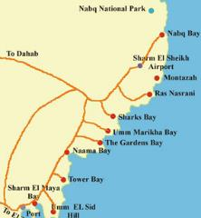
- Sharm El-Sheikh offers 170-190 hotels and resorts with approx. 45-55,000 guest rooms. Approximately 198,000 tourists visited Sharm El-Sheikh in 2017, after 127,000 in 2016. The number of overnight stays is steadily increasing after experiencing a decline between 2011 and 2016. As a result, the hospitality sector in Sharm El Sheikh has been struggling due to the decline in tourists to the region, resulting in 54 local and unbranded hotels been shut down in 2016. The total occupancy levels decreased to an average level of 45% during the last 5 years, which resulted in heavy financial and operational burdens for many hotels. 2019 was the first year where tourist arrivals and overnight stays were back to a pre-crisis level, at approximately 1 million overnights. The COVID-19 crisis was short-lived with a reasonably quick resumption of arrivals at the expected levels especially from eastern Europe.
- Sharm El-Sheikh also provides various conference and large meeting facilities, which serve as highly attractive multipurpose destinations for conference tourists and businesspeople alike. The city witnessed many international conferences, forums and meetings, and is sometimes called the "City of Peace", referring to the large number of international peace conferences that have been held there. In 2000, the UNESCO recognized Sharm El-Sheikh as the finest city in the world for peace and beauty.
- While the tourism sector is showing signs for recovery to and growth of tourist arrivals to stabilize over the coming years, the touristic destinations in Egypt, including Sharm El-Sheikh, have been witnessing growing population, industrialization, urbanization, and changing consumption patterns. Population growth amplifies the burden on urban infrastructure in numerous cities which are already overloaded with the transfer of urban services (e.g. transport, waste and wastewater management), so as well in Sharm El-Sheikh. The Governorate of South Sinai lacks the resources, both organizational/technical and financial, to satisfy the demand for public infrastructure services such as clean water, sanitation and solid waste management, clean transport and energy; it furthermore misses a coherent strategy and development plan to reflect the long-term vision and implementation plan to reflect a comprehensive approach for sustainable development in the region.
- An additional problem facing urban environments on the Red Sea coast, especially also Sharm El-Sheikh, is a lack of integration between tourism environment and the existing (old) cities. This is due to the difference in the urban form and the quality of services. Facilities and amenities developed for tourists are usually not available (or not being used) to members of the local community. This differentiation between the luxurious tourist areas on the beach and background poorer areas creates a very contrasted urban area.
- And finally, tourism in its current form results in many negative environmental impacts. The Red Sea coast – including in Sharm El Sheikh – is dominated by private tourism investment focused on maximizing profits. The challenge of sustainable tourism development is to balance the principles of encouraging conservation and providing benefits to the local population with the truths that tourism consumes resources and energy, creates waste and requires a developed infrastructure. This is ever more important given the projected growth of tourism in Egypt – which can be expected to lead to growing impacts on natural ecosystems, increasing energy consumption (fossil-fuel based, from electricity and transport), increasing stress on waste management infrastructure and practices, and increasing emissions from waste and so forth.

1.2 Environmental context and specific threats
Energy
- Egypt’s energy mix is dominated by oil and gas, with targets set by the Government to be complemented gradually by renewable energy to cover 20% of the electricity mix by 2022 and 42% by 2035. Egypt has ample potential to achieve these ambitious targets, as it enjoys an abundance of renewable energy resources with high deployment potential, including hydropower, wind, solar and biomass.
- In a similar vein, the energy system in Sharm El Sheikh is still heavily dependent on oil and gas, while local (renewable) sources are only marginally used. Sharm el Sheikh has 4 main power plants for energy production, two of them use natural gas with a production capacity of 288 MW, in addition to a 5 MW Solar PV plant, and there are plans to expand its production capacity up to 40 MW with a 35 million US$ investment. The public grid contributes significantly to the management of the electric power system and achieving rational and regulated consumption. The touristic characteristics for Sharm El Sheikh pose a major challenge towards electricity demand to meet the high-level tourism sector needs with its services and utilities. Under a BAU scenario, the expected increase in tourism can be expected to lead to a growth of energy consumption and GHG emissions.
- At the same time, the gradual phasing out of the current electricity subsidies policies have contributed to the rationalization of consumption and switching to alternative energy options in many sectors including tourism, as well as the incentives for consumers who apply energy efficiency measures and use renewable energy. Since natural gas is one of the available energy alternatives, the city has extended natural gas lines to most neighbourhoods and about 90% of hotel boilers have been switched to natural gas instead of diesel.
- In terms of other renewable energy options, there is scope for expanding the use of solar water heaters (only used so far in very limited numbers, with most hotels providing hot water through boilers; and reliable technical support for SWH missing to deal with the special nature of water quality in Sharm), and mainly photovoltaic systems (rooftop and larger scale greenfield systems). Currently, however, there are no specific government plans to address these in the project area.
- The city has been gradually changing the energy and lighting systems in the streets and public places in various neighbourhoods and sectors for several years. Several phases were implemented with the cooperation of the Arab Organization for Industrialization, the Ministry of Military Production and the Egyptian Environmental Affairs Agency. The solar powered light poles in the city streets reached 1,779 poles, whereas LED light poles reached 6,780, with about 32 million EGP (approx. 2 mln US$) been spent so far.
- Moreover, PV panelled rooftops have been installed in many residential units to generate electricity using solar energy. The Canal Company for Electricity Distribution, South Sinai Governorate and Schneider Electric (North Africa) have been coordinating the construction of a 20 MW solar power plant on an area of one km² in return for paying 2% of the value of the produced energy. Also to mention here the UNDP-GEF/Government of Egypt project on “Grid-Connected Small-Scale Photovoltaic Systems” (GEF # 5064): the objective of the Project was to remove any barriers to increase power generation by small, decentralized, grid-connected PV systems implemented by households and small- and medium-size enterprises, including industrial, commercial facilities as well as hotels.
- The Municipality of Sharm El-Sheikh does not overlook the important role of environmental awareness and encourage all sectors of investment and citizens to use clean energy options and its importance in contributing to mitigating climate change and realizing the real cost of energy and the consumption of natural resources.
- Egypt has also made significant progress in the energy efficiency scoring in the 2017 Arab Future Energy Index Report on Energy Efficiency since 2015 and has risen three places in the latest regional EE rankings. This progress is due in part to the implementation of several key EE policies and a variety of EE interventions supported by the GEF-funded “Improving the energy efficiency of lighting and other building appliances” project, as well as reduced subsidies for both electricity and fuel introduced in recent years. Energy efficiency provides a significant potential in buildings and public infrastructure as well: among the various uses of electricity, cooling contributes substantially to the electricity demand in summer when temperatures and humidity are high. Air conditioning is widespread not only along the Red Sea coast but all over Egypt.
- At hotels and resorts, various types of energy are required to operate the engineering services, which mainly include heating, ventilation and air conditioning (HVAC), lighting, vertical transportation and hot water supply. Additional heat and power are also consumed in the resort’s kitchen and laundry facilities. In Sharm El-Sheikh, three types of energy: electricity, gas and diesel fuel are normally used; diesel fuel is mainly used to operate steam or hot water boilers while liquefied petroleum gas (LPG) may be used in some kitchen equipment. Sharm El Sheikh is one of the few towns on the Red Sea coast which have access to the public electricity grid; most of the resorts are connected to the grid and only a very few depend on diesel generators for their power supply. Hotels in “Nabq” area (around 33 hotels) do not have access to the national grid. Instead, the private company “TAQA” sells electricity to hotels at a bit higher prices compared to the national grid.
- There are not many assessments available that have focused on energy demand and energy use of hotels and touristic infrastructure in Sharm El-Sheikh. A European Bank Study in 2013; "Sustainable Energy Support for Built Environment Projects Review of Sustainable Energy Opportunities in the Hotel Sector of Egypt (Red Sea and Sinai Region) "found that the design of the majority of the hotels led to significant energy consumptions burdens as the majority (i) were designed to maximize the view of the sea and/or the swimming pools, (ii) have high exposure of facades to solar radiation, with nearly no attention to type of glazing, shading and insulation, (iii) are multi-story buildings with maximum four stories, (iv) are constructed of high-watered concrete for the skeleton with single walls and glazing, (v) have several swimming pools (heated during winter season) and (vi) have large gardens and several sport facilities (tennis courts, gyms, etc.). The conclusion from this and another Energy Audit study done for one of the hotels within the GIZ-funded JCEE program is that design attributes lead to a very significant energy load and in particular mechanical refrigeration air conditioning demand in hotels.
- Energy efficiency measures implemented so far mainly focused on improving lighting systems (installations of LED), also with support of UNDP-GEF Project “Improving the energy efficiency of Lighting and other Building Appliances” (GEF # 3832), but apart from some international-owned resorts, there are hardly examples of significant energy refurbishments known from Sharm El-Sheikh hotels and resorts that have tackled HVAC systems, or have even combined them with renewable energy installations (solar PV, solar thermal, heat pumps, biomass, etc.). Renewable energies and energy efficiency thus require mainstreaming activities supported by technical assistance leading to increased awareness and committed energy management (accompanied by low- and no-cost measures), as well as further significant investments.
- Egypt has a large cooling equipment manufacturing sector dominated by local manufacturers. Refrigerants are currently imported. Egypt commonly use HCFC-22 for refrigeration and HVAC. Some local manufacturers of HVAC and refrigeration systems start shifting from HCFC-22 to alternative and environmental-friendly coolants, such as e.g. R-410A. Although technical capacities exist, in the current market, efficient compressors for HVAC and refrigeration systems are imported while local manufacturers manufacture less efficient compressors for fridge and local HVAC units. While refrigeration technologies, refrigerators, deep freezers, cold rooms, water dispensers are matured and dominated by local industry and there is a high opportunity to upgrade product quality and increase knowledge on energy efficiency and natural refrigerants, there is no F-gas/HFC regulation in place, and so a HFC reporting procedure is not set up. According to NOU, Egypt has not yet started the development of a National Cooling Strategy. There are no specific targets for cooling demand reduction in Intended Nationally Determined Contributions (INDC) but mitigation actions can have direct application in the cooling sector.
- There are many technology providers, manufacturers, and suppliers in Egypt that could provide a wide range of sustainable cooling technologies; however, there are no obligatory codes in Egypt that could enforce the use of sustainable cooling technologies in the residential and the commercial building sectors. Availability of these tools and the lack of any enforcement are the main gaps facing the deployment of sustainable cooling technologies.
Transport
- Public transport in the city is mainly based on private taxis and shuttle buses operated by hotels. The city has abandoned taxis and shuttle buses with high emissions, modernized the vehicles operating in the city, and established a traffic police unit equipped with vehicle exhaust emission measuring devices, as well as the establishment of two stations to supply cars with natural gas and modify gasoline cars to work with natural gas. More than 20 bus stations for public transportation were implemented (air-conditioned with Wi-Fi and monitors), however, there is no bus route operated by the city so far. The Project will study plans as one of the activities under Component 1 to evaluate the use of public regular buses (not minibuses) to operate along main roads and connecting the city centre with residential areas and major hotels en route.
- A cycling route has been established along the El Salam Road to encourage the use of transportation alternatives. Yet, so far, there is no system in place that would allow sharing or renting bicycles (even e-bikes) nor promoting cycling to hotels and residents, such as being implemented and operated by Baddelonline.com in El Gouna (60 e-bikes currently operated), Sodic West (30 e-bikes), Fayyoum City (100 normal bikes) and AUC Campus Cairo (10 bikes, thereof 5 e-bikes). The City of Sharm El-Sheikh has, however, shared its interest in setting up a similar bike sharing system, with the support of the Project.
Water, desalination and wastewater management
- Sharm El Sheikh is situated in an area of extreme aridity (annual rainfall between 20–50 mm/y). Its rapid development including about one million tourist overnights annually results in an ever-increasing demand for water. In terms of water supply, the city relies mainly on sea water desalination plants, both public and private, which with some other secondary sources achieve self-sufficiency for all sectors of the city. There are more than 30 reverse osmosis (RO) plants producing nearly 200,000 m³ of waters daily. 90% of the tourist resorts and hotels in the city have their own desalination plants with sufficient capacity to meet their needs. Two municipal, government-owned RO plants (with a capacity of 15,000 m3/day) sell water to the local residents at a very low subsidized price while the two centralized private RO plants (owned by two different companies) charge commercial rates and raise prices considerably in the summer periods of high-water demand. There are 5 companies that work on the supply and distribution through pumping stations to meet the city demands, this is performed in accordance with international quality standards. For all the desalination plants, there are concerns over the high consumption of energy drawn from the municipal grid that depends largely on the gas-fuelled power stations. A significant additional concern is the discharge of salt brine on the marine environment including especially coral reefs.
- Other sources of water in Sharm include tankers and pipes delivering groundwater from Al Tor (100 km distance), the supply line from the Nile River water, some ground wells in the city's valleys that serve the Bedouin communities living in the valleys, and treated domestic wastewater for landscape irrigation. Moreover, the network of dams built in recent years has contributed to the retention and storage of water, and between the north and south of the city there are strategic reservoirs. The Egyptian Environmental Affairs Agency (EEAA) is not regulating and monitoring water management sufficiently. Increasing water shortages and price rises as well as environmental degradation would impact the tourism industry.
- Additional aspects are: water shortage and low pressure in some settlements; network supply disruptions; lack of coordination in water tanker delivery; reliance on bottled water because desalinated water is not suited for drinking; brackish well water in some rural areas; leakage losses; and the need to locate groundwater recharges dams in appropriate areas.
- As for wastewater and wastewater reuse, the city of Sharm el-Sheikh is characterized by the existence of an effective and efficient sewage system serving all sectors, and through this system wastewater is collected through gravity slope networks in each region to its pumping station, and then to the treatment plant and oxidation ponds where treatment is carried out. The capacity of the treatment plant is 3,650,000 m³/year in addition to the private sector treatment plants. There are 15 pumping stations in the city. The sewage system is subject to environmental management, monitoring and follow-up due to the environmental and touristic importance of the city. Also, oxidation ponds are subject to environmental management because of the city’s location along a bird migration route. There’s also a follow-up of the environmental impacts resulting from the operation and maintenance of treatment plants. Wastewater is recycled and used mainly for irrigating the green areas, greenbelt and tree plantations in the city.
Waste & UPOPs
- In previous years, Egypt has been witnessing growing population, industrialization, urbanization, and changing consumption patterns; the phenomena causing the generation of growing amounts of diversified solid waste. Population growth amplifies the burden on urban infrastructure in numerous cities which are already overloaded with the transfer of urban services. Governorates lack the resources, both technical and financial, to satisfy the demand for services such as water, sanitation and municipal solid waste (MSW) management. Open burning and open dumping practices are widespread in various parts of the country, resulting in Greenhouse Gas (GHG) and UPOP emissions and leachates in disposal sites. In fact, incorrect waste disposal and illegal waste dumping impact both the environment and citizens.
- In Sharm El-Sheikh on average 70% of the population is served with waste collection services; approximately 80 % of the collected waste is collected through official waste collection services and 20% through informal waste collectors. The system covers urban and hotel waste collection. Depending on hotel occupation rate, the waste generation varies in the Governorate of South Sinai; for example, in 2010, in the peak tourism year, the produced municipal solid waste was approximately 334 tons per day. The average daily generation of MSW per capita falls within the highest category in Egypt, earlier studies estimated a daily waste production of approx. 2.2 kg/day/person, which have been also confirmed by surveys conducted at selected hotels during the PPG phase. In Sharm El Sheikh alone, the daily generated waste reaches approximately 120 to 160 tons (quantity was calculated in September 2013 and it increases during tourism high seasons.
- Additional aspects are: Inadequate waste collection in some non-tourist areas; plastic waste blown into the sea; illegal littering, dumping and burning of wastes - there are also counter-productive incentives which make boat operators dump garbage at sea rather than face the cost of disposal at land.
- According to 2013 statistics, there exists a combined sorting/composting plant in Sharm El-Sheikh, with efficiency of 60%, and three uncontrolled dumpsites. The city allocates a landfill for transporting solid, organic and agricultural wastes at a distance of 15 km, in Al-Khanassir, outside town. Wastes are collected by private nonspecialized transporters, collecting the waste (of the hotels) daily. Wastes are transferred to the dumpsite, meaning to numerous parcels of lands operated by the Bedouin community, covering in total an area of estimated 2-3 km². After opening the bags, the waste is spread and sorted by hand. Recyclables are collected in bags, brought to several baling presses to be baled and then transported to Cairo for final recycling. Separated organics and organics in mixed waste are fed to animals, there is no composting facility. The remaining waste is either open-burned for space reasons (and to get better access to the clean-burned metals), or left in the area. Aside from some exceptions there is no separate collection of medical and other hazardous waste.
- In 2006, a solid waste sorting plant in Sharm El-Sheikh was established, with financing fund from the European Union. The Governorate of South Sinai operated this plant during the period 2009 to 2010. The plant stopped operation because of the absence of labour. Following approval by the Cabinet of Ministers (20 February 2019), the Governorate of the South Sinai, which owns the waste management facilities, awarded a ten-year sole-source contract to the Zahret Ganoub Sinai Company to operate and raise the efficiency of a plant for sorting and recycling organic compost in the al Khanassir area of Sharm El Sheikh, and also to build and operate a landfill for the treated waste that cannot be recycled.
- Some of the activities implemented by Governorate of South-Sinai to increase waste management efficiency included: (i) The governorate requested from the National Solid Waste Management Program establishing a main plan for solid waste management in South Sinai. (ii) The Waste Management Regulatory Authority signed a contract with architecture and engineering centres in Faculty of Engineering, Cairo University, for performing studies associated with waste management in the governorate. (iii) The Engineering Design & Support Center, in Faculty of Engineering, Cairo University, established a plan for solid waste.
- Success stories on improved municipal waste management exist in Egypt, mainly in the city of Hurghada and neighbouring town El Gouna. The initiatives are mainly driven by the Hurghada Environmental Protection and Conservation Association (HEPCA), an internationally recognized NGO specializing in the field of marine and land conservation.
- HEPCA is engaged in various projects to encourage the understanding of the impact of climate change on the Red Sea Region:
- Recycling and solid waste management. HEPCA handles solid waste in Hurghada, collecting 600 tons of solid waste every morning. HEPCA’s solid waste management authority extends two hundred kilometers, starting at its northern most point at Port Ghalib and ending in the south at the small town of Beranice. The waste collection scheme has 34 subscribing resorts and businesses.
- Development of a sustainable hotels’ initiative. HEPCA is working alongside the Governorate to offer practical solutions and substitutes for plastic bags.
- Creation of a schools’ educational curriculum. HEPCA designed a Healthy Habitat Education Program. together with teachers and scientific experts. The sessions are informative and aim to establish awareness about local environment.
- In addition, HEPCA initiated training programs for more than 800 boat skippers and hundreds of additional boat crews throughout the Red Sea region on preservation of the coral reefs and marine life.
Biodiversity
- Egypt’s biodiversity is of global significance due to the fact that it is situated at the juncture of four bio-geographical realms, namely the Irano-Turanian, Mediterranean, Saharo-Sindian and Afrotropical regions; and due to the diversity of landscapes and topographic features, which range from the rugged mountains of South Sinai and the Eastern Desert, over featureless gravel plains including the Qattara Depression (134 m below sea level), to the freshwater habitats along the Nile River. The Red Sea and Mediterranean coastlines are a storehouse of highly distinct marine ecosystems, with high biodiversity. The eastern and western Red Sea coastlines are globally important flyways for migratory birds in the boreal spring and autumn. The Egypt Biodiversity Country Study estimated that Egypt hosts approximately 18,000 terrestrial and marine species, including more than 2,000 species of flowering plants. In general, terrestrial species richness and endemism are modest, but three areas stand out – the mountains of the southern Sinai, the north-western Mediterranean coastal belt towards Libya, and the south-eastern Gebel Elba on the border to Sudan. Species diversity and endemism are pronounced in the marine realm particularly in the Red Sea (e.g. up to 29 fish species are exclusively found in Egyptian waters). Egypt hosts a sizeable number of species listed by IUCN as needing conservation attention. At least 345 species of threatened animals are to be found in the country.
- However, tourism and related economic activities can have major harmful impacts on natural landscapes, ecosystems and biodiversity, in and near urban areas and the wider landscape, but also within nearby protected areas. Pressures vary across the landscape in time and space: some areas only experience seasonal impacts; and while some areas are currently not heavily impacted, there is no guarantee that they remain so in future. The resulting threats to biodiversity may be divided into direct and indirect categories.
- The direct threats to biodiversity include:
- The construction of buildings and other urban infrastructure such as roads, airports and ports or coastal defences leading to the loss, degradation and fragmentation of natural ecosystems. This includes the on-site destruction of natural habitats and extensive scarring of adjacent landscapes, off-site extraction of building materials, and the widespread uncontrolled disposal of building debris, the dredging/ smothering and mining of coral reefs including for artificial beaches, siltation, and the construction or deployment of piers crossing the coral reef give tourists access to deep water on the outer reef edge (in itself an impact-reducing measure as it reduces coral trampling yet there are different practices).
- Unsustainable economic or recreational activities in sensitive environments including within nearby protected areas causing disturbance and habitat degradation. Pressures on marine biodiversity (especially coral reefs and highly sensitive animal species such as the different species of sea turtles, larger reef and open-water fish species including whale sharks, etc.) include most notably fishing, impacts from snorkelling, diving, boating and anchoring (for instance, there were 380 tourism boats in Sharm El Sheikh in 2019, and while the number had been recently capped, operators simply doubled boat sizes and capacity creating new boating risks to coral reefs). In highly frequented areas already the sheer numbers of visitor lead to habitat disturbance and degradation, such as at the snorkel and dive sites in Ras Mohamed National Park on the southern tip of the Sinai. Pressures from economic or recreational activities on terrestrial biodiversity stem from farming and grazing, hunting, off-road vehicles/quadbikes, plant collection and trampling, uncontrolled trekking and climbing
- Solid and liquid waste disposal and accumulation. Urban and tourism activities generate a significant amount and diversity of waste, which is often dumped in ecologically sensitive areas. This has changed animal behaviour – waste dumps attract scavenging species such as vultures and gulls – and results in the accumulation of plastics and toxic compounds in the ecosystem and food chain; solid and liquid waste releases by tourism and fishing boats are a concern for marine biodiversity and corals
- Water pollution from human / urban sources – hotels, sewage and industrial effluents, including and also from pesticides in those (limited) areas where gardening or agriculture are possible. Recycled water irrigation of plants nearby the coastline is suspected to be an important silent cause of coral reef degradation in Sharm el Sheikh – with freshwater heavy in nutrients leaching through the porous sandy limestone into shallow aquifers or into the sea affecting the reefs. In addition, wastewater plants with open ponds in arid zones attract wildlife including migratory birds and are proven mortality hotspots (e.g. storks near Sharm El Sheikh). A significant additional concern is the discharge of salt brine from desalination plants on the marine environment including especially coral reefs.
- Collision with energy infrastructures. Bats and birds are proven victims of electric transmission lines and wind farms due to collision and electrocution. Migratory soaring species are particularly vulnerable when they pass in numbers through largely unfamiliar terrain.
- Unsustainable abstraction of surface and groundwater water resources. Excessive use of surface water especially in wadis is a serious problem as it threatens the fragile and disappearing natural habitats and often, rich biodiversity these contain.
- The indirect threats to biodiversity include:
- The development of new roads providing easier access to ecologically important areas; unless planned to incorporate biodiversity values and adequately monitored, this could have the inadvertent effect of increasing pressures exerted by residents and tourists;
- Increased exploitation pressures on natural resources due to demand from new urban populations: an increase in fishing, agriculture and animal grazing can occur to satisfy rising demand for food produce from tourism, causing additional pressure on biodiversity and potentially leading to habitat degradation and encroachment on protected areas; over-fishing and destructive fishing practices have already led to a significant degradation in many of Egypt’s coral reef ecosystems, which are critical to fisheries, tourism, and coastal protection.

1.3 Root causes
The problems and issues underlying the project’s development challenge arise from various root causes.
- Population growth. Development in South Sinai is largely taking place in urban areas, within the municipal boundaries. Sharm el Sheikh (including Nabq-Monteza) will dominate as the main economic and services center, and El Tur will remain the primary administrative center as the seat of South Sinai Governorate. Coastal tourism development will extend along the whole of the Gulf of Aqaba, with the exception of the protected areas of Nabq and Abu Galoum.
- Development of tourism industry. It is expected that tourism will remain the lead economic activity in the future both in terms of investments and employment. In hard times, due to political instability in the region, there has been a tendency for hotel and resort operators to sell rooms at considerable discounts and such discounts are very common in less strategically placed resorts. In South Sinai the resort tourism market is more buoyant than in other parts of Egypt, but even so such under-cutting of market price structures could be a serious threat to sustained growth in South Sinai. Already there are indications that there is a loss of quality tourists, i.e. those who are willing to pay for more than the cheapest holiday tour. With the huge number of new rooms coming online and number of tourists increasing again, this preoccupation with the mass holiday market, where numbers alone count, it is hard to see how cut-throat competition can be mitigated.
- Weak institutions with a lack of capacity, authority and willingness to plan and enforce laws, with weak institutional coordination to manage land use, community development and natural resources sustainably. There is a weak inter-institutional exchange and coordination considering integrated land use and resource planning. The main governmental bodies dealing with policy formulation and implementation of relevant plans and actions on national and local level, the General Organization for Physical Planning (GOPP), the Ministry of Local Development (MLD), the New Urban Communities Authority (NUCA), and the Ministry of Planning and Economic Development (MPED) have different mandates regarding the formulation and implementation of urban policies in both new and existing settlements: while GOPP formulates policies and spatial plans for development, both MLD and NUCA are responsible of the implementation and management of those policies in existing and new cities respectively. MPED ensures that the policies and plans are coordinated at the local, regional and national levels and that the required budget for implementation is allocated. However, to achieve a better urban inter-linkages and synergies, an improved consolidation of efforts between the four authorities is urgently needed and requires linkage with the environmental authority, Ministry of Environment/EEAA. Yet, the result is a weak urban resilience, and therefore lack of adaptive and sustainable growth at all levels (public, private and civil society). There is a need for better coordination between environmental regulators, increased capacity for governorate personnel, civil society organizations and the tourism workforce.

Strategy

2.1 The long-term solution
- The long-term solution of the Project is to support the City of Sharm El-Sheikh to become one of the first Green Tourist Destinations and Sustainable Cities in Egypt and the Arab region, ensuring a holistic approach to be applied to various ‘greening’ components – low carbon technologies, sustainable water supply and resource use, effective waste management, pollution prevention and well-managed protected areas safeguarding biodiversity and natural resources – to balance socio-economic and urban development and the growth of the tourism sector through sustainability planning and standards.
- Sharm El-Sheikh is a national treasure, yet if these challenges remain unaddressed, the very foundation on which its tourism economy depends (beautiful landscapes; healthy air, water and ecosystems especially coral reefs; clean urban areas and beaches; pleasant transport; etc.) risks being undermined. And Egypt would risk losing a key contributor to its international touristic reputation and national income.
- The here-proposed project will therefore support the City to make a first important step for integrating energy and resource efficiency, solid waste management, biodiversity and green infrastructure into a framework for a sustainable and resilient city to improve quality of life in Sharm El Sheikh. It shall result in the reduction of GHG and UPOPs emissions as well as the reduction of plastic wastes and impact on biodiversity and sensitive ecosystems within the broader context of urban and tourism sector sustainability. In addition, the project touches upon climate resilience – with regard both to specific issues such as water management in hotels, which saves both energy and water, and to broader planning, strategy, and policy for sustainability and responsiveness to climate change.
- In sum, the project will address the multifaceted issue of sustainable urban and tourism development in several ways: policy and governance support, technical assistance, organization and development of an integrated sustainable development strategy and its implementation plans, and promotion of behavioural change, in conjunction with national priorities and needs articulated by the Government.
- A change in governance structure will be required in order to successfully implement a Sustainable Urban Development Strategy. This will involve the use of multi-stakeholder processes (MSP), where political, technical, financial, and organizational capacities as well as citizen engagement and stakeholder processes are introduced in order to achieve the city’s ultimate sustainability goals. Measures introduced in public and private sector and supported by national, regional and local institutions will yield significant environmental and social benefits in the short and long term, while also showcasing the City as a basis for replication elsewhere in Egypt and beyond. In the end, the project will lead to a new paradigm of how touristic destinations in Egypt deal with growth, yielding change that will persist after the project’s interventions have ended.
- The idea to transform Sharm El Sheikh into an environmentally sustainable tourism destination is not new, given that the Government of Egypt in 2010 announced the Green Sharm Initiative and contracted a study (delivered by Booz & Co.) to define its objectives and content. The resulting proposal followed a holistic approach to be based on four key components, namely: reduced carbon emissions, sustainable water supply, effective waste management and healthy biodiversity including particularly coral reefs. The baseline studies identified the use of fossil fuels for energy generation and hotel energy consumption as a good opportunity for energy efficiency where energy use per guest night is significantly higher than comparable benchmarks. The strategy noted also that there was a lack of an effective solid waste management system that could negatively affect the tourism nature of the city. Water scarcity was identified as another issue, with desalination consuming significant amounts of energy, yet offering a large potential for energy efficiency and improved water use efficiency. And finally, the baseline studies noted that tourism activities that lacked enforcement of environmentally sustainable practices had severely degraded the coral reefs and marine ecosystems. In response, the recommended measures focused on sustainable transport approaches, energy efficiency improvement in hotels and other buildings, green building design, effective waste and water management, and coral reef conservation as an underpinning pillar.
- However, with the drop in tourism numbers and economic hardship between 2011 and 2018, the trend of urban and tourism development in Sharm El Sheikh (like elsewhere in Egypt) went largely in the opposite direction. The type of tourists going to Sharm El Sheikh has changed, like also the number and type of hotel and activity operators that have arrived, and unsustainable patterns have become even more pronounced, leading to substantial global environmental externalities: growing threats to globally significant coral reef biodiversity (for instance, there are now 380 tourism boats, and while the number was recently capped, operators simply doubled boat sizes and capacity creating new boating risks to coral reefs); poorly regulated hotel and infrastructure development; increasing energy consumption (fossil-fuel based, from electricity and transport); increasing stress on city-level waste management infrastructure and practices (with informal garbage collectors dumping much of the waste in the mountains out of the controlled dump site; also there are counter-productive incentives which make boat operators dump garbage at sea rather than face the cost of disposal at land). The city therefore risks to follow the path of other coastal cities in Egypt (like Hurghada on the opposite Egyptian mainland shore of the Red Sea, which would already need a massive investment and socio-economic turn-around) – unless a concerted effort is made to revive, update and upgrade the Green Sharm Initiative, and begin its implementation in earnest, accompanied with suitable and strong regulations and enforcement.
- Indeed, Sharm El Sheikh still has the potential to become a beacon for the country and world-class model, if interventions are benchmarked, consolidated and accelerated involving both the public and private sectors. It would assure a return to higher class tourism segments, with the prospect of becoming and remaining a premium-price destination. However, this should better happen before the return to the high tourism numbers from before 2011.
- Another relevant consideration in this context is that the Government of Egypt plans to
- significantly expand tourism infrastructure around the small tourism city of Dahab, 70 km to the north of Sharm El Sheikh and currently with a population of 15,000; and
- build from scratch a totally new “Sharm 2” somewhere between Sharm El Sheikh and the city of El Tour (80 km to the NW, capital of the Governorate of South Sinai), along the Golf of Suez coastal stretch to the west of Ras Mohamed National Park.
- A sustainable Sharm El Sheikh would be a model to follow for these plans/developments, and the project by engaging with relevant stakeholders can also inform related decisions as an additional project outcome. Having said that, the Government of Egypt wishes to focus the here-proposed GEF-financed project on Sharm El Sheikh but hopes that the approach can be extended to other cities in Egypt during the project’s lifetime, through additional external financing.

2.2 The baseline scenario
- The project’s scope and ambition and the choice of Sharm El Sheikh as intervention site build on a series of past, planned and ongoing projects in Egypt.
Sustainable Urban Planning and Tourism Development
- Two projects/initiatives stand out in this context. Firstly, the GOE/UNDP/GEF project on Mainstreaming the conservation and sustainable use of biodiversity into tourism development and operations in threatened ecosystems in Egypt (GEF ID 5073, GEF Project Grant USD 2,574,338), which was endorsed by the GEF in April 2015 and eventually started in 2019 after a long delay. This project will work on mainstreaming biodiversity into national-level planning and investment decisions to reduce biodiversity impacts by tourism infrastructure developments, provide a better framework for biodiversity-friendly tourism operations and practices and enhance biodiversity-friendly tourism promotion. On the ground, the project will work with local administrations, private companies and protected areas to implement better tourism practices and PA management, in three target regions: Siwa in the Western Desert, the north-western Mediterranean coast (towards Libya) and the southern Red Sea coast near Quseir and Marsa Alam (towards Sudan). On PA/BD financing, the project will focus at the national level on other tourism-related financing mechanisms, such as entry taxes and biodiversity offsets (as final step of the mitigation hierarchy). This project will play a critical supporting role to the here-proposed project at national level, and to clearly articulate best practices in terms of tourism activities, yet it cannot achieve the same level of integration at city and site levels. Both national and foreign donor projects including by the EU, USAID, Italian Cooperation, UNDP/GEF and World Bank/GEF had worked on the tourism/protected area interface in the past, yet failed to more systematically align tourism development with biodiversity needs, failed to address the underlying drivers, and made no significant difference. The here-proposed project aims to achieve a much more profound multi-focal transformation and more ambitious model linking tourism with coral reef conservation. This project is technical baseline but in spite of the overlapping implementation period cannot count as either financial baseline or co-financing.
- Secondly, the already-mentioned Green Sharm Initiative which underpins the entire project in terms of manifest interest and commitment by the Government of Egypt, and jointly triggers much of the future baseline and cofinancing investment.
- Developed in 2010 by Booz & Co. and the Municipality, Green Sharm Initiative is a promising foundation. The main components and their elements are:
- Emissions Reductions:
  - RE/EE at the municipality and resorts level
  - Sustainable transport introducing public bus system and regulating taxis
- Solid Waste Management:
  - Establishment of sanitary landfill and recycling facilities
  - Establishment of a sustainable collection system
- Improved Water Use Efficiency
  - Reduce water consumption/ guest in hotels
  - Reduce losses in the network
  - Improve wastewater treatment facilities
- Conservation of Biodiversity:
  - Preparation and implementation of a sustainable marine resources management strategy
  - Regulations for sustainable tourism activities including fishing
  - Enforcement of regulations, monitoring, evaluation and PAs management effectiveness
- While preparations have started for some of these elements and there are new relevant plans (which are discussed in the respective technical sections below), overall implementation of the Green Sharm Initiative since its announcement in 2010 has been slow, and it could benefit from a review and update to reflect the latest developments in policy and technology at global and national levels.
Energy / Water Nexus
- At the national level, there are number of relevant baseline conditions to consider as the context in which the proposed project will operate. Egypt’s national power sector strategy (www.moee.gov.eg) includes the following targets:
- To optimize the use of available energy resources and minimize environmental pollution;
- To provide electricity at minimum price and best quality;
- To restructure the electricity sector to optimize investments and improve electrical services;
- To utilize modern and sophisticated technical systems in the electricity sector's operation and activities; and
- To develop the expertise and skills of engineers and technicians working in the sector
- Meanwhile, in response to the electricity shortage, Egypt launched an ambitious energy sector reform programme including the following actions:
- A large contract was issued to Siemens to construct 14.8 GW of CCGTs by 2018 to close the gap in generation capacity on the short term.
- Change the energy mix to reduce dependency on oil and gas resources for electricity generation
- Issued a presidential decree to impose gradual increase electricity tariff to remove subsidies to the sector over a period of five years
- Promote renewable energy technologies to reach 20% of the total electricity generation in 2022 through a Feed in Tariff Pogramme depending on private sector investment
- The Government issued a National Energy Efficiency Action Plan (NEEAP) in 2012
- According to the Egyptian Hotel Association (EHA), in 2012 there were approximately 965 hotels in Egypt, with almost 180,000 rooms (equivalent to 342,302 available beds). Of these, the Sinai and Red Sea areas contain the 60% of the hotels in Egypt and 75% of the room capacity (134,761 rooms). Of these 90% of the rooms were concentrated in 389 three, four and five 5 star hotels. Significant development has taken place since that time but this concentration of hotels still represents the largest potential for energy efficiency interventions in the hotel sector.
- A European Bank Study in 2013; "Sustainable Energy Support for Built Environment Projects Review of Sustainable Energy Opportunities in the Hotel Sector of Egypt (Red Sea and Sinai Region) "found that the design of the majority of the hotels led to significant energy consumptions burdens as the majority
- Were designed to maximise the view of the sea and/or the swimming pools
- Have high exposure of facades to solar radiation, with nearly no attention to type of glazing, shading and insulation
- Are multi-storey buildings with maximum four stories
- Are constructed of a reinforced concrete for the skeleton with single walls and glazing
- Have several swimming pools (heated during winter-season)
- Have large gardens and several sport facilities (tennis courts, gyms, etc.)
- This design attributes lead to a very significant energy load and in particular mechanical refrigeration air conditioning. The study found that cooling demand is the largest energy consumption in the resorts, but only 28% of the hotels have centralized cooling systems for common areas and/or guest rooms; and most of them (81%) use split units for the guest rooms where they can freely control the temperature. Public areas are generally cooled using central air condition with large chillers. Guest rooms can use either central (mainly 5*) and/or split systems (4* and 3*). All HVAC systems are electrically powered with the exception of a very small number of absorption chillers.
- The energy demand for cooling is exacerbated as there is a relatively low penetration of variable speed drivers on fans, pumps and other motors. Various studies have shown that significant energy savings could be achieved by:
- Switching from individual splits to centralized cooling systems
- Replacement of air-cooled chillers to absorption chillers
- Waste heat recovery systems
- Improving the envelope energy performance (windows and walls)
- Building energy management system
- Adding pressure exchangers to the desalination plants
- More efficiency motors and pumps with variable speed drivers
- In addition to these options there is growing interest in application of district cooling systems for the provision of centrally generated cooling to distributed loads within a defined area by using conventional technology and not in kind (NIK) solutions including deep seawater cooling, natural gas fired absorptions chillers, Solar powered hybrid systems and thermal energy storage technology (TES).
- The current cooling loads and energy intensity of Sharm El Sheikh and its continuing development make it a possible candidate for the application of district cooling systems, which is successfully applied could bring about dramatic reductions in energy consumption in refrigeration and air-conditioning in the city.
- The 2013 study by the European Bank found that there was potential for large investments in single projects but that a significantly different approach would be required to generate the huge potential CO2 savings. This would require concerted action at the sector or city level. The report cited possible example as cogeneration of Desalinated Sea Water (DSW) and electricity using Concentrated Solar Power (CSP) in isolated areas, such as Marsa Alam or large CHP plants with district cooling in Sharm El Sheikh or Hurghada.
- However, these one-off projects cannot be initiated by single resorts; they require the coordination and integration of several groups of hotels with a common target, which is reducing the energy costs, guarantee of supply and sustainability.
- Currently there is no coordinated effort to follow through on these suggestions. There are however a number of other ongoing activities that have a bearing on this baseline:
- Low Emission Capacity Building (LECB) is a global UNDP project funded by the EU and the Governments of Germany and Australia and includes activities in Egypt. The project aimed to develop the capacity of experts and institutions in Egypt to respond to opportunities that have been identified for engaging Public Sector and Industry support and participation in addressing the issue of climate change. The project supported the preparation of Egypt’s Intended Nationally Determined Contributions (INDC) completed in 2015 as well as a Low Emission Development Strategy (LEDS) for Tourism Sector completed in 2018-2019.
- Green Star Hotel Programme. The Green Star Hotel (GSH) is a national green certification and capacity-building program managed by the Egyptian Hotel Association (EHA) under the patronage of the Egyptian Ministry of Tourism and Antiquities. The GSH program offers an opportunity for hotels operating in Egypt to be internationally recognized for raising their environmental performance and social standards while reducing their operational costs. A team of certified local and international experts guide interested hotels through a sequence of training and information support sessions leading to field audits to ensure compliance with the program standards prior to granting the GSH certification. Around USD 2,000 is request for the certification process (auditing) depending on the hotel size, while the overall investment per hotel to meet the requirement are around USD 400,000. 15 hotels in Sharm el Sheikh joined the program, representing a baseline of USD 3 million private investment.
- There is a 40 MW solar power station for on-grid electricity generation that is planned and will be funded through a Public Private Partnership between the municipality and private sector, in particular Schneider Electric. The first phase of 5 MW has just been completed. Work on the second phase of the additional 35 MW, is planned to start soon. In terms of other renewable energy options, there is scope for expanding the use of solar water heaters (only used so far in very limited numbers, with most hotels providing hot water through boilers), and roof-top PV. Currently however there are no plans to address these in the project area.
- As regards energy efficiency, Egypt has made important strides in energy efficiency in the last five years, but more rapid adoption is still required in the tourism sector. Egypt has made significant progress in the EE scoring in the 2017 Arab Future Energy Index Report on Energy Efficiency since 2015 and has risen three places in the latest regional EE rankings. This progress is due in part to the implementation of several key EE policies and a variety of EE interventions supported by the GEF-funded “Improving the energy efficiency of lighting and other building appliances” project, as well as reduced subsidies for both electricity and fuel introduced in recent years, as part of the government’s 5 year plan to remove energy subsidies by 2020. However much of the support for EE measures has focused either on the twin metropolis of Cairo and Alexandria or on ‘new cities’ such as El Gouna or Sheikh Zayed.
- As an example of recent energy efficiency interventions in the hotel sector, a recent GEF-UNDP project (GEF ID 3832) has completed remarkable achievements on energy efficient lighting. The project objective was to improve the energy efficiency of end-use equipment, namely building appliances and lighting systems manufactured, marketed and used in Egypt. The project has worked with several commercial buildings in Cairo. Below are some case studies regarding hotels in Cairo:
- JW Mariott Hotel:
  - Overall investment cost: USD 150,000.
  - Installation of 150 kW rooftop Solar PV
  - Electricity generation: 255,000 Kw.hr/year (This can cover the consumption of the entire lighting systems)
  - Payback period (estimated): 6 years
- Conrad Hotel Case (a high-rise building includes 617 rooms):
  - Overall investment cost: USD 100,000
  - Savings: 3.8 million Kw.hr/year represents 30% of the total electricity consumption.
  - Payback period at the time of implementation was 8 months
- Sharm El Sheikh experiences water shortages and is covering much of its needs through fossil-fuelled desalination plants. The water produced by these plants is very energy intensive and hence contains a high carbon content. While average performance in the hotel sector in Sharm El Sheikh seem roughly in line with international standards, there remains significant scope for more efficient water use and water savings, in particular in the lower tier hotels and resorts. There are plans for expanding the desalination capacity with new plants. The project will explore the potential for a solar powered plant instead of 2 fossil-fuelled ones combined with an aggressive water conservation and efficiency approach.
- Finally, an important reference point and learning opportunity for Sharm El Sheikh in this respect is El Gouna, a new city on the Red Sea Coast near Hurghada. El Gouna City has received the Global Green City award sponsored by the United Nations Environment Program. This award is handed to cities displaying substantial measures and efforts in progress within the field of environmental sustainability, especially cities that adhere to a strict environment conservation plan and employ different mechanisms for sustainability and a greener community. El Gouna was the first city to receive this award in Africa and the Arab Region. This prestigious award has been handled before by the Global Forum on Human Settlements to cities around the world such as Santa Monica in the United States, Vancouver in Canada, Nantes in France, Yokohama in Japan and Rockdale in Australia. It encourages cities, companies and individuals taking serious steps for a greener sustainable environment. El Gouna implemented their “Green Star” program with the Ministry of Tourism and Antiquities. Almost all of the cleantech measures in El Gouna were done by the private sector.
- Finally, in terms of wastewater management, the Sharm Initiative also plans to improve water use efficiency, through the below listed interventions:
- Reuse of treated wastewater for tree plantation and landscaping.
- Promote the use of high efficiency water systems in swimming pools and toilets in resorts.
- Licensing of private sector entities to establish commercial desalination facilities.
- Establish potable water strategic high reservoirs.
Waste Management & UPOPs reduction
- Currently waste management in Sharm El Sheikh is the responsibility of the local government which issued in 2018 five contracts to private waste collecting companies to cover the city’s residential and hotel areas, which have been divided into 5 waste collection wards and assume the responsibility of managing 100 tonnes of municipal waste per day, of which approximately 89% is collected but only 18% recycled. Costs for waste collection, transportation, transfer and disposal are borne by the governorate and covered through hotel and residential taxes and are estimated for Sharm El Sheikh at USD 1m per year.
- The average daily generation of MSW per capita is >2.2 kg/day, which is expected to a large extent to be contributed by the hotel and tourism sector. On average 70% of the population is served with waste collection services, of which 80% is collected by formal waste collection services and 20% by informal waste collectors. Waste collection rate is said to be at 89%, however recycling is currently only at 18%. The composting/fertilizer facility was operating at 60% capacity in 2011 but is thought to operate currently at a much lower capacity. The project aims to increase the recovery of recyclables (currently estimated at 18%, but this in reality could be much lower) in incremental steps, with an attempt to ultimately reach a recycling rate of 40% in the project’s pilot ward (meaning that from the current baseline it is expected that 40% of recyclables – including compostable materials) will be recovered separately from the regular municipal waste stream. Key in this endeavour will be the efficient operation (to be supported through capacity building provided by the project) of the Green Sharm Initiative supported composting facility which currently is operating far below capacity. Precise data on UPOPs releases from open burning (at ward level and landfill level) for the Governorate of South Sinai and the city of Sharm El Sheikh in particular are not easily available.
- The government owns a (controlled) dumpsite that is expected to be upgraded into a sanitary landfill (with EEAA support) as part of the Green Sharm Initiative. The costs for upgrading are estimated at USD 500,000. The improved monitoring, inspection, control of GHG emissions, and interventions to prevent fires or the spread of fires will significantly help reduce the release of UPOPs.
- In 2011 a composting facility was constructed with EU support. However, the facility has been operating under full capacity and needs further upgrading to ensure an increase in composting rates. The upgrading of the composting facility is foreseen as part of the Green Sharm Initiative and will help in significantly reducing UPOPs and GHG releases from the landfill as organic matter can be redirected to the composting facility resulting in GHG release reductions, and reduced occurrence of spontaneous ignition of the landfill, hence avoiding UPOPs releases. There are also plans to establish two intermediate sorting and recycling facilities as well as a station for the production of animal fodder from organic waste given shortage of fodder in the desert city; and to conduct a feasibility study to assess the potential for the establishment of a recycling facility for construction and demolition waste. The municipality and governorate plan to invest USD 3.5m here, including especially for civil and mechanical works as well as heavy machinery and compactors.
- As indicated in earlier sections, UPOPs releases resulting from the inadequate management of waste are significant. However, the number of projects that have dealt with addressing such releases are small considering the scope of the challenges in the country and its population size.
- POPs-related projects implemented in Egypt include the GOE/World Bank/GEF project Sustainable Persistent Organic Pollutants Management Project (GEF ID 3905, GEF project grant USD 8.1m) which focused on the improved management and environmentally-friendly disposal of targeted stockpiles of obsolete pesticides and PCBs, and the preparation of Egypt’s National Implementation Plan for the Stockholm Convention on POPs, implemented with UNIDO support.
- The most relevant POPs project to provide lessons-learned and experiences to the proposed Green Sharm-El-Sheikh project is the currently on-going GOE-UNDP-GEF project Protect Human Health and the Environment from Unintentional Releases of POPs Originating from Incineration and Open Burning of Health Care- and Electronic-waste (GEF ID 4392, GEF Project Grant USD 4.1m). The project intends to reduce the release of UPOPs from the inadequate management of healthcare and electronic waste. The project is currently at the mid-term evaluation stage and is such generating additional lessons learned. Lessons-learned and outcomes from the above-mentioned Health Care Waste Management and E-waste Management project, would potentially include the following (list not exhaustive) which will help to further inform the development of the Green Sharm-El-Sheikh project during its CEO endorsement phase:
- Feasible methods to calculate UPOPs baselines and UPOPs reductions over the duration of the project.
- Understanding of waste flows and involvement and roles of various actors in the waste management supply and demand chain in Egypt.
- Successful strategies, regulations and policies to support improved collection, treatment and disposal of various waste streams in Egypt.
- Assessed and implemented financial mechanisms to support the long-term (financial) sustainability of collection, transfer, treatment and disposal schemes.
- Developed and implemented incentives for public and private sector entities to improve waste segregation, collection, treatment and disposal.
- Feasible and workable BEP and BAT interventions that are suitable to the local conditions in Egypt.
- None of the above two GEF projects can be considered investment baseline for the here-proposed project, and there are no other plans for POPs interventions beyond the improved waste management measures outlined on the previous paragraphs.
- The total baseline investment provided (from the Governorate, Municipality and EEAA) towards these waste management and UPOP-related activities under the Green Sharm Initiative over the 5-year duration of the project is estimated to USD 9m, which are also considered co-financing.
Protected Area Management and Finance
Relevant recent achievements
- Protected areas (PAs) have been the most effective tool for biodiversity conservation in Egypt to date. The coverage of the network has grown over the last three decades to include 30 PAs covering 148,023 km² (c. 15% of the nation’s total land area). This included marine and coastal PAs: Saloum in the NW, Wadi Gemal and Gebel Elba in the SE, the Northern Red Sea Islands, and the three on the Sinai targeted by the here-proposed project, Ras Mohamed, Nabq and Abu Galum.
- A management effectiveness evaluation of Egypt’s protected area system in 2006 concluded that Egypt has declared a relatively good proportion of its land as PAs and that the ecological and social benefits offered by Egypt’s PA system are high. For long though most if not all PAs in Egypt were chronically under-resourced, and the PA system remained vulnerable as a result of insufficient on-the-ground presence, poor law enforcement, over-exploitation of natural resources, and high demands on PA managers. Between 2004 and 2008 Egypt spent an average of USD 2.4 million per year in the management of its protected area system from its national resources, in addition to an average of USD 3.1 million contributed annually by international donors (which together would amount to an average of USD 180,000 per PA). Since 2011 international aid for PAs dropped. In 2011-2012, the national annual investment for PAs stood at USD 2.8 million.
- Since 2011, two trends occurred. In the first years, PA management effectiveness suffered greatly due to a drop in local governance, enforcement and financing. Over the last couple of years however, the Government of Egypt has reinforced governance, and also started to more systemically invest in its PA system. The following table shows the evolution of spending on biodiversity more broadly in Egypt, to reflect this trend:
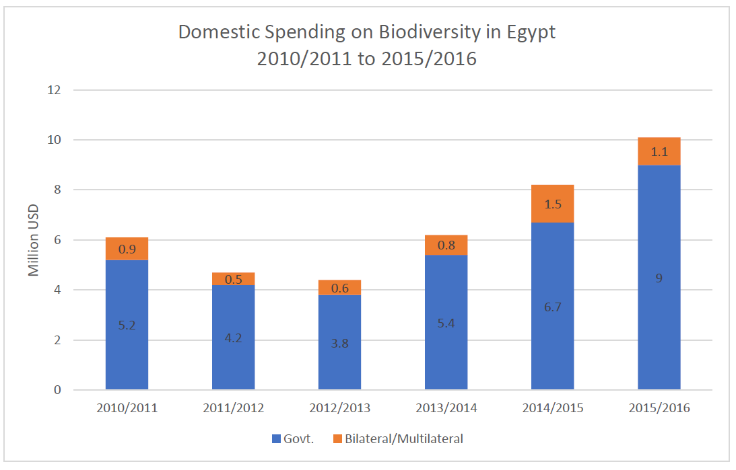
- Two closely-aligned interventions have been instrumental in this development: the work under the GoE/UNDP/GEF-4 project Strengthening Protected Area Financing and Management Systems (GEF ID 3209, GEF Project Grant USD 3,616,000, endorsed for Implementation in May 2010 and due to close in June 2019) and the work under the Italian-Egyptian Environment Programme which over the last 20 years invested EUR 16 million primarily in the operationalization and management of protected areas across the country, involving local communities and tourism initiatives. These two projects have triggered significant additional investments and improvements at national and site levels over the last 2-4 years:
- A new unit for financial sustainability and economics was established at NCS/EEAA, which involves the CBD Resource Mobilisation Focal Point, who is also directly involved in the PA Finance project; their reporting and analyses (on finance flows gaps and needs, indirect biodiversity spending, etc.) are very encouraging; a Resource Mobilisation Strategy was developed that is now under implementation.
- A framework was developed/enhanced and adopted for concessions for private businesses (tourism, mines, etc.) operating inside PAs, and implementation has begun; and a framework for PA entrance fees was developed and adopted and is currently being piloted in Wadi Gemal PA with the vision to expand it to other PAs if successful. Together these have started generating significant new revenue. In addition, a new financial management system was set up to facilitate government spending and revenue re-injection, by which revenues are transferred from MOE to a special PAs account; in 2017, this led to an additional investment via this account of USD 4.5m of government finance for the PA system, as well as to an unequalled PA budget delivery rate of >95%.
- NCS (or its PA sub-unit) is expected to eventually morph into an autonomous national PA agency with some budgetary autonomy able to capture and reinvest the revenue it generates; an “Institutional Reform Proposal” is presently under discussion at Parliament and may eventually be endorsed, given also the renewed interest in the PA system.
- Significant investments have been completed and more are underway to upgrade PA and related tourism infrastructure and services, including in Ras Mohamed NP in the project target area; the GOE channelled USD 5m through UNDP Egypt to this aim, complementing resources provided by the Italian-Egyptian Programme.
- Another relevant project of relevance is the two-tranche UNDP/GEF regional project Mainstreaming conservation of Migratory Soaring Birds (MSB) into key productive sectors along the Rift Valley/Red Sea flyway (Tranche I: GEF ID 1028, GEF Project Grant USD 6,243,243, closed; Tranche II: GEF ID 9491, USD 3,500,000, endorsed for implementation in July 2017, ongoing until March 2023). Implemented through BirdLife International, it is headquartered in Jordan and works in several countries along the flyway on those sectors that pose the greatest risk to the safe migration of these birds. These are most importantly hunting, agriculture, waste management and especially energy (from energy infrastructures). Some of the most exciting outcomes of this project have been in Egypt, most notably in the engagement of public authorities, private sector and finance institutions regarding the placement of wind farms and their operations (world-leading shut down on demand practices are being rolled out on reducing collision risks when migratory flocks approach turbines). The project here focuses especially on the key migration bottlenecks – which in Egypt is the crossing from Sinai to the Egyptian/African mainland. The project is also working in Sharm El Sheikh, on the open wastewater treatment plant, at which hundreds of White Storks die every year, presumably due to bacterial or chemical contamination; for now this is limited to installing bird hides to convert it to a birding spot, and reducing pathogen contamination through the proven addition of EM (Effective Microorganisms).
Future investment baseline
- On biodiversity and protected area management, the baseline and project cofinance relevant to the here-proposed project will consist of
- USD 6,000,000 by EEAA/NCS in the PAs in South Sinai over the duration of the project, to ensure continued basic PA management and visitor management, and respond to priority issues of the Green Sharm Initiative elements on biodiversity (regulations for sustainable marine resources management, buoys and maintenance, boat wastewater management, tracking system and routing for tourism and fishing boats, enforcement patrols, etc.); 50% of these count as recurrent, and 50% as investments mobilised to reinforce the here-proposed new GEF project.
- new contributions from the Italian Development Cooperation Agency, who will over the duration of the project invest USD 1,500,000 in CBNRM in Wadi Rayan, Wadi Gemal and Siwa – and USD 500,000 for the PAs in South Sinai that are here counted as baseline and cofinance.
- The total baseline investment and tentative co-finance provided towards these PA-related activities over the 5-year duration of the project is estimated to USD 6,500,000.

2.3 Barriers, theory of change and assumptions
Barriers that need to be addressed to overcome the baseline challenge
Horizontal barriers: institutional
Weak institutional capacities; lack of integrated planning, enabling conditions and adequate policies; lack of inter-institutional and inter-sectorial coordination. Firstly, the city lacks a framework for sustainable medium and long term development due to: i) Weak institutional capacities for integrated planning, implementation and monitoring of urban resilience, adaptive and sustainable growth at all levels (public, private and civil society); ii) Lack of adequate medium and long term planning instruments that integrate the relevant urban development sectors, namely land use plans (GOPP) and sustainable development plans covering multiple sectors (energy, waste, transport, tourism, biodiversity, etc.), and budgets and monitoring to measure progress on the level of implementation (actions planning); and (iii) limited effort to anchor decision-making on biodiversity and regulations for biodiversity harmful economic activities within municipal planning. Similarly, upstream planning at municipal/governorate level needs to specifically recognize management measures related to the protected areas.
Horizontal barriers: legal and regulatory
A generally weak enforcement of legal and regulatory frameworks, across all sectors.
Horizontal barriers: technical
Weaknesses in technical capacity in planning and design for urban sustainability. The broad concept of sustainable cities and specific technical approaches to sustainable urban development and hotel practices are quite new to both the Government and the private sector of Egypt. Elaboration and implementation of effective integrated strategies for sustainable urban development with specific target will require technical assistance from outside experts and capacity-building among governmental stakeholders and private sector. It will further require strong and effective key performance indicators that can be continuously monitored and verified.
There are some weaknesses in the technical capability in handling properly measures for energy and water efficiency in public and private facilities (e.g. hotels). There is also no entity that is responsible for measuring, reporting and verification of the EE performances of hotels in Sharm El Sheikh.
There are also constraints in technical capacity to handle threats to critical ecosystems, such as coral reefs and associated ecosystems in particular related to sustainable boat anchoring systems at dive sites, collection and disposal of wastes from diving and recreation boats, effective tracking system for recreational boats, etc.
Horizontal barriers: financial
There is a general lack of financial frameworks to trigger sustainable energy and integrated management of natural resources.
There are currently no attractive financing mechanisms available through which households or private sector can obtain financing for small-scale renewable energy projects by using a PPA or a Renewable Energy Certificate as security. Hotels in Sharm El-Sheikh were practically limited in providing sufficient creditworthiness for being eligible for bank loans. The interest rates of the currently available consumer loans in Egypt reach 10-15% per year and are therefore unattractive for financing RE and EE projects that require long-term financing at moderate interest rates (as with the case of financing larger power plants or larger refurbishments). Lending schemes specific to renewable energy projects have to be explored that would enable the best use of limited concessional public resources (including those provided by development banks and institutions) to soften the terms of overall project financing.
Although, there are new regulations related to collection of revenues from protected areas, there are no clear guidelines and procedures to ensure that revenues generated from protected areas are effectively channelled for conservation activities within the PAs themselves, that would enable recruitment of additional staff, support research and monitoring and improve management practices.
Horizontal barriers: information/awareness
Limited knowledge and experience with environmental sound technologies. Sharm El-Sheikh has limited experience with low carbon technologies being installed, there are only a few small- and large-scale solar PV installations. However, there is huge untapped potential to utilize solar and other renewable sources (wind, biomass, etc.) at large scale or distributed energy production facilities (e.g. hotels and other buildings), and at the same time benefit from implementing energy efficiency measures. Other areas lacking technical solutions are water and resource efficiency as well as the weak capacity to manage municipal solid wastes properly. While there is a waste-processing facility in Sharm El-Sheikh that conducts some recycling, there is also a need to focus on waste avoidance (minimization) and gradually improve the sorting, processing, and testing of incoming and outgoing waste streams from the city and the tourist infrastructures in order to avoid illegal dumping and burning of wastes, release to the sea and waters and expand recycling and make the use of recovered materials more economically viable.
Limited understanding and awareness of holistic threats/practices impacting biodiversity. Technical assistance including holistic threat assessment, financial assessment and appraisal, training and capacity building are needed. While, efforts have been initiated recently to survey and establish baselines for the coral reef ecosystem (in terms of assessment of coral reef health), regular monitoring of marine, coastal and terrestrial environments is needed to improve understanding of key threats and measures to manage these.
Further specific barriers to the sustainable management of the water-energy nexus
Ineffective environment to promote the accelerated deployment of small-scale renewable electricity. A set of laws, regulations and implementation schemes has been adopted by the government (NREA) to and encourage the participation of private investors in renewable energy development. However, some difficulties have been experienced by developers and investors of renewable energy sources for electricity during project implementation. While the NREA has a clear leading role under the EPC scheme, its overall institutional responsibilities, including its role in land acquisition for renewable energy implementation, need further clarifications and simplification for all renewable procurement schemes (BOO, IPP, FIT and net metering). The administrative procedures regarding land registration for renewable energy developers are rather complex. The Project will engage with governmental entities (NREA) to resolve some of the regulatory barriers and support the widescale implementation of renewable energy procurement schemes.
Weaknesses in robust planning, enabling conditions and adequate policies that trigger sustainable and integrated management of energy and water: Although there are policies specifically on EE, its still need to be tailored to the tourism/hotel sector in an urbanised setting where there are other parameters such as water management and requirement for a certain level of service to be provided (e.g. client comfort). In addition, enforcement is also key in adopting EE measures. The prevailing experience shows that enforcement of policies is not carried out systematically.
Limited technical capacity: There are some weaknesses in the technical capability in handling properly measures for EE in equipment and efficient water consumption. There is also no entity that is responsible for measuring, reporting and verification of the EE performances of hotels in Sharm El Sheikh.
Limited proper financial incentives: The main constraint to investing towards EE measures have been the heavily subsidized energy prices. EE investments can appear unattractive when hotels assume continued low energy prices. Although water is scarce in Egypt, water prices have also been heavily subsidized. This also gives no incentive in investing further towards efficient water usage. However, there is a strong signal recently from the Government of Egypt as water prices have been increased by 50% in July 2018. This is part of a wider plan from the Government to reduce its subsidies towards utilities (electricity, water and gas). It is a good start, but still insufficient.
Limited awareness and information: Most of the hotel managers do not have sufficient awareness regarding sustainable use of energy and water resources and related solutions. There is this consistent dilemma between the cost of the investment needed versus the payback period, but also fears of compromising guest comforts. A thorough information campaign is lacking in order to convince key stakeholders, but also to showcase and demonstrate the work done by UNDP and GEF in this regard. A previous UNDP-GEF funded project implemented its activities in Cairo where some of the hotels such as JW Marriott and Conrad demonstrated EE measures. These experiences need to be shared nation-wide, including in tourism areas like Sharm El Sheikh.
Inadequate quality control: Equipment suppliers import products of various quality levels. Since no systematic quality control mechanism yet exists, all kind of products and systems may be brought into the market with an objective of making short-term profits without considering market sustainability. As such, consumers face a high risk of acquiring systems that do not meet the expected performance. Energy standards for different type of products have been adopted, but the controls on domestic production and imports are not yet adequately organized.
Further specific barriers to sound waste management and pollution prevention
Until now, the focus in Egypt has been on recycling rather than on waste prevention. Often recycling takes places at disposal sites (legal and illegal dumpsites, waste bins and containers) by informal recyclers at a point in time when recyclables have already been mixed and are contaminated by other types of waste, making it hard to extract valuable recyclables and resulting in lower prices. Very limited focus is placed on practicing waste segregation at source or even better, introducing waste reduction measures.
The challenges reported for South Sinai in the area of municipal waste management are:
- Limited of public awareness
- Low capacity for processing and recycling
- Limited or inadequate facilities or equipment
- Inefficient collection systems
- Limited of financial resources
- Limited comprehensive and systematic integrated approaches for waste management
- Limited human skills and capacities
- Inadequacy of organizational and administrative systems.
Public services responsible for waste management are often inefficient and financially constrained, private sector activities are suffering from contractual and financial constraints, the informal sector has limited their engagement to what they believe profitable (recycling), waste management operations such as composting are failing in the majority of cases, and the official capability of attracting serious investments in municipal Solid Waste Management is almost non-existent.
The most constraining among the barriers listed is limited financing for the proper planning and implementation of waste prevention and solid waste management interventions, and a lack of the right incentives for those generating waste, whether those are hotels, the private sector or residents. In order to make waste management solutions work, SWM financing that includes full cost accounting, engaging waste generators and the general public in accepting the waste fees and institutionalising cost-recovery mechanisms are critical. Furthermore, putting in place the right incentives and disincentives for waste consumers, producers, and service providers to make environmental improvements or reduce adverse environmental penalties is key as economic instruments could create incentives and disincentives at different stages of the waste management, most importantly at the stages of generation, treatment and disposal.
Further specific barriers to sound biodiversity management
Limited implementation capacity to launch full implementation of Green Sharm Initiative. This applies to all the above topics as well, but is especially important for biodiversity because the topic doesn’t attract the same attention as the waste-energy-water nexus; the biodiversity issue is normally “outsourced” to the NCS Regional PA Authority even though it needs to be anchored more strongly in decision making (economic, infrastructure, investment) more broadly.
Municipal planning for biodiversity/natural capital and regulations for biodiversity-harmful economic activities are patchy and have loopholes. Ecosystem assets continue to be largely taken for granted in day-to-day decision making. Use of the marine space by different economic activities is not clearly regulated, especially in the Managed Resource PAs and in front of Sharm El Sheikh and other cities.
Limited monitoring for sustainability. This is because of the lack of a monitoring framework but also because of limited awareness and capacity in government agencies and private operators (with only a few exceptions).
Limited enforcement of regulations. This is valid at upstream level (municipal, governorate) and at site level (RMNP but especially in the Managed Resource PAs). This is linked to capacity issues but also to staff planning gaps and dedication. For example, an old Sharm/Ras Mohamed Management Plan and Marine Activities Zoning Plan has yet to be adopted or enforced by PA authorities. Such plans should be re-evaluated again with all relevant stakeholders before approval.
PA planning and management is acceptable but needs to be much better still in light of the huge pressures on RMNP especially. It could be enriched with internationally benchmarked innovative solutions. The Managed Resource PAs seem to impose limited constraints on harmful economic activities so their management plans especially should be reviewed.
Weak capacity on PA finance in South Sinai. PA revenue generation is still suboptimal and could benefit from a boost through a dedicated team and international technical assistance to make best use of the huge opportunities in South Sinai, to generate further resources for the national PA system. There is a risk that ongoing nationally led efforts on PA finance are not applied in RMNP.
Limited awareness and guidance about options and opportunities to reduce migratory bird mortalities. While the bird poisoning at the wastewater plant is being addressed through a targeted micro-intervention involving microorganisms by the ongoing GEF project on migratory soaring birds, the other risks to and opportunities for migratory birds cannot be addressed by that project because in Egypt it focuses largely on the placement and practices of wind farms on other areas of the country.
Theory of Change and Assumptions
- The Theory of Change (ToC) diagram shown in Annex 9 captures the linkages between the developmental challenge discussed in Section 1 and its causes and drivers. It also shows how the project interventions address the root causes of the problems related to the development of an integrated sustainable development strategy and implementation along the priority focal areas of energy and resource efficiency, solid waste management, biodiversity and green infrastructure in Sharm El Sheikh. The project outcomes are shown in the ToC diagram, but they are not detailed. The detailed discussion of the project outcomes and outputs is the focus of Section 3.2.
- The ToC contains a number of assumptions. At the level of project interventions, the main assumptions are:
- Political and institutional support received at all levels (National, regional, local)
- Public and Private (including tourism industry, technology suppliers, operators, residential) sector engagement in designing and implementing the Sustainable Development Strategy for Sharm El-Sheikh;
- Reliable and accurate data is available for monitoring and evaluating the pilot projects;
- Enforcement of integrated projects with focus on climate change mitigation, chemicals and waste and biodiversity;
- Policy and financial mechanisms identified and implemented.
21. At the level of the long‐term outcomes, the assumptions are:
- Project trained human resources are retained in Sharm El-Sheikh and tools, incentives and MRV system operational in government institutions/municipality;
- Regulatory and institutional frameworks and economic environment are conducive for investments in sustainable development projects;
- Project results and know-how built through the Project will be maintained and disseminated widely in the City, the country and beyond.
22. The assumptions relating to the intermediate goal are as follows:
- Hotel operators and owners are sufficiently stimulated by enabling environment and incentives to implement energy and water efficiency, renewable energy projects and commit to initiatives that help reducing waste and a clean environment;
- Municipality understands its role
- Sustainability is ensured beyond the project lifetime, including the mitigation of project risks.
- Stakeholders are well coordinated to ensure enforcement of the SESSDS and action plans.

Results and Partnerships

3.1 Project Area
- Egypt’s significant plans for the development of both expanded urban areas and genuinely new urban centres, including many linked to further coastal tourism development, demands for a new approach to achieve some form of environmental sustainability, and to not undermine the economic base on which these cities are built. The here-proposed project will focus on one key city and region – Sharm El Sheikh in the South Sinai Governorate – that brings together most of the above threats, but also a baseline and commitment on which significant innovation and results can realistically be achieved, with the aim to establish a model for other smaller and larger cities to follow, in Egypt and beyond.
- Situated near the southern tip of the Sinai Peninsula, on the coastal strip along the Gulf of Aqaba / Red Sea (please see the maps above and in Annex 1), Sharm El Sheikh is fundamentally a tourism city, of international fame, and counts with a resident population of approx. 75,000. The city and its economic, tourism-based activities depend directly on the assets offered by the surrounding landscapes, beaches and coral reef ecosystems. The project’s focus area will therefore include the terrestrial area of the city itself, as well as the bordering marine/coastal areas that are subject to economic activities originating from the city. This includes the three marine/coastal protected areas, namely:
- Ras Mohamed National Park, located at the meeting point of the Gulf of Suez and Gulf of Aqaba but extending north-east to include the coastal front of Sharm El Sheikh. Designated in 1983, 850 km² and proposed to become a World Heritage Site in 2002. It was designated a Green List Protected Area in 2018.
- Nabq Managed Resource Protected Area, stretching from north of Sharm El Sheikh to Dahab. Designated in 1992, 600 km².
- Abu Galoum Managed Resource Protected Area, stretching from north of Dahab to Taba at the border with Israel. Designated in 1992, 500 km².
- Another important purely terrestrial PA is located in the vicinity of Sharm El Sheikh, the declared World Heritage Site of St Katherine, but this was deemed a lesser priority as the pressure on its biodiversity are less pronounced, because the interventions required are rather different from those in the marine PAs, and because past projects have left a positive legacy in the communities in the area.
- As described above, the idea to transform Sharm El Sheikh into an environmentally sustainable tourism destination is not new, given that the Government of Egypt in 2010 announced the Green Sharm Initiative. The project thus builds on and enacts that long-standing statement of intent.
Figure 6: Sharm El Sheikh area with Ras Mohamed National Park
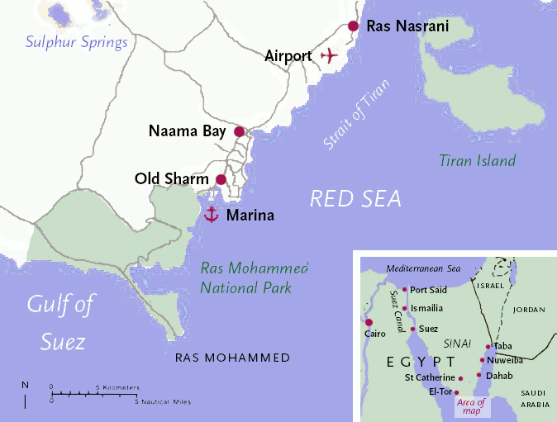

3.2 Project Description and Expected Results
- The overall Project Objective will be to Turn Sharm El Sheikh into a model integrated and ecologically sustainable tourism city of national and international importance through the adoption of further low-carbon technologies, proactive waste prevention and management practices and a further-enhanced protection of its natural capital basis.
- This will be achieved through a concerted effort to develop an integrated Sharm El-Sheikh Sustainable Development Strategy (SESSDS) and Action Plan to begin its implementation in earnest, with a major focus on technical assistance, capacity building and demonstration of good practice for climate change mitigation, chemicals & waste management, through a series of pilot investments, and accompanied by suitable and strong regulations and enforcement.
- To address the above-described challenges and barriers in conjunction with the baseline scenario interventions, and to work towards attainment of the Project Objective, the project will work on the integrated components outlined in this section.
- As detailed in Section 3.11 Risks to the project and social/environmental safeguards, as well as in Annexes 11 (ESMF) and 12 (SESP), the project is required to:
- Prepare a series of appropriately scoped SESAs for the potential social and environmental impacts from upstream activities
- Prepare at least two ESIAs/ESMPs, for the social and environmental risks under the waste management workstream (entire value chain), and under the biodiversity workstream
- Integrate and reflect UNDP SES requirements, including screening with the SESP and appropriately scoped ESIAs/ESMPs, in each individual feasibility study. This will include Livelihood Action Plans and/or Resettlement Action Plans as appropriate.
- This should all be completed within the first 3-6 months after project launch. All these assessments must be completed and the management plans and measures in place before the relevant project activities can be initiated. The latter affects especially on-the-ground activities in the target areas, while hiring and procurement as well as desktop work at central level may be initiated.
Component 1: Enabling framework for a green sustainable tourism city Sharm El Sheikh
- In order to setup an enabling framework for sustaining green tourism in Sharm El-Sheikh, this component will strengthen the legal, policy, regulatory and institutional frameworks at national and sub-national levels used to plan, improve and monitor tourism and related municipal infrastructure developments in the municipality. It will facilitate the setting up of an effective municipal development strategy and mainstreaming mechanisms required to ensure their coordinated implementation through setting up action plans to achieve better policy and planning coherence between tourism and municipal development and environmental/resource efficiency/chemicals and waste and biodiversity management in particular.
Outcome 1.1: Integrated urban sustainable development strategy and action plan for Sharm El Sheikh in place
- This outcome is targeted at the institutional capacities for planning, implementation, monitoring and enforcement so that they are strengthened in the South Sinai Governorate and especially the city of Sharm El-Sheikh and adjacent cities of Nabq and Dahab with their associated protected areas, in order to improve management of the impacts of tourism development on energy, water and waste management as well as biodiversity within ecologically valuable and sensitive areas.
Output 1.1.1: Proposed arrangement for a local governance framework prepared, setting up inter-institutional dialogue and participation mechanisms for integrated urban planning
- The project will review relevant policy frameworks including national and sub-national policies, legislations and development strategies that are applicable to the Green Sharm initiative. According to the findings of the National Urban Policy report, the Egyptian urban system is still suffering from the primacy problem of few urban settlements, which negatively affects the distribution of resources and investments, and hence, the functional and productive efficiency of settlements. The report calls for an amendment to the legislative and institutional urban management framework to accelerate economic growth and to achieve social equity. At the same time, new dimensions in the planning process in order to create novel solutions for the lingering Egyptian urban imbalances are required. An important base for thinking beyond traditional approaches for sustainable urban development in Egypt is the adoption of a new spatial planning approach that aims at achieving a better synergy and a balanced mechanism between existing and adjacent new settlements. A new multi-level territorial planning approach will be tested in Sharm El-Sheikh considering its inherent and fundamental economic, social and environmental functions: at the interurban level, it could foster economic development by promoting regional economies of agglomeration, increasing productivity and prosperity, addressing social, spatial and environmental disparities and promoting territorial cohesion and complementarities in both new and existing adjacent cities.
- Develop an enabling institutional framework/guideline for local sustainable development planning. Output 1.1.1 will acknowledge the necessity to provide an adequate implementation for the sustainable development strategy through an appropriate legal and institutional framework, an efficient interurban management mechanism, and a consensus building approach that reduces duplication of efforts, especially among governmental authorities (national, regional, local). It will develop an enabling institutional framework/guideline for territorial planning that: (i) acknowledges the different regional, urban and local situations and the need for spatially coherent territories, (ii) links and coordinates urban, regional and national plans, and (iii) establishes guidelines and mechanisms for coordinated urban territorial, environmental and infrastructure planning and management. Reference is made especially to other projects promoted with GOPP and UNDP support, such as the “Improving Interurban Synergies between Existing and New Egyptian Cities (CO-CITIES)” Project, or the UN-HABITAT initiative to support the development of “Sharm El-Sheikh’s Strategic Urban Plan”. Both initiatives are expected to provide relevant input in terms of policy framework and institutional setup/decision-making and be implemented in parallel.
- Producing Strategic Environmental Assessments (SEA) specifically to identify the potential impacts of tourism on biodiversity in Nabq and Abu Galoum areas that are classified as areas of special environmental importance with pristine natural resources, under threat of tourism development. These will identify the critical areas for biodiversity, the points of conflict with development and as much as possible the interconnectedness within these systems so that developments take notice of externalities and impacts. A key aim of these SEAs will be to identify areas which may be damaged beyond recovery, areas where tourism can be developed under strict controls and areas where tourism must have a minimal impact upon the environment. The purpose of these SEAs is to inform planning and provide the framework for avoidance, mitigation and any future offsetting mechanism.
- Install thematic working groups (Technical Coordination Groups and dialogue platforms) to promote dialogue and coordination between national and local institutions, private sector, associations and civil society. Stakeholder engagement will be a formal and fundamental component to develop the Sharm El-Sheikh Sustainable Development Strategy. Engaging with stakeholders increases the knowledge and expertise available for decision makers to draw on, potentially helping new ideas and innovations to surface. Empowering stakeholders to provide a meaningful contribution builds a shared sense of commitment and endorsement that can support decision makers as they undertake ambitious plans and interventions. Sharing data, indicators, and benchmarks with governmental decision makers, municipal staff, citizens, private sector and civil-society organizations is important to promote transparency, increase public awareness, and foster further community participation.
- Numerous thematic working groups will be established to ensure widespread input of ideas and dissemination of the new strategy, implementation plan and organization and selection of pilot activities. The project management unit will be appointed to assist the project in technical coordination and specialist inputs. UNDP will co-host and host required expertise from numerous previous and ongoing projects and initiatives in Egypt. It is expected that there will be at least 3 technical working groups formed that will be coordinated by MOE (with PMU organizational and technical support) and reporting to the Project Board, by contributing to Green Sharm El-Sheikh development issues reflected in the three GEF focal areas, (i) climate change mitigation (mainly water/energy efficiency and renewable energy), (ii) chemicals and waste and (iii) biodiversity and management of natural resources. Other cross-cutting issues, including policy framework, planning requirements, financial mechanisms and MRV issues will be either discussed of in additional working groups or incorporated into the focal area working groups.
- The form and content of stakeholder engagement efforts will mirror the diversity of the city’s population, as well as the complexity of sustainability topics. Participation should cover the full range of affected groups, with special attention given to representation of women, disadvantaged or marginalized groups. Two local stakeholders shall be engaged specifically: (1) firstly, the Bedouin communities living in Nabq PA or on the outer skirts of Sharm and (2) secondly, the local “Sharmers” (the owners of hotels, diving centers, homes, etc.) who have been living in Sharm for several decades and whose knowledge & connections are singular. The engagement of Sharmers & local communities will play an essential role in marketing the project within the city. The adoption of this project by local stakeholders would guarantee the longevity & sustainability of a Green Sharm mindset.
Output 1.1.2: Enhanced planning and integrated Sustainable Development Strategy and Action Plan for Sharm El Sheikh developed
- This output will build and strengthen a culture of integrated long-term planning fostering inter-institutional and inter-sectoral coordination between national, municipal and private sector institutions to optimize the use of resources and promote the sustainable development of within Sharm El-Sheikh in a coordinated and organized manner. One of the major outputs here will be the “Sharm El-Sheikh Sustainable Development Strategy” (SESSDS) forming an integrated planning and policy document which will be enhanced by a multi-annual implementation plan (action plan).
- To achieve this Output, the following activities are envisaged. External expert support will be required to assist the planning, strategy and action plan development and coordination of stakeholder participation.
Figure 7: Enhanced planning process leading to the Sustainable Development Strategy in Sharm El-Sheikh
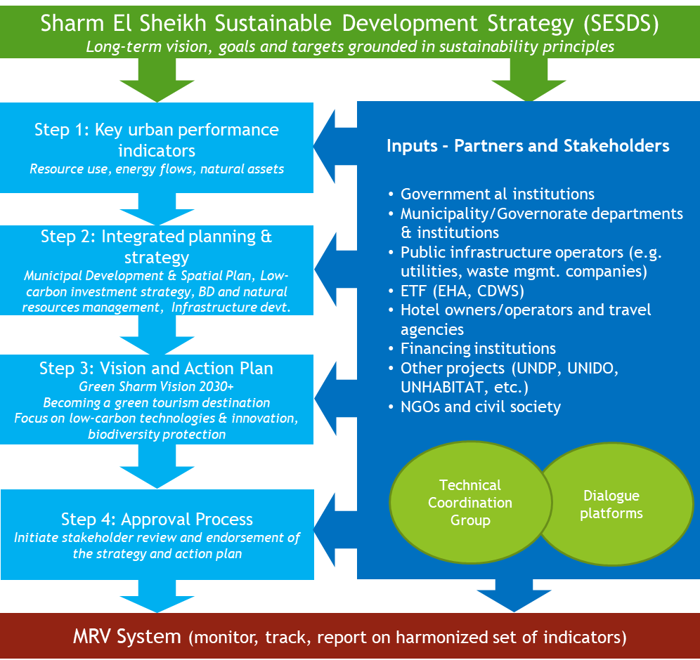
- Step 1: Assessment of key urban performance indicators. A city like Sharm El-Sheikh consumes a large amount of resources (incl. water and energy) and generates enormous waste outputs that impact the local environment (terrestrial and marine). However, it also offers opportunities for improving the resource efficiency, the better management of natural resources including conservation of natural habitats and biodiversity, by reducing the environmental impacts of local economic activity, especially by the tourism industry. The urban environment in Egypt is managed at national and sub-national level; therefore, effective action taken at municipal levels can potentially improve resource efficiencies and biodiversity protection and achieve other sustainable development goals at the same time.
- In order to provide relevant parameters for decision making and effective monitoring in the design and implementation of an integrated sustainable development strategy and action plan on the municipal level, the Project will identify baseline indicators that describe the current situation in terms of (i) resource use, (ii) energy flows and (iii) and natural assets in the city. The new baseline will be considering the revision, update and international benchmarking of the initial Green Sharm Initiative’s proposal of 2010, and it will allow monitoring & evaluation of the improvement of specific development indicators thereafter. Benchmark best practices from other tourism destinations will be used. The activity will entail the hiring of national and international consultants.
- Step 2: The performance indicators will feed into the "Sharm El Sheikh Sustainable Development Strategy (SESSDS)", that will define long-term priority development goals for implementation (perspective 2030+), and implementation targets incorporated into all major planning documents, policies and regulations. The SESSDS is considered to incorporate all major planning activities usually covered by a city administration, from spatial planning/land use planning, infrastructure and public services development (water/wastewater, waste management, energy supply, transportation, education, social & health services, etc.), private sector development (incl. tourism industry), and biodiversity & natural resources management (coastal areas, marine/terrestrial eco-systems, PAs). As an example, Green Fins management program as a performance indicator to assess the improvement of the eco-friendly diving centres/movement. The Green Fins program conducts a baseline study of the environmental impact of its diving & snorkelling centre members on biodiversity & its yearly improvement. Green Fins could help highlight the necessary policies; developments & changes needed to reduce the sectors’ impact on the Red Sea biodiversity.
- The SESSDS will be built off and harmonized with existing national principles on resource efficiency, sustainable consumption and the green economy, as adopted in the Sustainable Consumption and Production Action Plan (2016) and the Green Economy Work plan and Strategy (2010), which were developed in line with Egypt’s 2030 Sustainable Development Strategy.
- The Project will make use of the TA provided by UN-HABITAT to GOPP in the development of the “Strategic Urban Plan for Sharm El-Sheikh” (to be developed by autumn 2020), which already is supposed to provide the principles and basis, which the relevant authorities will rely on in taking physical development decisions, however, with its main focus on spatial planning and development issues. The Urban Plan can be considered a baseline assessment containing also thorough analysis of the demographic, economic, governance, social, and environmental challenges in Sharm El-Sheikh. It determines the city’s needs and suitable areas for interventions, examines its ability and capacity to take on investments, and facilitates monitoring and evaluation.
- The GEF intervention will be built on the Urban Plan and integrate it into a full-fledged Sustainable Development Strategy (SESSDS), with specific focus on the focal areas covered by the Project. The SESSDS will integrate the following plans: (i) Strategic Urban Plan, (ii) Waste Avoidance and Waste Management Plan, (iii) South Sinai Environmental Action Plan, (iv) Tourism Development Plan, and others, covering main infrastructures such as water supply/wastewater management, energy supply (with specific focus on renewable energy) and transportation infrastructure, and integrating updated planning for the South Sinai PAs
- Gender mainstreaming will be a priority in the development of the SESSDS and will be approached at different levels: i) political level dialogue with the authorities of the key concerned institutions (ministries, governorate/municipality, civil society organizations and private sector) to raise awareness on the importance of gender equality in development processes; ii) capacity building and training on gender mainstreaming; and iii) involvement of women’s groups considering job opportunities in sustainable development.
- Step 3: Develop the Vision and Action Plan for the SESSDS (short term 2020-2025, long-term 2025-2030+) in line with the sectoral development priorities and with short-, medium and long-term actions considered. A Vision for development of interventions and strategies in a systematic and coherent manner will be developed, resulting in a vision statement for Sharm El-Sheikh to make this destination environmentally sustainable and to capitalize on ecotourism trends by 2030.
- The GEF increment will cover a multi-year implementation plan (action plan) up to the year 2030 (or beyond). The action plan presents goals for the focus areas selected in the strategy. The goals are expanded upon through various actions. Targets specify the desired outcomes of SESSDS activities being an important step to translate the vision and goals into specific activities. The plan also defines who will carry out the actions, as well as the schedule for their implementation. The action plan is intended to function as a practical guideline for all parties involved on how to achieve common objectives. The action plan includes both, long-term strategic infrastructure investments (implementation scope beyond 6 years), as well as short-term measures implemented with TA and financial support under the GEF Project and providing a contribution to the implementation of the SESSDS. The action plan will form the prioritization framework and include a scoring system for infrastructure investment projects (incl. multi-criteria analysis), including assessment of environmental and climate impacts. The plan will be evaluated annually, and additions will be made as necessary.
- Step 4: Initiate stakeholder review and approval process. The SESSDS and its action plan will be provided for review and final endorsement will be sought. The draft will be presented to the core working groups and the representatives of the relevant stakeholders, participating in all the previous steps till the finalization of the sustainable development strategy. A final draft of the SESSDS, including the action plan, will be presented to the local council and the executive bodies concerned, at the level of the city, governorate and national level, for approval.
Output 1.1.3: Marketing and branding strategy for green tourism in Sharm El Sheikh endorsed
- The project aims to prepare a Strategy for the Marketing and Branding of Green tourism in Sharm El-Sheikh. This strategy will enhance ongoing activities of GOPP to market green tourism in the country. Technical assistance will be sought from specialized agencies, such as e.g. UNWTO that has prepared tourism marketing and branding strategies for many of its Member States. When successfully implemented, marketing strategies lead to increased international tourist arrivals and receipts and the expansion of domestic tourism, with the subsequent creation of jobs and opportunities for the local population. In addition, the Project will support mainstreaming activities for tourism facilities to adhere to the governmental requirements and international best practice concerning certification as well as COVID-19 health & safety procedures, and in addition waste management practices in favour of minimizing operational risks for these facilities.
- The following specific deliverables are considered under this output.
- Development of a CO₂-calculator which will allow the carbon footprint of the different international markets to reach the destination to be included in the assessment of potential source markets together with the socio-economic variables normally under consideration. The calculator is therefore aimed at supporting better decision-making and climate-aware investments in tourism promotion by enabling tourism marketers and tour operators to analyze and visualize the carbon footprint of tourism promotion strategies. The calculator will be combined in the future with carbon offsetting mechanisms (e.g. for carbon-intensive touristic activities in Sharm El-Sheikh, such as desert safari trips) to support small-scale local carbon offsetting projects that will be brainstormed in the thematic working groups.
- Delivery of a marketing strategy & plan including launch of a "green tourism" campaign in Sharm El Sheikh through a cooperation between the EHA and the big travel operators (responsible for getting more than 90% of international tourists to Sharm). The marketing plan should be considered a road map that enables the hotels and operators to maximize the benefits (revenues) of using green tourism as a tool for promoting tourism (e.g. a Green Sharm Tourist Information Center), and it should tackle different marketing aspects such as targeting, quality & level of hospitality and pricing and promotion. In addition, the project will support Sharm El-Sheikh develop awareness‐raising campaigns and public display of relevant (green city/tourism) indicators that will be differentiated to targets all the different beneficiaries and stakeholders in the city. The campaign will run in various languages and will provide visitors to Sharm El-Sheikh with a set of recommendations to help them make responsible choices when travelling and have a positive impact on the destination they visit.
- A branding strategy & plan for changing the brand identity for Sharm El-Sheikh (from a cheap destination to a green one) is required. To be developed and implemented in cooperation with Egyptian Tourism authority, being the official body responsible for tourism branding and promotion.
- The process of developing the awareness campaigns will adopt the stakeholder engagement process described in section 3.8 and Annex 4. A gender‐differentiated approach will be adopted by building on the Gender Analysis that was carried out during project design (please see Section 3.10 and Annex 13). The design of the awareness‐raising campaigns will be accompanied by a budget plan that will be used for financial resources mobilization and/or internalizing the cost of the awareness campaigns in the formal budgeting process of the governorate/city.
- In response to the global COVID-19 crisis, which heavily affected tourism industry globally and especially in the project region, hotels and tourism facilities have to make sure that precautionary measures are been taken. The Project will support, together with the Egyptian Ministry of Tourism and Antiquities and the Egyptian Tourism Federation, mainstreaming activities in tourism facilities to ensure that organizational, technical, and operational precautionary, preventive, and sanitary measures are being incorporated in all hotels, restaurants etc, to ensure that the tourism industry in the Red Sea will be able to continue its operations after experiencing outstanding difficult years.
Output 1.1.4: Municipal MRV system in place for relevant authorities to monitor, track, and report on a harmonized set of performance indicators as regards progress towards the SESSDS at regular intervals
- At present, mechanisms that ensure the regular monitoring of tangible data on tourism impacts continue to be limited in Egypt. Yet, for the health and competitiveness of destinations like Sharm El Sheikh that rely on irreplaceable natural treasures such as its coastline and marine resources, monitoring mechanisms that generate regular insights into impacts empower stakeholders with tangible evidence in the management, preservation and maintenance efforts of the environment to which they are connected.
- The project will support the establishment of a MRV system at local level, which will provide regular, reliable and context-specific insights for the sustainable development of tourism in Sharm El Sheikh and in the region, and will consequently play a key role in the effective monitoring and implementation of the SESSDS and Action Plan.
- Monitoring, reporting and verification will involve the systematic collection and analysis of information based on planned activities and set targets during the implementation of the urban sustainable development strategy and activities, where the data collected accords with a set of performance indicators relevant to the measurement of the progress made towards greening Sharm. Evaluation exercises will be designed and implemented in the year 1 after SESSDS and action plan endorsement, with biennial updates conducted to compare actual outcomes and impacts against the agreed
- A platform for Monitoring, Reporting and Verification (MRV) will be developed to guide and adapt the Sharm El-Sheikh urban infrastructure use and sustainable development plans over time. The monitoring platform will be based on ongoing successful experiences and will monitor sustainable city indicators based on indicators developed by the Global Platform for Sustainable Cities (GPSC) as well as other indicators that may be identified specifically for the case of Sharm. Monitoring will include project relevant impact indicators (e.g. resource efficiency and energy use, sustainable transport, solid waste management and chemicals, biodiversity, GHG & UPOP emissions). In addition, management efficiency indicators related to integrated planning, transparency and citizen participation will be defined and monitored.
Outcome 1.2: Increased investment in environmental sustainability in line with new strategy and implementation plan
Output 1.2.1: Preparing the grounds for investments in low-carbon technologies, improved chemicals & waste management, as well as enhanced biodiversity protection
- At the design, financing and implementation stage, preliminary feasibility and feasibility studies will be conducted addressing public infrastructure services, to determine whether investments in low-carbon, greener product design and waste technologies, and biodiversity are sound enough to be technically implemented and financed.
- The Project will provide Technical Assistance to the city and relevant stakeholders in the elaboration of relevant concepts and investment opportunities, by providing technical-economical solutions covered within feasibility studies, business plans and specifications for design and tender. The following priorities have been identified during the PPG with their view on an overall environmental impact; they will be eventually considered in the implementation of the SESSDS by prioritizing them within the Implementation Plan. The following assessments are going to be tendered in the frame of the project to specialist firms (national, international) or individual experts.
- Develop concept of sustainable waste management and business plan to improve operations for collection, sorting, recycling and safe disposal of wastes in Sharm El Sheikh, including tourism facilities (hotels, beaches, jetties/boats, restaurants, shops), PAs, public and residential areas.
- Sharm El-Sheikh is facing the challenge to lower the amount of wastes that is currently been dumped with no further treatment. Increasing the rates of waste separation, sorting and recycling (plus avoiding of waste) are the key requirements by the waste management component. The figures below outline the recent and the desired future situation of waste collection and treatment (hazardous and medical waste here not included).
- The key elements of the municipal waste management will be assessed, and a waste management concept and business plan developed for the overall city. Main directions to be covered by the Project are: (i) efforts to avoid waste and increase recyclability esp. by less packaging, reduction of single-use products, replacing plastics by paper, reduction of multicomponent packaging (ii) waste collection modalities including relevant transportation and collection infrastructure in the city, at tourism facilities (e.g. establish a waste collection schedule & plan for hotels, diving centres & boats/jetties) and other industries and businesses, (iii) waste separation and sorting routines including sorting facility, (iv) treatment of separated wastes, including recycling, composting, treatment of hazardous (e.g. electronic, medical) wastes, (v) final treatment & disposal (landfilling), (vi) organization and operational concept including costs for investments and operations.
- The package will be tendered in two phases: (i) feasibility study & business plan, (ii) service contract for implementation & operation (e.g. DBO – design/build/operate).

Figure 8: Current and future desired waste management scheme in Sharm El-Sheikh
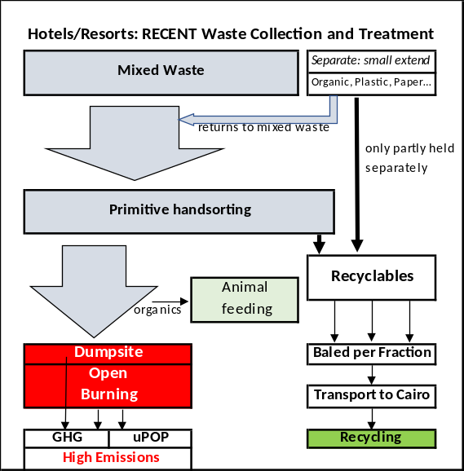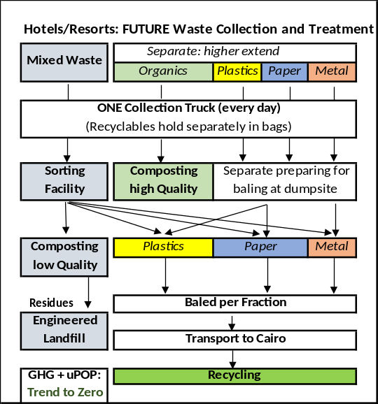
- Feasibility study(ies) on innovative renewable energy and energy efficiency infrastructure and smart solutions.
- Distributed solar systems connected to the grid – such as most rooftop installations – generate power where it is consumed and thus reduce transmission and distribution (T&D) losses and avoid additional T&D investments. In many cases they also can displace imported diesel for backup generators, thereby mitigating the environmental and health hazards faced by local communities when exposed to pollutants from diesel generators. While the GoE has not yet conducted a comprehensive assessment of its distributed solar potential, this potential is likely to be very significant, also in Sharm El-Sheikh. The Project will assess potential investment cases for rooftop and ground-mounted distributed PV solar systems, mainly linked to hotel facilities as well as public entities (hospitals, schools, public lighting). Integration of battery storage systems and charging infrastructure for e-vehicles will be assessed as well as other major electricity users, such as water supply (pumping energy) and desalination plants (pumping, compressors).
- Alternative cooling solutions. District cooling is a superior alternative to conventional air conditioning, thus being an essential utility for sustainable economic and urban development, as it helps reduce energy consumption and costs to both customers and governments alike, while also protecting the environment by cutting carbon dioxide emissions. Some of the advantages district cooling has over traditional air conditioning include: up to 40% less energy consumption, decreases energy costs, whilst it is noted that initial capital investment is higher, annual maintenance costs are substantially lower, protects the environment by reducing CO2 emissions due to lower energy consumption and phase-out of refrigerants HCFC. However, PPG assessments show that including DC into existing buildings/tourism facilities is not feasible, due to the large extensions of hotels resorts and – in most cases – large extended distribution grids required. Nevertheless, an objective of the feasibility study will be to module and simulate several centralized district cooling system concepts, e.g. using a hybrid solar or gas thermal driven absorption chiller. The hybrid system is considered very suitable for Egypt. The study will produce a detailed technical, financial as well as environmental and energy assessment / road map for Sharm El-Sheikh, in the development of alternative cooling systems (centralized and decentralized) with a focus on new real estate developments and aims at – in case of a positive outcome – to include specific investment cases in the implementation plan of the SESSDS. Other options the feasibility will investigate are for switching current HVAC systems in hotels to operate using absorption chiller technology.
- Feasibility study on Renewable Energy Powered Desalination Plants in Sharm El-Sheikh, including an environmental impact mitigation plan and zero liquid discharge (e.g. brine treatment instead of water reinjection).
- The right combination of a renewable energy source with a desalination technology can be the key to match both power and water demand economically, efficiently and in an environmentally friendly way. Assessing the technical feasibility and cost effectiveness of renewable desalination plants requires a detailed analysis, including a variety of factors, such as location, quality (salinity) of feed-water input and fresh-water output, the available renewable energy source, plant capacity and size, and the availability of grid electricity. There are four municipal desalination plants and an unknown number of desalination plants operated by hotels in Sharm El-Sheikh. Apart from being an energy-intensive process to prepare drinking water, the current practice prevailing is that the discharge of desalination brine takes place mainly by reinjection in surface or shallow waters, which leads to infiltration to the sea and therefore causes an currently unknown (or at least scientifically not well assessed) environmental impact to the marine ecosystem, including corals and fish. A feasibility study shall be elaborated to assess possibilities for renewable energy integration (e.g. solar PV to operate pressure pumps in reverse osmosis processes); furthermore, desalination plant discharges need to be inspected as they may not be injected at the correct depths and some of the plants (including hotels) are injecting at shallow levels. Alternative desalination concepts, including treatment of brine and useful recovery of by-products including energy shall be reviewed and specific recommendations/requirements for operators of existing and new desalination plants developed, with a specific consideration of the technical, economic conditions and legal requirements.
- Feasibility study and business model to diversify the transport modal split in Sharm El Sheikh by introducing a public bus system and bike sharing programs to connect hotels, residential and commercial areas within the city boundaries
- Based on existing examples in other parts of Egypt (e.g. El Gouna), the project will assess the feasibility of alternative transportation modes to improve the modal split with a focus on reducing environmental impacts and GHG emissions in the city. The mayor of Sharm El-Sheikh as well as the Egyptian Tourism Federation have expressed interest to setup a bike sharing scheme using the existing infrastructure of bike lanes across the city and provide tourists, but also residents the opportunity to rent out bicycles (ideally e-bikes) for getting around and thus avoiding transportation through taxis or minibuses. The case of a bike sharing scheme for Sharm El-Sheikh will be assessed using the experience from other touristic cities, such as El Gouna (and other cities, operated by Baddelonline) to come up with a business plan.
- Another concept study will be looking into opportunities to install bus routes along the main boulevards, connecting hotel resorts and residential areas with the city center (basically Nama Baya and Old Sharm). However, preliminary discussions with bus operators from Cairo (e.g. Mwasalat Misr Transport company) concluded that operating bus routes will require substantial financial support by the city to cover for the cost of operation. Further discussions will be therefore necessary during the project to assess feasible solutions together with the Governorate/City, before a feasibility study and business plan will be tendered out.
- In a combined approach of greening the transportation means within Sharm El-Sheikh, synergies of a bike sharing program and a public e-bus system which would connect the various areas in Sharm (Hadaba-Old Market-Go Bus Station-Naama Bay-Sharks Bay-Airport) will be studied, as well as the long-term opportunities to converting the touristic bus fleet to be electric vehicles (this scheme is supported inter alia also by the Egyptian Tourism Federation’s Committee on Environmental Protection & Sustainable Development).
- The value of these feasibility studies will be to provide a broad scope of innovative clean tech solutions to be incorporated in the SESSDS Action Plan. Some of these technologies/studies could result in concrete pilot investments within Component 2 – e.g. application of distributed solar energy systems in hotels, or alternative transport modes in the city or at touristic facilities. While other solutions due to their technical and financial complexity may make sense only in the longer term (e.g. 5-10 years, beyond the project implementation) such as the implementation of district cooling solutions or alternative desalination concepts.
Output 1.2.2: SESSDS Financing Strategy
- The technical assistance provided by the project will also develop a Financing Strategy (FS) for implementing the SESSDS – mobilising public and private investments that promote low carbon technologies, environmentally friendly management practices and biodiversity conservation considerations. The ability to mobilize resources to finance investments and interventions at the city level as well as private sector level, e.g. tourism infrastructure, will be crucial for implementing the priority measures from the action plan. Currently, Sharm El-Sheikh faces challenges to funding basic infrastructure and services to meet the needs of a growing urban population and recovered tourism industry, while also making capital investments for forward-looking projects. Investments in physical assets reduce any foreseeable risks to the city’s sustainability. Such investments may include hard infrastructure for upgrading informal low-income neighbourhoods, improving waste management or making solid waste collection and disposal more environmentally sound, providing public transportation, delivering water and sanitation services, expanding renewable energy distribution and energy efficiency in public and private entities. Hard infrastructure investments need to be carefully structured financially, institutionally, and legally in order to mobilize the necessary long-term capital financing needed for project implementation. The Project will offer technical assistance in setting up a single centralised financing mechanism, e.g. a Sustainable Development Fund, or several.
Output 1.2.3: Develop a long-term financing scheme to increase the uptake of private sector investments in environmental technologies (incl. energy, water, waste management, sustainable transport) and biodiversity conservation
- In 2015, the Ministry of Tourism and Antiquities developed a conceptual design of an incentive program aimed at supporting hotel owners and management companies in reducing their operational costs and their carbon footprint through increased penetration of energy efficiency (EE) and renewable energy (RE) technologies. A pilot program was prepared to test market acceptance and validate implementation elements in preparation for future adoption as a full program. In October 2015, the pilot concept received approval from the ‘Supreme Energy Council’ (SEC – a Cabinet committee headed by the Prime Minister) to test the program concept in 6-10 hotels with a funding level of EGP 20 million to be provided by the ‘Tourism Fund’. Approval of the Board of the Tourism Fund was later received in November 2015; however, the Fund has been stalled from its operations due to the economic situation at that time.
- The main concept of the 2015 pilot was to encourage investment by hotel owners and management companies in EE & RE proven technologies through offering capital investment from the Tourism Fund as loans that can be repaid in a manner that mirrors occupancy levels in the participating hotels. The pilot was to provide financing for two thirds of the necessary investment to upgrade lighting system by replacing existing traditional systems with LED technology; shifting water heating from traditional electric or fuel sources to solar thermal energy; and using photovoltaic-generated energy to partially offset electric use in off-grid locations. These loans were to be offered to hotels at zero interest as the expected repayment scheme was linked to the level of occupancy and not at a fixed interest rate as is the case in traditional bank finance. This was primarily to support the hotel sector during the difficult time associated with the 2011 political dynamics that left the sector with extreme low revenues, a situation that made their credit worthiness totally undesirable to banks.
- Current data on hotels occupancy in the majority of Sharm El-Sheikh hotels indicate that the sector is starting to gradually regain its health as the numbers seem to have increased steadily since 2017. This trend, coupled with the current government aggressive plan to restructure end-use energy subsidy, the hotel community is now more open to consider EE & RE solutions to help face the challenge of rising operational costs.
- The project will develop together with the MOTA and ETF a business model for setting up a long-term financing support scheme for hotels that is based on lending a portion of the necessary capital investment for either upgrading or installing new energy- and resource related infrastructure in hotels (e.g. energy efficiency, renewables, water efficiency, waste management) against specific criteria. Using respective co-financing from government and/or commercial financing sources, appropriate financing conditions at lower interest rates (compared to commercial interest rate) will be proposed for the benefit of developers of investment projects, ideally leading to a Fund solution (e.g. "Sustainable Tourism Fund") with financing sources being made available beyond this project. New developments such as the COVID-19 Impact Fund set up by Egypt’s Central Bank in 2020 will also be considered in the setup of the financing mechanism.
- The specific role of the project under this output will be limited to technical assistance and acting as a facilitator for further consultations; the actual establishment of any new lending (or guarantee) mechanism will primarily rely on the project’s financing partners. The specific activities to be supported by the project may include:
- Required background studies, analysis and initial drafting of the proposed financing scheme(s) and support for required follow-up consultations with the financing entities interested in developing the scheme(s) further;
- Support for technical due diligence of the projects proposed for financing and training of the participating banks on technical aspects of the projects;
- Involving local community including men and women associations to act as intermediaries, helping to promote the lending mechanism and support the projects; and
- Monitoring the impact and performance of the financing schemes introduced.
Component 2: Reducing GHG and UPOP emissions in targeted urban zones through innovations and public and private partnership
Outcome 2.1: Institutional capacity developed for integrated urban planning in Sharm El-Sheikh to identify, design and implement innovative low-carbon, climate-resilient sustainability solutions
- This outcome is targeted to deliver increased capacities at the institutional, managerial and technical levels at public and private entities coping with sustainable development planning and implementation. The result will be achieved by providing a series of training activities dedicated to different staff levels (administrative, managerial, technical) and considering gender specific needs.
Output 2.1.1: Training of staff in governorate, municipality and hotels on design and implementation of relevant low-carbon measures and sustainable development strategies
- Training needs assessment and training plan: The first approach will be to develop a needs assessment and a training plan targeting national and municipal institutions, private sector and CSOs. A detailed training program and action plan will be designed in PY1, and the training program will be implemented throughout the project´s duration. In addition, a Sustainable City Capacity Scorecard will be developed in PY1 to track the improvement of the institutional capacities of the key institutions (and others that may be included during implementation) in planning, implementation and monitoring of urban, resilient, adaptive and sustainable growth. The Sustainable City Scorecard will be completed at mid-term and end of project as part of the project´s M&E (Outcome 4.1).
- Within the themes identified in the plan, the specific services to be provided by the Project will be detailed, which may likely include short-term technical assistance and expertise for consultant-led trainings on:
- Institutional capacity building concerning development, management and implementation of sustainable development strategies and action plans at municipal level. Target group: mainly municipal/governorate staff.
- Training of public and private sector representatives on MRV methodologies for GHG and other emission reductions, in line with the SESSDS requirements and international standards
- Technical training activities for public officers/technical staff of utilities concerning design principles, technical specifications and selection criteria for energy & resource efficiency, renewable energy and waste management projects.
- Training activities for hotel staff (technical managers/FM, etc.) on conducting energy assessments/audits in their facilities and implement energy monitoring and management practices in line with international standards and norms (e.g. ISO 50001/50002), including best practices on resource efficiency measures for hotels
- Training activities for public officers and hotel managers/staff on green purchasing (criteria, tech specifications, selection of alternative products to e.g. single-use plastics)
- The training plan will be implemented throughout the project´s duration, building the capacities of at least 50 public administration (municipal, governorate, national administration) staff and at least 200 private sector technical staff from private enterprises and 5 CSOs/NGOs in and around Sharm El-Sheikh.
Outcome 2.2: Reduced GHG emissions and other negative environmental impact through interventions addressing tourism facilities and the built environment in Sharm el Sheikh
- This outcome will be focusing on demonstration activities and support concrete, on the ground activities that promote low-carbon and resource efficiency technologies in public and private sectors. The component will build on TA-funded activities supported below and under Outcome 1.2 and provide targeted cost-sharing GEF support for selected pilot investments in Sharm El-Sheikh, already from an early stage on and in parallel to the output 1.1.2 SESSDS development.
- In general, for all the envisaged outputs below, the TA will include support in technical design, installation and procurement specifications for the purchase of EE or RE equipment. Further guidance on the required technical specifications and other criteria for supporting the first installations will be provided in the documents to be finalized at the project inception phase. Besides the financial evaluation, all projects to be supported with GEF funding will be subject to technical due diligence and verification of the proper installation and performance of the system during the commissioning stage by the project’s technical expert(s) and/or installers authorized by the project before releasing the GEF support. Involvement of energy management information systems (EMIS) will be promoted to the local government to monitor their energy related systems and infrastructures. The investors receiving support are also expected to commit themselves to collecting and sharing with the project’s Implementing Partner and the PMU monthly performance data of the installed systems for the duration of the project, which then can be used for further public awareness-raising and research activities.
- The conditions and principles under which the pilot investments under this Outcome 2.2 can obtain GEF cost-sharing are outlined in Annex 8.
Output 2.2.1: Pilot low carbon technology solutions in public infrastructure of Sharm El Sheikh developed and applied
- In order to showcase low carbon technologies in Sharm El-Sheikh and demonstrate what can be done to reduce resource consumption in the built environment, GEF financing will be used as complementary financial contributions to leverage municipal and national sources of financing and other funding sources (private sector) for implementation of best practice energy efficiency and renewable energy measures in new and existing public buildings, public infrastructure, such as wastewater treatment, desalination plants, Sharm El-Sheikh Airport, street lighting using standalone on-grid and off-grid (battery-powered) solar PV in combination with LED (light emitting diode) lighting.
- Number of target investments supported: 2-3, project investment volume approx. 2-3 million USD
Output 2.2.2: Pilot projects introducing energy & water efficiency measures, and innovative transportation modes implemented by hotels in Sharm El Sheikh
- Some international and national hotel chains have a relevant presence in Sharm El-Sheikh, as Travco Group, Marriott, Intercontinental, Sheraton and Mövenpick; some of them already show a high interest and activity in investing in low carbon technologies, while others, mainly smaller owner-led hotels have been facing financial limitations over the past years and therefore have not engaged widely on energy and resource efficiency projects.
- Increasing the investment in innovative low carbon and resource efficiency technologies in hotel facilities will be supported in this component, by promoting the mobilization of innovative, commercially driven investments of more energy and resource efficient technologies, leading to GHG emission reductions and increased use of resources among the hotel and tourism industry. Based on a competitive selection process to be developed and introduced in cooperation with EHA, the project will select hotels and resorts that submit their investment proposals, covering a range of projects improving the use of energy and resources and provide them with TA and co-financing for implementation. The amount of financial contributions from GEF will be based on a set of criteria, including maturity of technologies put in place, amount of energy saved or renewable energy produced, and other hard and soft criteria (e.g. other environmental benefits achieved, number of combined measures implemented, willingness to disseminate and promote good practice). The following types of investments will be eventually considered eligible:
- Replacement of lighting systems based on LED technology (indoor and outdoor)
- Purchase and installation of high-efficient equipment (e.g. boilers, pumps, office equipment, chillers, heat recovery units, etc.)
- Improvement of heating/hot water preparation, ventilation and A/C systems
- Reduction of cooling load (e.g. reduce heat sources, shading systems, free cooling, remote A/C performance monitoring systems)
- Supporting the phase-down of hydrofluorocarbons (HFCs) in A/C systems as well as replacing and safely disposing inefficient cooling appliances and refrigerants
- Installation of energy controls and regulations systems (e.g. install occupancy-linked controls, room-based key cards, occupancy sensors, building energy monitoring systems)
- Installation of water saving technologies (e.g. adjustable flow restrictors on taps, faucet aerators, reduce of water leakages, drip-irrigation systems)
- Innovative transportation systems offered by hotels to their guests and staff for local transportation (to/from hotels to city/airport, nearby destinations), e.g. using electric or hybrid vehicles or offering bikes for rent.
- Hotels selected for the investment support will have the chance to benefit from TA services provided by the project, including energy assessment (energy audits), development of technical specifications, design and procurement support, as well as training courses for members of the hospitality industry, information on best practices and relevant energy and environment related indicators. Reference will be also made to other UNDP-GEF financed initiatives, such as the “Improving the energy efficiency of lighting and other building appliances” Project or the UNEP initiative “U4E” (United for Efficiency), a global effort supporting developing countries and emerging economies to move their markets to energy-efficient appliances and equipment.
- Since cooling applications constitute a major source of energy consumption in buildings in general and especially hotels, linkages to other initiatives will be sought. The “COOL_ME” project – with UNDP being a consortium member – will promote accelerated technological change in cooling demand reduction and support the capacity of building & facility managers as well as engineers, service technicians and stakeholders on local and national authority level.
- Hoteliers will be also enhanced to apply good environmental practice and demonstrate commitment to long-term continuous improvements, e.g. by certifying their facilities according to the available Green Star hotel rating program promoted by MOTA/STU and EHA, by introducing other management systems (e.g. environmental management according to ISO 14.001 or energy management according ISO 50.001; please refer also to Output 3.5.1). The Egyptian Tourism Federation’s Committee on Environmental Protection & Sustainable Development in collaboration with the UNDP-GEF Mainstreaming Biodiversity in the Tourism Sector project have begun in 2019 with the update & approval of the new Green Star Hotel criteria by the Global Sustainable Tourism Council (GSTC) to include more environmentally-friendly practices which focus on energy efficiency, biodiversity protection, chemical waste usage, bio-pesticides, sustainable garden & beach management, migratory bird conservation & more. The project might provide additional recommendations for further upgrades of the GS rating criteria in agreement with MOTA/STU and EHA and in line with other international Green Hotel standards and benchmarks, the GSTC, or Green Hotelier, and organize information/dissemination events to promote the GS rating among Sharm El-Sheikh and other tourist destinations in Egypt. In the Egyptian Tourism Federation’s Committee on Environmental Protection & Sustainable Development’s obligatory environmental awareness courses for the hotel sector; the GS Hotel label will be also promoted as the goal for the sector & encouraged amongst hotels.
- For example, standards for water conservation are currently under consideration; and for new hotels, compulsory energy and environmental benchmarks have been already introduced. The Project will engage with the MOTA/TDA and the hotel association to define such benchmarks.
- Public promotion of successes in green hotel practices in Sharm El Sheikh and public sector, including awards. Broad dissemination of successful experiences and best practices will improve the deployment of low carbon technologies in the tourism industry, together with the systematization of experiences and lessons learned at the local level to be replicated to other tourism destinations in Egypt and throughout the region. The ETF and especially EHA has both, institutional capacities and knowledge management for replication and upscaling the project outcomes beyond the target region, on a national scale. The project will, in cooperation with the ETF, organize a biennial “Egyptian Green Tourism Award” ceremony and dissemination event in Sharm El-Sheikh to award and promote good practice green hoteliers and tourism industries (e.g. also tour operators, and providers of diving and water sports) including their lighthouse projects.
- The Project will provide an effective brokering and will promote dialogue between policymakers, associations, consultants, engineers, investors, hoteliers and tour operators. Training materials, information sources, best practices and lessons derived from the experiences of the “pilot hotels” will be actively shared through outreach and dissemination activities. The intent of this activity is to make a variety of stakeholders – not only hoteliers – aware of energy and resource efficiency projects as a viable business opportunity including the huge potential to save on operational costs, and thereby be motivated to adopt good practices as part of their business operations.
- Target indicators:
- Number of projects supported: approx. 20-30, total investment triggered by hotels approx. 4-5 million USD, with 20-30 million USD investment due to upscaling and replication
- Number of public events: 2
- Number of additional Green Star rated hotels in Sharm El-Sheikh by project mid-term (15) and end-of-project (30)
Output 2.2.3: Pilot projects to mainstream distributed renewable energy generation in hotels
- This output will look into removing specific barriers for the increased installation of renewable energy technologies for electricity and thermal (heating, cooling) applications, mainly solar photovoltaic, but also solar thermal, small-scale wind, biogas, etc. by providing technical assistance to hotels looking for the installation into technically and economically feasible solutions.
- Installation of on-grid distributed PV systems in Egypt only began in 2014 through two government initiatives for rooftop PV systems on public buildings. Meanwhile, distributed solar PV technologies are developing quite rapidly with many projects in the pipeline. As electricity subsidies are gradually been removed and tariffs go up, the industrial and commercial sectors can couple small-scale PV systems to meet heightened energy demand and decrease their utility bills.
- Many hotels in Sharm El-Sheikh are being approached by energy service companies (ESCOs) and other private investors interested to install photovoltaic systems via IPP models on their premises. While the net-metering scheme is limited in power plant capacity (20 MW), independent power production through third party access scheme allows independent power producers (IPP) to construct a plant of any size and enter bilateral electricity purchase contracts with eligible consumers and sell them produced electricity directly on the site or through wheeling (dislocated, but in the same network). The Egyptian Electricity Transmission Company (EETC) must allow for conclusion of such contract and make grid network available. In this case, EETC is allowed to charge and collect an access fee for grid usage (or wheeling fee). However, the practice shows that there is not sufficient knowledge and experience in the market, especially at the level of hotels, to understand the legal provisions and procedures, and on the other hand there are also dubious and untrustworthy companies around trying to engage hotels into IPP contracts.
- The Project will utilize experiences from the UNDP-GEF “Grid connected small-scale photovoltaic systems” Project and provide technical assistance in evaluation and specification of contractual requirements, such as IPP contracts, and the necessary technical specifications and technical guidelines (or grid code), as needed for installation and grid-connection of PV and other renewable energy systems in hotels.
- Pilot projects will be receiving TA and investment support, similar to the mechanism described under output 2.2.2. Priority will be given to integrate renewable energy systems into buildings (rooftop PV/solar thermal systems) or open space, and connection to existing infrastructures at hotels/resorts such as wastewater treatment plants, desalination plants, farms or transportation infrastructure (e.g. charging stations for e-vehicles). The Project will be engaging with hotels, renewable energy installation and energy service companies selected based on a competitive bidding process, with the aim to demonstrate good practice and increase the visibility of renewable energy installations in tourism facilities.
- Target indicators:
- Number of projects supported: 10-15, project investment volume approx. up to 2-3 million USD (or approx. 0.2-0.25 million USD per project), and at least 5 million USD in the long term
Outcome 2.3: Improved waste management, reduced UPOPs emissions and prevention of plastic waste from land-based sources and boats ending up in the sea
- The conditions and principles under which any pilot investments under this Outcome 2.3 can obtain GEF cost-sharing are outlined in Annex 8.
Output 2.3.1: GHG and UPOPs emissions reduced through green purchasing and improved waste management and recycling
- This Output will seek to reduce the emissions of mainly UPOPs (dioxins and furans) as well as some toxic chemicals generated through inadequate management (burning) of MSW and hazardous wastes in dump sites (formal and informal). To achieve this, the project will develop a set of activities to organize green purchasing initiatives among hotels and tourism facilities and pilot an integrated municipal waste management system (separation-collection-transport-classification-packaging-recycling) that will help the municipality to enhance resource recovery from municipal organic wastes using 3R approaches (reduce, reuse, recycle/recover), regional and national institutions increase their knowledge on state-of-the-art waste management practices and acquire experience to implement and enforce it; including the execution of demonstration activities.
- Activity 1: Plastic ban and green purchasing guidelines for alternative products. As an additional measure to support the separate waste collection a plastic ban is to be executed: about 1,000 tons annually of plastic waste from land-based sources and boats are to be prevented from being uncontrolled dumped and ending up in the sea. The land-based sources will be eliminated to a large extend by the controlled waste management. Nonetheless, avoiding and replacing of single-use plastic products is necessary, this concerning bags, water bottles, one-way cups, drinking straws, wrapping foils, aside avoiding often giving a chance to replace it by natural, degradable materials. The numerous options are checked for practicability realization, costs and mitigation efficiency. A reduction by 50% seems to be achievable, this mainly determined by the possibility to replace one-way plastic bottles. The project will, in cooperation with the ETFEHA, assess the opportunities to purchase alternative products, e.g. wood-based cutlery, metal straws or paper cups, and elaborate “Green purchase guidelines” to be available online and linked to a catalogue of products and suppliers available. In addition, innovations to optimize the product supply chains through substitution of harmful substances and packaged materials will be elaborated and hotel operators sensitized through the support of the ETFEHA.
- Activity 2: Install proper working organization of public waste management in Sharm El-Sheikh. The first activity in the development will be the properly build up and organization of relevant stakeholders. To optimize the collection and treatment process these should be the municipality, the on-site-operator for waste treatment and the EHA. The municipality will act as the general supervisor and enforcement entity and will thereby support qualified performance. Measures should also be taken to halt the dumping of waste on the road from Sharm to Dahab, and to collect small waste landfills scattered around the town by (illegal) waste collectors.
- Activity 3: Operational improvement of separate waste collection at hotels. With the support of the EHA, a group of around 20 hotels/resorts will be selected which are already separating their wastes in a better manner. These hotels will further increase separate collection and will record masses and volumes of the separated fractions over at least one month to get reliable planning data, then provided specifically “per tourist and night”. This enables to upscale and estimate future daily volume and mass flows by extension to the other hotels, and for the needed treatment and sorting capacities. Accompanying training of the hotel’s staff at source for consequent separate collection and monitoring of volumes and masses will be required. The result of consequent separation and potential GHG emission reduction will be used to advertise the improved collection system to other hotels.
- The waste operator will secure the complete fraction-separated collection and transport to the sorting/composting/dump site – easy to do since all fractions should be collected in bags which should have different colors following the concerned content. He as well assures the sound treatment of the fractions according to their quality, without littering and open burning.
- Activity 4: Technical development of the sorting facility at Wadi Khanaseer. In parallel, the Project will support the optimization of the sorting facility at Wadi Khanaseer. The first runs will be observed to detect deficits (operative/technical problems), this to eliminate technical deficits and to develop improvement concepts and reconstruct the facility in an early state of the timeline. The performance will be checked for different inputs, esp. for the pre-sorted remaining waste from the 20 hotels and mixed waste from other sources. Special attention will be given to the composting process after hand sorting: Function of the turning machine, water supply, last separation by the compost screen, quality and application of the compost. In addition, the project may provide in-depth waste management training for the Bedouin community managing the Wadi Khanaseer area, such as organizing visits to different types recycling factories in Cairo/El Gouna areas.
- Activity 5: Check options for best treatment of separate collected organics. Best treatment options of all sorted fractions will be studied and determined. This to be done on one hand for all “dry” recyclables like paper, plastics, metals and glass by identifying and optimizing their final recycling ways. Collection of data of masses and the best achievable quality will determine the options. Aside of this, special attention is given to the most relevant separate collectable fraction: Organic waste from esp. kitchen waste and grass clippings, these forming 60-70% of the hotel´s waste. Two ways of composting are possible: (i) Either decentralized composting, directly on the resort’s area (as far as locally possible, e.g. as seen at the resort Movenpick) or collection and centralized composting. A good option for centralized composting might be the site of the sewage water treatment – shorter ways than to Wadi Khanaseer and water on site available (for remoistening) without its transport. Since the organics are source separated, the produced compost is of very high quality – no doubt this will be a highly desired material to improve the local soils. (ii) Aside, proper treatment of the organics will contribute the highest share of GHG-reduction within waste management, since the methane forming dump siting is eliminated – this being valid for both organic fractions: the separate collected and the one in the remaining waste, being composted at Wadi Khanaseer.
- Activity 6: Monitoring and optimization of further treatment of other waste fractions. A secure storage and treatment concept for hazardous and medical wastes will be developed - first a save storage favorably at an already paved sector of the sorting facility at Wadi Khanaseer, then realizing the best options for final treatment of the different fractions (e.g. oil, batteries, chemicals as hazardous waste, autoclave treatment or combustion for medical waste).
- The following insert illustrates the initial waste amounts and amounts that could be reduced through separate collection, improved sorting and composting measures at the existing waste management facility of El Khanaseer:
Figure 9: Waste management flow diagram

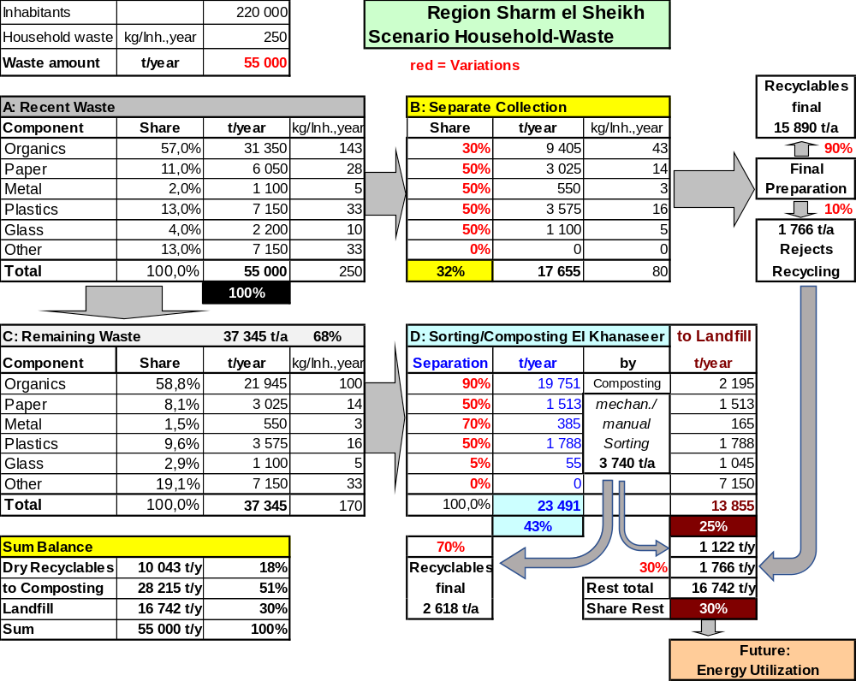

Responsibilities of the municipality, including subsequent control measures (refers to graph above):
- Contract with the operator of the El Khanaseer facility, that
- Already separate collected recyclables are kept separate and recycled,
- Valuables in the rest of the waste are sorted out as much as possible
- Remaining waste is landfilled in an orderly manner
- The quality of sorting and landfilling is continuously improved
- Absolutely no waste is open burned,
- Hazardous wastes are stored in an environmentally safe manner and treated in an orderly way.
- Companies are only authorized to collect and transport waste if they
- Keep already separated waste fractions further separate in collection and transport
- Deliver all wastes exclusively to the El Khanaseer plant,
- bring hazardous and medical waste exclusively there,
- do not allow external sorting of waste outside the El Khanaseer plant
- Instruction of all tourism companies,
- ensure the proper collection of waste in their area of responsibility;
- install a separate waste collection as far as possible,
- only contract an authorized waste collector following B)
- prevent any form of littering on land and at sea, especially plastics
- Instruction of citizens
- Education on the tasks and objectives of waste disposal
- Obligation to use the waste collection systems offered and prescribed
- Prohibition of illegal disposal, littering and incineration of waste
- Obligation to pay waste fees
- In all the above six activities, the interests of Zahret Ganoub as the operator of the waste site and the contract conditions of Zahret Ganoub with the municipality will be taken into account. Directly at the start of the project a meeting with Zahret Ganoub will take place to share information, project aims, benefits and restrictions. In general, all the planned outlined measures will lead not only to better environmental and health conditions but increase also the revenues for Zahret Ganoub due to more and higher qualified recyclable output materials.
- Parallel to the activity described, planning works will be started for an engineered landfill for the residues, in the area of Wadi Khanaseer, close to the sorting facility. First steps are to determine the capacity, the allocation and the basics for construction. The results of the investigations will show whether there is an unavoidable share of high caloric fraction, especially residues of paper, plastics, textiles. This can justify technical concepts to separate this high energetic fraction as refuse derived fuel (RDF) and identify options to make use of it e.g. in cement kilns (if they fulfil low emission standards).
- The “scale up” of the concept is foreseen in two steps: After collection of data and practical experience in 20 hotels the system is first scaled up to all hotels/resorts (about 175). Thereby - as a first collective - the waste collection at tourism facilities shall be considered as solved. During this first phase, more precise data and information will be collected for the city of Sham el Sheikh as a basis for a concept to separate waste there as well. The basics for a successful proceeding are known, in short: establishing a completed collection of waste in general, creating general awareness for the necessities (public information esp. via schools), first model districts with offered and explained possibilities for separate collection, thereby gathering experience in participation and operation, based on this, extension to the whole city. The Project will beyond that provide TA in developing technical specifications and support tendering procedures for municipal service providers.
Component 3: Promote enhanced biodiversity protection measures for management and mitigation of key threats
- In order to ensure that biodiversity and ecosystem services on which the economic potential of Sharm El Sheikh is dependent on is maintained, Component 3 aims to better manage and mitigate threats on biodiversity and ecosystems. To achieve these objectives, Component 3 is set to improve the management of marine and coastal PAs adjacent to Sharm El Sheikh; reduce the impacts of fisheries and their coral reef impacts to sustainable levels; manage and mitigate the impacts from boating, anchoring, diving and snorkelling on coral reef ecosystems; improve financing for PAs; engage local PA communities in biodiversity-friendly livelihood and resource management activities to enhance their contribution to conservation; and encourage hotelier and enterprises to improve their conservation management efforts, within and outside their areas of operation.
Outcome 3.1: PA planning and management of marine and coastal PAs adjacent to Sharm El Sheikh further strengthened to manage and mitigate biodiversity-harmful economic practices
Output 3.1.1: Protected Area planning and management strengthened to manage and mitigate biodiversity-harmful economic practices
- This Output will support the improved management of the three marine and coastal protected areas around Sharm El Sheikh. The three protected areas are: Ras Mohamed National Park, Nabq Managed Resource Protected Area, and Abu Galoum Managed Resource Protected Area, which collectively encompass the entire inshore coral reef system along the south-eastern and eastern boundaries of the Sinai Peninsula. The intent of this exercise is to further reinforce their planning and management, especially regarding the management of biodiversity-harmful economic activities. It would provide an opportunity to ensure harmonization of economic development activities with biodiversity conservation and ensure effective planning of tourism and related economic activities and management of threats posed by these development activities. To achieve this Output, the following activities are envisaged:
- Activity 1: Validation of key impacts on protected areas and their biodiversity and resources. Based on the preliminary assessment outlined in paragraphs 46-48 in Section 1.2 above, the project will conduct a more in-depth and site-specific review and assessment of the different threats that together put at risk the biodiversity and resources in the targeted protected areas. The threats identified in greater resolution would then be the focus of management actions through the project.
- Activity 2: Identification of all relevant stakeholders and their roles and impacts relating to each category of threat listed above. The Committee of stakeholders established to develop and implement the conservation strategy and action plan for PAs could serve this responsibility. Once the links between specific stakeholders / stakeholder groups and specific threats are defined, appropriate management interventions will be proposed that need to be negotiated and coordinated amongst the relevant stakeholders.
- Activity 3: Provision of technical assistance and support to identify suitable best practices and solutions. This will entail the hiring of national and international technical assistance to help to identify best practices and alternative technologies to minimize and manage the specific threats identified. This will tentatively look at reducing impacts from construction (hotels, piers, marinas; planning and practices), reef dredging and siltation; integrated management planning and zoning; carrying capacity assessments; enforcing (seasonal) closures of specific parts of the marine and coastal environment to conserve areas that are critical to life histories of species; setting carrying capacity limits and introducing a systems of permits to provide specific controls and/or limits to the boat numbers and boat capacities (diving and snorkelling boats and beyond, different access levels - beginner, advanced, etc.); setting and monitoring fishing access and harvest levels; preparing/updating guidelines for mooring including new anchoring systems; prohibiting or limiting harmful activities and practices, such as water-skiing, at least in vulnerable areas; monitoring; waste management. Performance indicators and certifications will be introduced to guide and assess the improvements, such as the ‘Green Fins’ initiative for diving centres (which conducts a baseline study of the environmental impact of its diving & snorkelling centre members on biodiversity & its yearly improvement, highlighting necessary policies and changes needed to reduce harmful impacts).
- Activity 4: Stakeholder agreement on strategies and roadmap for management of key threats to biodiversity. Through a consultative process with the relevant stakeholders, a roadmap can be agreed for managing and mitigating threats to biodiversity, particularly those from fisheries and tourism. The Roadmap will comprise a set of needed policy interventions, capacitation and management strategies to address the identified threats that have been negotiated with relevant stakeholders and to ensure cooperation with all sectors and joint implementation. The Roadmap will also identify the roles and responsibilities of key partners in such efforts along with a realistic timetable for implementation of such actions. It is expected that this should lead to mitigation of the pressures from tourism, especially diving & boats, looking at tourism load management, sustainable mooring installations & maintenance program and beyond.
- Activity 5: Implementation of the roadmap and investment for piloting new technologies and capacity building and monitor effectiveness of such pilots. The project will support the implementation of the roadmap and provide some initial investments to demonstrate such new technologies as relevant.
- Activity 6: Support for training and skills advancement. In particular for application of new tools and technologies for management and mitigation of threats.
Outcome 3.2: Protected Area financing increased through improved revenue generation and re-investment
Output 3.2.1: PA revenue collection and reinvestment
- Under this Outcome and Output, the project will further strengthen and support the recent government decision to enable PA authorities to collect entrance fees from visitors to all Egyptian PAs and from the jetties that boats are obliged to use to ferry visitors to the diving and snorkelling sites. In Sharm El Sheikh, the 3 PAs provide an opportunity for collection of significant entrance fees, as well as permitting fees for activities conducted within the PAs and its re-investment for conservation and related activities within Sharm El Sheikh. The project will facilitate PA authorities to develop improved methods for revenue regeneration, including also opportunities for private sector to contribute to conservation efforts, within and outside the 3 PAs. It will also facilitate improved planning for reinvestment in activities to improve the tourism’s natural capital base. This Output will support the following activities.
- Activity 1: Support on-going efforts to ensure effective reinvestment of revenues in conservation actions. Under the recently closed GEF-4 PA Sustainable Financing project (GEF ID 3209), guidelines and procedures for transfer and reinvestments in PAs have been prepared, but neither endorsed nor applied as yet. The funds get currently transferred to the EEAA Special Account, and although the Decree for revenue collection and re-investment in PAs has been approved, the mechanisms for ensuring effective re-investment are still unclear. Assurance of fund re-investment hinges on the decision to transform the Nature Conservation Sector (now under the EEAA) into an autonomous body with its own financial rules for revenue generation and re-investment. However, it is unclear, when this transformation will happen and how funds generated would be re-invested within the PAs. The Project will help this process by providing technical support to enable the institutional re-organization of NCS.
- Activity 2: Development of guidelines and instructions for re-investment of revenues: The project will support the development of clear instructions to ensure that significant amount of the revenues currently generated from visitor and permit fees are actually re-invested in the PA themselves, in particular for contracting new staff, research and monitoring, training and equipment.
- Activity 3: Support for electronic system for South Sinai for collection of entrance fees and permit charges. Currently, gate and jetty fees are collected manually, which is cumbersome, and entails use of park staff for this purpose. The GEF-4 PA Sustainable Financing project developed guidelines and procedures for improving revenue generation. The Green Sharm Project will help pilot these new guidelines and procedures in South Sinai by provision of equipment, training and establishing an electronic permitting system and marketing and increasing awareness of these new collection system.
- Activity 4: Expansion of system to issue permit for hotels and tour operators. These permits will expand opportunities for revenue collection from visitors to use campsites within PAs and bird watching expeditions and dive centres to enable them to operate diving and other low-impact marine activities. In addition, the project would investigate possibilities of providing incentives for local enterprises (e.g. hotels, tour operators, and private businesses) to directly finance conservation initiatives within the PAs and outside to broaden cooperation and enhance the conservation base – keeping I mind the recent regulatory improvements under which only dive and snorkel centres are allowed to offer snorkelling excursions, requiring strong controls of activities by other less-prepared players applying for permits or conducting activities.
- Activity 5: Support development of a comprehensive financing and resource mobilization investment plan for South Sinai PAs that extends beyond visitation and permitting system. As a long-term strategy to ensure that PAs in South Sinai can be self-sustaining, it is necessary to seek further opportunities for revenue generation and collaboration in conservation efforts, building upon recent approvals for collection of visitor and permit fees that can potentially benefit the PAs directly. The project will support the development of a long-term financing and resource investment plan for South Sinai PAs, aligned with the country’s long-term vision for PAs. This Output will cover the following activities: (i) identification and assessment of an array of potential investment opportunities for PAs (following for instance the BIOFIN catalogue of financing solutions); (ii) defining a time plan and sequencing of different revenue options; (iii) providing recommendations for best concessionary options, partnerships and investments for potential promotion and marketing; (iv) identifying and supporting feasibility studies and business plan development for best business opportunities; (v) developing safeguards and environmental actions for these businesses that integrates best practices; (vi) capacity building for National Conservation Sector for enhancing co-management practices with businesses and the effective enforcement and monitoring of business outcomes; and (vii) seed financing to support implementation of pilot business investment opportunities.
Outcome 3.3: Improved and systematic monitoring of status of key biodiversity resources to assess effectiveness of management of biodiversity-harmful economic practices
Output 3.3.1: Establishment of clear baselines for monitoring of condition of marine, coastal and terrestrial biodiversity
- Activity 1: Assess adequacy of baseline information available on PA marine biodiversity and natural resources: A coral reef survey has already been completed for Ras Mohamed National Park, Sharm El Sheikh and South Nabq. Sensitivity mapping and ranking was based on measurement of (i) diversity and abundance of coral reefs; (ii) diversity and availability of fish associated with coral reefs; (iii) diversity and abundance of marine invertebrates; (iv) extent of coral reef disease; (v) status of coral bleaching (full or partial); and (vi) level of negative impacts on coral reefs on account of human impacts (questionnaire survey). 189 sites were surveyed (2017) along 125 km coastline in Ras Mohamed National Park, Sharm El Sheikh and South Nabq (see Annex 20 for methodology and survey results for the 189 individual surveyed sites). The project will fill survey gaps, using a further enhanced internationally benchmarked methodology, as required, and thus provide the required monitoring framework, potentially complemented by further indicators if required. This could entail enlisting Green Fin Dive centres in biodiversity monitoring.
- Activity 2: Conduct of rapid assessment of terrestrial biodiversity: The project will support a rapid assessment of terrestrial and coastal areas in the 3 PAs (fauna and flora, ecosystems, etc.) that will include initially a review on publications, research papers on fauna and flora and identify gaps in terrestrial and coastal information and then contract a national research institution or university institution to undertake this rapid assessment (including a botanist/taxonomist, ecologist, faunal taxonomist, etc.) as well as training of PA staff on survey methodology and species identification.
Output 3.3.2: Regular monitoring and evaluation to support responses for management of biodiversity-harmful economic practices
- Activity 1: Support for biennial monitoring of marine, coastal and terrestrial areas to assess any changes in species or ecosystem health from baselines. The project will help further develop and support a monitoring program for South Sinai through a partnership between the Egyptian Tourism Federation’s Committee on Environmental Protection and Sustainable Development, the South Sinai National Park Authorities and the Chamber of Diving and Water Sports. Through such a partnership arrangement, the project will help create a coral reef and marine mammal monitoring program for the dive centres to participate. This monitoring program will provide research materials, data and photographic information that would contribute to improved understanding within NCS of the status and condition of South Sinai’s coral and marine resources. On the long-term such a partnership can help develop protocols for rescue of marine mammals and help establish an action plan that would enable the diving/snorkelling/water sports centres to effectively respond to reports of injured marine mammals. Through this partnership, efforts will be made to also enable volunteer participation of dive instructors in the biennial coral reef surveys to be conducted by the National Park Authorities. The private diving/snorkelling sector can be a key asset in the monitoring of the coral reefs and marine environment and a key partner in the efforts to conserve Red Sea biodiversity. The project will provide technical oversight (national consultant) and costs for monitoring (staff transport, lodging, materials etc.) for two additional monitoring surveys during the project’s implementation period. This monitoring will help assess, analyse and document the effectiveness of management measures to reduce biodiversity-harmful economic activities.
- Activity 2: Conduct consultative workshops to review monitoring results and agree on proposed mitigation measures with relevant stakeholders, in conjunction with Output 3.1.1 above.
- Activity 3: Constant monitoring of threats – with updates of management responses to address monitoring results and reassess and recommend mitigation measures as appropriate, across the spectrum of threats to coastal and marine biodiversity, in conjunction with Output 3.1.1 above. This could entail enlisting Green Fin Dive centres in PA monitoring efforts.
- Activity 4: Create electronic website for data and information management. This would entail the support for IT consultant (for a period of 6 months) to facilitate establishment of a server, data input and analysis, training of PA staff, input of new data by PA staff at regional level, computer and software. The PA authorities will assign two existing staff for data management (part time basis).
- Activity 5: Design and rollout of mobile app for diving instructors to report on any coral condition or related issues. This would require about 4 months of IT consultant time for development of mobile app and training of diving instructors to apply the app. This will be conducted in collaboration with the Chamber of Diving and Water Sports, who will also facilitate the rollout of the App through its members outreach. A transparency agreement could be signed between the PA authority and CDWS ensuring open access to data and collaboration.
- Activity 6: End of project workshop to present information on effectiveness of management on marine and terrestrial environment and disseminate best practices emanating from the project, as well as develop a plan for its sustainability and replication.
Outcome 3.4: Improved Protected Area community participation and benefit sharing from conservation and biodiversity-friendly tourism practices
Output 3.4.1: Participatory planning for community involvement in biodiversity-friendly livelihood activities
- The Nabq Protected Area comprises a single Bedouin village of around 310 individuals with a traditional lifestyle of fishing, livestock rearing and tourism. This community is an integral part of the PA and has largely lived a harmonious life with its environment. However, a recent strengthening of security measures in the Sharm El Sheikh area has limited their mobility, including access to fishing areas/resources. Based on the potential that exists in the area, given its proximity to Sharm El Sheikh, the GEF increment aims to support the following key activities: (i) improved rangeland, pasture and livestock management to improve productivity and reduce resource-use conflicts; (ii) sustainable livelihood improvement and diversification practices, including promotion of ecotourism, handicrafts and service facilities for tourists; and (iii) improved sanitation, waste management and pollution. The project will provide technical assistance, training and support demonstration of the livelihood improvement activities, and through the implementation of a village plan enhance the livelihoods and well-being of its inhabitants, while improving their contribution to the project conservation and sustainable management of their natural environment and resources. The village plan will be developed through extensive consultations with local communities and PA authorities and other relevant stakeholders, ensuring transparency.
- Implementation of the village plan will be well coordinated and promoted through effective technical support, regular review of implementation arrangements and the use of monitoring and evaluation information to adjust and refine the system in consultation with the stakeholders. The project will provide cash for work payments based on the following principles: (i) competitive assessment to beneficiaries; (ii) selection of beneficiaries in accordance with transparent criteria (to be defined early in the project); (iii) upfront payment (percentage of payment to be defined in consultation with stakeholders); and (iv) balance payment on successful completion and verification of work. Efforts will be made to try and identify additional funding support for this activity from existing government, local development programs and private investors. The Output is expected to enhance incomes of local communities, including fishermen from alternative livelihood activities to supplement their existing income.
- To achieve this Output, the following activities are envisaged:
- Activity 1: Recruit local technical support team acceptable to local communities to facilitate participatory processes and develop and support implementation of an integrated community develop plan. Given that there is only a single village within the protected area, it is important that they be fully integrated into the operations of the PA, so that they become effective partners in the conservation effort. The Bedouin village of Gharqana consists of 51 households that eke out a living from livestock grazing, fishing and limited tourism activities. However, given the location of the Gharqana village in terms of its close proximity to Sharm El Sheikh, it offers ample opportunity for promotion of sustainable ecotourism operations that can provide a sustainable income to the community to compensate for the declining fisheries harvest on account of the restrictions placed on their fishing activities. The project will support the development of an integrated village development plan that seeks to develop and integrate ecotourism opportunities with improved development and marketing of local products, development of local handicrafts and service facilities to support the ecotourism efforts, as well as improved sanitation and waste collection and management. Given the conflict that already exists between the local communities and PA authorities, it is important to get the services of independent consultants who are familiar with Bedouin culture to work with the community to develop an integrated biodiversity-friendly package of investments to support the community.
- Activity 2: Participatory mapping of community resources and needs to assess the potential for livelihood and income improvements. The consultant team will work with the community to undertake a participatory mapping of resources used by the Bedouin, understand their perceptions related to natural resources management as well as identifying opportunities that can contribute to improve the well-being of the community through support for sustainable use of natural resources, in and around their village. This will entail a number of consultative meetings and mapping exercises.
- Activity 3: Based on the participatory mapping and community consultations, develop a sustainable biodiversity-friendly investment plan for the Gharqana village. Such a plan would entail agreement with the community on sustainable livelihoods including ecotourism activities, livestock improvement, sustainable fisheries, handicraft and tourism services provision, waste management, sanitation, etc. It will require liaising with tourism and security authorities to license eco-lodges and camps and arrange a convenient system for visitor access and registration.
Output 3.4.2: Implementation of ecotourism and livelihood activities to build community support for conservation
- Activity 1: Capacity development and training for various income generation activities: These might include training on setting up and management of camp sites, running of eco-lodges, diving and snorkelling expeditions, sustainable fishing, women-based handicrafts development and provision of food and other tourism related services, waste collection and disposal, etc.
- Activity 2: Financial support for community income generation activities: The project will provide limited support based on the sustainable village investment plan for developing sustainable fisheries operations including marketing and storage, camping equipment, boats, craft equipment, etc. Any major infrastructure requirements for tourism-based activities or village infrastructure will be supported from funds generated and re-invested from visitor fees and permits.
- Activity 3: Limited Technical Assistance support will be provided for improving income generation, sustainable fishing methods, marketing (linked to visitor centre, small stalls, etc.), value addition, etc.
Outcome 3.5: Hotels and related enterprises integrate biodiversity-friendly practices
Output 3.5.1: Development of guidelines, best practices and improved management responsibility for conservation-friendly practices that protect biodiversity and ecosystems on which their economic interest depends
- In an extension to the efforts under Output 2.2.2 (selecting hotels to pilot best practices in environmentally sustainable measures), the project under Outcome 3.5 will help integrate biodiversity-friendly practices and activities in these pilot hotels to promote a more holistic and integrated approach to improving their overall environmental management. This would require these enterprises, particularly the hotels to grasp emerging opportunities based on biodiversity and ecosystem service (BES), securing cost effective options, develop new and biodiversity-friendly products and services and help them integrate BES in their business strategy and actions. Under Output 3.5.1, the project will work internally to introduce management practices and procedures that contribute to BES as follows:
- Activity 1: Support for review and implementation of updated guidelines for Chamber of Hotels (linked to Green Star Certification) that include specific biodiversity related aspects in hotel management. To facilitate this effort, the project will support one month of national technical assistance support for review of existing guidelines (Green Star Certification) to assess gaps and integrate biodiversity considerations in gardening (fertilizer and pesticide use indoor and outdoor), in landscaping and species choices to reduce IAS, use of less water demanding and more tolerant species, recycling, composting, improvement in garden and shore management, beach clean-up, (to complement waste management and discharge, energy efficiency and renewable energy use to be addressed under Output 1.2.1).
- Activity 2: Encouraging the nomination of a focal point within senior management or a “Green Team” to take responsibility for overseeing environmental related aspects of hotel management. Such a focal point or team will ensure that all aspects of hotel management take into consideration all potential opportunities for reducing the hotel “footprint” on the environment and catalyse a more proactive approach to conserving biodiversity. The project can facilitate this process by provision of training and provide access to international best practices that are used elsewhere.
- Activity 3: Strengthening Environmental Impact Assessments in Sharm El Sheikh. All new hotels to be constructed go through an EIA process. The overall responsibility for overseeing the EIA and permitting system rests with the Tourism Development Agency (TDA) for the Nabq area and with the Governorate for Sharm El Sheikh city. The project will provide training to the TDA Environmental Management Unit and Governorate Environmental Office staff to improve their capacity to oversee and guide EIA process, and the implementation, monitoring and enforcement of the environmental management measures. The project will provide 2-day training events for TDA and Governorate staff in Years 2 and 4.
Output 3.5.2: Improved staff and guest awareness and increased support for conservation action
- Activity 1: Improving staff awareness and responsibility for biodiversity and ecosystems. The Egyptian Tourism Federation’s Committee on Environmental Protection and Sustainable Development in collaboration with the TVET project will initiate obligatory environmental courses for the hotel and diving/snorkelling/water sports and daily boat sectors in South Sinai and Red Sea Governorates. These courses will be tailored to create awareness of the impact of tourism on the coral reef ecosystem and marine environment and easy practices that could be introduced to reduce their impacts. To complement this program, the project can provide supplementary materials and best practices that can be used by hotel management to make their staff aware of the need for environmental stewardship and to recognize the linkages between good environmental ethics and tourism benefits. In addition, workshops will be conducted to encourage hotels to recognize the benefits of sourcing from sustainable food producers, use of bio-fertilizers, composting, Integrated Pest Management (IPM), etc. This will be held in conjunction with wider environmental management training provided to hotel management and staff under Components 1 and 2.
- Activity 2: Improving visitor awareness, behaviour and experience on biodiversity aspects. Under this Output, annual workshops would be conducted for staff from the pilot hotels and other interested hotels to introduce best practices and improve hotel capacity to develop and promote education and awareness activities for hotel guests. This is intended to provide information to visitors on important environmental aspects in, and around Sharm El Sheikh so that they are better informed, appreciate and are informed on measures they can take to protect the natural environment that Sharm El Sheikh has to offer.
- Activity 3: Expanding working relationships with the Chamber of Diving and Water Sports, Association of Travel Agencies and Operators (Travco) and TUI Travel. These agencies are already promoting environmental stewardship in the tourism sector. The project can facilitate on-going programs by supplementing with additional electronic awareness materials including documentaries and other materials to engage these entities as partners in promotion of environmental stewardship.
- Activity 4: Organise and directly participate in actions that protect the environment and biodiversity. There is a range of actions that can be taken by hotels to protect the environment, in and around their premises such as improving inshore management, establishing demarcating buoys and poster boards to ensure that visitors do not trample coral reefs, overseeing tourist and boating behaviour, organizing regular beach clean-ups, provision of waste collection bins, re-vegetating degraded slopes, etc. Moreover, some enterprises have previously indicated desire to directly support conservation actions with the PAs or organize environmental events in the city (such as conducting awareness campaigns and school programs, etc.). The Project will work with the Nature Conservation Sector of EEAA to find suitable procedures to encourage enterprises to get directly involved and support such conservation efforts.
Component 4: M&E and knowledge management
Outcome 4.1: M&E and knowledge management plans fully and successfully implemented
Output 4.1.1: Project progress towards objectives continuously monitored and evaluated
- This Output will provide the necessary means for the monitoring and evaluation (M&E) of project results in order to inform adaptive management of the program and improve the implementation of the project. Building on the monitoring data generated under the technical components 1-3, GEF PIRs will be prepared on an annual basis, an independent Mid-Term (MTR) Review will be conducted between the second and third PIR, and an independent Terminal Evaluation (TE) will be conducted before project closure.
- Please see Section V. Monitoring and Evaluation (M&E) Plan for further details on M&E.
Output 4.1.2: Project lessons compiled and shared
- This Output will enable consolidation of lessons learned extracted throughout the course of the project’s implementation and support dissemination of lessons-learned and experiences at local, and in collaboration with the engaged stakeholders at regional and national levels. Building on the outputs and reports from Components 1-3, the project, most notably the KM Officer, Comms Officer and Project Manager, will systematize and publish best practices and lessons learned, which will help ensure access to this information by the wider stakeholder community to the experiences, failures and successes of the pilots undertaken by the project.
- The Project design takes into account the assumption that achievement of the proposed outcomes relies heavily on the willingness of the national and sub-national institutions to overcome the predominant culture of short term planning, sector-based solutions and the influence of political interests in prioritizing interventions, that results in inefficiencies, superposition of actions, and missed opportunities for inter-sectorial collaboration. There is an increasing recognition of the need of developing a discipline of coordinating and collaborating under a common long term vision, incorporating citizen participation and gender issues in the processes leading to the construction and implementation of plans, programs and regulations that are needed to achieve this vision; and allocating the necessary budgetary resources for investments to advance toward the sustainable and resilient development of Green Sharm. The strategy explained in detail in component 1 is therefore expected to result in an improved integrated approach to implementation planning and allocating resources to define overall objectives, identify synergies and exploit the cross sectorial benefits of integrated actions.

3.3 Alignment with GEF focal area strategy
- On Climate Change, the here-proposed project is fully aligned with two of the four entry points outlined in the GEF VII CCM Focal Area 1 Promote innovation and technology transfer for sustainable energy breakthroughs, namely Accelerating energy efficiency adoption (CCM 1-3) and Cleantech innovation (CCM 1-4). As regards CCM 1-3, this project would provide much needed support to accelerate the adoption of EE measures in Sharm El Sheikh. The project is similarly harmonized with the key features of the CCM 1-4 Cleantech innovation entry point, given that technology deployment, dissemination, and transfer through entrepreneurship, is supported by the project through innovative renewable energy and energy efficiency infrastructure and smart solutions such as alternative cooling solutions (district cooling and hybrid solar or gas thermal driven absorption chillers) as well as renewable energy powered Desalination Plants. The project will thereby provide technical assistance to relevant stakeholders such as specialist firms to develop these solutions and SMEs that can take on the implementation.
- In terms of green buildings, the project will address issues of energy efficiency (Climate Change); green purchasing practices - including influencing a change in procurement of construction materials and goods and services for cities and in particular the hotel and hospitality sector; and finally waste management solutions that not only deal with the waste from buildings and the hotel and hospitality sector but also plan to recycle the building components at the end of life.
- On Chemicals and Waste, the proposed project is aligned with GEF-7 Program 1: Industrial Chemicals, Focal Area Strategy 1-2 Chemicals used/emitted from/in processes and products, which seeks to eliminate or significantly reduce chemicals covered under the Stockholm Convention on Persistent Pollutants; the Strategic Approach to International Chemicals Management; and the Montreal Protocol on Substances that Deplete the Ozone Layer, by supporting interventions that address chemicals and waste at the end of life; chemicals that are emitted from (waste management) processes and the management of waste. In terms of integrated waste management the project will seek to reduce UPOPs, reduce plastics pollution of oceans, and reduce GHGs through better waste management practices, source waste reduction and product substitution (particularly plastics related consumption), potentially including a plastic bag/styrofoam phase-out component, phase out of POPs containing building products, and the promotion of larger scale sustainable general recycling and processing and improved land disposal practices.
- On Biodiversity, the project is furthermore and primarily aligned with Objective 2 – Reduce direct drivers of biodiversity loss, Focal Area Strategy 2-7 Improving Financial Sustainability, Effective Management, and Ecosystem Coverage of the Global Protected Area Estate (Marine Protected Areas). In doing so it addresses priorities and outcomes identified by CBD COP-13: E) Reduce pressures on coral reefs and other vulnerable coastal and marine ecosystems and its Expected Outcome 7: Anthropogenic pressures on vulnerable coastal and marine ecosystems, including coral reefs, mangroves and seagrass beds, and associated ecosystems, including pollution, overfishing and destructive fishing, and unregulated coastal development, are reduced, thus contributing to ecosystem integrity and resilience. In addition, the project is aligned with Objective 1 – Mainstream biodiversity across sectors as well as landscapes and seascapes, Focal Area Strategy 1-1 Biodiversity Mainstreaming in Priority Sectors, most notably the tourism sector in the effort to convert Sharm El Sheikh into a more sustainable tourism destination and city.
- CBD Aichi Biodiversity Targets. The here-proposed project, due to its multi-focal and integrated nature, will contribute to the achievement of numerous Aichi Targets.
- Target 2 is supported by the work under Component 1 on natural capital accounting, urban planning and marine spatial planning, supporting the integration of biodiversity in local decision-making.
- Targets 4, 8 and 10 are supported by the reduction of solid and liquid waste ending in the marine environment as well as more remotely by the reduction of UPOP/POP emissions from waste burning, under Component 2.
- Target 10 is moreover supported, like also Target 5, by a better regulation and control of economic activities inside PAs especially fishing, boating and diving, under Component 3, and by the emplacement of a Marine Spatial Plan under Component 1. Reducing legal and illegal fishing pressure in both Ras Mohamed NP and the Managed Resource PAs Nabq and Abu Galoum supports Target 6.
- Target 11 and 12 are supported by the work under Component 3 contributing to the improvement of PA management in 3 PAs, protecting globally significant marine biodiversity.
- Target 14 is supported by the entire project, which is geared towards reducing environmental impacts and resource consumption and will help safeguard the recreational services provided by the natural ecosystems (most notably the coral reefs with their colourful biodiversity) – which are key for the business model of the tourism city Sharm El Sheikh and hence for the livelihoods of its people.
- Finally, Target 20 will finally be supported through the mobilization of further financial resources to the management of the PA system in the long-term, also under Component 3.

3.4 Global Environmental Benefits and Incremental Cost Analysis (Baseline vs Alternative Scenario)
- The project will generate multiple global environmental benefits building on a substantial baseline but also a strong incentivising increment, as follows:
CCM – Baseline/BAU Scenario w/o GEF Intervention
With regard to CCM, the energy generation in Sharm El Sheikh is still widely from fossil fuels (more than 90%). Most of the hotels and other tourism facilities have excessive energy consumption to accommodate client comfort standards. Water is scarce in the region, resulting in using excessive energy for water services. Energy and water prices at utility scale are subsidized, thus preventing any investment on renewable energy or energy efficiency to be financially viable.
CCM – GEF Increment and Global Environmental Benefits
Please refer to Annex 10 for details on the calculations.
The GHG analysis conducted for this Green Sharm Project takes into account the updated “Guidelines for Greenhouse Gas Emissions Accounting and Reporting for GEF Projects” which were presented by the GEF Secretariat to the GEF Council in its 48th meeting in June 2015.
For direct GHG emission reduction estimates, the GEF support will be crucial to foster the implementation of the Action Plan developed under the Sharm El-Sheikh Sustainable Development Strategy (SESSDS). For the purpose of setting the direct end-of-the project GHG emission reduction targets for the Project’s Results Framework, analysis is provided in Annex 10 with the underlying assumptions of the incrementality of the proposed GEF cost-sharing mechanism for pilot investments – to be facilitated under the Project component 2 – namely Output 2.2.1 to be implemented within the Municipality of Sharm El-Sheikh and Output 2.2.2 focused on investments in hotels & resorts.
The conditions and principles under which the pilot investments under Component 2 can obtain GEF cost-sharing are outlined in Annex 8.
In addition, the Output 2.3.1 will focus on additional GHG and UPOPs emission reductions reduced through waste minimisation/green purchasing practices and improved waste management and recycling in the city.
The total direct GHG reduction target of the project are estimated to 105,837 tCO2eq. In monitoring the achievement of this target, the recommended GEF technology specific accounting methodologies will be used to the full extent.
Consequential (or former indirect) emission reductions are the result from market facilitation and development through project-supported policy frameworks and institutional strengthening, capacity building and demonstrations proceeding through the development and implementation of the Sharm El-Sheikh Sustainable Development Strategy (SESSDS). Consequential emission reductions are typically achieved after the GEF project closure and occur outside of the project logical framework. The Project uses only the bottom-up approach to estimate consequential emission reductions. Since these estimates rely heavily on assumptions and expert judgment regarding the GEF project investment and its assumed contribution to future market potential and penetration, consequential GHG emission reductions are reported as separate indicators in the Project Results Framework and Monitoring Plan.
The consequential indirect GHG emission reductions are estimated to 1,174,166 tCO2eq.
Table 1: GHG Emissions Reductions Summary
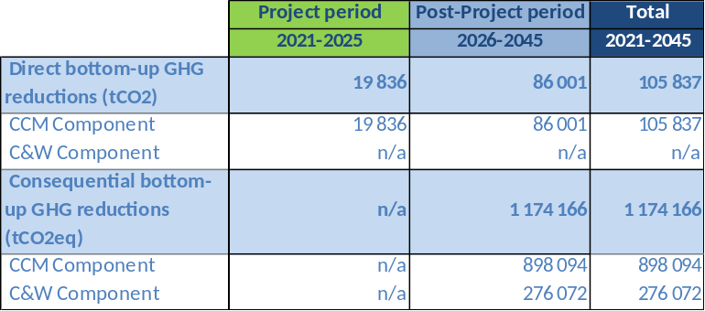
CW – Baseline/BAU Scenario w/o GEF Intervention
The average daily generation of MSW per capita is >2.2 kg/day, most likely to a large extent contributed by the hotel and tourism sector. On average 70% of the population is served with waste collection services, of which 80% is collected by formal waste collection services and 20% by informal waste collectors. Waste collection rate is said to be at 89%, however recycling is currently only at 18%. The composting/fertilizer facility was operating at 60% capacity in 2011 but is thought to operate currently at a much lower capacity.
UPOPs releases from open burning for the Governorate of South Sinai and the city of Sharm El Sheikh were estimated to 6.42 g-TEQ/yr, which is significant. In the baseline scenario, it is expected that the current situation with waste collection efforts with prevail; however, no smart purchasing on environmentally friendly and multi-use materials/articles will be in consideration. The segregation rate of 18% will be expected to stay at the same level due to weak sorting and presence of informal sector. Open burning of MSW will continue to take place and as the waste stream will continue to contain substantial amounts of plastic products, UPOPs emissions will continue as well. With the current plans, they may be gradually reduced as infrastructure related investment is planned for better waste collection and segregation; yet the speed of these investments may be slow depending on implementation capacity and funding availability in the municipality. At the same time, input materials, such daily used products and articles in the target area, will stay as in the past, containing single-use articles, made of plastic packaging with no greener products present as options to the hotel services. With increase of tourism in the area, the anthropogenic pressure from tourists who adopt a relaxed attitude when on holidays will only increase. This will lead to increases in open waste burning and plastic spread to the environment.
CW – GEF Increment and Global Environmental Benefits
The proposed GEF intervention (alternative scenario) will ensure acceleration of understanding of the incoming materials and products (as well as their packaging) and their impact on the environment in the target area. This will be done by a special analysis of the inventory these materials, and especially single-use items for the tourism industry, their source (importation or local manufacture), and potential for minimization of their use or substitution, as a priority action. Further work with common standards on green procurement will be planned, and this will reflect in smart purchasing approaches by giving consideration to the lifecycle of such products, and plastic packaging. Such holistic approach to the supply chain will assist in creating a gradual master plan for the municipality in order to avoid the most polluting products and articles in the target area.
The master plan will be based consultations with the industry and suppliers, as well as manufacturers of such products, in order to determine a staged approach for banning certain categories of materials, or making packaging less voluminous and more environmentally friendly, with recyclability aspects seriously taken into consideration which may put pressure on manufacturers located outside of the target area to re-design their product packaging. Green supply agreements with importers and producers will be established for pilot hotels. Such approach will aim to reduce opposition to immediate bans and reformation of the market at once, which may be a challenging task and can create implementability risks to the sustainability improvement programme.
The project will also assist in accelerating of proper source separation, recycling key materials and residual waste disposal operations in joint work with the planned municipality’s investments in this area. Backed by public awareness raising campaigns and with better understanding of informal collection sector, the GEF support will be able to improve GEBs, as compared to the baseline scenario.

Concerning UPOPs being released by open burning, a strict control and enforcement of waste management practices should lead to at least 95% reduction of UPOP from this source. Following the estimation (source: PIF) that 1,832 g-TEQ/yr to air and 621 g-TEQ/yr in residue are released from 21 million tons/yr of municipal waste in Egypt, this results in 0.117 mg TEQ/ton. Considering the total number of waste in Sharm El-Sheikh with 55,000 tons/yr, from which 40% are estimated to be burnt (~22,000 tons/yr), and the specific emission factor for TEQ of 0.292 mg/ton, the amount of UPOPs to be reduced is approx. 6.5 gTEQ/year: 22,000 [t/a] * 0.292 [TEQ mg/t] = 6.42gTEQ/yr.

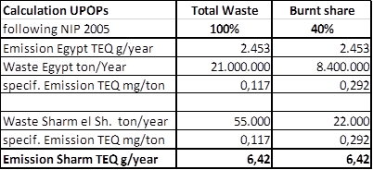

BD – Baseline/BAU Scenario w/o GEF Intervention
In the baseline scenario, the Green Sharm Initiative would continue to be rolled out, yet with limited impetus due to poor absorption and implementation capacity. Biodiversity would continue to be largely neglected in urban planning and local level economic decision making, there would be no organised planning of marine activities, and regulations would maintain loopholes and remain poorly enforced (e.g. on boat operators doubling boats sizes). Monitoring for sustainability indices would remain absent or weak. There would be no breakthrough in building an inspirational model tourism city to follow that connected urban environmental improvements with a maintenance of the natural capital basis/ecosystems on which the city’s business model is built; much rather, given recent trends there is a risk that the city and region could be exposed to a degradation like in other coastal cities, with waste problems in the marine environment and ecosystem impacts by economic activities.
The situation of the 3 PAs would remain acceptable and maybe improve but the NCS would not be able to reach international management benchmarks. The lack of enforcement of some harmful activities like illegal fishing at night including in RMNP could prevail. Finally, impacts on migratory birds would be somewhat improved – with the wastewater treatment plant hopefully continuing to apply the microorganisms that reduce bird mortalities – however the risks of collisions with power lines, incl. from new energy infrastructures, would remain.
BD – GEF Increment and Global Environmental Benefits
Under the alternative scenario, the GEF-funded project would trigger a forceful and comprehensive upgrade of sustainability planning for the city and region. Biodiversity aspects would be mainstreamed into the urban sustainability plans and enhanced coastal and marine planning and protected area management would form a strong basis for better use of the marine space by economic actors. A monitoring system for sustainability would be established that would allow tracking of progress. Importantly regulations would be reviewed and better enforced given a clearer mandate. PA management would be enhanced in 117,000 ha of terrestrial and 78,000 ha of marine areas, to achieve global benchmarks, and further financing would be generated from private and public sector to be reinvested into the national PA system. Enhanced waste management (i.e. less plastic ending up in the Red Sea) would benefit the landscape and seascape values and reduce impacts on biodiversity.
This all would significantly reduce the impacts from harmful economic activities, especially in the marine and coastal realm along the coast of the Gulf of Aqaba, and thus help safeguard globally important coral ecosystems, that in addition have been proven to be especially resilient to temperature spikes and are hence of interest in the context of coral reef adaptation to climate change.
And finally, Sharm El Sheikh could transform its wastewater treatment plant into a bird friendly wetland in an desert environment, offering migratory birds (which include several endangered species) a safe stopover and reduce mortality, together with a reduced risk of collisions with power lines in the area.

3.5 Local and national project beneficiaries and benefits
- Tourism is an important domain for economic development in Egypt, with almost 95% of tourism activity in the country leisure and culture-oriented and mostly concentrated on Cairo, Upper Egypt, Sinai and the Red Sea. Indeed, if the economic development of a certain country is to be based to some extent on tourism, diversification and enhancement of the tourism product is an appropriate strategy, such as through sustainable tourism. The Egyptian government is starting to take actions towards sustainability efforts and to assume full environmental responsibility, which often conflict with tourism development goals of creating job opportunities and increasing foreign currency. Government engagement and supervision is essential in this initiative because the private sector cannot be relied on its own and requires policy and framework conditions and guidance and capacity to develop sustainable investments. Moreover, the Egyptian Ministry of Tourism and Antiquities believes that tourism in the Red Sea will need to benefit the environment if practiced in a sustainable manner by promoting eco-destinations and raising awareness. The economic benefits in the tourism industry will generate social and socio-economic benefits for local communities and other job seekers in the tourism industry, in particular from Upper Egypt. Sustainable tourism activities create jobs and generate income from environmentally friendly activities. These include income generation for local communities engaged in ecotourism activities, handicrafts and other service facilities. It also includes improvement of livelihoods and well-being for local communities through establishment of new facilities in the targeted protected areas. The project will also improve health conditions for waste collectors through formalization of the solid waste management and recycling initiatives. The CCM mitigation technologies for small scale renewable energy and energy efficiency technologies will open new lines of small businesses in installation, operation and maintenance of these applications.
- Thus, environmental protection, conservation and inclusiveness is essential for the success of sustainable tourism development and ensuring a high-quality tourism destination in Sharm El-Sheikh in the future. The Green Sharm project will improve the management and organizational capacities for elaborating a Sustainable Development Strategy and planning and launching its implementation with different stakeholders at the national and local levels.

3.6 Consistency with national convention strategies/plans/reports/assessments
- The project is in line with Egypt’s Sustainable Development Strategy: Egypt Vision 2030, responding to the SDGs. Environment is one of its 4 dimensions and entails an Urban Development Pillar and an Environment Pillar, who have as visions, respectively: A balanced spatial development management of land and resources to accommodate population and improve the quality of their lives and Environment is integrated in all economic sectors to preserve natural resources and support their efficient use and investment, while ensuring next generations’ rights. A clean, safe and healthy environment leading to diversified production resources and economic activities, supporting competitiveness, providing new jobs, eliminating poverty and achieving social justice.
- The project is also fully in line with the Third National Communication Report (2016) to the UNFCCC, which identified tourism as one of the main sectors with large potential and benefit for climate change mitigation actions – including inter alia:
- Improve energy efficiency and load/energy management;
- Increase on-site energy production from renewable sources, in particular solar energy;
- Promote for sea water desalination-based concentrated solar power and using highly efficient desalination technologies;
- Set achievable specific energy, water consumption and waste generation
- While Egypt hasn’t prepared a UNFCCC Technology Needs Assessment, a National Economic and Development Study for Climate Change (NEEDS) was submitted to UNFCCC in 2010. It highlighted that mitigation alternatives at 2020- and 2050-time horizons rely on 10 mitigation priority programs identified as a result of NEEDS assessment for climate change.
- The 2016 Intended NDC included an initial estimate for the cost of implementing adaptation and mitigation measures in Egypt during the period 2020-2030: USD 73 billion. The INDC reflected Egypt’s commitment to implement polices targeting development that is more sustainable and highlighted that the coral reefs which constitute a major attraction in Red Sea resorts are highly vulnerable to climate change. Climate change mitigation and further actions emphasized in the INDC that are strongly linked to the Green Sharm initiative and the tourism sector include the following:
- Reform energy subsidies to increase energy efficiency and promote switching from conventional energy sources to cleaner energy sources.
- Promote efficient use of energy, especially by consumers
- Increase use of renewable energy as alternative for power generation
- Shift use to advanced locally appropriate low emission fossil fuel technologies
- Improve wastewater treatment and solid waste management and recycling
- Reduce climate change risks in touristic areas
- Raise environmental awareness
- Cooperate with international agencies
- Promote sustainable tourism in Egypt
- Capacity building for local communities in touristic areas
- Egypt as a Party to the CBD in 2016 prepared a revised NBSAP / Egyptian Biodiversity Strategy and Action Plan 2015-2030 in line with the CBD Strategic Plan 2011-2020 through a wide participatory process. The project with is different components is in line with the following national targets:
- 1 – By 2030, PAs network secured and expanded to cover 17% of total terrestrial and inland water and at least 5% of coastal and marine representative areas, especially priority sites of particular importance for biodiversity and key ecological processes, and effective management of PAs.
- 6 – By 2018, apply CBD tools to monitor and control the impact of tourism on biodiversity, in particular in protected areas and vulnerable ecosystems.
- 7 - By 2020, measures, including waste management plans and law enforcement, are in place to prevent and reduce the impact of pollution and waste on ecosystems, especially on wetlands and coastal and marine areas.
- 8a – By 2025, negative effects of different sectoral policies (land-use planning, transport, energy, uncontrolled urbanization, etc.) on priority elements of biodiversity are minimized, and measures to correct these effects are applied through developing and implementing land use management plans.
- 9 – By 2027, promote the implementation of good fishing practices in both Mediterranean Sea and Red Sea, favorable to fish protection and their habitats.
- 16 – By 2018, biodiversity values are promoted and integrated into national planning process and mechanisms to support their incorporation into national accounting and reporting systems to be developed.
- 18 – By 2017, proper NBSAP and associated resource mobilization are in place, in addition to establishment of the national biodiversity committee to ensure periodic evaluation of NBSAP
- With regard to Chemicals and Waste, Egypt's latest 2005 POPs National Implementation Plan (NIP) identifies the open burning of waste, medical waste incinerators and industrial processes as the three largest emitters of UPOPs. Priorities related to UPOPs listed in Egypt’s NIP are: prevention of uncontrolled waste combustion, sound environmental management of waste, implementation of BAT/BEP measures for the reduction of dioxin and furan emissions, adjustment of national legislation to adequately address POPs/UPOPs issues as well as the provision of education and awareness building. Furthermore, the 2002-2017 Governorate Environment Action Plan (GEAP) for South Sinai lists programs on sustaining tourism, strengthening institutional and capacity building, waste management, pollution abatement, transferring clean technologies, environmental monitoring and evaluation, and technical assistance among the seven listed main priority actions. The proposed project will address all the priorities listed in the NIP, as well as address the priorities related to waste management as listed in the GEAP, to reduce the releases of UPOPs from uncontrolled waste combustion in Sharm El Sheikh.
- Egypt is committed to the Montreal Protocol and to implementing the relevant Programmes of the National Environmental Action Plan. The country is in the process of ratification Kigali amendment, currently the documents are under review from the Ministry of Foreign Affairs. National Ozone Unit and the Egyptian Organization for Standardization and Quality have a collaboration protocol for the development and update of 19 new standards for the safety of freons/refrigerants. An enforcement plan is needed for the existing and newly developed standards and codes.
- The project is also line with the National Capacity Self-Assessment regarding the three Rio Conventions, given that it includes joint work towards Climate Change and Biodiversity. Because there are no pressing land degradation issues in the area of Sharm El Sheikh, LD was not considered a further work stream to be added. Instead work on Chemicals was added that now also fall under the global environmental conventions served by the GEF. The NCSA highlighted the need for enhanced cooperation and synergies across the conventions at national level, which the here-proposed project will contribute to.

3.7 Relevance to SDGs
- The UN Sustainable Development Summit (https://sustainabledevelopment.un.org/) in September 2015 adopted 17 Sustainable Development Goals (SDGs) to establish a basis for the new UN Development Agenda until 2030. Goals such the SDG 5 “Achieve gender equality and empower all women and girls”, the SDG 6 “Clean Water and Sanitation”, the SDG 7 “Affordable and Clean Energy”, SDG 11 “Sustainable Cities and Communities”, SDG 12 “Responsible Consumption and Production”, SDG 13 “Climate Action”, SDG 14 “Life below Water” and SDG 15 “Protect, restore and promote sustainable use of terrestrial ecosystems and halt biodiversity loss” are having direct linkages to the project under consideration. Egypt is in the process of ‘localizing’ SDGs, started by screening the policy, programs and laws prior to the identification of national indicators. In line with the 2030 Agenda, the Egyptian Government has launched a working plan called Egypt’s Vision 2030, also known as Sustainable Development Strategy (SDS), which encompasses the economic, social and environmental dimensions of development. SDS promotes economic flourishing based on justice, social integrity and participation. It is under the SDS that all development plans in Egypt are incorporated while at the same time being strongly guided by the SDGs.

3.8 Stakeholder engagement
- For the project to meet its objectives, since it is operating at several political and decision-making levels from national government to the regional (governorate) and local levels (Municipal administration Sharm El-Sheikh) to local businesses, tourism industry, and local population, a multi-stakeholder process (MSP) will be used as an elementary tool to engage with relevant stakeholders.
- The primary stakeholder beneficiaries to be engaged in the UNDP-GEF project will be the urban inhabitants in Sharm El-Sheikh. This will include several classes of stakeholders, from central government policymakers and their planning and management entities (e.g. PA management) to municipal administration and technical staff, to the ultimate beneficiaries being private businesses engaged in tourism industry – tour operators, hotels, diving and boat trip operators, etc. – as well as residents and local populations. The primary lever to engage stakeholders within the project is to incorporate new dimensions in the sustainable planning process between the centralized and local level in order to create novel solutions for the lingering Egyptian urban imbalances at the municipal level. As discussed in Section 3.2, an urban sustainability framework will be developed for Sharm El-Sheikh covering a Sustainable Development Strategy, link it with an Implementation Plan, a Financing Strategy and a marketing/branding strategy for green tourism. A multi-stakeholder engagement approach will be adopted. This will involve engaging the local stakeholders to understand the needs and benefits of pursuing a sustainable development agenda at the municipal level, and to be fully engaged in the implementation of the Sustainability Strategy, which will cover climate change mitigation (incl. low carbon and resource efficiency), chemicals and waste and enhanced biodiversity protection.
- More specifically, the central and local Government policymakers will be engaged with the project to strengthen the efforts on inter-institutional coordination and cooperation for a sustainable urban development strategy and implementation planning. The policy formulation and implementation of relevant plans and actions that face the challenge require a strong coordination and collaboration between several main governmental bodies and the governorate/municipality. The Project will contribute to emplacing a framework that will pilot a low-carbon initiative at city level using innovative mechanisms. It will also help putting in place a sound monitoring, reporting and verification system (MRV) that will track all GHG and other emission reductions as well as environmental benefits achieved through the project.
- Output 2.1.1 will focus on training and capacity building of all key stakeholders at governorate, municipality and hotel levels. The establishment of a MRV for GHG in the tourism sector is imperative for the following reasons: (i) to help provide transparency, accuracy, accountability and comparability of information regarding impacts of climate change on the tourism sector; ii) to help recognise good practices, promote capacity building and allow international benchmarking; (iii) to help determine and showcase sectoral mitigation actions; (iv) to help quantify the real impact of sector and sub-sector policies in terms of GHG emissions; (v) to help account national progress in the framework of international obligations (such as National communications / NDCs); (v) it helps to identify gaps and needed international support; and finally (vi) it helps to facilitate access to financial support from international donors.
- For municipal staff in Sharm El-Sheikh, their engagement with the project will stem from the benefits they will derive from the project’s capacity building efforts, which will enable municipal personnel to design and implement relevant low-carbon measures and sustainable development strategies.
- The private sector will also be engaged with the project mainly through Components 2 and 3. Under Component 2, hotel staff will be trained on technical, managerial and organizational aspects related to energy, resource efficiency, use of renewable energies, waste management practices and good environmental practice. Furthermore, the private sector and private individuals will be directly engaged in the project through the implementation of pilot and demonstration activities, with the aim to promote success stories in green hotel practices and public sector within Sharm El-Sheikh.
- Lastly, in recognition that the UNDP‐GEF project is not operating in a vacuum and that it does not have all the financial and operational capacity to alone turn Sharm El-Sheikh into a green city, development partners (e.g. UN Habitat, GIZ, EBRD, etc.) will be engaged including through collaboration with their ongoing projects as further described in Section 3.9 and Annex 4.
- The Project provides a unique opportunity for engaging the Bedouin community (310 individuals) living within the Nabq Protected Area in sharing the benefits from tourism and other economic activities around Sharm El Sheikh. Located near Sharm El Sheikh, the GEF project would support improved and biodiversity-friendly livelihoods and economic diversification practices, including promotion of ecotourism, handicrafts and service facilities that could benefit the community and ensure that they become active partners in the conservation activities as well as sustainable management of their natural environment and resources.
- The main other potentially affected group are the waste-pickers currently active at the El Khanassir waste field. Their situation will be assessed as part of the Environmental and Social Audit of Sharm El Sheikh’s solid waste management system before project start. The waste-pickers will be consulted during the preparation of the audit and the resulting Environmental and Social Management Plan will include appropriate mitigation measures.
- A Stakeholder Engagement Plan with a full list of stakeholders and their roles is included in Annex 4. This will be reviewed, refined and adopted at the Inception Workshop and approved by the Project Board. It will ensure that stakeholders are given the opportunity to participate meaningfully in project implementation, monitoring and evaluation.

3.9 Coordination and partnerships
- This proposed project will liaise/ coordinate with and use relevant lessons and experience from the following GEF-funded projects:
Initiative | Objective | Coordination with project
EEAA/ UNDP/ GEF  Strengthening Protected Area Financing and Management Systems  GEF-4 Project ID 3209, GEF Project Grant USD 3,616,000, endorsed in May 2010 and closed in mid-2020. | The project objective was the establishment of a sustainable protected area financing system, with associated management structures, systems and capacities needed to ensure the effective use of generated revenues for priority biodiversity conservation needs. It should achieve this objective by: (i) strengthening legal, policy, regulatory and institutional frameworks that facilitate revenue generation, revenue retention and other aspects of sustainable PA financing and management are established and functional; (ii) ensuring that levels of financial resource mobilization are adequate for effective conservation-oriented management of Egypt’s PA system; (iii) establishing business planning and cost-effective management systems ensuring the effective allocation and management of mobilized resources.  This project worked much on Visitor Entrance Fees and PA Concessions, both at national level and in a range of PAs across Egypt. The project with government co-financing also built significant tourism infrastructures in PAs. In South Sinai, this project delivered the infrastructure for tourism services to Ras Mohamed National Park. | The proposed project will build on and complement the efforts of the financial sustainability project. It will continue upgrading and maintaining tourism infrastructure within the three targeted PAs. Moreover, the project will develop and implement integrated long-term integrated monitoring programs for biodiversity components with special concentration on the marine fragile ecosystems in the Gulf of Aqaba (i.e. Red List of marine species, Red List of ecosystems, etc.). Additionally, the project will take steps toward recognizing the three targeted PAs on the available global initiatives (World Heritage Site, Ramsar Site, Green List, etc.). Also, the project will enhance the existing institutional and legal framework of the targeted PAs for more effective management with long term mechanisms of monitoring and evaluation. Coordination will be achieved by involving the former PA Finance project management unit as well as the consultants and govt staff that worked with the project (such as the Head of the PA and BD Units in NCA and CBD Resource Mobilisation Focal Point) in the implementation of this new project. Also, the project will support the three targeted PAs to turn the existing entrance and concession fees into electronic ways to increase the efficiency of the financial procedures within these PAs.
BirdLife/ EEAA/ UNDP/ GEF  Mainstreaming conservation of Migratory Soaring Birds (MSB) into key productive sectors along the Rift Valley/Red Sea flyway  Tranche I: GEF ID 1028, GEF Project Grant USD 6,243,243, closed;  Tranche II: GEF ID 9491, GEF Project Grant USD 3,500,000, endorsed in July 2017, ongoing until March 2023. | Implemented through BirdLife International, the MSB Project is headquartered in Jordan and works in several countries along the flyway on those sectors that pose the greatest risk to the safe migration of these birds. These are most importantly hunting, agriculture, waste management and especially energy (from energy infrastructures). Some of the most exciting outcomes of this project have been in Egypt, most notably in the engagement of public authorities, private sector and finance institutions regarding the placement of wind farms and their operations. This involves world-leading shut down on demand practices that are being rolled out on reducing collision risks when migratory flocks approach turbines.  The project here focuses especially on the key migration bottlenecks – which in Egypt is the crossing from Asia/Sinai to the Egyptian/African mainland, especially around the Suez region.  The project is also working in Sharm El Sheikh, on the open wastewater treatment plant, at which hundreds of White Storks die every year, presumably due to bacterial or chemical contamination; for now this is limited to installing bird hides to convert it to a birding spot, and reducing pathogen contamination through the proven addition of EM (Effective Microorganisms). | The here-proposed project will complement the efforts of the Migratory Soaring Birds project by: enhancing existing efforts for integrating biodiversity in the tourism, energy and waste management sectors at the governorate and municipal levels. Also, it will enhance the efforts regarding the conservation of migratory birds as Ras Mohamed NP is an important bird area (IBA) according to Birdlife International. The project will work to support activities to reduce the negative impacts of sewage treatment plans on migratory birds in Sharm El Sheikh, and in fact promote its conversion into a bird-friendly wetland. Additionally, the project will further introduce bird watching as a tourism activity that respects the environment. The project will use all available data about bird migration to develop booklets for bird matcher inside the three targeted PAs. All these will complement the efforts to turn Sharm El Sheikh into Green Sharm. Coordination will be achieved by involving the MSB project management unit in the planning and implementation of this new project.
EEAA/ MOTA / UNDP/ GEF  Mainstreaming the conservation and sustainable use of biodiversity into tourism development and operations in threatened ecosystems in Egypt  GEF-5 Project ID 5073, GEF Project Grant 2,574,338, endorsed Apr 2015, due to start eventually before 2019 | This project focuses will work on mainstreaming biodiversity into national-level planning and investment decisions to reduce biodiversity impacts by tourism infrastructure developments, provide a better framework for biodiversity-friendly tourism operations and practices and enhance biodiversity-friendly tourism promotion;  On the ground, the project will work with local administrations, private companies and protected areas to implement better tourism practices and PA management, in three target regions: Siwa in the Western Desert, the north-western Mediterranean coast (towards Libya) and the southern Red Sea coast near Quseir and Marsa Alam (towards Sudan).  On PA/BD financing, the project will focus at the national level on other tourism-related financing mechanisms, such as entry taxes and biodiversity offsets (as final step of the mitigation hierarchy). | This project will play a critical supporting role to the here-proposed project at national level, and to clearly articulate best practices in terms of tourism activities, yet it cannot achieve the same level of integration at city and site levels. The here-proposed project aims to achieve a much more profound multi-focal transformation and more ambitious model linking tourism with coral reef conservation. The two projects will have to work hand in hand, with the GEF-5 project focusing on national level planning and practices, and the new GEF-7 project focusing on implementation at Governorate level. Coordination will be achieved because both projects fall under NCS, or the future PA agency, but special attention has to be paid that MOTA is strongly involved. Coordination will focus moreover on the GEF-5 project’s focus on voluntary national certification schemes and verification mechanisms on responsible NB/BTF tourism for hotels and operators (Green fins and Green Star Hotel), on support to the tourism sector with needed equipment to minimize adverse impacts on biodiversity, on the development of guidelines for NB/BFT and lessons learnt, and on investment opportunities/ concessions/ partnerships inside the targeted PAs.
Egyptian-Italian Environmental Cooperation Programme | Presently in its third phase, EIECP aims at further developing Egypt's PA system, mainly with the view of establishing income-generating mechanism and, thus, facilitate the process for mobilizing resources toward the financial sustainability of the Egypt's PAs system and, in this way, its conservation and sustainable development endeavours. EIECP also tackles other PA management needs identified by NCS/EEAA, such as on information gathering/ generation management and analysis. A new phase is expected that will focus on CBNRM in a number of PAs, incl. those in S Sinai where they plan to work with Bedouin tribes, incl. through support of women to enhance their capacities in production of handcrafts. | This project will support the work with the local communities through the CBNRM. It will support infrastructure work in South Sinai and support eco-tourism business plans.  Given that EIECP has been implemented by MOE and UNDP Egypt through cost-sharing, the projects will be directly linked and integrated to achieve synergies and economies of scale. EIECP is co-financing for this new project.
Cleaner Production Center/ UNIDO/ GEF  Utilizing Solar Energy for Industrial Process Heat in Egyptian Industry  GEF-5 ID 4790, GEF Project Grant USD 6,500,000, endorsed Dec 2014 | The project is implemented by the Cleaner Production Center of the Ministry of Industry and Foreign Trade. Its objective is to develop the market environment for the diffusion and local manufacturing of solar energy for industrial process heat. | The project focuses on improving the energy efficiency of the industrial process heat system and the introduction of solar thermal technologies mainly in industrial companies with a high fraction of low and medium temperature heat demand in industrial sectors. The same solar water heating systems will be suitable for hotels as well. Accordingly, the UNDP project will liaise with the Cleaner Production Center to obtain the technical assistance packages that were provided under the UNIDO project, using these to provide technical and financial support to pilot the solar water heating systems in selected hotels. The successful pilot projects will encourage expanding the use of the technology at the level of hotels in Sharm El-Sheikh and in Egypt more widely.
Industrial Modernization Center/ UNDP/ GEF  Grid-Connected Small-Scale Photovoltaic Systems  GEF-5 ID 5064, GEF Project Grant USD 3,536,364, endorsed in Dec 2014 | The project aims to encourage and accelerate the development of solar PV systems by opening markets for roof top small scale PV systems in industrial, residential and commercial sectors. | The project can use the case studies and methodologies that helped disseminate EE appliances in Cairo. In addition, the project has been providing technical and financial assistance to hotels in Sharm El Sheikh to promote installation of roof top PV system, and training for engineers in hotels on the design, implementation and maintenance of PV systems and LED lighting.  The project has completed support to the first pilot project in a hotel in Sharm El-Sheikh to install 150 KW of roof top PV system. Following the successful implementation of the pilot project, the owner of the hotel has added 350KW without any financial contribution from the PV project that will encourage other hotels in Sharm El-Sheikh to replicate. The project is currently negotiating with another hotel to provide technical support for 1 MW solar power based on a Purchase Power Agreement (PPA) modality. The successful pilot projects will pave the road for Green Sharm Project to replicate the technology in other hotels to support energy transition in the city. Meanwhile PV Project team is planned to support Green Sharm Project team to continue providing technical assistance, as needed, until the end of the PV Project for promotion of the roof top PV systems as one of the most promising CCM technologies in the city.
Ministry of Electricity and Renewable Energy/ UNDP/ GEF  Improving the Energy Efficiency of Lighting and Building Appliances  GEF-4 ID 3832, GEF Project Grant USD 4,450,000, Oct 2010-2018 | The project aim was to achieve a market transformation to efficient lighting systems and home appliances in Egypt. | The project has implemented pilot projects for converting lighting systems in hotels to efficient lighting systems. The pilot projects results were documented and contributed to the replication in many hotels in Egypt. The project will end in 2018 but the case studies and other project outputs will be shared with the hotels in Sharm El Sheikh that have not converted yet. The project Terminal Evaluation has acknowledged its role in supporting the market transformation to efficient lighting in Egypt. Green Sharm will build on the success of the Energy Efficiency project and benefits from its generated knowledge and technical capacities to technically support any hotels in Sharm that were not able to complete shift to efficient lighting.
UNDP Low Emission Capacity Building Project (LECB) | Low Emission Capacity Building (LECB) is a global UNDP project funded by the EU and the Governments of Germany and Australia and includes activities in Egypt. The project aimed to develop the capacity of experts and institutions in Egypt to respond to opportunities that have been identified for engaging Public Sector and Industry support and participation in addressing the issue of climate change. | The project supported the preparation of Egypt’s Intended Nationally Determined Contributions (INDC) completed in 2015 as well as a Low Emission Development Strategy (LEDS) for Tourism Sector completed in 2018-2019. The LEDS includes recommended CCM actions in the tourism facilities that will induce the largest GHG emission reduction in the sector.  In the here-proposed GEF project, the LEDS will guide hotels in the selection of the CCM technologies to be piloted, to induce replication at the level of Sharm El-Sheikh City and upscaling on the national level. The LEDS will also facilitate the estimation of the GHG emissions reductions attributed to the interventions in Sharm.
EEAA/ MoH / UNDP/ GEF  Protect human health and the environment from unintentional releases of POPs originating from incineration and open burning of health care- and electronic waste.  GEF-5 Project ID 4392, GEF Project Grant USD 4,100,000, endorsed in 2013. | The project objective is to protect human health and the environment from unintentional releases of POPs originating from incineration and open burning of health care- and electronic waste. The project is expected to achieve this objective by: (i) Reduction of UPOPs emissions through capacity building, introduction and demonstration of BEP and BAT and strengthening of the legislative and policy framework; (ii) Reduction of Mercury emissions through capacity building, demonstration and introduction of mercury-free medical instruments and strengthening of the legislative/policy frameworks (in combination with component 1); (iii) E-Waste: Reduction of emissions of UPOPs, and POPs through capacity building, introduction and demonstration of BEP and BAT (refurbishment and end-of-life) and strengthening of the legislative and policy framework; (iv) E-Waste: Reduction of emissions of other hazardous substances (mercury, lead, cadmium) through capacity building, introduction and demonstration of BEP and BAT (in combination with Component 3’s investments for the end-of-life management) and strengthening of the legislative and policy framework. | The HCWM and E-waste Management project under implementation will be able to provide lessons-learned and outcomes related to hazardous and non-hazardous waste management in Egypt (collection, storage, treatment and disposal), including the following (list not exhaustive) which will help to further inform the development of the Green Sharm-El-Sheikh project during its CEO endorsement phase and support the proposed project with guidance during its initial stages of implementation: (i) Feasible methods to calculate UPOPs baselines and UPOPs reductions over the duration of the project; (ii) understanding of waste flows and involvement and roles of various actors in the waste management supply and demand chain in Egypt; (iii) Successful stategies, regulations and policies to support improved collection, treatment and disposal of various waste streams in Egypt; (iv) Assessed and implemented financial mechanisms to support the long-term (financial) sustainability of collection, transfer, treatment and disposal schemes; (v) Developed and implemented incentives for public and private sector entities to improve waste segregation, collection, treatment and disposal; and, (vi) Feasible and workable BEP and BAT interventions that are suitable to the local conditions in Egypt.
Egyptian - German Joint Committee on Renewable Energy, Energy Efficiency and Environmental Protection | The project is implemented by GIZ in collaboration with the Ministry of Electricity and Renewable Energy to support climate-friendly investments in renewable energies and energy efficiency. | The GIZ project is supporting the Green/Sustainable Tourism Unit in MOTA while GTU/STU is a main stakeholder in the UNDP project. Hence, this GIZ project will provide technical assistance to hotels and piloting of specific RE/EE technologies that will complement the GEF project activities and will work jointly with the GEF CC projects to disseminate the results of pilot project aiming to expand replication in Sharm El Sheikh.
GOPP/UNDP: Improving Interurban Synergies between Existing and New Egyptian Cities (CO-CITIES) | UNDP with GOPP are developing urban plans for a number of cities in Egypt, an experience useful in the development of the integrated urban plan for Sharm El Sheikh | Expected to provide relevant input in terms of policy framework and institutional setup/decision-making and be implemented in parallel.
UN-HABITAT: Support the development of Sharm El-Sheikh’s Strategic Urban Plan | UN-HABITAT is developing a Sustainability Master Plan for Sharm El Sheikh. | The Sustainability Master Plan includes all initiatives to be implemented by City of Sharm El-Sheikh to support its transformation into a Green City. Meanwhile, the Green Sharm project will provide further inputs in terms of policy framework and institutional setup/decision-making and provide technical assistance to support implementation of the plan.

3.10 Gender equality and empowering women
- The project will mainstream gender issues through several strategies including: i) PMU composed of gender-sensitive staff, whose awareness of the importance of gender equality and skills in incorporating gender into their work are enhanced through capacity development; ii) PMU recruitment will consider gender balance in the selection of candidates: iii) participation of women in the development of the implementation plan and sustainable development strategy for Sharm El-Sheikh, in multi-stakeholder platforms and other project processes; iv) specific training to build the capacities of public institutions for mainstreaming gender into the aforementioned plan, in institutional processes (e.g. gender sensitive budgets, generation of gender disaggregated data) and in citizen participation protocols, among others; v) promoting participation and involvement of women in project activities (e.g. training activities); iv) developing actions to promote masculinities in institutions; and vi) awareness raising on gender issues in the private sector.
- A Gender Analysis and Action Plan for the project is included in Annex 13.

3.11 Risks to the project and social/environmental safeguards
- The risks associate with the project are detailed in the Risk Register in Annex 5. This includes the risks that could undermine project success – as well as key social and environmental safeguards risks that are detailed in the PPG-stage Social and Environmental Screening (SESP) in Annex 12 and the Environmental and Social Management Framework (ESMF) in Annex 11.
- The SESP (in its updated version of Feb 2022) identified a total of 12 social and environmental risks of which six (6) were rated MODERATE, four (4) SUBSTANTIAL, and two (2) HIGH. Therefore, the overall Social and Environmental Risk categorization for the project is HIGH.
- The ESMF outlines the safeguard risk assessment and management measures the project implementing partner and project management unit (under UNDP oversight) must undertake at project launch to ensure the environmental and social risks and potential impacts are fully assessed and management measures are fully defined and emplaced.
- With dedicated support from one or several social and environmental safeguards experts, the project is required to:
- Prepare a series of appropriately scoped SESAs for the potential social and environmental impacts from upstream activities
- Prepare at least two ESIAs/ESMPs, for the social and environmental risks under the waste management workstream (entire value chain), and under the biodiversity workstream
- Integrate and reflect UNDP SES requirements, including screening with the SESP and appropriately scoped ESIAs/ESMPs, in each individual feasibility study. This will include Livelihood Action Plans and/or Resettlement Action Plans as appropriate.
- This should all be completed within the first 3-6 months after project launch. All these assessments must be completed and the management plans and measures in place before the relevant project activities can be initiated. The latter affects especially on-the-ground activities in the target areas, while hiring and procurement as well as desktop work at central level may be initiated.
- As per standard UNDP requirements, project risks will be monitored quarterly by the Project Manager, who will report on the status of the risks to the UNDP Country Office, which will record progress in the UNDP ATLAS risk log.

3.12 Innovativeness, sustainability and potential for scaling up
Innovativeness
- The project is innovative – at least for Egypt – especially because of its integrated nature linking urban planning and various environmental improvements (energy efficiency, renewable energy, water management, waste management, plastics, UPOPs reduction) to a better protection of adjacent important marine/coral reef ecosystems, as well as because of its ambition and potential to become a role model and catalyse similar sustainability improvements elsewhere in the country. Given the scale of these issues, choosing a medium-size city like Sharm El Sheikh will offer greater opportunities for having a tangible and visible impact during the project’s lifetime, especially given the city’s fame as an international tourism destination. It provides an opportunity to work on multiple local, regional and global environmental dimensions at the same time, without challenges becoming too large to tackle properly and in a hands-on manner. The project includes more general upstream policy support for urban planning and measurement/monitoring frameworks that systematically address resource efficiency and natural capital issues across the continuum of energy, water, waste and ecosystems. The GEF-intervention project will be important to trigger the eventual implementation of this innovative vision already laid out in a preliminary manner in the 2010 Green Sharm Initiative – which has struggled to take off. It would appear to be the first city in the world working with GEF funding on all these inter-connected streams and GEF Focal Areas.
Sustainability
- The project has been designed to create an enabling framework for a sustainable city and tourism destination through enhanced inter-institutional and inter-sectorial coordination, integrating sectorial planning, and defining short, medium and long-term goals, thus ensuring sustainability. In this sense, Component 1 of the project is specifically designed to promote project sustainability since it is focused on the medium and long term. It will ensure that the benefits derived from integrated planning and budgeting are mainstreamed into the city’s decision-making processes.
- The optimization of joint planning exercises, strengthened dialogue, improved policy and regulatory instruments, and better coordination in the implementation of the different development initiatives will help the project partners and especially the participating government institutions to overcome the predominant culture of short term planning, sector-based solutions and the influence of political interests in prioritizing interventions, and develop a discipline of coordinating and collaborating under a common long term vision, thus ensuring sustainability of project results.
- Capacity development will enable project partners to improve their capacities for planning, implementation and monitoring of urban, resilient, adaptive and sustainable growth through training tailored to the specific stakeholder needs and demands; information management systems to facilitate information and knowledge sharing; and MRV systems to track progress. Learning from international best practice will ensure that the most up to date knowledge and international high-level expertise on urban sustainability and resilience is available to the project partners in building the new capacities.
- Dialogue and the development of partnerships will be essential tools for building consensus, enabling coordinated planning and regulatory oversight and encouraging sustainable forms of investment. Dialogue platforms will be emphasizing participation of civil society and private sector will constitute a long-term space where the public, private and civil society stakeholders will recognize themselves as equal and complementary partners and take ownership in discussing and identifying joint solutions and actions to promote urban sustainability and resilience.
- Regarding the financial sustainability of the PA system, Section 2.2 The baseline scenario sub-section Protected Area Management and Finance, outlines how under the previous GEF 4 funded Strengthening Protected Area Financing and Management Systems project, a framework was developed and adopted for concessions for private businesses (tourism, mines, etc.) operating inside PAs. PA entrance fees are being collected, now generating substantial new revenue. In addition, a new financial management system was set up to facilitate government spending and revenue re-injection, by which revenues are transferred from MOE to a special PAs account; in 2017, this led to an additional investment via this account of USD 4.5m of government finance for the PA system. In Sharm El Sheikh, the 3 PAs already started collection of gate revenues as well as permitting fees for activities conducted within the PAs. However, while funds are collected from gate fees and transferred to a centralized MOE account, guidelines and procedures for transfer of these funds to individual PAs are not well defined, thus creating some current uncertainty in use of these resources for conservation purposes.
- The intent of Outcome 3.2 (and Output 3.2.1) is to (i) Activity 1: facilitate PA authorities to develop improved methods for revenue regeneration, including also opportunities for private sector to contribute to conservation efforts, within and outside the 3 PAs and (ii) Activity 2: facilitate development of procedures for transfer of funds from the central account to the individual PAs and development of guidelines for reinvestment in activities to improve PA management and the tourism’s natural capital base; (iii) Activity 3: development of an electronic systems for collection of gate fees and permit changes for tourism activities in the PAs (jetting fees, boating, campsites, bird watching, diving, recreation, etc.) and (iv) Activity 4: develop a comprehensive financing strategy for the PAs that includes other options as well (e.g. concessions, BIOFIN options, PPP, etc.) so that PAs can be self-sustaining. These new mechanisms will help sustain and support conservation activities in the future in the PAs.
- In addition, the Ministry of Environment is presently working on: i) a new Protected Areas law that involves a sustainable financing framework (financial , legal and institutional); ii) Updates of PA management and visitor management plans to reflect the needed organizational changes and cater for the EcoEgypt campaign that promotes eco-tourism in Egyptian PAs; iii) finalizing an MoU with the Ministry of Tourism and Antiquities to cover mutual areas of cooperation regarding sustainable tourism and ecotourism development that is expected to leverage additional income.
Potential for scaling up
- Successful uptake and upscaling of successful interventions has already been demonstrated in several recent GEF CCM and BD projects in Egypt. The Government of Egypt is committed to intervene with strength and future investments for the integrated sustainability model to be proven. The notoriety of Sharm El Sheikh will also allow opportunities for significant awareness-raising, communication and in consequence opportunities for scaling up. Smaller and new cities in Egypt can learn basic principles of environmental sustainability, while large cities can learn from the enhanced waste management and GHG reduction approaches.
- The project will work closely with the private sector to reduce risks and support the required upfront investment costs. UNDP’s DREI approach on de-risking of RE and EE will be applied, based on a detailed understanding of investment risks, how these result in financing barriers and how these can be reduced or removed. On Investment, the project will achieve GHG emission reductions through a set of measures that combined, will ensure greater global environmental benefits. It will ensure efficient utilization of natural resources in tourism facilities and built environment (outcomes 2.2, 2.3 and 3.5 mainly). Context-specific resource efficient opportunities will be identified. The project will support the private sector in securing upfront investments through (i) conducting due diligence private sector risk assessment; (ii) building the relationship and capacity together with local financial institutions in order to create domestic markets for low-carbon investment; (iii) seeking cooperation and collaboration with multilateral and bilateral financial institutions and international climate funds; and (iv) providing technical assistance and capacity building at different stages of the project lifecycle; raising awareness, advocacy and opportunities such as the Global Green City award, eco-tourism and other environmentally friendly initiatives. The project will also have an exit strategy, that will help all the system to continue working smoothly after the project term. The project will for example gradually decrease its financial support towards the end of the project.
- The adoption of sustainable CCM technologies and solid waste management initiatives will be promoted through the project’s technical and financial support offered to the municipality and to private sector facilities to implement the pilot projects. The successful implementation of these pilot projects by the government and private sector entities participating in the project will encourage replication and upscaling by further cities and private sector entities in Sharm El-Sheikh and Egypt more widely. The project will work through key partners such as the Ministry of Tourism and Antiquities and EHA, using their platforms and workshops for sharing lessons learnt and best practices, with catalytic support provided by the project’s knowledge management workstream. The expectation is of a gradual market transformation within the tourism and other sectors at the national level that will yield the desired upscaling.
- The same will apply for interventions in protected areas within the domain of City of Sharm while the organized tourism in the globally significant and fragile eco-systems and engagement of local community in conservation will develop models to be replicates in all Red Sea Protected Areas.

3.13 Knowledge Management
- A Knowledge Management Strategy for the project is included in Annex 21. This project builds on several past and ongoing initiatives given that this is inherent in the cross-sector nature of the project. The socio-economic and environmental/ecological impacts of the project’s interventions in Sharm El Sheikh and adjacent sites will be regularly monitored following the M&E framework to be developed during the project preparation stage. The project will integrate important work on KM and related communication efforts to reflect the innovation and complexity of this cross-sector undertaking and the need to constantly monitor the project’s activities in relation to its goals and react through careful adaptive management. KM/Communication efforts (domestic and international) will be especially important to replicate the best practices and exploit the potential for Sharm El Sheikh to become a model green tourism destination, especially where there are plans even in Egypt (and in the region) to build more new tourism cities. KM/ Communications will hence target at least on a yearly basis the MOTA, the ETF, the Governorate of South-Sinai and Municipalities especially in the Red Sea and South Sinai, and relevant NGOs such as HEPCA in Hurghada, with the dissemination of project activities and results. Lessons can also be shared internationally via platforms on sustainable cities and sustainable tourism. The project will identify and participate, as relevant and appropriate, in scientific, policy-based and any other network that could be beneficial to the project implementation in terms of teachings.

3.14 South-South and Triangular Cooperation
- Learning opportunities and technology transfer from peer countries will be further explored during project implementation. To present opportunities for replication in other countries, the project will codify good practices and facilitate dissemination through global ongoing South-South and global platforms, such as Africa Solutions Platform, the UN South-South Galaxy knowledge sharing platform and PANORAMA.
- In addition, to bring the voice of Egypt to global and regional fora, the project will explore opportunities for meaningful participation in specific events where UNDP could support engagement with the global development discourse on urban sustainable development and green tourism The project will furthermore provide opportunities for regional cooperation with countries that are implementing similar initiatives in geopolitical, social and environmental contexts relevant to the proposed project in Egypt.

Project Results Framework
This project will contribute to the following Sustainable Development Goal (s):
Goal 5: Achieve gender equality and empower all women and girls  Goal 6: Ensure access to water and sanitation for all  Goal 7: Ensure access to affordable, reliable, sustainable and modern energy for all  Goal 11: Make cities inclusive, safe, resilient and sustainable | Goal 12: Ensure sustainable consumption and production patterns  Goal 13: Take urgent action to combat climate change and its impacts  Goal 14: Conserve and sustainably use the oceans, seas and marine resources  Goal 15: Protect, restore and promote sustainable use of terrestrial ecosystems and halt biodiversity loss

This project will contribute to the following country outcome (UNDAF/CPD, RPD, GPD):
Output 1.4.1 Solutions scaled up for sustainable management of natural resources, including sustainable commodities and green and inclusive value chains.
Output 2.5.1: Solutions developed, financed & applied at scale for energy efficiency & transformation to clean energy & zero-carbon development, for poverty eradication & structural transformation.

 | Objective and Outcome Indicators | Baseline | Mid-term Target | End of Project Target
Project Objective:  To turn Sharm El Sheikh into a model integrated and ecologically sustainable tourism city of national and international importance through the adoption of further low-carbon technologies, proactive waste prevention and management practices and a further-enhanced protection of its natural capital basis | Indicator 1 / GEF Core Indicator 11: Number of direct individual and institutional participants (including both women and men) benefiting from project-led initiatives on energy efficiency and renewable energy, alternative transport, pilot waste sorting and management, biodiversity protection and green hotel management | 0 | 5% of Sharm El-Sheikh population, approx. 3,750, 50%/50% men/women | 10% of Sharm El-Sheikh population, approx. 7,500, 50%/50% men/women
 | Indicator 2 / Core Indicator 6: Direct and indirect GHG emissions mitigated (tCO2eq) | 0 | 30% of EOP targets | 105,837 tCO2eq direct,  1,174,166 tCO2eq indirect,  1,280,003 tCO2eq total
 | Indicator 3 / Core Indicator 10: Reduction, avoidance of emissions of UPOPs to air from point and non-point sources (waste burning) (g-TEQ) | 6.42 g-TEQ/year UPOPs, 0% avoidance | 5.78 g-TEQ cumulated UPOP avoidance (6.42 g-TEQ/yr * 1yr * 90% avoidance from yr2) | 28.9 g-TEQ cumulated UPOP avoidance during project lifetime (6.42 g-TEQ/yr * 5yrs * 90% avoidance from yr2)
 | Indicator 4 / Core Indicators 1 and 2: PA management effectiveness as measured by METT in 117,000 ha of terrestrial PA area and 78,000 ha of marine PA area:  - Ras Mohamed (34,000 ha terrestrial, 51,000 marine)  - Nabq (48,000 ha, 12,000 ha)  - Abu Galoum (35,000 ha, 15,000 ha) | Baseline METT scores:  Ras Mohamed - 50  Nabq - 29  Abu Galoum - 31 | MTR METT increase to:  Ras Mohamed - 55  Nabq - 34  Abu Galoum – 36 | EOP METT increase to:  Ras Mohamed - 70  Nabq - 49  Abu Galoum - 51
Component 1: Enabling framework for a green sustainable tourism city Sharm El Sheikh
Outcome 1.1  Integrated urban sustainable development strategy and action plan for Sharm El Sheikh in place | Indicator 5: Sharm El Sheikh Sustainable Development Strategy (SESSDS) and Action Plan for planning and investment delivered and approved | No integrated municipal development strategy available, only individual national and local strategies/plans | SESSDS submitted for government adoption after stakeholder consultations | SESSDS adopted by government and under implementation
 | Indicator 6: Existence of specific monitoring and performance indicators and systems to track the progress of SESSDS implementation (GHG and UPOP emissions, waste and recycling, investment, etc.) in Sharm El Sheikh, based on international best practice, relevant national indicators, and in line with GEF core indicators | No such monitoring and performance indicators and systems in place | SESSDS monitoring and performance indicators and systems developed | SESSDS monitoring and performance indicators and systems proven and applied for at least 1 year, with guarantee of post-project continuation
Outputs to achieve Outcome 1.1 | Output 1.1.1: Proposed arrangement for a local governance framework prepared, setting up inter-institutional dialogue and participation mechanisms for integrated urban planning  Output 1.1.2: Enhanced planning and integrated Sustainable Development Strategy and Action Plan for Sharm El Sheikh developed  Output 1.1.3: Marketing and branding strategy for green tourism in Sharm El Sheikh endorsed  Output 1.1.4: Municipal MRV system in place for relevant authorities to monitor, track, and report on a harmonized set of performance indicators as regards progress towards the SESSDS at regular intervals
Outcome 1.2  Increased investment in environmental sustainability in line with new strategy and implementation plan | Indicator 7: Public investment in support of multi-dimensional environmental sustainability under the SESSDS | There is no SESSDS yet | At least USD 2,000,000/yr public investment anticipated and requested specifically to implement and achieve the SESSDS | At least USD 2,000,000/yr public investment budgeted and approved specifically to implement and achieve the SESSDS
 | Indicator 8: Existence of long-term financing scheme for hotels supporting the upgrading or installation of sustainability infrastructure | There is no scheme yet | Draft scheme proposed and under discussion with stakeholders | A long-term financing support scheme for hotels for upgrading or installing new sustainability infrastructure (e.g. energy efficiency, renewables, water efficiency, waste management, coral reef protection) established with MOTA and ETF and operational
Outputs to achieve Outcome 1.2 | Output 1.2.1: Preparing the grounds for investments in low-carbon technologies, improved chemicals & waste management, as well as enhanced biodiversity protection  Output 1.2.2: SESSDS Financing Strategy  Output 1.2.3: Develop a long-term financing scheme to increase the uptake of private sector investments in environmental technologies (incl. energy, water, waste management, sustainable transport) and biodiversity conservation
Component 2: Reducing GHG and UPOP emissions in targeted urban zones through innovations and public and private partnership
Outcome 2.1  Institutional capacity developed for integrated urban planning in Sharm El-Sheikh to identify, design and implement innovative low-carbon, climate-resilient sustainability solutions | Indicator 9: Capacity of administrative/operational staff of Municipality of Sharm El-Sheikh to manage/monitor the SESSDS and support the realization of innovative pilot projects in urban space | Individual projects have been realized, e.g. PV electricity used in few public buildings and hotels, PV-supported street lighting, yet planning capacities at municipal level are weak, and results were never documented or shared to support replication | At least 50 municipal/govt staff (thereof min 50% women) trained in the development and management of integrated sustainable urban development planning  At least 200 private sector technical staff from private enterprises and 5 CSOs/NGOs trained.  TA provided (e.g. technical specifications, procurement support), with 2-3 projects to be finally selected and implemented in public sector:  - Solar PV roofs  - Solar-PV street lighting  - Solar water heaters  - EE lighting and equipment in buildings  - Charging infrastructure for electric mobility (bikes, cars) | At least 100 municipal/govt staff (thereof min 50% women) trained in the development and management of integrated sustainable urban development planning  At least 400 private sector technical staff from private enterprises and 5 CSOs/NGOs trained.  TA provided (e.g. technical specifications, procurement support), with 5+ projects to be finally selected and implemented in public sector:  - Solar PV roofs  - Solar-PV street lighting  - Solar water heaters  - EE lighting and equipment in buildings  - Charging infrastructure for electric mobility (bikes, cars)
 | Indicator 10: Score of Capacity Development Scorecard | CDS score: 33/45 | CDS score: 40/45 | CDS score: 45/45
Outputs to achieve Outcome 2.1 | Output 2.1.1: Training of staff in governorate, municipality and hotels on design and implementation of relevant low-carbon measures and sustainable development strategies
Outcome 2.2  Reduced GHG emissions and other negative environmental impact through interventions addressing tourism facilities and the built environment in Sharm el Sheikh | Indicator 11: Energy and water efficiency measures as well as innovative transportation modes in public infrastructure or hotels (or combined) | Sector-wide baseline data unavailable. Experience from other donor supported show energy/water saving potential of average 30% per facility. Further data to be obtained by facility audits in first two project years | 20 feasibility assessments for innovative low-carbon technologies (energy, water efficiency, sustainable transportation applications) conducted.  Energy and water audits supported in at least 15 hotels.  At least 5 hotels implement cost-effective resource efficiency measures by mid-term. | 20-30 innovative energy and water efficiency measures supported and implemented in at least 10 hotels, leading to reduction in energy and water consumption per guest by an average of 30%, with total investment triggered by hotels of USD 5 million, and with USD 20-30 million investment expected for upscaling and replication.
 | Indicator 12: Renewable energy generation opportunities selected for pilot investments in Sharm El-Sheikh hotels | Share of RE production in Sharm El-Sheikh energy supply is not available. There are a few installations, one large-scale PV system (5 MW), other scattered small-scale PV systems, PV street lighting, and solar-thermal water heaters | Capacity of RE installations supported directly through the project by mid-term:  - 1 MW solar PV  - 1-2 other innovative RE (CSP, ST energy storage, etc.) feasibility conducted | Capacity of RE installations supported directly through the project by project-end:  - 2.5 MW solar PV  - At least 1 other innovative RE (CSP, ST energy storage, etc.) project implemented
Outputs to achieve Outcome 2.2 | Output 2.2.1: Pilot low carbon technology solutions in public infrastructure of Sharm El Sheikh developed and applied  Output 2.2.2: Pilot projects introducing energy & water efficiency measures, and innovative transportation modes implemented by hotels in Sharm El Sheikh  Output 2.2.3: Pilot projects to mainstream distributed renewable energy generation in hotels
Outcome 2.3  Improved waste management, reduced UPOPs emissions and prevention of plastic waste from land-based sources and boats ending up in the sea | Indicator 13: Tons per year of waste managed through pilot on strengthened collection and separation of MSW | 5,500 t/yr (10%) | 11,000 t/yr sorted (20%) | 27,500 t/yr sorted (50%)
 | Indicator 14: Amount of plastic waste prevented from illegal disposal into land and sea | 1,000 t/a plastic, 0% prevention | 10% prevention | 90% prevention
 | Indicator 15: % of reusable materials and products in hotels and touristic facilities | Estimated 10-20% | Increase through green procurement practices: pilot hotels 70%, all hotels 50% | Increase through green procurement practices: all hotels 70%
Outputs to achieve Outcome 2.3 | Output 2.3.1: GHG and UPOPs emissions reduced through green purchasing and improved waste management and recycling
Component 3: Promote enhanced biodiversity protection measures for management and mitigation of key threats
Outcome 3.1  PA planning and management of marine and coastal PAs adjacent to Sharm El Sheikh further strengthened to manage and mitigate biodiversity-harmful economic practices | Indicator 16: Sensitivity Index for coral reefs in 189 diving sites | Sensitivity Index at baseline provided in Annex 20 | “Sensitivity index” improved by 10% | “Sensitivity index” improved by 30%
Outputs to achieve Outcome 3.1 | Output 3.1.1: Protected Area planning and management strengthened to manage and mitigate biodiversity-harmful economic practices
Outcome 3.2  Protected Area financing increased through improved revenue generation and re-investment | Indicator 17: Public domestic financing for 3 South Sinai PAs | Annual average cumulative budget for 3 South Sinai PAs of $75,000 | At least 20% increase annual financing for 3 South Sinai PAs | At least 100% increase annual financing for 3 South Sinai PAs
Outputs to achieve Outcome 3.2 | Output 3.2.1: PA revenue collection and reinvestment
Outcome 3.3  Improved and systematic monitoring of status of key biodiversity resources to assess effectiveness of management of biodiversity-harmful economic practices | Indicator 18: % of mortality of migratory birds in Sharm El Sheikh / Ras Mohamed | TBD at inception | % reduced by 30% | % reduced by 60%
 | Indicator 19: Multi-indicator coral reef health assessment at diving and snorkelling sites: coral cover and diversity, fish diversity, coral resilience, coral new recruitment, extent of broken and fragmented coral | Ras Mohamed (baseline per data collected in 2017):  Coral diversity (number of genera) -47  Coral abundance (% living coral) -85  Fish species diversity -52  Butterfly/angel fish species -15  Parrotfish species – 10  Coral resilience (average number infected colonies/100m²) -60  Coral recruitment (>2cm) -62  Coral recruitment (>5cm) -38  Coral recruitment (>) 10cm) -35  Average number broken coral/site -6  Average number of coral fragments/site -12  Sharm El Sheikh (baseline per data collected in 2017):  Coral diversity (number of genera) -13  Coral abundance (% living coral) -40  Fish species diversity -16  Butterfly/angel fish species -5  Parrotfish species – 5  Coral resilience (average number infected colonies/100m²) -178  Coral recruitment (>2cm) -7  Coral recruitment (>5cm) -5  Coral recruitment (>) 10cm) -18  Average number broken coral/site -22  Average number of coral fragments/site -44  Southern Nabq (baseline per data collected in 2017):  Coral diversity (number of genera) -30  Coral abundance (% living coral) -60  Fish species diversity -32  Butterfly/angel fish species -7  Parrotfish species – 7  Coral resilience (average number infected colonies/100m²) -122  Coral recruitment (>2cm) -18  Coral recruitment (>5cm) -16  Coral recruitment (>) 10cm) -29  Average number broken coral/site -28  Average number of coral fragments/site -14  Northern Naqb  Baseline to developed in Year 1  Abu Galoum  Baseline to developed in Year 1 | Multi-indicator coral reef health assessment at diving and snorkelling sites: maintained | Multi-indicator coral reef health assessment at diving and snorkelling sites: improved
Outputs to achieve Outcome 3.3 | Output 3.3.1: Establishment of clear baselines for monitoring of condition of marine, coastal and terrestrial biodiversity  Output 3.3.2: Regular monitoring and evaluation to support responses for management of biodiversity-harmful economic practices
Outcome 3.4  Improved Protected Area community participation and benefit sharing from conservation and biodiversity-friendly tourism practices | Indicator 20: Change in annual household income in PA communities due to sustainable livelihoods | Baselines to be developed in Year 1 during the village planning process | At least 10% increase in annual household income | At least 20% increase in annual household income
Outputs to achieve Outcome 3.4 | Output 3.4.1: Participatory planning for community involvement in biodiversity-friendly livelihood activities  Output 3.4.2: Implementation of ecotourism and livelihood activities to build community support for conservation
Outcome 3.5  Hotels and related enterprises integrate biodiversity-friendly practices | Indicator 21: # of hotels and related enterprises that implement and enforce at least 50% of the guidelines on conservation-friendly activities | None | At least 5 hotels | At least 20 hotels
Outputs to achieve Outcome 3.5 | Output 3.5.1: Development of guidelines, best practices and improved management responsibility for conservation-friendly practices that protect biodiversity and ecosystems on which their economic interest depends  Output 3.5.2: Improved staff and guest awareness and increased support for conservation action
Component 4: M&E and knowledge management
Outcome 4.1  M&E and knowledge management plans fully and successfully implemented | Indicator 22: Independent Quality Ratings of PIR, MTR and TE | N/A | All PIRs are completed reliably and rated S or HS | All PIRs are completed reliably. PIRs and MTR rated S or HS
Outputs to achieve Outcome 4.1 | Output 4.1.1: Project progress towards objectives continuously monitored and evaluated  Output 4.1.2: Project lessons compiled and shared

Monitoring and Evaluation (M&E) Plan
- The project results, corresponding indicators and mid-term and end-of-project targets in the project results framework will be monitored annually and evaluated periodically during project implementation. If baseline data for some of the results indicators is not yet available, it will be collected during the first year of project implementation. The Monitoring Plan included in Annex 3 details the roles, responsibilities, and frequency of monitoring project results.
- Project-level monitoring and evaluation will be undertaken in compliance with UNDP requirements as outlined in the UNDP POPP (including guidance on GEF project revisions) and UNDP Evaluation Policy The UNDP Country Office is responsible for ensuring full compliance with all UNDP project M&E requirements including project monitoring, UNDP quality assurance requirements, quarterly risk management, and evaluation requirements.
- Additional mandatory GEF-specific M&E requirements will be undertaken in accordance with the GEF Monitoring Policy and the GEF Evaluation Policy and other relevant GEF policies. The M&E plan and budget included below , and the Monitoring plan in Annex 3, will guide the GEF-specific M&E activities to be undertaken by this project.
- In addition to these mandatory UNDP and GEF M&E requirements, other M&E activities deemed necessary to support project-level adaptive management will be agreed – including during the Project Inception Workshop - and will be detailed in the Inception Report.
Minimum project monitoring and reporting requirements as required by the GEF:
Inception Workshop and Report
- A project inception workshop will be held within 2 months from the First disbursement date, with the aim to:
- Familiarize key stakeholders with the detailed project strategy and discuss any changes that may have taken place in the overall context since the project idea was initially conceptualized that may influence its strategy and implementation.
- Discuss the roles and responsibilities of the project team, including reporting lines, stakeholder engagement strategies and conflict resolution mechanisms.
- Review the results framework and monitoring plan.
- Discuss reporting, monitoring and evaluation roles and responsibilities and finalize the M&E budget; identify national/regional institutes to be involved in project-level M&E; discuss the role of the GEF OFP and other stakeholders in project-level M&E.
- Update and review responsibilities for monitoring project strategies, including the risk log; SESP report, Social and Environmental Management Framework (where relevant) and other safeguard requirements; project grievance mechanisms; gender strategy; knowledge management strategy, and other relevant management strategies.
- Review financial reporting procedures and budget monitoring and other mandatory requirements and agree on the arrangements for the annual audit.
- Plan and schedule Project Board meetings and finalize the first-year annual work plan. Finalize the TOR of the Project Board.
- Formally launch the Project.
GEF Project Implementation Report (PIR)
- The annual GEF PIR covering the reporting period July (previous year) to June (current year) will be completed for each year of project implementation. UNDP will undertake quality assurance of the PIR before submission to the GEF. The PIR submitted to the GEF will be shared with the Project Board. UNDP will conduct a quality review of the PIR, and this quality review and feedback will be used to inform the preparation of the subsequent annual PIR.
GEF Core Indicators
- The GEF Core indicators included as Annex 17 will be used to monitor global environmental benefits and will be updated for reporting to the GEF prior to MTR and TE. Note that the project team is responsible for updating the indicator status. The updated monitoring data should be shared with MTR/TE consultants prior to required evaluation missions, so these can be used for subsequent ground truthing. The methodologies to be used in data collection have been defined by the GEF and are available on the GEF website.
- The required Protected Area Management Effectiveness Tracking Tool (METTs) have been prepared and the scores include in the GEF Core Indicators.
Independent Mid-term Review (MTR)
- The terms of reference, the review process and the final MTR report will follow the standard UNDP templates and UNDP guidance for GEF-financed projects available on the UNDP Evaluation Resource Center (ERC).
- The evaluation will be ‘independent, impartial and rigorous’. The evaluators that UNDP will hire to undertake the assignment will be independent from organizations that were involved in designing, executing or advising on the project to be evaluated. Equally, the evaluators should not be in a position where there may be the possibility of future contracts regarding the project under review.
- The GEF Operational Focal Point and other stakeholders will be actively involved and consulted during the evaluation process. Additional quality assurance support is available from the BPPS/NCE-VF Directorate.
- The final MTR report and MTR TOR will be publicly available in English and will be posted on the UNDP ERC by 01 September 2024. A management response to MTR recommendations will be posted in the ERC within six weeks of the MTR report’s completion.
Terminal Evaluation (TE)
- An independent terminal evaluation (TE) will take place upon completion of all major project outputs and activities. The terms of reference, the evaluation process and the final TE report will follow the standard templates and guidance for GEF-financed projects available on the UNDP Evaluation Resource Center. TE should be completed 3 months before the estimated operational closure date, set from the signature of the ProDoc and according to the duration of the project. Provisions should be taken to complete the TE in due time to avoid delay in project closure. Therefore, TE must start no later than 6 months to the expected date of completion of the TE (or 9 months prior to the estimated operational closure date).
- The evaluation will be ‘independent, impartial and rigorous’. The evaluators that UNDP will hire to undertake the assignment will be independent from organizations that were involved in designing, executing or advising on the project to be evaluated. Equally, the evaluators should not be in a position where there may be the possibility of future contracts regarding the project being evaluated.
- The GEF Operational Focal Point and other stakeholders will be actively involved and consulted during the terminal evaluation process. Additional quality assurance support is available from the BPPS/NCE-VF Directorate.
- The final TE report and TE TOR will be publicly available in English and posted on the UNDP ERC by 30 November 2027. A management response to the TE recommendations will be posted to the ERC within six weeks of the TE report’s completion.
Final Report
- The project’s terminal GEF PIR along with the terminal evaluation (TE) report and corresponding management response will serve as the final project report package. The final project report package shall be discussed with the Project Board during an end-of-project review meeting to discuss lesson learned and opportunities for scaling up.
Agreement on intellectual property rights and use of logo on the project’s deliverables and disclosure of information
- To accord proper acknowledgement to the GEF for providing grant funding, the GEF logo will appear together with the UNDP logo on all promotional materials, other written materials like publications developed by the project, and project hardware. Any citation on publications regarding projects funded by the GEF will also accord proper acknowledgement to the GEF. Information will be disclosed in accordance with relevant policies notably the UNDP Disclosure Policy and the GEF policy on public involvement.
Table 2: Monitoring and Evaluation Plan and Budget
Monitoring and Evaluation Plan and Budget: This M&E plan and budget provides a breakdown of costs for M&E activities to be led by the Project Management Unit during project implementation. The oversight and participation of the UNDP Country Office/Regional technical advisors/HQ Units is not included as it is covered by the GEF Fee. These costs are included in Component 4 of the Results Framework and TBWP.
GEF M&E requirements | Indicative costs (US$) | Time frame
Inception Workshop and other M&E meetings | $10,000 + $10,000 (budget note 37) | Within 60 days of CEO endorsement of this project
Travel costs incl. shares of vehicle, fuel, insurance | $20,000 ($17,070 travel budget, $1,850 car share, $780 fuel share, $300 insurance share) (budget notes 33-36)
M&E general oversight and technical contributions by % of PM, 4 Tech Officers, Comms & KM Officer | $35,000 (budget note 31)
Inception Report | $35,000 (budget note 31) | Within 90 days of CEO endorsement of this project.
Monitoring of indicators in project results framework | $35,000 (budget note 31) | Annually prior to GEF PIR. This will include GEF core indicators and METTs
GEF Project Implementation Report (PIR) | $35,000 (budget note 31) | Annually typically between June-August
Monitoring of safeguards management framework and stakeholder engagement plan | $35,000 (budget note 31) | On-going.
Monitoring of gender action plan | $35,000 (budget note 31) | On-going
Supervision missions | None | Annually
Contract evaluators to conduct Independent Mid-term Review (MTR) | $42,500. $30,000 International (budget note 29) + $10,000 National (budget note 30) + $2,500 translation into Arabic (budget note 32) | 01 September 2024
Contract evaluators to conduct Independent Terminal Evaluation (TE) | $42,500. $30,000 International (budget note 29) + $10,000 National (budget note 30) + $2,500 translation into Arabic (budget note 32) | 30 November 2027
TOTAL indicative COST | USD 160,000

Governance and Management Arrangements
Section 1: General roles and responsibilities in the projects’ governance mechanism
Implementing Partner
- The Implementing Partner for this project is the Ministry of Environment (MOE) of Egypt. The Implementing Partner is the entity to which the UNDP Administrator has entrusted the implementation of UNDP assistance specified in this signed project document along with the assumption of full responsibility and accountability for the effective use of UNDP resources and the delivery of outputs, as set forth in this document.
- The Implementing Partner is responsible for executing this project. Specific tasks include:
- Project planning, coordination, management, monitoring, evaluation and reporting. This includes providing all required information and data necessary for timely, comprehensive and evidence-based project reporting, including results and financial data, as necessary. The Implementing Partner will strive to ensure project-level M&E is undertaken by national institutes and is aligned with national systems so that the data used and generated by the project supports national systems.
- Overseeing the management of project risks as included in this project document and new risks that may emerge during project implementation.
- Procurement of goods and services, including human resources.
- Financial management, including overseeing financial expenditures against project budgets.
- Approving and signing the multiyear workplan.
- Approving and signing the combined delivery report at the end of the year; and,
- Signing the financial report or the funding authorization and certificate of expenditures.
Responsible Parties:
- Not applicable
Project stakeholders and target groups
- Stakeholder participation at all project levels will contribute to the cost-effectiveness of the project. The governance (Project Board, Technical Coordination Groups) as well as the dialogue platforms (see Sections 3.10, 3.12) will ensure adequate planning and implementation of activities in line with the project objectives, urban sustainability priorities, as well as complementarity with ongoing and planned programs and projects. Coordination mechanisms will be closely linked, ensuring in this manner that stakeholder concerns are up-streamed into higher project management levels and likewise project management decisions are down-streamed to keep stakeholders duly informed. The dialogue platforms will have a key role in this process. The project will benefit from the experiences and knowledge of civil society and private sector participating in the platforms. Systematization of project experiences and lessons learned will contribute to cost-effective upscaling and replication of project results throughout the region and other cities of the country.
UNDP:
- UNDP is accountable to the GEF for the implementation of this project. This includes overseeing project execution undertaken by the Implementing Partner to ensure that the project is being carried out in accordance with UNDP and GEF policies and procedures and the standards and provisions outlined in the Delegation of Authority (DOA) letter for this project. The UNDP GEF Executive Coordinator, in consultation with UNDP Bureaus and the Implementing Partner, retains the right to revoke the project DOA, suspend or cancel this GEF project. UNDP is responsible for the Project Assurance function in the project governance structure and presents to the Project Board and attends Project Board meetings as a non-voting member.
Section 2: Project governance structure
- The UNDP Resident Representative assumes full responsibility and accountability for oversight and quality assurance of this Project and ensures its timely implementation in compliance with the GEF-specific requirements and UNDP’s Programme and Operations Policies and Procedures (POPP), its Financial Regulations and Rules and Internal Control Framework. A representative of the UNDP Country Office will assume the assurance role and will present assurance findings to the Project Board, and therefore attends Project Board meetings as a non-voting member.
Figure 10: Project Organisation Structure
Implementing Partner: Ministry of Environment
National Project Management Unit – Cairo:
National Project Manager Cairo
Admin & Finance Officer
Comms & KM Officer
Driver
Local Coordination Unit – Sharm El Sheikh:
Local Project Coordinator/Tech Officer 1 (energy & water efficiency)
Tech Officer 2 (renewable energy) & M&E/MRV
Tech Officer 3 (chemicals & waste) & Safeguards
Tech Officer 4 (biodiversity) & Gender
Admin & Finance Assistant SES
Driver
Project Board/Steering Committee
Beneficiary Representatives:
MOE, EEAA, WRMA, MoFA, MoT, MoERE, MoH, Governorate of South Sinai
Project Executive:
MOE

UNDP Project Assurance:
UNDP Egypt Environment Team Leader & ARR
Development Partners:
UNDP Egypt RR
Technical Coordination Groups
Sustainable Energy & Transport
Chemicals and Waste
Biodiversity
Project Management Committee:
PMU, MOE, UNDP Egypt
Second line of defense: UNDP Regional Bureau oversees RR and Country Office compliance at portfolio level. UNDP BBPS NCE RTA oversee technical quality assurance and GEF compliance. BBPS PTA oversees RTA function. UNDP-GEF Executive Coordinator and Regional Bureau Deputy Director can revoke DOA/cancel/suspend project or provide enhanced oversight.
Section 3: Segregation of duties and firewalls vis-à-vis UNDP representation on the project board:
- As noted in the Minimum Fiduciary Standards for GEF Partner Agencies, in cases where a GEF Partner Agency (i.e. UNDP) carries out both implementation oversight and execution of a project, the GEF Partner Agency (i.e. UNDP) must separate its project implementation oversight and execution duties, and describe in the relevant project document a: 1) Satisfactory institutional arrangement for the separation of implementation oversight and executing functions in different departments of the GEF Partner Agency; and 2) Clear lines of responsibility, reporting and accountability within the GEF Partner Agency between the project implementation oversight and execution functions.
- In this case, UNDP is only performing an implementation oversight role in the project vis-à-vis our role in the project board and in the project assurance function and therefore a full separation of project implementation oversight and execution duties has been assured.
Section 4: Roles and Responsiblities of the Project Organization Strucutre:
Project Board
- All UNDP projects must be governed by a multi-stakeholder board or committee established to review performance based on monitoring and evaluation, and implementation issues to ensure quality delivery of results. The Project Board (also called the Project Steering Committee) is the most senior, dedicated oversight body for a project.
- The two main (mandatory) roles of the project board are as follows:
- High-level oversight of the execution of the project by the Implementing Partner (as explained in the “Provide Oversight” section of the POPP). This is the primary function of the project board and includes annual (and as-needed) assessments of any major risks to the project, and decisions/agreements on any management actions or remedial measures to address them effectively. The Project Board reviews evidence of project performance based on monitoring, evaluation and reporting, including progress reports, evaluations, risk logs and the combined delivery report. The Project Board is responsible for taking corrective action as needed to ensure the project achieves the desired results.
- Approval of strategic project execution decisions of the Implementing Partner with a view to assess and manage risks, monitor and ensure the overall achievement of projected results and impacts and ensure long term sustainability of project execution decisions of the Implementing Partner (as explained in the “Manage Change” section of the POPP).
- Requirements to serve on the Project Board: [to be included in the TOR of the Project Board]
- Agree to the Terms of Reference of the Board and the rules on protocols, quorum and minuting.
- Meet annually; at least once.
- Disclose any conflict of interest in performing the functions of a Project Board member and take all measures to avoid any real or perceived conflicts of interest. This disclosure must be documented and kept on record by UNDP.
- Discharge the functions of the Project Board in accordance with UNDP policies and procedures.
- Ensure highest levels of transparency and ensure Project Board meeting minutes are recorded and shared with project stakeholders.
- Responsibilities of the Project Board: [to be included in the TOR of the Project Board]
- Consensus decision making:
  - The project board provides overall overall guidance and direction to the project, ensuring it remains within any specified constraints, and providing overall oversight of the project implementation.
  - Review project performance based on monitoring, evaluation and reporting, including progress reports, risk logs and the combined delivery report;
  - The project board is responsible for making management decisions by consensus.
  - In order to ensure UNDP’s ultimate accountability, Project Board decisions should be made in accordance with standards that shall ensure management for development results, best value money, fairness, integrity, transparency and effective international competition.
  - In case consensus cannot be reached within the Board, the UNDP representative on the board will mediate to find consensus and, if this cannot be found, will take the final decision to ensure project implementation is not unduly delayed.
- Oversee project execution:
  - Agree on project manager’s tolerances as required, within the parameters outlined in the project document, and provide direction and advice for exceptional situations when the project manager’s tolerances are exceeded.
  - Appraise annual work plans prepared by the Implementing Partner for the Project; review combined delivery reports prior to certification by the implementing partner.
  - Address any high-level project issues as raised by the project manager and project assurance;
  - Advise on major and minor amendments to the project within the parameters set by UNDP and the donor and refer such proposed major and minor amendments to the UNDP BPPS Nature, Climate and Energy Executive Coordinator (and the GEF, as required by GEF policies);
  - Provide high-level direction and recommendations to the project management unit to ensure that the agreed deliverables are produced satisfactorily and according to plans.
  - Track and monitor co-financed activities and realisation of co-financing amounts of this project.
  - Approve the Inception Report, GEF annual project implementation reports, mid-term review and terminal evaluation reports.
  - Ensure commitment of human resources to support project implementation, arbitrating any issues within the project.
- Risk Management:
  - Provide guidance on evolving or materialized project risks and agree on possible mitigation and management actions to address specific risks.
  - Review and update the project risk register and associated management plans based on the information prepared by the Implementing Partner. This includes risks related that can be directly managed by this project, as well as contextual risks that may affect project delivery or continued UNDP compliance and reputation but are outside of the control of the project. For example, social and environmental risks associated with co-financed activities or activities taking place in the project’s area of influence that have implications for the project.
  - Address project-level grievances.
- Coordination:
  - Ensure coordination between various donor and government-funded projects and programmes.
  - Ensure coordination with various government agencies and their participation in project activities.
- Composition of the Project Board: The composition of the Project Board must include individuals assigned to the following three roles:
- Project Executive: This is an individual who represents ownership of the project and chairs (or co-chairs) the Project Board. The Executive usually is the senior national counterpart for nationally implemented projects (typically from the same entity as the Implementing Partner), and it must be UNDP for projects that are direct implementation (DIM). In exceptional cases, two individuals from different entities can co-share this role and/or co-chair the Project Board. If the project executive co-chairs the project board with representatives of another category, it typically does so with a development partner representative. The Project Executive is: the National Project Director at MOE.
- Beneficiary Representative(s): Individuals or groups representing the interests of those groups of stakeholders who will ultimately benefit from the project. Their primary function within the board is to ensure the realization of project results from the perspective of project beneficiaries. Often representatives from civil society, industry associations, or other government entities benefiting from the project can fulfil this role. There can be multiple beneficiary representatives in a Project Board. The Beneficiary representative (s) is/are: Ministry of Environment, EEAA, Ministry of Foreign Affairs, Ministry of Tourism and Antiquities/Sustainable Tourism Unit, Ministry of Electricity and Renewable Energies, Ministry of Housing/GOPP, WMRA and Governorate of South Sinai.
- Development Partner(s): Individuals or groups representing the interests of the parties concerned that provide funding, strategic guidance and/or technical expertise to the project. The Development Partner(s) is/are: the UNDP Egypt Resident Representative, Alessandro Fracassetti.
Project Assurance:
- Project assurance is the responsibility of each project board member; however, UNDP has a distinct assurance role for all UNDP projects in carrying out objective and independent project oversight and monitoring functions. UNDP performs quality assurance and supports the Project Board (and Project Management Unit) by carrying out objective and independent project oversight and monitoring functions, including compliance with the risk management and social and environmental standards of UNDP. The Project Board cannot delegate any of its quality assurance responsibilities to the Project Manager. Project assurance is totally independent of project execution.
- A designated representative of UNDP playing the project assurance role is expected to attend all board meetings and support board processes as a non-voting representative. It should be noted that while in certain cases UNDP’s project assurance role across the project may encompass activities happening at several levels (e.g. global, regional), at least one UNDP representative playing that function must, as part of their duties, specifically attend board meeting and provide board members with the required documentation required to perform their duties. The UNDP representative playing the main project assurance function is: the UNDP Egypt Environment Team Leader and Assistant Resident Representative, Mohamed Bayoumi.
Project Management – Execution of the Project
- The National Project Manager (PM) is the senior-most representative of the Project Management Unit (PMU) and is responsible for the overall day-to-day management of the project on behalf of the Implementing Partner, including the mobilization of all project inputs, supervision over project staff, responsible parties, consultants and sub-contractors. The PM typically presents key deliverables and documents to the board for their review and approval, including progress reports, annual work plans, adjustments to tolerance levels and risk registers.
- A designated representative of the PMU is expected to attend all board meetings and support board processes as a non-voting representative. The primary PMU representative attending board meetings is: the National Project Manager.
Technical Coordination Groups
- Technical Coordination Groups will be installed and shall be composed of representatives from institutions and organizations involved in the achievement of Project outcomes, as generally identified below. The working groups will represent thematic priorities of the project and ensure a formal inter-governmental and inter-institutional dialogue throughout the Project duration. Within the first six months of project start-up, it is expected that this initial listing be complemented with other institutions, organizations and private sector companies preliminarily contacted during project design.
- The following table shows the partners responsible for the main thematic priorities to be covered by the Project.
Table 3: Key institutions involved in project components
Project components | Key institutions and organizations involved
Component 1: Enabling framework for a green sustainable tourism city Sharm El Sheikh | Responsible: Governorate of South Sinai, Municipality of Sharm El-Sheikh, EEAA  Relevant partners: GOPP, TDA, ETF, UN Habitat
Component 2: Reducing GHG and UPOP emissions in targeted urban zones through innovations and public and private partnership | Responsible: Municipality of Sharm El-Sheikh, WMRA, ETF  Relevant partners: NREA, EGYPTERA, S-Sinai Investors Association, hotel owners, financing sector, waste management companies, NGOs, GIZ (JCEEE), EBRD
Component 3: Promote enhanced biodiversity protection measures for management and mitigation of key threats | Responsible: EEAA, NCS, ETF (CDWS, EHA)  Relevant partners: S-Sinai Investors Association, Hotel owners/operators, diving centers, travel agencies, NGOs

Financial Planning and Management
- The total cost of the project is USD 62,902,694. This is financed through a GEF grant of USD 6,212,694 administered by UNDP, USD 90,000 in cash co-financing to be administered by UNDP and additional support of USD 56,600,000. UNDP, as the GEF Implementing Agency, is responsible for the oversight of the GEF resources and the cash co-financing transferred to the UNDP bank account only.
Co-financing
- The actual realization of project co-financing amounts will be monitored by the UNDP Country Office and the PMU on an annual basis in the GEF PIR and will be reported to the GEF during the mid-term review and terminal evaluation process as follows:
Co-financing source | Co-financing type | Co-financing amount (USD) | Included in project results? | Co-financing activities / outputs
GEF Agency: UNDP | Grant, Inv Mobilised | 90,000 | Yes | PA management, PMC
Donor Agency: UNDP (from Government of Italy) | Grant, Inv Mobilised | 500,000 | Yes | PA management, PMC
Government: Ministry of Environment | Grant, Inv Mobilised | 30,000,000 | No | 35 MW Solar Plant, PMC
Government: Ministry of Environment | Grant, Inv Mobilised | 3,000,000 | No | Solid waste management facility, PMC
Government: Ministry of Environment | Grant, Inv Mobilised | 1,400,000 | No | LED PV Street Lighting, PMC
Government: Ministry of Environment | Grant, Inv Mobilised | 1,200,000 | No | Green Transport, PMC
Government: Ministry of Environment | Grant, Inv Mobilised | 7,000,000 | No | Wastewater treatment, PMC
Government: Ministry of Environment | Grant, Inv Mobilised | 500,000 | No | Landfill upgrade, PMC
Government: Ministry of Environment | Grant, Inv Mobilised | 10,000,000 | No | PA Management, PMC
Private Sector: Egyptian Hotel Association/ member hotels | Grant, Inv Mobilised | 3,000,000 | Yes | Investment in energy efficiency, renewable energy, solid waste management
Budget Revision and Tolerance
- As per UNDP POPP, the project board may agree with the project manager on a tolerance level for each detailed plan under the overall multi-year workplan. The agreed tolerance should be written in the project document or approved project board meeting minutes. It should normally not exceed 10 percent of the agreed annual budget at the activity level, but within the overall approved multi-year workplan at the activity level. Within the agreed tolerances, the project manager can operate without intervention from the project board. Restrictions apply as follows:
- Should the following deviations occur, the Project Manager/IP through UNDP Country Office will seek the approval of the BPPS/NCE-VF team to ensure accurate reporting to the GEF:
- Budget reallocations must prove that the suggested changes in the budget will not lead to material changes in the results to be achieved by the project. A strong justification is required and will be approved on an exceptional basis. Budget re-allocations among the components (including PMC) of the approved Total Budget and Work Plans (TBWP) that represent a value greater than 10% of the total GEF grant
- Introduction of new outputs/activities (i.e. budget items) that were not part of the agreed project document and TBWP that represent a value greater than 5% of the total GEF grant. The new budget items must be eligible as per the GEF and UNDP policies.
- Project management cost (PMC): budget under PMC component is capped and cannot be increased.
- It is strongly encouraged to maintain the expenditures within the approved budget at the budgetary account and at the component level.
- Any over expenditure incurred beyond the available GEF grant amount must be absorbed by non-GEF resources (e.g. UNDP TRAC or cash co-financing).
Project extensions
- The UNDP Resident Representative and the UNDP-GEF Executive Coordinator must approve all project extension requests. Note that all extensions incur costs and the GEF project budget cannot be increased. A single extension may be granted on an exceptional basis and subject to the conditions and maximum durations set out in the UNDP POPP; the project management costs during the extension period must remain within the originally approved amount, and any increase in PMC costs will be covered by non-GEF resources; the additional UNDP oversight costs during the extension period must be covered by non-GEF resources, in accordance with UNDP’s guidance set out in UNDP POPP.
Audit
- The project will be audited as per UNDP Financial Regulations and Rules and applicable audit policies. Audit cycle and process must be discussed during the Inception workshop. If the Implementing Partner is an UN Agency, the project will be audited according to that Agencies applicable audit policies.
Project Closure
- Project closure will be conducted as per UNDP requirements outlined in the UNDP POPP. All costs incurred to close the project must be included in the project closure budget and reported as final project commitments presented to the Project Board during the final project review. The only costs a project may incur following the final project review are those included in the project closure budget.
Operational completion
- The project will be operationally completed when the last UNDP-financed inputs have been provided and the related activities have been completed. This includes the final clearance of the Terminal Evaluation Report (that will be available in English) and the corresponding management response, and the end-of-project review Project Board meeting. Operational closure must happen at the end date calculated by the approved duration after the Project Document signature or at the revised operational closure date as approved in the project extension. Any expected activity after the operational date requires project extension approval. The Implementing Partner through a Project Board decision will notify the UNDP Country Office when operational closure has been completed. At this time, the project should have completed the transfer or disposal of any equipment that is still the property of UNDP.
Transfer or disposal of assets
- In consultation with the Implementing Partner and other parties of the project, UNDP is responsible for deciding on the transfer or other disposal of assets. Transfer or disposal of assets is recommended to be reviewed and endorsed by the project board following UNDP rules and regulations. Assets may be transferred to the government for project activities managed by a national institution at any time during the life of a project (it is strongly encouraged to be done before the operational closure date). In all cases of transfer, a transfer document must be prepared and kept on file. The transfer should be done before Project Management Unit complete their assignments.
Financial completion (closure)
- The project will be financially closed when the following conditions have been met: a) the project is operationally completed or has been cancelled; b) the Implementing Partner has reported all financial transactions to UNDP; c) UNDP has closed the accounts for the project; d) UNDP and the Implementing Partner have certified a final Combined Delivery Report (which serves as final budget revision).
- The project will be financially completed within 6 months of operational closure or after the date of cancellation. If Operational Closure is delayed for any justified and approved reason, the Country Office should do all efforts to Financially Close the project within 9 months after TE is completed. Between operational and financial closure, the implementing partner will identify and settle all financial obligations and prepare a final expenditure report. The UNDP Country Office will send the final signed closure documents including confirmation of final cumulative expenditure and unspent balance to the BPPS/NCE-VF Unit for confirmation before the project will be financially closed in Atlas by the UNDP Country Office.
Refund to GEF
- Should a refund of unspent funds to the GEF be necessary, this will be managed directly by the BPPS/NCE-VF Directorate in New York. No action is required by the UNDP Country Office on the actual refund from UNDP project to the GEF Trustee.

Total Budget and Work Plan
Atlas Project ID (formerly Award ID): | 123342
Atlas Output ID (formerly Project ID): | 118606
Atlas Proposal or Award Title: | Green Sharm El Sheikh - Full Size project
Atlas Business Unit: | EGY 10
Atlas Primary Output Project Title: | Green Sharm Project
UNDP-GEF PIMS no. | 6249
Implementing Partner (Executing Agency) | Ministry of Environment

Atlas  Activity / GEF  Component | Atlas  Impl  Agent | Atlas  Fund ID | Donor  ID | Atlas  Budget  Code | ATLAS Budget Account Description | Amount  Yr 1  (USD) | Amount  Yr 2  (USD) | Amount  Yr 3  (USD) | Amount  Yr 4  (USD) | Amount  Yr 5  (USD) | Amount  Yr 6  (USD) | Total  (USD) | See  Budget  Note:
Comp 1: Enabling framework for a green sustainable tourism city Sharm El Sheikh | MOE | 62000 | 10003 | 71200 | International Consultants | 0 | 16,000 | 8,000 | 0 | 0 | 0 | 24,000 | 1
 |  |  |  | 71300 | Local Consultants | 10,000 | 20,000 | 20,000 | 20,000 | 10,000 | 0 | 80,000 | 2
 |  |  |  | 71400 | Contractual services – indiv. | 61,940 | 24,000 | 24,000 | 24,000 | 24,000 | 24,000 | 181,940 | 3
 |  |  |  | 71600 | Travel | 8,000 | 8,000 | 4,000 | 4,000 | 4,000 | 3,000 | 31,000 | 4
 |  |  |  | 72100 | Contractual services – comp. | 20,000 | 215,480 | 200,000 | 60,000 | 30,000 | 0 | 525,480 | 5
 |  |  |  | 72200 | Equipment and Furniture | 11,100 |  |  |  |  |  | 11,100 | 6
 |  |  |  | 73400 | Rental & Maint of Other Equip | 780 | 780 | 780 | 780 | 780 | 780 | 4,680 | 7
 |  |  |  | 74500 | Miscellaneous Expenses (Insurance) | 300 | 300 | 300 | 300 | 300 | 300 | 1,800 | 8
 |  |  |  | 75700 | Workshops and meetings | 8,000 | 8,000 | 6,000 | 6,000 | 6,000 | 6,000 | 40,000 | 9
 | Total Component 1 |  |  |  |  | 120,120 | 292,560 | 263,080 | 115,080 | 75,080 | 34,080 | 900,000
Comp 2: Reducing GHG and UPOP emissions in targeted urban zones through innovations and public and private partnership | MOE | 62000 | 10003 | 71200 | International Consultants | 10,000 | 40,000 | 60,000 | 30,000 | 20,000 | 8,000 | 168,000 | 10
 |  |  |  | 71300 | Local Consultants | 10,000 | 80,000 | 80,000 | 60,000 | 37,500 | 0 | 267,500 | 11
 |  |  |  | 71400 | Contractual services – indiv. | 211,250 | 73,500 | 73,500 | 73,500 | 73,500 | 73,500 | 578,750 | 12
 |  |  |  | 71600 | Travel | 4,000 | 8,000 | 8,000 | 8,000 | 6,000 | 5,000 | 39,000 | 13
 |  |  |  | 72200 | Equipment and Furniture | 26,100 |  |  |  |  |  | 26,100 | 14
 |  |  |  | 73400 | Rental & Maint of Other Equip | 780 | 780 | 780 | 780 | 780 | 780 | 4,680 | 16
 |  |  |  | 74500 | Miscellaneous Expenses (Insurance) | 300 | 300 | 300 | 300 | 300 | 300 | 1,800 | 17
 |  |  |  | 72100 | Contractual services – comp. | 20,000 | 800,000 | 800,000 | 700,000 | 174,170 | 0 | 2,494,170 | 18
 |  |  |  | 75700 | Workshops and meetings | 3,000 | 8,000 | 4,000 | 0 | 0 | 0 | 15,000 | 19
 | Total Component 2 |  |  |  |  | 285,430 | 1,010,580 | 1,026,580 | 872,580 | 312,250 | 87,580 | 3,595,000
Comp 3: Promote enhanced biodiversity protection measures for management and mitigation of key threats | MOE | 62000 | 10003 | 71200 | International Consultants | 8,000 | 24,000 | 8,000 | 0 | 0 | 0 | 40,000 | 20
 |  |  |  | 71300 | Local Consultants | 10,000 | 40,000 | 40,000 | 20,000 | 5,500 | 0 | 115,500 | 21
 |  |  |  | 71400 | Contractual services – indiv. | 29,375 | 34,500 | 34,500 | 34,500 | 34,500 | 34,500 | 201,875 | 22
 |  |  |  | 71600 | Travel | 10,000 | 10,000 | 10,000 | 10,000 | 10,000 | 10,000 | 60,000 | 23
 |  |  |  | 73400 | Rental & Maint of Other Equip | 780 | 780 | 780 | 780 | 780 | 780 | 4,680 | 24
 |  |  |  | 74500 | Miscellaneous Expenses (Insurance) | 300 | 300 | 300 | 300 | 300 | 300 | 1,800 | 25
 |  |  |  | 72100 | Contractual services – comp. | 100,000 | 144,000 | 144,000 | 104,000 | 64,000 | 61,897 | 617,897 | 26
 |  |  |  | 72200 | Equipment and Furniture | 21,100 | 28,000 | 18,000 | 14,000 | 0 | 0 | 81,100 | 27
 |  |  |  | 75700 | Workshops and meetings | 16,000 | 17,000 | 12,000 | 9,000 | 10,000 | 10,000 | 74,000 | 28
 | Total Component 3 |  |  |  |  | 195,555 | 298,580 | 267,580 | 192,580 | 125,080 | 117,477 | 1,196,852
Comp 4: M&E and knowledge management | MOE | 62000 | 10003 | 71200 | International Consultants | 0 | 0 | 30,000 | 0 | 0 | 30,000 | 60,000 | 29
 |  |  |  | 71300 | Local Consultants | 0 | 0 | 10,000 | 0 | 0 | 10,000 | 20,000 | 30
 |  |  |  | 71400 | Contractual services – indiv. | 10,000 | 12,000 | 12,000 | 12,000 | 12,000 | 12,000 | 70,000 | 31
 |  |  |  | 74100 | Professional services |  |  | 2,500 |  |  | 2,500 | 5,000 | 32
 |  |  |  | 71600 | Travel | 6,000 | 6,000 | 6,000 | 6,000 | 6,000 | 4,140 | 34,140 | 33
 |  |  |  | 72200 | Equipment and Furniture | 3,700 |  |  |  |  |  | 3,700 | 34
 |  |  |  | 73400 | Rental & Maint of Other Equip | 260 | 260 | 260 | 260 | 260 | 260 | 1,560 | 35
 |  |  |  | 74500 | Miscellaneous Expenses (Insurance) | 100 | 100 | 100 | 100 | 100 | 100 | 600 | 36
 |  |  |  | 75700 | Workshops and meetings | 10,000 | 2,000 | 2,000 | 2,000 | 2,000 | 12,000 | 30,000 | 37
Comp 4: M&E and knowledge management | Total Component 4 |  |  |  |  | 30,060 | 20,360 | 62,860 | 20,360 | 20,360 | 71,000 | 225,000
PMU | MOE | 62000 | 10003 | 71400 | Contractual services – indiv. | 20,625 | 24,750 | 24,750 | 24,750 | 24,750 | 24,750 | 144,375 | 38
 |  |  |  | 72500 | Supplies | 2,000 | 2,000 | 2,000 | 2,000 | 1,500 | 1,000 | 10,500 | 14b
 |  |  |  | 73100 | Rental & Maintenance-Premises | 12,000 | 18,000 | 18,000 | 12,000 | 12,000 | 12,000 | 84,000 | 39
 |  |  |  | 72200 | Equipment and Furniture | 20,967 |  |  |  |  |  | 20,967 | 40
 |  |  |  | 74100 | Professional services | 4,000 | 4,000 | 4,000 | 4,000 | 4,000 | 4,000 | 24,000 | 41
 |  |  |  | 72800 | IT equipment | 12,000 | 0 | 0 | 0 | 0 | 0 | 12,000 | 42
 |  |  |  | Sub-total Project Management (GEF) |  | 71,592 | 48,750 | 48,750 | 42,750 | 42,250 | 41,750 | 295,842
PMU | UNDP | 4000 | 00012 | 74100 | Professional services | 15,000 | 15,000 | 15,000 | 15,000 | 15,000 | 15,000 | 90,000 | 43
 |  |  |  | Sub-total Project Management (UNDP) |  | 15,000 | 15,000 | 15,000 | 15,000 | 15,000 | 15,000 | 90,000
PMU | Total PMC (GEF+UNDP) |  |  |  |  | 86,592 | 63,750 | 63,750 | 57,750 | 57,250 | 56,750 | 385,842
PROJECT TOTAL GEF |  |  |  |  |  | 702,757 | 1,670,830 | 1,668,850 | 1,243,350 | 575,020 | 351,887 | 6,212,694
PROJECT TOTAL UNDP |  |  |  |  |  | 15,000 | 15,000 | 15,000 | 15,000 | 15,000 | 15,000 | 90,000
GRAND TOTAL (GEF + UNDP) |  |  |  |  |  | 717,757 | 1,685,830 | 1,683,850 | 1,258,350 | 590,020 | 366,887 | 6,302,694

Summary of Funds
Source of funding | Amount  Yr 1 (USD) | Amount  Yr 2 (USD) | Amount  Yr 3 (USD) | Amount  Yr 4 (USD) | Amount  Yr 5 (USD) | Amount  Yr 6 (USD) | Total  (USD)
GEF Grant | 702,757 | 1,670,830 | 1,668,850 | 1,243,350 | 575,020 | 351,887 | 6,212,694
UNDP (TRAC resources) | 15,000 | 15,000 | 15,000 | 15,000 | 15,000 | 15,000 | 90,000
UNDP (from Government of Italy) | 100,000 | 80,000 | 80,000 | 80,000 | 80,000 | 80,000 | 500,000
Recipient Government (Ministry of Environment) – Landfill upgrade | 100,000 | 80,000 | 80,000 | 80,000 | 80,000 | 80,000 | 500,000
Recipient Government (Ministry of Environment) - PA management | 2,000,000 | 1,600,000 | 1,600,000 | 1,600,000 | 1,600,000 | 1,600,000 | 10,000,000
Recipient Government (Ministry of Environment) – 35 MW solar plant | 6,000,000 | 4,800,000 | 4,800,000 | 4,800,000 | 4,800,000 | 4,800,000 | 30,000,000
Recipient Government (Ministry of Environment) - Solid waste recycling facility | 500,000 | 500,000 | 500,000 | 500,000 | 500,000 | 500,000 | 3,000,000
Recipient Government (Ministry of Environment) - Solar LED PV streetlighting | 240,000 | 232,000 | 232,000 | 232,000 | 232,000 | 232,000 | 1,400,000
Recipient Government (Ministry of Environment) – Green transport / Cycling lanes | 200,000 | 200,000 | 200,000 | 200,000 | 200,000 | 200,000 | 1,200,000
Recipient Government (Ministry of Environment) - Wastewater treatment plant upgrade | 1,200,000 | 1,160,000 | 1,160,000 | 1,160,000 | 1,160,000 | 1,160,000 | 7,000,000
Private Sector (Solid Waste Management Operator)
Private Sector (Egyptian Hotel Association) | 500,000 | 500,000 | 500,000 | 500,000 | 500,000 | 500,000 | 3,000,000
Subtotal co-financing | 10,855,000 | 9,167,000 | 9,167,000 | 9,167,000 | 9,167,000 | 9,167,000 | 56,690,000
TOTAL | 11,557,757 | 10,837,830 | 10,835,850 | 10,410,350 | 9,742,020 | 9,518,887 | 62,902,694

Please see also the co-financing letters in Annex 14.
Budget notes
Number | Note
Component 1
1 | 71200 International Consultants: to set up MRV methodology (output 1.1.4)
2 | 71300 Local short-term consultants: to do a legal/framework gap analysis and review of intl. best practice and prepare guidelines for local sustainable development planning (1.1.1, $15,000); to develop a green tourism marketing/branding strategy and action plan and continuous promotional activities (1.1.3, $27,500); to develop a MRV platform (1.2.2, $17,500); to support SESSDS financing strategy and long-term financing scheme to increase the uptake of private sector investments in environmental technologies and biodiversity conservation (1.2.3, $20,000)
3 | 71400 Contractual Services Ind: 5% PM ($13,125; please see TOR in Annex 7); 20% 4 Technical Officers (1*$26,250+3*$21,875=$91,875); 20% Comms & KM Officer ($21,875); 30% Driver ($13,125); $41,940 for ESIA/SESA/ESMP in Yr1
4 | 71600 Travel: Travel costs of PMU team, international and local consultants under Component 1
5 | 72100 Contractual Services – Comp: (1.1.2 & 1.2.2) International TA to support the SESSDS development, incl. action plan and financing strategy ($100,000); (1.1.3) Development of a CO2 calculator (and/or other promotional tools) ($10,000); (1.2.1) 4 feasibility studies to be tendered out: (1) waste management + business plan ($80,000), (2) innovative RE + EE solutions ($80,000), (3) renewable energy desalination plants + EIA ($80,000), (4) transport & mobility ($40,000); (1.1.3) Dissemination and communication activities, incl. development/launching of marketing and branding strategy / campaign for green tourism ($60,000); (1.2.3) International TA for long-term financing scheme to increase the uptake of private sector investments in environmental technologies and biodiversity conservation ($75,480)
6 | 72200 Equipment and Furniture: 4x4 Vehicle Sharm El Sheikh ($37,000), 30% of which under Component 1 ($11,100) (see note at table end)
7 | 73400 Rental & Maint of Other Equip: vehicle fuel ($50/wk*52 weeks*1vehicle*6yrs) (30% of which under Component 1)
8 | 74500 Miscellaneous Expenses (Insurance): vehicle insurance ($1000/yr*1vehicle*6yrs) (30% of which under Component 1)
9 | 75700 Workshops and meetings: Stakeholder consultation and capacity development meetings for inter-institutional development and coordination and to develop strategies and action plans, financing strategies, review measures continuously
Component 2
10 | 71200 International Consultants: EE and resource efficiency experts to support design/implementation of innovative pilot solutions in hotels (2.2.2, $80,000); Waste management experts providing expertise for conducting feasibilities, design, implementation support, monitoring (2.3.1, $88,000);
11 | 71300 Local short-term Consultants: Hiring individual trainers for conducting trainings in public and private sector on sustainable strategies devt. planning, MRV, energy & resource efficiency, green purchasing, etc. (altogether 150 days incl. preparation; 2.1.1, $75,000); Feasibility studies and monitoring/supervision support for outputs 2.2.1 $50,000, 2.2.2 ($32,500), 2.2.3 ($25,000); Support and supervise local implementation of avoided GHG/UPOPs/MSW activities under 2.3.1 ($85,000)
12 | 71400 Contractual Services Ind: 50% PM ($131,250; please see TOR in Annex 7); 50% 4 Technical Officers (1*$65,625+3*$54,687.50=$229,687.50); 50% Comms & KM Officer ($54,687.50); 30% Driver ($13,125); $150,000 for ESIA/SESA/ESMP in Yr1
13 | 71600 Travel: Travel costs of PMU team, international and local consultants under Component 2
14 | 72200 Equipment and Furniture: Purchase of monitoring/metering equipment for energy/emission monitoring ($15,000, allocated to output 2.1.1); 4x4 Vehicle Sharm El Sheikh ($37,000), 30% of which under Component 2 ($11,100) (see note at table end)
16 | 73400 Rental & Maint of Other Equip: vehicle fuel ($50/wk*52 weeks*1vehicle*6yrs) (30% of which under Component 2)
17 | 74500 Miscellaneous Expenses (Insurance): vehicle insurance ($1000/yr*1vehicle*6yrs) (30% of which under Component 2)
18 | 72100 Contractual Services – Comp: Local/Intl. consultant firms to be contracted: Design, implementation, supervision company ($170,000), Cost sharing mechanism for pilot investments ($2,324,170) under outputs 2.2.1, 2.2.2, 2.2.3 and 2.3.1.
19 | 75700 Workshops and meetings: Training workshops and stakeholder consultations (2.1.1)
Component 3
20 | 71200 International Consultants: IC to provide new technologies for management of threats (e.g. new anchoring systems, waste management on boats and piers, etc.) allocated to output 3.1.1
21 | 71300 Local short-term Consultants: to facilitate consultations and assessment related to threat management (3.1.1, $14,000); to develop electronic system for management of visiting and permitting (4 weeks) and prepare of financing/resource mobilization and reinvestment strategies for 3 PAs (3.2.1, $47,500); to provide oversight for marine ecosystem monitoring in YR 2 and 4 (3.3.2, $20,000); to update Chamber of Hotels guidelines and support hotels with biodiversity-friendly hotel improvements (3.5.1 $10,000, 3.5.2 $15,000); to help develop electronic database and input baseline and monitoring data and training of staff for use of system in YR 2 and to evaluate and adjust operations in YR 4 (3.3.2, $9,000)
22 | 71400 Contractual Services Ind: 20% PM ($52,500; please see TOR in Annex 7); 20% 4 Technical Officers (1*$26,250+3*$21,875=$91,875); 20% Comms & KM Officer ($21,875); 30% Driver ($13,125); CSs to provide technical support and training for income generation activities in output 3.4.2 ($22,500 divided equally between 6 yrs)
23 | 71600 Travel: Travel costs of PMU team, international and local consultants under Component 3
24 | 73400 Rental & Maint of Other Equip: vehicle fuel ($50/wk*52 weeks*1vehicle*6yrs) (30% of which under Component 3)
25 | 74500 Miscellaneous Expenses (Insurance): vehicle insurance ($1000/yr*1vehicle*6yrs) (30% of which under Component 3)
26 | 72100 Contractual Services – Comp: (i) to support installation of new technologies and tools for threat management ($40,000, yr 1); (ii) to document best practices ($20,000, yr 1) and (iii) technical support and pilot installation of new technologies (e.g. anchoring systems, waste collection and disposal from boats and piers, etc.; $80,000 yrs 2 and 3 each and $40,000 yr 4 (3.1.1, subtotal $260,000); CSs to conduct inventory and define baselines for terrestrial and coastal areas of 3 PAs (3.3.1, $20,000, yr 1); to undertake monitoring of terrestrial, coastal and marine systems (3.3.2, $40,000 @ $8000 each yrs 2-6); NGO to support participatory planning in Gharqana village (3.4.1, $40,000 @ $8000 each yrs 2-6); NGO to support implementation of ecotourism and livelihood activities in Gharqana village (3.4.2, $40,000 @ $8000 each yrs 2-6); support to communities for income generation activities for activities on cost sharing basis that will be defined following the village participatory planning process in Year 1 (3.4.2, $197,897 @ $40,000 each yrs 2-5 + $37,897 yr 6); Produce electronic awareness related materials for hotel staff and visitors (output 3.5.2, $20,000, yr 1).
27 | 72200 Equipment: Equipment related to income generation activities (e.g. craft making, eco-lodges, fishing boats, etc.) (3.4.2, $20,000); equipment/investments in PA management such as moorings, trails, interpretation facilities and signage, camp sites, etc., as based on management plans (3.1.1, $50,000); 4x4 Vehicle Sharm El Sheikh ($37,000), 30% of which under Component 3 ($11,100) (see note at table end)
28 | 75700 Workshops and meetings: Stakeholder consultations related to threat assessment options and implementation of new technologies and tools and training of junior biodiversity staff in Sharm El Sheikh PMU (3.1.1, $12,000); Workshops related to development of financing/resource mobilization strategies and development and application of guidelines for financing of PA activities (3.2.1, $6,000); Training workshops for terrestrial and coastal area assessment methodology (3.3.1, $4,000); YR 2 and 4 workshops to discuss management responses to monitoring results and YR 5 national workshop to discuss project learning (3.3.2, $6,000); Community workshops and meetings (with other stakeholders) to define community management interventions (3.4.1, $8,000); Stakeholder and training workshops related to development of income generation activities (3.4.2, $12,000); Workshops to training staff of new biodiversity-friendly hotel operations (3.5.1, $6,000); Annual workshops and training for hotel and enterprise staff on biodiversity-related aspects (3.5.2, $20,000).
Component 4
29 | 71200 International Consultants: M&E: Mid-Term Review ($30,000) and Terminal Evaluation ($30,000) (4.1.1.) (100% M&E)
30 | 71300 Local short-term Consultants: M&E: Mid-Term Review ($10,000) and Terminal Evaluation ($10,000) (100% M&E)
31 | 71400 Contractual Services Ind: 3% PM ($8,750); 10% 4 Technical Officers (1*$13,125+3*$10,937.50=$45,937.50); 10% Driver ($4,375); 10% Comms & KM Officer ($10,937.50; 50% KM / 50% M&E)
32 | 74100 Professional services: M&E: Translation of MTR and TE to Arabic ($5,000) (100% M&E)
33 | 71600 Travel: Travel costs of PMU team, international and local consultants under Component 4 (50% KM / 50% M&E)
34 | 72200 Equipment and Furniture: 4x4 Vehicle Sharm El Sheikh ($37,000), 10% of which under Component 4 ($3,700) (see note at table end) (50% KM / 50% M&E)
35 | 73400 Rental & Maint of Other Equip: vehicle fuel ($50/wk*52 weeks*1vehicle*6yrs) (10% of which under Component 4) (50% KM / 50% M&E)
36 | 74500 Miscellaneous Expenses (Insurance): vehicle insurance ($1000/yr*1vehicle*6yrs) (10% of which under Component 4) (50% KM / 50% M&E)
37 | 75700 Workshops and meetings: M&E: Inception workshop and other M&E meetings (output 4.1.1, $10,000 + $10,000); KM: Final Project Dissemination Conference (output 4.1.2, $10,000);
PMC
38 | 71400 Contractual Services Ind: 22% PM ($56,875; please see TOR in Annex 7); 100% Admin & Finance Assistant in Cairo ($87,500)
14b | 72500 Supplies: supplies, communications, maintenance of IT equipment ($10,500)
39 | 73100 Rental & Maintenance-Premises: Office rent in Cairo ($500/mth * 32 months) & Sharm El Sheikh ($1000/mth * 68 months) (100% under PMC)
40 | 72200 Equipment and Furniture: Office equipment
41 | 74100 Professional services: auditing costs (6*$4000)
42 | 72800 IT equipment: IT equipment for project staff – PCs, laptops, printers, etc. ($12,000)
43 | 74100 Professional services: UNDP cash co-finance for management and reporting
Note: The project HQs will be based in Cairo where the Project Manager will be sitting next to the Ministry of Environment as the project Implementing Partner including Nature Conservation Sector and Waste Management Regulatory Authority. The PM will initiate and coordinate activities with main project stakeholders and partners who are based in Cairo including Ministry of Tourism and Antiquities, New and Renewable Energy Authority, Chamber of Hotels, HQs of companies owning the hotels in Sharm, national consulting firms, UNDP, etc. The Project Manager will need an office car in Cairo to facilitate movement and meetings on daily basis with stakeholders that are essential to initiate and coordinate the implementation of the project activities in Sharm (this vehicle will be mobilised by Government). Meanwhile, the project operations cover more than 100 km along the Red Sea Coast from Ras Mohamed PA to Abu Galoum PA including off road desert areas. Public transportation is not existing in Sharm El-Sheikh and renting cars is overpriced in the touristic city. Hence, it is imperative that the field team in Sharm will have a 4x4 car to support daily movements between hotels, municipality and protected areas to implement and monitor the field activities.

Legal Context
- This project document shall be the instrument referred to as such in Article 1 of the Standard Basic Assistance Agreement between the Government of (country) and UNDP, signed on (date). All references in the SBAA to “Executing Agency” shall be deemed to refer to “Implementing Partner.”
- This project will be implemented by [name of entity] (“Implementing Partner”) in accordance with its financial regulations, rules, practices and procedures only to the extent that they do not contravene the principles of the Financial Regulations and Rules of UNDP. Where the financial governance of an Implementing Partner does not provide the required guidance to ensure best value for money, fairness, integrity, transparency, and effective international competition, the financial governance of UNDP shall apply.
- The designations employed and the presentation of material on this map do not imply the expression of any opinion whatsoever on the part of the Secretariat of the United Nations or UNDP concerning the legal status of any country, territory, city or area or its authorities, or concerning the delimitation of its frontiers or boundaries.

Risk Management
Implementing Partner is a Government Entity (NIM)
- Consistent with the Article III of the SBAA, the responsibility for the safety and security of the Implementing Partner and its personnel and property, and of UNDP’s property in the Implementing Partner’s custody, rests with the Implementing Partner. To this end, the Implementing Partner shall:

- put in place an appropriate security plan and maintain the security plan, taking into account the security situation in the country where the project is being carried;
- assume all risks and liabilities related to the Implementing Partner’s security, and the full implementation of the security plan.
- UNDP reserves the right to verify whether such a plan is in place, and to suggest modifications to the plan when necessary. Failure to maintain and implement an appropriate security plan as required hereunder shall be deemed a breach of the Implementing Partner’s obligations under this Project Document.
- The Implementing Partner agrees to undertake all reasonable efforts to ensure that no UNDP funds received pursuant to the Project Document are used to provide support to individuals or entities associated with terrorism and that the recipients of any amounts provided by UNDP hereunder do not appear on the list maintained by the Security Council Committee established pursuant to resolution 1267 (1999). The list can be accessed via http://www.un.org/sc/committees/1267/aq_sanctions_list.shtml.
- The Implementing Partner acknowledges and agrees that UNDP will not tolerate sexual harassment and sexual exploitation and abuse of anyone by the Implementing Partner, and each of its responsible parties, their respective sub-recipients and other entities involved in Project implementation, either as contractors or subcontractors and their personnel, and any individuals performing services for them under the Project Document.
- (a) In the implementation of the activities under this Project Document, the Implementing Partner, and each of its sub-parties referred to above, shall comply with the standards of conduct set forth in the Secretary General’s Bulletin ST/SGB/2003/13 of 9 October 2003, concerning “Special measures for protection from sexual exploitation and sexual abuse” (“SEA”).
- (b) Moreover, and without limitation to the application of other regulations, rules, policies and procedures bearing upon the performance of the activities under this Project Document, in the implementation of activities, the Implementing Partner, and each of its sub-parties referred to above, shall not engage in any form of sexual harassment (“SH”). SH is defined as any unwelcome conduct of a sexual nature that might reasonably be expected or be perceived to cause offense or humiliation, when such conduct interferes with work, is made a condition of employment or creates an intimidating, hostile or offensive work environment.
- a) In the performance of the activities under this Project Document, the Implementing Partner shall (with respect to its own activities), and shall require from its sub-parties referred to in paragraph 4 (with respect to their activities) that they, have minimum standards and procedures in place, or a plan to develop and/or improve such standards and procedures in order to be able to take effective preventive and investigative action. These should include: policies on sexual harassment and sexual exploitation and abuse; policies on whistleblowing/protection against retaliation; and complaints, disciplinary and investigative mechanisms. In line with this, the Implementing Partner will and will require that such sub-parties will take all appropriate measures to:
- Prevent its employees, agents or any other persons engaged to perform any services under this Project Document, from engaging in SH or SEA;
- Offer employees and associated personnel training on prevention and response to SH and SEA, where the Implementing Partner and its sub-parties referred to in paragraph 4 have not put in place its own training regarding the prevention of SH and SEA, the Implementing Partner and its sub-parties may use the training material available at UNDP;
- Report and monitor allegations of SH and SEA of which the Implementing Partner and its sub-parties referred to in paragraph 4 have been informed or have otherwise become aware, and status thereof;
- Refer victims/survivors of SH and SEA to safe and confidential victim assistance; and
- Promptly and confidentially record and investigate any allegations credible enough to warrant an investigation of SH or SEA. The Implementing Partner shall advise UNDP of any such allegations received and investigations being conducted by itself or any of its sub-parties referred to in paragraph 4 with respect to their activities under the Project Document, and shall keep UNDP informed during the investigation by it or any of such sub-parties, to the extent that such notification (i) does not jeopardize the conduct of the investigation, including but not limited to the safety or security of persons, and/or (ii) is not in contravention of any laws applicable to it. Following the investigation, the Implementing Partner shall advise UNDP of any actions taken by it or any of the other entities further to the investigation.
- b) The Implementing Partner shall establish that it has complied with the foregoing, to the satisfaction of UNDP, when requested by UNDP or any party acting on its behalf to provide such confirmation. Failure of the Implementing Partner, and each of its sub-parties referred to in paragraph 4, to comply of the foregoing, as determined by UNDP, shall be considered grounds for suspension or termination of the Project.
- Social and environmental sustainability will be enhanced through application of the UNDP Social and Environmental Standards (www.undp.org/ses) and related Accountability Mechanism (www.undp.org/secu-srm).
- The Implementing Partner shall: (a) conduct project and programme-related activities in a manner consistent with the UNDP Social and Environmental Standards, (b) implement any management or mitigation plan prepared for the project or programme to comply with such standards, and (c) engage in a constructive and timely manner to address any concerns and complaints raised through the Accountability Mechanism. UNDP will seek to ensure that communities and other project stakeholders are informed of and have access to the Accountability Mechanism.
- All signatories to the Project Document shall cooperate in good faith with any exercise to evaluate any programme or project-related commitments or compliance with the UNDP Social and Environmental Standards. This includes providing access to project sites, relevant personnel, information, and documentation.
- The Implementing Partner will take appropriate steps to prevent misuse of funds, fraud or corruption, by its officials, consultants, responsible parties, subcontractors and sub-recipients in implementing the project or using UNDP funds. The Implementing Partner will ensure that its financial management, anti-corruption and anti-fraud policies are in place and enforced for all funding received from or through UNDP.
- The requirements of the following documents, then in force at the time of signature of the Project Document, apply to the Implementing Partner: (a) UNDP Policy on Fraud and other Corrupt Practices and (b) UNDP Office of Audit and Investigations Investigation Guidelines. The Implementing Partner agrees to the requirements of the above documents, which are an integral part of this Project Document and are available online at www.undp.org .
- In the event that an investigation is required, UNDP has the obligation to conduct investigations relating to any aspect of UNDP projects and programmes in accordance with UNDP’s regulations, rules, policies and procedures. The Implementing Partner shall provide its full cooperation, including making available personnel, relevant documentation, and granting access to the Implementing Partner’s (and its consultants’, responsible parties’, subcontractors’ and sub-recipients’) premises, for such purposes at reasonable times and on reasonable conditions as may be required for the purpose of an investigation. Should there be a limitation in meeting this obligation, UNDP shall consult with the Implementing Partner to find a solution.
- The signatories to this Project Document will promptly inform one another in case of any incidence of inappropriate use of funds, or credible allegation of fraud or corruption with due confidentiality.
- Where the Implementing Partner becomes aware that a UNDP project or activity, in whole or in part, is the focus of investigation for alleged fraud/corruption, the Implementing Partner will inform the UNDP Resident Representative/Head of Office, who will promptly inform UNDP’s Office of Audit and Investigations (OAI). The Implementing Partner shall provide regular updates to the head of UNDP in the country and OAI of the status of, and actions relating to, such investigation.
- UNDP shall be entitled to a refund from the Implementing Partner of any funds provided that have been used inappropriately, including through fraud or corruption, or otherwise paid other than in accordance with the terms and conditions of the Project Document. Such amount may be deducted by UNDP from any payment due to the Implementing Partner under this or any other agreement. Recovery of such amount by UNDP shall not diminish or curtail the Implementing Partner’s obligations under this Project Document.
- Where such funds have not been refunded to UNDP, the Implementing Partner agrees that donors to UNDP (including the Government) whose funding is the source, in whole or in part, of the funds for the activities under this Project Document, may seek recourse to the Implementing Partner for the recovery of any funds determined by UNDP to have been used inappropriately, including through fraud or corruption, or otherwise paid other than in accordance with the terms and conditions of the Project Document.
- Note: The term “Project Document” as used in this clause shall be deemed to include any relevant subsidiary agreement further to the Project Document, including those with responsible parties, subcontractors and sub-recipients.
- Each contract issued by the Implementing Partner in connection with this Project Document shall include a provision representing that no fees, gratuities, rebates, gifts, commissions or other payments, other than those shown in the proposal, have been given, received, or promised in connection with the selection process or in contract execution, and that the recipient of funds from the Implementing Partner shall cooperate with any and all investigations and post-payment audits.
- Should UNDP refer to the relevant national authorities for appropriate legal action any alleged wrongdoing relating to the project, the Government will ensure that the relevant national authorities shall actively investigate the same and take appropriate legal action against all individuals found to have participated in the wrongdoing, recover and return any recovered funds to UNDP.
- The Implementing Partner shall ensure that all of its obligations set forth under this section entitled “Risk Management” are passed on to each responsible party, subcontractor and sub-recipient and that all the clauses under this section entitled “Risk Management Standard Clauses” are included, mutatis mutandis, in all sub-contracts or sub-agreements entered into further to this Project Document.

Annexes

Annex 1: Geospatial coordinates and maps of the project area
The project will focus on the city of Sharm El Sheikh in the Sinai, located at 27.97° N 34.36° E. Project activities will cover an area stretching approximately from the southern tip of the Sinai at 27.72° N 24.25° E to Taba at 29.49° N 34.9° E.
Location of Sharm El Sheikh
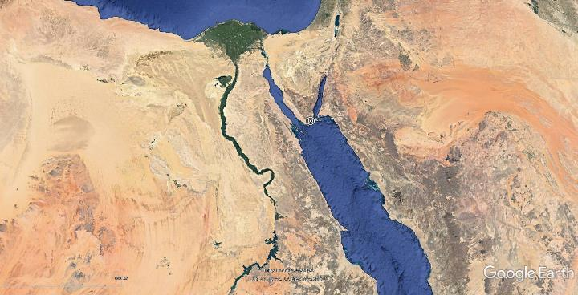
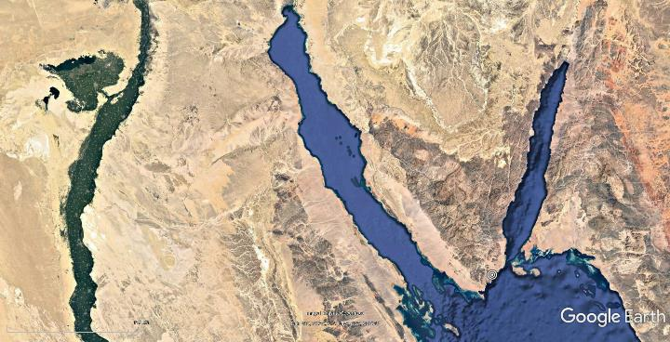
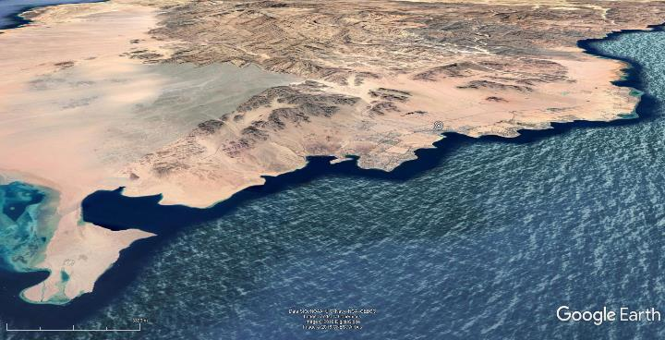
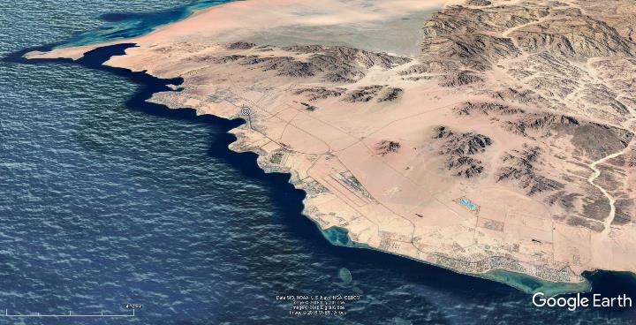

WDPA – Ras Mohamed NP:
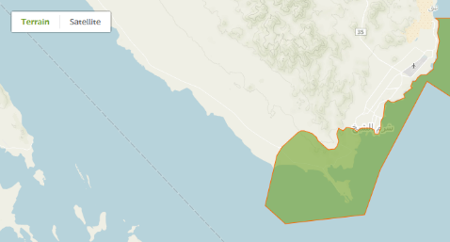
WDPA – Nabq Managed Resource PA:
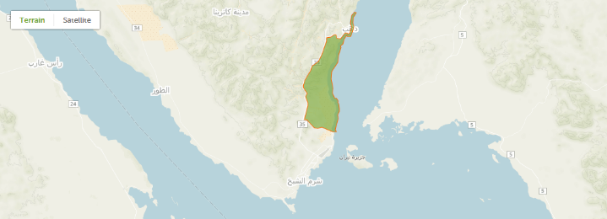
WDPA – Abu Galoum Managed Resource PA:
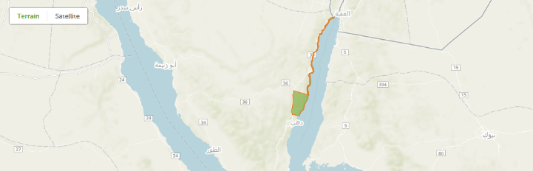

Annex 2: Multi-Year Work Plan
Outcomes | Outputs | Year 1 - Quarters |  |  |  | Year 2 – Quarters |  |  |  | Year 3 – Quarters |  |  |  | Year 4 – Quarters |  |  |  | Year 5 – Quarters
Outcomes | Outputs | 1 | 2 | 3 | 4 | 1 | 2 | 3 | 4 | 1 | 2 | 3 | 4 | 1 | 2 | 3 | 4 | 1 | 2 | 3 | 4
1.1 Integrated urban sustainable development strategy and action plan for Sharm El Sheikh in place | 1.1.1 Proposed arrangement for a local governance framework prepared, setting up inter-institutional dialogue and participation mechanisms for integrated urban planning
 | 1.1.2 Enhanced planning and integrated Sustainable Development Strategy and Action Plan for Sharm El Sheikh developed
 | 1.1.3 Marketing and branding strategy for green tourism in Sharm El Sheikh endorsed
 | 1.1.4 Municipal MRV system in place for relevant authorities to monitor, track, and report on a harmonized set of performance indicators as regards progress towards the SESSDS at regular intervals.
1.2 Increased investment in environmental sustainability in line with new strategy and implementation plan | 1.2.1 Preparing the grounds for investments in low-carbon technologies, improved chemicals & waste management, as well as enhanced biodiversity protection
 | 1.2.2 SESSDS Financing Strategy
 | 1.2.3 Develop a long-term financing scheme to increase the uptake of private sector investments in environmental technologies (incl. energy, water, waste management, sustainable transport) and biodiversity conservation
2.1 Institutional capacity developed for integrated urban planning in Sharm El-Sheikh to identify, design and implement innovative low-carbon, climate-resilient sustainability solutions | 2.1.1 Training of staff in governorate, municipality and hotels on design and implementation of relevant low-carbon measures and sustainable development strategies
2.2 Reduced GHG emissions and other negative environmental impact through interventions addressing tourism facilities and the built environment in Sharm el Sheikh | 2.2.1 Pilot low carbon technology solutions in public infrastructure of Sharm El Sheikh developed and applied
 | 2.2.2 Pilot projects introducing energy & water efficiency measures, and innovative transportation modes implemented by hotels in Sharm El Sheikh
 | 2.2.3 Pilot projects to mainstream distributed renewable energy generation in hotels
2.3 Improved waste management, reduced UPOPs emissions and prevention of plastic waste from land-based sources and boats ending up in the sea | 2.3.1 GHG and UPOPs emissions reduced through green purchasing and improved waste management and recycling
3.1 PA planning and management of marine and coastal PAs adjacent to Sharm El Sheikh further strengthened to manage and mitigate biodiversity-harmful economic practices | 3.1.1 Protected Area planning and management strengthened to manage and mitigate biodiversity-harmful economic practices
3.2 Protected Area financing increased through improved revenue generation and re-investment | 3.2.1 PA revenue collection and reinvestment
3.3 Improved and systematic monitoring of status of key biodiversity resources to assess effectiveness of management of biodiversity-harmful economic practices | 3.3.1 Establishment of clear baselines for monitoring of condition of marine, coastal and terrestrial biodiversity
 | 3.3.2 Regular monitoring and evaluation to support responses for management of biodiversity-harmful economic practices
3.4 Improved Protected Area community participation and benefit sharing from conservation and biodiversity-friendly tourism practices | 3.4.1 Participatory planning for community involvement in biodiversity-friendly livelihood activities
 | 3.4.2 Implementation of ecotourism and livelihood activities to build community support for conservation
3.5 Hotels and related enterprises integrate biodiversity-friendly practices | 3.5.1 Development of guidelines, best practices and improved management responsibility for conservation-friendly practices that protect biodiversity and ecosystems on which their economic interest depends
 | 3.5.2 Improved staff and guest awareness and increased support for conservation action
4.1 M&E and knowledge management plans fully and successfully implemented | 4.1.1: Project progress towards objectives continuously monitored and evaluated
 | 4.1.2: Project lessons compiled and shared

Annex 3: Monitoring Plan
This Monitoring Plan in Section V and the M&E Plan and Budget in Section VI of this project document will both guide monitoring and evaluation at the project level for the duration of project implementation. Data for most indicators will be sought from existing and credible national or international sources. Frequency will be annual as in PIR.
Monitoring | Indicators | Targets | Description of indicators and targets | Data source/Collection Methods | Responsible for data collection | Means of verification | Risks/Assumptions
Project objective indicators | Indicator 1 / GEF Core Indicator 11 | MT: 5% of Sharm El-Sheikh population, approx. 3,750, 50%/50% men/women  EOP: 10% of Sharm El-Sheikh population, approx. 7,500, 50%/50% men/women | Number of direct individual and institutional participants (including both women and men) benefiting from project-led initiatives on energy efficiency and renewable energy, alternative transport, pilot waste sorting and management, biodiversity protection and green hotel management | Survey of project targets via a baseline study during inception stage. | PMU and technical advisors | PIRs  National/local statistics  Related background studies | Adequate capacity and commitment exist
Project objective indicators | Indicator 2 / Core Indicator 6 | MT: 30% of EOP targets  EOP: 105,837 tCO2eq direct, 1,174,166 tCO2eq indirect, 1,280,003 tCO2eq total  (Refer to Annex 10 GHG ER calculation) | Direct and indirect GHG emissions mitigated (tCO2eq) | Specific MRV / monitoring reports from pilot installations  Statistical reports | PMU and technical advisors | MRV system  Related background studies
Project objective indicators | Indicator 3 / Core Indicator 10 | MT: 5.78 g-TEQ cumulated UPOP avoidance (6.42 g-TEQ/yr * 1yr * 90% avoidance from yr2)  EOP: 28.9 g-TEQ cumulated UPOP avoidance during project lifetime (6.42 g-TEQ/yr * 5yrs * 90% avoidance from yr2) | Reduction, avoidance of emissions of UPOPs to air from point and non-point sources (waste burning) (g-TEQ) | Specific MRV / monitoring reports  Statistical reports | PMU and technical advisors | MRV system  Related background studies
Project objective indicators | Indicator 4 / Core Indicators 1 and 2 | MTR METT increase to:  Ras Mohamed – 55, Nabq – 34, Abu Galoum – 36  EOP METT increase to:  Ras Mohamed – 70, Nabq – 49, Abu Galoum - 51 | PA management effectiveness as measured by METT in 117,000 ha of terrestrial PA area and 78,000 ha of marine PA area:  - Ras Mohamed (34,000 ha terrestrial, 51,000 marine)  - Nabq (48,000 ha, 12,000 ha)  - Abu Galoum (35,000 ha, 15,000 ha) | METT | PMU and technical advisors, PA staff | -METT scorecards  -Project progress reports  -Community survey and perception reports  -Annual work plans and budget reports | Development strategies and management plans will be officially approved by governments with allocation of appropriate funding for their implementation and capacity exists for monitoring progress
Outcome 1.1 | Indicator 5 | MT: SESSDS submitted for government adoption after stakeholder consultations  EOP: SESSDS adopted by government and under implementation | Sharm El Sheikh Sustainable Development Strategy (SESSDS) and Action Plan for planning and investment delivered and approved | Stakeholder consultations  Inputs from technical coordination groups | PB/PMU  Technical Coordination Groups | SESSDS Approval and Implementation | The indicator will be built on a strengthened culture of integrated long-term planning fostering inter-institutional and inter-sectoral coordination between national, municipal and private sector institutions to optimize the use of resources and promote the sustainable development of within Sharm El-Sheikh in a coordinated and organized manner with different steps.  Since it is a new form of stakeholder consultation the risk prevails that engagement methods will not work or will require constant adaptation.
Outcome 1.1 | Indicator 6 | MT: SESSDS monitoring and performance indicators and systems developed  EOP: SESSDS monitoring and performance indicators and systems proven and applied for at least 1 year, with guarantee of post-project continuation | Existence of specific monitoring and performance indicators and systems to track the progress of SESSDS implementation (GHG and UPOP emissions, waste and recycling, investment, etc.) in Sharm El Sheikh, based on international best practice, relevant national indicators, and in line with GEF core indicators | On-site surveys, questionnaires, technical and socio-economic assessments | PMU  Consultants | Consultants’ reports | TA will be provided to the city and relevant stakeholders in the elaboration of relevant concepts and investment opportunities, by providing technical-economical solutions covered within feasibility studies, business plans and specifications for design and tender.
Outcome 1.2 | Indicator 7 | MT: At least USD 2,000,000/yr public investment anticipated and requested specifically to implement and achieve the SESSDS  EOP: At least USD 2,000,000/yr public investment budgeted and approved specifically to implement and achieve the SESSDS | Public investment in support of multi-dimensional environmental sustainability under the SESSDS
Outcome 1.2 | Indicator 8 | MT: Draft scheme proposed and under discussion with stakeholders  EOP: A long-term financing support scheme for hotels for upgrading or installing new sustainability infrastructure (e.g. energy efficiency, renewables, water efficiency, waste management, coral reef protection) established with MOTA and ETF and operational | Existence of long-term financing scheme for hotels supporting the upgrading or installation of sustainability infrastructure | Background studies  Inputs from technical coordination groups  Training needs assessment | PMU  Consultants | Consultants’ Reports  Training materials | TA required from the project to establish a new lending (or guarantee) mechanism for hotels to make financing sources available for tourism industry for new or upgraded energy and resource efficient infrastructure.  Project will also require a range of capacity building activities assuming that technical/managerial staff in municipalities and hotels are under capacitated or unaware of technical solutions.
Outcome 2.1 | Indicator 9 | At least 50 municipal/govt staff (thereof min 50% women) trained in the development and management of integrated sustainable urban development planning  At least 200 private sector technical staff from private enterprises and 5 CSOs/NGOs trained.  TA provided (e.g. technical specifications, procurement support), with 2-3 projects to be finally selected and implemented in public sector:  - Solar PV roofs  - Solar-PV street lighting  - Solar water heaters  - EE lighting and equipment in buildings  - Charging infrastructure for electric mobility (bikes, cars)  EOP:  At least 100 municipal/govt staff (thereof min 50% women) trained in the development and management of integrated sustainable urban development planning  At least 400 private sector technical staff from private enterprises and 5 CSOs/NGOs trained.  TA provided (e.g. technical specifications, procurement support), with 5+ projects to be finally selected and implemented in public sector:  - Solar PV roofs  - Solar-PV street lighting  - Solar water heaters  - EE lighting and equipment in buildings  - Charging infrastructure for electric mobility (bikes, cars) | Capacity of administrative/operational staff of Municipality of Sharm El-Sheikh to manage/monitor the SESSDS and support the realization of innovative pilot projects in urban space
Outcome 2.1 | Indicator 10 | MT: CDS score: 40/45  EOP: CDS score: 45/45 | Score of Capacity Development Scorecard | UNDP Capacity Development Scorecard
Outcome 2.2 | Indicator 11 | MT: 20 feasibility assessments for innovative low-carbon technologies (energy, water efficiency, sustainable transportation applications) conducted. Energy and water audits supported in at least 15 hotels. At least 5 hotels implement cost-effective resource efficiency measures by mid-term.  EOP: 20-30 innovative energy and water efficiency measures supported and implemented in at least 10 hotels, leading to reduction in energy and water consumption per guest by an average of 30%, with total investment triggered by hotels of USD 5 million, and with USD 20-30 million investment expected for upscaling and replication. | Energy and water efficiency measures as well as innovative transportation modes in public infrastructure or hotels (or combined) | Technical audits  Feasibility studies  Design reports | PMU  Consultants | Implementation reports, M&E reports | TA will include support in technical design, installation and procurement specifications for the purchase of EE or RE equipment. Further guidance on the required technical specifications and other criteria for supporting the first installations will be provided in the documents to be finalized at the project inception phase. Besides the financial evaluation, all projects to be supported with GEF funding will be subject to technical due diligence and verification of the proper installation and performance of the system during the commissioning stage by the project’s technical expert(s) and/or installers authorized by the project before releasing the GEF support.
Outcome 2.2 | Indicator 12 | MT: Capacity of RE installations supported directly through the project by mid-term:  - 1 MW solar PV  - 1-2 other innovative RE (CSP, ST energy storage, etc.) feasibility conducted  EOP: Capacity of RE installations supported directly through the project by project-end:  - 2.5 MW solar PV  - At least 1 other innovative RE (CSP, ST energy storage, etc.) project implemented | Renewable energy generation opportunities selected for pilot investments in Sharm El-Sheikh hotels | Technical audits  Feasibility studies  Design reports | PMU  Consultants | Implementation reports, M&E reports
Outcome 2.3 | Indicator 13 | MT: 11,000 t/yr sorted (20%)  EOP: 27,500 t/yr sorted (50%) | Tons per year of waste managed through pilot on strengthened collection and separation of MSW | Survey conducted among hotels and from municipal statistic sources. | PMU  Consultants  Hotels | PIRs  Local statistics  Related background studies | The project will develop a set of activities to organize and pilot an integrated municipal waste management system (separation-collection-transport-classification-packaging-recycling) that will help the municipality to enhance resource recovery from municipal organic wastes using 3R approaches (reduce, reuse, recycle/recover). A scale-up approach to improve waste minimization, collection and sorting is foreseen in some 20 test hotels to be scaled-up throughout the project.
Outcome 2.3 | Indicator 14 | 10% prevention of 1,000 t/a plastic  90% prevention of 1,000 t/a plastic | Amount of plastic waste prevented from illegal disposal into land and sea | Survey conducted among hotels and from municipal statistic sources. | PMU  Consultants  Hotels | PIRs  Local statistics  Related background studies
Outcome 2.3 | Indicator 15 | MT: Increase through green procurement practices: pilot hotels 70%, all hotels 50%  EOP: Increase through green procurement practices: all hotels 70% | % of reusable materials and products in hotels and touristic facilities | Survey conducted among hotels and from municipal statistic sources. | PMU  Consultants  Hotels | PIRs  Local statistics  Related background studies
Outcome 3.1 | Indicator 16 | MT: “Sensitivity index” improved by 10%  EOP: “Sensitivity index” improved by 30% | Sensitivity Index for coral reefs in 189 diving sites | Sensitivity Index | PMU and technical advisors |  | Make sure the methodology is more explicit on what it measures and concludes
Outcome 3.2 | Indicator 17 | Baseline: Annual average cumulative budget for 3 South Sinai PAs of $75,000  MT: At least 20% increase annual financing for 3 South Sinai PAs  EOP: At least 100% increase annual financing for 3 South Sinai PAs | Public domestic financing for 3 South Sinai PAs | Budget review and approval validation | PA managers | Government budget documents | Government is willing to using gate and permit fees for conservation activities and appropriate agreement to transfer of funds to PA managers
Outcome 3.3 | Indicator 18 | MT: % reduced by 30%  EOP: % reduced by 60% | % of mortality of migratory birds in Sharm El Sheikh / Ras Mohamed | Regular surveys carried out by PA staff and bird experts during migration season | PA managers | Bird survey reports | Adequate technical capacity available for undertaking monitoring species populations and external factors beyond the control of the project (e.g. climate change) do not affect bird populations negatively
Outcome 3.3 | Indicator 19 | MT: Multi-indicator coral reef health assessment at diving and snorkelling sites: maintained  EOP: Multi-indicator coral reef health assessment at diving and snorkelling sites: improved | Multi-indicator coral reef health assessment at diving and snorkelling sites: coral cover and diversity, fish diversity, coral resilience, coral new recruitment, extent of broken and fragmented coral  Ras Mohamed (baseline per data collected in 2017):  Coral diversity (number of genera) -47  Coral abundance (% living coral) -85  Fish species diversity -52  Butterfly/angel fish species -15  Parrotfish species – 10  Coral resilience (average number infected colonies/100m²) -60  Coral recruitment (>2cm) -62  Coral recruitment (>5cm) -38  Coral recruitment (>) 10cm) -35  Average number broken coral/site -6  Average number of coral fragments/site -12  Sharm El Sheikh (baseline per data collected in 2017):  Coral diversity (number of genera) -13  Coral abundance (% living coral) -40  Fish species diversity -16  Butterfly/angel fish species -5  Parrotfish species – 5  Coral resilience (average number infected colonies/100m²) -178  Coral recruitment (>2cm) -7  Coral recruitment (>5cm) -5  Coral recruitment (>) 10cm) -18  Average number broken coral/site -22  Average number of coral fragments/site -44  Southern Nabq (baseline per data collected in 2017):  Coral diversity (number of genera) -30  Coral abundance (% living coral) -60  Fish species diversity -32  Butterfly/angel fish species -7  Parrotfish species – 7  Coral resilience (average number infected colonies/100m²) -122  Coral recruitment (>2cm) -18  Coral recruitment (>5cm) -16  Coral recruitment (>) 10cm) -29  Average number broken coral/site -28  Average number of coral fragments/site -14  Northern Naqb  Baseline to developed in Year 1  Abu Galoum  Baseline to developed in Year 1 | Regular surveys to measure coral and fish diversity status, at least 2x during project (MTR, TE) | PA managers | Coral survey reports
Outcome 3.4 | Indicator 20 | MT: At least 10% increase in annual household income  EOP: At least 20% increase in annual household income | Change in annual household income in PA communities due to sustainable livelihoods | Livelihood and social surveys conducted by social experts | PA managers | Income status reports | Local communities, national and parish governments understand livelihood benefits and ecological security from cooperation with and sustainable management of land, forest and other natural resources. Thus, they will participate in sustainable management and ecosystem restoration work
Outcome 3.5 | Indicator 21 | MT: At least 5 hotels  EOP: At least 20 hotels | # of hotels and related enterprises that implement and enforce at least 50% of the guidelines on conservation-friendly activities | Energy and environmental surveys | PMU | Environment and energy audit reports | Hotel are willing to participate and recognize the economic opportunities for engaging in sustainable actions
Outcome 4.1 | Indicator 22 | MT: All PIRs are completed reliably and rated S or HS  EOP: All PIRs are completed reliably. PIRs and MTR rated S or HS | Independent Quality Ratings of PIR, MTR and TE |  | PMU  RTA  CO

Annex 4: Stakeholders Consulted during project development and Stakeholder Engagement Plan
Introduction
- The Stakeholder Engagement Plan (SEP) is designed to ensure effective engagement between various stakeholders throughout the lifecycle of the Green Sharm project. This plan will build on any other work which is being undertaken with regard to planning and impact assessment processes. The Green Sharm project will aim to maintain dialogue with the relevant government ministries and parastatals, the Governorate of South Sinai, the Municipality of Sharm El-Sheikh and selected local community groups and NGOs and international community.
Definitions
- Consultation: Consultation involves information exchanges among the government, the Implementing Agency, the project management board, and other stakeholders. Although decision making authority rests with the government and the project executing agency, periodic consultations throughout the project cycle help managers make informed choices about project activities. More important, it provides opportunities for communities and local groups to contribute to project design, implementation, and evaluation.
- Public Involvement: Public involvement consists of three related, and often overlapping, processes: information dissemination, consultation, and stakeholder participation. Stakeholders are the individuals, groups, or institutions which have an interest or "stake" in the outcome of the GEF-financed project or are potentially affected by it. Stakeholders include the recipient country government; project executing agency; groups contracted to carry out project activities and/or consulted at various stages of the project; project beneficiaries; groups of people who may be affected by project activities; and other groups in the civil society which may have an interest in the project.
- Stakeholder participation: Where stakeholders collaboratively engage in the identification of project concepts and objectives, selection of sites, design and implementation of activities, and monitoring and evaluation of project outcomes. Developing strategies for incorporating stakeholder participation throughout the project cycle is particularly necessary in projects which have impacts on the incomes and livelihoods of local groups, especially disadvantaged populations in and around project sites (e.g., indigenous peoples, women, poor households).
Legal requirements for public consultation in Egypt
- According to Egyptian regulations, public consultation is included in the project development process where a given project may significantly affect the quality of the environment and are part of the environmental impact assessment. However, for other projects which might involve policy and system set up, public participation and consultation is still necessary.
- The national EIA guidelines address social aspects through scoping meetings and public consultations. The consultation mainly focuses on the environmental and social aspects related to the project. The consultation process provides the concerned parties with the opportunity to express their opinion on the mitigation measures to minimize potential negative environmental and social impacts, strengthens the social acceptance of the project, informs the concerned parties that the environmental impacts will be minimized to levels that are low as reasonably practical and achieve the balance between legitimate requirements for development and environmental protection.
- The list of stakeholders should include, at a minimum, the following concerned parties:
- MoE/EEAA and its branches
- CAAs
- Representatives from the governorate in which the project is located
- Local popular councils
- Representatives from the affected communities such as neighbouring facilities
- Local NGOs
- Local Universities and research centres
- The consultation should take place twice; first during the identification of the scope of the project, and the second after preparing the draft ESIA for pilot projects. During the first phase (scoping meetings), the stakeholders are informed with the scope of the ESIA (project description, aspects and impacts that will be addressed and analysed). The consultation in the first phase could be held either in the form of one-to-one meetings with the stakeholders or through a unified meeting with all the concerned parties. The project proponent is responsible for inviting the concerned parties. A report with the consultation results should be prepared and discussed with the EEAA.
Summary of initial stakeholder engagement activities
- During the project preparation (PIF and PPG stage), several stakeholder consultations were held with an objective of project design and activities to be as inclusive as possible and in line with the existing Acts, Rules and Regulations and the Government of Egypt’s priorities and long-term plans.
- The following summarizes the stakeholder engagement activities to date:
- During the PIF preparation meetings were held with Ministry of Environment including WMRA and NCS, Ministry of Tourism and Antiquities, Representatives from Sharm Hotel Sector/EHA Branch in Sharm El-Sheikh
- A series of stakeholder meetings on the occasion of the PPG consultant team’s two in-country-missions have taken place between end July 2019 and end of November 2019.
- Presentation on project objectives and components for creation of awareness and seeking feedback through bilateral and group meetings, focus group discussions with gender focus. The project was also covered in local media explaining about the project and its benefits to the Country and Region at large.
- The target groups and users were interviewed to understand their possible engagement priorities, preferences and gender aspects covered.
- Bilateral and group meetings were conducted with the relevant agencies and private sector representatives during the project formulation phase.
- Presentations/workshops were conducted with representatives from the Egyptian Tourism Federation, including their members (owners and operators of hotels, diving centres), and representatives of the S-Sinai Investors Association
- Deliberations were made on the financial support required from the project, criteria for selection of pilot activities as well as associated project and environment and social risks assessments.
- Mission reports and summary of meetings held during PPG team mission 1 (July 28th until August 1st 2019) and mission 2 (October 21st until October 28th 2019) are available and provided as separate Annexes.
- Mission 1:
  - The mission consisted of two parts: meetings in Cairo and meetings in Sharm Elsheikh over a period of 5 days. The mission was carried out by representatives from UNDP Cairo office and a team of International and national experts. UNDP was represented by Dr. Mohamed Bayoumi and Mr. Khaled Bahader while the international experts included Mr. Andreas Karner, Dr. Ulrich Wiegel and the national experts team included Dr. Amr Abdelaziz, Dr. Ahmed Wafiq, and Dr. Yasmine Kamal. Ms. Hoda Elshawadfy Head of GEF Unit of EEAA, Mr. Ahmed Badawy representative of Waste Management Regulatory Agency (WMRA), MoE, Eng. Emad Hassan and Mr. Mohamed Atef from the Ministry of Tourism and Antiquities accompanied the team during the part of the mission in Sharm El Sheikh. The meetings were conducted with representatives from governmental authorities, private sector and other key stakeholders for the implementation of Green Sharm project.
  - Meetings held:
 | - Ministry of Environment/EEAA (Climate Change Department, Nature Conservation Sector, Waste Management Regulatory Authority) | - Eng. Sherif Abdelreheem (Head, Climate Change Department, MoE, UNFCCC National Focal Point)  - Dr. Tarek El-Kanawaty (EEAA)  - Eng. Ahmed Badawy (WMRA)
 | - Ministry of Tourism and Antiquities | - Eng. Emad Hassan (Energy Advisor to the Minister of Tourism and Antiquities)
 | - General Organization for Physical Planning (GOPP) | - Dr. Alaa Abdelfattah (Chairman)  - Dr. Bassem Fahmy (Programme Manager, Strategic and Urban Planning Programme, UNHABITAT)
 | - Waste Management Regulatory Authority (WMRA) and National Solid Waste Management Program, Cairo House | - Dr. Hazem Zanan (Program Manager)  - Dr. Heba Zaki (Technical Program Officer NSWMP)
 | - UNDP/GEF Medical and Electronic Waste Management Project | - Dr. Tarek El-Araby (Project Manager)  - Eng. Hoda Shakra (Technical Program Officer)  - Dr. Sherif El Nagdy (Technical Program Officer)
 | - EBRD GEFF Project | - Mr. Ashraf Zaytoon Program Program (Officer, GEFF)
 | - PV Project, EE Project – UNDP/GEF | - Dr. Hend Farouh (PV Project manager, UNDP-GEF/ Industrial Modernization Center  - Eng. Viola Zaklama (EE Project Deputy Manager, UNDP-GEF/Ministry of Electricity and Renewable Energy)
 | - UNIDO CCM Project | - Dr. Ahmed Hozayen (Chemonics)  - Dr. Ahemd Yehia (Chemonics)  - Mr Yahia El-Masry (Technical Expert, UNIDO SHIP)
 | - Sharm El Sheikh City Council | - Gen. Mahmoud El Solaya (Mayor, Sharm El Sheikh city)  - Mr. Hesham Gabr (Head of the Sustainable Tourism, Chamber of Hotels)  - Hoda Elshawadfy (Head of GEF Unit ,EEAA, MoE)
 | - Egyptian Hotel Association EHA | - Mr. Givara El Gafy (Chair and Deputy Chair, Local Branch of Egyptian Hotel Association Members)  - Mr. Hany Wagih (Egyptian Hotel Association Members)
 | - Nature Conservation Sector | - Mr. Waleed Hassan (Central Department for Protectorates – South Sinai protectorates general directorate)
- Dr Yasser Awad Allah (Central Department for Protectorates – South Sinai protectorates general directorate)
- Mr Ibrahim (Zahret Janob Sinai Company for solid waste management)
 | - National Renewable Energy Authority (NREA) | - Dr. AbouBakr Abdelhameed (Technical Consultant)  - Ehab Ismail (Vice Chairman for Technical Affairs)  - Ahmed Moustafa (Manager of Chairman’s Office)
 | - Ministry of Electricity and Renewable Energy (MoERE) | - Dr. Ahmed Mehina Undersecretary for follow up  - Eng. Saber El-Hadary (MoERE), Energy Efficiency Unit  - Eng. Taghreed (MoERE), Energy Efficiency Unit
 | - Movenpick Resort Sharm Elsheikh Naama Bay | - Mr Sameh Farghaly (Learning and quality manager)
 | - Savoy Resort Sharm Elsheikh | - Mr Hossam Farouk (Quality manager)  - Mrs Kirsten Hilger (Quality manager)
 | - Rixos Sharm Elsheikh | - Mr Tahsin Donmez (Quality Manager)  - Dr Yehia Zakaria (Quality Department)
 | - Camel Dive Hotel and Dive Center | - Hesham Gabr (Owner of Camel Dive Hotel & Head of Egyptian tourism federation environment and sustainable committee)

- Mission 2:
  - The mission consisted of two parts: meetings in Cairo and meetings in Sharm Elsheikh. The mission was carried out by representatives from UNDP Cairo office and a team of International and national experts. UNDP was represented by Dr. Mohamed Bayoumi, Dr Amany Nakhla, Mrs Heba Helmy and Mr. Khaled Bahader while the international experts included Mr. Andreas Karner (CCM), Mr. Malcolm Jansen (BD) and the national experts team included Dr. Amr Abdelaziz, Dr. Ahmed Wafiq, Dr Magdy Alelwany and Dr. Yasmine Kamal. Ms. Hoda Elshawadfy, Head of GEF Unit in EEAA. The meetings were conducted with representatives from governmental authorities, private sector and other key stakeholders for the implementation of Green Sharm project.
  - Meetings held:
- 1 | - UNDP | - Mr Sylvain Merlen, UNDP DRR Egypt  - Dr. Mohamed Bayoumi (Energy and Climate Change Team Leader, UNDP)  - Ms Amany Nakhla, (Biodiversity Team Leader, UNDP)  - Mrs. Heba Helmy (UNDP, Environment Team)
- 2 | - UNHABITAT | - Dr. Bassem Fahmy (Program Manager, Strategic and Urban Planning Program)  - Eng. Anas (Project Manager, UNHABITAT)  - Mrs. Shahd (UNHABITAT)
- 3 | - Egyptian Tourism Federation (ETF), Egyptian Hotel Association (EHA) | - Mr. Ahmed Wassif (Chairman, ETF)  - Mr. Maged Fawzy Malak (Chairman, EHA)  - Ms. Hoda Omar (Head of GEF Unit in EEAA, MoE)
- 4 | - HEPCA | - Ms. Heba Shawky (Deputy Managing Director, Hepca)
- 5 | - Natural Conservation Sector | - Mohamed Salem (Head of Natural Conservation Sector)
- 6 |  | - Dr Mostafa Fouda (Minister Advisor on Biodiversity, CBD National Focal Point)
- 7 | - Commercial International Bank (CIB) | - Ms. Neveen Gamal (Assistant Vice President, Global Customer Relations)  - Ms. Nouran Emad (Social & Environmental Risk Analyst)
- 8 | - South Sinai Investors Association | - Mr. Tamer Youssef (President of South Sinai Investor Association)  - Mr. Amr Sedky (Head of Tourism Unit, Parliament)
- 9 | - Ministry of Tourism and Antiquities | - Mrs. Samia Samy (Department Head)  - Ms. Rowaida Ezzat (General Department for Diving )  - Mr. Hesham Demerdash (General Manager, Yachts and diving tourism Department)  - Dr. Mohamed Atta (Egyptian Tourism Promotion Board Report Directly to the Minister)
- 10 | - Chairman of Egypt’s Chamber of Diving and Water Sports | - Hesham Gabr (Chairman of Egypt's Chamber of Diving and Watersports (CDWS), Head of the Federation’s Environmental Protection and Sustainable Development Committee)  - Ms. Lina Challita (the Federation’s Environmental Protection and Sustainable Development Committee)  - Mr. Waleed Hassan (Central Department for Protectorates – Ras Mohamed Park Manager)  - Mr. Mohamed Kotb (Central Department for Protectorates – South Sinai protectorates general directorate)
- 11 | - Protectorate Management Unit | - Dr. Osama Elgebaly (Project Manager of the Migratory Soaring Birds Project)
- 12 | - Mowasalat Misr | - Dr. Hesham Taha (CEO)  - Mr. Ahmed Elleithy (COO)
- 13 | - TDA and Green Star Program | - Mrs. Samia Samy (Department Head)  - Dr. Elham Fouda (Manager, Sustainable/Green Tourism Unit)  - Eng. Yasser Farouk (Secretary General of the Tourism Fund, Tourism)

Stakeholder Engagement Plan
- Table below presents the Stakeholder Engagement plan and summarizes different categories of stakeholders:

# | Stakeholder Group | Why Involved | Participation and Involvement | Timeline |  | Required resources
# | Stakeholder Group | Why Involved | Responsibility
1 | The Ministry of Environment (MOE) | The MOE is the project Implementing Partner and will lead on the high-level coordination with other ministries and agencies, especially the Ministry of Electricity and Renewable Energy and Ministry of Tourism and Antiquities and the new Waste Management Regulatory Agency. | MOE is the Implementing Partner for the project and a key co-financier. MOE will be involved in all project activities and ensure coordination of stakeholders. | Continuously throughout project |  | Staff time and in-town travel in Cairo, monitoring visits to Sharm El-Sheikh  Chair in PB meetings
2 | Egyptian Environmental Affairs Agency (EEAA) | The EEAA is the executive arm of the Ministry of Environment. The main functions of EEAA include formulating environmental policies and regulations; preparing the necessary plans for environmental protection and environmental development projects, following up on their implementation; and undertaking pilot projects. EEAA hosts the GEF Operational Focal Point as well as the focal points for UNFCCC and CBD. | National environmental authority. Co-financier. Project Board member. Member of Technical Coordination Group. Will coordinate with the Municipality of Sharm El-Sheikh, Governorate of South Sinai and key relevant stakeholders in project planning, implementation and monitoring. EEAA will chair the Project Board and host the PMU to ensure coordination of project activities with all the stakeholders. EEAA is also an important co-financier and oversees NCS.  Outcomes: 1.1, 1.2, 2.1, 3.1, 3.2, 3.3, 3.4, 3.5 4.1 | Continuously throughout project |  | Staff time and in-town travel in Cairo, monitoring visits to Sharm El-Sheikh
3 | Nature Conservation Sector (NCS) | NCS is the national entity under EEAA that is responsible for the conservation of biodiversity. It is in charge of the management of protected areas but also for improving biodiversity management in production landscapes through sectoral engagement. NCS has offices in Sharm El Sheikh for the South Sinai Governorate. In the project, the NCS will identify and advance key biodiversity conservation issues and priorities in the targeted region in Southern Sinai with its PAs. | Lead all activities inside the Proctored Areas. Member of Technical Coordination Group. NCS will be instrumental in and urban/marine spatial planning, in enhancing the management of PAs, in advancing new PA financing mechanisms, in patrolling and monitoring the reef system and in engaging local-level stakeholders.  Outcomes: 3.1, 3.2, 3.3, 3.4 | Continuously throughout component 3 |  | Staff time and travel in South Sinai, patrolling in PAs under their responsibility
4 | Waste Management Regulatory Agency (WMRA) | Waste Management Regulatory Agency was established in 2015 under the Ministry of Environment. The main objective of the agency is setting the rules and responsibilities for all entities working on Solid Waste as well as developing adequate legislation and strategic plans to improve all aspects of waste management in Egypt. | The agency will be responsible for supporting, coordinating and monitoring the work for MSW in the city of Sharm El Sheikh, in particular the infrastructure works on upgrading the landfill establishment of recycling factory as well as support the engagement of private sector in a sustainable collection system. Member of Technical Coordination Group.  Outcomes: 2.3, 3.5 | Intermittently, during tasks assigned within component 2 and 3 |  | Staff time and participation in TCG meetings
5 | Ministry of Foreign Affairs (MOFA) | MOFA is a key counterpart for UNDP, because the GEF Political Focal Point is based in the Environment and Sustainable Development Department, and because the International Cooperation Department is the signatory to all UNDP projects and member of Project Boards. | Member of Project Board | Intermittently, participation in PB meetings |  | Staff time and participation in Project Board meetings
6 | Ministry of Tourism and Antiquities (MOTA) | MOTA has the responsibility for planning, coordinating, and promoting tourism development projects within the framework of the country's general policy and its economic plan. MOTA has a Sustainable Tourism Unit (STU, formerly Green Tourism Unit GTU) that is mandated to promote use RE/EE in tourism sector and act a focal point for coordination with MOE/EEAA. It promotes the Green Star hotel rating scheme and supports awareness and capacity building measures together with ETF. | The STU will be a member of the Project Board, Technical Coordination Group, and will facilitate the development of the SESSDS with input from the tourism sector, and coordination with the tourism enterprises/chambers in the implementation of capacity building, awareness, and pilot activities.  Outcomes: 1.1, 1.2, 2.2, 3.5 | Intermittently, during tasks assigned within component 1, 2 and 3 |  | Staff time and participation in Project Board meetings
7 | Tourism Development Authority (TDA) | Statutory autonomous agency with substantial jurisdiction authority over tourism development areas and tourism planning. TDA’s roles: a) provide support for coherent private sector tourism development; b) provide institutional framework for environmentally sound private investment participation in tourism development, and c) to help safeguard the resources of Egypt from environmental development degradation. TDA has the authority to acquire and sell tourism development lands and retain the income; to charge fees for the assessment and monitoring of projects; and to borrow, repay loans, and receive grants from national and international institutions. | The role of the TDA in this project will be to get involved in stakeholder coordination activities related to the development of the SESSDS, provide information and promotional support for the Green Star scheme, coordinate work between EEAA/NCS and MOTA to impose regulations related to environmental standards inspections, as well as implementation of renewable energy and energy efficiency measures for new hotels and developments in Sharm El Sheikh. Member of Technical Coordination Group.  Outcomes: 1.1, 1.2, 2.2, 3.5 | Intermittently, during tasks assigned within component 1, 2 and 3 |  | Staff time and participation in TCG meetings
8 | Egyptian Tourism Federation (ETF) | The ETF is the union of elected tourism industry members from the private sector. It works with MOTA on matters related to tourism planning, environmental considerations and manages the Tourism Workforce Skills Development.  It is composed of five tourism industry business associations:  - the Egyptian Hotels Association (EHA),  - the Travel Agents’ Association (TAA),  - the Chamber of Tourist Establishments,  - the Egyptian Chamber of Tourist Commodities and  - the Egyptian Chamber of Diving and Water Sports (CDWS) | The ETF has a Committee on Environmental Protection and Sustainable Development that deals with matters related to environmental impact of tourism, awareness raising and capacity building/trainings among its federation members and dialogue with governmental entities and policy makers. It promotes the Green Star Hotel rating scheme together with MOTA/STU. The ETF and its related associations EHA, TAA and CDWS will be a key partner and linkage to the hotel and tour operators/sports and diving centres and be involved the project components 2 and 3. Member of Technical Coordination Group.  Outcomes: 2.1,2.2, 3.3, 3.4, 3.5 | Continuously throughout project |  | Staff time, local travels, engagement with their member hotels and touristic infrastructures, organization of workshops and dissemination events
9 | Ministry of Electricity and Renewable Energy (MoERE) | The Egyptian electricity sector is managed by the Ministry of Electricity and Renewable Energy (MoERE) and overseen by the Supreme Council for Energy (SEC). The MOERE provided EgyptERA with the authority to set electricity tariffs. It furthermore leads the policy development on renewable energy strategy and the NEEAP (Natl Energy Efficiency Action Plan). | MoERE will be member of the Project Board and Technical Coordination Group, and further involved in energy-related stakeholder coordination activities related to the development of the SESSDS.  Outcomes: 1.1, 1.2 | Intermittently, during assigned tasks within component 1 |  | Staff time and participation in Project Board meetings
10 | The Electric Utility and Consumer Protection Regulatory Agency (EGYPTERA) | EGYPTERA is affiliated with the MoERE and is regulating, supervising and controlling all matters related to electricity generation, transmission, distribution and consumption in Egypt with the aim of ensuring the availability and continuity of supply and satisfying environmental protection, the interests of the electric power consumers as well as the interest of the producers, transmitters and distributors. | EGYPTERA will facilitate the connection of the installed renewable energy technologies with the electricity grid and engage on necessary energy regulatory measures in coordination with MoERE, NREA and other line ministries.  Outcomes: 1.1, 1.2, 2.2 | Intermittently, during tasks assigned within component 1 and 2 |  | Staff time and local travels
11 | The New and Renewable Energy Authority (NREA) | NREA falls under the responsibility of the MoERE that serves as the focal point for expanding the use of renewable energy resources in Egypt and is implementing projects involving the use of wind energy, solar energy and biofuels. NREA is an independent agency but reports to Minister of Electricity and Renewable Energy. It coordinates with EGYPTRA and EETC (Egyptian Electricity Transmission Company) under supervision of EEHC (Egyptian Electricity Holding Company) the signing the Power Purchase Agreements (PPAs) of renewable energy generated by the private sector. NREA also has a well-equipped testing laboratory for renewable energy technologies and energy efficient appliances. | NREA has a list of certified suppliers for renewable energy technologies and will support the RE and EE technical activities and solutions offered by the project.  Outcomes: 2.2 | Intermittently, during tasks assigned within component 2 |  | Staff time and local travels
12 | Governorate of South Sinai and Municipality of Sharm El Sheikh | The Governorate of South Sinai and Municipality of Sharm El Sheikh are responsible for local administration, infrastructure, social and economic development. Although the responsibilities and powers are centralized in sectoral ministries, they have budgets and administration, social and economic development.  The Municipality provides public services, including managing collection services and controlling final disposal of municipal solid waste; water supply and wastewater management; maintenance of green areas; and developing of public roads and bicycle lanes.  The Governor represents the executive branch of the government, supervises the implementation of the state policy within the governorate and enforces laws and regulations of governance. The Governor monitors and coordinates the work of all public utilities. | Governorate and city government will be involved through the Project Board and Technical Coordination Group and supported in the stakeholder participation process to develop the SESSDS and action plan. The governorate/city will moreover lead pilot activities on greening the infrastructure of the city such as efficient street lighting, solar power station, upgrading of the landfill, etc. They will be also responsible for coordinating with and encouraging the hotel sector to join in this initiative. Member of public authority administration and technical staff will be participating in capacity building/training and awareness raising activities throughout the project.  Outcomes: 1.1, 1.2, 2.1, 2.2, 2.3, 3.1, 3.4, 3.5, 4.1 | Continuously throughout project durations |  | Staff time, travels within governorate and to Cairo, and participation in Project Board meetings.  Investment in infrastructure as per the city plans
13 | S Sinai Investors Association | The Association members include the owners of the hotels in S Sinai as well as other touristic facilities in the region. | The Association has been consulted during the PPG and will play a major role in selecting hotels to benefit from the project services as well as assist in dissemination of pilot project results to beneficiaries in order to promote replication. Furthermore, the Investors’ Association is interested in supporting the development of a sustainable financing mechanism for hotels in the long-term. It will become member of Technical Coordination Group.  Outcomes: 1.2, 2.1, 2.2, 3.5 | Intermittently, during tasks assigned within component 1, 2 and 3 |  | Staff time, local travels
14 | Private sector | The following sectors will be represented in the project:  - Tourism industry (Egyptian Hotel Association, hotels, travel agencies, tour/diving operators)  - Energy service/management companies (ESCOs, PPA operators)  - Waste management companies (waste collection, recycling companies, landfill operator)  - Sustainable Transport service providers  Different members from private sector will be engaged within the Project, either as beneficiaries, service providers, operators or as facilitators of innovative services and technologies concerning low carbon development, resource efficiency and waste management.  Tourism will be the main sector where private investment into energy and resource efficiency technologies, including renewable energy and waste mitigation will take place. | Hotels/resorts and travel agencies, tour operators will be involved in training and capacity buildings and pilot facilities will act as showcase and best practice examples for other representatives of the tourism sector to replicate in the future. Hotels are expected to provide project co-financing in the form of investments for the pilot project, as well as for subsequent replication and upscaling of these pilot projects  Energy service/management companies will be capacitated in providing sustainable energy services to their customers.  Waste management companies will be trained and selected upon the improved MSW strategy and business plan to be implemented within the project.  The solid waste management/landfill operator will also provide co-financing to the project under its contract with the government.  Private sector will be nominated into Technical Coordination Group, related to their specific topics.  Outcomes: 1.2, 2.1, 2.2, 2.3, 3.5 | Intermittently, during tasks assigned within component 1, 2 and 3 |  | Staff time, local travels, own funds for pilot investments, replication and upscaling
15 | Financing sector (commercial banks, development banks, funds) | There are only a few commercial banks active in Southern Sinai nowadays, but some of them (e.g. CIB) are financing large hotel operations. | The Project will engage with financial sector to leverage funds in the short and long-term (e.g. through development of a “Sustainable Tourism Fund” etc.).  Outcomes: 2.2, 2.3, 3.5 | Intermittently, during tasks assigned within component 2 and 3 |  | Staff time, financing sources for project beneficiaries
16 | NGOs/CSOs | The NGO community will act as a multiplier for the project experience. NGOs in Egypt are constrained in their operations, in particular in their ability to receive funds from outside of Egypt. However, UNDP has worked well with NGOs on a number of projects and is trusted by the Government and the NGO community. The Hurghada Environmental Protection and Conservation Association (HEPCA) is well-respected in the Red Sea area and can support both in particular in providing a voice for the conservation NGO community in the scenario planning and in setting up and (and potentially operating) a sustainable waste management system in Sharm El-Sheikh.  At a lower-level associations and other recognised civil society organisations are important in enabling local community and women representation and to some extent participation in the tourism market. | NGOs and CSOs can play important roles in supporting improved waste management and biodiversity conservation and sustainable use practices in target areas (public infrastructure, hotels, other touristic facilities, Bedouin communities). They will be also nominated into the Technical Coordination Groups, as deemed necessary.  Outcomes: 2.1, 2.3, 3.4, 3.5  In addition, gender related CSOs will be involved in the project where appropriate in the context of the implementation of the Gender Action Plan. | Intermittently, during tasks assigned within component 2 and 3 |  | Staff time and personal resources, local travels for participation in meetings
17 | Local communities | There are Bedouin communities in limited areas along the coastal stretch where the project will work, most importantly in Nabq PA and the outskirts of Sharm El Sheikh. They are involved in PA related tourism activities, but also in fishing, and will be beneficiaries of the project and hence be beneficiaries for the improved PA community participation activities. | The project will support sustainable and diversified income opportunities to compensate for the declining fisheries harvest. The development of an integrated village development plan will seek to develop and integrate ecotourism opportunities with improved development and marketing of milk and meat products, development of local handicrafts and service facilities to support the ecotourism efforts, as well as improved sanitation and waste collection and management.  Outcome: 3.4 | Intermittently, during tasks assigned within component 3 |  | Staff time and personal resources, local travels for participation in meetings and consultation workshops
18 | Old-time local “Sharmers” | The local “Sharmers” (owners of hotels, dive centre, homes, etc.) who have been living in Sharm for decades and whose knowledge & connections are singular. | The engagement of Sharmers & local communities will play an essential role in marketing the project within the city. The adoption of this project by local stakeholders would guarantee the longevity & sustainability of a Green Sharm mindset.  All outcomes | Continuous |  | TA and INV
19 | UN Habitat | UN Habitat is the United Nations Agency for Human Settlements mandated by the UN General Assembly to promote socially and environmentally sustainable towns and cities with the goal of providing adequate shelter for all while leading the urban agenda for the future. UN Habitat supports the efforts of the General Organization for Physical Planning (GOPP) in developing the strategic urban plans for 70 small cities in Egypt, and especially for Sharm El-Sheikh the development of a Strategic Urban Plan (SUP) to provide the appropriate mechanisms, to ensure sustainable development and to maintain the uniqueness of the city. | UNDP and UN Habitat will join forces on to share tasks and responsibilities in the development of the Sharm El-Sheikh Sustainable Development Strategy (SESSDS) and action plan under component 1.  Outcomes: 1.1, 1.2 | Intermittently, during tasks assigned within component 1 |  | Staff time
20 | JCEE/GIZ | The Egyptian-German High Level Joint Committee for the bilateral cooperation on Renewable Energy, Energy Efficiency and Environmental Protection (JCEE), according to the MoU signed between German and Egyptian government, helps to promote an environmentally sustainable economic development, based on the contribution of securing energy supplies, improving living conditions and conserving the natural environment.  The JCEEE has supported energy assessments in over 80 businesses/industries, also one hotel in Sharm El-Sheikh. Their mission is to provide technical cooperation through GIZ, but no financing of demonstration projects.  Currently in the planning of its fourth phase, JCEE is providing a platform for the cross-sectoral policy dialogue in the five thematic focal areas Renewable Energy, Energy Efficiency, Institutional Transformation, Awareness and Communication and Climate Change. The committee cooperates with a range of stakeholders in Egypt, most of them being ministries or other governmental bodies. | JCEE plans a future focus on supporting – among others – small-scale PV projects, support practice measures in industrial sector (the exact sub-sector is not yet defined), including awareness campaigns and trainings for private sector and industries. Experiences from their previous programmatic activities and support offered to private sector will be incorporated into the feasibility assessments of component 1, as well as trainings and energy pilot activities under component 2.  Their focus to work also in tourism industry is not yet confirmed but may lead to cooperation opportunities during the Project.  Outcomes: 1.2, 2.1, 2.2 | Intermittently, during tasks assigned within component 1 and 2 |  | Staff time
21 | EBRD GEFF | The EBRD’s Green Economy Financing Facility (GEFF) helps Egyptian businesses invest in high-performing technologies by providing financing through local participating financial institutions. Since 2017 in operation, offers TA (preliminary and full assessments) of energy efficiency and renewable projects in private sector (mainly industries, but to some extent also in tourism industry). A few financing requests have come from local Sharm El-Sheikh hotels that are interested to install solar PV systems. | The Project will engage with GEFF to identify possible energy and resource efficiency financing links with tourism facilities and banks as well as opportunities with the involved banks to set up a long-term financing scheme for the hotel sector.  Outcomes: 2.1, 2.2 | Intermittently, during tasks assigned within component 2 |  | Staff time, financing sources for project beneficiaries
22 | Academia | Several departments of Cairo University will be mobilised to provide policy and technical/scientific expertise in support of this multi-facetted project, for output/outcome delivery under its different axes and for project-relevant M&E. This includes especially the Departments of Engineering, Economy and Science, as well as the Cairo University Research Centre and Energy Center. In addition, the outpost of the Technical University of Berlin in El-Gouna will be mobilised who have led innovative sustainability and climate change mitigation work in the region. The Faculty of Science of Suez Canal University will support the biodiversity workstreams. |  |  | Intermittently
23 | UNDP and UNDP/GEF Small Grants Programme | UNDP is the GEF Agency providing oversight to the project but will also contribute co-financing from its own resources.  SGP will be solicited to support local initiatives in the targeted PAs to complement the project’s activities and can contribute to CCM pilot projects including for awareness raising. |  |  | Intermittently
24 | Local informal waste pickers | A vulnerable stakeholder group exposed to changes in the waste management operations in the city. The ESMF (Annex 11) deals with this in detail to involve this stakeholder group and prevent harmful impacts. |  |  | Intermittently

- The project will effectively engage the stakeholders involved in the project to get their support and guide the project implementation to achieve higher results.
- Project outreach proposed includes project website, media (print/audio-visual), workshops, trainings, publications, etc.
- The PMU and the Project Board will ensure that the Gender Action Plan (GAP), Environmental and Social Management Framework (ESMF) and SESP recommended by the project is pursued and implemented. The various groups especially women will be engaged during the consultation meetings, prioritized to avail the program and be included in the different capacity building programs. The project will also ensure that it is in line with all national policies and strategies/programs and be as inclusive as possible.
- Meetings, monitoring visits, surveys and written communications will be used to receive feedback to continue the ongoing dialogue as well as during the course of implementation.
- The project will follow a participatory approach in decision making by engaging all the relevant stakeholders. The Government agencies and the private sector will be actively involved during the project implementation.
Indicative timelines:
- Inception workshop Q1/2021, tentatively to be organized in Sharm El-Sheikh
- First Project Board Meeting (once a year)
- There will be a Project Management Committee that will meet more frequent, maybe every 3 months
- All further stakeholder engagement activities, including consultation, disclosure, and partnerships – by when they will take place and the date by which such activities will be undertaken – will be defined in detail during the Project Inception stage (to be summarised in the Inception Report).
Resources and Responsibilities
- The PMU is primarily responsible for carrying out the specified stakeholder engagement activities.
- The stakeholders will be engaged while carrying out various consultation rounds (e.g. thematic working groups, regular meetings, workshops, trainings), during specific project assessments and studies (feasibility studies, planning and design of pilot project activities/investments).
Monitoring and Reporting
- The project stakeholders will be engaged at various levels to carry out the monitoring activities. The PMU will involve relevant experts and liaise with partners from public government agencies and private sector to provide inputs on the indicators and benchmarks required to assess GHG mitigation; feedback on the performance will be provided in regular intervals and suggestions for further improvement if necessary.
- The PMU will report back the results to the stakeholders at the earliest through reports, website and/or other form of publications (e.g. lessons learnt report), and conduct meetings both individually as well as through engagement of all relevant agencies and private sector stakeholders.

Annex 5: UNDP Risk Register
# | Risk Category & Description | Date Identified | Risk Level/ Impact &  Likelihood | Risk Treatment / Management Measures | Risk Owner
1 | Political: Political instability and security concerns threaten the consolidation and further development of tourism in Egypt, undermining the value creation needed for the tourism sector to willingly adopt a more sustainable business model. | PIF | MODERATE  I = 3  L = 2 | Political stability is now secured and there are large plans for investing in the Sinai in particular. The uniqueness of Egypt’s cultural heritage and the quality of its tourism product and climate make the country’s tourism sector fairly resilient, and after the crisis between 2011-2018 tourism numbers have been increasing again in the last years. While the project is unable to proactively manage such a high-level risk, it could react in terms of adaptive management within the resources it can make available should the risk materialize – such as by deploying temporary support to tourism-dependent communities that could increase both legal and illegal exploitation of resources in protected areas; but project resources would be insufficient to support larger economic stakeholders such as tourism operators and hotels needing to cut costs and avoid bankruptcy – which is something the Sharm El Sheikh tourism community experienced between 2011 and 2018. | PMU, PM, UNDP Country Office
2 | Political: Given Egypt’s strategic geographical position all three PA covered in the project area are in geographical locations considered sensitive by security authorities and subject to restrictions on movements at times. | PPG | SUBSTANTIAL  I = 4  L = 4 | Similar to measures taken by other UNDP-GEF projects, the Ministry of Environment will establish good communications and coordination mechanisms with security authorities to ensure that they are kept informed of the project and fully understand its aims and objectives and that the project’s activities are completely transparent to the security services at all times. | PMU, PM, UNDP Country Office
3 | Operational: Slow start and delivery in related other GOE/UNDP/GEF projects undermine achievements of the stipulated outcomes of the present new project. The possible impact is that targeted outputs/ outcomes across the components would be delayed or unfulfilled. | PIF | MODERATE  I = 3  L = 2 | The Project Team to be recruited with Government and as designed during the PPG is substantial and should be able to deliver the project in due time. UNDP Egypt has assigned significant co-financing to provide critical implementation support most notably on procurement/recruitment and payments, and the UNDP Regional Hub will pay dedicated oversight attention to fast delivery. UNDP has recently installed new milestones monitoring such as on project signature, inception, regular financial delivery and deliverables. | PMU, PM, UNDP Country Office
4 | Operational: Lack of technical capacity in hotels to assess and implement RE/EE projects. Anticipated cost savings and environmental benefits may not materialize, and hotels may risk losing competitiveness in the international tourism market. | PPG | MODERATE  I = 4  L = 2 | Many hotels have shown interest during the PPG stakeholder consultations to invest in energy and resource efficiency. The project will support hotels with capacity building and training activities, specific TA during design, selection and implementation of pilot projects in a number of hotels, to demonstrate the technical and financial feasibility of the technologies and the pilot projects results will be documented and shared with the owners of hotels to promote replication. Also, the Green Star hotel certification scheme will be further promoted among hotels. | PMU, PM, MOTA/STU, ETF
5 | Strategic: Vested interests – especially from selected tourism operators – will oppose and work to undermine the adoption and enforcement of stricter environmental regulations and practices. | PIF | MODERATE  I = 3  L = 3 | During project implementation, the project will mitigate the risk of conflict from vested interests by maintaining a continuous constructive and informed high-level dialogue with key decision-makers and by engaging all concerned stakeholders, including policy makers, the private sector and community members, to agree on specific controls on location and nature of tourism activity (e.g diving, boating, and land based activities), number of divers, boats, visitors, etc. to sensitive coral reef and mangrove sites; development of guidelines for diving and visitation and waste disposal and a monitoring program to assess the health of these sensitive habitats and adaptive management measures to address impacts as they evolve. | PMU, PM, MOTA/STU, ETF
6 | Regulatory: Effective implementation of enhanced protection and regulations for biodiversity in the (marine) PAs near Sharm El Sheikh is undermined by a growth of tourism development, tourism numbers and fishing pressure. | PIF | SUBSTANTIAL  I = 4  L = 4 | Special attention will be paid to identify the most effective conservation measures in the different PAs with their different PA categories, and to identify and resolve barriers to effective enforcement. The project will look at updating PA zoning and categories and at enforcement regimes and resources and ensure that the growth of financial resources made available to the PA system as per the predecessor projects, is realized, including in Southern Sinai. It will also monitor the status of corals and marine ecosystems to enable effective measures to reduce impacts from diving snorkelling and movement of boats | PMU, PM, NCS
7 | Financial: Lack of financial mechanisms to support investment in RE/EE in hotels. Lack of financing has been one major barrier for hotels in the past and will further reduce their engagement, in case not being solved within the project. | PIF | SUBSTANTIAL  I = 4  L = 3 | Different commercial banks (e.g. CIB) and development banks (like EBRD) are offering credit lines to support investments in hotel facilities, or even EE/RE. The Project will engage with MOTA/STU, ETF, hotel owners and financing sector to develop short and long-term support mechanisms (within and beyond project duration). | PMU, PM, UNDP, Banking sector
8 | Financial: Lack of materialization of co-financing from private sector and/or government. | PPG | LOW  I = 1  L = 4 | Past experience has shown that co-finance by government has been trustworthy. Given the strong interest of the government in the project, this is further strengthened for this project. Co-finance from private sector will be monitored and guaranteed through continuous engagement and assistance. | IP, PMU, PM
9 | Strategic: the COVID-19 pandemic has had a significant impact on the tourism industry globally and in Egypt, due to the resulting travel restrictions as well as slump in demand among travellers. Egypt and especially the Red Sea has been equally affected by the travel restrictions, which increases pressure on tourism facilities after years of low tourist arrivals in the region. Financial pressure on operators will is expected to be prolonged for some facilities, especially owner-led hotels, which will impact their willingness to resume investments in energy and resource efficient equipment.  Should the crisis extend, deepen or prove to have stressed some institutions beyond recovery, political will to support the project to its full extent could weaken. | PPG | SUBSTANTIAL  I=4  L=3 | The project will support mainstreaming activities that help hotels and touristic infrastructure to operate safely under COVID-19 conditions, i.e. to take all precautionary, preventive, and sanitary measures to ensure operation.  Since interest of many hotels has been confirmed to invest in energy and resource efficiency the project will make sure that hotels and touristic facilities will be able to receive TA support once situation stabilizes.  Regarding the risk related to potential COVID resurgence, the project will highlight how it provides opportunities for economic growth and tourism sector recovery, as well as increased resilience to future shocks and positive impacts on livelihoods. Investing in clean technologies including renewable energy will contribute to reducing risks also posed by COVID and eventually reduce costs to operators and contribute to a greener recovery. | PMU, PM, UNDP Country Office, Tourism industry
10 | Operational: The COVID situation may lead to operational hurdles stemming from official sanitary measures: Respecting the aforementioned official sanitary measures - movement restrictions, curfews, gathering restrictions, etc. - could involve some re-arranging of activities to the profit of online/remote participation. It could also slow down progress on activities that ultimately require physical presence - site visits, consultations of populations without access to mobile network, waste separation by local operators, etc. | PPG | MODERATE  I = 2  L = 5 | Official sanitary measures will be assessed before planning activities that absolutely require physical presence. When they do not, alternatives will be suggested.  This risk could influence the timing or format of preliminary feasibility and feasibility studies (e.g., Output 1.2.1), training activities (e.g. Output 2.2.1) as well as consultations with stakeholders who may not be familiar with the type of information technologies that are required to conduct virtual meetings or consultations (e.g. Bedouin populations). | IP, PMU, PM
11 | Social and Environmental: Risk 1. The COVID situation may cause health risks to staff, consultants and populations: a significant part of the projects involves consultations, meetings, on-the-ground studies and other opportunities for communicable diseases (such as COVID-19) to spread) | PPG | MODERATE  I = 3  L = 3 | In Egypt, from 3 January 2020 to 19 May 2021, there have been 248,078 confirmed cases of COVID-19 with 14,441 deaths, reported to WHO. As of 11 May 2021, a total of 1,371,976 vaccine doses have been administered. While it is expected that the country makes a speedy recovery from the crisis in time for the start of this project, additional “waves” of infections of infections through variants are not to be excluded. The mitigation measures (to the right) would be necessary should this latter scenario materialise to some extent.  This risk could influence the timing or format of preliminary feasibility and feasibility studies (e.g. Output 1.2.1), training activities (e.g. Output 2.2.1) as well as consultations with stakeholders who may not be familiar with the type of information technologies that are required to conduct virtual meetings or consultations (e.g. Bedouin populations).  Awareness of current sanitary situation will be ensured for all parties involved before planning activities with the potential to spread COVID-19, in line with UN/DSS and national government guidelines. When activities bear such risks, alternatives will be suggested, or the activities will be postponed if they absolutely require physical presence.  The risk will be further assessed in the planned assessments and managed through the subsequent ESMP, as needed. | IP, PMU, PM
12 | Social and Environmental: Risk 2. The project will fund the development of policies (strategies and planning documents such as SESSDS, etc.) that may cause unintended downstream social and/or environmental impacts, including through the poor placement of new urban, protected area and tourism infrastructures, changes in protected area status or resource management regimes, opening of new areas for “sustainable” tourism development, etc. | PPG | SUBSTANTIAL  I = 4  L = 3 | An ESMF was prepared to address the project’s environmental and social risks and impacts during implementation. The ESMF includes the following measures linked to the Project’s upstream work:  - Preparation of a Strategic Environmental and Social Assessment (SESA) to assess and manage relevant specific risks through the design of the policies  Inclusion of any risks that cannot be avoided in an ESMF for the given policy(ies), with other frameworks (Resettlement Action Plan and/or Livelihood Action Plan if indicated). | IP, PMU, PM
13 | Social and Environmental: Risk 3. The Project will fund feasibility studies in support of large-scale infrastructure that could lead to activities with high environmental or social risks and impacts, particularly if construction is involved; for instance: poorly designed, placed or operated desalination plants could impact coral reefs due to brine releases, and could pose a threat to worker safety if not properly built and operated | PPG | SUBSTANTIAL  I = 4  L = 4 | The Project might finance feasibility studies for one or more of: (i) solid waste management concept and business plans, (ii) distributed PV, (iii) centralized cooling systems, (iv) renewable energy powered desalination plants, (v) business model to diversify the transport modal split.  Preparation of these feasibility studies would be a first step in seeking private or public investors, who could then be considered as cofunders of the Project.  These potential risks and impacts must be taken into account by the Project during the preparation of the feasibility studies, given the absence of a definitive list of feasibility study or of ToRs for the studies indicating their nature, scope, or the location of potential investments.  An ESMF was prepared to address the project’s environmental and social risks and impacts during implementation. All the individual feasibility studies will integrate and reflect UNDP SES requirements, including appropriately scoped ESIAs/ESMPs, Resettlement Action Plans and/or Livelihood Action Plans, if appropriate. The SES documents will be subjected to due public consultations. | IP, PMU, PM
14 | Social and Environmental: Risk 4. The rehabilitation of the solid waste sorting and composting units, as well as the construction of a new landfill, might result in the release of pollutants to the environment due to routine or non-routine circumstances with the potential for adverse local impacts on human and environmental health. | PPG | SUBSTANTIAL  I = 4  L = 3 | The Project must address the environmental and social risks associated with the solid waste disposal site’s performance because of the direct link between the Project’s target outcome and the performance of the solid waste disposal waste site. Management of the solid waste disposal site has been commercially leased to Zahret Ganoub Sinai, a newly established private entity. The Egyptian Environmental Affairs Agency (EEAA) and local authorities in the past have not been able to oversee or control the solid waste disposal site, which has grown from 13 ha in 2005 to approximately 200 ha in 2019.  An ESMF was prepared to address the project’s environmental and social risks and impacts during implementation. The ESMF includes the following measures linked to the Project’s potential release of pollutants from solid waste management facilities to the environment:  - The preparation of an Environmental and Social Impact Assessment (ESIA) of the current situation, and of an Environmental and Social Management Plan (ESMP) funded by the Project at project inception, which meet UNDP’s Environmental and Social Standards including on pollution prevention and community health.  - The signature of a Memorandum of Understanding (MoU) between EEAA, the Governorate of the South Sinai, and Zahret Ganoub Sinai (the contracted operator of the waste site), possibly as an addendum to the environment permit that will be delivered by EEAA, specifying:  - Zahret Ganoub’s inclusion in the project  - The provision of targeted Technical Assistance by the Project to improve solid waste management performance  - A commitment by Zahret Ganoub to implement the mitigation measures defined in the ESMP, as a condition for UNDP’s support.  The ESIA/ESMP will be subjected to public and transparent consultations with all concerned stakeholders, and consultation results will be considered in their finalisation and implementation. | IP, PMU, PM
15 | Social and Environmental: Risk 5. The construction and operation of the energy efficiency and waste management pilot projects may pose potential occupational safety risks. | PPG | MODERATE  I = 3  L = 3 | The project must ensure compliance with Egypt’s labour and occupational health and safety laws with obligations under international law, and consistency with the principles and standards embodied in ILO fundamental conventions and ensuring no forms of child labour.  An ESMF was prepared to address the project’s environmental and social risks and impacts during implementation. The ESMF includes the following measures linked to the Project’s occupational safety risks:  - A set of Environment, Social, Health and Safety (ESHS) requirements that will be followed by Zahret Ganoub Sinai, and a Code of Conduct that will apply to all contracts related to the rehabilitation and operations of the solid waste disposal site.  The preparation of an Environmental and Social Impact Assessment (ESIA) of the current situation, and of an Environmental and Social Management Plan (ESMP) funded by the Project at project inception, which meet UNDP’s Environmental and Social Standards including on safety and working conditions. | IP, PMU, PM
16 | Social and Environmental: Risk 6. The project activities on solid waste management might impact the livelihoods of waste-pickers and users of organic waste (marginalised and disaffected groups) and lead to physical and/or economic displacement, if not forced evictions, because of changing waste management routines introduced by the project. This might happen without due consultations or consideration. It is possible that affected populations are not aware of their rights and do not have the capacity to claim them, and that duty bearers (municipality, private sector) do not have full control over related decisions. | PPG | HIGH  I = 4  L = 5 | The Project must address the social risks associated with the presence of an unknown number of established waste-pickers, as well as the livelihoods of an unknown number of persons who rely on access to organic waste to feed their livestock.  An Environmental and Social Management Framework (ESMF) was prepared to address the Project’s environmental and social risks and impacts during implementation. The ESMF includes the following measures linked to the project’s potential impact on waste-dependent livelihoods:  - Complementing the already-completed Stakeholder Engagement Plan, the preparation of an Environmental and Social Impact Assessment (ESIA) of the current situation, and of an Environmental and Social Management Plan (ESMP) at project inception, which meet UNDP’s Environmental and Social Standards including on human rights, and displacement; this will include a survey of the livelihoods dependent on the current waste management situation (mainly waste-pickers and users of the organic waste).  - If appropriate, the preparation of a Resettlement Action Plan (RAP) and/or Livelihood Action Plan (LAP) for persons directly or indirectly affected.  Through these management plans, the project will prohibit forced evictions, in line with SES Standard 5. Namely, any evictions that might be associated with project activities shall occur only in exceptional circumstances and be carried out lawfully with full justification and meet all of the following criteria: (a) authorized by national law; (b) carried out in full accordance with relevant provisions of international human rights and humanitarian law; (c) undertaken solely for the purpose of promoting the general welfare; (d) are reasonable and proportional, and (e) follow due process standards and are regulated so as to ensure full and fair compensation and rehabilitation. The protection provided by these requirements applies to all affected persons and groups, irrespective of whether they hold title to home and property under domestic law.  The ESIA/ESMP/RAP/LAP will be subjected to public and transparent consultations with all concerned stakeholders, and consultation results will be considered in their finalisation and implementation. The project will facilitate conflict resolution and emplace a grievance mechanism. | IP, PMU, PM
17 | Social and Environmental: Risk 7. Biodiversity conservation activities under Component 3 are prone to curtail long-standing access to (or, unsustainable use of) natural resources (mangroves, pastures, fisheries) by local marginalised (Bedouin) communities living near or within the targeted protected areas, which could lead to economic displacement, if not forced physical displacement and/or forced evictions, and affect women in particular. This might happen without due consultations or consideration. It is possible that affected populations are not aware of their rights and do not have the capacity to claim them, and that duty bearers (municipality, private sector) do not have full control over related decisions. | PPG | MODERATE  I = 2  L = 4 | The relationship between the various Bedouin tribal communities and Park authorities is sometimes delicate and complicated. Sensitive issues include sharing the benefits from the tourist trade, cumulative impacts of the tourist trade on social norms, and access to resources within protected areas.  An ESMF was prepared to address the Project’s environmental and social risks and impacts during implementation. The ESMF includes the following measures linked to the project’s potential social impacts on the local communities near or inside the targeted PAs:  - Complementing the already-completed Stakeholder Engagement Plan, the preparation of an Environmental and Social Impact Assessment (ESIA) of the current situation that includes a social assessment specifically for Component 3, as a prerequisite to the Benefit Sharing Plan under Component 3  - Preparation of an Environmental and Social Management Plan (ESMP) at project inception, which meet UNDP’s Environmental and Social Standards including on human rights, gender and displacement.  - If appropriate, the preparation of a Resettlement Action Plan (RAP) and/or Livelihood Action Plan (LAP) for persons directly or indirectly affected.  - As part of its design, the Project will involve CSOs or individuals that are acceptable to the Bedouin community at Gharqana village to facilitate dialogue and consultation, leading to the design and implementation of a package of incentives (and benefit sharing arrangements) that are acceptable to the Bedouin community as well as address existing tensions.  As noted above, these plans will ensure the prohibition on forced eviction, as required under SES Standard 5.  The ESIA/ESMP/RAP/LAP will be subjected to public and transparent consultations with all concerned stakeholders, and consultation results will be considered in their finalisation and implementation. The project will facilitate conflict resolution and emplace a grievance mechanism. | IP, PMU, PM
18 | Social and Environmental: Risk 8. Enforcement of more restrictive access and practices especially in the marine/coral ecosystems around Sharm El Sheikh (including in PAs) could cause further economic hardship to tourism operators such as hotels, dive/snorkel shops, boat charters, etc. (after years of political instability, security issues and COVID-19), which could lead to local-level conflicts. | PPG | HIGH  I = 4  L = 5 | An ESMF was prepared to address the Project’s environmental and social risks and impacts during implementation. The ESMF includes the following measures linked to the project’s potential economic impacts on tourism operators:  - Complementing the already-completed Stakeholder Engagement Plan, the preparation of an Environmental and Social Impact Assessment (ESIA) of the current situation, with a social assessment specifically for Component 3, as a prerequisite to the Benefit Sharing Plan under Component 3  - Preparation of an Environmental and Social Management Plan (ESMP) at project inception, which meet UNDP’s Environmental and Social Standards including on human rights, gender and displacement.  - If appropriate, the preparation of a Livelihood Action Plan (LAP) for persons directly or indirectly affected.  The ESIA/ESMP/LAP will be subjected to public and transparent consultations with all concerned stakeholders, and consultation results will be considered in their finalisation and implementation. The project will facilitate conflict resolution and emplace a grievance mechanism. | IP, PMU, PM
19 | Social and Environmental: Risk 9. The project could reproduce gender discrimination, limit the consultation and involvement of women in project decision-making and implementation | PPG | MODERATE  I = 2  L = 4 | Egyptian women face:  - Persistent negative social and cultural traditions that prevent women from accessing and practicing their rights, especially in rural communities and regions, partially due to lack of women's awareness of their rights and partially due to social constraints.  - Lack of training and capacity building.  - The reluctance of some private sector operators to uphold women's rights.  - A low percentage of women in decision-making positions, despite increasing participation of women in civil society organizations; new generations are reluctant to volunteer.  - Insufficient support to women's needs and concerns, or to their participation across all fields.  - Lack of awareness of society, especially women, about the environmental risks posed by climate change and environmental pollution.  - Underutilized potential in entrepreneurship opportunities and access to finance.  The Project prepared a Gender Analysis and Action Plan and will conduct a field level gender analysis during implementation to establish a baseline and help integrate Gender Equality and Women Empowerment (GEWE) into Project activities. The GAAP will be implemented throughout project implementation under the responsibility of one of the 4 technical officers. | IP, PMU, PM
20 | Social and Environmental: Risk 10: Climate change: Long-term changes in climate will exacerbate or present additional challenges for biodiversity in the targeted regions, most notably impacting the coral reefs | PPG | SUBSTANTIAL  I = 4  L = 4 | The objective of the project is to support biodiversity conservation efforts and alleviate current and future threats and pressure, including those presented by climate change. The project has been designed to climate-proof its activities ex ante and adopt adaptive management approaches as required. Well-designed measures taken to protect biodiversity are amongst the most valuable options to increase the resistance and resilience of species and ecosystems to climate change. Damage to coral reefs is best managed by reducing all non-climate pressures such as pollution, which this project will work towards.  Nonetheless, this risk will be further assessed and managed through each ESIA/ESMP and SESA prepared and implemented by the project. | IP, PMU, PM
21 | Social and Environmental: Risk 11. Climate change: Long-term changes in climate can reduce efficiency of solar PV due to higher temperatures and dust. Increased air temperatures lower solar PV efficiency and energy output. Dry conditions increase dust events. | PPG | MODERATE  I = 2  L = 4 | The project may anticipate taking actions such as:  Enhanced panel cleaning and maintenance of all equipment vulnerable to dust  Checklists to limit or avoid damage from flooding, hazardous objects, loose connections, etc. and checklists to check for damage or increased vulnerabilities  These and other measures will be identified, assessed and articulated through the ESIA/ESMP(s), and then implemented accordingly. | IP, PMU, PM
22 | Social and Environmental: Risk 12. Climate Change: increased energy consumption from transport could contribute to increasing GHG emissions impacting climate change. | PPG | MODERATE  I = 3  L = 3 | The project is dedicating activities to cleaner transport including exploring the feasibility of introducing a public bus system and e-bike sharing programs to connect hotels, residential and commercial areas within the city boundaries as well as long-term opportunities to converting the touristic bus fleet to be electric vehicles.  Nonetheless, this risk will be further assessed and managed through the relevant ESIA/ESMP and/or SESA prepared and implemented by the project. | IP, PMU, PM

Annex 6: GEF PA Management Effectiveness Tracking Tool
Tracking Tool for GEF-7 Protected Area Projects in the Biodiversity Focal Area

GEF 7 Objective 2: Improving Financial Sustainability, Effective Management, and Ecosystem Coverage of the Global Protected Area Estate
SECTION I
PLEASE NOTE THAT THIS TOOL IS ONLY FOR USE FOR GEF-7 Protected Area Projects
I. General Data | Please indicate your answer here | Notes
Please complete this section for all projects under Objective 1.
Project Title | Green Sharm El Sheikh
GEF Project ID | 10117
Agency Project ID | 6249
Implementing Agency | Ministry of Environment
Project Type | FSP | FSP or MSP
Country | Egypt
Region | MENA
Date of submission of the tracking tool | April 23, 2020 | Month DD, YYYY (e.g., May 12, 2010)
Name of reviewers completing tracking tool and completion date | Magdy Al-Elwany, 2019 | Completion Date
Planned project duration | 6 | years
Actual project duration |  | years under implementation to date
Lead Project Executing Agency (ies) | EEAA
II. Total Extent by Biome | Please indicate your answer here
Please complete this table with the total extent of protected areas targeted by the project by terrestrial, freshwater, and marine biome.
Please complete this section for all projects under Objective 1.
Terrestrial (insert total hectares for terrestrial coverage) | 117,000 | ha
Freshwater (insert total hectares for freshwater coverage) | 0 | ha
Marine (insert total hectares for marine coverage) | 78,000 | ha
III. Targeted Protected Areas | Please indicate your answer here
Please complete the table below for the protected areas that are the target of the GEF intervention (i.e. completing a METT). Add new tables (copy/paste rows) for each protected area, as needed.
Use N/A for not applicable.
1. Protected Area
Name of Protected Area | Abu Galoum Managed Resource Protected Area
Is this a new protected area that is being established through this project intervention? | 0 | Yes = 1, No = 0
Area in Hectares | 50,000
Biome type | Marine | Please select from the drop-down list.
Global designation or priority lists |  | Please select from the drop-down list.
Local Designation of Protected Area | Protectorate | (E.g, indigenous reserve, private reserve, etc.)
IUCN Category | 6: Managed Resource Protected Area: managed mainly for the sustainable use of natural ecosystems | Please select from the drop-down list.
2. Protected Area
Name of Protected Area | Nabq Managed Resource Protected Area
Is this a new protected area that is being established through this project intervention? | 0 | Yes = 1, No = 0
Area in Hectares | 60,000
Biome type | Marine | Please select from the drop-down list.
Global designation or priority lists |  | Please select from the drop-down list.
Local Designation of Protected Area | Protectorate | (E.g, indigenous reserve, private reserve, etc.)
IUCN Category | 6: Managed Resource Protected Area: managed mainly for the sustainable use of natural ecosystems | Please select from the drop-down list.
3. Protected Area
Name of Protected Area | Ras Mohamed National Park
Is this a new protected area that is being established through this project intervention? | 0 | Yes = 1, No = 0
Area in Hectares | 85,000
Biome type | Marine | Please select from the drop-down list.
Global designation or priority lists |  | Please select from the drop-down list.
Local Designation of Protected Area | National Park | (E.g, indigenous reserve, private reserve, etc.)
IUCN Category | 1: Strict Nature Reserve/Wilderness Area: managed mainly for science or wilderness protection | Please select from the drop-down list.

Tracking Tool for GEF-7 Protected Area Projects in the Biodiversity Focal Area

GEF 7 Objective 2: Improving Financial Sustainability, Effective Management, and Ecosystem Coverage of the Global Protected Area Estate
SECTION II: Management Effectiveness Tracking Tool for Protected Areas
PLEASE NOTE THAT THIS TOOL IS ONLY FOR USE FOR GEF-7 Protected Area Projects
Data Sheet 1: Reporting Progress at Protected Area Sites
Questions | Please indicate your answers here |  |  | Notes
Questions | Project Start-up | Midterm | Project Completion | Notes
Name, affiliation and contact details for person responsible for completing the METT (email etc.) | Magdy Al-Elwany,  magdy.elalwany@yahoo.com, Marine biodiversity expert
Date assessment carried out | November 15, 2019 |  |  | Month DD, YYYY (e.g., May 12, 2010)
Name of protected area | Ras Mohamed National Park
WDPA site code (these codes can be found on www.protectedplanet.net) | 9782
Country | Egypt
Location of protected area (province and if possible map reference) | South Sinai Governorate
Date of establishment | (November 13, 1983)
Ownership details (please choose 1-4) | 1 |  |  | 1: State  2: Private  3: Community  4: Other
Management Authority | Egyptian Environmental Affairs Agency-Nature Consecration Sector
Size of protected area (ha) | 85,000
Number of Permanent staff | 8
Number of Temporary staff | 5
Annual budget (US$) for recurrent (operational) funds – excluding staff salary costs | 200,000
Annual budget (US$) for project or other supplementary funds – excluding staff salary costs | 350,000
What are the main values for which the area is designated | Marine ecosystem
List the two primary protected area management objectives in below:
Management objective 1 | To maintain the valuable natural narine resources and biodiversity as a common property and hereditary resources for all Egyptians and international community
Management objective 2 | Enhance the sustainable use of the natural resources to support increasing tourism development in the region
No. of people involved in completing assessment | 6
Including: (please choose 1-8) | 1,2,6 |  |  | 1: PA manager  2: PA staff  3: Other PA agency staff  4: Donors  5: NGOs  6: External experts  7: Local community  8: Other
Data Sheet 2: Key Biodiversity Indicators Used in This Protected Area
At project start-up, identify and list up to five key biodiversity indicators that are monitored on a regular basis in the protected area; these indicators can relate to any/all trophic levels OR using other indicators. For each identified indicator, provide the current (project start-up) status of that indicator in numerical terms or with a short description (see examples below), as appropriate. The examples are only illustrative and the protected area manager should use the indicators that currently are being monitored and/or will be monitored.
At project midterm and at project completion, provide updates on the status of the same indicator(s) identified at project start.
The overall condition of biodiversity -- based on the status of the indicator(s) identified here -- will be reported on in Question 30 in Data Sheet 4 (METT Assessment Form). Therefore the inputs here require focused analysis to assess whether trends are positive, negative or neutral.
Indicator | Project Start-up | Midterm | Project Completion | Comments (optional)
Indicator 1: coral reef fishes diversity by means of visual Census (%) | 52
Indicator 2: coral reef diversity (number of species) | 47
Indicator 3: coral resilience (average number of infected colonies/100m2) | 60
Indicator 4: extent of damaged coral (aveage number of broke corals/dive site) | 6
Indicator 5: coral abundance (% of living coral) | 85
Data Sheet 3: Protected Areas Threats
Please describe each threat that the project is directly addressing and provide the threat reduction indicator that the project is using from the project logframe to measure progress in reducing each threat. An example is provided.
Questions | Please enter your answers in this column. |  |  | Comments (optional)
Threat 1 | coral loss due to bleaching, pollution or recreational stress
Threat reduction indicator | controlled diving and toursimn activities
Baseline status | diversity and abundance: 47 genera and 85%. Resilience of ave. 60 infected colonies per 100m2. 6 broken ind. per site and 13 fragmented. 62 new recruitment >2cm, 38>5cm and 35>10 cm.
Target
Midterm status
End of project status
Threat 2 | decreased coral reef fish diversity due to pollution, habitat shift or overfishing
Threat reduction indicator | controlled diving and toursimn activities
Baseline status | 52 %overall diversity, 15 ind. Of Angel fish and 10 ind. Of Parrotfish.
Target
Midterm status
End of project status

Data Sheet 4: METT Assessment Form
Please select a score from the drop-down list for each question. If a question is not applicable, then do not select a score and enter "N/A" in the comments space along with a brief explanation.
Questions | Project start-up | Midterm | Project Completion | Criteria and Scores
1. Legal status: Does the protected area have legal status (or in the case of private reserves is covered by a covenant or similar)? | 3 |  |  | 0: The protected area is not gazetted/covenanted  1: There is agreement that the protected area should be gazetted/covenanted but the process has not yet begun  2: The protected area is in the process of being gazetted/covenanted but the process is still incomplete (includes sites designated under international conventions, such as Ramsar, or local/traditional law such as community conserved areas, which do not yet have national legal status or covenant)  3: The protected area has been formally gazetted/covenanted
Comments and Next Steps | Ras Muhammed protectorate was officially gazetted in november 1983
2. Protected area regulations: Are appropriate regulations in place to control land use and activities (e.g. hunting)? | 2 |  |  | 0: There are no regulations for controlling land use and activities in the protected area  1: Some regulations for controlling land use and activities in the protected area exist but these are major weaknesses  2: Regulations for controlling land use and activities in the protected area exist but there are some weaknesses or gaps  3: Regulations for controlling inappropriate land use and activities in the protected area exist and provide an excellent basis for management
Comments and Next Steps | The land of RMNP is completely owned by the Egyptian Governorate (Egyptian Environmental  Affairs Agency) but there are some areas inside the protected area under other ownership or  administrative control (South Sinai Governorate – Army, etc.), the next step is to design a strict management plan for the protected area with and to include every involevd party in the implementation process.
3. Law  Enforcement: Can staff (i.e. those with responsibility for managing the site) enforce protected area rules well enough? | 1 |  |  | 0: The staff have no effective capacity/resources to enforce protected area legislation and regulations  1: There are major deficiencies in staff capacity/resources to enforce protected area legislation and regulations (e.g. lack of skills, no patrol budget, lack of institutional support)  2: The staff have acceptable capacity/resources to enforce protected area legislation and regulations but some deficiencies remain  3: The staff have excellent capacity/resources to enforce protected area legislation and regulations
Comments and Next Steps | an intensive capacity building program to be put for rangers, staff recruitment and training. Working on scheduled work plan with outlined goals and objectives that fulfill the main objectives of management plan eventually.
4. Protected area objectives: Is management undertaken according to agreed objectives? | 2 |  |  | 0: No firm objectives have been agreed for the protected area  1: The protected area has agreed objectives, but is not managed according to these objectives  2: The protected area has agreed objectives, but is only partially managed according to these objectives  3: The protected area has agreed objectives and is managed to meet these objectives
Comments and Next Steps | this is due to staff defficiency which will be solved by further recruitment and setting new implementation approches of the management plan.
5. Protected area design: Is the protected area the right size and shape to protect species, habitats, ecological processes and water catchments of key conservation concern? | 2 |  |  | 0: Inadequacies in protected area design mean achieving the major objectives of the protected area is very difficult  1: Inadequacies in protected area design mean that achievement of major objectives is difficult but some mitigating actions are being taken (e.g. agreements with adjacent land owners for wildlife corridors or introduction of appropriate catchment management)  2: Protected area design is not significantly constraining achievement of objectives, but could be improved (e.g. with respect to larger scale ecological processes)  3: Protected area design helps achievement of objectives; it is appropriate for species and habitat conservation; and maintains ecological processes such as surface and groundwater flows at a catchment scale, natural disturbance patterns etc
Comments and Next Steps | as previously mentioned, some parts of the protectorate are under the administartion of the government or the army which should be included and get involved into the management plan of the protected area.
6. Protected area boundary demarcation:  Is the boundary known and demarcated? | 3 |  |  | 0: The boundary of the protected area is not known by the management authority or local residents/neighbouring land users  1: The boundary of the protected area is known by the management authority but is not known by local residents/neighbouring land users  2: The boundary of the protected area is known by both the management authority and local residents/neighbouring land users but is not appropriately demarcated  3: The boundary of the protected area is known by the management authority and local residents/neighbouring land users and is appropriately demarcated
Comments and Next Steps | the protectorate's boundaries are stable since it was first announced in 1983.
7. Management plan: Is there a management plan and is it being implemented? | 2 |  |  | 0: There is no management plan for the protected area  1: A management plan is being prepared or has been prepared but is not being implemented  2: A management plan exists but it is only being partially implemented because of funding constraints or other problems  3: A management plan exists and is being implemented
Comments and Next Steps | further improvements should be done to the exiting management plan with a strict and monitored impementation plan. Extended financial support will aid the process via staff recruitment and purchasing equipments such as SCUBA sets, under water cameras and different vehicles.
7.a Planning process: The planning process allows adequate opportunity for key stakeholders to influence the management plan | 0 |  |  | 0: No  1: Yes
Comments and Next Steps | there are some legal conflicts that usually hinder the collaboration of stakeholders in the management plan of the protectorates in Egypt and almost all agreements are lost in jargons. Next steps should be to Identify and prioritise key stakeholders. Understand and align stakeholder expectations. Proactively resolve disputes. and Speak plainly of what could actually be done and what is needed to be done.
7.b Planning process: There is an established schedule and process for periodic review and updating of the management plan | 0 |  |  | 0: No  1: Yes
Comments and Next Steps | a timely pinpointed schedule will be established and reviewed for adequate implementation of the management plan.
7.c Planning process: The results of monitoring, research and evaluation are routinely incorporated into planning | 1 |  |  | 0: No  1: Yes
Comments and Next Steps | monitoring results are incorporated into the management plan however its not completely effective for shortage of equipment and poor implementation of management plans, also research results done by external institutes are almost neglected due do lack of cooperation. Next steps; to enhance collaboration between the protected area sdministration and other outter research institiutions for best use of research resources and capabilities and make sure to outline studies and evaluations upon which management plans are put.
8. Regular work plan: Is there a regular work plan and is it being implemented | 1 |  |  | 0: No regular work plan exists  1: A regular work plan exists but few of the activities are implemented  2: A regular work plan exists and many activities are implemented  3: A regular work plan exists and all activities are implemented
Comments and Next Steps | this is due to financial, staff and equipment deficiencies.
9. Resource inventory: Do you have enough information to manage the area? | 2 |  |  | 0: There is little or no information available on the critical habitats, species and cultural values of the protected area  1: Information on the critical habitats, species, ecological processes and cultural values of the protected area is not sufficient to support planning and decision making  2: Information on the critical habitats, species, ecological processes and cultural values of the protected area is sufficient for most key areas of planning and decision making  3: Information on the critical habitats, species, ecological processes and cultural values of the protected area is sufficient to support all areas of planning and decision making
Comments and Next Steps | use available data and information effectively in designing the management plan, predecting potential scenarios and decission making
10. Protection systems:  Are systems in place to control access/resource use in the protected area? | 1 |  |  | 0: Protection systems (patrols, permits etc) do not exist or are not effective in controlling access/resource use  1: Protection systems are only partially effective in controlling access/resource use  2: Protection systems are moderately effective in controlling access/resource use  3: Protection systems are largely or wholly effective in controlling access/ resource use
Comments and Next Steps | restablishing a permanent land and sea patrolling schedule to support wider  protection of the valued marine resources and improved operational effectiveness.
11. Research: Is there a programme of management-orientated survey and research work? | 2 |  |  | 0: There is no survey or research work taking place in the protected area  1: There is a small amount of survey and research work but it is not directed towards the needs of protected area management  2: There is considerable survey and research work but it is not directed towards the needs of protected area management  3:There is a comprehensive, integrated programme of survey and research work, which is relevant to management needs
Comments and Next Steps | use available data and information resulted from different reaserch programs effectively in designing the management plan, predecting potential scenarios and decission making
12. Resource management: Is active resource management being undertaken? | 1 |  |  | 0: Active resource management is not being undertaken  1: Very few of the requirements for active management of critical habitats, species, ecological processes and cultural values are being implemented  2: Many of the requirements for active management of critical habitats, species, ecological processes and, cultural values are being implemented but some key issues are not being addressed  3: Requirements for active management of critical habitats, species, ecological processes and, cultural values are being substantially or fully implemented
Comments and Next Steps | law renforcement, education and re-evaluating resources and cretical habitats in the protected area.
13. Staff numbers: Are there enough people employed to manage the protected area? | 1 |  |  | 0: There are no staff  1: Staff numbers are inadequate for critical management activities  2: Staff numbers are below optimum level for critical management activities  3: Staff numbers are adequate for the management needs of the protected area
Comments and Next Steps | part of the staff are permenant while the other aren't, employees should be permenant and adequate accomodation places to be offered near the protectorate
14. Staff training: Are staff adequately trained to fulfill management objectives? | 1 |  |  | 0: Staff lack the skills needed for protected area management  1: Staff training and skills are low relative to the needs of the protected area  2: Staff training and skills are adequate, but could be further improved to fully achieve the objectives of management  3: Staff training and skills are aligned with the management needs of the protected area
Comments and Next Steps | intensive capacity building programs are planned ahead as an elementary step of the management plan
15. Current budget: Is the current budget sufficient? | 1 |  |  | 0: There is no budget for management of the protected area  1: The available budget is inadequate for basic management needs and presents a serious constraint to the capacity to manage  2: The available budget is acceptable but could be further improved to fully achieve effective management  3: The available budget is sufficient and meets the full management needs of the protected area
Comments and Next Steps | While Sharm El-Sheikh city and the region enjoy substantial economic benefits  derived from the coral reef ecosystems, the management of the park is substantially  under-funded. The past investments of the EU support program and current work of  the park are undermined by lack of adequate funding for patrolling, monitoring  ecosystems, research, and public and stakeholder awareness. Declining infrastructure  (visitor centre – camp sites – WCs – exhibits) poses a huge threat and can be  expected to result in a loss of customers and revenues.There is a very large potential to increase revenues through tickets sales to them hundreds of thousands of visitors entering the park by sea on boats. This is a great business case for revenues generation and retention of funds at the protectorate.
16. Security of budget: Is the budget secure? | 1 |  |  | 0: There is no secure budget for the protected area and management is wholly reliant on outside or highly variable funding  1: There is very little secure budget and the protected area could not function adequately without outside funding  2: There is a reasonably secure core budget for regular operation of the protected area but many innovations and initiatives are reliant on outside funding  3: There is a secure budget for the protected area and its management needs
Comments and Next Steps | fees and other protectorate revenues are not retained  locally, but are directed to the national Environmental Protection Fund (EPF) and are its main  source of revenue.
17. Management of budget: Is the budget managed to meet critical management needs? | 1 |  |  | 0: Budget management is very poor and significantly undermines effectiveness (e.g. late release of budget in financial year)  1: Budget management is poor and constrains effectiveness  2: Budget management is adequate but could be improved  3: Budget management is excellent and meets management needs
Comments and Next Steps | since the protectorate depends mainly on grants or funds; it has poor budget management; usually the budget only meets short term objectives relevant to the funding project so its hard to have longterm budget management.
18. Equipment: Is equipment sufficient for management needs? | 1 |  |  | 0: There are little or no equipment and facilities for management needs  1: There are some equipment and facilities but these are inadequate for most management needs  2: There are equipment and facilities, but still some gaps that constrain management  3: There are adequate equipment and facilities
Comments and Next Steps | lack of budget
19. Maintenance of equipment: Is equipment adequately maintained? | 1 |  |  | 0: There is little or no maintenance of equipment and facilities  1: There is some ad hoc maintenance of equipment and facilities  2: There is basic maintenance of equipment and facilities  3: Equipment and facilities are well maintained
Comments and Next Steps | lack of budget, the protectorate generally depends on external funding programs
20. Education and awareness: Is there a planned education programme linked to the objectives and needs? | 1 |  |  | 0: There is no education and awareness programme  1: There is a limited and ad hoc education and awareness programme  2: There is an education and awareness programme but it only partly meets needs and could be improved  3: There is an appropriate and fully implemented education and awareness programme
Comments and Next Steps | the program is poorly planned and is not directly connected to obvoius objectives or needs in the protected area its just a general awareness program. Next steps: systematic educational and awareness program should be planned depending on strong and determined objectives that are linked directly to the whole management plan of the protectorate.
21. Planning for land and water use: Does land and water use planning recognise the protected area and aid the achievement of objectives? | 1 |  |  | 0: Adjacent land and water use planning does not take into account the needs of the protected area and activities/policies are detrimental to the survival of the area  1: Adjacent land and water use planning does not takes into account the long term needs of the protected area, but activities are not detrimental the area  2: Adjacent land and water use planning partially takes into account the long term needs of the protected area  3: Adjacent land and water use planning fully takes into account the long term needs of the protected area
Comments and Next Steps | Land use can be categorized by the jurisdictional boundaries of the three key government  agencies involved in the area: (a) the local government with authority over the urbanized areas  consisting of four small cities: Sharm El Sheikh, Dahab, Nuweiba and Taba; (b) the Department of  Nature Protection (DNP) of the Egyptian Environmental Affairs Agency (EEAA) which supervises the  core protected areas: the Ras Mohammed National Park, and the Nabq and Abu Galum Managed  Resource Area; and (c) the Tourism Development Authority (TDA) which has jurisdiction over the  currently undeveloped remainder of the Gulf coast outside of the municipalities and the core protected  areas. on the other hand, water is supplied to the municipality of Sharrn El Sheikh by four collective desalination plants, two water conveyors, and a number of small and nkedium size individual hotel desalination plants). cooperation among all parties is needed to achieve management objectives.
21a. Land and water planning for habitat conservation: Planning and management in the catchment or landscape containing the protected area incorporates provision for adequate environmental conditions (e.g. volume, quality and timing of water flow, air pollution levels etc) to sustain relevant habitats. | 1 |  |  | 0: No  1: Yes
Comments and Next Steps | habitats are kept in almost pristin conditions except in case of accidents such as oil spills in water, a case in which the protectorate has a special manipulation plan to decrease its impact.
21b. Land and water planning for connectivity: Management of corridors linking the protected area provides for wildlife passage to key habitats outside the protected area (e.g. to allow migratory fish to travel between freshwater spawning sites and the sea, or to allow animal migration). | 1 |  |  | 0: No  1: Yes
Comments and Next Steps | there isn't any kind of habitat fragmentation in the protectorate.
21c. Land and water planning for ecosystem services and species conservation: "Planning adresses ecosystem-specific needs and/or the needs of particular species of concern at an ecosystem scale (e.g. volume, quality and timing of freshwater flow to sustain particular species, fire management to maintain savannah habitats etc.)" | 0 |  |  | 0: No  1: Yes
Comments and Next Steps | Brine effluent discharge from desalination plants must be managed and monitored
22. State and commercial neighbours:Is there co-operation with adjacent land and water users? | 1 |  |  | 0: There is no contact between managers and neighbouring official or corporate land and water users  1: There is contact between managers and neighbouring official or corporate land and water users but little or no cooperation  2: There is contact between managers and neighbouring official or corporate land and water users, but only some co-operation  3: There is regular contact between managers and neighbouring official or corporate land and water users, and substantial co-operation on management
Comments and Next Steps | Routinly, adjacent land and water use of the protected area are managed by south sinai governorate which also contributes to managing the resources of protected areas in south sinai. However, apropriate actions should be taken to fill the gabs the might occure in the management process.
23. Indigenous people: Do indigenous and traditional peoples resident or regularly using the protected area have input to management decisions? | 0 |  |  | 0: Indigenous and traditional peoples have no input into decisions relating to the management of the protected area  1: Indigenous and traditional peoples have some input into discussions relating to management but no direct role in management  2: Indigenous and traditional peoples directly contribute to some relevant decisions relating to management but their involvement could be improved  3: Indigenous and traditional peoples directly participate in all relevant decisions relating to management, e.g. co-management
Comments and Next Steps | Ras mohamed protected area is a natural reserve that has no indigenous people living in and its completely run by the ministry of environment.
24. Local communities: Do local communities resident or near the protected area have input to management decisions? | 0 |  |  | 0: Local communities have no input into decisions relating to the management of the protected area  1: Local communities have some input into discussions relating to management but no direct role in management  2: Local communities directly contribute to some relevant decisions relating to management but their involvement could be improved  3: Local communities directly participate in all relevant decisions relating to management, e.g. co-management
Comments and Next Steps | Ras mohamed protecetd area is a natural reserve that has no indigenous people living in and its completely run by the ministry of environment.
24 a. Impact on communities: There is open communication and trust between local and/or indigenous people, stakeholders and protected area managers | 1 |  |  | 0: No  1: Yes
Comments and Next Steps | The Local Bedouin community have an exclusive tourism concession within the protected area, including a beachside camp that allows unprecedented access to prime reef areas for their visitors. This arrangement ensures local benefits from hospitality and avoids elite capture of the marine reserve’s tourism bounty.
24 b. Impact on communities: Programmes to enhance community welfare, while conserving protected area resources, are being implemented | 0 |  |  | 0: No  1: Yes
Comments and Next Steps | community engagement ventures should be developed so as to economically support communities and enhanc women’s socioeconomic conditions. Support will be given through a series of activities that include, alternative income development, access to financial services, and access to productive inputs, logistical services, market linkages and awareness raising initiatives.
24 c. Impact on communities: Local and/or indigenous people actively support the protected area | 0 |  |  | 0: No  1: Yes
Comments and Next Steps | Ras mohamed protecetd area is a natural reserve that has no indigenous people living in and its completely run by the ministry of environment.
25. Economic benefit: Is the protected area providing economic benefits to local communities, e.g. income, employment, payment for environmental services? | 1 |  |  | 0: The protected area does not deliver any economic benefits to local communities  1: Potential economic benefits are recognised and plans to realise these are being developed  2: There is some flow of economic benefits to local communities  3: There is a major flow of economic benefits to local communities from activities associated with the protected area
Comments and Next Steps | The Local Bedouin community have an exclusive tourism concession within the protected area, including a beachside camp that allows unprecedented access to prime reef areas for their visitors. This arrangement ensures local benefits from hospitality and avoids elite capture of the marine reserve’s tourism bounty. and more community engagement ventures should be developed.
26. Monitoring and evaluation: Are management activities monitored against performance? | 2 |  |  | 0: There is no monitoring and evaluation in the protected area  1: There is some ad hoc monitoring and evaluation, but no overall strategy and/or no regular collection of results  2: There is an agreed and implemented monitoring and evaluation system but results do not feed back into management  3: A good monitoring and evaluation system exists, is well implemented and used in adaptive management
Comments and Next Steps | management activites can be a reflection of some improvement or stable status of the biodiversity and senstive habitats in the protected area.
27. Visitor facilities: Are visitor facilities adequate? | 2 |  |  | 0: There are no visitor facilities and services despite an identified need  1: Visitor facilities and services are inappropriate for current levels of visitation  2: Visitor facilities and services are adequate for current levels of visitation but could be improved  3: Visitor facilities and services are excellent for current levels of visitation
Comments and Next Steps | A variety of beaches will be developed and equipped with basic beach services such as umbrellas, environmentally friendly restrooms, visitors’ facilities, parking lot, as well as the main camping sites and the mangrove areas.
28. Commercial tourism operators: Do commercial tour operators contribute to protected area management? | 1 |  |  | 0: There is little or no contact between managers and tourism operators using the protected area  1: There is contact between managers and tourism operators but this is largely confined to administrative or regulatory matters  2: There is limited co-operation between managers and tourism operators to enhance visitor experiences and maintain protected area values  3: There is good co-operation between managers and tourism operators to enhance visitor experiences, and maintain protected area values
Comments and Next Steps | generally all commercial touristic operations must have permission from the protectorate so it seems to be controlled, however, tourism has high impact on the different habitats around the protected area causing significant damages annually, so further regulations should be taken to control commertial tourism by involving some of the main operators in sharm el sheikh into the managment plan of the protected area.
29. Fees: If fees (i.e. entry fees or fines) are applied, do they help protected area management? | 1 |  |  | 0: Although fees are theoretically applied, they are not collected  1: Fees are collected, but make no contribution to the protected area or its environs  2: Fees are collected, and make some contribution to the protected area and its environs  3: Fees are collected and make a substantial contribution to the protected area and its environs
Comments and Next Steps | fees and other protectorate revenues are not retained  locally, but are directed to the national Environmental Protection Fund (EPF) and are its main  source of revenue. Steps towards self financing of the protected area shouls be taken
30. What is the overall condition of the biodiversity of the protected area in terms of the indicator(s) indicated in Data Sheet 2 above? | 1 |  |  | 0: Severely degraded  1: Partially degraded  2: Mostly intact  3: Completely intact
Comments and Next Steps | Please complete Data Sheet 5 for Question 30 that follows below.
Total METT Score (automatically calculated) | 44 | 0 | 0 | Provide comments here (optional)
Data Sheet 5: Data sources and methods used to assess the present overall condition of biodiversity in the protected area (METT Question 30, above).
Summarize the data sources used to track the indicator(s) given in Data Sheet 2, and outline the method for assessing the indicator results. The indicator(s) will automatically appear in this table once entered in Data Sheet 2.
This table (Data Sheet 5) should be updated, as appropriate, during each application of the METT. An example is provided.
Indicator | Summarize the data sources used to track this indicator |  | Outline the method used for assessing the indicator results and what these show about the condition of biodiversity
Indicator 1: coral reef fishes diversity by means of visual Census (%) | estimation of species density by dung count, tracking effect on sand, monitoring number of burrows |  | tracking diversity in comparison to the protectorates species lists
Indicator 2: coral reef diversity (number of species) | monitor the increase in algal cover over the coral reef cover and the disappearence of certain fishes by periodic underwayet surveys |  | tracking diversity in comparison to the protectorates previous reports, calculating diversity indices
Indicator 3: coral resilience (average number of infected colonies/100m2) | estimating the cover of dead, broken or distached hard and soft corals through periodic underwater surveys |  | tracking diversity in comparison to the protectorates previous reports, calculating diversity indices
Indicator 4: extent of damaged coral (aveage number of broke corals/dive site) | monitoring the decreased number of certain coral reef fishes families that is associated with flourished coral cover by periodic under water surveys |  | tracking diversity in comparison to the protectorates species lists
Indicator 5: coral abundance (% of living coral) | estimation of mangrove cover in terms of number of indeviduals per squared meter |  | track changes in mangrove cover through different seasons

Tracking Tool for GEF-7 Protected Area Projects in the Biodiversity Focal Area

GEF 7 Objective 2: Improving Financial Sustainability, Effective Management, and Ecosystem Coverage of the Global Protected Area Estate
SECTION II: Management Effectiveness Tracking Tool for Protected Areas
PLEASE NOTE THAT THIS TOOL IS ONLY FOR USE FOR GEF-7 Protected Area Projects
Data Sheet 1: Reporting Progress at Protected Area Sites
Questions | Please indicate your answers here |  |  | Notes
Questions | Project Start-up | Midterm | Project Completion | Notes
Name, affiliation and contact details for person responsible for completing the METT (email etc.) | Magdy Al-Elwany,  magdy.elalwany@yahoo.com
Date assessment carried out | November 15, 2019 |  |  | Month DD, YYYY (e.g., May 12, 2010)
Name of protected area | Nabq Managed Resources Protected Area
WDPA site code (these codes can be found on www.protectedplanet.net) | 40977
Country | Egypt
Location of protected area (province and if possible map reference) | South Sinai Governorate
Date of establishment | June 10 1992 )
Ownership details (please choose 1-4) | 1 |  |  | 1: State  2: Private  3: Community  4: Other
Management Authority | Egyptian Environmental Affairs Agency-Nature Consecration Sector
Size of protected area (ha) | 60,000
Number of Permanent staff | 7
Number of Temporary staff | 6
Annual budget (US$) for recurrent (operational) funds – excluding staff salary costs | 15,000
Annual budget (US$) for project or other supplementary funds – excluding staff salary costs
What are the main values for which the area is designated | habitat diversity
List the two primary protected area management objectives in below:
Management objective 1 | Conserving marine, coastal and terrestrial habitats (desert fauna and flora). Protecting threatened species like Mangrove (Avicennia marina), Arak (Salva doreapersica), Gazelle, Nubian Ibex, Hyrax and small mammal populations
Management objective 2 | Conserving the culture of the local people and supporting them, where five Bedouins settlements exist in the PA: Khriza (winter), El Gharqana (summer), and other isolated sites (Abu Tolyhate, Manhar El Nagah, Shorfit El Maraghe).
No. of people involved in completing assessment | 6
Including: (please choose 1-8) |  |  |  | 1: PA manager  2: PA staff  3: Other PA agency staff  4: Donors  5: NGOs  6: External experts  7: Local community  8: Other
Data Sheet 2: Key Biodiversity Indicators Used in This Protected Area
At project start-up, identify and list up to five key biodiversity indicators that are monitored on a regular basis in the protected area; these indicators can relate to any/all trophic levels OR using other indicators. For each identified indicator, provide the current (project start-up) status of that indicator in numerical terms or with a short description (see examples below), as appropriate. The examples are only illustrative and the protected area manager should use the indicators that currently are being monitored and/or will be monitored.
At project midterm and at project completion, provide updates on the status of the same indicator(s) identified at project start.
The overall condition of biodiversity -- based on the status of the indicator(s) identified here -- will be reported on in Question 30 in Data Sheet 4 (METT Assessment Form). Therefore the inputs here require focused analysis to assess whether trends are positive, negative or neutral.
Indicator | Project Start-up | Midterm | Project Completion | Comments (optional)
Indicator 1: coral reef fishes diversity by means of visual Census (%) | baseline in Year 1
Indicator 2: coral reef diversity (number of species) | baseline in Year 1
Indicator 3: coral resilience (average number of infected colonies/100m2) | baseline in Year 1
Indicator 4: extent of damaged coral (aveage number of broke corals/dive site) | baseline in Year 1
Indicator 5: coral abundance (% of living coral) | baseline in Year 1
Data Sheet 3: Protected Areas Threats
Please describe each threat that the project is directly addressing and provide the threat reduction indicator that the project is using from the project logframe to measure progress in reducing each threat. An example is provided.
Questions | Please enter your answers in this column. |  |  | Comments (optional)
Threat 1 | coral loss due to bleaching, pollution or recreational stress
Threat reduction indicator | controlled diving and toursimn activities
Baseline status | diversity and abundance: 30 genera and 60%. Resilience of ave. 122 infected colonies per 100m2. 28 broken ind. per site and 14 fragmented. 18 new recruitment >2cm, 16>5cm and 29>10 cm.
Target
Midterm status
End of project status
Threat 2 | decreased coral reef fish diversity due to pollution, habitat shift or overfishing
Threat reduction indicator | controlled diving and toursimn activities
Baseline status | 32 %overall diversity, 7 ind. Of Angel fish and 7 ind. Of Parrotfish.
Target
Midterm status
End of project status
Data Sheet 4: METT Assessment Form
Please select a score from the drop-down list for each question. If a question is not applicable, then do not select a score and enter "N/A" in the comments space along with a brief explanation.
Questions | Project start-up | Midterm | Project Completion | Criteria and Scores
1. Legal status: Does the protected area have legal status (or in the case of private reserves is covered by a covenant or similar)? | 3 |  |  | 0: The protected area is not gazetted/covenanted  1: There is agreement that the protected area should be gazetted/covenanted but the process has not yet begun  2: The protected area is in the process of being gazetted/covenanted but the process is still incomplete (includes sites designated under international conventions, such as Ramsar, or local/traditional law such as community conserved areas, which do not yet have national legal status or covenant)  3: The protected area has been formally gazetted/covenanted
Comments and Next Steps | the protectorate was officially gazetted in 1992
2. Protected area regulations: Are appropriate regulations in place to control land use and activities (e.g. hunting)? | 0 |  |  | 0: There are no regulations for controlling land use and activities in the protected area  1: Some regulations for controlling land use and activities in the protected area exist but these are major weaknesses  2: Regulations for controlling land use and activities in the protected area exist but there are some weaknesses or gaps  3: Regulations for controlling inappropriate land use and activities in the protected area exist and provide an excellent basis for management
Comments and Next Steps | local community has partial authority inside the protectorate extent, recreational and commercial fishing activities are happening freely. Laws and regulations should be admitted and renforeced
3. Law  Enforcement: Can staff (i.e. those with responsibility for managing the site) enforce protected area rules well enough? | 1 |  |  | 0: The staff have no effective capacity/resources to enforce protected area legislation and regulations  1: There are major deficiencies in staff capacity/resources to enforce protected area legislation and regulations (e.g. lack of skills, no patrol budget, lack of institutional support)  2: The staff have acceptable capacity/resources to enforce protected area legislation and regulations but some deficiencies remain  3: The staff have excellent capacity/resources to enforce protected area legislation and regulations
Comments and Next Steps | The land of NMRPA is completely owned by the Egyptian Government, administered by  (Egyptian environmental affairs agency), some area inside the protect area are under the  ownership of the local communities (Bedouin) other sites are under the ownership of the  army.
4. Protected area objectives: Is management undertaken according to agreed objectives? | 0 |  |  | 0: No firm objectives have been agreed for the protected area  1: The protected area has agreed objectives, but is not managed according to these objectives  2: The protected area has agreed objectives, but is only partially managed according to these objectives  3: The protected area has agreed objectives and is managed to meet these objectives
Comments and Next Steps | NMRPA vision statement is to conserve, maintain and improve natural and cultural  resources for the next generation. However, this vision is hardly fulfilled.
5. Protected area design: Is the protected area the right size and shape to protect species, habitats, ecological processes and water catchments of key conservation concern? | 2 |  |  | 0: Inadequacies in protected area design mean achieving the major objectives of the protected area is very difficult  1: Inadequacies in protected area design mean that achievement of major objectives is difficult but some mitigating actions are being taken (e.g. agreements with adjacent land owners for wildlife corridors or introduction of appropriate catchment management)  2: Protected area design is not significantly constraining achievement of objectives, but could be improved (e.g. with respect to larger scale ecological processes)  3: Protected area design helps achievement of objectives; it is appropriate for species and habitat conservation; and maintains ecological processes such as surface and groundwater flows at a catchment scale, natural disturbance patterns etc
Comments and Next Steps | Napq protected area has a potential for more recreational and touristic development which could easily impact its uniquness, efforts should be directed toward preventing the expansion of heavy coastal development in the area as well as the enforcement of strict laws and regulations.
6. Protected area boundary demarcation:  Is the boundary known and demarcated? | 2 |  |  | 0: The boundary of the protected area is not known by the management authority or local residents/neighbouring land users  1: The boundary of the protected area is known by the management authority but is not known by local residents/neighbouring land users  2: The boundary of the protected area is known by both the management authority and local residents/neighbouring land users but is not appropriately demarcated  3: The boundary of the protected area is known by the management authority and local residents/neighbouring land users and is appropriately demarcated
Comments and Next Steps | The land of NMRPA is completely owned by the Egyptian Governorate, administered by  (Egyptian environmental affairs agency), some area inside the protect area are under the  ownership of the local communities (Bedouin) other sites are under the ownership of
7. Management plan: Is there a management plan and is it being implemented? | 1 |  |  | 0: There is no management plan for the protected area  1: A management plan is being prepared or has been prepared but is not being implemented  2: A management plan exists but it is only being partially implemented because of funding constraints or other problems  3: A management plan exists and is being implemented
Comments and Next Steps | further improvements should be done to the exiting management plan with a strict and monitored impementation plan. Extended financial support will aid the process via staff recruitment and purchasing equipments such as SCUBA sets, under water cameras and different vehicles.
7.a Planning process: The planning process allows adequate opportunity for key stakeholders to influence the management plan | 0 |  |  | 0: No  1: Yes
Comments and Next Steps | there are some legal conflicts that usually hinder the collaboration of stakeholders in the management plan of the protectorates in Egypt and almost all agreements are lost in jargons. Next steps should be to Identify and prioritise key stakeholders. Understand and align stakeholder expectations. Proactively resolve disputes. and Speak plainly of what could actually be done and what is needed to be done.
7.b Planning process: There is an established schedule and process for periodic review and updating of the management plan | 0 |  |  | 0: No  1: Yes
Comments and Next Steps | a timely pinpointed schedule will be established and reviewed for adequate implementation of the management plan.
7.c Planning process: The results of monitoring, research and evaluation are routinely incorporated into planning | 0 |  |  | 0: No  1: Yes
Comments and Next Steps | monitoring results are incorporated into the management plan however its not completely effective for shortage of equipment and poor implementation of management plans, also research results done by external institutes are almost neglected due do lack of cooperation. Next steps; to enhance collaboration between the protected area sdministration and other outter research institiutions for best use of research resources and capabilities and make sure to outline studies and evaluations upon which management plans are put.
8. Regular work plan: Is there a regular work plan and is it being implemented | 1 |  |  | 0: No regular work plan exists  1: A regular work plan exists but few of the activities are implemented  2: A regular work plan exists and many activities are implemented  3: A regular work plan exists and all activities are implemented
Comments and Next Steps | this is due to financial, staff and equipment deficiencies.
9. Resource inventory: Do you have enough information to manage the area? | 0 |  |  | 0: There is little or no information available on the critical habitats, species and cultural values of the protected area  1: Information on the critical habitats, species, ecological processes and cultural values of the protected area is not sufficient to support planning and decision making  2: Information on the critical habitats, species, ecological processes and cultural values of the protected area is sufficient for most key areas of planning and decision making  3: Information on the critical habitats, species, ecological processes and cultural values of the protected area is sufficient to support all areas of planning and decision making
Comments and Next Steps | more frequent surveys to be done
10. Protection systems:  Are systems in place to control access/resource use in the protected area? | 1 |  |  | 0: Protection systems (patrols, permits etc) do not exist or are not effective in controlling access/resource use  1: Protection systems are only partially effective in controlling access/resource use  2: Protection systems are moderately effective in controlling access/resource use  3: Protection systems are largely or wholly effective in controlling access/ resource use
Comments and Next Steps | fishing, mining and hunting activities should have further restrictions
11. Research: Is there a programme of management-orientated survey and research work? | 1 |  |  | 0: There is no survey or research work taking place in the protected area  1: There is a small amount of survey and research work but it is not directed towards the needs of protected area management  2: There is considerable survey and research work but it is not directed towards the needs of protected area management  3:There is a comprehensive, integrated programme of survey and research work, which is relevant to management needs
Comments and Next Steps | provide feasibility to national and international research institutes and universities to do research programs and use their results in designing management plans and decision making
12. Resource management: Is active resource management being undertaken? | 1 |  |  | 0: Active resource management is not being undertaken  1: Very few of the requirements for active management of critical habitats, species, ecological processes and cultural values are being implemented  2: Many of the requirements for active management of critical habitats, species, ecological processes and, cultural values are being implemented but some key issues are not being addressed  3: Requirements for active management of critical habitats, species, ecological processes and, cultural values are being substantially or fully implemented
Comments and Next Steps | No active management other than patrolling, halting of  damaging activities, removal of feral species, etc.; only non-manipulative scientific  research is allowed. Any existing tracks will be closed to public access and used only for  management purposes.
13. Staff numbers: Are there enough people employed to manage the protected area? | 1 |  |  | 0: There are no staff  1: Staff numbers are inadequate for critical management activities  2: Staff numbers are below optimum level for critical management activities  3: Staff numbers are adequate for the management needs of the protected area
Comments and Next Steps | staff recruitment and intensive training and capacity building programs will be provided
14. Staff training: Are staff adequately trained to fulfill management objectives? | 0 |  |  | 0: Staff lack the skills needed for protected area management  1: Staff training and skills are low relative to the needs of the protected area  2: Staff training and skills are adequate, but could be further improved to fully achieve the objectives of management  3: Staff training and skills are aligned with the management needs of the protected area
Comments and Next Steps | intensive capacity building programs are planned ahead as an elementary step of the management plan
15. Current budget: Is the current budget sufficient? | 1 |  |  | 0: There is no budget for management of the protected area  1: The available budget is inadequate for basic management needs and presents a serious constraint to the capacity to manage  2: The available budget is acceptable but could be further improved to fully achieve effective management  3: The available budget is sufficient and meets the full management needs of the protected area
Comments and Next Steps | While Sharm El-Sheikh city and the region enjoy substantial economic benefits derived from the coral reef ecosystems, the management of the park is substantially under-funded. The past investments of the EU support program and current work of the park are undermined by lack of adequate funding for patrolling, monitoring ecosystems, research, and public and stakeholder awareness. Declining infrastructure (visitor centre – camp sites – WCs – exhibits) poses a huge threat and can be expected to result in a loss of customers and revenues.There is a very large potential to increase revenues through tickets sales to them hundreds of thousands of visitors entering the park by sea on boats. This is a great business case for revenues generation and retention of funds at the protectorate.
16. Security of budget: Is the budget secure? | 0 |  |  | 0: There is no secure budget for the protected area and management is wholly reliant on outside or highly variable funding  1: There is very little secure budget and the protected area could not function adequately without outside funding  2: There is a reasonably secure core budget for regular operation of the protected area but many innovations and initiatives are reliant on outside funding  3: There is a secure budget for the protected area and its management needs
Comments and Next Steps | fees and other protectorate revenues are not retained locally but are directed to the national Environmental Protection Fund (EPF) and are its main source of revenue.
17. Management of budget: Is the budget managed to meet critical management needs? | 0 |  |  | 0: Budget management is very poor and significantly undermines effectiveness (e.g. late release of budget in financial year)  1: Budget management is poor and constrains effectiveness  2: Budget management is adequate but could be improved  3: Budget management is excellent and meets management needs
Comments and Next Steps | since the protectorate depends mainly on grants or funds; it has poor budget management; usually the budget only meets short term objectives relevant to the funding project so its hard to have longterm budget management.
18. Equipment: Is equipment sufficient for management needs? | 2 |  |  | 0: There are little or no equipment and facilities for management needs  1: There are some equipment and facilities but these are inadequate for most management needs  2: There are equipment and facilities, but still some gaps that constrain management  3: There are adequate equipment and facilities
Comments and Next Steps | lack of budget, the protectorate generally depends on external funding programs
19. Maintenance of equipment: Is equipment adequately maintained? | 0 |  |  | 0: There is little or no maintenance of equipment and facilities  1: There is some ad hoc maintenance of equipment and facilities  2: There is basic maintenance of equipment and facilities  3: Equipment and facilities are well maintained
Comments and Next Steps | lack of budget, the protectorate generally depends on external funding programs
20. Education and awareness: Is there a planned education programme linked to the objectives and needs? | 1 |  |  | 0: There is no education and awareness programme  1: There is a limited and ad hoc education and awareness programme  2: There is an education and awareness programme but it only partly meets needs and could be improved  3: There is an appropriate and fully implemented education and awareness programme
Comments and Next Steps | an intensive capacity building program to be planed for rangers, staff recruitment and training. Working on scheduled work plan with outlined goals and objectives that fulfill the main objectives of management plan eventually.
21. Planning for land and water use: Does land and water use planning recognise the protected area and aid the achievement of objectives? | 1 |  |  | 0: Adjacent land and water use planning does not take into account the needs of the protected area and activities/policies are detrimental to the survival of the area  1: Adjacent land and water use planning does not takes into account the long term needs of the protected area, but activities are not detrimental the area  2: Adjacent land and water use planning partially takes into account the long term needs of the protected area  3: Adjacent land and water use planning fully takes into account the long term needs of the protected area
Comments and Next Steps | There are three dry toilets at El Ghargana Cafeteria, El Rewisiia and El Monqteaa, still there are sites need toilets like Nakhlet El Tall and Ras Tantour which they are also important as a diving, snorkeling and camping sites. The PA is divided into zones each is managed differebtly according to how critical its habitat
21a. Land and water planning for habitat conservation: Planning and management in the catchment or landscape containing the protected area incorporates provision for adequate environmental conditions (e.g. volume, quality and timing of water flow, air pollution levels etc) to sustain relevant habitats. | 0 |  |  | 0: No  1: Yes
Comments and Next Steps | habitats are kept in almost pristin conditions except in case of accidents such as oil spills in water, a case in which the protectorate has a special manipulation plan to decrease its impact.
21b. Land and water planning for connectivity: Management of corridors linking the protected area provides for wildlife passage to key habitats outside the protected area (e.g. to allow migratory fish to travel between freshwater spawning sites and the sea, or to allow animal migration). | 1 |  |  | 0: No  1: Yes
Comments and Next Steps | there isn't any kind of habitat fragmentation in the protectorate.
21c. Land and water planning for ecosystem services and species conservation: "Planning adresses ecosystem-specific needs and/or the needs of particular species of concern at an ecosystem scale (e.g. volume, quality and timing of freshwater flow to sustain particular species, fire management to maintain savannah habitats etc.)" | 0 |  |  | 0: No  1: Yes
Comments and Next Steps | further improvements should be done to the exiting management plan with a strict and monitored impementation plan.
22. State and commercial neighbours:Is there co-operation with adjacent land and water users? | 1 |  |  | 0: There is no contact between managers and neighbouring official or corporate land and water users  1: There is contact between managers and neighbouring official or corporate land and water users but little or no cooperation  2: There is contact between managers and neighbouring official or corporate land and water users, but only some co-operation  3: There is regular contact between managers and neighbouring official or corporate land and water users, and substantial co-operation on management
Comments and Next Steps | some cooperation are there among rangers, local community of bedoins and the government although it could be improved by multible meetings and hearing sessions as well as taking into consideration the different needs of local community.
23. Indigenous people: Do indigenous and traditional peoples resident or regularly using the protected area have input to management decisions? | 1 |  |  | 0: Indigenous and traditional peoples have no input into decisions relating to the management of the protected area  1: Indigenous and traditional peoples have some input into discussions relating to management but no direct role in management  2: Indigenous and traditional peoples directly contribute to some relevant decisions relating to management but their involvement could be improved  3: Indigenous and traditional peoples directly participate in all relevant decisions relating to management, e.g. co-management
Comments and Next Steps | some cooperation are there among rangers, local community of bedoins and the government although it could be improved by multible meetings and hearing sessions as well as taking into consideration the different needs of local community.
24. Local communities: Do local communities resident or near the protected area have input to management decisions? | 1 |  |  | 0: Local communities have no input into decisions relating to the management of the protected area  1: Local communities have some input into discussions relating to management but no direct role in management  2: Local communities directly contribute to some relevant decisions relating to management but their involvement could be improved  3: Local communities directly participate in all relevant decisions relating to management, e.g. co-management
Comments and Next Steps | some cooperation are there among rangers, local community of bedoins and the government although it could be improved by multible meetings and hearing sessions as well as taking into consideration the different needs of local community.
24 a. Impact on communities: There is open communication and trust between local and/or indigenous people, stakeholders and protected area managers | 1 |  |  | 0: No  1: Yes
Comments and Next Steps | local community has partial authority inside the protectorate extent and they are a significant part of it.
24 b. Impact on communities: Programmes to enhance community welfare, while conserving protected area resources, are being implemented | 1 |  |  | 0: No  1: Yes
Comments and Next Steps | its not a special program but local community that resides in the protectorate work in fishing and ecotourism.
24 c. Impact on communities: Local and/or indigenous people actively support the protected area | 1 |  |  | 0: No  1: Yes
Comments and Next Steps | Nabq is managed resource area that local community has significant role in it
25. Economic benefit: Is the protected area providing economic benefits to local communities, e.g. income, employment, payment for environmental services? | 1 |  |  | 0: The protected area does not deliver any economic benefits to local communities  1: Potential economic benefits are recognised and plans to realise these are being developed  2: There is some flow of economic benefits to local communities  3: There is a major flow of economic benefits to local communities from activities associated with the protected area
Comments and Next Steps | The Local Bedouin community have an exclusive tourism concession within the protected area, including a beachside camp that allows unprecedented access to prime reef areas for their visitors. This arrangement ensures local benefits from hospitality and avoids elite capture of the marine reserve’s tourism bounty. and more community engagement ventures should be developed.
26. Monitoring and evaluation: Are management activities monitored against performance? | 1 |  |  | 0: There is no monitoring and evaluation in the protected area  1: There is some ad hoc monitoring and evaluation, but no overall strategy and/or no regular collection of results  2: There is an agreed and implemented monitoring and evaluation system but results do not feed back into management  3: A good monitoring and evaluation system exists, is well implemented and used in adaptive management
Comments and Next Steps | management activites can be a reflection of some improvement or stable status of the biodiversity and senstive habitats in the protected area.
27. Visitor facilities: Are visitor facilities adequate? | 0 |  |  | 0: There are no visitor facilities and services despite an identified need  1: Visitor facilities and services are inappropriate for current levels of visitation  2: Visitor facilities and services are adequate for current levels of visitation but could be improved  3: Visitor facilities and services are excellent for current levels of visitation
Comments and Next Steps | A variety of beaches will be developed and equipped with basic beach services such as umbrellas, environmentally friendly restrooms, visitors’ facilities, parking lot, as well as the main camping sites and the mangrove areas.
28. Commercial tourism operators: Do commercial tour operators contribute to protected area management? | 0 |  |  | 0: There is little or no contact between managers and tourism operators using the protected area  1: There is contact between managers and tourism operators but this is largely confined to administrative or regulatory matters  2: There is limited co-operation between managers and tourism operators to enhance visitor experiences and maintain protected area values  3: There is good co-operation between managers and tourism operators to enhance visitor experiences, and maintain protected area values
Comments and Next Steps | generally all commercial touristic operations must have permission from the protectorate so it seems to be controlled, however, tourism has high impact on the different habitats around the protected area causing significant damages annually, so further regulations should be taken to control commertial tourism by involving some of the main operators in sharm el sheikh into the managment plan of the protected area.
29. Fees: If fees (i.e. entry fees or fines) are applied, do they help protected area management? | 0 |  |  | 0: Although fees are theoretically applied, they are not collected  1: Fees are collected, but make no contribution to the protected area or its environs  2: Fees are collected, and make some contribution to the protected area and its environs  3: Fees are collected and make a substantial contribution to the protected area and its environs
Comments and Next Steps | fees and other protectorate revenues are not retained  locally, but are directed to the national Environmental Protection Fund (EPF) and are its main  source of revenue. Steps towards self financing of the protected area shouls be taken
30. What is the overall condition of the biodiversity of the protected area in terms of the indicator(s) indicated in Data Sheet 2 above? | 2 |  |  | 0: Severely degraded  1: Partially degraded  2: Mostly intact  3: Completely intact
Comments and Next Steps | Please complete Data Sheet 5 for Question 30 that follows below.
Total METT Score (automatically calculated) | 30 | 0 | 0 | Provide comments here (optional)
Data Sheet 5: Data sources and methods used to assess the present overall condition of biodiversity in the protected area (METT Question 30, above).
Summarize the data sources used to track the indicator(s) given in Data Sheet 2, and outline the method for assessing the indicator results. The indicator(s) will automatically appear in this table once entered in Data Sheet 2.
This table (Data Sheet 5) should be updated, as appropriate, during each application of the METT. An example is provided.
Indicator | Summarize the data sources used to track this indicator |  | Outline the method used for assessing the indicator results and what these show about the condition of biodiversity
Indicator 1: coral reef fishes diversity by means of visual Census (%) | estimation of mangrove cover in terms of number of indeviduals per squared meter |  | track changes in mangrove cover through different seasons
Indicator 2: coral reef diversity (number of species) | estimation of species density by dung count |  | tracking diversity in comparison to the protectorates species lists
Indicator 3: coral resilience (average number of infected colonies/100m2) | estimating of the cover of dead, broken or distached hard and soft corals by regular underwater surveys |  | tracking diversity in comparison to the protectorates previous reports
Indicator 4: extent of damaged coral (aveage number of broke corals/dive site) | monitor the decreased number of certain coral reef fishes families that is associated with flourished coral cover by regular underwater surveys |  | tracking diversity in comparison to the protectorates species lists
Indicator 5: coral abundance (% of living coral) | track the increase in algal cover over the coral reef cover and the disappearence of certain fishes through regular underwater surveys |  | tracking diversity in comparison to the protectorates previous reports, calculating diversity indices

Tracking Tool for GEF-7 Protected Area Projects in the Biodiversity Focal Area

GEF 7 Objective 2: Improving Financial Sustainability, Effective Management, and Ecosystem Coverage of the Global Protected Area Estate
SECTION II: Management Effectiveness Tracking Tool for Protected Areas
PLEASE NOTE THAT THIS TOOL IS ONLY FOR USE FOR GEF-7 Protected Area Projects
 | Data Sheet 1: Reporting Progress at Protected Area Sites
 | Questions | Please indicate your answers here |  |  | Notes
 | Questions | Project Start-up | Midterm | Project Completion | Notes
 | Name, affiliation and contact details for person responsible for completing the METT (email etc.) | Magdy Al-Elwany,  magdy.elalwany@yahoo.com
 | Date assessment carried out | November 15, 2019 |  |  | Month DD, YYYY (e.g., May 12, 2010)
 | Name of protected area | Abu Galum Managed Resources Protected Area
 | WDPA site code (these codes can be found on www.protectedplanet.net) | 40978
 | Country | Egypt
 | Location of protected area (province and if possible map reference) | South Sinai Governorate
 | Date of establishment | 1,992
 | Ownership details (please choose 1-4) | 1 |  |  | 1: State  2: Private  3: Community  4: Other
 | Management Authority | Egyptian Environmental Affairs Agency-Nature Consecration Sector
 | Size of protected area (ha) | 50,000
 | Number of Permanent staff | NA
 | Number of Temporary staff | NA
 | Annual budget (US$) for recurrent (operational) funds – excluding staff salary costs | NA
 | Annual budget (US$) for project or other supplementary funds – excluding staff salary costs
 | What are the main values for which the area is designated | habitat diversity
 | List the two primary protected area management objectives in below:
 | Management objective 1 | Conserving marine, coastal and terrestrial habitats (desert fauna and flora). Protecting unique coral reef habitats, sea turtle nests and bird watching sites.
 | Management objective 2 | Achieve the balance between environmental conservation and touristic development
 | No. of people involved in completing assessment | 6
 | Including: (please choose 1-8) | 1,2,6 |  |  | 1: PA manager  2: PA staff  3: Other PA agency staff  4: Donors  5: NGOs  6: External experts  7: Local community  8: Other
 | Data Sheet 2: Key Biodiversity Indicators Used in This Protected Area
At project start-up, identify and list up to five key biodiversity indicators that are monitored on a regular basis in the protected area; these indicators can relate to any/all trophic levels OR using other indicators. For each identified indicator, provide the current (project start-up) status of that indicator in numerical terms or with a short description (see examples below), as appropriate. The examples are only illustrative and the protected area manager should use the indicators that currently are being monitored and/or will be monitored.
At project midterm and at project completion, provide updates on the status of the same indicator(s) identified at project start.
The overall condition of biodiversity -- based on the status of the indicator(s) identified here -- will be reported on in Question 30 in Data Sheet 4 (METT Assessment Form). Therefore the inputs here require focused analysis to assess whether trends are positive, negative or neutral.
 | Indicator | Project Start-up | Midterm | Project Completion | Comments (optional)
 | Indicator 1: coral reef fishes diversity by means of visual Census (%) | baseline in Year 1
 | Indicator 2: coral reef diversity (number of species) | baseline in Year 1
 | Indicator 3: coral resilience (average number of infected colonies/100m2) | baseline in Year 1
 | Indicator 4: extent of damaged coral (aveage number of broke corals/dive site) | baseline in Year 1
 | Indicator 5: coral abundance (% of living coral) | baseline in Year 1
 | Data Sheet 3: Protected Areas Threats
 | Please describe each threat that the project is directly addressing and provide the threat reduction indicator that the project is using from the project logframe to measure progress in reducing each threat. An example is provided.
 | Questions | Please enter your answers in this column. |  |  | Comments (optional)
 | Threat 1 | coral loss due to bleaching, pollution or recreational stress
 | Threat reduction indicator | controlled diving and toursimn activities
 | Baseline status | to be collected by March 2020
 | Target
 | Midterm status
 | End of project status
 | Threat 2 | decreased coral reef fish diversity due to pollution, habitat shift or overfishing
 | Threat reduction indicator | controlled diving and toursimn activities
 | Baseline status | to be collected by March 2020
 | Target
 | Midterm status
 | End of project status
 | Data Sheet 4: METT Assessment Form
 | Please select a score from the drop-down list for each question. If a question is not applicable, then do not select a score and enter "N/A" in the comments space along with a brief explanation.
 | Questions | Project start-up | Midterm | Project Completion | Criteria and Scores
 | 1. Legal status: Does the protected area have legal status (or in the case of private reserves is covered by a covenant or similar)? | 3 |  |  | 0: The protected area is not gazetted/covenanted  1: There is agreement that the protected area should be gazetted/covenanted but the process has not yet begun  2: The protected area is in the process of being gazetted/covenanted but the process is still incomplete (includes sites designated under international conventions, such as Ramsar, or local/traditional law such as community conserved areas, which do not yet have national legal status or covenant)  3: The protected area has been formally gazetted/covenanted
 | Comments and Next Steps | the protectorate was officially gazetted in 1992
 | 2. Protected area regulations: Are appropriate regulations in place to control land use and activities (e.g. hunting)? | 1 |  |  | 0: There are no regulations for controlling land use and activities in the protected area  1: Some regulations for controlling land use and activities in the protected area exist but these are major weaknesses  2: Regulations for controlling land use and activities in the protected area exist but there are some weaknesses or gaps  3: Regulations for controlling inappropriate land use and activities in the protected area exist and provide an excellent basis for management
 | Comments and Next Steps | the land is completely owned by the Egyptian Government, administered by  (Egyptian environmental affairs agency), however some area inside the protect area are under the  ownership of the local communities (Bedouin) other sites are under the ownership of the  army. cooperation should be strengthen among all parties to reach the most effective conservation protocol
 | 3. Law  Enforcement: Can staff (i.e. those with responsibility for managing the site) enforce protected area rules well enough? | 1 |  |  | 0: The staff have no effective capacity/resources to enforce protected area legislation and regulations  1: There are major deficiencies in staff capacity/resources to enforce protected area legislation and regulations (e.g. lack of skills, no patrol budget, lack of institutional support)  2: The staff have acceptable capacity/resources to enforce protected area legislation and regulations but some deficiencies remain  3: The staff have excellent capacity/resources to enforce protected area legislation and regulations
 | Comments and Next Steps | more patrol equipments and staff recruitment would improve law inforcement significantly as well as building rangers capacity through regular training and work shops
 | 4. Protected area objectives: Is management undertaken according to agreed objectives? | 0 |  |  | 0: No firm objectives have been agreed for the protected area  1: The protected area has agreed objectives, but is not managed according to these objectives  2: The protected area has agreed objectives, but is only partially managed according to these objectives  3: The protected area has agreed objectives and is managed to meet these objectives
 | Comments and Next Steps | strong management plans should be designed
 | 5. Protected area design: Is the protected area the right size and shape to protect species, habitats, ecological processes and water catchments of key conservation concern? | 1 |  |  | 0: Inadequacies in protected area design mean achieving the major objectives of the protected area is very difficult  1: Inadequacies in protected area design mean that achievement of major objectives is difficult but some mitigating actions are being taken (e.g. agreements with adjacent land owners for wildlife corridors or introduction of appropriate catchment management)  2: Protected area design is not significantly constraining achievement of objectives, but could be improved (e.g. with respect to larger scale ecological processes)  3: Protected area design helps achievement of objectives; it is appropriate for species and habitat conservation; and maintains ecological processes such as surface and groundwater flows at a catchment scale, natural disturbance patterns etc
 | Comments and Next Steps | generally rangers suffer from access feasibility to some extents of the protected area due to its complex geomorphology and land features
 | 6. Protected area boundary demarcation:  Is the boundary known and demarcated? | 2 |  |  | 0: The boundary of the protected area is not known by the management authority or local residents/neighbouring land users  1: The boundary of the protected area is known by the management authority but is not known by local residents/neighbouring land users  2: The boundary of the protected area is known by both the management authority and local residents/neighbouring land users but is not appropriately demarcated  3: The boundary of the protected area is known by the management authority and local residents/neighbouring land users and is appropriately demarcated
 | Comments and Next Steps | by cooperation with the responsible authorities, boundaries should be appropriately demarcated
 | 7. Management plan: Is there a management plan and is it being implemented? | 1 |  |  | 0: There is no management plan for the protected area  1: A management plan is being prepared or has been prepared but is not being implemented  2: A management plan exists but it is only being partially implemented because of funding constraints or other problems  3: A management plan exists and is being implemented
 | Comments and Next Steps | this is due to lack of sufficient equiped and trained rangers
 | 7.a Planning process: The planning process allows adequate opportunity for key stakeholders to influence the management plan | 1 |  |  | 0: No  1: Yes
 | Comments and Next Steps | there are some legal conflicts that usually hinder the collaboration of stakeholders in the management plan of the protectorates in Egypt and almost all agreements are lost in jargons. Next steps should be to Identify and prioritise key stakeholders. Understand and align stakeholder expectations. Proactively resolve disputes. and Speak plainly of what could actually be done and what is needed to be done.
 | 7.b Planning process: There is an established schedule and process for periodic review and updating of the management plan | 1 |  |  | 0: No  1: Yes
 | Comments and Next Steps | a timely pinpointed schedule will be established and reviewed for adequate implementation of the management plan.
 | 7.c Planning process: The results of monitoring, research and evaluation are routinely incorporated into planning | 0 |  |  | 0: No  1: Yes
 | Comments and Next Steps | monitoring results are incorporated into the management plan however its not completely effective for shortage of equipment and poor implementation of management plans, also research results done by external institutes are almost neglected due do lack of cooperation. Next steps; to enhance collaboration between the protected area sdministration and other outter research institiutions for best use of research resources and capabilities and make sure to outline studies and evaluations upon which management plans are put.
 | 8. Regular work plan: Is there a regular work plan and is it being implemented | 1 |  |  | 0: No regular work plan exists  1: A regular work plan exists but few of the activities are implemented  2: A regular work plan exists and many activities are implemented  3: A regular work plan exists and all activities are implemented
 | Comments and Next Steps | due to budget shortage.
 | 9. Resource inventory: Do you have enough information to manage the area? | 0 |  |  | 0: There is little or no information available on the critical habitats, species and cultural values of the protected area  1: Information on the critical habitats, species, ecological processes and cultural values of the protected area is not sufficient to support planning and decision making  2: Information on the critical habitats, species, ecological processes and cultural values of the protected area is sufficient for most key areas of planning and decision making  3: Information on the critical habitats, species, ecological processes and cultural values of the protected area is sufficient to support all areas of planning and decision making
 | Comments and Next Steps | lack of staff and equipment could make it hard to cover the whole area of the protectorate
 | 10. Protection systems:  Are systems in place to control access/resource use in the protected area? | 1 |  |  | 0: Protection systems (patrols, permits etc) do not exist or are not effective in controlling access/resource use  1: Protection systems are only partially effective in controlling access/resource use  2: Protection systems are moderately effective in controlling access/resource use  3: Protection systems are largely or wholly effective in controlling access/ resource use
 | Comments and Next Steps | fishing, mining and hunting activities should have further restrictions
 | 11. Research: Is there a programme of management-orientated survey and research work? | 1 |  |  | 0: There is no survey or research work taking place in the protected area  1: There is a small amount of survey and research work but it is not directed towards the needs of protected area management  2: There is considerable survey and research work but it is not directed towards the needs of protected area management  3:There is a comprehensive, integrated programme of survey and research work, which is relevant to management needs
 | Comments and Next Steps | provide feasibility to national and international research institutes and universities to do research programs and use their results in designing management plans and decision making
 | 12. Resource management: Is active resource management being undertaken? | 0 |  |  | 0: Active resource management is not being undertaken  1: Very few of the requirements for active management of critical habitats, species, ecological processes and cultural values are being implemented  2: Many of the requirements for active management of critical habitats, species, ecological processes and, cultural values are being implemented but some key issues are not being addressed  3: Requirements for active management of critical habitats, species, ecological processes and, cultural values are being substantially or fully implemented
 | Comments and Next Steps | law renforcement, education and re-evaluating resources and cretical habitats in the protected area.
 | 13. Staff numbers: Are there enough people employed to manage the protected area? | 1 |  |  | 0: There are no staff  1: Staff numbers are inadequate for critical management activities  2: Staff numbers are below optimum level for critical management activities  3: Staff numbers are adequate for the management needs of the protected area
 | Comments and Next Steps | staff recruitment and intensive training and capacity building programs will be provided
 | 14. Staff training: Are staff adequately trained to fulfill management objectives? | 0 |  |  | 0: Staff lack the skills needed for protected area management  1: Staff training and skills are low relative to the needs of the protected area  2: Staff training and skills are adequate, but could be further improved to fully achieve the objectives of management  3: Staff training and skills are aligned with the management needs of the protected area
 | Comments and Next Steps | intensive capacity building programs are planned ahead as an elementary step of the management plan
 | 15. Current budget: Is the current budget sufficient? | 1 |  |  | 0: There is no budget for management of the protected area  1: The available budget is inadequate for basic management needs and presents a serious constraint to the capacity to manage  2: The available budget is acceptable but could be further improved to fully achieve effective management  3: The available budget is sufficient and meets the full management needs of the protected area
 | Comments and Next Steps | lack of budget, the protectorate generally depends on external funding programs
 | 16. Security of budget: Is the budget secure? | 0 |  |  | 0: There is no secure budget for the protected area and management is wholly reliant on outside or highly variable funding  1: There is very little secure budget and the protected area could not function adequately without outside funding  2: There is a reasonably secure core budget for regular operation of the protected area but many innovations and initiatives are reliant on outside funding  3: There is a secure budget for the protected area and its management needs
 | Comments and Next Steps | fees and other protectorate revenues are not retained  locally, but are directed to the national Environmental Protection Fund (EPF) and are its main  source of revenue.
 | 17. Management of budget: Is the budget managed to meet critical management needs? | 0 |  |  | 0: Budget management is very poor and significantly undermines effectiveness (e.g. late release of budget in financial year)  1: Budget management is poor and constrains effectiveness  2: Budget management is adequate but could be improved  3: Budget management is excellent and meets management needs
 | Comments and Next Steps | since the protectorate depends mainly on grants or funds; it has poor budget management; usually the budget only meets short term objectives relevant to the funding project so its hard to have longterm budget management.
 | 18. Equipment: Is equipment sufficient for management needs? | 1 |  |  | 0: There are little or no equipment and facilities for management needs  1: There are some equipment and facilities but these are inadequate for most management needs  2: There are equipment and facilities, but still some gaps that constrain management  3: There are adequate equipment and facilities
 | Comments and Next Steps | lack of budget, the protectorate generally depends on external funding programs
 | 19. Maintenance of equipment: Is equipment adequately maintained? | 0 |  |  | 0: There is little or no maintenance of equipment and facilities  1: There is some ad hoc maintenance of equipment and facilities  2: There is basic maintenance of equipment and facilities  3: Equipment and facilities are well maintained
 | Comments and Next Steps | lack of budget, the protectorate generally depends on external funding programs
 | 20. Education and awareness: Is there a planned education programme linked to the objectives and needs? | 1 |  |  | 0: There is no education and awareness programme  1: There is a limited and ad hoc education and awareness programme  2: There is an education and awareness programme but it only partly meets needs and could be improved  3: There is an appropriate and fully implemented education and awareness programme
 | Comments and Next Steps | an intensive capacity building program to be planed for rangers, staff recruitment and training. Working on scheduled work plan with outlined goals and objectives that fulfill the main objectives of management plan eventually.
 | 21. Planning for land and water use: Does land and water use planning recognise the protected area and aid the achievement of objectives? | 1 |  |  | 0: Adjacent land and water use planning does not take into account the needs of the protected area and activities/policies are detrimental to the survival of the area  1: Adjacent land and water use planning does not takes into account the long term needs of the protected area, but activities are not detrimental the area  2: Adjacent land and water use planning partially takes into account the long term needs of the protected area  3: Adjacent land and water use planning fully takes into account the long term needs of the protected area
 | Comments and Next Steps | an intensive capacity building program to be planed for rangers, staff recruitment and training. Working on scheduled work plan with outlined goals and objectives that fulfill the main objectives of management plan eventually.
 | 21a. Land and water planning for habitat conservation: Planning and management in the catchment or landscape containing the protected area incorporates provision for adequate environmental conditions (e.g. volume, quality and timing of water flow, air pollution levels etc) to sustain relevant habitats. | 0 |  |  | 0: No  1: Yes
 | Comments and Next Steps | habitats are kept in almost pristin conditions except in case of accidents such as oil spills in water, a case in which the protectorate has a special manipulation plan to decrease its impact.
 | 21b. Land and water planning for connectivity: Management of corridors linking the protected area provides for wildlife passage to key habitats outside the protected area (e.g. to allow migratory fish to travel between freshwater spawning sites and the sea, or to allow animal migration). | 0 |  |  | 0: No  1: Yes
 | Comments and Next Steps | there isn't any kind of habitat fragmentation in the protectorate except during the flooding season wadis could be closed and flooded by rain water making a temporary natural barrier
 | 21c. Land and water planning for ecosystem services and species conservation: "Planning adresses ecosystem-specific needs and/or the needs of particular species of concern at an ecosystem scale (e.g. volume, quality and timing of freshwater flow to sustain particular species, fire management to maintain savannah habitats etc.)" | 0 |  |  | 0: No  1: Yes
 | Comments and Next Steps | further improvements should be done to the exiting management plan with a strict and monitored impementation plan.
 | 22. State and commercial neighbours:Is there co-operation with adjacent land and water users? | 1 |  |  | 0: There is no contact between managers and neighbouring official or corporate land and water users  1: There is contact between managers and neighbouring official or corporate land and water users but little or no cooperation  2: There is contact between managers and neighbouring official or corporate land and water users, but only some co-operation  3: There is regular contact between managers and neighbouring official or corporate land and water users, and substantial co-operation on management
 | Comments and Next Steps | some cooperation are there among rangers, local community of bedoins and the government although it could be improved by multible meetings and hearing sessions as well as taking into consideration the different needs of local community.
 | 23. Indigenous people: Do indigenous and traditional peoples resident or regularly using the protected area have input to management decisions? | 1 |  |  | 0: Indigenous and traditional peoples have no input into decisions relating to the management of the protected area  1: Indigenous and traditional peoples have some input into discussions relating to management but no direct role in management  2: Indigenous and traditional peoples directly contribute to some relevant decisions relating to management but their involvement could be improved  3: Indigenous and traditional peoples directly participate in all relevant decisions relating to management, e.g. co-management
 | Comments and Next Steps | some cooperation are there among rangers, local community of bedoins and the government although it could be improved by multible meetings and hearing sessions as well as taking into consideration the different needs of local community.
 | 24. Local communities: Do local communities resident or near the protected area have input to management decisions? | 1 |  |  | 0: Local communities have no input into decisions relating to the management of the protected area  1: Local communities have some input into discussions relating to management but no direct role in management  2: Local communities directly contribute to some relevant decisions relating to management but their involvement could be improved  3: Local communities directly participate in all relevant decisions relating to management, e.g. co-management
 | Comments and Next Steps | some cooperation are there among rangers, local community of bedoins and the government although it could be improved by multible meetings and hearing sessions as well as taking into consideration the different needs of local community.
 | 24 a. Impact on communities: There is open communication and trust between local and/or indigenous people, stakeholders and protected area managers | 1 |  |  | 0: No  1: Yes
 | Comments and Next Steps | local community has partial authority inside the protectorate extent and they are a significant part of it.
 | 24 b. Impact on communities: Programmes to enhance community welfare, while conserving protected area resources, are being implemented | 1 |  |  | 0: No  1: Yes
 | Comments and Next Steps | its not a special program but local community that resides in the protectorate work in fishing and ecotourism.
 | 24 c. Impact on communities: Local and/or indigenous people actively support the protected area | 0 |  |  | 0: No  1: Yes
 | Comments and Next Steps | Abogalum is managed resource area that local community has significant role in it
 | 25. Economic benefit: Is the protected area providing economic benefits to local communities, e.g. income, employment, payment for environmental services? | 1 |  |  | 0: The protected area does not deliver any economic benefits to local communities  1: Potential economic benefits are recognised and plans to realise these are being developed  2: There is some flow of economic benefits to local communities  3: There is a major flow of economic benefits to local communities from activities associated with the protected area
 | Comments and Next Steps | The Local Bedouin community have an exclusive tourism concession within the protected area, including a beachside camp that allows unprecedented access to prime reef areas for their visitors. This arrangement ensures local benefits from hospitality and avoids elite capture of the marine reserve’s tourism bounty. and more community engagement ventures should be developed.
 | 26. Monitoring and evaluation: Are management activities monitored against performance? | 1 |  |  | 0: There is no monitoring and evaluation in the protected area  1: There is some ad hoc monitoring and evaluation, but no overall strategy and/or no regular collection of results  2: There is an agreed and implemented monitoring and evaluation system but results do not feed back into management  3: A good monitoring and evaluation system exists, is well implemented and used in adaptive management
 | Comments and Next Steps | management activites can be a reflection of some improvement or stable status of the biodiversity and senstive habitats in the protected area.
 | 27. Visitor facilities: Are visitor facilities adequate? | 0 |  |  | 0: There are no visitor facilities and services despite an identified need  1: Visitor facilities and services are inappropriate for current levels of visitation  2: Visitor facilities and services are adequate for current levels of visitation but could be improved  3: Visitor facilities and services are excellent for current levels of visitation
 | Comments and Next Steps | A variety of beaches will be developed and equipped with basic beach services such as umbrellas, environmentally friendly restrooms, visitors’ facilities, parking lot, as well as the main camping sites and the mangrove areas.
 | 28. Commercial tourism operators: Do commercial tour operators contribute to protected area management? | 0 |  |  | 0: There is little or no contact between managers and tourism operators using the protected area  1: There is contact between managers and tourism operators but this is largely confined to administrative or regulatory matters  2: There is limited co-operation between managers and tourism operators to enhance visitor experiences and maintain protected area values  3: There is good co-operation between managers and tourism operators to enhance visitor experiences, and maintain protected area values
 | Comments and Next Steps | generally all commercial touristic operations must have permission from the protectorate so it seems to be controlled, however, tourism has high impact on the different habitats around the protected area causing significant damages annually, so further regulations should be taken to control commertial tourism by involving some of the main operators in sharm el sheikh into the managment plan of the protected area.
 | 29. Fees: If fees (i.e. entry fees or fines) are applied, do they help protected area management? | 0 |  |  | 0: Although fees are theoretically applied, they are not collected  1: Fees are collected, but make no contribution to the protected area or its environs  2: Fees are collected, and make some contribution to the protected area and its environs  3: Fees are collected and make a substantial contribution to the protected area and its environs
 | Comments and Next Steps | fees and other protectorate revenues are not retained  locally, but are directed to the national Environmental Protection Fund (EPF) and are its main  source of revenue. Steps towards self financing of the protected area shouls be taken
 | 30. What is the overall condition of the biodiversity of the protected area in terms of the indicator(s) indicated in Data Sheet 2 above? | 1 |  |  | 0: Severely degraded  1: Partially degraded  2: Mostly intact  3: Completely intact
 | Comments and Next Steps | Please complete Data Sheet 5 for Question 30 that follows below.
 | Total METT Score (automatically calculated) | 27 | 0 | 0 | Provide comments here (optional)
 | Data Sheet 5: Data sources and methods used to assess the present overall condition of biodiversity in the protected area (METT Question 30, above).
Summarize the data sources used to track the indicator(s) given in Data Sheet 2, and outline the method for assessing the indicator results. The indicator(s) will automatically appear in this table once entered in Data Sheet 2.
This table (Data Sheet 5) should be updated, as appropriate, during each application of the METT. An example is provided.
 | Indicator | Summarize the data sources used to track this indicator |  | Outline the method used for assessing the indicator results and what these show about the condition of biodiversity
 | Indicator 1: coral reef fishes diversity by means of visual Census (%) | loss of certain key species |  | tracking diversity in comparison to the protectorates species lists
 | Indicator 2: coral reef diversity (number of species) | the increase in algal cover over the coral reef cover and the disappearence of certain fishes |  | tracking diversity in comparison to the protectorates previous reports, calculating diversity indices
 | Indicator 3: coral resilience (average number of infected colonies/100m2) | the cover of dead, broken or distached hard and soft corals |  | tracking diversity in comparison to the protectorates previous reports, calculating diversity indices
 | Indicator 4: extent of damaged coral (aveage number of broke corals/dive site) | the decreased number of certain coral reef fishes families that is associated with flourished coral cover |  | tracking diversity in comparison to the protectorates species lists
 | Indicator 5: coral abundance (% of living coral)

Annex 7: Project Team and Terms of References
The Implementing Partner will jointly with UNDP appoint a National Project Manager (PM), who must be different from the Implementing Partner’s representative in the Project Board.
The PM has the authority to run the project on a day-to-day basis on behalf of the Implementing Partner within the constraints laid down by the Project Board. The PM will provide overall technical direction for delivery of key outcomes as part of the functions. In addition, s(he) will inform the Project Board and the Project Assurance roles of any delays or difficulties as they arise during implementation so that appropriate support and corrective measures can be adopted. The PM will be located in an office provided by MOE in Cairo; and in addition, will have to travel to the project area occasionally. S(he) will provide the managerial leadership for the project, working closely with institutions represented in the Project Board, the Technical Working Groups and key stakeholders.
The PM will be assisted by a Local Project Coordinator/Technical Officer in Sharm El-Sheikh across all components, who will be responsible for day-to-day coordination of the project team and experts in Sharm El Sheikh, ensure engagement of local beneficiaries and stakeholders, as well as lead and oversee the technical work in one of the project’s four domains (energy/water efficiency, renewable energy, chemicals and waste, and biodiversity protection).
Both PM and LPC/TO therefore require significant technical experience related to the scope of the project in addition to strong project management skills.
An Admin & Finance Officer will be stationed in the PMU in Cairo providing support to the PM in management and financial administration/accounting of the project as well as provide logical support to technical components of the project. An Admin & Finance Assistant will be stationed in the local project office in Sharm El Sheikh supporting the LPC.
In addition to the LPC/TO, three further Thematic Officers will be hired to lead and oversee the technical work in the project’s other technical domains.
The table below provides specific TORs for these and further key project personnel.
Staff/ Consultant | Role/Responsibilities/Outputs with Required Qualifications and Competencies (Summary TORs)
Local / National contracting
National Project Manager  (Based in Cairo with frequent travel to Sharm El-Sheikh) | The Project Manager (PM) will be appointed jointly by the project implementing partner and UNDP. The PM will be responsible for the overall day to day management of the project, including the mobilisation of all project inputs, technical inputs and leadership, supervision over of project team, reporting, etc.  It is the PM’s primary responsibility to ensure that the project produces the results specified in the project document, to the required standard of quality and within the specified constraints of time and cost. The Project Manager will inform the Project Board and the Project Management Committee of any delays or difficulties as they arise during implementation so that appropriate support and corrective measures can be adopted.  Duties and Responsibilities  Project management:  - Manage the overall conduct of the project including general coordination, management and supervision of day to day project implementation in both Cairo and Sharm El-Sheikh offices.  - Plan the activities of the project and monitor progress against the approved workplan.  - Execute activities by managing personnel, goods and services, and training including drafting terms of reference and work specifications and overseeing all contractors’ work.  - Monitor events as determined in the project monitoring plan, and update the plan as required.  - Provide support for completion of assessments required by UNDP, spot checks and audits.  - Manage requests for the provision of UNDP financial resources through funding advances, direct payments or reimbursement using the FACE form.  - Monitor financial resources and accounting to ensure the accuracy and reliability of financial reports and maintain project expenditures within available funds.  - Monitor progress and watch for plan deviations and make course corrections when needed within project board-agreed tolerances to achieve results.  - Ensure that changes are controlled, and problems addressed.  - Manage and monitor the project risks – including social and environmental risks - initially identified and submit new risks to the Project Board for consideration and decision on possible actions if required; update the status of these risks by maintaining the project risks log;  - Prepare revisions to the multi-year workplan, as needed, as well as annual and quarterly plans if required.  - Monitor co-finance with project partners and stakeholders  - Assess major and minor amendments to the project within the parameters set by UNDP-GEF  - Monitor implementation plans including the gender action plan, stakeholder engagement plan, and any environmental and social management plans  Technical input to project activities:  - Lead the integration of the different technical workstreams, ensuring quality delivery and scientific rigour  - Under Component 1:  - Oversee, provide input to and coordinate the preparation of the local governance framework and inter-institutional dialogue;  - Oversee, provide input to and coordinate the development of the integrated strategy for and Action Plan for Sharm El Sheikh  - Under Component 2:  - Oversee, provide input to and coordinate the development of the long-term financing scheme to increase the uptake of private sector investments in environmental technologies, including the coordination and interaction of all relevant stakeholders involved in this development  - Provide input to the selection of pilot projects on low carbon technology solutions in the public infrastructure (public buildings, street lighting), the selection of pilot projects on energy efficiency and water efficiency in hotels and the selection of pilot projects to mainstream renewable energy technologies in hotels.  - Under Component 3:  - Oversee, provide input to and coordinate the activities on increased financing for Protected Area conservation activities in light of alignment with the investment and long-term financing scheme being developed for investment in environmental technologies under Comp 2.  - Under Component 4:  - Prepare the inception report no later than one month after the inception workshop.  - Ensure that the indicators included in the project results framework are monitored annually in advance of the GEF PIR submission deadline so that progress can be reported in the GEF PIR.  - Prepare the GEF PIR  - Capture lessons learned during project implementation.  - Perform regular progress reporting to the project board as agreed with the board, including measures to address challenges and opportunities.  - Contributions and coordination of knowledge management activities as well as participation in monitoring activities as an essential part of the project manager role. Monitor and track progress against the GEF Core indicators.  - Oversee and ensure the implementation of the project’s M&E plan, including periodic appraisal of the Project’s Theory of Change and Results Framework with reference to actual and potential project progress and results;  - Support the Mid-term review and Terminal Evaluation process.  Qualifications required:  - Advanced university degree (prefereable Masters or PhD) in a subject related to environmental engineering, natural resources management or environmental sciences.  - At least 5 years of demonstrable project/programme management experience in environment related projects.  - At least 10 years of proferssional experience working with ministries, national or provincial institutions that are concerned with natural resource and/or environmental management.  - Familiarity and prior experience with UNDP and GEF requirements and procedures are considered as an asset  Competencies  - Strong leadership, managerial and coordination skills, with a demonstrated ability to effectively coordinate the implementation of large multi-stakeholder projects, including financial and technical aspects.  - Ability to effectively manage technical and administrative teams, work with a wide range of stakeholders across various sectors and at all levels, to develop durable partnerships with collaborating agencies.  - Ability to administer budgets, train and work effectively with counterpart staff at all levels and with all groups involved in the project.  - Ability to coordinate and supervise multiple Project Implementation Units in their implementation of technical activities in partnership with a variety of subnational stakeholder groups, including private sector partners and government.  - Ability to coordinate and supervise multi-disciplinary teams of engineering, economics, biodiversity conservation, energy, climate change mitigation and community development specialists, to effectively organize and lead it and to motivate its members and other project counterparts to effectively work towards the project’s objective and expected outcomes;.  - Strong drafting, presentation and reporting skills.  - Strong communication skills, especially in timely and accurate responses to emails.  - Strong computer skills, in particular mastery of all applications of the MS Office package and internet search.  - Strong knowledge about the political, socio-economic and environmental context related to South Sinai and City of Sharm El-Sheikh.  - Excellent language skills in English (writing, speaking and reading) and Arabic languages.
Administrative and Finance Officer  (Based in Cairo with occasional travel to Sharm El-Sheikh) | Under the guidance and supervision of the Project Manager, the incumbent will have the following specific responsibilities:  - Assist the Project Manager and PMU team in day-to-day management and oversight of project activities;  - Keep records of project funds and expenditures, and ensure all project-related financial documentation are well maintained and readily available when required by the Project Manager;  - Review project expenditures and ensure that project funds are used as per project budget and in compliance with and UNDP and GoE financial rules and procedures;  - Validate and certify FACE forms before submission to UNDP;  - Provide necessary financial information as and when required for project management decisions;  - Provide necessary financial information during project audit(s);  - Assist in the preparation of progress reports;  - Review annual budgets and project expenditure reports, and notify the Project Manager if there are any discrepancies or issues;  - Consolidate financial progress reports submitted by the responsible parties for implementation of project activities;  - Liaise and follow up with the responsible parties for implementation of project activities in matters related to project funds and financial progress reports.  - Maintain updated project financial status  - Manage project procurement processes  - Ensure all project documentation (progress reports, consulting and other technical reports, minutes of meetings, etc.) are properly maintained in hard and electronic copies in an efficient and readily accessible filing system, for when required by PB, TAC, UNDP, project consultants and other PMU staff;  - Provide administrative and logistical assistance support to all project operations including travel arrangements, office space, hotel bookings, workshops and meetings arrangements, procurement, etc.  Qualifications required:  - University degree in accounting/ financial management;  - At least five years of relevant work experience preferably in a project management setting involving multi-lateral/ international funding agency.  - Previous experience with UNDP or UN project will be a definite asset;  - Proficiency in the use of computer software applications particularly MS Excel;  - Good language skills in English (writing, speaking and reading) and Arabic languages.
Administrative and Finance Assistant  (Based in Sharm El-Sheikh) | Under the guidance and supervision of the Project Manager and Administrative and Finance Officer, the incumbent will have the following specific responsibilities:  - Assist the Project Manager, LPC and PMU team in the day-to-day management and oversight of project activities in Sharm El Sheikh;  - Keep records of project funds and expenditures, and ensure all project-related financial documentation are well maintained and readily available when required by the Project Manager;  - Provide necessary financial information as and when required for project management decisions;  - Provide necessary financial information during project audit(s);  - Assist in the preparation of progress reports;  - Liaise and follow up with the responsible parties for implementation of project activities in matters related to project funds and financial progress reports.  - Maintain updated project financial status  - Support project procurement processes  - Provide administrative and logistical assistance support to all project operations including travel arrangements, office space, hotel bookings, workshops and meetings arrangements, procurement, etc.  Qualifications required:  - University degree in accounting/ financial management;  - At least 3 years of relevant work experience preferably in a project management setting involving multi-lateral/ international funding agency.  - Previous experience with UNDP or UN project will be a definite asset;  - Proficiency in the use of computer software applications particularly MS Excel;  - Good language skills in English (writing, speaking and reading) and Arabic languages.
Local Project Coordinator / Technical Officer 1 (energy & water efficiency)  (Based in Sharm El-Sheikh) | Under the guidance and supervision of the Project Manager, the incumbent will have the following specific responsibilities:  - Responsible for day to day management of project office in Sharm El-Sheikh  - Lead on one of the project technical focus areas: energy & water efficiency  - Represents the project in meetings with the local authorities and stakeholders in the City of Sharm El-Sheikh in full coordination with the Project Manager  - Coordinate and monitor the day to day activities of the Technical Officers as planned with the Project Manager  - Coordinate and facilitate national and international missions to Sharm El-Sheikh  - Oversee/develop/coordinate the implementation of the stakeholder engagement plan;  - Keep Project Manager abreast on work progress and challenges facing implementation  - Monitor progress in development/implementation of the project’s ESMF/ESIA/SESA/ESMP ensuring that UNDPs SES policy is fully met and the reporting requirements are fulfilled;  - Contribute to implementation of all safeguard related plans;  - Ensure social and environmental grievances are managed effectively and transparently;  - Review the SESP annually, and update and revise corresponding risk log; mitigation/management plans as necessary;  - Ensure full disclosure with concerned stakeholders;  - Ensure environmental and social risks are identified, avoided, mitigated and managed throughout project implementation;  - Oversee and ensure the implementation of the project’s M&E plan;  - Monitor project progress and participate in the production of progress reports ensuring that they meet the necessary reporting requirements and standards  - Oversee/develop/coordinate implementation of all gender-related work;  - Monitor progress in implementation of the project Gender Action Plan ensuring that targets are fully met and the reporting requirements are fulfilled;  - Review the Gender Action Plan annually, and update and revise corresponding management plans as necessary;  - Manage risks at the local level and inform Project Manager about any issues that would impede implementation  - Organize local training and information dissemination workshops with the targeted groups  Qualifications required:  - University degree in engineering/science/environmental science or related field  - At least 3 years of work experience in energy and water efficiency  - Experience working with ministries, national or provincial institutions that are concerned with natural resource and/or environmental management  - Previous work experience with international organizations is an asset  - Strong communication skills  - Proficiency in computer application and information technology.  - Excellent language skills in English (writing, speaking and reading) and Arabic languages.
Technical Officer 2 – renewable energy & M&E/MRV  (Based in Sharm El-Sheikh) | Under the guidance and supervision of the Project Manager and day to day management of the Local Project Coordinator, the incumbent has the following specific responsibilities:  - Lead on one of the project technical focus areas: renewable energy  - Lead and coordinate project M&E / MRV  - Represent the project in meetings with the project partners  - Participate in the design of pilot projects and consultations with the local stakeholders  - Conduct site inspections at project implementation sites during various design and implementation stages  - Supervise and follow up implementation of pilot projects and prepare site visits reports  - Conduct research work on new approaches and technologies pertaining to green cities  - Assist in quarterly reporting of the activities carried out for the given assignments  - Contribute to local information dissemination, knowledge sharing and awareness sharing workshops with the stakeholders.  - Provide recommendations for improvement of project activities.  - Support the implementation of different project technical aspects as requested by the Project Manager.  - Contribute to the project progress reports  - Contribute to the project training and information sharing workshops.  - Provide logistical and admin support to local events as needed  Qualifications Required:  - University degree in engineering/science/environmental science or related field  - At least 3 years of work experience in renewable energy  - Experience working on project M&E and MRV  - Experience working with ministries, national or provincial institutions that are concerned with natural resource and/or environmental management  - Previous work experience with international organizations is an asset  - Strong communication skills  - Proficiency in computer application and information technology.  - Good language skills in English (writing, speaking and reading) and Arabic languages
Technical Officer 3 – chemicals, waste & social and environmental safeguards  (Based in Sharm El-Sheikh) | Under the guidance and supervision of the Project Manager and day to day management of the Local Project Coordinator, the incumbent has the following specific responsibilities:  - Lead on one of the project technical focus areas: chemicals and waste  - Represent the project in meetings with the project partners  - Participate in the design of pilot projects and consultations with the local stakeholders  - Conduct site inspections at project implementation sites during various design and implementation stages  - Supervise and follow up implementation of pilot projects and prepare site visits reports  - Conduct research work on new approaches and technologies pertaining to green cities  - Assist in quarterly reporting of the activities carried out for the given assignments  - Contribute to local information dissemination, knowledge sharing and awareness sharing workshops with the stakeholders.  - Provide recommendations for improvement of project activities.  - Support the implementation of different project technical aspects as requested by the Project Manager.  - Contribute to the project progress reports  - Contribute to the project training and information sharing workshops.  - Provide logistical and admin support to local events as needed  - Oversee work on social and environmental safeguard and related compliance;  - Monitor progress in development/implementation of the project ESMP/ESMF ensuring that UNDPs SES policy is fully met and the reporting requirements are fulfilled;  - Ensure social and environmental grievances are managed effectively and transparently;  - Review the SESP annually, and update and revise corresponding risk log; mitigation/management plans as necessary;  - Ensure full disclosure with concerned stakeholders;  - Ensure environmental and social risks are identified, avoided, mitigated and managed throughout project implementation;  - Work with the M&E officer to ensure reporting, monitoring and evaluation fully address the safeguard issues of the project;  Qualifications Required:  - University degree in engineering/ chemistry/science/environmental science/natural resource management or related field  - At least 3 years of work experience in solid and liquid waste management and pollution  - Experience working on social and environmental safeguard and related compliance  - Very good inter-personal skills  - Proficiency in computer application and information technology.  - Good language skills in English (writing, speaking and reading) and Arabic languages
Technical Officer 4 – biodiversity & gender  (Based in Sharm El-Sheikh) | Under the guidance and supervision of the Project Manager and day to day management of the Local Project Coordinator, the incumbent has the following specific responsibilities:  - Lead on one of the project technical focus areas: biodiversity conservation and protected area management  - Oversee and lead work on gender including the implementation of the Gender Action Plan  - Represent the project in meetings with the project partners  - Participate in the design of pilot projects and consultations with the local stakeholders  - Conduct site inspections at project implementation sites during various design and implementation stages  - Supervise and follow up implementation of pilot projects and prepare site visits reports  - Conduct research work on new approaches and technologies pertaining to green cities  - Assist in quarterly reporting of the activities carried out for the given assignments  - Contribute to local information dissemination, knowledge sharing and awareness sharing workshops with the stakeholders.  - Provide recommendations for improvement of project activities.  - Support the implementation of different project technical aspects as requested by the Project Manager.  - Contribute to the project progress reports  - Contribute to the project training and information sharing workshops.  - Provide logistical and admin support to local events as needed  Qualifications Required:  - University degree in biology/ecology/environmental science/natural resource management or related field  - At least 3 years of work experience in nature conservation/protected area management  - Experience working on gender issues  - Very good inter-personal skills  - Proficiency in computer application and information technology.  - Good language skills in English (writing, speaking and reading) and Arabic languages
Project Communications and Knowledge Management Officer  (Cairo Based) | Under the overall supervision and guidance of the Project Manager, the Communications and KM Officer will have the responsibility for leading knowledge management outputs and developing the project communications strategy at the project outset and coordinating its implementation across all project components. Specific responsibilities will include:  - Develop the project communications and KM strategy / plan, incorporate it with the annual work plans and update it annually in consultation with project stakeholders;  - Lead and coordinate the implementation of the project communications and KM strategy;  - Coordinate and oversee the implementation of public awareness activities across all project components;  - Lead and coordinate the development of knowledge management outputs of the project;  - Facilitate the design and maintenance of the project website/webpages and ensure it is up-to-date and dynamic;  - Facilitate learning and sharing of knowledge and experiences relevant to the project;  - Provide logistical and admin support to information sharing events  Qualifications required:  - University degree, preferably in the field of community development or natural resource / environmental management; mass communication, or related field  - A communications qualification (diploma, Bachelor’s degree)  - At least three years of relevant work experience of communications for project or programme implementation, ideally involving international donors. Previous experience with UN projects will be a definite asset;  - Previous experience in developing and implementing communications strategies for organizations or projects  - Strong professional working capacity to use information and communications technology, specifically including website design and desk top publishing software  - Understanding principles of environmental management and natural resources management is an asset;  - Very good inter-personal skills  - Excellent language skills in English (writing, speaking and reading) and Arabic languages

Annex 8: Summary of the GEF Cost-Sharing Mechanism for Pilot Investments under Component 2
The Project Outcome 2.2 foresees the reduction of environmental impacts incl. GHG emissions and other impacts resulting from inefficient use of natural resources and energy, and thus contributing to climate mitigation impacts in Sharm El-Sheikh in the long-term. The component will build on TA-funded activities described below and under Outcome 1.2 and provide targeted cost-sharing GEF support for selected pilot investments in Sharm El-Sheikh, already from an early stage on and in parallel to the output 1.1.2.
In general, for all the envisaged pilot activities triggered by the Project, TA support will be available to selected beneficiaries from the public (Municipality of Sharm El-Sheikh) as well as the private sector, including hotels, operators of touristic infrastructure (e.g. tour operators, diving centers) as well as operators of transport facilities.
Beneficiaries will be able to receive TA support in the form of:
- Technical audits (e.g. energy, resource efficiency audits)
- Pre(Feasibility) studies, due diligences
- Technical design
- Procurement (incl. technical specifications)
- Search for suitable suppliers and maintenance companies to ensure high-quality installation and operation
- Construction supervision, monitoring & verification
Additional support will be made available through capacity building and training activities, and dissemination of good practice and benefits of realized projects.
The investors receiving support are expected to commit themselves to collecting and sharing with the PMU monthly performance data of the installed systems for the duration of the UNDP-GEF Project, which then can be used for further public awareness-raising and research activities.
Output 2.2.1: Pilot low carbon technology solutions in public infrastructure of Sharm El Sheikh developed and applied
The Municipality of Sharm El-Sheikh plans to invest in energy efficiency and renewable energy measures in new and existing public buildings and public infrastructure, such as wastewater treatment, desalination plants, Sharm El-Sheikh Airport, street lighting using standalone on-grid and off-grid (battery-powered) solar PV in combination with LED (light emitting diode) lighting.
- By following a participatory planning approach, pilot/demonstration project shall be developed and implemented in selected substance areas, consisting of either i) energy efficiency in buildings or public facilities, ii) renewable energy use; or iii) resource efficiency in public infrastructure.
- The participatory planning approach will be established by refining and calibrating the suggested demonstration project areas in consultation with the municipality or service users fostering an atmosphere of trust and visible results and benefits. Some of the demonstrations are still to be considered after implementation of a feasibility study (compare Output 1.2.1), e.g. on renewable powered desalination plants, or public bus system running on e-vehicles. A final selection will be made by the Project Board in cooperation with the beneficiaries in the course of the project.
- The direct beneficiaries of the supported projects should reach at least 10,000 people, taking into account gender considerations meaning that demonstration projects should not directly benefit not more than 60% of persons from the same gender.
Output 2.2.2: Pilot projects introducing energy & water efficiency measures, and innovative transportation modes implemented by hotels in Sharm El Sheikh
The project will support increasing the investment in innovative low carbon and resource efficiency technologies in hotel facilities and other touristic infrastructures.
Based on a competitive selection process to be developed and introduced in cooperation with EHA, the project will select hotels and resorts that submit their investment proposals, covering a range of projects improving the use of energy and resources and provide them with TA and co-financing for implementation. The following types of investments will be eventually considered eligible:
- Replacement of lighting systems based on LED technology (indoor and outdoor)
- Purchase and installation of high-efficient equipment (e.g. boilers, pumps, office equipment, chillers, heat recovery units, etc.)
- Improvement of heating/hot water preparation, ventilation and A/C systems
- Reduction of cooling load (e.g. reduce heat sources, shading systems, free cooling)
- Installation of energy controls and regulations systems (e.g. install occupancy-linked controls, room-based key cards, occupancy sensors, building energy monitoring systems)
- Installation of water saving technologies (e.g. adjustable flow restrictors on taps, faucet aerators, reduce of water leakages, drip-irrigation systems)
- Innovative transportation systems offered by hotels to their guests and staff for local transportation (to/from hotels to city/airport, nearby destinations), e.g. using electric or hybrid vehicles or offering bikes for rent.
In an initial stage of project implementation, this list of technologies will be reassessed and adjusted regarding revised baseline technologies, to define energy and resource efficiency/renewable energy technologies eligible for support that do not yet have a reasonable return on investment, and exclude any technologies already firmly established in the country.
Hoteliers will be enhanced to apply good environmental practice and demonstrate commitment to long-term continuous improvements, e.g. by certifying their facilities according to the available Green Star hotel rating programme promoted by MOTA/STU and EHA, by introducing other management systems (e.g. environmental management according to ISO 14.001 or energy management according ISO 50.001).
Output 2.2.3: Pilot projects to mainstream distributed renewable energy generation in hotels
Tourism industry will be also supported for the increased installation of renewable energy technologies for electricity and thermal (heating, cooling) applications, mainly solar photovoltaic, but also solar thermal, small-scale wind, biogas, etc. by providing technical assistance to hotels looking for the installation into technically and economically feasible solutions.
Pilot projects will be receiving TA and investment support, similar to the mechanism described under output 2.2.2. Priority will be given to integrate renewable energy systems into buildings (rooftop PV/solar thermal systems) or open space, and connection to existing infrastructures at hotels/resorts such as wastewater treatment plants, desalination plants, farms or transportation infrastructure (e.g. charging stations for e-vehicles). A competitive bidding process will be established by the PMU in cooperation with ETF, with the aim to demonstrate good practice and increase the visibility of renewable energy installations in tourism facilities.
Hoteliers will be encouraged to demonstrate best-practice installations and make them available for public display and visits.
Output 2.3.1: GHG and UPOPs emissions reduced through green purchasing and improved waste management and recycling
As mentioned in chapter 3.2 (Outcome 2.3), the project will develop a set of activities to organize and pilot an integrated municipal waste management system (separation-collection-transport-classification-packaging-recycling) that will help the municipality to enhance resource recovery from municipal organic wastes using 3R approaches (reduce, reuse, recycle/recover), regional and national institutions increase their knowledge on state-of-the-art waste management practices and acquire experience to implement and enforce it; including the execution of demonstration activities. The long-term benefit of output 2.3.1 will be to reduce the emissions of mainly UPOPs (dioxins and furans) as well as some toxic chemicals generated through inadequate management (burning) of MSW and hazardous wastes in dump sites (formal and informal).
One main focus will be to select – together with the EHA – and engage with 20 hotels/resorts in a first stage (possibly extended to as many further hotels as possible throughout the project) that will pilot improved waste collection and separating practices within their premises. These hotels will further increase separate collection and will record masses and volumes of the separated fractions over at least one month to get reliable planning data, then provided specifically “per tourist and night”. This enables to upscale and estimate future daily volume and mass flows by extension to the other hotels, and for the needed treatment and sorting capacities. Accompanying training of the hotel’s staff at source for consequent separate collection and monitoring of volumes and masses will be required.
The criteria for selection of the pilot hotels/resorts will be developed within the Project; however, the condition for GEF support and technical assistance by the Project will be that owners/operators of these facilities will be actively engaging in improving their waste collection and sorting capacities, involve their staff in training and capacity-building activities, and – again, analogous to other pilot activities on energy & resource efficiency – will be willing to actively disseminate their demonstration activities and results.
General conditions and principles for the financial mechanism for pilot investments with GEF funds
- A financial mechanism for applying GEF contributions for pilot investments will be developed during project implementation, under which the specific terms of each GEF contribution for each pilot investment will be determined. The following principles for the design of the financial mechanism will be adhered:
  - Competitive selection. The recipients of GEF contributions will be selected based on a competitive process, with selection criteria to be determined in
  - Independent, third party confirmation of investment costs. In addition to the competitive process, an independent, third-party expert will confirm that the investment cost of the selected pilot investment – to which GEF funds will be contributed - reflects market value.
  - Minimum additionality of GEF financial contributions. The share of the GEF contribution towards the investment cost of each pilot investment will be determined on a case-by-case basis for each pilot investment, on the principle of incremental cost– i.e. the GEF contribution will not exceed the anticipated incremental cost of the low-carbon technology versus a baseline conventional technology for the particular pilot investment. In addition to the competitive process, an independent, third party financial expert will perform financial modelling in Excel to determine that the level of GEF contribution reflects minimum additionality. Overall, using this approach, the share of GEF contribution should not exceed 40% of the investment cost of the pilot investment.
- For projects promoted by the municipality, a target GEF contribution of USD 0.4 million shall be available for TA and pilot investments. The supported pilot/demonstration project that benefit from direct GEF cost-sharing shall collectively leverage at least a target USD 1-2 million in co-financing and with a potential to leverage another USD 5 million by the end of the project by their effective replication or scaling up.
- For projects promoted by the tourism industry, a target GEF contribution of USD 0.98 million shall be available for energy and resource efficiency, and another target USD 0.45 million for renewable energy projects, both used for TA and pilot investments. The GEF cost-sharing mechanism shall leverage at least a target USD 5 million in co-financing, with a potential to leverage beyond end of project another USD 15-20 million through replication and scale-up.
- For pilot activities related to improved waste management at hotels/resorts, a target GEF contribution of USD 0.3 million is foreseen for TA support at hotels and another target USD 0.5 million for improving solid waste management practices at municipal level (i.e. improving the technical development of the sorting facility at Wadi Khanaseer, as well as options for best treatment of separated collected organics).
The PPG has assessed different investment opportunities and the type and nature of pilot/demonstration projects that shall be considered for development and implementation by the Green Sharm El-Sheikh project.
Since the number and size of pilot projects is depending on a number of factors, including prioritization and approval within the SESSDS (Sharm El Sheikh Sustainable Development Strategy) and Action Plan (to be also approved by PB), a few illustrative examples of typical project cases are given here.
The final criteria for selection, the corresponding amount and % of GEF cost sharing and the modalities will be developed within the project implementation phase (outputs 1.1 and 1.2).

- Illustrative possible demonstration projects at municipality level:
Pilot projects # | #1 Energy efficiency in municipal buildings | #2 LED street lighting | # 3 Solar PV roof installation
(Output 2.2.1)
Project | Energy efficient retrofit of public buildings | LED street lighting in Sharm El-Sheikh | Solar PV installation on a public roof
Type | TA and investment | TA and investment | TA and investment
Objective of demonstration | To improve EE in public sector, e.g. in administration or school buildings. | - To improve EE/RE use and innovate public facilities.  Approx. 375 light poles on public roads or public space (e.g. pedestrian zones, parking lots) will be grid connected | - To increase the share of renewable and own energy production in public facilities.  Total installation of ~ 500 kWp solar PV on roofs
Investment cost USD | USD 650,000 | USD 750,000 | USD 700,000
Illustrative GEF resources tentatively allocated | USD 130,000  (20% per project) | USD 150,000  (20% per project) | USD 120,000  (20% per project)
Use of GEF resources described | TA: USD 60,000  Invest: USD 70,000 | TA: USD 50,000  Invest: USD 100,000 | TA: USD 50,000  Invest: USD 70,000
Co-financing amount | USD 520,000 by Municipality | USD 600,000 by Municipality | USD 590,000 by Municipality
Incremental Value Added | - Assess and prioritize specific EE measures and building retrofits needs, related investment and savings potential and structure and negotiate financing for the projects  - prepare proposals for required maintenance and EE retrofit investments  - monitor the energy consumption of the building | - Street lighting is a major energy consumer for the city. Yet, inefficient lighting has low quality and thus provides safety risks.  - Increasing the energy efficiency of public facilities by reducing toxic chemicals like mercury in lamps, at lower maintenance costs.  - Concept to systematically replace all public lights to be developed. | - Increasing the auto production of energy from renewable sources is a priority in the country. Yet, on local level opportunities are not fully exploited.  - Visibility of renewable technologies on public buildings to increase awareness and the overall picture of a “city becoming green”
Global Environmental benefit | 30% saving in average  Consumption: ~ 600 MWh/a (90% electricity, 10% gas), savings 18 MWh/a (natural gas), 162 MWh/a electricity  Direct GHG benefit: ~ 88 t/a CO2eq savings or 1,760 t over 20 years  Abatement cost ~73 USD/t | 100% electricity saving from fossil fuels due to switch to off-grid PV solar installed light poles  Baseline consumption: ~ 375 mercury lamps @ 250 W each: 410 MWh/a  Consumption of ~ 375 LED poles @100 W each: 164 MWh/a  Savings: 246 MWh/a  Direct GHG benefit: ~128 t/a CO₂eq or 2,560 t over 20 years  Abatement cost ~58 USD/t | Replacement of electricity from public grid at 0.5 kg CO2eq/kWh, reduced to zero for the electricity produced from PV.  Installation of 500 kW:  Capacity factor of Solar PV: 20%  Electricity generation: 500 * 24h * 365days * 20% = 875 MWh/a  Direct GHG benefit: 437 t CO2eq/a, or 8,750 t over 20 years.  Abatement cost ~ 14 USD/t
Indicators to be used to evaluate project success/failure | - Installation approved and running  - Monitoring of energy data available  - Public dissemination of results

- Illustrative possible demonstration projects in hotels:
Pilot projects # | #1 Energy efficient indoor lighting | #2 Energy efficient air-conditioning | # 3 Water savings | #4 Rooftop Solar PV
 | (Output 2.2.2) |  |  | (Output 2.2.3)
Project | Energy efficient lighting in interior space of hotels | Replacing existing split ACs with high-efficient ACs | Shower flow reducers | Solar PV installation on hotel/resort roofs with total size of about 2 MW (200 kWp each)
Type | TA and investment | TA and investment | TA and investment | TA and investment
Objective of demonstration | Replacement of conventional CFL, halogen and high-power metal halide lamps with high-efficient LED lamps (approx. 2,000 light points per project). | This measure promotes the installation of high-efficient split system air conditioning equipment with inverter-based compressor. | Shower flow reducer is a measure which restricts the water flow from shower head without negatively affecting the comfort for the user | To increase the share of renewable and own energy production in hotel facilities.
Illustrative GEF resources tentatively allocated | USD 230,000 | USD 650,000 | USD 100,000 | USD 450,000
Use of GEF resources described | TA: USD 60,000  Invest: USD 170,000 | TA: USD 150,000  Invest: USD 500,000 | TA: USD 10,000  Invest: USD 90,000 | TA: USD 100,000  Invest: USD 350,000
Specific avoidance cost:  USD/kW or USD/m³ peak savings | 300 USD/kW | 600 USD/kW | 0.3 USD/m³ | 660 USD/kW
Average project size per hotel: | USD 10,000 | USD 450,000 | USD 6,000 | USD 200,000
Illustrative GEF contribution /project | 15%  USD 1,500 | 20%  USD 90,000 | 15%  USD 900 | 20%  USD 40,000
No. of projects triggered with contribution | 150 | 7 | 110 | 11
Total investment triggered by hotels | USD 1.5 million | USD 3.1 million | USD 0.66 million | USD 2.2 million
Global Environmental benefit | 20-25% electricity saving in average  Per one hotel: Consumption: ~ 160 MWh/a, savings 32 MWh/a  Direct GHG benefit: ~ 16 t/a CO2eq  For 150 hotels: 2,400 t/a CO2eq  Total savings: 48,000 t over 20 years  Abatement cost ~5 USD/t | 15-20% electricity saving per one installation:  Consumption: 840 MWh/a  Savings: 126 MWh/a  Direct GHG benefit: ~63 t/a CO₂eq  For 7 hotels: 441 t/a CO2eq  or 8,820 t over 20 years  Abatement cost ~75 USD/t | Average savings of water about 19,000 m³/a for a resort-type hotel with approx. 70,000 room nights  Total benefit: approx. 2 mill. m³ of water/year | Replacement of electricity from public grid at 0.5 kg CO2eq/kWh, reduced to zero for the electricity produced from PV.  Installation of 2,000 kW:  - Capacity factor of Solar PV: 20%  Electricity generation: 2,000 * 24h * 365days * 20% = 3,500 MWh/a  Direct GHG benefit: 1,748 t CO2eq/a, or 35,000 t over 20 years.  Abatement cost ~ 12 USD/t
Indicators to be used to evaluate project success/failure | - Installation approved and running  - Monitoring of energy data assured  - Public dissemination of results through ETF/EHA

Annex 9: Theory of Change
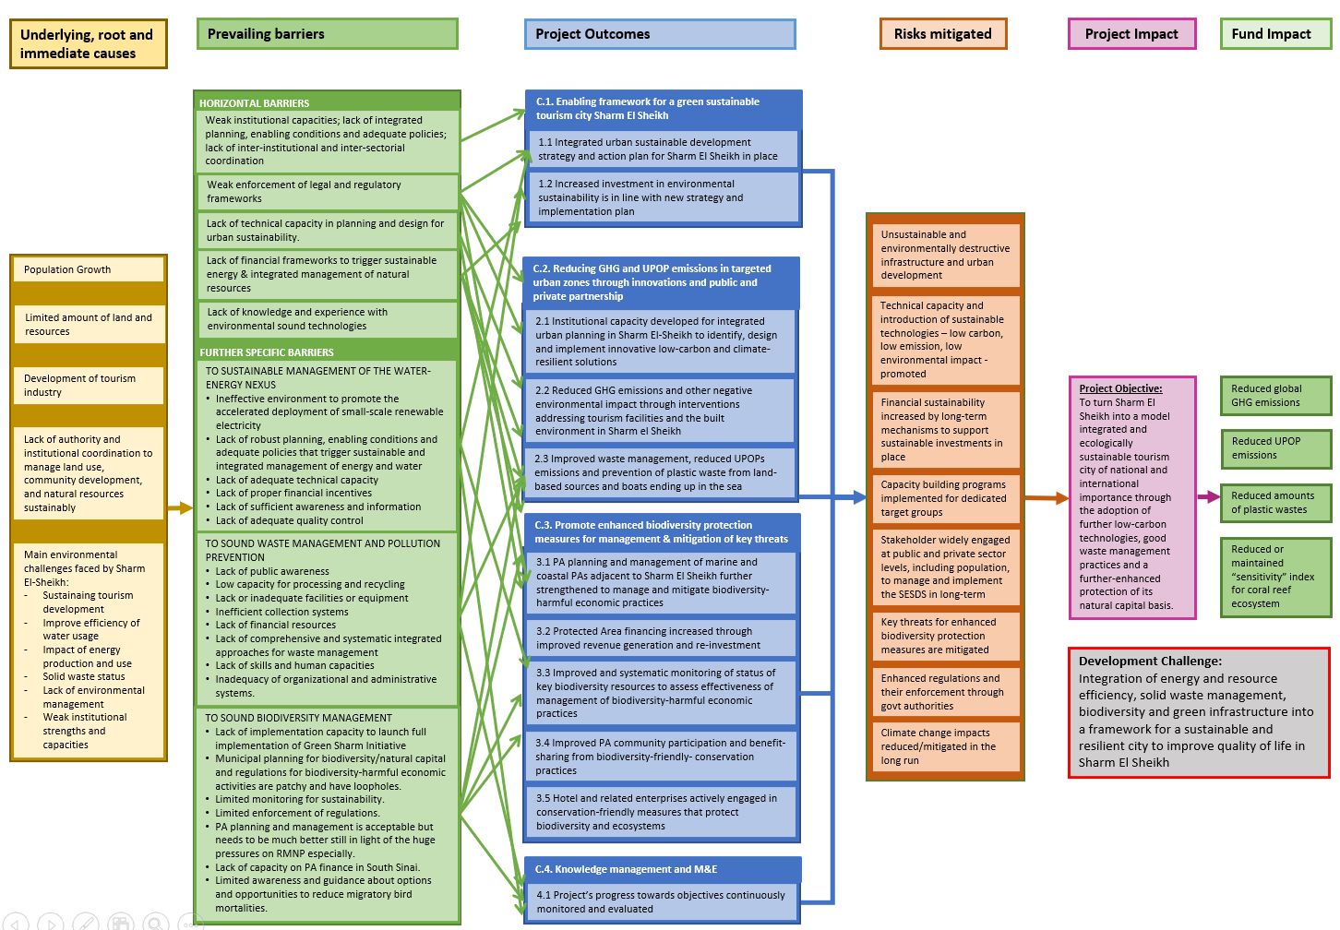
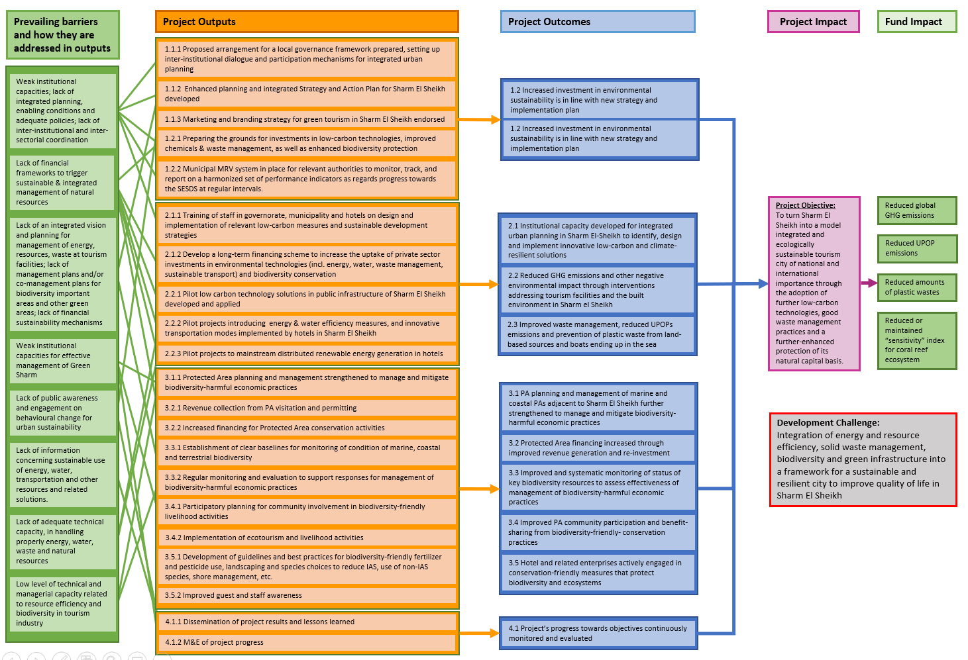

Annex 10: Details on the GHG Emissions Reduction calculations
1) Climate change mitigation (CCM) workstream
Baseline scenario:
With regard to CCM, the energy generation in Sharm El Sheikh is still widely from fossil fuel (more than 90%). Most of the hotels and other tourism facilities have excessive energy consumption to accommodate client comfort standards. Water is scarce in the region, resulting in using excessive energy for water services. Energy and water prices at utility scale are subsidized, thus preventing any investment on renewable energy or energy efficiency to be financially viable.

Electricity demand growth has been robust with annual average increases of 9% from 1980 to 1990, 6% from 1990 to 2000, and 6.7% per year between 1980 and 2013 and thereafter. Annual electricity demand rose from about 43 TWh in 1990 to 78 TWh in 2000 and then to 164.6 TWh in 2013. During 2013 and 2017 it was fluctuating and reached 89.550 TWh in 2017.

On a per capita basis, electricity demand has risen significantly over the last three decades from 422 kWh in 1980 to 1,704 kWh in 2008 and to 1,910 kWh in 2013. In 2017, the per capita consumption was around 2,060 kWh, an average annual increase of 5.1%.

In 2017, almost 50.5% of electricity consumption was from the residential sector, while the industrial sector accounted for 15.5%. The final consumption pattern has shifted over the years. In 1980, the industry sector accounted for 58.8% of electricity final consumption and the residential share was 20.4%.

The tourism sector including major hotel & resorts infrastructure in Egypt and especially the Red Sea are characterized by high energy-intensity and electricity demand, mainly for ventilation, cooling, lighting, water heating and water desalination applications. The average consumption per guest night (expressed in kWh per person-night) is depending on the star-rating and thus the size and amount of facilities and amenities provided by individual hotels. There is no firm source on energy consumption in hotels, however, based on input received from hotel operators during the PPG phase the average electricity demand in hotels is between 35 and 45 kWh/person-night. At a level of approx. 1 million over-night stays in 2019 and 170 hotels (5*, 4*, 3*, 2* including large resorts and very small boutique hotels) operating in Sharm El-Sheikh, the average electricity consumption in a hotel would be 235 MWh/year. However, energy audits conducted through EBRD and JCEE/GIZ support in larger resorts (mainly 5* and 4*) calculated an average total energy demand of 10,000-12,000 MWh/year (mainly electricity, diesel for backup, LPG/natural gas), which seems a more realistic level for targeted hotel facilities in this project.

The PIF assumed a 30% of energy savings of 12,000 MWh/year in 15 large hotels in Sharm El-Sheikh, which accounts for approx. 3,800 MWh/year energy savings and equivalent of 1,900 tCO2eq/year reduction potential. In addition, own electricity generation in these hotels is assumed to be developed through the installation of rooftop solar PV systems (average capacity 100 kWp), producing about 175 MWh/year of clean energy (equivalent to 87 tCO2eq/year emission reduction potential).

Alternative scenario:
The project scenario is based on a set of individual measures proposed in the Municipality of Sharm El-Sheikh, as well as numerous hotels & resorts. The numbers from the PIF have been revaluated and revised to more realistic levels and increasing the number of hotels in Sharm El-Sheikh being addressed by the TA support through the GEF Project. Instead of a focus on large hotels only as suggested in the PIF, during the PPG a strategy was chosen that puts stronger emphasis and potential on replicability and therefore likeliness of sustainability of project results. Whereas the number of large hotels may be limited and therefore replicability may be modest, a stronger focus on smaller size hotels and easy to implement measures means that many more hotels can be targeted whereby the project interventions are more likely to be replicated. In line with the strong public sector focus of the Green Sharm initiative, project interventions in public buildings are also included, aiming for energy efficiency improvement and solar roof top technology for administrative and school buildings as well as LED streetlighting powered by PV. This strategy results in slightly reduced direct energy saving targets comparing PIF (3.8 GWh savings) and ProDoc (2.2 GWH savings) but higher targets for PV comparing PIF (1.5 MW solar PV) and ProDoc (2.5 MW solar PV). Whereas direct emission reductions are reduced as a consequence of the alternative strategy, replication is expected to be much higher and therefore overall emission reduction is similar as reported in the PIF. The further replication impact of a wider spread mitigation strategy is expected to contribute to more stronger mitigation results on the longer term.
Municipality of Sharm El-Sheikh
- The energy mix in Sharm El Sheikh is balanced, with approx. 40 MW (15%) coming from renewables. New renewable energy capacities are under development, e.g. a large-scale solar PV power plant (5 MW already in operation, another 35 MW planned).
- The Municipality of Sharm El-Sheikh is planning with TA facilitation of the GEF Project to realise investments that will improve the energy efficiency in public infrastructure and increase the share of renewable energy production:
  - Public buildings (e.g. administration, school buildings). Retrofitting (building envelope, EE equipment) of the building to result in average 30% of energy savings (~135 MWh/a for electricity and 15 MWh/a for natural gas). Assumed direct lifetime reductions of CO2eq is in average 70 t/a per building or 1,400 t over 20 years.
  - Street lighting using LED technology with solar PV (off-grid), to replace ~250 mercury lamps@250 W each with 250 LED poles@100 W each: annual energy savings ~164 MWh/a, direct GHG benefit ~80 t/a or 1,600 t of CO2eq over 20 years
  - Installation of ~ 500 kWp solar PV on roofs facilitated by the Project, with about 875 MWh/a of renewable electricity generated, with a direct GHG benefit of 437 t CO2eq/year or ~ 8,750 t over 20 years.
  - Other directions of the project will include the development of feasibility studies for assessing investment cases (for public and private sector) for ground-mounted distributed solar PV systems, integration of renewable energy for battery storage systems, charging infrastructure for e-vehicles together with the promotion of public transportation system with electric drives, or renewable based water pumping and desalination plants and alternative cooling systems. No specific investment cases have been available yet during the PPG stage, and therefore no GHG emission benefits have been calculated so far. In case the project will come up with feasible business cases, they will be included into the GHG M&E methodology at the implementation stage.
Hotels & resorts
- Hotels in Sharm El-Sheikh are going to invest in less complex and more substantial energy efficiency and renewable energy technologies. It is assumed, that the investments will be triggered through the GEF project support with TA and a cost-sharing mechanism to reach a larger number of hotels and resorts in the area. The average 30% of savings (equivalent to 3,800 MWh/year) seem achievable only for a few large resorts – a more realistic level is 15-20% of total energy demand – however, the feedback received from hotels and EHA received during the PPG suggested to lower the benchmark and therefore address a larger number of hotels with a broader set of measures that have a high replication potential. The individual measures proposed are exemplary, i.e. the hotels are expected to come up with similar or different measures that might result in other energy and GEB benefits (smaller or bigger volumes).

The resulting global environmental benefits for the project scenario here are based on the following assumptions:
  - EE indoor lighting (switch to LED technology) with at least 300,000 light points to be replaced (from conventional CFL, halogen, metal halide lamps etc.). Assuming that the majority of hotels (~150) will be willing to switch, with an average 20-25% of electricity savings (in average 32 MWh/a) potentially reached. GHG benefits: ~ 2,400 t/a CO2eq, or 48,000 t CO2eq over 20 years.
  - EE air conditioning (replacement of existing split ACs with high-efficient ACs using inverter based compressors): Since AC systems are usually very complex and individually designed to the needs of the buildings/facilities, it is not possible to provide a “one-size-fits-all” measure for hotels. Nevertheless, hotels shall be facilitated by the GEF project in realising efficiency gains and thus energy and GHG emissions savings by replacing conventional split ACs with high-efficient split system air conditioning equipment with inverter-based compressors. The assumptions made here are based on energy audits conducted for a resort hotel in Sharm El-Sheikh. Calculated electricity savings per one hotel approx. 126 MWh/a, in total 7 hotels can be supported, leading to a total of 882 MWh/a. Resulting GHG benefits: ~441 t/a CO2eq, or 8,820 t CO2eq over 20 years.
  - Rooftop solar PV installations are going to help increasing the share of renewable production and own energy production of hotels in the project region. At least 2 MWp capacity to be installed (average 200 kWp per hotel) with a total of 3,500 MWh of electricity potentially produced per year. Direct GHG benefit: 1,748 t CO2eq/a, or 35,000 t over 20 years.
Direct GHG Emission Reductions
The following table summarises the direct GHG emission reductions for the project life-time and a 20-years post-project period, referring to the cumulative best operating practices in place in the respective year (net benefit of project over baseline scenario) and considering the useful lifetime of each technology put in place. The emissions factors applied are 0.2kg CO2eq/kWh for natural gas and 0.519 kgCO₂eq/kWh for electricity production in Egypt.

The direct GHG emissions avoided during project implementation are approx. 19,800 t/a, and approx. 86,000 t/a over the 20 years after project finalisation.
The total direct GHG emission reductions are estimated to 105,837 tCO2eq.
Table: CCM Project component – Direct GHG emission reductions
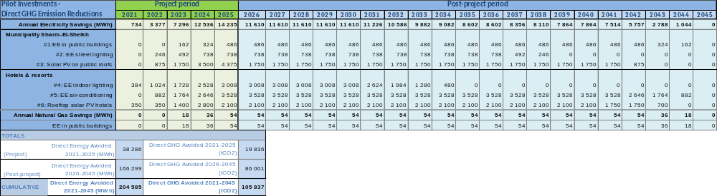
Consequential (indirect) GHG Emission Reductions
The consequential (indirect) emission reductions are calculated using a bottom-up approach, i.e. the direct energy savings for the pilot investments, their useful lifetime of technology, and the total number of replications resulting from the project and post-project implementation and their resulting indirect energy savings achievable.
The consequential bottom-up savings was calculated for cumulative 20 years after project completion in 2025 and are estimated to 898,094 tons of CO2eq.
Table: CCM Project component – Consequential GHG emission reductions
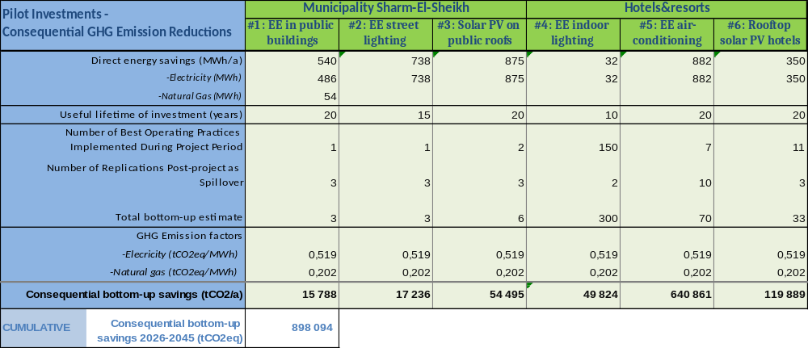
2) Chemicals and Waste (C&W) workstream
Baseline scenario:
The average daily generation of MSW per capita is approx. 2.2 kg/day, most likely to a large extent contributed by the hotel and tourism sector. On average 70% of the population is served with waste collection services, of which 80% is collected by formal waste collection services and 20% by informal waste collectors. Waste collection rate is said to be at 89%, however recycling is currently only at 18%. The composting/fertilizer facility was operating at 60% capacity in 2011 but is thought to operate currently at a much lower capacity.

Precise data on UPOPs releases from open burning for the Governorate of South Sinai and the city of Sharm El Sheikh in particular are not easily available, reference was made to the 2005 Egypt NIP, according to which the open burning of waste deposits, including the burning of landfill sites is responsible for the release of ~ 1,832 g-TEQ/yr to air and 621 g-TEQ/yr in residue. Combined releases from these sources were approximately 14 g-TEQ/yr (air) and 28 g-TEQ/yr (residue) in Greater Cairo alone and 1,731 g-TEQ/yr (air) and 312 g-TEQ/yr (residues) in the other governorates combined. These releases are very significant. As such, the impact that the unsound management of waste in Egypt has, from a UPOPs release perspective, but also from a land, water and marine contamination point of view, are significant.

In the baseline scenario, it is expected that the current situation with waste collection efforts will prevail; however, no smart purchasing on environmentally friendly and multi-use materials/articles will be in consideration. The segregation rate of about 20% will be expected to stay at the same level due to weak sorting and presence of informal sector. Open burning of MSW will continue to take place and as the waste stream will continue to contain substantial amounts of plastic products, UPOPs emissions will continue as well. With the current plans, they may be gradually reduced as infrastructure related investment is planned for better waste collection and segregation; yet the speed of these investments may be slow depending on implementation capacity and funding availability in the municipality. At the same time, input materials, such daily used products and articles in the target area, will stay as in the past, containing single-use articles, made of plastic packaging with no greener products present as options to the hotel services. With increase of tourism in the area, the anthropogenic pressure from tourists who adopt a relaxed attitude when on holidays will only increase. This will lead to increases in open waste burning and plastic spread to the environment.
Alternative scenario:
In the proposed GEF intervention (alternative scenario), the key elements of the municipal waste management will be assessed, and a waste management concept and business plan developed for the overall city (refer also to description in Outcome 1.2 Figure 8). Main directions to be covered by the Project are: (i) efforts to avoid waste and increase recyclability esp. by less packaging, reduction of single-use products, replacing plastics by paper, reduction of multicomponent packaging (ii) waste collection modalities including relevant transportation and collection infrastructure in the city, at tourism facilities (e.g. establish a waste collection schedule & plan for hotels, diving centres & boats/jetties) and other industries and businesses, (iii) waste separation and sorting routines including sorting facility, (iv) treatment of separated wastes, including recycling, composting, treatment of hazardous (e.g. electronic, medical) wastes, (v) final treatment & disposal (landfilling), (vi) organization and operational concept including costs for investments and operations.

Further work with common standards on green procurement will be planned, and this will reflect in smart purchasing approaches by giving consideration to the lifecycle of such products, and plastic packaging. Such holistic approach to the supply chain will assist in creating a gradual master plan for the municipality in order to avoid the most polluting products and articles in the target area.

The project will also assist in accelerating of proper source separation, recycling key materials and residual waste disposal operations in joint work with the planned municipality’s investments in this area. Backed by public awareness raising campaigns and with better understanding of informal collection sector, the GEF support will be able to improve GEBs, as compared to the baseline scenario, and achieve about 90% of 6.42 g-TEQ/year reductions in UPOPs (starting from the second implementation year), culminating in 28.9 g-TEQ as the project result during its duration, and far better results when further investment resources are mobilized in this direction based on private/governmental support or international loans where planned.
Direct GHG Emission Reductions
Due to the fact that the Project will only support the conceptualisation and improvement of the organization of the waste management system in the Municipality of Sharm El-Sheikh, and not initiate direct investments through the GEF, there are no direct GHG emission reductions assigned to the C&W component.

Consequential GHG Emission Reduction Impact of the Project
The Table summarises the consequential GHG emission reductions initiated during the project life-time and the 20 years after project ends, assuming that the optimized collection and treatment (mainly composting the organic compounds instead of dumping/landfilling or open burning the whole MSW) will significantly increase from about 10% to at least 50% by the end of the project, and gradually become 100% within 10 years after project termination.
The consequential GHG emissions avoided over the 20 years after the project implementation are estimated to 276,072 tCO2eq.
Table: C&W Project component – Direct GHG emission reductions
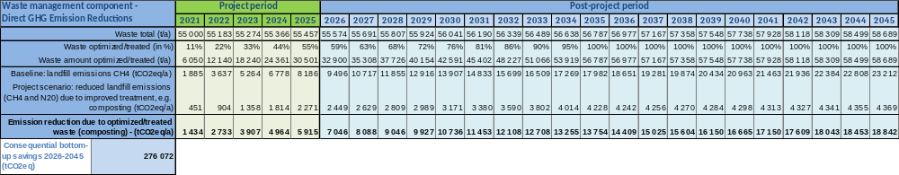

Annex 11: Environmental & Social Management Framework (ESMF)
See separate document, prepared by the SES expert consultant Yves Prevost and edited and completed by UNDP RTA Yves de Soye.

Annex 12: UNDP Social and Environmental Screening Procedure (SESP)
Project Information
Project Title | Green Sharm El Sheikh
Project Number UNDP PIMS: | 6249
Project Number GEF ID: | 10117
Atlas Project ID (formerly Award ID): | 00123342
Atlas Output ID (formerly Project ID): | 00118606
Location (Global/Region/Country) | Sharm El Sheikh, Egypt
Project stage (Design or Implementation) | Implementation
Date | 06.02.2022
Part A. Integrating Programming Principles to Strengthen Social and Environmental Sustainability
QUESTION 1: How Does the Project Integrate the Programming Principles in Order to Strengthen Social and Environmental Sustainability?
Briefly describe in the space below how the project mainstreams the human rights-based approach
The proposed Project was guided by UNDP’s Human Rights Principle, and adversely impacts the human rights (civil, political, economic, environmental, social or cultural) of key or potential stakeholders, most particularly Bedouins. All relevant concerns of these groups must be considered in the project design. The Project consulted with all concerned stakeholders during preparation and through its Stakeholder Engagement Plan will ensure their involvement throughout implementation.
Briefly describe in the space below how the project is likely to improve gender equality and women’s empowerment
Project preparation was guided by the SES principle on Gender Equality and Women’s Empowerment. It includes the preparation of a Gender Analysis and Action Plan by UNDP Egypt’s gender team, as well as the preparation of activity specific gender action plans during Project implementation. Implementation of the Gender Action Plan will ensure the participation access to opportunities and benefits for state and non-state stakeholders. The project will adopt a gender-sensitive procurement policy through supporting the collection and analysis of sex-disaggregated data on trade and entrepreneurship to identify women-owned businesses and develop a network of existing and new suppliers that are owned by women and capable of providing goods and services in the quantities and of the quality required to support the implementation of the project activities. The Project’s results framework includes special measures and indicators to address any gender inequality.
Under the project, gender mainstreaming shall be done at all levels of project planning, decision-making, and implementation. In line with the Sustainable Development Strategy: Egypt Vision 2030, capacity building activities and knowledge products shall enhance the roles and status of women as participants and agents of change, build on their strengths and experiences, knowledge and coping capacity, and ensure women’s access to information. The Project aims to mainstream gender considerations into the financing, technical assistance, capacity building and policy dialogue activities of the project.
Briefly describe in the space below how the project mainstreams sustainability and resilience
Project activities will support the implementation of the environmental sustainability priorities identified in the Green Sharm Initiative, and Egypt’s 2030 Sustainable Development Strategy, as well as international agreements such as CBD and UNFCCC, and the Paris Accord. The support will include strengthening of the environmental management capacity of public and private sector partners in low carbon tourism and green economy, promoting technologies to reduce carbon emissions, and to improve the sustainability of solid waste management and water supply, and strengthening the management of protected areas and their biodiversity, most particularly coral reefs. By increasing environmental and social sustainability, the Project will improve the health, welfare and well-being of Sharm El Sheikh’s population.
This proposed project will also help Egypt attain its climate change mitigation targets and reduce global GHG emissions, by improving energy efficiency in urban systems and hotels, and through integrated chemicals and solid waste management systems.
Finally, the Project will help improve global biodiversity outcomes by strengthening biodiversity management in marine and coastal PAs.
Briefly describe in the space below how the project strengthens accountability to stakeholders
Project development has involved wide consultations with relevant stakeholders, including inter alia the Governorate of South Sinai, Municipality of Sharm El Sheikh, hotels and other tourism operators, local communities and informal waste pickers. During implementation, the Project Board will include representatives of the Governorate, Municipality and the Tourism Federation as key project beneficiaries so they will have the opportunity to directly participate in project planning and decisions. These beneficiaries will also benefit from capacity building provided by the project.
Resources have been allocated in the project budget for implementation of the Environmental and Social Management Framework, including the preparation of a Strategic Environmental and Social Assessment (SESA), Environmental and Social Impact Assessments (ESIAs) and Environmental and Social Management Plans (ESMPs) covering different workstreams, with possibly Resettlement Action Plans (RAPs) and Livelihood Action Plans (ALPs). The ESMP(s) will subsequently be implemented throughout the project, together with a stakeholder engagement plan that will ensure due consultation and participation of all stakeholders; and a gender action plan with capacity building, livelihood interventions and other activities to ensure gender equity and women’s empowerment.
The project will also design and set in place a Stakeholder Response Mechanism with a grievance redress mechanism to allow those who have a complaint or feel aggrieved by the project to be able to communicate their concern, complaint and/or grievance through an appropriate process. The details of the grievance mechanism will be announced to enable all targeted groups to be aware about the procedures and establish a system to respond and resolve arising issues.
Part B. Identifying and Managing Social and Environmental Risks
QUESTION 2: What are the Potential Social and Environmental Risks?  Note: Complete SESP Attachment 1 before responding to Question 2. | QUESTION 3: What is the level of significance of the potential social and environmental risks?  Note: Respond to Questions 4 and 5below before proceeding to Question 5 |  |  | QUESTION 6: Describe the assessment and management measures for each risk rated Moderate, Substantial or High
Risk Description  (broken down by event, cause, impact) | Impact  and Likelihood (1-5) | Significance  (Low, Moderate, Substantial, High) | Comments (optional) | Description of assessment and management measures for risks rated as Moderate, Substantial or High
Risk 1: The COVID situation may cause health risks to staff, consultants and populations: a significant part of the projects involves consultations, meetings, on-the-ground studies and other opportunities for communicable diseases (such as COVID-19) to spread)  (SES Principles: Accountability P14, P15; SES Standards: Community Health, Safety and Working Conditions q4) | I = 3  L = 3 | Moderate | In Egypt, from 3 January 2020 to 19 May 2021, there have been 248,078 confirmed cases of COVID-19 with 14,441 deaths, reported to WHO. As of 11 May 2021, a total of 1,371,976 vaccine doses have been administered. While it is expected that the country makes a speedy recovery from the crisis in time for the start of this project, additional “waves” of infections of infections through variants are not to be excluded. The mitigation measures (to the right) would be necessary should this latter scenario materialise to some extent.  This risk could influence the timing or format of preliminary feasibility and feasibility studies (e.g., Output 1.2.1), training activities (e.g., Output 2.2.1) as well as consultations with stakeholders who may not be familiar with the type of information technologies that are required to conduct virtual meetings or consultations (e.g., Bedouin populations). | Awareness of current sanitary situation will be ensured for all parties involved before planning activities with the potential to spread COVID-19, in line with UN/DSS and national government guidelines. When activities bear such risks, alternatives will be suggested, or the activities will be postponed if they absolutely require physical presence.  The risk will be further assessed in the planned assessments and managed through the subsequent ESMP, as needed.
Risk 2: The project will fund the development of policies (strategies and planning documents such as SESSDS, etc.) that may cause unintended downstream social and/or environmental impacts, including through the poor placement of new urban, protected area and tourism infrastructures, changes in protected area status or resource management regimes, opening of new areas for “sustainable” tourism development, etc..  (SES Principles: Human Rights P2, P3, P4, P5, P6, P7; Gender Equality and Women’s Empowerment P11; Accountability P13, P14, P15; SES Standards: Biodiversity Conservation and Sustainable Natural Resource Management q1, q2, q3, q4, q10; Displacement and Resettlement q1, q2, q3, q4) | I = 4  L = 3 | Substantial |  | An ESMF was prepared to address the project’s environmental and social risks and impacts during implementation. The ESMF includes the following measures linked to the Project’s upstream work:  - Preparation of a Strategic Environmental and Social Assessment (SESA) to assess and manage relevant specific risks through the design of the policies  - Inclusion of any risks that cannot be avoided in an ESMF for the given policy(ies), with other frameworks (Resettlement Action Framework and/or Livelihood Action Framework if indicated).
Risk 3: The Project will fund feasibility studies in support of large-scale infrastructure that could lead to activities with high environmental or social risks and impacts, particularly if construction is involved; for instance: poorly designed, placed or operated desalination plants could impact coral reefs due to brine releases, and could pose a threat to worker safety if not properly built and operated  (SES Principles: Human Rights P2, P3, P5; Accountability P13, P14, P15; SES Standards: Biodiversity Conservation and Sustainable Natural Resource Management q1, q2, q4, q11; Community Health, Safety and Working Conditions q1, q3, q5; Displacement and Resettlement q1, q2, q3, q4; Labour and Working Conditions q1, q5, q6; Pollution Prevention and Resource Efficiency q1, q2, q3, q4, q6 | I = 4  L = 4 | Substantial | The Project might finance feasibility studies for one or more of: (i) solid waste management concept and business plans, (ii) distributed PV, (iii) centralized cooling systems, (iv) renewable energy powered desalination plants, (v) business model to diversify the transport modal split.  Preparation of these feasibility studies would be a first step in seeking private or public investors, who could then be considered as cofunders of the Project.  These potential risks and impacts must be taken into account by the Project during the preparation of the feasibility studies, given the absence of a definitive list of feasibility study or of ToRs for the studies indicating their nature, scope, or the location of potential investments. | An ESMF was prepared to address the project’s environmental and social risks and impacts during implementation. All the individual feasibility studies will integrate and reflect UNDP SES requirements, including appropriately scoped ESIAs/ESMPs, Resettlement Action Plans and/or Livelihood Action Plans, if appropriate. The SES documents will be subjected to due public consultations.
Risk 4: The rehabilitation of the solid waste sorting and composting units, as well as the construction of a new landfill, might result in the release of pollutants to the environment due to routine or non-routine circumstances with the potential for adverse local impacts on human and environmental health.  (SES Principles: Accountability P14, P15; SES Standards: Community Health, Safety and Working Conditions q1, q3, q5; Labour and Working Conditions q3, q5, q6; Pollution prevention and resource efficiency q1) | I = 4  L = 3 | Substantial | The Project must address the environmental and social risks associated with the solid waste disposal site’s performance because of the direct link between the Project’s target outcome and the performance of the solid waste disposal waste site. Management of the solid waste disposal site has been commercially leased to Zahret Ganoub Sinai, a newly established private entity. The Egyptian Environmental Affairs Agency (EEAA) and local authorities in the past have not been able to oversee or control the solid waste disposal site, which has grown from 13 ha in 2005 to approximately 200 ha in 2019. | An ESMF was prepared to address the project’s environmental and social risks and impacts during implementation. The ESMF includes the following measures linked to the Project’s potential release of pollutants from solid waste management facilities to the environment:  - The preparation of an Environmental and Social Impact Assessment (ESIA) of the current situation, and of an Environmental and Social Management Plan (ESMP) funded by the Project at project inception, which meet UNDP’s Environmental and Social Standards including on pollution prevention and community health.  - The signature of a Memorandum of Understanding (MoU) between EEAA, the Governorate of the South Sinai, and Zahret Ganoub Sinai (the contracted operator of the waste site), possibly as an addendum to the environment permit that will be delivered by EEAA, specifying:  - Zahret Ganoub’s inclusion in the project  - The provision of targeted Technical Assistance by the Project to improve solid waste management performance  - A commitment by Zahret Ganoub to implement the mitigation measures defined in the ESMP, as a condition for UNDP’s support.  The ESIA/ESMP will be subjected to public and transparent consultations with all concerned stakeholders, and consultation results will be considered in their finalisation and implementation.
Risk 5: The construction and operation of the energy efficiency and waste management pilot projects may pose potential occupational safety risks.  (SES Principles: Accountability P14, P15; SES Standards: Community Health, Safety and Working Conditions q1, q3, q5; Labour and Working Conditions q1, q3, q5, q6) | I = 3  L = 3 | Moderate | The project must ensure compliance with Egypt’s labour and occupational health and safety laws with obligations under international law, and consistency with the principles and standards embodied in ILO fundamental conventions and ensuring no forms of child labour. | An ESMF was prepared to address the project’s environmental and social risks and impacts during implementation. The ESMF includes the following measures linked to the Project’s occupational safety risks:  - A set of Environment, Social, Health and Safety (ESHS) requirements that will be followed by Zahret Ganoub Sinai, and a Code of Conduct that will apply to all contracts related to the rehabilitation and operations of the solid waste disposal site.  The preparation of an Environmental and Social Impact Assessment (ESIA) of the current situation, and of an Environmental and Social Management Plan (ESMP) funded by the Project at project inception, which meet UNDP’s Environmental and Social Standards including on safety and working conditions.
Risk 6: The project activities on solid waste management might impact the livelihoods of waste-pickers and users of organic waste (marginalised and disaffected groups) and lead to physical and/or economic displacement, if not forced evictions, because of changing waste management routines introduced by the project. This might happen without due consultations or consideration. It is possible that affected populations are not aware of their rights and do not have the capacity to claim them, and that duty bearers (municipality, private sector) do not have full control over related decisions.  (SES Principles: Human Rights P2, P3, P4, P5, P7; Accountability P13, P14, P15; SES Standards: Community Health, Safety and Working Conditions q8; Displacement and Resettlement q1, q2, q3) | I = 4  L = 5 | High | The Project must address the social risks associated with the presence of an unknown number of established waste-pickers, as well as the livelihoods of an unknown number of persons who rely on access to organic waste to feed their livestock. | An Environmental and Social Management Framework (ESMF) was prepared to address the Project’s environmental and social risks and impacts during implementation. The ESMF includes the following measures linked to the project’s potential impact on waste-dependent livelihoods:  - Complementing the already-completed Stakeholder Engagement Plan, the preparation of an Environmental and Social Impact Assessment (ESIA) of the current situation, and of an Environmental and Social Management Plan (ESMP) at project inception, which meet UNDP’s Environmental and Social Standards including on human rights, and displacement; this will include a survey of the livelihoods dependent on the current waste management situation (mainly waste-pickers and users of the organic waste).  - If appropriate, the preparation of a Resettlement Action Plan (RAP) and/or Livelihood Action Plan (LAP) for persons directly or indirectly affected.  Through these management plans, the project will prohibit forced evictions, in line with SES Standard 5. Namely, any evictions that might be associated with project activities shall occur only in exceptional circumstances and be carried out lawfully with full justification and meet all of the following criteria: (a) authorized by national law; (b) carried out in full accordance with relevant provisions of international human rights and humanitarian law; (c) undertaken solely for the purpose of promoting the general welfare; (d) are reasonable and proportional, and (e) follow due process standards and are regulated so as to ensure full and fair compensation and rehabilitation. The protection provided by these requirements applies to all affected persons and groups, irrespective of whether they hold title to home and property under domestic law.  The ESIA/ESMP/RAP/LAP will be subjected to public and transparent consultations with all concerned stakeholders, and consultation results will be considered in their finalisation and implementation. The project will facilitate conflict resolution and emplace a grievance mechanism.
Risk 7. Biodiversity conservation activities under Component 3 are prone to curtail long-standing access to (or, unsustainable use of) natural resources (pastures and fisheries) by local marginalised (Bedouin) communities living near or within the targeted protected areas, which could lead to economic displacement, if not forced physical displacement and/or forced evictions, and affect women in particular. This might happen without due consultations or consideration. It is possible that affected populations are not aware of their rights and do not have the capacity to claim them, and that duty bearers (municipality, private sector) do not have full control over related decisions.  (SES Principles: Human Rights P2, P3, P4, P5, P6 , P7; Gender Equality and Women’s Empowerment P10, P11; Accountability P13, P14, P15; SES Standards: Biodiversity Conservation and Sustainable Natural Resource Management q2, q8; Displacement and Resettlement q1, q2, q3, q4) | I = 2  L = 4 | Moderate | The relationship between the various Bedouin tribal communities and Park authorities is sometimes delicate and complicated. Sensitive issues include sharing the benefits from the tourist trade, cumulative impacts of the tourist trade on social norms, and access to resources within protected areas. | An ESMF was prepared to address the Project’s environmental and social risks and impacts during implementation. The ESMF includes the following measures linked to the project’s potential social impacts on the local communities near or inside the targeted PAs:  - Complementing the already-completed Stakeholder Engagement Plan, the preparation of an Environmental and Social Impact Assessment (ESIA) of the current situation that includes a social assessment specifically for Component 3, as a prerequisite to the Benefit Sharing Plan under Component 3  - Preparation of an Environmental and Social Management Plan (ESMP) at project inception, which meet UNDP’s Environmental and Social Standards including on human rights, gender and displacement.  - If appropriate, the preparation of a Resettlement Action Plan (RAP) and/or Livelihood Action Plan (LAP) for persons directly or indirectly affected.  - As part of its design, the Project will involve CSOs or individuals that are acceptable to the Bedouin community at Gharqana village to facilitate dialogue and consultation, leading to the design and implementation of a package of incentives (and benefit sharing arrangements) that are acceptable to the Bedouin community as well as address existing tensions.  As noted above, these plans will ensure the prohibition on forced eviction, as required under SES Standard 5.  The ESIA/ESMP/RAP/LAP will be subjected to public and transparent consultations with all concerned stakeholders, and consultation results will be considered in their finalisation and implementation. The project will facilitate conflict resolution and emplace a grievance mechanism.
Risk 8. Enforcement of more restrictive access and practices especially in the marine/coral ecosystems around Sharm El Sheikh (including in PAs) could cause further economic hardship to tourism operators such as hotels, dive/snorkel shops, boat charters, etc. (after years of political instability, security issues and COVID-19), which could lead to local-level conflicts.  (SES Principles: Human Rights P7; Accountability P13, P14, P15; SES Standards: Displacement and Resettlement q2, q4) | I = 4  L = 5 | High |  | An ESMF was prepared to address the Project’s environmental and social risks and impacts during implementation. The ESMF includes the following measures linked to the project’s potential economic impacts on tourism operators:  - Complementing the already-completed Stakeholder Engagement Plan, the preparation of an Environmental and Social Impact Assessment (ESIA) of the current situation, with a social assessment specifically for Component 3, as a prerequisite to the Benefit Sharing Plan under Component 3  - Preparation of an Environmental and Social Management Plan (ESMP) at project inception, which meet UNDP’s Environmental and Social Standards including on human rights, gender and displacement.  - If appropriate, the preparation of a Livelihood Action Plan (LAP) for persons directly or indirectly affected.  The ESIA/ESMP/LAP will be subjected to public and transparent consultations with all concerned stakeholders, and consultation results will be considered in their finalisation and implementation. The project will facilitate conflict resolution and emplace a grievance mechanism.
Risk 9. The project could reproduce gender discrimination, limit the consultation and involvement of women in project decision-making and implementation  (SES Principles: Accountability P14, P15; Gender Equality and Women’s Empowerment P10, P11) | I = 2  L = 4 | Moderate | Egyptian women face:  - Persistent negative social and cultural traditions that prevent women from accessing and practicing their rights, especially in rural communities and regions, partially due to lack of women's awareness of their rights and partially due to social constraints.  - Lack of training and capacity building.  - The reluctance of some private sector operators to uphold women's rights.  - A low percentage of women in decision-making positions, despite increasing participation of women in civil society organizations; new generations are reluctant to volunteer.  - Insufficient support to women's needs and concerns, or to their participation across all fields.  - Lack of awareness of society, especially women, about the environmental risks posed by climate change and environmental pollution.  - Underutilized potential in entrepreneurship opportunities and access to finance. | The Project prepared a Gender Analysis and Action Plan and will conduct a field level gender analysis during implementation to establish a baseline and help integrate Gender Equality and Women Empowerment (GEWE) into Project activities. The GAAP will be implemented throughout project implementation under the responsibility of one of the 4 technical officers.
Risk 10. Climate change: Long-term changes in climate will exacerbate or present additional challenges for biodiversity in the targeted regions, most notably impacting the coral reefs  SES Standards: Climate Change Mitigation and Adaptation q2 | I = 4  L = 4 | Substantial |  | The objective of the project is to support biodiversity conservation efforts and alleviate current and future threats and pressure, including those presented by climate change. The project has been designed to climate-proof its activities ex ante and adopt adaptive management approaches as required. Well-designed measures taken to protect biodiversity are amongst the most valuable options to increase the resistance and resilience of species and ecosystems to climate change. Damage to coral reefs is best managed by reducing all non-climate pressures such as pollution, which this project will work towards.  Nonetheless, this risk will be further assessed and managed through each ESIA/ESMP and SESA prepared and implemented by the project.
Risk 11. Climate change: Long-term changes in climate can reduce efficiency of solar PV due to higher temperatures and dust. Increased air temperatures lower solar PV efficiency and energy output. Dry conditions increase dust events.  SES Standards: Climate Change Mitigation and Adaptation q2 | I = 2  L = 4 | Moderate |  | The project may anticipate taking actions such as:  Enhanced panel cleaning and maintenance of all equipment vulnerable to dust  Checklists to limit or avoid damage from flooding, hazardous objects, loose connections, etc. and checklists to check for damage or increased vulnerabilities  These and other measures will be identified, assessed and articulated through the ESIA/ESMP(s), and then implemented accordingly.
Risk 12. Climate Change: increased energy consumption from transport could contribute to increasing GHG emissions impacting climate change.  SES Standards: Climate Change Mitigation and Adaptation q4 | I = 3  L = 3 | Moderate |  | The project is dedicating activities to cleaner transport including exploring the feasibility of introducing a public bus system and e-bike sharing programs to connect hotels, residential and commercial areas within the city boundaries as well as long-term opportunities to converting the touristic bus fleet to be electric vehicles.  Nonetheless, this risk will be further assessed and managed through the relevant ESIA/ESMP and/or SESA prepared and implemented by the project.

QUESTION 4: What is the overall project risk categorization?
Low Risk
Moderate Risk
Substantial Risk
High Risk | X | In line with UNDP’s SES, an SESP was prepared during project design (PIF and PPG stages), and an environmental and social management framework (ESMF) was developed during the PPG.  These original SESPs were still based on the dated 3-tier risk categories. The SESP was now updated in the present version to the new 4-tier risk category template.  In both the PPG version and the present version, 12 social and environmental risks were identified. In the former, four (4) were ranked HIGH and eight (8) MODERATE. In this updated version, two (2) were ranked HIGH, four (4) SUBSTANTIAL and six (6) MODERATE.
QUESTION 5: Based on the identified risks and risk categorization, what requirements of the SES are triggered? (check all that apply)
Question only required for Moderate, Substantial and High Risk projects
Is assessment required? (check if “yes”) | X |  | Status? (completed, planned)
if yes, indicate overall type and status | X | Targeted assessment(s) | Resources have been allocated in the project budget for implementation of the ESMF, including the preparation of an Environmental and Social Impact Assessment (ESIA) covering different workstreams, Strategic Environmental and Social Assessment (SESA), Environmental and Social Management Plan (ESMP) with possibly Resettlement Action Plans (RAPs) and Livelihood Action Plans (ALPs).  These are all still pending and must be initiated prior to the start of relevant workstreams.  The project will also implement other social and environment risk management plans, including but not limited to:  - Implementation of the project gender action plan (Annex 13) in capacity building, livelihoods, and other activities to ensure gender equity and women’s empowerment.  - Implementation of a stakeholder engagement plan (Annex 4) that identifies the roles and responsibilities of implementing partners, beneficiaries, enabling stakeholders, and others.  - Implementation of a grievance and accountability mechanism that will allow local communities and other stakeholders to raise concerns and grievances and facilitate follow-up corrective action responses.  - Standard M&E and adaptive management procedures, to be applied during project implementation. The independent Mid-term Review and Terminal Evaluation will assess whether appropriate risk mitigation measures have been taken, and how the SES work has been implemented.
if yes, indicate overall type and status | X | ESIA (Environmental and Social Impact Assessment)
if yes, indicate overall type and status | X | SESA (Strategic Environmental and Social Assessment)
Are management plans required? (check if “yes) | X
If yes, indicate overall type | X | Targeted management plans (e.g. Gender Action Plan, Emergency Response Plan, Waste Management Plan, others) | See above
If yes, indicate overall type | X | ESMP (Environmental and Social Management Plan which may include range of targeted plans) | See above
If yes, indicate overall type | X | ESMF (Environmental and Social Management Framework) | Completed in PPG, yet based on the 3-tier risk categories
Based on identified risks, which Principles/Project-level Standards triggered? |  | Comments (not required)
Overarching Principle: Leave No One Behind
Human Rights | X | See Risks 2, 3, 6, 7, 8
Gender Equality and Women’s Empowerment | X | See Risks 2, 7, 9
Accountability | X | See Risks 1, 2, 3, 4, 5, 6, 7, 8, 9
1. Biodiversity Conservation and Sustainable Natural Resource Management | X | See Risks 2, 3, 7
2. Climate Change and Disaster Risks | X | See Risks 10, 11, 12
3. Community Health, Safety and Security | X | See Risks 1, 3, 4, 5, 6
4. Cultural Heritage
5. Displacement and Resettlement | X | See Risks 2, 3, 6, 7, 8
6. Indigenous Peoples
7. Labour and Working Conditions | X | See Risks 3, 4, 5
8. Pollution Prevention and Resource Efficiency | X | See Risks 3, 4

Final Sign Off
Final Screening at the design-stage is not complete until the following signatures are included
Signature | Date | Description
QA Assessor |  | UNDP staff member responsible for the project, typically a UNDP Programme Officer. Final signature confirms they have “checked” to ensure that the SESP is adequately conducted.
QA Approver |  | UNDP senior manager, typically the UNDP Deputy Country Director (DCD), Country Director (CD), Deputy Resident Representative (DRR), or Resident Representative (RR). The QA Approver cannot also be the QA Assessor. Final signature confirms they have “cleared” the SESP prior to submittal to the PAC.
PAC Chair |  | UNDP chair of the PAC. In some cases PAC Chair may also be the QA Approver. Final signature confirms that the SESP was considered as part of the project appraisal and considered in recommendations of the PAC.

SESP Attachment 1. Social and Environmental Risk Screening Checklist
Checklist Potential Social and Environmental Risks
INSTRUCTIONS: The risk screening checklist will assist in answering Questions 2-6 of the Screening Template. Answers to the checklist questions help to (1) identify potential risks, (2) determine the overall risk categorization of the project, and (3) determine required level of assessment and management measures. Refer to the SES toolkit for further guidance on addressing screening questions.
Overarching Principle: Leave No One Behind  Human Rights | Answer  (Yes/No)
P.1 (prior 7) Have local communities or individuals raised human rights concerns regarding the project (e.g. during the stakeholder engagement process, grievance processes, public statements)? | N
P.2 (prior 5) Is there a risk that duty-bearers (e.g. government agencies) do not have the capacity to meet their obligations in the project? | Y
P.3 (prior 6) Is there a risk that rights-holders (e.g. project-affected persons) do not have the capacity to claim their rights? | Y
Would the project potentially involve or lead to:
P.4 (prior 1) adverse impacts on enjoyment of the human rights (civil, political, economic, social or cultural) of the affected population and particularly of marginalized groups? | Y
P.5 (prior 2) inequitable or discriminatory impacts on affected populations, particularly people living in poverty or marginalized or excluded individuals or groups, including persons with disabilities? | Y
P.6 (prior 3) restrictions in availability, quality of and/or access to resources or basic services, in particular to marginalized individuals or groups, including persons with disabilities? | Y
P.7 (prior 8) exacerbation of conflicts among and/or the risk of violence to project-affected communities and individuals? | Y
Gender Equality and Women’s Empowerment
P.8 (prior 3) Have women’s groups/leaders raised gender equality concerns regarding the project, (e.g. during the stakeholder engagement process, grievance processes, public statements)? | N
Would the project potentially involve or lead to:
P.9 (prior 1) adverse impacts on gender equality and/or the situation of women and girls? | N
P.10 (prior 2) reproducing discriminations against women based on gender, especially regarding participation in design and implementation or access to opportunities and benefits? | Y
P.11 (prior 4) limitations on women’s ability to use, develop and protect natural resources, taking into account different roles and positions of women and men in accessing environmental goods and services?  For example, activities that could lead to natural resources degradation or depletion in communities who depend on these resources for their livelihoods and well being | Y
P.12 exacerbation of risks of gender-based violence?  For example, through the influx of workers to a community, changes in community and household power dynamics, increased exposure to unsafe public places and/or transport, etc. | N
Sustainability and Resilience: Screening questions regarding risks associated with sustainability and resilience are encompassed by the Standard-specific questions below
Accountability
Would the project potentially involve or lead to:
P.13 (prior 1.4) exclusion of any potentially affected stakeholders, in particular marginalized groups and excluded individuals (including persons with disabilities), from fully participating in decisions that may affect them? | Y
P.14 grievances or objections from potentially affected stakeholders? | Y
P.15 risks of retaliation or reprisals against stakeholders who express concerns or grievances, or who seek to participate in or to obtain information on the project? | Y
Project-Level Standards
Standard 1: Biodiversity Conservation and Sustainable Natural Resource Management
Would the project potentially involve or lead to:
1.1 adverse impacts to habitats (e.g. modified, natural, and critical habitats) and/or ecosystems and ecosystem services?  For example, through habitat loss, conversion or degradation, fragmentation, hydrological changes | Y
1.2 activities within or adjacent to critical habitats and/or environmentally sensitive areas, including (but not limited to) legally protected areas (e.g. nature reserve, national park), areas proposed for protection, or recognized as such by authoritative sources and/or indigenous peoples or local communities? | Y
1.3 changes to the use of lands and resources that may have adverse impacts on habitats, ecosystems, and/or livelihoods? (Note: if restrictions and/or limitations of access to lands would apply, refer to Standard 5) | Y
1.4 risks to endangered species (e.g. reduction, encroachment on habitat)? | Y
1.5 exacerbation of illegal wildlife trade? | N
1.6 (prior 1.5) introduction of invasive alien species? | N
1.7 adverse impacts on soils? | N
1.8 (prior 1.6) harvesting of natural forests, plantation development, or reforestation? | Y
1.9 significant agricultural production? | N
1.10 (prior 1.7) animal husbandry or harvesting of fish populations or other aquatic species? | Y
1.11 (prior 1.8) significant extraction, diversion or containment of surface or ground water?  For example, construction of dams, reservoirs, river basin developments, groundwater extraction | Y
1.12 handling or utilization of genetically modified organisms/living modified organisms? | N
1.13 (prior 1.9) utilization of genetic resources? (e.g. collection and/or harvesting, commercial development) | N
1.14 (prior 1.10) adverse transboundary or global environmental concerns? | N
Standard 2: Climate Change and Disaster Risks
Would the project potentially involve or lead to:
2.1 (prior 3.5) areas subject to hazards such as earthquakes, floods, landslides, severe winds, storm surges, tsunami or volcanic eruptions? | N
2.2 (prior 2.2) outputs and outcomes sensitive or vulnerable to potential impacts of climate change or disasters?  For example, through increased precipitation, drought, temperature, salinity, extreme events, earthquakes | Y
2.3 (prior 2.3) increases in vulnerability to climate change impacts or disaster risks now or in the future (also known as maladaptive or negative coping practices)?  For example, changes to land use planning may encourage further development of floodplains, potentially increasing the population’s vulnerability to climate change, specifically flooding | N
2.4 (prior 2.1) increases of greenhouse gas emissions, black carbon emissions or other drivers of climate change? | Y
Standard 3: Community Health, Safety and Security
Would the project potentially involve or lead to:
3.1 (prior 3.1 & 3.3) construction and/or infrastructure development (e.g. roads, buildings, dams)? (Note: the GEF does not finance projects that would involve the construction or rehabilitation of large or complex dams) | Y
3.2 air pollution, noise, vibration, traffic, injuries, physical hazards, poor surface water quality due to runoff, erosion, sanitation? | N
3.3 (prior 3.4) harm or losses due to failure of structural elements of the project (e.g. collapse of buildings or infrastructure)? | Y
3.4 (prior 3.6) risks of water-borne or other vector-borne diseases (e.g. temporary breeding habitats), communicable and noncommunicable diseases, nutritional disorders, mental health? | Y
3.5 (prior 3.2) transport, storage, and use and/or disposal of hazardous or dangerous materials (e.g. explosives, fuel and other chemicals during construction and operation)? | Y
3.6 adverse impacts on ecosystems and ecosystem services relevant to communities’ health (e.g. food, surface water purification, natural buffers from flooding)? | N
3.7 influx of project workers to project areas? | N
3.8 (prior 3.9) engagement of security personnel to protect facilities and property or to support project activities? | Y
Standard 4: Cultural Heritage
Would the project potentially involve or lead to:
4.1 activities adjacent to or within a Cultural Heritage site? | N
4.2 significant excavations, demolitions, movement of earth, flooding or other environmental changes? | N
4.3 (prior 4.1) adverse impacts to sites, structures, or objects with historical, cultural, artistic, traditional or religious values or intangible forms of culture (e.g. knowledge, innovations, practices)? (Note: projects intended to protect and conserve Cultural Heritage may also have inadvertent adverse impacts) | N
4.4 alterations to landscapes and natural features with cultural significance? | N
4.5 (prior 4.2) utilization of tangible and/or intangible forms (e.g. practices, traditional knowledge) of Cultural Heritage for commercial or other purposes? | N
Standard 5: Displacement and Resettlement
Would the project potentially involve or lead to:
5.1 temporary or permanent and full or partial physical displacement (including people without legally recognizable claims to land)? | Y
5.2 economic displacement (e.g. loss of assets or access to resources due to land acquisition or access restrictions – even in the absence of physical relocation)? | Y
5.3 risk of forced evictions? | Y
5.4 impacts on or changes to land tenure arrangements and/or community based property rights/customary rights to land, territories and/or resources? | Y
Standard 6: Indigenous Peoples
Would the project potentially involve or lead to:
6.1 areas where indigenous peoples are present (including project area of influence)? | N
6.2 activities located on lands and territories claimed by indigenous peoples? | N
6.3 impacts (positive or negative) to the human rights, lands, natural resources, territories, and traditional livelihoods of indigenous peoples (regardless of whether indigenous peoples possess the legal titles to such areas, whether the project is located within or outside of the lands and territories inhabited by the affected peoples, or whether the indigenous peoples are recognized as indigenous peoples by the country in question)?  If the answer to screening question 6.3 is “yes”, then the potential risk impacts are considered significant and the project would be categorized as either Substantial Risk or High Risk | N
6.4 the absence of culturally appropriate consultations carried out with the objective of achieving FPIC on matters that may affect the rights and interests, lands, resources, territories and traditional livelihoods of the indigenous peoples concerned? | N
6.5 the utilization and/or commercial development of natural resources on lands and territories claimed by indigenous peoples? | N
6.6 forced eviction or the whole or partial physical or economic displacement of indigenous peoples, including through access restrictions to lands, territories, and resources?  Consider, and where appropriate ensure, consistency with the answers under Standard 5 above | N
6.7 adverse impacts on the development priorities of indigenous peoples as defined by them? | N
6.8 risks to the physical and cultural survival of indigenous peoples? | N
6.9 impacts on the Cultural Heritage of indigenous peoples, including through the commercialization or use of their traditional knowledge and practices?  Consider, and where appropriate ensure, consistency with the answers under Standard 4 above. | N
Standard 7: Labour and Working Conditions
Would the project potentially involve or lead to: (note: applies to project and contractor workers)
7.1 (prior 3.8) working conditions that do not meet national labour laws and international commitments? | Y
7.2 working conditions that may deny freedom of association and collective bargaining? | N
7.3 use of child labour? | Y
7.4 use of forced labour? | N
7.5 discriminatory working conditions and/or lack of equal opportunity? | Y
7.6 (prior 3.7) occupational health and safety risks due to physical, chemical, biological and psychosocial hazards (including violence and harassment) throughout the project life-cycle? | Y
Standard 8: Pollution Prevention and Resource Efficiency
Would the project potentially involve or lead to:
8.1 (prior 7.1) the release of pollutants to the environment due to routine or non-routine circumstances with the potential for adverse local, regional, and/or transboundary impacts? | Y
8.2 (prior 7.2) the generation of waste (both hazardous and non-hazardous)? | Y
8.3 (prior 7.3) the manufacture, trade, release, and/or use of hazardous materials and/or chemicals? | Y
8.4 (from prior 7.3) the use of chemicals or materials subject to international bans or phase-outs?  For example, DDT, PCBs and other chemicals listed in international conventions such as the Montreal Protocol, Minamata Convention, Basel Convention, Rotterdam Convention, Stockholm Convention | Y
8.5 (prior 7.4) the application of pesticides that may have a negative effect on the environment or human health? | N
8.6 (prior 7.5) significant consumption of raw materials, energy, and/or water? | Y

Table 2. Rating the ‘Impact’ of a Risk
Score | Rating | Social and environmental impacts
5 | Extreme | Significant adverse impacts on human populations and/or environment. Adverse impacts of large-scale magnitude and/or spatial extent (large geographic area, large number of people, transboundary impacts, cumulative impacts) and duration (long-term, permanent and/or irreversible); areas adversely impacted include areas of high value and sensitivity (e.g. valuable ecosystems, critical habitats); adverse impacts to rights, lands, resources and territories of indigenous peoples; involve significant levels of displacement or resettlement; generates significant quantities of greenhouse gas emissions; impacts may give rise to significant social conflict
4 | Extensive | Adverse impacts on people and/or environment of considerable magnitude, spatial extent and duration, but more limited than Extreme (e.g. more predictable, mostly temporary, reversible). Impacts of projects that may affect the human rights, lands, natural resources, territories, and traditional livelihoods of indigenous peoples are to be considered at a minimum potentially Extensive
3 | Intermediate | Impacts of medium magnitude, limited in scale (site-specific) and duration (temporary), can be avoided, managed and/or mitigated with relatively uncomplicated accepted measures
2 | Minor | Very minor impacts in terms of severity and magnitude (e.g. small affected area, very low number of people affected) and duration (short), may be easily avoided, managed, mitigated
1 | Negligible | Negligible or no adverse impacts on communities, individuals, and/or environment

  Table 3. Rating the ‘Likelihood’ of a Risk
  Score | Rating
  5 | Expected
  4 | Very likely
  3 | Moderately likely
  2 | Low likelihood
  1 | Not likely
  Table 4. Determining ‘Significance’ of Risk
  Impact | 5 | M | S | S | H | H
  Impact | 4 | L | M | S | S | H
  Impact | 3 | L | M | M | M | S
  Impact | 2 | L | L | L | M | M
  Impact | 1 | L | L | L | L | L
  Impact |  | 1 | 2 | 3 | 4 | 5
  Impact | Likelihood
  Low, Moderate, Substantial, High

Annex 13: Gender Analysis and Gender Action Plan

GREEN SHARM EL SHEIKH PROJECT

GENDER ANALYSIS AND ACTION PLAN

Presented by Community Development Services (CDS)

March 2020

Table of Contents
- Background
- The Gender Analysis
- Relevance to the SDGs
- The Gender Context in Egypt
- GEWE, the Environment and Natural Resources Management in Egypt
- Women living in Remote and Rural Areas
- The UNWTO: Global Report on Women in Tourism
- Ecotourism and Entrepreneurship: Women-led and owned Businesses
- GEWE, the Environment and Natural Resources Management in Egypt
- The Gender Action Plan

I – Background
The overall project objective of the Green Sharm Project in accordance with the project document, is to turn Sharm El Sheikh into “a model integrated and ecologically sustainable tourism city of national and international importance through the adoption of further low-carbon technologies, good waste management practices and a further-enhanced protection of its natural capital basis”. This would be achieved through the development of an integrated Sharm El-Sheikh Sustainable Development Strategy (SESSDS) and Action Plan, with a focus on technical assistance, capacity building and demonstrable best practice for climate change mitigation, and chemicals & waste management. Eenvironmental protection, conservation and inclusiveness are key pre-requisites for the success of sustainable tourism development in Sharm El-Sheikh.
The primary stakeholder beneficiaries to be engaged in the UNDP-GEF project will be the urban inhabitants in Sharm El-Sheikh. Thus, a multi-stakeholder engagement approach will be adopted. This will involve engaging the local stakeholders to understand the needs and benefits of pursuing a sustainable development agenda at the municipal level, and to be fully engaged in the implementation of the Sustainability Strategy. In addition to the central Government policymakers, the municipal administration and technical staff, the private businesses in the tourism industry, the residents and local population are of prime importance in the design, implementation, monitoring and sustainability of the SESSDS and action plan. Thus, underscoring the importance of conducting a full stakeholder analysis including a gender analysis, which is the first component of this report, to be followed with a gender action plan on the basis of the findings and recommendations of the analysis. This includes an integration of stakeholder participation and gender analysis and action plan throughout the project management cycle including a gender dimension to the monitoring and evaluation framework. The gender dimension is also fundamental to the urban sustainability framework that will be developed for Sharm El-Sheikh, the project Implementation Plan, Financing Strategy and the marketing/branding strategy for green tourism.
II – The Gender Analysis
Ideally, the gender analysis and gender mainstreaming for the Green Sharm should be based on a set of sex-disaggregated data on women in the tourism and environmental sector, including local communities and the women in the workforce whether in governmental/ institutional jobs or in the tourism industry (hotels and tourism services). This information is unfortunately scarce, globally, not only in Egypt. The analysis will therefore mainly involve a desk review of the available information from data sources including UNDP, Ministry of Environment (MoE) and the National Council for Women (NCW).
The gender analysis is intended to ensure equitable participation of women and men in the project activities, and their equal benefit from its development outcomes. It also alludes to the existing inequalities, short comings and obstacles and as such supports in directing or re-directing project-informed policies and actions. Addressing gender equality and women empowerment in the current design phase also supports in identifying fundamental baselines and informing a gender-responsive theory of change. This all becomes part of the monitoring and evaluation framework of the project through key gender-sensitive indicators. For Green Sharm, a gender analysis and mainstreaming approach will lead to a better understanding and integration of women in society, for example in terms of the labor market, community decision-making, access to services, and use and control over natural resources, income-generation/ livelihood opportunities, entrepreneurship, access to credit and training; in addition to identifying means of capitalizing on traditional knowledge and crafts.
Further to this desk review and action plan, a field level gender analysis should be conducted in order to establish a baseline. Introducing tools of gender analysis and field methods (such as seasonal calendars, Gender Analysis Matrix (GAM), Gender Analysis Activity Profile (GAAP) – who does what and why including legal, religious, cultural, educational and ecological factors – to help integrate Gender Equality and Women's Empowerment (GEWE) into sustainable resource management and ecotourism could include household interviews, to be further verified through Focus Group Discussions (FGDs) and stakeholder consultations to address gender roles, gender-based priorities for community action, level and nature of resource awareness and use, access and management, and perceptions of women and men on institutional effectiveness and constraints.
The analysis below will include an overview of the links with the SDGs, the national strategic frameworks and commitments in Egypt, progress and challenges made in GEWE in Egypt, a global tool for integrating GEWE in tourism through a UNWTO guideline. This will be followed by a Gender Action Plan (GAP) based on the project’s results framework, with the aim of enabling gender-sensitive monitoring of project progress through gender-specific indicators such as:
- Quantitatively: Number of women included in project consultations, number of women involved in ecotourism activities, or waste management activities etc. number of women who report improved livelihoods/ employment as a result of involvement in project activities, number of women reached by project related capacity development activities and awareness raising
- Qualitatively: involvement in community affairs as a result of the engagement with the project, awareness of the economic and social impacts of ecotourism and sustainable development, access to income generating opportunities and productive resources as reported by women, populations/ trails/ handicrafts / traditional knowledge/ traditional medicines and natural resource management featuring greater involvement and decision making roles and ownership by women.
Advocacy campaigns to change negative social perceptions on the traditional gender roles of women in society -in particular in Bedouin communities- and the economy through emphasizing the potential role of women as entrepreneurs engaging in local business or non-traditional employment that does not defy or contradict with the local traditions or culture will be very significant. This can align with the marketing and branding that will be developed by the project.
A Sustainable Livelihoods Approach/ Gender Transformative Approach is recommended throughout the project cycle. The SLA places people at the center, rather than resources or institutions. It broadens the lens and looks at short term and long term means of sustaining livelihoods, through improved access of women and communities to opportunities and resources. The GTA addresses root causes of gender inequality and the power imbalances perpetuating those inequalities.
III – Relevance to the SDGs
The UN Sustainable Development Summit adopted 17 Sustainable Development Goals (SDGs) in September 2015, to establish a basis for the new UN Development Agenda until 2030. Goals directly linked with the objective and outcomes of the Green Sharm project are the following:
- SDG 5 Achieve gender equality and empower all women and girls
- SDG 6 Clean Water and Sanitation
- SDG 7 Affordable and Clean Energy
- SDG 11 Sustainable Cities and Communities
- SDG 12 Responsible Consumption and Production
- SDG 13 Climate Action
- SDG 14 Life below Water
- SDG 15 Protect, restore and promote sustainable use of terrestrial ecosystems and halt biodiversity loss
It is important to note that SDG5, while being a stand-alone goal in itself, is to be mainstreamed across the rest of the 17 SDGs.
Egypt, within the process of ‘localizing’the SDGs, started by screening the policy, programmes and laws prior to the identification of national indicators. In line with the 2030 Agenda, the Egyptian Government has launched a working plan called ‘Egypt’s Vision 2030’, also known as Sustainable Development Strategy (SDS), which encompasses the economic, social and environmental dimensions of development. SDS promotes economic flourishing based on justice, social integrity and participation. It is under the SDS that all development plans in Egypt are incorporated while at the same time being strongly guided by the SDGs.
Parallel to Egypt’s Sustainable Development Strategy: Egypt Vision 2030, the National Council for Women (NCW) launched its ‘National Strategy for the Empowerment of Egyptian Women 2030’. The strategy is comprised of four comprehensive pillars: women’s political empowerment and leadership; women’s economic empowerment; women’s social empowerment; and women’s protection. An emphasis is made on the need for serious efforts to change the socio-cultural norms that limit women’s full participation, in addition to strengthening women’s access to their rights. Egypt is the first country to settle the quantitative targets for the SDGs at the governorate level and started to employ them to ensure the participation of the entire society and ensure that no one is left behind. Egypt also launched the first observatory for the strategy of empowerment of Egyptian women "Observatory of Egyptian Women" to follow up the progress of indicators on women. This strategy will also be used as a benchmark for strategic interventions for GEWE within the project, including “serious efforts to truly empower the broader base of Egyptian women, ensure their full participation, and support the fulfilment of their full potential, contributing to the nation-building process and the achievement of sustainable development”. The strategy contains 34 indicators of sustainable development objectives around the four pillars of the strategy, with legislation and culture as cross-cutting themes within them.
IV – The Gender Context in Egypt
Egypt has witnessed major strides in women empowerment and gender equality, mainly owing to a supportive political administration and commitment to constitutional rights and to strategies and executive programmes carried out by governmental and non-governmental organizations. The Constitution (2014) affirms the values of justice and equality, with over 20 articles securing the rights of women in all aspects of life.
In addition, Egypt launched the 2030 National Strategy for Women in line with the SDGs, making it the first country to do so thus confirming the state's commitment to women’s rights and contributions to the development process.
The 2030 National Strategy for Women contains 34 indicators of sustainable development goals and is made up of 4 pillars: political empowerment and leadership, economic and social empowerment, protection, legislation and culture as cross-cutting pillars of those four chapters. In parallel, the National Council for Women (NCW) established the Egyptian National Observatory for Women (ENOW) to monitor the implementation of the strategy.
Furthermore, Egypt, with the support of the UNDP, is amongst the first in the world to launch the Gender Equality Achievement (The Gender Equality Seal) for private and public institutions to recognize outstanding performance and tangible results in gender equality. The Micro, Small and Medium Enterprises Development Authority (MSMEDA) was the first entity to be awarded.
However, according to The Global Gender Gap Report (2014), the Gender Inequality Index, which has been developed to quantify the concept of gender inequality and includes the Gender Inequality Index (GII) and Gender Development Index (GDI), place Egypt at a GII of 0.565 and ranks Egypt at a GDI of 111 out of 159 countries assessed. These figures continue to perpetuate owning to a set of challenges that include the following:
- Persisting negative social and cultural traditions that prevent women from accessing and practicing their rights, especially in rural communities and regions, partially due to lack of women's awareness of their rights and partially due to social constraints.
- Lack of training and capacity building.
- The reluctance of some private sector operators to uphold women's rights.
- Despite the increasing participation of women in civil society organizations, their percentage in decision-making positions remains low, and new generations are reluctant to volunteer.
- Addressing women's needs and concerns and supporting their participation in all fields are insufficient.
- Lack of awareness of society, especially women, about the environmental risks posed by climate change and environmental pollution.
- Underutilized potential in entrepreneurship opportunities and access to finance.
- Under representation in STEM academically and professionally.
GEWE, the Environment and Natural Resources Management in Egypt
Various measures have been taken to integrate the gender perspective into environmental policies including support to women’s participation in leadership, management and governance of the environment and natural resources. These include the establishment of environmental camps "Addressing climate change and its effects" to train and encourage women to engage in environmentally friendly industries and to spread the culture of environmental investment and small projects through a mobile environmental complex as well as training in applied models for most environmental activities such as waste recycling, solar energy use, biofuels, etc. targeting 2034 people. In addition to launching of an Energy-by-Card Initiative in cooperation with the Egyptian Electricity Holding Company (EEHC) to improve energy efficiency and reduce greenhouse gas emissions, to educate women to the conservation of energy resources.
In terms of increasing women's access to and control over land, water, energy and other natural resources, recent strides in favor of women included the amendment of provisions of Act No. 77 (1943) to criminalize deprivation of women from inheritance. In addition to enabling women to have equal access to bank loans, mortgages and other financial products without distinction from men and do not require the consent of the husband or guardian to apply for a loan.
Measures have also been taken by the Egyptian government to integrate a gender perspective in policies and programmes on disaster risk reduction, climate resistance and mitigation. This includes establishing a rapid intervention teams to support women in disaster affected areas and homeless women.
The NCW is also in the process of developing a manual on gender and sustainable development. This should be coordinated with the Ministry of Environment (MoE) and UNDP and could be aligned with the knowledge product proposed in the action plan below. However, a Gender Strategy within the MoE is still necessary.
Egypt is the first country to announce the start of the work on the integration of the principles of gender equality and the empowerment of women to obtain the award of the Seal of Gender Equality in the tourism sector. A concept has been agreed between the NCW and the Ministry of Tourism and Antiquities (MOTA), in coordination with the UNDP in this respect. This is a valuable starting point for work to be coordinated with MOTA with the commencement of the Green Sharm Project.
Women living in Remote and Rural Areas
The Egyptian government pays particular attention to women living in remote and rural areas. It is worth noting that the concept of rural women includes women who live in the rural and desert environment, which includes Bedouin communities. These segments of the population are estimated to be women and rural female residents, equivalent to 27.8% of the population of Egypt. Article 8, 78 and 180 of the Constitution affirms the right to improve the quality of life for all citizens, to achieve social justice and to provide social solidarity, and to allocate 25% of the seats to women in local councils. The government also allows rural women to participate as members of local executive councils by appointment. It has also established a legal entity to organize the work of rural women leaders in all governorates by setting up 27 civil societies in each of the governorates. Their economic activities are commonly concentrated around agriculture, forestry, logging and fishing, accounting for 53.8% of the total employment of rural women in 2017.
Amongst the recent and ongoing governmental initiatives targeting women in the mentioned areas -and which can be relevant to the activities of the Green Sharm project as it pertains to women- are the following:
- The national development programme that includes the provision of concessional loans to rural women through the Local Development Fund, providing training and technical assistance needed by SMEs, and providing new marketing opportunities to assist women in marketing their products through local and foreign exhibitions and markets. Currently 18,000 women benefit from this programme.
- Granting rural women loans to establish productive developmental projects with a financial return commensurate with the conditions of society and the surrounding environment, in order to provide minimum living for them and their families to contribute to reducing poverty and unemployment. Currently 247,759 women benefit from this programme.
- Establishing environmental camps in some governorates entitled "Addressing climate change and its effects" to train women and encourage them to engage in eco-friendly industries and to spread the culture of environmental investment and small enterprises (such as: waste disposal units from the source, waste recycling, uses of solar energy, biofuels, soilless agriculture using feeder solutions and fish, reuse of used cars rubber and oil drums). Currently 2034 women are targeted by this programme.
- Establishing a training center for rural women and develop their skills in the establishment and management of small projects, in accordance with prevailing local conditions, considering the available environmental and material resources and emphasizing the use of appropriate technologies for the community.
- Improving financial services and access to credit, including self-employed to women
V – The UNWTO: Global Report on Women in Tourism
A fundamental resource for establishing a framework or guideline on women in tourism is the Global Report on Women in Tourism of the UNWTO (2018). This report presents the key factors that contribute to gender equality in the tourism sector, and points to the challenges and identifies approaches to addressing inequality and harness tourism’s potential to advance gender equality and women’s empowerment worldwide. The report provides a framework for action through key findings and recommendations and diverse case studies. It focuses on five particular areas: employment, entrepreneurship, leadership, education and community. The key findings, recommendations and action points can be used to design a set of tools needed to empower women in the tourism sector from a sustainable development perspective. It also provides a comprehensive analysis of tourism’s contribution towards the United Nations 2030 Agenda for Sustainable Development, in particular, SDG 5 – to achieve gender equality and empower all women and girls. The five themes of the report are relevant to the GEWE agenda as follows:
Employment: Tourism provides decent work for women;
Entrepreneurship: Women’s tourism businesses lead to women’s economic empowerment;
Education: Tourism education and training promote gender equality and women’s
empowerment in the sector;
Leadership: Women are leaders in the tourism sector and are represented and influential in
decision-making spaces; and
Community: Tourism empowers women to work collectively for justice and gender equality.

The key findings, recommendations and action points identified by the report provide a valuable tool for the development of interventions that aim to achieve gender equality and empower women in the tourism sector, and as such some of them have been used in the proposed actions in the Gender Action Plan section of this report. These findings and recommendations are summarized as follows:
 | Key Finding | Recommendation
1 | Targeted interventions by public, private and civil society actors – such as promoting equal pay, tackling sexual harassment and recruiting women into high-level employment – help to promote decent work for women in tourism. | Implement strategies that promote decent work for women across all aspects of the tourism sector.
2 | Gender-sensitive legal and macroeconomic policies at the national level increase women’s economic empowerment in the tourism sector when they are implemented effectively. | Include tourism in gender-sensitive legal and macroeconomic policy, in order to ensure the sector is able to contribute to gender equality and women’s empowerment.
3 | Investment in skills training for women – including training on soft skills and awareness raising on available training opportunities – and gender equality training across the sector, lead to greater outcomes for gender equality. | Develop skills and leadership training for women in tourism, as well as gender equality training  programmes for tourism representatives in the public and private sectors.
4 | Gender equality strategies for the tourism sector are vital for women’s empowerment and must be backed by institutional and budgetary support. | Mainstream gender equality considerations in national tourism policies and plans, including  committing sufficient human and financial resources to ensure that these are fully institutionalized and implemented.
5 | Women can be empowered politically and socially through tourism when links are made with the broader community and civil society organizations. | Support grassroots women’s organizations in tourism communities and fully facilitate women’s  participation and leadership in trade unions across the sector.
6 | When targeted gender-sensitive training is provided and women have access to appropriate technology, the digitalization of tourism can offer exciting new opportunities for women’s innovation and empowerment. | Increase women’s participation in training on digital technologies in tourism, at the same time  address issues of women’s access to and usage of technology.
7 | The availability of sex-disaggregated tourism data allows for better targeted gender equality interventions in the sector and leads to greater women‘s empowerment. | Strengthen national capacity to research and report on gender disaggregated tourism data and  to use it to promote gender equality and women’s empowerment.
Adapted from the Global Report on Women in Tourism of the UNWTO (2018)
Ecotourism and Entrepreneurship: Women-led and owned Businesses
The recommendations of the UNWTO report advocate for interventions at the public and private levels to create an enabling environment that favors women’s economic empowerment through tourism
entrepreneurship. “A conducive legal environment for women’s entrepreneurship leads not only to increased women’s entrepreneurship; but also, that increase is higher in the tourism sector than in the broader economy”. Recent research suggests addressing gender-related constraints to women’s entrepreneurship in tourism, including discriminatory laws, cultural constraints and constricting business regulations. According to the report, the tourism sector offers women considerable options for entrepreneurship that do not require considerable financing. However, there are still challenges to women in terms of limited or no access to collateral, financing and markets to start or grow a tourism business. Another challenge is the lack of access to technology, information, business skills, education and training.
“Gender equality strategies for the tourism sector and gender-sensitive tourism policies make a difference for women’s empowerment, especially when backed by institutional and budgetary support”. The importance of which is being recognized through mainstreaming gender in tourism and environmental policy frameworks and initiatives.
It is also vital to note the value of digitalization within the tourism sector, and particularly for women and small business owners, since digital platforms can expand the access to global markets.
A Case for Community-based tourism: Ecotourism and Sustainable Development
“When links are made between tourism and the broader community and civil society, women’s empowerment is more substantive. It is vital to look beyond tourism’s purely economic benefits to achieve gender equality and sustainable development”. UNWTO Global Report (2018)
Within the frame of a sustainable livelihood approach and a gender transformative approach , and considering the value of the knowledge and role within the society and economy of women in particular in Bedouin communities of South Sinai-Sharm El Sheikh, there is a strong case for a participatory, inclusive approach that integrates these communities in the program design, implementation and monitoring. Yousria Abdel Rahman, elaborates in a PhD thesis entitled: ‘The Contribution of the Bedouin Indigenous Knowledge to an Environmental Education Programme in the St Katherine Protectorate, South Sinai’ (August 2009) on the tribes present in South Sinai and the needs for more community engagement and institutional support to realize the full engagement and potential of the community’s indigenous knowledge. She identifies the tribal formulations in the region of South Sinai, were tribal territories and the Bedouin population are relatively small and are composed of seven tribes of varied origins but which are collectively referred to as Tawarah, or Arabs of El-Tur, formerly a major port and now South Sinai's regional capital. Other tribes that originally settled in Sinai include the Aleiqat and various clans of the Suwalha, however, the largest tribe now is the Muzeina, who occupy the most southern part of Sinai along the coastal areas from Sharm El Sheikh to Nuweiba. Each tribe has one or more traditional territories, which are still recognized, though nowadays different tribes live together such as in Feiran valley. From 1967, the traditional form of nomadic lifestyle of the Bedouin began to change and this caused a gradual move away from the traditional tent settlements to more permanent stone housing. It is this that is mostly seen in the Sinai now. Bedouins are a people with a rich culture, a reputation for hospitality and a profound knowledge of their land. Wild plants and animals have traditionally supplemented their livelihood, health, and income and tangible culture. Many Bedouin men work in non-traditional activities, mainly in tourism enterprises as guides or cameleers, though some continue to cultivate mountain gardens. The women herd the livestock and produce traditional craft items. Her thesis analyzes how knowledge of the Bedouin community living in, and around the protected areas can be used to design an environmental education programme/ education for sustainable development, involving the Ministry of Environment – the nature conservation sector (NCS), MoE and Ministry of Youths and Sport (MoYS). This is of direct relevance to the field level stakeholder and gender analysis that should be conducted during the inception phase of the Green Sharm project.
According to the UNWTO global report, women’s participation in community-based tourism is particularly important for understanding gender issues as – along with the accommodation industry – it is the form of tourism with which most women engage around the world. Community-based tourism – which is sometimes broadly referred to as a form of ecotourism, responsible tourism or sustainable tourism– has its own specific gender dynamics. “It is important to note that there is no automatic connection between these alternative forms of tourism and increased gender equality and women’s empowerment in tourism destinations”. However, with the deliberate, systematic effort to mainstream gender throughout the project cycle, initiatives can be instrumental in empowering women. The below Gender Action Plan serves as a guide for strategically identifying actions and indicators aiming to positively contribute towards gender equality and women empowerment in the Green Sharm Project.
VI – The Gender Action Plan
According to the project document, the project aims to mainstream gender considerations into the financing, technical assistance, capacity building and policy dialogue activities of the project through the following:
- The PMU will be composed of gender-sensitive staff, whose awareness of the importance of gender equality and skills in incorporating gender into their work are enhanced through capacity development; recruitment will also consider gender balance in the selection of candidates.
- Stakeholder engagement will ensure all consultations be designed in a gender-responsive way and women will be equally consulted and participate in all discussions related to the project.
- The project will give a priority to women-owned enterprises to be supported with technical assistance.
- All capacity building activities will ensure equal participation of women and men.
- The project will adopt a gender-sensitive procurement policy through supporting the collection and analysis of sex-disaggregated data on trade and entrepreneurship to identify women-owned businesses, and develop a network of existing and new suppliers that are owned by women and capable of providing goods and services in the quantities and of the quality required to support the implementation of the project activities.
- Converting Sharm El Sheikh into a green city will attract tourists to the city and accordingly will increase sales of handicrafts in the cultural center that the municipality intends to build. This is expected to increase the income of Bedouin women who are the main providers of those handicrafts.
The Gender Action plan below, builds on the above and provides a set of ‘Gender Sensitive Actions’ (GSA) as gender-responsive activities to be undertaken for each output of the project under each of the four components and their corresponding outcomes. In addition, ‘Gender Sensitive Indicators’ (GSI) are proposed to measure and track progress on these actions, and which should be integrated in the detailed M&E plan which will be developed during the inception phase of the project. The M&E process should ensure gender-disaggregated data continues to be collected and measured throughout implementation. It is recommended that a gender-specific budget should be allocated for each relevant project output/ activity.
Component/Output | Gender Sensitive Action (GSA) | Gender Sensitive Indicator (GSI)
Component 1: Enabling framework for a green sustainable tourism city Sharm El Sheikh
Outcome 1.1 Integrated urban sustainable development strategy and action plan for Sharm El Sheikh in place
Output 1.1.1  Proposed arrangement for a local governance framework prepared, setting up inter-institutional dialogue and participation mechanisms for integrated urban planning | GSA 1: Review existing legislations or regulatory frameworks, including gender strategies/ plans within the respective institutions to ensure they are abided by, were they exist.  GSA 2: Establish an inclusive and participatory process that ensures equitable representation of women and men in the development of, and benefit from, the framework.  GSA 3: Develop skills and leadership training for women in the respective institutions, as well as GEWE training  for environmental, tourism and urban planning representatives of the institutions involved (including women and men). | GSI1: Gender review of existing legislations or regulatory frameworks of the respective institutions.  GSI2: Governance framework is gender equitable and representative and addresses women empowerment explicitly.  GSI3: Training delivered including pre-and post-testing documented for monitoring and follow-up.
Output 1.1.2  Enhanced planning and integrated Sustainable Development Strategy and Action Plan for Sharm El Sheikh developed | GSA 4: Ensure a participatory stakeholder consultation/ analysis process with a focus on gender assessment  GSA 5: Mainstream gender equality considerations in the strategy and action plan.  GSA 6: Secure commitments for sufficient human and financial resources to ensure that gender considerations in the strategy and action plan are institutionalized  and implemented. | GSI4: Stakeholder consultation report including gender and social inclusion recommendations and concerns.  GSI5: A gender mainstreamed strategy and action plan, addressing the recommendations and concerns raised in the consultation report.  GSI6: Action Plan includes budget estimates, staffing needs and commitments necessary for gender mainstreaming, by the respective institution/ partner.
Output 1.1.3 Marketing and branding strategy for green tourism in Sharm El Sheikh endorsed | GSA 7: ensure the GEWE dimension is included in the strategy.  GSA 8: consistently use the brand to support local communities, especially women entrepreneurs to market and sell their products/ services.  GSA 9: capacity building and training delivered to women for entrepreneurship and marketing including use of digital platforms. (linked to activities of Output 3.4.2) | GSI7: The marketing and branding strategy includes a GEWE section including budget allocations.  GSI8: The brand used on all products and services delivered by women-led businesses.  GSI9: entrepreneurship and marketing capacity building and training delivered to women. (linked to activities of Output 3.4.2)
Output 1.1.4 Municipal MRV system in place for relevant authorities to monitor, track, and report on a harmonized set of performance indicators as regards progress towards the SESSDS at regular intervals | GSA 12: Age and gender-related data gaps identified.  GSA 13: Gender disaggregated data-collection system established.  GSA 14: Deliver training to the municipal staff on gender disaggregated data collection and analysis for monitoring purposes. | GSI12: Data needs report  GSI13: Operationalized gender-disaggregated data collection system  GSI14 (a): Training delivered to municipal staff  GSI14 (b): Gender disaggregated data featured in monitoring/ progress reports.
Outcome 1.2 Increased investment in environmental sustainability in line with new strategy and implementation plan
Output 1.2.1 Preparing the grounds for investments in low-carbon technologies, improved chemicals & waste management, as well as enhanced biodiversity protection | GSA 10: Promoting the gender equality seal to existing and potential businesses/ industries/ government entities working in the mentioned fields within the scope of the SDGs and further promoting them to investors.  GSA 11: Include strict considerations during tendering and hiring processes to hire community members, and in particular women, within the bounds of what is culturally acceptable. In addition to external recruitments for technical staff to also be gender equitable and competency based. | GSI10: One pilot gender equality seal achieved with one of the partner establishments or government entities involved in the project.  GSI11(a): Recruitment procedures documenting a non-discrimination clause.  GSI11(b): Number of women vs. men employed annually for the various positions.
Output 1.2.2 SESSDS Financing Strategy | GSA 18: Include a stringent pre-requisite for eligibility to financing focused on gender equality policies and measures in the workplace in terms of employment, pay, capacity development and decision-making. This includes attention to local community integration, particularly women.  Include a balanced membership in the governance structure/ management board of the financing scheme whereby women are equitably represented. | GSI18 (a): Gender polices or gender-sensitive HR polices within the eligible private sector companies.  GSI18 (b): Community level action/ CSR initiatives engaging local communities.
Output 1.2.3 Develop a long-term financing scheme to increase the uptake of private sector investments in environmental technologies (incl. energy, water, waste management, sustainable transport) and biodiversity conservation
Component 2: Reducing GHG and UPOP emissions in targeted urban zones through innovations and public and private partnership
Outcome 2.1 Institutional capacity developed for integrated urban planning in Sharm El-Sheikh to identify, design and implement innovative low-carbon, climate-resilient sustainability solutions
Output 2.1.1  Training of staff in governorate, municipality and hotels on design and implementation of relevant low-carbon measures and sustainable development strategies | GSA 15: Conduct a training needs assessment and capacity development plan that is inclusive and gender sensitive.  GSA 16: Ensure the training material includes relevant GEWE principles and gender responsive approaches and examples. (Align with the NCW anticipated Gender and Sustainable Development Manual)  GSA 17: Encourage women’s participation for example by including women-led/ delivered trainings and discussions, improving accessibility of women to the training through facilitating transportation and provision of safe spaces. | GSI15: Gender sensitive TNA and CDP  GSI16: Gender sensitive training material  GSI17 (a): Number of men and women participating in each training.  GSI17 (b): Number of women reporting increased participation and benefit from technical training.  This can be added to overall monitoring framework as necessary: Number of women and men reporting involvement in actual design and implementation of low-carbon measures and sustainable development strategies.
Outcome 2.2 Reduced GHG emissions and other negative environmental impact through interventions addressing tourism facilities and the built environment in Sharm el Sheikh
Output 2.2.1 Pilot low carbon technology solutions in public infrastructure of Sharm El Sheikh developed and applied | GSA 19: Ensure representation of women in the technical process and any accompanying capacity building or training.  GSA 20: Ensure all staff or local communities involved are gender-sensitized through a capacity building, training or awareness raising activity. | GSI19: Women and/or GEWE CSO’s are included in the piloting process.  GSI20: At least one training session of staff and one awareness raising initiative to the community on GEWE in low carbon technology solutions in public infrastructure.
Output 2.2.2 Pilot projects introducing energy & water efficiency measures, and innovative transportation modes implemented by hotels in Sharm El Sheikh | GSA 21: Ensure representation of women in the technical process and any accompanying capacity building or training.  GSA 22: Ensure all staff or local communities involved are gender-sensitized through a capacity building, training or awareness raising activity. | GSI21: Women and/or GEWE CSO’s are included in the piloting process.  GSI22: At least one training session of staff and one awareness raising initiative to the community on GEWE in energy & water efficiency, and innovative transportation modes.
Output 2.2.3 Pilot projects to mainstream distributed renewable energy generation in hotels | GSA 23: Ensure representation of women in the technical process and any accompanying capacity building or training.  GSA 24: Ensure all staff or local communities involved are gender-sensitized through a capacity building, training or awareness raising activity. | GSI23: Women and/or GEWE CSO’s are included in the piloting process.  GSI24: At least one training session of staff and one awareness raising initiative to the community on GEWE and renewable energy generation.
Outcome 2.3 Improved waste management, reduced UPOPs emissions and prevention of plastic waste from land-based sources and boats ending up in the sea
Output 2.3.1 GHG and UPOPs emissions reduced through green purchasing and improved waste management and recycling | GSA 43: Ensure representation of women in green purchasing and waste management and any accompanying capacity building or training. | GSI43: Women and/or GEWE CSO’s are included in the process.
Component 3: Promote enhanced biodiversity protection measures for management and mitigation of key threats
Outcome 3.1 PA planning and management of marine and coastal PAs adjacent to Sharm El Sheikh further strengthened to manage and mitigate biodiversity-harmful economic practices
Output 3.1.1  Protected Area planning and management strengthened to manage and mitigate biodiversity-harmful economic practices | GSA 25: Hold stakeholder consultations/ orientations to explain project objectives and community aspect, in particular the engagement of men and women in the various activities. | GSI25: Consultation report and number of men and women participating.  GSI25: Gender and social inclusion concerns identified and integrated into project design and implementation activities.
Outcome 3.2 Protected Area financing increased through improved revenue generation and re-investment
Output 3.2.1  PA revenue collection and reinvestment | GSA 26: Design a revenue-collection and utilization plan/ system that is gender-responsive and addresses vulnerable groups in the community.  GSA27: Ensure re-investment includes community level activities with emphasis on women and vulnerable groups. | GSI26: Gender-sensitive, inclusive, revenue-collection plan/ system.  GSI27: Number of women-led and community level conservation activities.
Outcome 3.3 Improved and systematic monitoring of status of key biodiversity resources to assess effectiveness of management of biodiversity-harmful economic practices
Output 3.3.1  Establishment of clear baselines for monitoring of condition of marine, coastal and terrestrial biodiversity | GSA 28: Utilize the gender analysis conducted during the inception phase to mobilize women within the community who have knowledge or access to biodiversity resources in order to capitalize on their role or support their engagement in monitoring of the marine and coastal and terrestrial biodiversity. | GSI28: Baselines complete, including community feedback.
Output 3.3.2  Regular monitoring and evaluation to support responses for management of biodiversity-harmful economic practices | GSA 29: Conduct regular awareness raising sessions with the community on harmful practices.  GSA 30: Design M&E plan with GEWE consideration. | GSI29: Number of awareness raising sessions, and number of women and men attending them.  GSI30: Evidence in M&E plan of gender responsiveness in indicators and data collection procedures.
Outcome 3.4 Improved Protected Area community participation and benefit sharing from conservation and biodiversity-friendly tourism practices
Output 3.4.1  Participatory planning for community involvement in biodiversity-friendly livelihood activities | GSA 31: Collect gender disaggregated data, and conduct a gender analysis including identification of roles, responsibilities, needs and knowledge of women, men, youths and elderly, about natural resources, biodiversity and livelihoods.  GSA 32: Raising awareness of women on green tourism and opportunities for women-led businesses and networks and new job opportunities availed through ecotourism. | GSI31 (a): The gender analysis and needs assessment reports.  GSI31 (b): Number of men and women participating in the consultations.  GSI32: Surveys on level of awareness and interest in new livelihoods opportunities and employment.
Output 3.4.2  Implementation of ecotourism and livelihood activities to build community support for conservation | GSA 33: Develop and deliver a capacity building ‘training package’ for women, including vocational training, training on ecotourism, project design, implementation and management, marketing, and use of digital platforms. (Align with the NCW anticipated Gender and Sustainable Development Manual)  GSA 34: Promote mechanisms for access to finance and supporting projects with a direct benefit to women.  GSA 35: Identify and incorporate income-generating activities for women and most vulnerable communities within the scope of the project. | GSI33: Training package produced and delivered.  GSI34: Number of women reporting improved access to finance and employment opportunities.  GSI35: At least two community initiatives implemented.
Outcome 3.5 Hotels and related enterprises integrate biodiversity-friendly practices
Output 3.5.1  Development of guidelines, best practices and improved management responsibility for conservation-friendly practices that protect biodiversity and ecosystems on which their economic interest depends | GSA 36: Ensure a gender dimension is mainstreamed through the formulation and content of the guidelines. | GSI36: The guideline is gender sensitive.
Output 3.5.2  Improved staff and guest awareness and increased support for conservation action | GSA 37: Deliver tailored training to staff on GEWE dimension of guest relations.  GSA 38: Ensure the space is safe and accessible to women, children and people living with disability.  GSA 39: Promote women-produced handicrafts and products using the ‘brand’ and quality assurance support in the production and display process. | GSI37: Number of trainings delivered and number of men and women attending the training.  GSI38: Architectural design accommodating women and vulnerable groups in terms of accessibility and other.  GSI39: Design and execute display set-up for women’s handicrafts including the use of marketing techniques and the ‘brand’.
Component 4: M&E and knowledge management
Outcome 4.1 M&E and knowledge management plans fully and successfully implemented
Output 4.1.1 Project progress towards objectives continuously monitored and evaluated | GSA 40: Deliver strategy and gender action plan throughout project cycle  GSA 41: Address gender dimension in the M&E missions of the project | GSI40: Strategy and action plan delivered and institutionalized  GSI41: Mid-term and final M&E report of the project
Output 4.1.2 Project lessons compiled and shared | GSA 42: Generate knowledge products including toolkit/manual on GEWE and natural resource management, biodiversity, clean energy, waste management, entrepreneurship and ecotourism etc.; including drafting a policy brief on GEWE in Green initiatives. | GSI42: At least 3 knowledge products produced and disseminated on GEWE themes, including one policy brief produced on GEWE in green initiatives.

Annex 14: Co-financing letters
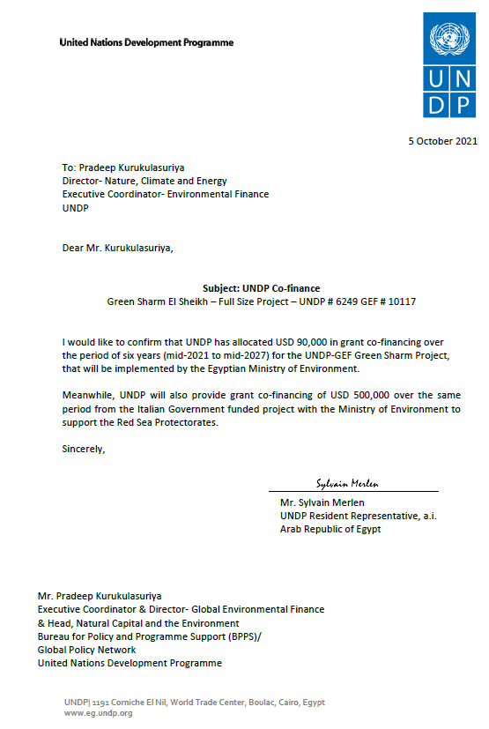
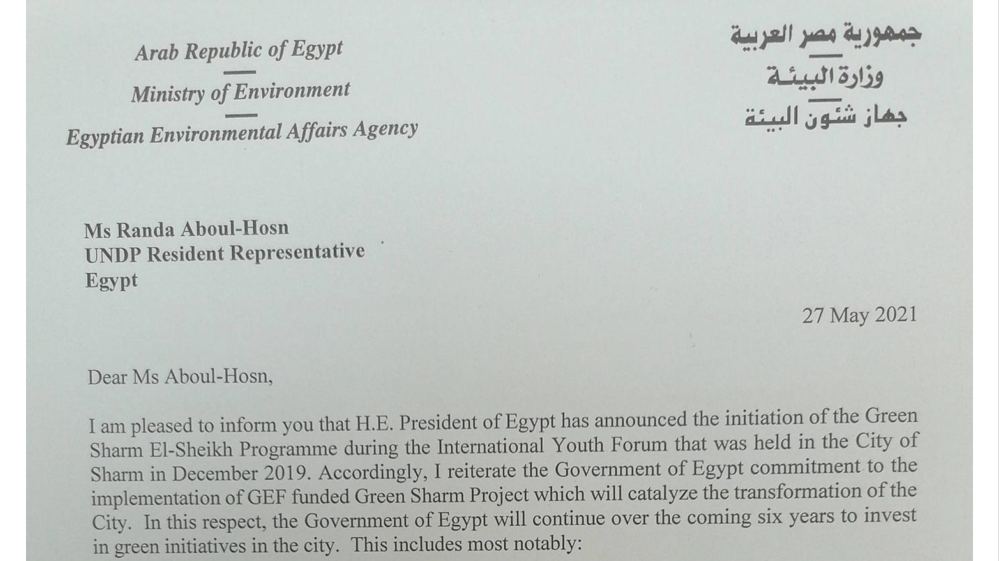
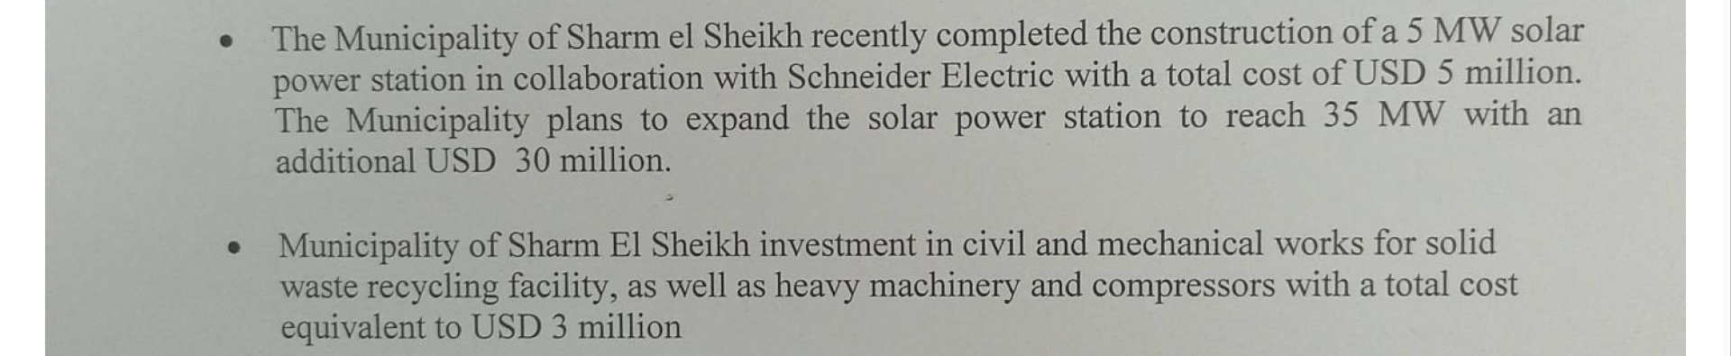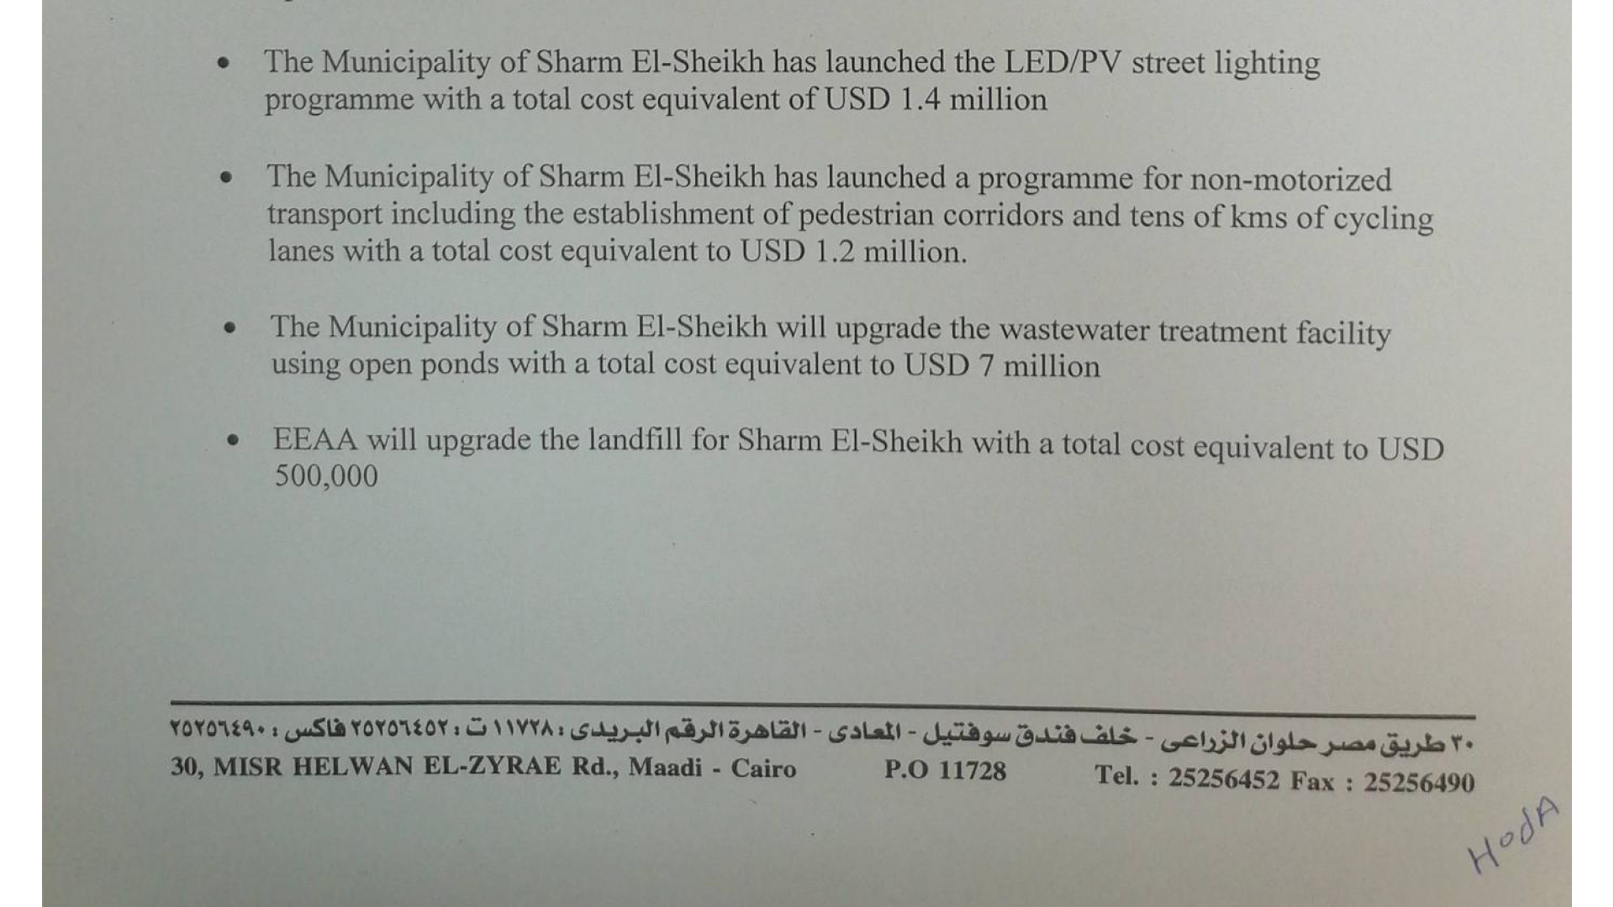

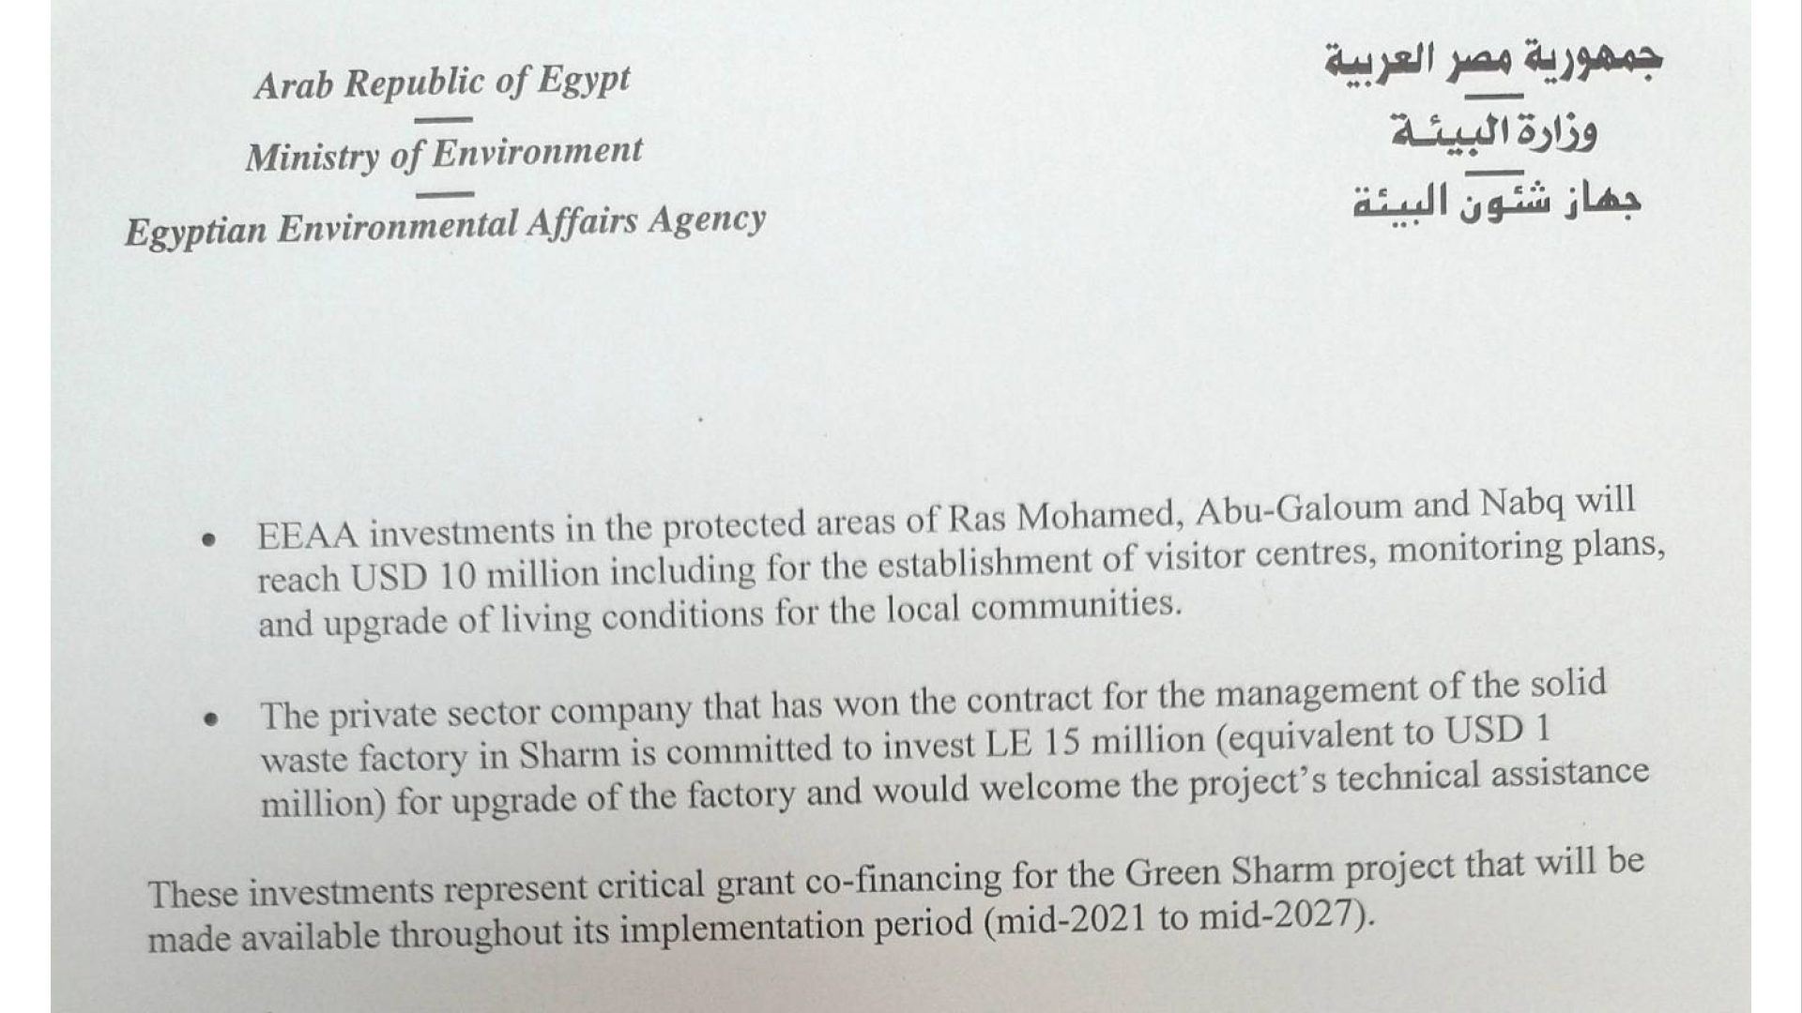
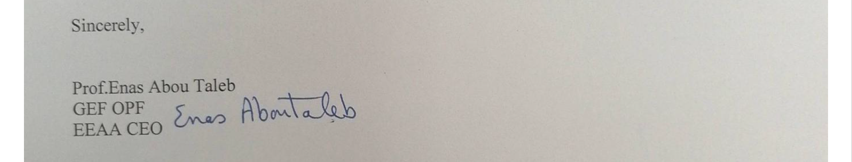
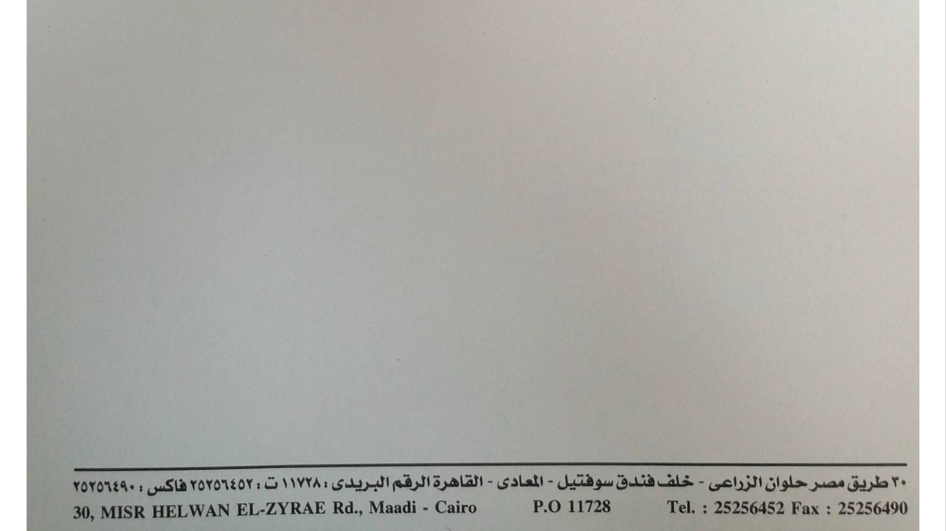

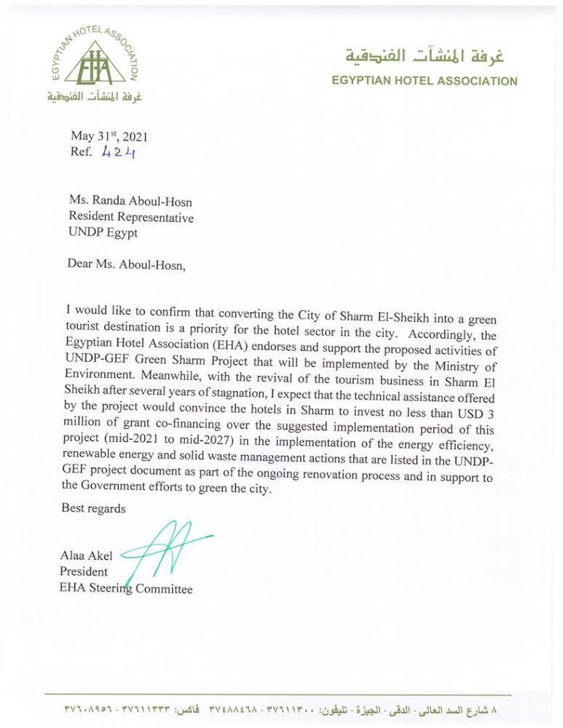

Annex 15: GEF OFP Endorsement Letter for PIF
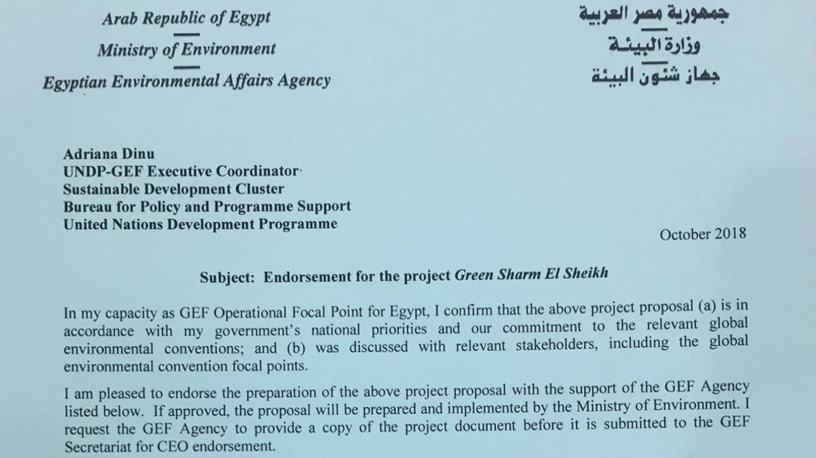
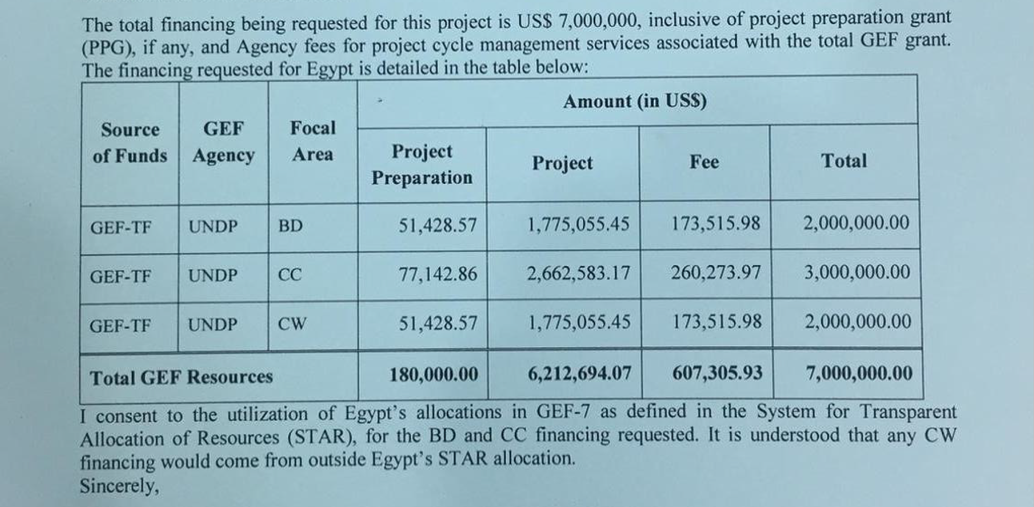
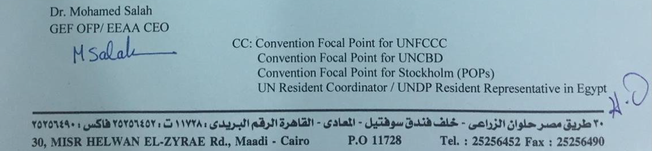

Annex 17: GEF Core Indicators at Baseline
Core Indicator 1 | Terrestrial protected areas created or under improved management for conservation and sustainable use |  |  |  |  |  | 117,000 (Hectares)
 |  |  |  | Hectares (1.1+1.2)
 |  |  |  | Expected |  | Achieved
 |  |  |  | PIF | Endorsement | MTR | TE
 |  |  |  | 1,170,000 | 117,000
Indicator 1.1 | Terrestrial protected areas newly created
Name of Protected Area | WDPA ID | IUCN category |  | Hectares
Name of Protected Area | WDPA ID |  |  | Expected |  | Achieved
Name of Protected Area | WDPA ID |  |  | PIF | Endorsement | MTR | TE
 |  | Sum
Indicator 1.2 | Terrestrial protected areas under improved management effectiveness
Name of Protected Area | WDPA ID | IUCN category | Hectares | METT Score
 |  |  |  | Baseline |  | Achieved
 |  |  |  |  | Endorsement | MTR | TE
Ras Mohamed NP (estimated 40% of 85,000 ha) | 9782 | II | 34,000 |  | 44
Nabq Managed Resource PA (estimated 80% of 60,000 ha) | 40977 | VI | 48,000 |  | 30
Abu Galoum Managed Resource PA (estimated 70% of 50,000 ha) | 40978 | VI | 35,000 |  | 27
 |  | Sum | 117,000
Core Indicator 2 | Marine protected areas created or under improved management for conservation and sustainable use |  |  |  |  |  | 78,000 (Hectares)
 |  |  |  | Hectares (2.1+2.2)
 |  |  |  | Expected |  | Achieved
 |  |  |  | PIF | Endorsement | MTR | TE
 |  |  |  | 780,000 | 78,000
Indicator 2.1 | Marine protected areas newly created
Name of Protected Area | WDPA ID | IUCN category |  | Hectares
Name of Protected Area | WDPA ID |  |  | Expected |  | Achieved
Name of Protected Area | WDPA ID |  |  | PIF | Endorsement | MTR | TE
 |  | Sum
Indicator 2.2 | Marine protected areas under improved management effectiveness
Name of Protected Area | WDPA ID | IUCN category | Hectares | METT Score
 |  |  |  | Baseline |  | Achieved
 |  |  |  |  | Endorsement | MTR | TE
Ras Mohamed NP  (estimated 60% of 85,000 ha) | 9782 | II | 51,000 |  | 44
Nabq Managed Resource PA (estimated 20% of 60,000 ha) | 40977 | VI | 12,000 |  | 30
Abu Galoum Managed Resource PA (estimated 30% of 50,000 ha) | 40978 | VI | 15,000 |  | 27
 |  | Sum | 78,000
Core Indicator 3 | Area of land restored |  |  |  |  |  | (Hectares)
N/A
Core Indicator 4 | Area of landscapes under improved practices (hectares; excluding protected areas) |  |  |  |  |  | (Hectares)
N/A
Core Indicator 5 | Area of marine habitat under improved practices to benefit biodiversity |  |  |  |  |  | (Hectares)
N/A
Core Indicator 6 | Greenhouse gas emissions mitigated |  |  |  |  |  | 1,280,003 (metric tons of CO₂e )
 |  |  |  | Expected metric tons of CO₂e (6.1+6.2)
 |  |  |  | PIF | Endorsement | MTR | TE
 | Expected CO2e (direct) |  |  | 750,000 | 105,837
 | Expected CO2e (indirect) |  |  | 360,000 | 1,174,166
 | Sum |  |  | 1,100,000 | 1,280,003
Indicator 6.1 | Carbon sequestered or emissions avoided in the AFOLU sector
 |  |  |  | Expected metric tons of CO₂e
 |  |  |  | PIF | Endorsement | MTR | TE
 | Expected CO2e (direct)
 | Expected CO2e (indirect)
 | Anticipated start year of accounting
 | Duration of accounting
Indicator 6.2 | Emissions avoided Outside AFOLU
 |  |  |  | Expected metric tons of CO₂e
 |  |  |  | PIF | Endorsement | MTR | TE
 | Expected CO2e (direct) |  |  | 750,000 | 105,837
 | Expected CO2e (indirect) |  |  | 360,000 | 1,174,166
 | Sum |  |  | 1,100,000 | 1,280,003
 | Anticipated start year of accounting |  |  |  | 2021
 | Duration of accounting |  |  |  | 2045
Indicator 6.3 | Energy saved
 |  |  |  | MJ
 |  |  |  | Expected |  | Achieved
 |  |  |  | PIF | Endorsement | MTR | TE
Energy savings in hotels |  |  |  | 3.8 GWh | 0.9 GWh
Energy savings in municipal buildings and infrastructure |  |  |  | 3.8 GWh | 1.3 GWh
Indicator 6.4 | Increase in installed renewable energy capacity per technology
 |  | Technology |  | Capacity (MW)
 |  |  |  | Expected |  | Achieved
 |  |  |  | PIF | Endorsement | MTR | TE
 |  | Solar Photovoltaic |  | 1.5 | 2.5
Core Indicator 7 | Number of shared water ecosystems (fresh or marine) under new or improved cooperative management |  |  |  |  |  | (Number)
N/A
Core Indicator 8 | Globally over-exploited fisheries Moved to more sustainable levels |  |  |  |  |  | (Metric Tons)
N/A
Core Indicator 9 | Reduction, disposal/destruction, phase out, elimination and avoidance of chemicals of global concern and their waste in the environment and in processes, materials and products |  |  |  |  |  | (Metric Tons)
 |  |  |  | Metric Tons (9.1+9.2+9.3)
 |  |  |  | Expected |  | Achieved
 |  |  |  | PIF | Endorsement | MTR | TE
Indicator 9.1 | Solid and liquid Persistent Organic Pollutants (POPs) removed or disposed (POPs type)
POPs type |  |  |  | Metric Tons
 |  |  |  | Expected |  | Achieved
 |  |  |  | PIF | Endorsement | MTR | TE
Indicator 9.2 | Quantity of mercury reduced
N/A
Indicator 9.3 | Hydrochloroflurocarbons (HCFC) Reduced/Phased out
 |  |  |  | Metric Tons
 |  |  |  | Expected |  | Achieved
 |  |  |  | PIF | Endorsement | MTR | TE
Indicator 9.4 | Number of countries with legislation and policy implemented to control chemicals and waste
 |  |  |  | Number of Countries
 |  |  |  | Expected |  | Achieved
 |  |  |  | PIF | Endorsement | MTR | TE
 |  |  |  | 1
Indicator 9.5 | Number of low-chemical/non-chemical systems implemented particularly in food production, manufacturing and cities
N/A
Indicator 9.6 | Quantity of POPs/Mercury containing materials and products directly avoided
N/A
Core Indicator 10 | Reduction, avoidance of emissions of POPs to air from point and non-point sources |  |  |  |  |  | 28.9 g-TEQ  (grams of toxic equivalent)
Indicator 10.1 | Number of countries with legislation and policy implemented to control emissions of POPs to air
 |  |  |  | Number of Countries
 |  |  |  | Expected |  | Achieved
 |  |  |  | PIF | Endorsement | MTR | TE
 |  |  |  | 1 | 1
Indicator 10.2 | Number of emission control technologies/practices implemented
 |  |  |  | Number
 |  |  |  | Expected |  | Achieved
 |  |  |  | PIF | Endorsement | MTR | TE
 |  |  |  | 1, leading to emission reductions by 2.7 g-TEQ/yr with 10.8 g-TEQ during project lifetime (2.7g/yr*4yrs from yr2) | 1, leading to emission reductions by 90% of 6.42 g-TEQ/yr with 28.9 g-TEQ during project lifetime (6.42g/yr * 5yrs @ 90% reduction from yr2)
Core Indicator 11 | Number of direct beneficiaries disaggregated by gender as co-benefit of GEF investment |  |  |  |  |  | (Number)
 |  |  |  | Number
 |  |  |  | Expected |  | Achieved
 |  |  |  | PIF | Endorsement | MTR | TE
 |  | Female |  | 3,750 | 3,750
 |  | Male |  | 3,750 | 3,750
 |  | Total |  | 7,500 | 7,500 (10% of Sharm El Sheikh population; to be reconfirmed during inception stage)

Annex 18: GEF 7 Taxonomy
Level 1 | Level 2 | Level 3 | Level 4
Influencing models
 | Transform policy and regulatory environments
 | Strengthen institutional capacity and decision-making
 | Convene multi-stakeholder alliances
 | Demonstrate innovative approaches
 | Deploy innovative financial instruments
Stakeholders
 | Indigenous Peoples
 | Private Sector
 |  | Capital providers
 |  | Financial intermediaries and market facilitators
 |  | Large corporations
 |  | SMEs
 |  | Individuals/Entrepreneurs
 |  | Non-Grant Pilot
 |  | Project Reflow
 | Beneficiaries
 | Local Communities
 | Civil Society
 |  | Community Based Organization
 |  | Non-Governmental Organization
 |  | Academia
 |  | Trade Unions and Workers Unions
 | Type of Engagement
 |  | Information Dissemination
 |  | Partnership
 |  | Consultation
 |  | Participation
 | Communications
 |  | Awareness Raising
 |  | Education
 |  | Public Campaigns
 |  | Behavior Change
Capacity, Knowledge and Research
 | Enabling Activities
 | Capacity Development
 | Knowledge Generation and Exchange
 | Targeted Research
 | Learning
 |  | Theory of Change
 |  | Adaptive Management
 |  | Indicators to Measure Change
 | Innovation
 | Knowledge and Learning
 |  | Knowledge Management
 |  | Innovation
 |  | Capacity Development
 |  | Learning
 | Stakeholder Engagement Plan
Gender Equality
 | Gender Mainstreaming
 |  | Beneficiaries
 |  | Women groups
 |  | Sex-disaggregated indicators
 |  | Gender-sensitive indicators
 | Gender results areas
 |  | Access and control over natural resources
 |  | Participation and leadership
 |  | Access to benefits and services
 |  | Capacity development
 |  | Awareness raising
 |  | Knowledge generation
Focal Areas/Theme
 | Integrated Programs
 |  | Commodity Supply Chains (Good Growth Partnership)
 |  |  | Sustainable Commodities Production
 |  |  | Deforestation-free Sourcing
 |  |  | Financial Screening Tools
 |  |  | High Conservation Value Forests
 |  |  | High Carbon Stocks Forests
 |  |  | Soybean Supply Chain
 |  |  | Oil Palm Supply Chain
 |  |  | Beef Supply Chain
 |  |  | Smallholder Farmers
 |  |  | Adaptive Management
 |  | Food Security in Sub-Sahara Africa
 |  |  | Resilience (climate and shocks)
 |  |  | Sustainable Production Systems
 |  |  | Agroecosystems
 |  |  | Land and Soil Health
 |  |  | Diversified Farming
 |  |  | Integrated Land and Water Management
 |  |  | Smallholder Farming
 |  |  | Small and Medium Enterprises
 |  |  | Crop Genetic Diversity
 |  |  | Food Value Chains
 |  |  | Gender Dimensions
 |  |  | Multi-stakeholder Platforms
 |  | Food Systems, Land Use and Restoration
 |  |  | Sustainable Food Systems
 |  |  | Landscape Restoration
 |  |  | Sustainable Commodity Production
 |  |  | Comprehensive Land Use Planning
 |  |  | Integrated Landscapes
 |  |  | Food Value Chains
 |  |  | Deforestation-free Sourcing
 |  |  | Smallholder Farmers
 |  | Sustainable Cities
 |  |  | Integrated urban planning
 |  |  | Urban sustainability framework
 |  |  | Transport and Mobility
 |  |  | Buildings
 |  |  | Municipal waste management
 |  |  | Green space
 |  |  | Urban Biodiversity
 |  |  | Urban Food Systems
 |  |  | Energy efficiency
 |  |  | Municipal Financing
 |  |  | Global Platform for Sustainable Cities
 |  |  | Urban Resilience
 | Biodiversity
 |  | Protected Areas and Landscapes
 |  |  | Terrestrial Protected Areas
 |  |  | Coastal and Marine Protected Areas
 |  |  | Productive Landscapes
 |  |  | Productive Seascapes
 |  |  | Community Based Natural Resource Management
 |  | Mainstreaming
 |  |  | Extractive Industries (oil, gas, mining)
 |  |  | Forestry (Including HCVF and REDD+)
 |  |  | Tourism
 |  |  | Agriculture & agrobiodiversity
 |  |  | Fisheries
 |  |  | Infrastructure
 |  |  | Certification (National Standards)
 |  |  | Certification (International Standards)
 |  | Species
 |  |  | Illegal Wildlife Trade
 |  |  | Threatened Species
 |  |  | Wildlife for Sustainable Development
 |  |  | Crop Wild Relatives
 |  |  | Plant Genetic Resources
 |  |  | Animal Genetic Resources
 |  |  | Livestock Wild Relatives
 |  |  | Invasive Alien Species (IAS)
 |  | Biomes
 |  |  | Mangroves
 |  |  | Coral Reefs
 |  |  | Sea Grasses
 |  |  | Wetlands
 |  |  | Rivers
 |  |  | Lakes
 |  |  | Tropical Rain Forests
 |  |  | Tropical Dry Forests
 |  |  | Temperate Forests
 |  |  | Grasslands
 |  |  | Paramo
 |  |  | Desert
 |  | Financial and Accounting
 |  |  | Payment for Ecosystem Services
 |  |  | Natural Capital Assessment and Accounting
 |  |  | Conservation Trust Funds
 |  |  | Conservation Finance
 |  | Supplementary Protocol to the CBD
 |  |  | Biosafety
 |  |  | Access to Genetic Resources Benefit Sharing
 | Forests
 |  | Forest and Landscape Restoration
 |  |  | REDD/REDD+
 |  | Forest
 |  |  | Amazon
 |  |  | Congo
 |  |  | Drylands
 | Land Degradation
 |  | Sustainable Land Management
 |  |  | Restoration and Rehabilitation of Degraded Lands
 |  |  | Ecosystem Approach
 |  |  | Integrated and Cross-sectoral approach
 |  |  | Community-Based NRM
 |  |  | Sustainable Livelihoods
 |  |  | Income Generating Activities
 |  |  | Sustainable Agriculture
 |  |  | Sustainable Pasture Management
 |  |  | Sustainable Forest/Woodland Management
 |  |  | Improved Soil and Water Management Techniques
 |  |  | Sustainable Fire Management
 |  |  | Drought Mitigation/Early Warning
 |  | Land Degradation Neutrality
 |  |  | Land Productivity
 |  |  | Land Cover and Land cover change
 |  |  | Carbon stocks above or below ground
 |  | Food Security
 | International Waters
 |  | Ship
 |  | Coastal
 |  | Freshwater
 |  |  | Aquifer
 |  |  | River Basin
 |  |  | Lake Basin
 |  | Learning
 |  | Fisheries
 |  | Persistent toxic substances
 |  | SIDS : Small Island Dev States
 |  | Targeted Research
 |  | Pollution
 |  |  | Persistent toxic substances
 |  |  | Plastics
 |  |  | Nutrient pollution from all sectors except wastewater
 |  |  | Nutrient pollution from Wastewater
 |  | Transboundary Diagnostic Analysis and Strategic Action Plan preparation
 |  | Strategic Action Plan Implementation
 |  | Areas Beyond National Jurisdiction
 |  | Large Marine Ecosystems
 |  | Private Sector
 |  | Aquaculture
 |  | Marine Protected Area
 |  | Biomes
 |  |  | Mangrove
 |  |  | Coral Reefs
 |  |  | Seagrasses
 |  |  | Polar Ecosystems
 |  |  | Constructed Wetlands
 | Chemicals and Waste
 |  | Mercury
 |  | Artisanal and Scale Gold Mining
 |  | Coal Fired Power Plants
 |  | Coal Fired Industrial Boilers
 |  | Cement
 |  | Non-Ferrous Metals Production
 |  | Ozone
 |  | Persistent Organic Pollutants
 |  | Unintentional Persistent Organic Pollutants
 |  | Sound Management of Chemicals and Waste
 |  | Waste Management
 |  |  | Hazardous Waste Management
 |  |  | Industrial Waste
 |  |  | e-Waste
 |  | Emissions
 |  | Disposal
 |  | New Persistent Organic Pollutants
 |  | Polychlorinated Biphenyls
 |  | Plastics
 |  | Eco-Efficiency
 |  | Pesticides
 |  | DDT - Vector Management
 |  | DDT - Other
 |  | Industrial Emissions
 |  | Open Burning
 |  | Best Available Technology / Best Environmental Practices
 |  | Green Chemistry
 | Climate Change
 |  | Climate Change Adaptation
 |  |  | Climate Finance
 |  |  | Least Developed Countries
 |  |  | Small Island Developing States
 |  |  | Disaster Risk Management
 |  |  | Sea-level rise
 |  |  | Climate Resilience
 |  |  | Climate information
 |  |  | Ecosystem-based Adaptation
 |  |  | Adaptation Tech Transfer
 |  |  | National Adaptation Programme of Action
 |  |  | National Adaptation Plan
 |  |  | Mainstreaming Adaptation
 |  |  | Private Sector
 |  |  | Innovation
 |  |  | Complementarity
 |  |  | Community-based Adaptation
 |  |  | Livelihoods
 |  | Climate Change Mitigation
 |  |  | Agriculture, Forestry, and other Land Use
 |  |  | Energy Efficiency
 |  |  | Sustainable Urban Systems and Transport
 |  |  | Technology Transfer
 |  |  | Renewable Energy
 |  |  | Financing
 |  |  | Enabling Activities
 |  | Technology Transfer
 |  |  | Poznan Strategic Programme on Technology Transfer
 |  |  | Climate Technology Centre & Network (CTCN)
 |  |  | Endogenous technology
 |  |  | Technology Needs Assessment
 |  |  | Adaptation Tech Transfer
 |  | United Nations Framework on Climate Change | Nationally Determined Contribution
 | Rio Markers
 |  | Paris Agreement
 |  | Sustainable Development Goals
 |  | Climate Change Mitigation 0
 |  | Climate Change Mitigation 1
 |  | Climate Change Mitigation 2
 |  | Climate Change Adaptation 0
 |  | Climate Change Adaptation 1
 |  | Climate Change Adaptation 2

Annex 19: UNDP Capacity Development Scorecard
Capacity Result / Indicator | Staged Indicators | Rating Score | Count | Comments
CR 1: Capacities for Engagement
Indicator 1: Degree of legitimacy/mandate of lead environmental organizations | Organizational responsibilities for environmental management are not clearly defined | 0
 | Organizational responsibilities for environmental management are identified | 1
 | Authority and legitimacy of all lead organizations responsible for environmental management are partially recognized by stakeholders | 2
 | Authority and legitimacy of all lead organizations responsible for environmental management recognized by stakeholders | 3 | 3 | Ministry of Environment, including its affiliated authorities, is the lead organization for environmental management and the Project Implementing Partner whose mandate is supported by the Environmental law No 9 for 2009
Indicator 2: Existence of operational co-management mechanisms | No co-management mechanisms are in place | 0
 | Some co-management mechanisms are in place and operational | 1
 | Some co-management mechanisms are formally established through agreements, MOUs, etc. | 2
 | Comprehensive co-management mechanisms are formally established and are operational/functional | 3 | 3 | Minister of Environment has an agreement with Governorate of South Sinai to support transformation of Sharm El-Sheikh City into a green city. Ministry of Environment has strong work relationship with main government authorities with stake in the project implementation
Indicator 3: Existence of cooperation with stakeholder groups | Identification of stakeholders and their participation/involvement in decision-making is poor | 0
 | Stakeholders are identified, but their participation in decision-making is limited | 1
 | Stakeholders are identified, and regular consultations mechanisms are established | 2 | 2 | Stakeholders participation is crucial for achieving the project objectives. Consultations with the stakeholders during the project preparation reflected strong understanding and interest in supporting the project objectives. The consultations and engagement of stakeholders in converting the city into a green city will be further strengthened during project implementation
 | Stakeholders are identified, and they actively contribute to established participative decision-making processes | 3
CR 2: Capacities to Generate, Access and Use Information and Knowledge
Indicator 4: Degree of environmental awareness of stakeholders | Stakeholders are not aware of global environmental issues and their relevant possible solutions | 0
 | Stakeholders are aware of global environmental issues, but not the possible solutions | 1
 | Stakeholders are aware of global environmental issues and the possible solutions, but do not know how to participate | 2
 | Stakeholders are aware of global environmental issues, and are actively participating in the implementation of relevant solutions | 3 | 3 | Most stakeholders are aware about global environmental issues and are expected to be show active participation in the implementation
Indicator 5: Access and sharing of environmental information by stakeholders | The environmental information needs are not identified, and the information management infrastructure is inadequate | 0
 | The environmental information needs are identified, but the information management infrastructure is inadequate | 1
 | The environmental information is partially available and shared among stakeholders, but is not covering all focal areas and/or the information management infrastructure is limited | 2 | 2 | Environmental information is partially available. Green Sharm project will work on closing environmental information gaps and dissemination to targeted groups
 | Comprehensive environmental information is available and shared through an adequate information management infrastructure | 3
Indicator 6: Existence of environmental education programmes | No environmental education programmes are in place | 0
Indicator 6: Existence of environmental education programmes | Environmental education programmes are partially developed and partially delivered | 1 |  | Environmental education programmes are missing global environmental issues and a GEF project is addressing this issue
Indicator 6: Existence of environmental education programmes | Environmental education programmes are fully developed but partially delivered | 2
Indicator 6: Existence of environmental education programmes | Comprehensive environmental education programmes exist and are being delivered | 3
Indicator 7: Extent of the linkage between environmental research/science and policy development | No linkage exist between environmental policy development and science/research strategies and programmes | 0
 | Research needs for environmental policy development are identified, but are not translated into relevant research strategies and programmes | 1
 | Relevant research strategies and programmes for environmental policy development exist, but the research information is not responding fully to the policy research needs | 2 | 2 | Research is not responding fully to the policy research needs and implementation mechanism
 | Relevant research results are available for environmental policy development | 3
Indicator 8: Extent of inclusion/use of traditional knowledge in environmental decision-making | Traditional knowledge is ignored and not taken into account for relevant participative decision-making processes | 0
 | Traditional knowledge is identified and recognized as important, but is not collected and used in relevant participative decision-making processes | 1 | 1 | Traditional knowledge is identified and recognized as important and there are ongoing efforts to collect and document it to preserve ownership rights of the local community
 | Traditional knowledge is collected, but is not used systematically into relevant participative decision-making processes | 2
 | Traditional knowledge is collected, used, and shared for effective participative decision-making processes | 3
CR 3: Capacities for Strategy, Policy and Legislation development
Indicator 9: Extent of the environmental planning and strategy development process | The environmental planning and strategy development process is not coordinated, and does not produce adequate environmental plans and strategies | 0
 | The environmental planning and strategy development process does produce adequate environmental plans and strategies, but they are not implemented or used | 1
 | Adequate environmental plans and strategies are produced, but are only partially implemented because of funding constraints and/or other problems | 2 | 2 | Environmental plans and strategies are produced but funding is always a challenge in implementation of environmental interventions that are not cost effective
 | The environmental planning and strategy development process is well coordinated by the lead environmental organizations, and produces the required environmental plans and strategies that are being implemented | 3
Indicator 10: Existence of adequate environmental policies and regulatory frameworks | The environmental policy and regulatory frameworks are insufficient; they do not provide an enabling environment | 0
 | Some relevant environmental policies and laws exist, but few are implemented and enforced | 1
 | Adequate environmental policy and legislation frameworks exist, but there are problems in implementing and enforcing them | 2 | 2 | Adequate environmental legislations exist and the project will support strengthening enforcement of legislation and generating specific policies for the City of Sharm El-Sheikh
 | Adequate policy and legislation frameworks are implemented, and provide an adequate enabling environment; a compliance and enforcement mechanism is established and functions | 3
Indicator 11: Adequacy of the environmental information available for decision-making | The availability of environmental information for decision-making is lacking | 0
 | Some environmental information exists, but it is not sufficient to support environmental decision-making processes | 1
 | Relevant environmental information is made available to environmental decision-makers, but the process for updating this information is not functioning properly | 2 | 2 | Relevant environmental information is available but conflicting interests among parties delay decision making process
 | Political and administrative decision-makers obtain and use updated environmental information to make environmental decisions | 3
CR 4: Capacities for Management and Implementation
Indicator 12: Existence and mobilization of resources | The environmental organizations don’t have adequate resources for their programmes and projects, and the requirements have not been assessed | 0
Indicator 12: Existence and mobilization of resources | The resource requirements are known but are not being addressed | 1
Indicator 12: Existence and mobilization of resources | The funding sources for these resource requirements are partially identified, and the resource requirements are partially addressed | 2
Indicator 12: Existence and mobilization of resources | Adequate resources are mobilized and available for the functioning of the lead environmental organizations | 3 | 3 | Converting Sharm into a green city is a priority for all parties and adequate resources is allocated for this purpose
Indicator 13: Availability of required technical skills and technology transfer | The necessary required skills and technology are not available, and the needs are not identified | 0
 | The required skills and technologies needs are identified, as well as their sources | 1
 | The required skills and technologies are obtained, but their access depends on foreign sources | 2
 | The required skills and technologies are available, and there is a national-based mechanism for updating the required skills and upgrading the technologies | 3 | 3 | There is a national base of technical expertise in many aspects of Green Sharm that was developed in the previous UNDP CCM and BD projects. As for new technologies/applications, the project will seek international expertise
CR 5: Capacities to Monitor and Evaluate
Indicator 14:  Adequacy of the  project/programme  monitoring process | Irregular project monitoring is being done without an adequate monitoring framework, for detailing what and how to monitor the particular project or programme | 0
 | An adequate resourced monitoring framework is in place, but project monitoring is irregularly conducted | 1
 | Regular participative monitoring of results is being conducted, but this information is only partially used by the project/programme implementation team | 2 | 2 | GEF projects include a comprehensive monitoring plans and the project team will provide sufficient time and resources for monitoring the results
 | Monitoring information is produced timely and accurately, and is used by the implementation team to learn and possibly change the course of action | 3
Indicator 15:  Adequacy of the  project/programme  evaluation process | No or ineffective evaluations are being conducted, with no adequate evaluation plan or the necessary resources | 0
 | An adequate evaluation plan is in place, but evaluation activities are irregularly conducted | 1
 | Evaluations are being conducted as per an adequate evaluation plan, but the evaluation results are only partially used by the project or programme implementation team | 2
 | Effective evaluations are conducted timely and accurately, and are used by the implementation team and the Implementing Agencies and/or GEF staff to correct the course of action, if needed, and to learn for further planning activities | 3 | 3 | GEF projects include comprehensive evaluation plans and UNDP strictly adhere to it while CO and HQs M&E team follow up regularly implementation of the activities in the management response
 |  | Max 45 | 33

Annex 20: Ranking Environmental Sensitivity of Marine Habitats
The study that was undertaken by the Suez Canal University in 2017 to rank environmental sensitivity of the marine ecosystem utilized the Analytic Hierarchy Process (AHP) procedure developed by Saaty (1977) to produce Environmental Sensitivity map of the study area through determining the different relative criteria that control habitat sensitivity then rank the sensitivity of each site within the study area according to the generated hierarchy model. The sensitivity of each site was generated using four criteria; habitats, coral, exploitation and outbreak.
The study has introduced a five-point continuous measuring scale based on Saaty's ten-point scale for a simplified ranking. The study area included 189 sites distributed over a total area of 125 kilometer of coastline covering from Ras Mohamed national park and Nabq national protected area in addition to a few sites on Tiran island coast. Sensitivity of each site is weighed according to five-point scale; low sensitivity, moderately low sensitivity, moderate sensitivity, moderately high sensitivity and high sensitivity ranking the four previously mentioned criteria.
In terms of the Coral reef ecosystem, the diversity and abundance of corals were subjected to natural stresses that included: coral bleaching, crown of thorns (COT), and floods. On the other hand the human impacts and stresses on coral reefs were considered to be more catastrophic and long-lasting in their effects: coral damage from divers and snorkelers, anchoring, reef filling, sedimentation and destruction of natural habitats for tourism development are all examples of how humans can damage the marine resources. Coral reef damage due to tourism was classified into direct impact of divers and snorkelers and indirect impact caused by tourism facilities including landfill, Dredging for artificial beaches, boat anchors and grounding, and siltation.
In terms of fishing activities, the fishing is almost seasonally and linked with the spawning seasons of the valuable commercial fishes. Uncontrolled increase of fishing activity and trawling, over fishing removes important fish groups that affect the natural balance of ecosystems and causes population explosions within the food chain. Newcomers to traditional fishing have limited knowledge about the local ecology and use unsustainable fishing practices. This has led to an increase in habitat destruction from net damage. More recently fishing activities targeted some key species including sharks and sea cucumber, and increasing the international market demand on shark fins, fishing of sharks increased sharply during the last decades.
The mapping process collectively found that, Ras Mohamed national park had the highest sensitivity of all on its western sector and it decreased gradually around the coast and to the northern extent of Nabq protected area and the opposite coast of Tiran island where the lowest overall sensitivity was measured, meanwhile the eastern sector of Ras Mohamed national park was ranked moderately highly sensitive followed by a moderately sensitive sector along Sharm el Sheikh and finally a moderately low sensitive sector covering most of Nabq protected area.
Similarly, the five sectors have followed that descending order of sensitivity regarding each of the four criteria with some minor differences. Firstly, the habitat category was measured according to four sub-categories, spawning aggregation, nursery ground, Area of high productivity and turtle nesting. This criterion had the same sensitivity ranking as the mentioned above except that the lowest habitat sensitivity was restricted to Tiran Island sites which are roughly the sites from 184 to 189.
Second criterion was the coral and was divided into abundance whether its hard or soft coral and if hard, massive or encrusting and coral health if damaged or recruited and coral diversity. Similarly, it has the same sensitivity ranking distribution except for the lowest sensitivity was found at the northmost sites of Nabq protected area roughly at the sites from 170 to 180 and Tiran sites from 184 to 189.
The third criterion was Fishes and it was divided into abundance, availability of endangered fish species and species diversity. The first 40 sites -located in western coast of Ras Mohamed national park were highly sensitive mostly in terms of fish abundance while the lowest sensitivity was measured at the sites from 166 to 189 covering the northern extent of Nabq protected area and Tiran strait.
Finally, the fourth criterion exploitation and outbreak was measured in terms of four key species the sea cucumber, Tridacna, Top shell and the Diadema sea urchin. In this criterion the low sensitivity rank has expended to cover almost one third of Nabq protected area sites in addition to Tiran strait sector roughly including the sites from 155 to 189.
The relative sensitivity for each site was calculated for each main criterion Habitats, Coral, Fishes and Exploitation and outbreak (Figures B-E), as well as the whole relative important of all the criteria that determine the total sensitivity score (Figure F) at each site.
Figure A: Sensitivity criteria hierarchy model
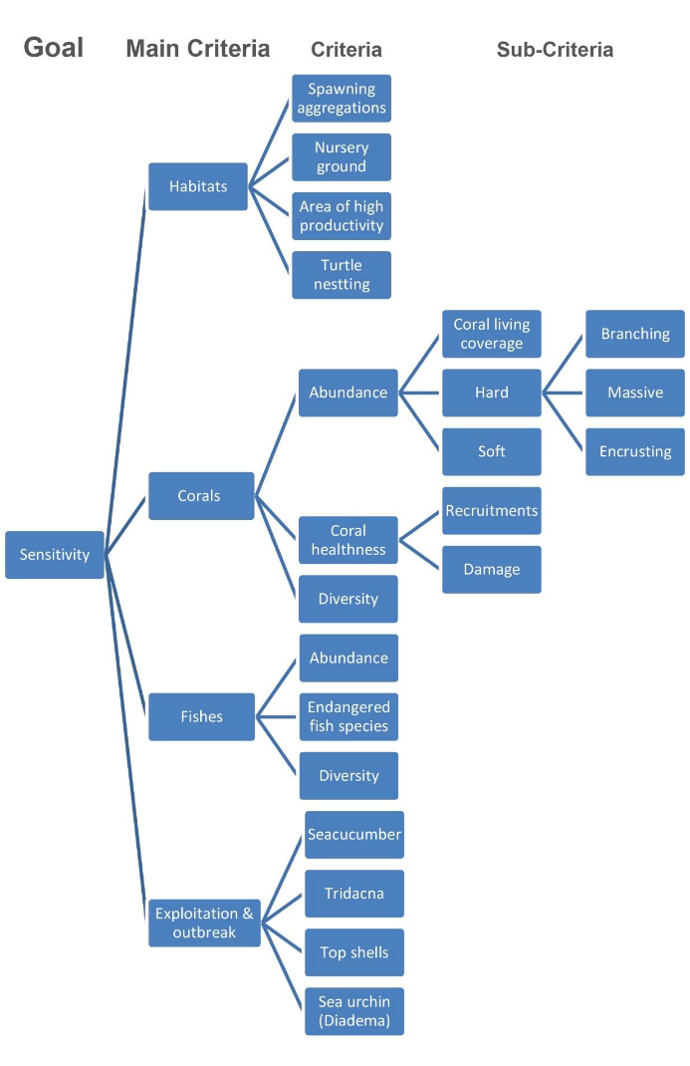

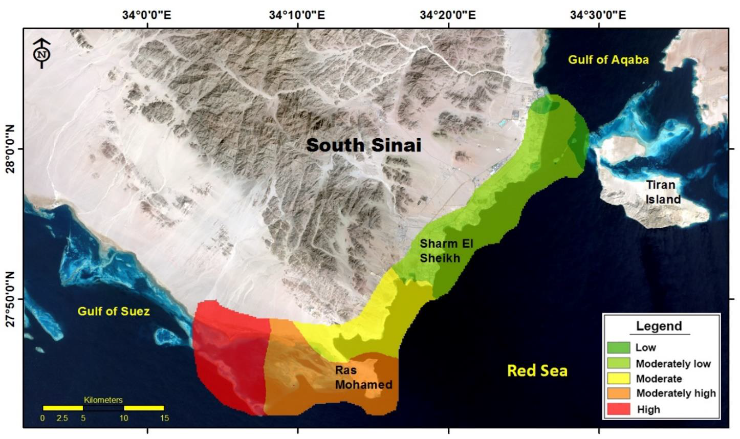
Figure B: Environmental sensitivity of the study area based on coral criteria

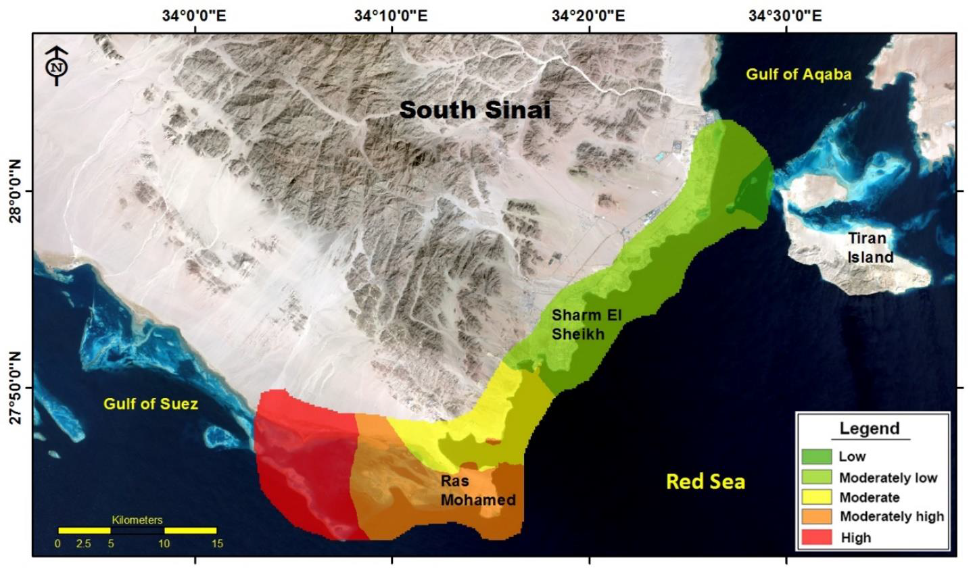
Figure C: Environmental sensitivity of the study area based on habitats criteria

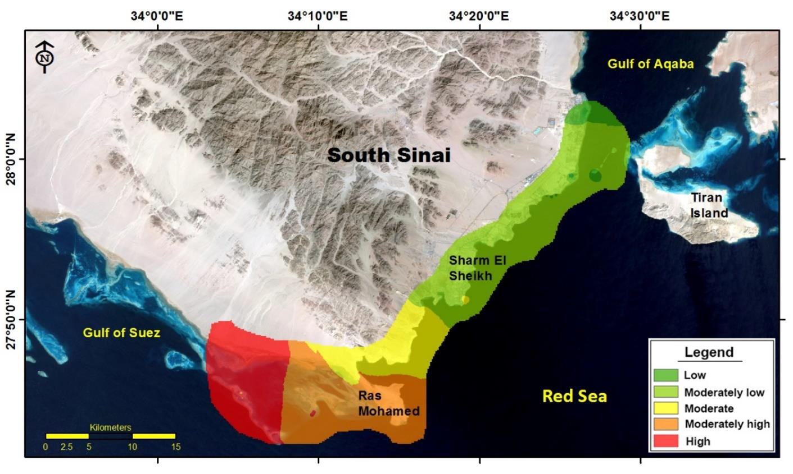
Figure D: Environmental sensitivity of the study area based on fish criteria

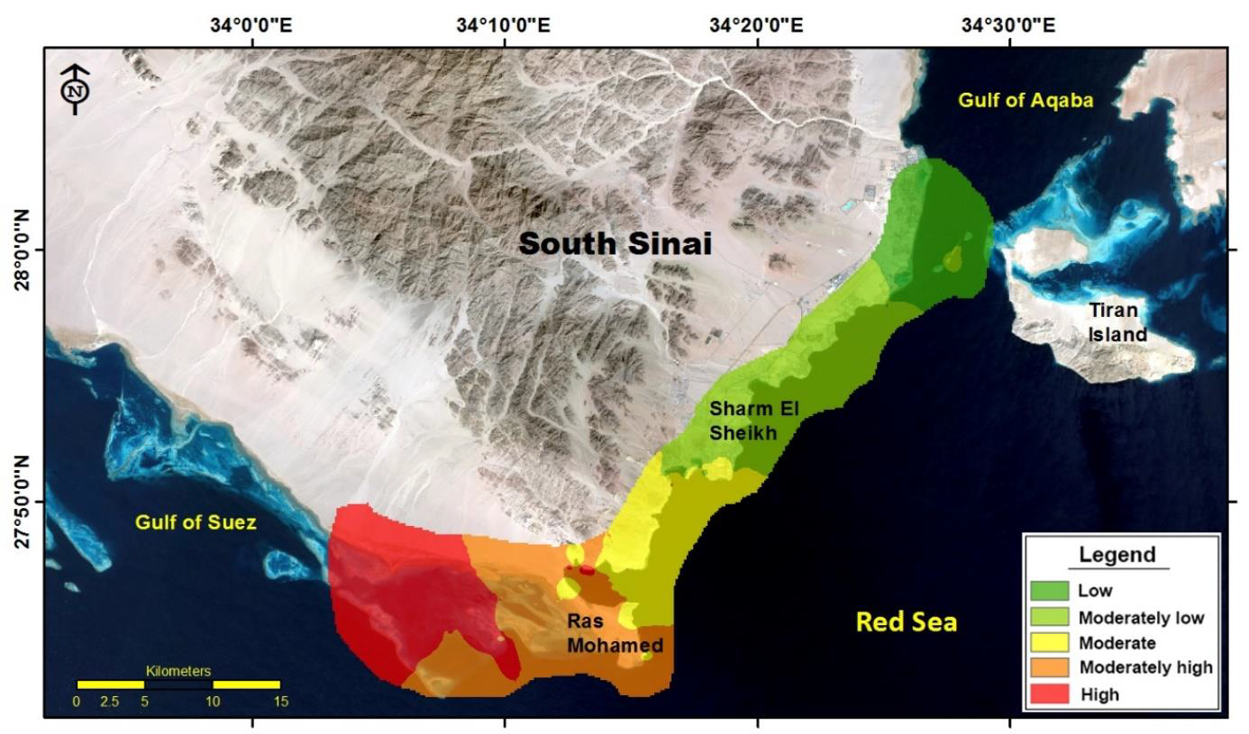
Figure E: Environmental sensitivity of the study area based on exploitation and disease outbreak criteria

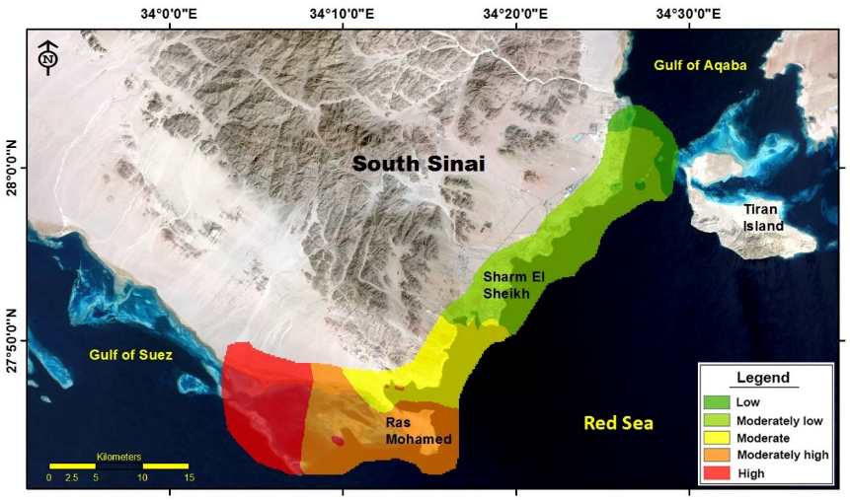
Figure F: Overall Environmental sensitivity of the study area

Attachment -1: The relative sensitivity based on the habitats, coral, fish and exploitation and outbreak criteria for the 189 diving sites are provided in the tables below.

Station |  | Habitats
Station | Spawning  aggregations | Nursery ground |  | Area of high  productivity | Turtle  nesting | Total * 10⁴
1 | 0.0099 | 0.0098 |  | 0.0097 | 0.0096 | 97.6442
2 | 0.0098 | 0.0098 |  | 0.0097 | 0.0095 | 96.9394
3 | 0.0097 | 0.0097 |  | 0.0096 | 0.0095 | 96.2397
4 | 0.0097 | 0.0096 |  | 0.0095 | 0.0094 | 95.5450
5 | 0.0093 | 0.0093 |  | 0.0093 | 0.0095 | 93.4553
6 | 0.0095 | 0.0095 |  | 0.0094 | 0.0093 | 94.1808
7 | 0.0095 | 0.0094 |  | 0.0093 | 0.0092 | 93.5010
8 | 0.0094 | 0.0093 |  | 0.0093 | 0.0091 | 92.8261
9 | 0.0093 | 0.0093 |  | 0.0092 | 0.0090 | 92.1561
10 | 0.0093 | 0.0092 |  | 0.0091 | 0.0090 | 91.4909
11 | 0.0092 | 0.0091 |  | 0.0091 | 0.0089 | 90.8306
12 | 0.0091 | 0.0091 |  | 0.0090 | 0.0089 | 90.1750
13 | 0.0091 | 0.0090 |  | 0.0089 | 0.0088 | 89.5241
14 | 0.0090 | 0.0089 |  | 0.0089 | 0.0087 | 88.8779
15 | 0.0089 | 0.0089 |  | 0.0088 | 0.0087 | 88.2364
16 | 0.0089 | 0.0088 |  | 0.0088 | 0.0086 | 87.5995
17 | 0.0088 | 0.0088 |  | 0.0087 | 0.0085 | 86.9673
18 | 0.0087 | 0.0087 |  | 0.0086 | 0.0085 | 86.3395
19 | 0.0087 | 0.0086 |  | 0.0086 | 0.0084 | 85.7164
20 | 0.0086 | 0.0086 |  | 0.0085 | 0.0083 | 85.0977
21 | 0.0086 | 0.0085 |  | 0.0084 | 0.0083 | 84.4835
22 | 0.0085 | 0.0084 |  | 0.0084 | 0.0082 | 83.8737
23 | 0.0084 | 0.0084 |  | 0.0083 | 0.0082 | 83.2683
24 | 0.0084 | 0.0083 |  | 0.0083 | 0.0081 | 82.6673
25 | 0.0083 | 0.0083 |  | 0.0082 | 0.0080 | 82.0706
26 | 0.0083 | 0.0082 |  | 0.0081 | 0.0080 | 81.4782
27 | 0.0082 | 0.0081 |  | 0.0081 | 0.0079 | 80.8901
28 | 0.0081 | 0.0081 |  | 0.0080 | 0.0079 | 80.3063
29 | 0.0081 | 0.0080 |  | 0.0080 | 0.0078 | 79.7266
30 | 0.0080 | 0.0080 |  | 0.0079 | 0.0078 | 79.1512
31 | 0.0080 | 0.0079 |  | 0.0079 | 0.0077 | 78.5799
32 | 0.0079 | 0.0079 |  | 0.0078 | 0.0076 | 78.0127
33 | 0.0078 | 0.0078 |  | 0.0077 | 0.0076 | 77.4496
34 | 0.0078 | 0.0077 |  | 0.0077 | 0.0075 | 76.8906
35 | 0.0077 | 0.0077 |  | 0.0076 | 0.0075 | 76.3357
36 | 0.0077 | 0.0076 |  | 0.0076 | 0.0074 | 75.7847
37 | 0.0076 | 0.0076 |  | 0.0075 | 0.0074 | 75.2377
38 | 0.0076 | 0.0075 |  | 0.0075 | 0.0073 | 74.6946
39 | 0.0075 | 0.0075 |  | 0.0074 | 0.0073 | 74.1555
40 | 0.0075 | 0.0074 |  | 0.0074 | 0.0072 | 73.6203
41 | 0.0074 | 0.0074 |  | 0.0073 | 0.0072 | 73.0889
42 | 0.0074 | 0.0073 |  | 0.0073 | 0.0071 | 72.5614
47 | 0.0071 | 0.0070 |  | 0.0070 | 0.0068 | 72.0376
48 | 0.0063 | 0.0070 |  | 0.0090 | 0.0068 | 71.5177
49 | 0.0070 | 0.0069 |  | 0.0089 | 0.0067 | 71.0015
50 | 0.0069 | 0.0069 |  | 0.0089 | 0.0067 | 70.4890
51 | 0.0069 | 0.0068 |  | 0.0088 | 0.0067 | 69.9802
52 | 0.0068 | 0.0068 |  | 0.0087 | 0.0066 | 72.8211
53 | 0.0068 | 0.0092 |  | 0.0089 | 0.0066 | 74.0030
54 | 0.0067 | 0.0092 |  | 0.0088 | 0.0065 | 73.4692
55 | 0.0067 | 0.0091 |  | 0.0088 | 0.0065 | 72.9392
56 | 0.0066 | 0.0088 |  | 0.0085 | 0.0064 | 72.4130
57 | 0.0066 | 0.0065 |  | 0.0063 | 0.0064 | 78.5945
58 | 0.0065 | 0.0064 |  | 0.0063 | 0.0063 | 78.0276
59 | 0.0065 | 0.0086 |  | 0.0083 | 0.0063 | 77.4649
60 | 0.0064 | 0.0063 |  | 0.0062 | 0.0062 | 75.8392
61 | 0.0088 | 0.0063 |  | 0.0061 | 0.0062 | 64.2957
62 | 0.0087 | 0.0062 |  | 0.0061 | 0.0061 | 63.8316
63 | 0.0086 | 0.0062 |  | 0.0060 | 0.0061 | 74.0625
64 | 0.0062 | 0.0061 |  | 0.0060 | 0.0060 | 62.8030
65 | 0.0061 | 0.0061 |  | 0.0059 | 0.0060 | 68.2975
66 | 0.0061 | 0.0060 |  | 0.0059 | 0.0060 | 67.8046
67 | 0.0060 | 0.0060 |  | 0.0059 | 0.0059 | 67.3152
68 | 0.0060 | 0.0059 |  | 0.0058 | 0.0059 | 60.8293
69 | 0.0060 | 0.0059 |  | 0.0058 | 0.0058 | 60.3903
70 | 0.0059 | 0.0059 |  | 0.0075 | 0.0058 | 59.9543
71 | 0.0059 | 0.0058 |  | 0.0075 | 0.0057 | 59.5216
72 | 0.0058 | 0.0058 |  | 0.0074 | 0.0057 | 59.0919
73 | 0.0058 | 0.0057 |  | 0.0056 | 0.0057 | 58.6654
74 | 0.0057 | 0.0057 |  | 0.0055 | 0.0056 | 62.6825
75 | 0.0057 | 0.0057 |  | 0.0072 | 0.0056 | 62.2303
76 | 0.0057 | 0.0056 |  | 0.0054 | 0.0055 | 61.7814
77 | 0.0056 | 0.0056 |  | 0.0054 | 0.0055 | 56.8506
78 | 0.0056 | 0.0055 |  | 0.0053 | 0.0055 | 56.4402
79 | 0.0055 | 0.0055 |  | 0.0053 | 0.0054 | 60.3857
80 | 0.0055 | 0.0055 |  | 0.0053 | 0.0054 | 55.5828
81 | 0.0055 | 0.0054 |  | 0.0052 | 0.0053 | 55.1816
82 | 0.0047 | 0.0044 | 0.0052 |  | 0.0053 | 48.9831
83 | 0.0054 | 0.0053 | 0.0052 |  | 0.0053 | 52.7556
84 | 0.0053 | 0.0053 | 0.0051 |  | 0.0052 | 52.3748
85 | 0.0053 | 0.0052 | 0.0051 |  | 0.0052 | 51.9967
86 | 0.0053 | 0.0052 | 0.0050 |  | 0.0051 | 51.6214
87 | 0.0052 | 0.0052 | 0.0050 |  | 0.0051 | 51.2487
88 | 0.0052 | 0.0051 | 0.0050 |  | 0.0051 | 50.8788
89 | 0.0051 | 0.0051 | 0.0049 |  | 0.0100 | 63.0361
90 | 0.0051 | 0.0051 | 0.0049 |  | 0.0100 | 62.5799
91 | 0.0051 | 0.0050 | 0.0049 |  | 0.0099 | 62.1271
92 | 0.0050 | 0.0050 | 0.0048 |  | 0.0049 | 49.4262
93 | 0.0050 | 0.0049 | 0.0048 |  | 0.0049 | 49.0694
94 | 0.0050 | 0.0049 | 0.0048 |  | 0.0049 | 48.7152
95 | 0.0049 | 0.0049 | 0.0047 |  | 0.0048 | 48.3636
96 | 0.0049 | 0.0048 | 0.0047 |  | 0.0048 | 48.0144
97 | 0.0048 | 0.0048 | 0.0047 |  | 0.0047 | 47.6679
98 | 0.0048 | 0.0048 | 0.0046 |  | 0.0047 | 47.3238
99 | 0.0048 | 0.0047 | 0.0046 |  | 0.0047 | 46.9822
100 | 0.0047 | 0.0047 | 0.0057 |  | 0.0046 | 49.5785
101 | 0.0047 | 0.0047 | 0.0045 |  | 0.0046 | 46.2739
102 | 0.0047 | 0.0046 | 0.0045 |  | 0.0046 | 45.9399
103 | 0.0046 | 0.0046 | 0.0045 |  | 0.0045 | 45.6083
104 | 0.0046 | 0.0046 | 0.0044 |  | 0.0045 | 45.2790
105 | 0.0046 | 0.0045 | 0.0044 |  | 0.0045 | 44.9522
106 | 0.0045 | 0.0045 | 0.0044 |  | 0.0044 | 44.6277
107 | 0.0037 | 0.0034 | 0.0033 |  | 0.0044 | 37.1734
108 | 0.0037 | 0.0034 | 0.0033 |  | 0.0044 | 36.9049
109 | 0.0037 | 0.0034 | 0.0033 |  | 0.0043 | 36.6383
110 | 0.0036 | 0.0033 | 0.0032 |  | 0.0043 | 36.3736
111 | 0.0036 | 0.0033 | 0.0032 |  | 0.0043 | 36.1108
112 | 0.0043 | 0.0043 | 0.0041 |  | 0.0043 | 42.3644
113 | 0.0043 | 0.0042 | 0.0041 |  | 0.0042 | 42.0586
114 | 0.0035 | 0.0032 | 0.0031 |  | 0.0042 | 35.1900
115 | 0.0035 | 0.0032 | 0.0031 |  | 0.0042 | 34.9357
116 | 0.0035 | 0.0032 | 0.0031 |  | 0.0041 | 34.6834
117 | 0.0034 | 0.0032 | 0.0031 |  | 0.0041 | 34.4328
118 | 0.0034 | 0.0031 | 0.0030 |  | 0.0041 | 34.1840
119 | 0.0040 | 0.0040 | 0.0039 |  | 0.0040 | 39.9182
120 | 0.0040 | 0.0040 | 0.0039 |  | 0.0040 | 39.6301
121 | 0.0040 | 0.0040 | 0.0038 |  | 0.0040 | 39.3440
122 | 0.0039 | 0.0039 |  | 0.0038 | 0.0040 | 39.0600
123 | 0.0039 | 0.0039 |  | 0.0038 | 0.0039 | 38.7780
124 | 0.0039 | 0.0039 0.0038 |  |  | 0.0039 | 38.4981
125 | 0.0038 | 0.0038 0.0037 |  |  | 0.0039 | 38.2201
126 | 0.0038 | 0.0038 |  | 0.0037 | 0.0038 | 37.9442
127 | 0.0038 | 0.0038 |  | 0.0037 | 0.0038 | 37.6703
128 | 0.0038 | 0.0038 |  | 0.0036 | 0.0038 | 37.3984
129 | 0.0037 | 0.0037 |  | 0.0036 | 0.0038 | 37.1284
130 | 0.0037 | 0.0037 |  | 0.0036 | 0.0037 | 36.8604
131 | 0.0037 | 0.0037 |  | 0.0036 | 0.0037 | 36.5943
132 | 0.0037 | 0.0037 |  | 0.0035 | 0.0037 | 36.3301
133 | 0.0036 | 0.0036 |  | 0.0035 | 0.0036 | 36.0679
134 | 0.0036 | 0.0036 |  | 0.0035 | 0.0036 | 35.8075
135 | 0.0029 | 0.0026 |  | 0.0026 | 0.0036 | 29.2066
136 | 0.0035 | 0.0035 |  | 0.0034 | 0.0036 | 35.2410
137 | 0.0035 | 0.0035 |  | 0.0034 | 0.0035 | 34.9866
138 | 0.0028 | 0.0026 |  | 0.0025 | 0.0035 | 28.4467
139 | 0.0028 | 0.0025 |  | 0.0025 | 0.0035 | 28.2411
140 | 0.0028 | 0.0025 |  | 0.0024 | 0.0035 | 28.0371
141 | 0.0034 | 0.0034 |  | 0.0033 | 0.0034 | 33.8411
142 | 0.0034 | 0.0034 |  | 0.0033 | 0.0034 | 33.5969
143 | 0.0033 | 0.0034 |  | 0.0033 | 0.0034 | 33.3543
144 | 0.0033 | 0.0033 |  | 0.0032 | 0.0034 | 33.1135
145 | 0.0033 | 0.0033 |  | 0.0032 | 0.0033 | 32.8745
146 | 0.0033 | 0.0033 |  | 0.0032 | 0.0033 | 32.6372
147 | 0.0032 | 0.0033 |  | 0.0032 | 0.0033 | 32.4016
148 | 0.0032 | 0.0032 |  | 0.0031 | 0.0033 | 32.1677
149 | 0.0032 | 0.0032 |  | 0.0031 | 0.0032 | 31.9354
150 | 0.0032 | 0.0032 |  | 0.0031 | 0.0032 | 31.7049
151 | 0.0032 | 0.0032 |  | 0.0031 | 0.0032 | 31.4760
152 | 0.0031 | 0.0031 |  | 0.0030 | 0.0032 | 31.2488
153 | 0.0031 | 0.0031 |  | 0.0030 | 0.0031 | 31.0232
154 | 0.0031 | 0.0031 |  | 0.0030 | 0.0031 | 30.7993
155 | 0.0031 | 0.0031 |  | 0.0030 | 0.0031 | 30.5769
156 | 0.0030 | 0.0031 |  | 0.0030 | 0.0031 | 30.3562
157 | 0.0030 | 0.0030 |  | 0.0029 | 0.0031 | 30.1370
158 | 0.0030 | 0.0030 |  | 0.0029 | 0.0030 | 29.9195
159 | 0.0030 | 0.0030 |  | 0.0029 | 0.0030 | 29.7035
160 | 0.0030 | 0.0030 |  | 0.0029 | 0.0030 | 29.4891
161 | 0.0029 | 0.0029 |  | 0.0029 | 0.0030 | 29.2762
162 | 0.0029 | 0.0029 |  | 0.0028 | 0.0029 | 29.0649
163 | 0.0029 | 0.0029 |  | 0.0028 | 0.0029 | 28.8550
164 | 0.0029 | 0.0031 |  | 0.0031 | 0.0029 | 29.8505
165 | 0.0029 | 0.0031 |  | 0.0030 | 0.0029 | 29.6350
166 | 0.0028 | 0.0031 |  | 0.0030 | 0.0029 | 29.4211
167 | 0.0028 | 0.0030 |  | 0.0030 | 0.0028 | 29.2088
168 | 0.0028 | 0.0030 0.0030 |  |  | 0.0028 | 28.9980
169 | 0.0028 | 0.0030 |  | 0.0030 | 0.0028 | 28.7887
170 | 0.0028 | 0.0030 |  | 0.0029 | 0.0028 | 28.5809
171 | 0.0027 | 0.0029 |  | 0.0029 | 0.0028 | 28.3747
172 | 0.0027 | 0.0029 |  | 0.0029 | 0.0027 | 28.1699
173 | 0.0027 | 0.0029 |  | 0.0029 | 0.0027 | 27.9666
174 | 0.0027 | 0.0029 |  | 0.0028 | 0.0027 | 27.7647
175 | 0.0027 | 0.0029 |  | 0.0028 | 0.0027 | 27.5643
176 | 0.0026 | 0.0028 |  | 0.0028 | 0.0027 | 27.3654
177 | 0.0026 | 0.0028 |  | 0.0028 | 0.0026 | 27.1679
178 | 0.0026 | 0.0028 |  | 0.0028 | 0.0026 | 26.9718
179 | 0.0026 | 0.0028 |  | 0.0027 | 0.0026 | 26.7772
180 | 0.0026 | 0.0028 |  | 0.0027 | 0.0026 | 26.5839
181 | 0.0025 | 0.0027 |  | 0.0027 | 0.0026 | 26.3920
182 | 0.0025 | 0.0027 |  | 0.0027 | 0.0025 | 26.2016
183 | 0.0025 | 0.0027 |  | 0.0027 | 0.0025 | 26.0125
184 | 0.0025 | 0.0024 |  | 0.0023 | 0.0025 | 24.3912
185 | 0.0025 | 0.0024 |  | 0.0023 | 0.0025 | 24.2151
186 | 0.0025 | 0.0024 |  | 0.0023 | 0.0025 | 24.0403
187 | 0.0024 | 0.0024 |  | 0.0023 | 0.0025 | 23.8668
188 | 0.0024 | 0.0024 |  | 0.0023 | 0.0024 | 23.6945
189 | 0.0024 | 0.0023 |  | 0.0023 | 0.0024 | 23.5234

Station | Corals
Station | Abundance |  |  |  |  |  | Coral healthiness |  |  |  | Diversity |  | Total * 10⁴
Station | Hard |  |  |  | Soft |  | Recruitments |  | Damage |  |  |  | Total * 10⁴
Station | Massive Encrusting
1 | 0.0096 0.0097 0.0090 0.0097 |  |  |  |  |  |  |  |  | 0.0103 | 0.0096 |  | 98.3256
2 | 0.0103 0.0097 0.0104 0.0097 |  |  |  |  |  |  |  |  | 0.0102 | 0.0095 |  | 100.9329
3 | 0.0102 0.0096 0.0104 0.0096 |  |  |  |  |  |  |  |  | 0.0104 | 0.0095 |  | 100.5086
4 | 0.0102 0.0095 0.0094 0.0095 |  |  |  |  |  |  |  |  | 0.0101 | 0.0094 |  | 97.3810
5 | 0.0093 0.0095 0.0093 0.0095 |  |  |  |  |  |  |  |  | 0.0092 | 0.0093 |  | 93.5281
6 | 0.0100 0.0094 0.0102 0.0094 |  |  |  |  |  |  |  |  | 0.0081 | 0.0101 |  | 96.8520
7 | 0.0100 0.0093 0.0102 0.0093 |  |  |  |  |  |  |  |  | 0.0081 | 0.0100 |  | 96.2603
8 | 0.0099 0.0093 0.0101 0.0093 |  |  |  |  |  |  |  |  | 0.0080 | 0.0099 |  | 95.6019
9 | 0.0098 0.0092 0.0101 0.0092 |  |  |  |  |  |  |  |  | 0.0049 | 0.0099 |  | 90.6332
10 | 0.0089 0.0091 0.0073 0.0091 |  |  |  |  |  |  |  |  | 0.0120 | 0.0089 |  | 86.5189
11 | 0.0088 0.0091 0.0072 0.0091 |  |  |  |  |  |  |  |  | 0.0119 | 0.0089 |  | 85.8936
12 | 0.0095 0.0090 0.0099 0.0090 |  |  |  |  |  |  |  |  | 0.0048 | 0.0096 |  | 88.4392
13 | 0.0095 0.0089 0.0098 0.0089 |  |  |  |  |  |  |  |  | 0.0048 | 0.0095 |  | 87.7990
14 | 0.0094 0.0089 0.0097 0.0089 |  |  |  |  |  |  |  |  | 0.0047 | 0.0094 |  | 87.1635
15 | 0.0093 0.0088 0.0097 0.0088 |  |  |  |  |  |  |  |  | 0.0047 | 0.0094 |  | 86.5325
16 | 0.0093 0.0087 0.0096 0.0087 |  |  |  |  |  |  |  |  | 0.0047 | 0.0093 |  | 85.9061
17 | 0.0092 0.0087 0.0095 0.0087 |  |  |  |  |  |  |  |  | 0.0046 | 0.0092 |  | 85.2843
18 | 0.0091 0.0086 0.0096 0.0086 |  |  |  |  |  |  |  |  | 0.0090 | 0.0092 |  | 91.0571
19 | 0.0091 0.0085 0.0095 0.0085 |  |  |  |  |  |  |  |  | 0.0089 | 0.0091 |  | 90.4826
20 | 0.0090 0.0085 0.0094 0.0085 |  |  |  |  |  |  |  |  | 0.0088 | 0.0091 |  | 89.8282
21 | 0.0089 0.0084 0.0095 0.0084 |  |  |  |  |  |  |  |  | 0.0088 | 0.0090 |  | 89.3134
22 | 0.0089 0.0084 0.0094 0.0084 |  |  |  |  |  |  |  |  | 0.0087 | 0.0089 |  | 88.6674
23 | 0.0088 0.0083 0.0093 0.0083 |  |  |  |  |  |  |  |  | 0.0086 | 0.0089 |  | 88.0261
24 | 0.0087 0.0082 0.0093 0.0082 |  |  |  |  |  |  |  |  | 0.0086 | 0.0088 |  | 87.3894
25 | 0.0087 0.0082 0.0092 0.0082 |  |  |  |  |  |  |  |  | 0.0085 | 0.0087 |  | 86.8100
26 | 0.0086 0.0081 0.0092 0.0081 |  |  |  |  |  |  |  |  | 0.0085 | 0.0087 |  | 86.1822
27 | 0.0077 0.0081 0.0067 0.0081 |  |  |  |  |  |  |  |  | 0.0102 | 0.0077 |  | 75.7820
28 | 0.0076 0.0080 0.0067 0.0080 |  |  |  |  |  |  |  |  | 0.0102 | 0.0077 |  | 75.2343
29 | 0.0076 0.0079 0.0066 0.0079 |  |  |  |  |  |  |  |  | 0.0101 | 0.0076 |  | 74.6904
30 | 0.0075 0.0079 0.0066 0.0079 |  |  |  |  |  |  |  |  | 0.0100 | 0.0075 |  | 74.1505
31 | 0.0074 0.0078 0.0065 0.0078 |  |  |  |  |  |  |  |  | 0.0100 | 0.0075 |  | 73.6145
32 | 0.0074 0.0078 0.0065 0.0078 |  |  |  |  |  |  |  |  | 0.0099 | 0.0074 |  | 73.0824
33 | 0.0080 0.0077 0.0086 0.0077 |  |  |  |  |  |  |  |  | 0.0079 | 0.0081 |  | 81.0038
34 | 0.0080 0.0076 0.0081 0.0076 |  |  |  |  |  |  |  |  | 0.0066 | 0.0075 |  | 77.0637
35 | 0.0072 0.0076 0.0063 0.0076 |  |  |  |  |  |  |  |  | 0.0096 | 0.0073 |  | 71.3913
36 | 0.0078 0.0075 0.0080 0.0075 |  |  |  |  |  |  |  |  | 0.0065 | 0.0074 |  | 75.9013
37 | 0.0071 0.0075 0.0062 0.0075 |  |  |  |  |  |  |  |  | 0.0095 | 0.0072 |  | 70.2854
38 | 0.0077 0.0074 0.0079 0.0074 |  |  |  |  |  |  |  |  | 0.0075 | 0.0073 |  | 76.3798
39 |  | 0.0076 0.0074 |  |  | 0.0078 0.0074 |  |  |  |  | 0.0075 | 0.0072 |  | 75.8273
40 |  | 0.0076 | 0.0073 |  | 0.0077 0.0073 |  |  |  |  | 0.0074 | 0.0072 |  | 75.2787
41 |  | 0.0075 | 0.0073 |  | 0.0077 0.0073 |  |  |  |  | 0.0074 | 0.0071 |  | 74.7131
42 |  | 0.0074 | 0.0072 |  | 0.0076 0.0072 |  |  |  |  | 0.0073 | 0.0071 |  | 74.1298
43 |  | 0.0074 | 0.0072 |  | 0.0079 0.0072 |  |  |  |  | 0.0074 | 0.0075 |  | 75.1413
44 |  | 0.0067 | 0.0071 |  | 0.0059 0.0071 |  |  |  |  | 0.0089 | 0.0068 |  | 66.4531
45 |  | 0.0066 | 0.0071 |  | 0.0058 0.0071 |  |  |  |  | 0.0088 | 0.0067 |  | 65.9727
46 |  | 0.0066 | 0.0070 |  | 0.0058 0.0070 |  |  |  |  | 0.0088 | 0.0067 |  | 65.4958
47 |  | 0.0071 | 0.0070 |  | 0.0076 0.0070 |  |  |  |  | 0.0070 | 0.0072 |  | 72.3784
48 |  | 0.0071 | 0.0069 |  | 0.0075 0.0069 |  |  |  |  | 0.0070 | 0.0071 |  | 71.7916
49 |  | 0.0070 | 0.0069 |  | 0.0075 0.0069 |  |  |  |  | 0.0069 | 0.0071 |  | 71.2584
50 |  | 0.0070 | 0.0068 |  | 0.0072 0.0068 |  |  |  |  | 0.0069 | 0.0070 |  | 70.4169
51 |  | 0.0069 | 0.0068 |  | 0.0072 0.0068 |  |  |  |  | 0.0068 | 0.0069 |  | 69.9075
52 |  | 0.0069 | 0.0067 |  | 0.0071 0.0067 |  |  |  |  | 0.0068 | 0.0069 |  | 69.4018
53 |  | 0.0068 | 0.0067 |  | 0.0071 0.0067 |  |  |  |  | 0.0067 | 0.0068 |  | 68.8998
54 |  | 0.0068 | 0.0066 |  | 0.0072 0.0066 |  |  |  |  | 0.0067 | 0.0068 |  | 68.7414
55 |  | 0.0067 | 0.0066 |  | 0.0072 0.0066 |  |  |  |  | 0.0066 | 0.0068 |  | 68.3073
56 |  | 0.0067 | 0.0065 |  | 0.0072 0.0065 |  |  |  |  | 0.0066 | 0.0067 |  | 67.8132
57 |  | 0.0066 | 0.0065 |  | 0.0071 0.0065 |  |  |  |  | 0.0065 | 0.0067 |  | 67.3227
58 |  | 0.0066 | 0.0064 |  | 0.0072 0.0064 |  |  |  |  | 0.0066 | 0.0067 |  | 67.3443
59 |  | 0.0065 | 0.0064 |  | 0.0072 0.0064 |  |  |  |  | 0.0064 | 0.0066 |  | 66.7966
60 |  | 0.0065 | 0.0063 |  | 0.0074 0.0063 |  |  |  |  | 0.0064 | 0.0066 |  | 66.6312
61 |  | 0.0064 | 0.0063 |  | 0.0071 0.0063 |  |  |  |  | 0.0063 | 0.0066 |  | 65.9886
62 |  | 0.0064 | 0.0062 |  | 0.0066 0.0062 |  |  |  |  | 0.0065 | 0.0065 |  | 64.7943
63 |  | 0.0063 | 0.0062 |  | 0.0065 0.0062 |  |  |  |  | 0.0064 | 0.0064 |  | 64.1638
64 |  | 0.0063 | 0.0061 |  | 0.0064 0.0061 |  |  |  |  | 0.0064 | 0.0063 |  | 63.6498
65 |  | 0.0062 | 0.0061 |  | 0.0064 0.0061 |  |  |  |  | 0.0063 | 0.0063 |  | 63.1659
66 |  | 0.0062 | 0.0060 |  | 0.0064 0.0060 |  |  |  |  | 0.0063 | 0.0062 |  | 62.7597
67 |  | 0.0062 | 0.0060 |  | 0.0063 0.0060 |  |  |  |  | 0.0062 | 0.0062 |  | 62.3640
68 |  | 0.0061 | 0.0060 |  | 0.0063 0.0060 |  |  |  |  | 0.0062 | 0.0062 |  | 61.9129
69 |  | 0.0061 | 0.0059 |  | 0.0063 0.0059 |  |  |  |  | 0.0061 | 0.0061 |  | 61.4952
70 |  | 0.0060 | 0.0059 |  | 0.0062 0.0059 |  |  |  |  | 0.0061 | 0.0061 |  | 61.0725
71 |  | 0.0060 | 0.0058 |  | 0.0062 0.0058 |  |  |  |  | 0.0061 | 0.0060 |  | 60.6307
72 |  | 0.0059 | 0.0058 |  | 0.0061 0.0058 |  |  |  |  | 0.0060 | 0.0060 |  | 60.1921
73 |  | 0.0059 | 0.0057 |  | 0.0061 0.0057 |  |  |  |  | 0.0060 | 0.0059 |  | 59.7567
74 |  | 0.0058 | 0.0057 |  | 0.0060 0.0057 |  |  |  |  | 0.0059 | 0.0059 |  | 59.3245
75 |  | 0.0058 | 0.0057 |  | 0.0060 0.0057 |  |  |  |  | 0.0057 | 0.0059 |  | 58.6383
76 |  | 0.0058 | 0.0056 |  | 0.0059 0.0056 |  |  |  |  | 0.0057 | 0.0058 |  | 58.1558
77 |  | 0.0057 | 0.0056 |  | 0.0059 0.0056 |  |  |  |  | 0.0058 | 0.0058 |  | 58.0821
78 | 0.0057 0.0055 0.0059 0.0055 |  |  |  |  |  |  |  |  | 0.0056 | 0.0057 |  | 57.4343
79 | 0.0049 0.0055 0.0044 0.0055 |  |  |  |  |  |  |  | 0.0067 |  | 0.0050 |  | 50.2926
80 | 0.0049 0.0055 0.0044 0.0055 |  |  |  |  |  |  |  | 0.0067 |  | 0.0050 |  | 49.9290
81 | 0.0049 0.0054 0.0043 0.0054 |  |  |  |  |  |  |  | 0.0066 |  | 0.0049 |  | 49.5680
82 | 0.0055 0.0054 0.0057 0.0054 |  |  |  |  |  |  |  | 0.0054 |  | 0.0055 |  | 55.5230
83 | 0.0054 0.0053 0.0060 0.0053 |  |  |  |  |  |  |  | 0.0054 |  | 0.0055 |  | 55.7243
84 | 0.0047 0.0053 0.0042 0.0053 |  |  |  |  |  |  |  | 0.0065 |  | 0.0048 |  | 48.3975
85 | 0.0053 0.0053 0.0062 0.0053 |  |  |  |  |  |  |  | 0.0053 |  | 0.0054 |  | 55.3243
86 | 0.0053 0.0052 0.0059 0.0052 |  |  |  |  |  |  |  | 0.0052 |  | 0.0053 |  | 54.4523
87 | 0.0053 0.0052 0.0058 0.0052 |  |  |  |  |  |  |  | 0.0052 |  | 0.0053 |  | 53.9202
88 | 0.0052 0.0051 0.0057 0.0051 |  |  |  |  |  |  |  | 0.0053 |  | 0.0053 |  | 53.7094
89 | 0.0052 0.0051 0.0054 0.0051 |  |  |  |  |  |  |  | 0.0053 |  | 0.0052 |  | 52.9428
90 | 0.0051 0.0051 0.0056 0.0051 |  |  |  |  |  |  |  | 0.0053 |  | 0.0052 |  | 52.9557
91 | 0.0051 0.0050 0.0056 0.0050 |  |  |  |  |  |  |  | 0.0050 |  | 0.0051 |  | 52.4153
92 | 0.0051 0.0050 0.0056 0.0050 |  |  |  |  |  |  |  | 0.0050 |  | 0.0051 |  | 52.0362
93 | 0.0050 0.0050 0.0056 0.0050 |  |  |  |  |  |  |  | 0.0050 |  | 0.0051 |  | 51.6825
94 | 0.0050 0.0049 0.0055 0.0049 |  |  |  |  |  |  |  | 0.0049 |  | 0.0050 |  | 51.3086
95 | 0.0050 0.0049 0.0055 0.0049 |  |  |  |  |  |  |  | 0.0049 |  | 0.0050 |  | 50.9375
96 | 0.0049 0.0049 0.0054 0.0049 |  |  |  |  |  |  |  | 0.0049 |  | 0.0050 |  | 50.5690
97 | 0.0049 0.0048 0.0054 0.0048 |  |  |  |  |  |  |  | 0.0048 |  | 0.0049 |  | 50.2032
98 | 0.0049 0.0048 0.0054 0.0048 |  |  |  |  |  |  |  | 0.0048 |  | 0.0049 |  | 49.8401
99 | 0.0048 0.0047 0.0053 0.0047 |  |  |  |  |  |  |  | 0.0048 |  | 0.0049 |  | 49.4795
100 | 0.0041 0.0047 0.0039 0.0047 |  |  |  |  |  |  |  | 0.0056 |  | 0.0042 |  | 42.6938
101 | 0.0047 0.0047 0.0052 0.0047 |  |  |  |  |  |  |  | 0.0047 |  | 0.0048 |  | 48.5676
102 | 0.0047 0.0046 0.0049 0.0046 |  |  |  |  |  |  |  | 0.0024 |  | 0.0047 |  | 44.5575
103 | 0.0047 0.0046 0.0048 0.0046 |  |  |  |  |  |  |  | 0.0024 |  | 0.0047 |  | 44.2034
104 | 0.0046 0.0046 0.0048 0.0046 |  |  |  |  |  |  |  | 0.0034 |  | 0.0047 |  | 45.4234
105 | 0.0046 0.0045 0.0047 0.0045 |  |  |  |  |  |  |  | 0.0034 |  | 0.0046 |  | 45.0719
106 | 0.0046 0.0045 0.0047 0.0045 |  |  |  |  |  |  |  | 0.0045 |  | 0.0046 |  | 46.3563
107 | 0.0038 0.0045 0.0037 0.0045 |  |  |  |  |  |  |  | 0.0052 |  | 0.0039 |  | 40.2542
108 | 0.0038 0.0044 0.0036 0.0044 |  |  |  |  |  |  |  | 0.0052 |  | 0.0039 |  | 39.9631
109 | 0.0038 0.0044 0.0036 0.0044 |  |  |  |  |  |  |  | 0.0051 |  | 0.0038 |  | 39.6741
110 | 0.0038 0.0044 0.0036 0.0044 |  |  |  |  |  |  |  | 0.0051 |  | 0.0038 |  | 39.3872
111 | 0.0037 0.0043 0.0036 0.0043 |  |  |  |  |  |  |  | 0.0051 |  | 0.0038 |  | 39.1024
112 | 0.0043 0.0043 0.0048 0.0043 |  |  |  |  |  |  |  | 0.0043 |  | 0.0042 |  | 44.3230
113 | 0.0043 0.0043 0.0035 0.0043 |  |  |  |  |  |  |  | 0.0044 |  | 0.0041 |  | 41.2599
114 | 0.0036 0.0043 0.0035 0.0043 |  |  |  |  |  |  |  | 0.0050 |  | 0.0037 |  | 38.2098
115 | 0.0036 0.0042 0.0035 0.0042 |  |  |  |  |  |  |  | 0.0049 |  | 0.0037 |  | 37.9335
116 | 0.0036 0.0042 0.0035 0.0042 |  |  |  |  |  |  |  | 0.0049 |  | 0.0037 |  | 37.6592
117 | 0.0036 0.0042 0.0034 0.0042 |  |  |  |  |  |  |  | 0.0048 |  | 0.0036 |  | 37.3869
118 | 0.0040 0.0041 0.0034 0.0041 |  |  |  |  |  |  |  | 0.0048 |  | 0.0040 |  | 38.3437
119 | 0.0040 0.0041 0.0036 0.0041 |  |  |  |  |  |  |  | 0.0040 |  | 0.0040 |  | 40.4807
120 | 0.0040 0.0041 0.0038 0.0041 |  |  |  |  |  |  |  | 0.0040 |  | 0.0040 |  | 40.4968
121 | 0.0040 0.0040 0.0041 0.0040 |  |  |  |  |  |  |  | 0.0040 |  | 0.0039 |  | 40.6698
122 | 0.0040 0.0040 0.0040 0.0040 |  |  |  |  |  |  |  | 0.0041 |  | 0.0039 |  | 40.6643
123 | 0.0039 0.0040 0.0040 0.0040 |  |  |  |  |  |  |  | 0.0039 |  | 0.0039 |  | 40.1195
124 | 0.0039 0.0040 0.0040 0.0040 |  |  |  |  |  |  |  | 0.0039 |  | 0.0038 |  | 39.8792
125 | 0.0039 0.0039 0.0040 0.0039 |  |  |  |  |  |  |  | 0.0029 |  | 0.0039 |  | 38.3832
126 | 0.0038 0.0039 0.0039 0.0039 |  |  |  |  |  |  |  | 0.0038 |  | 0.0039 |  | 39.4152
127 | 0.0038 0.0039 0.0039 0.0039 |  |  |  |  |  |  |  | 0.0038 |  | 0.0038 |  | 39.1300
128 | 0.0038 0.0038 0.0039 0.0038 |  |  |  |  |  |  |  | 0.0038 |  | 0.0038 |  | 38.8696
129 | 0.0038 0.0038 0.0038 0.0038 |  |  |  |  |  |  |  | 0.0037 |  | 0.0038 |  | 38.4852
130 | 0.0037 0.0038 0.0036 0.0038 |  |  |  |  |  |  |  | 0.0037 |  | 0.0037 |  | 37.7336
131 | 0.0037 0.0038 0.0035 0.0038 |  |  |  |  |  |  |  | 0.0037 |  | 0.0037 |  | 37.3963
132 | 0.0037 0.0037 0.0033 0.0037 |  |  |  |  |  |  |  | 0.0036 |  | 0.0037 |  | 36.9289
133 | 0.0037 0.0037 0.0038 0.0037 |  |  |  |  |  |  |  | 0.0027 |  | 0.0037 |  | 36.2052
134 | 0.0036 0.0037 0.0029 0.0037 |  |  |  |  |  |  |  | 0.0038 |  | 0.0036 |  | 34.8602
135 | 0.0036 0.0036 0.0029 0.0036 |  |  |  |  |  |  |  | 0.0038 |  | 0.0035 |  | 33.2085
136 | 0.0035 0.0036 0.0029 0.0036 |  |  |  |  |  |  |  | 0.0041 |  | 0.0033 |  | 33.0281
137 | 0.0035 0.0036 0.0029 0.0036 |  |  |  |  |  |  |  | 0.0040 |  | 0.0031 |  | 32.5197
138 | 0.0029 0.0036 0.0029 0.0036 |  |  |  |  |  |  |  | 0.0040 |  | 0.0030 |  | 31.4580
139 | 0.0029 0.0035 0.0028 0.0035 |  |  |  |  |  |  |  | 0.0040 |  | 0.0030 |  | 31.2305
140 | 0.0035 0.0035 0.0028 0.0035 |  |  |  |  |  |  |  | 0.0034 |  | 0.0034 |  | 33.2526
141 | 0.0034 0.0035 0.0035 0.0035 |  |  |  |  |  |  |  | 0.0034 |  | 0.0034 |  | 35.0877
142 | 0.0034 0.0035 0.0034 0.0035 |  |  |  |  |  |  |  | 0.0036 |  | 0.0034 |  | 35.0753
143 | 0.0034 0.0034 0.0033 0.0034 |  |  |  |  |  |  |  | 0.0035 |  | 0.0034 |  | 34.7412
144 | 0.0034 0.0034 0.0034 0.0034 |  |  |  |  |  |  |  | 0.0035 |  | 0.0033 |  | 34.5702
145 | 0.0033 0.0034 0.0034 0.0034 |  |  |  |  |  |  |  | 0.0035 |  | 0.0033 |  | 34.4166
146 | 0.0033 0.0034 0.0034 0.0034 |  |  |  |  |  |  |  | 0.0035 |  | 0.0033 |  | 34.2271
147 | 0.0033 0.0033 0.0034 0.0033 |  |  |  |  |  |  |  | 0.0034 |  | 0.0033 |  | 34.0191
148 | 0.0033 0.0033 0.0033 0.0033 |  |  |  |  |  |  |  | 0.0034 |  | 0.0033 |  | 33.6369
149 | 0.0032 0.0033 0.0027 0.0033 |  |  |  |  |  |  |  | 0.0037 |  | 0.0033 |  | 32.8489
150 | 0.0032 0.0033 0.0032 0.0033 |  |  |  |  |  |  |  | 0.0023 |  | 0.0032 |  | 31.6247
151 | 0.0032 0.0032 0.0029 0.0032 |  |  |  |  |  |  |  | 0.0023 |  | 0.0032 |  | 30.8399
152 | 0.0032 0.0032 0.0027 0.0032 |  |  |  |  |  |  |  | 0.0023 |  | 0.0031 |  | 30.3000
153 | 0.0031 0.0032 0.0029 0.0032 |  |  |  |  |  |  |  | 0.0033 |  | 0.0031 |  | 31.8820
154 | 0.0031 0.0032 0.0036 0.0032 |  |  |  |  |  |  |  | 0.0015 |  | 0.0031 |  | 30.4448
155 | 0.0031 0.0031 0.0029 0.0031 |  |  |  |  |  |  |  | 0.0032 |  | 0.0031 |  | 31.6205
156 | 0.0031 0.0031 0.0031 0.0031 |  |  |  |  |  |  |  | 0.0032 |  | 0.0031 |  | 31.7789
157 | 0.0031 0.0031 0.0029 0.0031 |  |  |  |  |  |  |  | 0.0030 |  | 0.0031 |  | 30.8612
158 | 0.0030 0.0031 0.0024 0.0031 |  |  |  |  |  |  |  | 0.0021 |  | 0.0030 |  | 27.6187
159 | 0.0030 0.0031 0.0024 0.0031 |  |  |  |  |  |  |  | 0.0021 |  | 0.0030 |  | 27.1059
160 | 0.0030 0.0030 0.0024 0.0030 |  |  |  |  |  |  |  | 0.0015 |  | 0.0030 |  | 25.7659
161 | 0.0030 0.0030 0.0023 0.0030 |  |  |  |  |  |  |  | 0.0014 |  | 0.0029 |  | 25.3103
162 | 0.0030 0.0030 0.0023 0.0030 |  |  |  |  |  |  |  | 0.0014 |  | 0.0029 |  | 24.8976
163 | 0.0029 0.0030 0.0023 0.0030 |  |  |  |  |  |  |  | 0.0028 |  | 0.0029 |  | 28.4888
164 | 0.0029 0.0029 0.0029 0.0029 |  |  |  |  |  |  |  | 0.0030 |  | 0.0029 |  | 29.8902
165 | 0.0029 |  |  | 0.0029 |  | 0.0027 |  | 0.0029 | 0.0028 |  |  | 0.0029 | 29.0919
166 | 0.0029 |  |  | 0.0029 |  | 0.0025 |  | 0.0029 | 0.0028 |  |  | 0.0028 | 28.5370
167 | 0.0022 |  |  | 0.0029 |  | 0.0022 |  | 0.0029 | 0.0031 |  |  | 0.0024 | 24.8093
168 | 0.0028 |  |  | 0.0029 |  | 0.0028 |  | 0.0029 | 0.0027 |  |  | 0.0028 | 28.6797
169 | 0.0028 |  |  | 0.0028 |  | 0.0028 |  | 0.0028 | 0.0029 |  |  | 0.0028 | 28.7784
170 | 0.0028 |  |  | 0.0028 |  | 0.0028 |  | 0.0028 | 0.0029 |  |  | 0.0028 | 28.5836
171 | 0.0028 |  |  | 0.0028 |  | 0.0027 |  | 0.0028 | 0.0029 |  |  | 0.0027 | 28.2600
172 | 0.0027 |  |  | 0.0028 |  | 0.0025 |  | 0.0028 | 0.0028 |  |  | 0.0027 | 27.7377
173 | 0.0027 |  |  | 0.0028 |  | 0.0024 |  | 0.0028 | 0.0028 |  |  | 0.0027 | 27.4383
174 | 0.0027 |  |  | 0.0027 |  | 0.0023 |  | 0.0027 | 0.0028 |  |  | 0.0027 | 27.0992
175 | 0.0027 |  |  | 0.0027 |  | 0.0027 |  | 0.0027 | 0.0030 |  |  | 0.0027 | 27.8069
176 | 0.0027 |  |  | 0.0027 |  | 0.0027 |  | 0.0027 | 0.0029 |  |  | 0.0026 | 27.6347
177 | 0.0026 |  |  | 0.0027 |  | 0.0027 |  | 0.0027 | 0.0029 |  |  | 0.0026 | 27.4348
178 | 0.0026 |  |  | 0.0027 |  | 0.0026 |  | 0.0027 | 0.0029 |  |  | 0.0026 | 27.2230
179 | 0.0020 |  |  | 0.0026 |  | 0.0020 |  | 0.0026 | 0.0029 |  |  | 0.0021 | 22.5144
180 | 0.0019 |  |  | 0.0026 |  | 0.0020 |  | 0.0026 | 0.0029 |  |  | 0.0021 | 22.3516
181 | 0.0019 |  |  | 0.0026 |  | 0.0020 |  | 0.0026 | 0.0028 |  |  | 0.0021 | 22.1899
182 | 0.0025 |  |  | 0.0026 |  | 0.0025 |  | 0.0026 | 0.0028 |  |  | 0.0025 | 26.3097
183 | 0.0025 |  |  | 0.0026 |  | 0.0023 |  | 0.0026 | 0.0026 |  |  | 0.0025 | 25.5638
184 | 0.0025 |  |  | 0.0025 |  | 0.0021 |  | 0.0025 | 0.0024 |  |  | 0.0025 | 24.8896
185 | 0.0025 |  |  | 0.0025 |  | 0.0030 |  | 0.0025 | 0.0026 |  |  | 0.0025 | 26.2750
186 | 0.0025 |  |  | 0.0025 |  | 0.0025 |  | 0.0025 | 0.0024 |  |  | 0.0025 | 25.1535
187 | 0.0024 |  |  | 0.0025 |  | 0.0023 |  | 0.0025 | 0.0016 |  |  | 0.0025 | 23.7897
188 | 0.0024 |  |  | 0.0025 |  | 0.0018 |  | 0.0025 | 0.0011 |  |  | 0.0024 | 21.2616
189 | 0.0024 |  |  | 0.0025 |  | 0.0019 |  | 0.0025 | 0.0025 |  |  | 0.0024 | 24.0364

Station | Fishes |  |  |  |  |  |  | Total * 10⁴
Station | Abundance |  | Endangered fish species |  |  |  | Diversity | Total * 10⁴
1 | 0.0111 0.0097 |  |  |  |  |  | 0.0097 | 102.0423
2 | 0.0110 0.0097 |  |  |  |  |  | 0.0097 | 101.3047
3 | 0.0110 0.0096 |  |  |  |  |  | 0.0096 | 100.5725
4 | 0.0109 0.0095 |  |  |  |  |  | 0.0095 | 99.8455
5 | 0.0091 0.0095 |  |  |  |  |  | 0.0095 | 93.5468
6 | 0.0107 0.0094 |  |  |  |  |  | 0.0094 | 98.4468
7 | 0.0107 0.0093 |  |  |  |  |  | 0.0093 | 97.7352
8 | 0.0106 0.0093 |  |  |  |  |  | 0.0093 | 97.0288
9 | 0.0116 0.0092 |  |  |  |  |  | 0.0092 | 99.9184
10 | 0.0051 0.0091 |  |  |  |  |  | 0.0091 | 77.8499
11 | 0.0051 0.0091 |  |  |  |  |  | 0.0091 | 77.2847
12 | 0.0113 0.0090 |  |  |  |  |  | 0.0090 | 97.5087
13 | 0.0112 0.0089 |  |  |  |  | 0.0089 |  | 96.8043
14 | 0.0111 0.0089 |  |  |  |  | 0.0089 |  | 96.1051
15 | 0.0110 0.0088 |  |  |  |  | 0.0088 |  | 95.4109
16 | 0.0110 0.0087 |  |  |  |  | 0.0087 |  | 94.7217
17 | 0.0109 0.0087 |  |  |  |  | 0.0087 |  | 94.0375
18 | 0.0108 0.0086 |  |  |  |  | 0.0086 |  | 93.3582
19 | 0.0107 0.0085 |  |  |  |  | 0.0085 |  | 92.6838
20 | 0.0107 0.0085 |  |  |  |  | 0.0085 |  | 92.0143
21 | 0.0106 0.0084 |  |  |  |  | 0.0084 |  | 91.3497
22 | 0.0105 0.0084 |  |  |  |  | 0.0084 |  | 90.6898
23 | 0.0104 0.0083 |  |  |  |  | 0.0083 |  | 90.0347
24 | 0.0104 0.0082 |  |  |  |  | 0.0082 |  | 89.3844
25 | 0.0103 0.0082 |  |  |  |  | 0.0082 |  | 88.7387
26 | 0.0102 0.0081 |  |  |  |  | 0.0081 |  | 88.0977
27 | 0.0044 0.0081 |  |  |  |  | 0.0081 |  | 68.3669
28 | 0.0044 0.0080 |  |  |  |  | 0.0080 |  | 67.8705
29 | 0.0043 0.0079 |  |  |  |  | 0.0079 |  | 67.3777
30 | 0.0043 0.0079 |  |  |  |  | 0.0079 |  | 66.8885
31 | 0.0043 0.0078 |  |  |  |  | 0.0078 |  | 66.4028
32 | 0.0043 0.0078 |  |  |  |  | 0.0078 |  | 65.9207
33 | 0.0095 0.0077 |  |  |  |  | 0.0077 |  | 83.1047
34 | 0.0095 0.0076 |  |  |  |  | 0.0076 |  | 82.5044
35 | 0.0041 0.0076 |  |  |  |  | 0.0076 |  | 64.4449
36 | 0.0093 0.0075 |  |  |  |  | 0.0075 |  | 81.2118
37 | 0.0041 0.0075 |  |  |  |  | 0.0075 |  | 63.4878
38 | 0.0091 0.0074 |  |  |  |  | 0.0074 |  | 79.9391
39 | 0.0091 0.0074 |  |  |  |  | 0.0074 |  | 79.3616
40 | 0.0090 0.0073 |  |  |  |  | 0.0073 |  | 78.7882
41 | 0.0089 0.0073 |  |  |  |  | 0.0073 |  | 78.2190
42 | 0.0089 0.0072 |  |  |  |  | 0.0072 |  | 77.6539
43 | 0.0088 0.0072 |  |  |  |  | 0.0072 |  | 77.0929
44 | 0.0038 0.0071 |  |  |  |  | 0.0071 |  | 60.1886
45 | 0.0038 0.0071 |  |  |  |  | 0.0071 |  | 59.7515
46 | 0.0038 0.0070 |  |  |  |  | 0.0070 |  | 59.3176
47 | 0.0085 0.0070 |  |  |  |  | 0.0070 |  | 74.6036
48 | 0.0084 0.0069 |  |  |  |  | 0.0069 |  | 74.0646
49 | 0.0084 0.0069 |  |  |  |  | 0.0069 |  | 73.5295
50 | 0.0083 0.0068 |  |  |  |  | 0.0068 |  | 72.9983
51 | 0.0082 0.0068 |  |  |  |  | 0.0068 |  | 72.4709
52 | 0.0082 0.0067 |  |  |  |  | 0.0067 |  | 71.9473
53 | 0.0081 0.0067 |  |  |  |  | 0.0067 |  | 71.4274
54 | 0.0081 0.0066 |  |  |  |  | 0.0066 |  | 70.9114
55 | 0.0080 0.0066 |  |  |  |  | 0.0066 |  | 70.3991
56 | 0.0079 0.0065 |  |  |  |  | 0.0065 |  | 69.8904
57 | 0.0079 0.0065 |  |  |  |  | 0.0065 |  | 69.3855
58 | 0.0078 0.0064 |  |  |  |  | 0.0064 |  | 68.8842
59 | 0.0078 0.0064 |  |  |  | 0.0064 |  |  | 68.3865
60 | 0.0077 0.0063 |  |  |  | 0.0063 |  |  | 67.8924
61 | 0.0077 0.0063 |  |  |  | 0.0063 |  |  | 67.4019
62 | 0.0076 0.0062 |  |  |  | 0.0062 |  |  | 66.9150
63 | 0.0076 0.0062 |  |  |  | 0.0062 |  |  | 66.4315
64 | 0.0075 0.0061 |  |  |  | 0.0061 |  |  | 65.9516
65 | 0.0075 0.0061 |  |  |  | 0.0061 |  |  | 65.4751
66 | 0.0074 0.0060 |  |  |  | 0.0060 |  |  | 65.0020
67 | 0.0074 0.0060 |  |  |  | 0.0060 |  |  | 64.5324
68 | 0.0073 0.0060 |  |  |  | 0.0060 |  |  | 64.0662
69 | 0.0072 0.0059 |  |  |  | 0.0059 |  |  | 63.6033
70 | 0.0072 0.0059 |  |  |  | 0.0059 |  |  | 63.1438
71 | 0.0071 0.0058 |  |  |  | 0.0058 |  |  | 62.6876
72 | 0.0071 0.0058 |  |  |  | 0.0058 |  |  | 62.2347
73 | 0.0070 0.0057 |  |  |  | 0.0057 |  |  | 61.7851
74 | 0.0070 0.0057 |  |  |  | 0.0057 |  |  | 61.3387
75 | 0.0069 0.0057 |  |  |  | 0.0057 |  |  | 60.8956
76 | 0.0069 0.0056 |  |  |  | 0.0056 |  |  | 60.4556
77 | 0.0068 0.0056 |  |  |  | 0.0056 |  |  | 60.0188
78 | 0.0068 0.0055 |  |  |  | 0.0055 |  |  | 59.5852
79 | 0.0028 0.0055 |  |  |  | 0.0055 |  |  | 45.9939
80 | 0.0028 0.0055 |  |  |  | 0.0055 |  |  | 45.6598
81 | 0.0028 0.0054 |  |  |  | 0.0054 |  |  | 45.3282
82 | 0.0058 0.0054 |  |  |  | 0.0054 |  |  | 55.1197
83 | 0.0065 0.0053 |  |  |  | 0.0053 |  |  | 57.3013
84 | 0.0027 0.0053 |  |  |  | 0.0053 |  |  | 44.3184
85 | 0.0064 0.0053 |  |  |  | 0.0053 |  |  | 56.4168
86 | 0.0064 0.0052 |  |  |  | 0.0052 |  |  | 56.0092
87 | 0.0063 0.0052 |  |  |  | 0.0052 |  |  | 55.6045
88 | 0.0063 0.0051 |  |  |  | 0.0051 |  |  | 55.2028
89 | 0.0055 0.0051 |  |  |  | 0.0051 |  |  | 52.2662
90 | 0.0062 0.0051 |  |  |  | 0.0051 |  |  | 54.4260
91 | 0.0061 0.0050 |  |  |  | 0.0050 |  |  | 54.0328
92 | 0.0061 0.0050 |  |  |  | 0.0050 |  |  | 53.6424
93 | 0.0061 0.0050 |  |  |  | 0.0050 |  |  | 53.2548
94 | 0.0060 0.0049 |  |  |  | 0.0049 |  |  | 52.8700
95 | 0.0060 0.0049 |  |  |  | 0.0049 |  |  | 52.4881
96 | 0.0059 0.0049 |  |  |  | 0.0049 |  |  | 52.1088
97 | 0.0059 0.0048 |  |  |  | 0.0048 |  |  | 51.7324
98 | 0.0058 0.0048 |  |  |  | 0.0048 |  |  | 51.3586
99 | 0.0058 0.0047 |  |  |  | 0.0047 |  |  | 50.9875
100 | 0.0023 0.0047 |  |  |  | 0.0047 |  |  | 39.1541
101 | 0.0057 0.0047 |  |  |  | 0.0047 |  |  | 50.2069
102 | 0.0049 0.0046 |  |  |  | 0.0046 |  |  | 47.3430
103 | 0.0043 0.0046 |  |  |  | 0.0046 |  |  | 44.9731
104 |  | 0.0042 0.0046 |  | 0.0046 |  |  |  | 44.6476
105 |  | 0.0042 0.0045 |  | 0.0045 |  |  |  | 44.3244
106 |  | 0.0031 0.0045 |  | 0.0045 |  |  |  | 40.4841
107 |  | 0.0022 0.0045 |  | 0.0045 |  |  |  | 37.1575
108 |  | 0.0022 0.0044 |  | 0.0044 |  |  |  | 36.8875
109 |  | 0.0022 0.0044 |  | 0.0044 |  |  |  | 36.6195
110 |  | 0.0021 0.0044 |  | 0.0044 |  |  |  | 36.3535
111 |  | 0.0021 0.0043 |  | 0.0043 |  |  |  | 36.0894
112 |  | 0.0030 0.0043 |  | 0.0043 |  |  |  | 38.6901
113 |  | 0.0030 0.0043 |  | 0.0043 |  |  |  | 38.4095
114 |  | 0.0021 0.0043 |  | 0.0043 |  |  |  | 35.2525
115 |  | 0.0021 0.0042 |  | 0.0042 |  |  |  | 34.9964
116 |  | 0.0020 0.0042 |  | 0.0042 |  |  |  | 34.7422
117 |  | 0.0020 0.0042 |  | 0.0042 |  |  |  | 34.4897
118 |  | 0.0028 0.0041 |  | 0.0041 |  |  |  | 36.9887
119 |  | 0.0028 0.0041 |  | 0.0041 |  |  |  | 36.7204
120 |  | 0.0028 0.0041 |  | 0.0041 |  |  |  | 36.4541
121 |  | 0.0037 0.0040 |  | 0.0040 |  |  |  | 39.2842
122 |  | 0.0037 0.0040 |  | 0.0040 |  |  |  | 38.9998
123 |  | 0.0037 0.0040 |  | 0.0040 |  |  |  | 38.7174
124 |  | 0.0041 0.0040 |  | 0.0040 |  |  |  | 40.1655
125 |  | 0.0046 0.0039 |  | 0.0039 |  |  |  | 41.5652
126 |  | 0.0041 0.0039 |  | 0.0039 |  |  |  | 39.5746
127 |  | 0.0041 0.0039 |  | 0.0039 |  |  |  | 39.2884
128 |  | 0.0035 0.0038 |  | 0.0038 |  |  |  | 37.2638
129 |  | 0.0035 0.0038 |  | 0.0038 |  |  |  | 36.9940
130 |  | 0.0035 0.0038 |  | 0.0038 |  |  |  | 36.7262
131 |  | 0.0034 0.0038 |  | 0.0038 |  |  |  | 36.4603
132 |  | 0.0034 0.0037 |  | 0.0037 |  |  |  | 36.1964
133 |  | 0.0024 0.0037 |  | 0.0037 |  |  |  | 32.8002
134 |  | 0.0024 0.0037 |  | 0.0037 |  |  |  | 32.5623
135 |  | 0.0024 0.0036 |  | 0.0036 |  |  |  | 32.3261
136 |  | 0.0024 0.0036 |  | 0.0036 |  |  |  | 32.0916
137 |  | 0.0024 0.0036 |  | 0.0036 |  |  |  | 31.8588
138 |  | 0.0024 0.0036 |  | 0.0036 |  |  |  | 31.6277
139 |  | 0.0017 0.0035 |  | 0.0035 |  |  |  | 29.1590
140 |  | 0.0032 0.0035 |  | 0.0035 |  |  |  | 34.0547
141 |  | 0.0023 0.0035 |  | 0.0035 |  |  |  | 30.9053
142 |  | 0.0040 0.0035 |  | 0.0035 |  |  |  | 36.4727
143 |  | 0.0031 0.0034 |  | 0.0034 |  |  |  | 33.2738
144 |  | 0.0022 0.0034 |  | 0.0034 |  |  |  | 30.2159
145 |  | 0.0036 0.0034 |  | 0.0034 |  |  |  | 34.5032
146 |  | 0.0030 0.0034 |  | 0.0034 |  |  |  | 32.5289
147 |  | 0.0022 0.0033 |  | 0.0033 |  |  |  | 29.4943
148 |  | 0.0030 0.0033 |  | 0.0033 |  |  |  | 32.0453
149 |  | 0.0030 0.0033 |  | 0.0033 |  |  |  | 31.8133
150 |  | 0.0029 0.0033 |  | 0.0033 |  |  |  | 31.5829
151 |  | 0.0021 0.0032 |  | 0.0032 |  |  |  | 28.5660
152 |  | 0.0021 0.0032 |  | 0.0032 |  |  |  | 28.3588
153 |  | 0.0029 0.0032 |  | 0.0032 |  |  |  | 30.8759
154 |  | 0.0020 0.0032 |  | 0.0032 |  |  |  | 27.9220
155 |  | 0.0020 0.0031 |  | 0.0031 |  |  |  | 27.7194
156 |  | 0.0020 0.0031 |  | 0.0031 |  |  |  | 27.5183
157 |  | 0.0020 0.0031 |  | 0.0031 |  |  |  | 27.3186
158 |  | 0.0020 0.0031 |  | 0.0031 |  |  |  | 27.1205
159 |  | 0.0020 0.0031 |  | 0.0031 |  |  |  | 26.9237
160 |  | 0.0014 0.0030 |  | 0.0030 |  |  |  | 24.8033
161 |  | 0.0014 0.0030 |  | 0.0030 |  |  |  | 24.6230
162 |  | 0.0014 0.0030 |  | 0.0030 |  |  |  | 24.4441
163 |  | 0.0032 0.0030 |  | 0.0030 |  |  |  | 30.2973
164 |  | 0.0033 0.0029 |  | 0.0029 |  |  |  | 30.7807
165 |  | 0.0031 0.0029 |  | 0.0029 |  |  |  | 29.8556
166 |  | 0.0018 0.0029 |  | 0.0029 |  |  |  | 25.4927
167 |  | 0.0013 0.0029 |  | 0.0029 |  |  |  | 23.5231
168 |  | 0.0032 0.0029 |  | 0.0029 |  |  |  | 29.8719
169 |  | 0.0032 0.0028 |  | 0.0028 |  |  |  | 29.6559
170 |  | 0.0032 0.0028 |  | 0.0028 |  |  |  | 29.4416
171 |  | 0.0032 0.0028 |  | 0.0028 |  |  |  | 29.2287
172 |  | 0.0031 0.0028 |  | 0.0028 |  |  |  | 29.0174
173 |  | 0.0031 0.0028 |  | 0.0028 |  |  |  | 28.8077
174 |  | 0.0031 0.0027 |  | 0.0027 |  |  |  | 28.5994
175 |  | 0.0029 0.0027 |  | 0.0027 |  |  |  | 27.7249
176 |  | 0.0029 0.0027 |  | 0.0027 |  |  |  | 27.5244
177 |  | 0.0023 0.0027 |  | 0.0027 |  |  |  | 25.6182
178 |  | 0.0023 0.0027 |  | 0.0027 |  |  |  | 25.4326
179 |  | 0.0012 0.0026 |  | 0.0026 |  |  |  | 21.4547
180 |  | 0.0011 0.0026 |  | 0.0026 |  |  |  | 21.2987
181 |  | 0.0011 0.0026 |  | 0.0026 |  |  |  | 21.1439
182 |  | 0.0022 0.0026 |  | 0.0026 |  |  |  | 24.7027
183 |  | 0.0022 0.0026 |  | 0.0026 |  |  |  | 24.5238
184 |  | 0.0016 0.0025 |  | 0.0025 |  |  |  | 22.2160
185 |  | 0.0027 0.0025 |  | 0.0025 |  |  |  | 25.8132
186 |  | 0.0027 0.0025 |  | 0.0025 |  |  |  | 25.6266
187 |  | 0.0027 0.0025 |  | 0.0025 |  |  |  | 25.4412
188 |  | 0.0026 0.0025 |  | 0.0025 |  |  |  | 25.2572
189 |  | 0.0026 0.0025 |  | 0.0025 |  |  |  | 25.0746

Station | Exploitation & outbreak |  |  |  |  |  |  |  |  |  |  |  |  | Total * 10⁴
Station | Seacucumber Tridacna |  |  |  |  |  |  |  | Top shells |  |  | Sea urchin (Diadema) |  | Total * 10⁴
1 | 0.0094 |  |  |  |  | 0.0095 |  |  | 0.0114 |  |  | 0.0075 |  | 94.4044
2 | 0.0094 |  |  |  |  | 0.0094 |  |  | 0.0113 |  |  | 0.0074 |  | 93.7234
3 | 0.0093 |  |  |  |  | 0.0093 |  |  | 0.0139 |  |  | 0.0074 |  | 99.7679
4 | 0.0092 |  |  |  |  | 0.0093 |  |  | 0.0111 |  |  | 0.0073 |  | 92.3007
5 | 0.0094 |  |  |  |  | 0.0095 |  |  | 0.0092 |  |  | 0.0093 |  | 93.4439
6 | 0.0091 |  |  |  |  | 0.0091 |  |  | 0.0158 |  |  | 0.0072 |  | 102.9581
7 | 0.0090 |  |  |  |  | 0.0091 |  |  | 0.0157 |  |  | 0.0071 |  | 102.2164
8 | 0.0089 |  |  |  |  | 0.0090 |  |  | 0.0156 |  |  | 0.0071 |  | 101.4800
9 | 0.0089 |  |  |  |  | 0.0089 |  |  | 0.0154 |  |  | 0.0070 |  | 100.7489
10 | 0.0088 |  |  |  |  | 0.0089 |  |  | 0.0070 |  |  | 0.0070 |  | 79.1355
11 | 0.0088 |  |  |  |  | 0.0088 |  |  | 0.0069 |  |  | 0.0069 |  | 78.5640
12 | 0.0087 |  |  |  |  | 0.0087 |  |  | 0.0151 |  |  | 0.0069 |  | 98.4706
13 | 0.0086 |  |  |  |  | 0.0087 |  |  | 0.0150 |  |  | 0.0068 |  | 97.7612
14 | 0.0086 |  |  |  |  | 0.0086 |  |  | 0.0149 |  |  | 0.0068 |  | 97.0568
15 | 0.0085 |  |  |  |  | 0.0086 |  |  | 0.0147 |  |  | 0.0067 |  | 96.3576
16 | 0.0084 |  |  |  |  | 0.0085 |  |  | 0.0146 |  |  | 0.0067 |  | 95.6634
17 | 0.0084 |  |  |  |  | 0.0084 |  |  | 0.0145 |  |  | 0.0066 |  | 94.9742
18 | 0.0083 |  |  |  |  | 0.0084 |  |  | 0.0123 |  |  | 0.0066 |  | 89.0738
19 | 0.0083 |  |  |  |  | 0.0083 |  |  | 0.0095 |  |  | 0.0066 |  | 81.5742
20 | 0.0082 |  |  |  |  | 0.0082 |  |  | 0.0094 |  |  | 0.0065 |  | 80.9857
21 | 0.0081 |  |  |  |  | 0.0082 |  |  | 0.0063 |  |  | 0.0065 |  | 72.8134
22 | 0.0081 |  |  |  |  | 0.0081 |  |  | 0.0063 |  |  | 0.0064 |  | 72.2875
23 | 0.0080 |  |  |  |  | 0.0081 |  |  | 0.0063 |  |  | 0.0064 |  | 71.7655
24 | 0.0080 |  |  |  |  | 0.0080 |  |  | 0.0062 |  |  | 0.0063 |  | 71.2472
25 | 0.0079 |  |  |  |  | 0.0079 |  |  | 0.0062 |  |  | 0.0063 |  | 70.7326
26 | 0.0078 |  |  |  |  | 0.0079 |  |  | 0.0061 |  |  | 0.0062 |  | 70.2218
27 | 0.0078 |  |  |  |  | 0.0078 |  |  | 0.0061 |  |  | 0.0062 |  | 69.7146
28 | 0.0077 |  |  |  |  | 0.0078 |  |  | 0.0060 |  |  | 0.0061 |  | 69.2112
29 | 0.0077 |  |  |  |  | 0.0077 |  |  | 0.0060 |  |  | 0.0061 |  | 68.7113
30 | 0.0076 |  |  |  |  | 0.0077 |  |  | 0.0059 |  |  | 0.0061 |  | 68.2151
31 | 0.0076 0.0076 0.0059 0.0060 |  |  |  |  |  |  |  |  |  |  |  |  | 67.7224
32 | 0.0075 | 0.0076 |  |  |  |  |  | 0.0059 |  |  | 0.0060 |  |  | 67.2333
33 | 0.0213 | 0.0183 |  |  |  |  |  | 0.0058 |  |  | 0.0173 |  |  | 156.7457
34 | 0.0074 | 0.0074 |  |  |  |  |  | 0.0126 |  |  | 0.0059 |  |  | 83.1592
35 | 0.0073 | 0.0074 |  |  |  |  |  | 0.0057 |  |  | 0.0058 |  |  | 65.5802
36 | 0.0073 | 0.0073 |  |  |  |  |  | 0.0107 |  |  | 0.0088 |  |  | 85.2146
37 | 0.0072 | 0.0073 |  |  |  |  |  | 0.0057 |  |  | 0.0057 |  |  | 64.5710
38 | 0.0072 | 0.0072 |  |  |  |  |  | 0.0081 |  |  | 0.0086 |  |  | 77.8253
39 | 0.0071 | 0.0072 |  |  |  |  |  | 0.0081 |  |  | 0.0086 |  |  | 77.2643
40 | 0.0071 | 0.0071 0.0055 |  |  |  |  |  |  |  |  | 0.0085 |  |  | 70.4102
41 | 0.0070 0.0071 |  |  |  |  |  |  | 0.0054 |  |  | 0.0106 |  |  | 75.2197
42 | 0.0070 |  | 0.0070 |  |  |  |  | 0.0054 |  |  | 0.0105 |  |  | 74.6773
43 | 0.0069 |  | 0.0070 |  |  |  |  | 0.0054 |  |  | 0.0116 |  |  | 76.9947
44 | 0.0069 |  | 0.0069 |  |  |  |  | 0.0053 |  |  | 0.0053 |  |  | 61.0447
45 | 0.0068 |  | 0.0068 |  |  |  |  | 0.0053 |  |  | 0.0053 |  |  | 60.6038
46 | 0.0068 |  | 0.0068 |  |  |  |  | 0.0053 |  |  | 0.0053 |  |  | 60.1661
47 | 0.0067 |  | 0.0068 |  |  |  |  | 0.0052 |  |  | 0.0101 |  |  | 71.9864
48 | 0.0067 |  | 0.0067 |  |  |  |  | 0.0052 |  |  | 0.0111 |  |  | 74.1337
49 | 0.0066 |  | 0.0067 |  |  |  |  | 0.0051 |  |  | 0.0110 |  |  | 73.5993
50 | 0.0066 |  | 0.0066 |  |  |  |  | 0.0051 |  |  | 0.0110 |  |  | 73.0687
51 | 0.0065 |  | 0.0066 |  |  |  |  | 0.0051 |  |  | 0.0109 |  |  | 72.5419
52 | 0.0065 |  | 0.0065 |  |  |  |  | 0.0050 |  |  | 0.0108 |  |  | 72.0190
53 | 0.0064 |  | 0.0065 |  |  |  |  | 0.0050 |  |  | 0.0107 |  |  | 71.4998
54 | 0.0064 |  | 0.0064 |  |  |  |  | 0.0050 |  |  | 0.0106 |  |  | 70.9844
55 | 0.0063 |  | 0.0064 |  |  |  |  | 0.0049 |  |  | 0.0106 |  |  | 70.4726
56 | 0.0063 |  | 0.0063 |  |  |  |  | 0.0049 |  |  | 0.0105 |  |  | 69.9646
57 | 0.0062 |  | 0.0063 |  |  |  |  | 0.0049 |  |  | 0.0104 |  |  | 69.4602
58 | 0.0062 |  | 0.0062 |  |  |  |  | 0.0048 |  |  | 0.0048 |  |  | 55.0275
59 | 0.0061 |  | 0.0062 |  |  |  |  | 0.0048 |  |  | 0.0092 |  |  | 65.8102
60 | 0.0061 |  | 0.0061 |  |  |  |  | 0.0048 |  |  | 0.0047 |  |  | 54.2379
61 | 0.0061 |  | 0.0061 |  |  |  |  | 0.0047 |  |  | 0.0101 |  |  | 67.4131
62 | 0.0060 |  | 0.0060 |  |  |  |  | 0.0047 |  |  | 0.0090 |  |  | 64.3737
63 | 0.0060 |  | 0.0060 |  |  |  |  | 0.0047 |  |  | 0.0067 |  |  | 58.3879
64 | 0.0059 |  | 0.0060 |  |  |  |  | 0.0046 |  |  | 0.0045 |  |  | 52.6261
65 | 0.0059 |  | 0.0059 |  |  |  |  | 0.0046 |  |  | 0.0045 |  |  | 52.2460
66 | 0.0058 |  | 0.0059 |  |  |  |  | 0.0046 |  |  | 0.0066 |  |  | 57.1010
67 | 0.0058 |  | 0.0058 |  |  |  |  | 0.0045 |  |  | 0.0065 |  |  | 56.6889
68 | 0.0058 |  | 0.0058 |  |  |  |  | 0.0063 |  |  | 0.0065 |  |  | 60.9154
69 | 0.0057 |  | 0.0057 |  |  |  |  | 0.0063 |  |  | 0.0064 |  |  | 60.4761
70 | 0.0057 |  | 0.0057 |  |  |  |  | 0.0063 |  |  | 0.0084 |  |  | 65.1169
71 | 0.0056 |  | 0.0057 |  |  |  |  | 0.0062 |  |  | 0.0084 |  |  | 64.6477
72 | 0.0056 |  | 0.0056 |  |  |  |  | 0.0062 |  |  | 0.0083 |  |  | 64.1818
73 | 0.0055 |  | 0.0056 |  |  |  |  | 0.0061 |  |  | 0.0082 |  |  | 63.7193
74 | 0.0055 |  | 0.0055 |  |  |  |  | 0.0061 |  |  | 0.0082 |  |  | 63.2602
75 | 0.0055 0.0055 0.0041 |  |  |  |  |  |  |  |  |  | 0.0061 |  |  | 52.9232
76 | 0.0054 |  |  | 0.0055 |  |  |  | 0.0041 0.0041 |  |  |  |  |  | 47.6989
77 | 0.0054 |  |  | 0.0054 |  |  |  | 0.0041 0.0090 |  |  |  |  |  | 59.6075
78 | 0.0105 |  |  | 0.0106 |  |  |  | 0.0041 0.0118 |  |  |  |  |  | 92.6201
79 | 0.0053 |  |  | 0.0053 |  |  |  | 0.0040 0.0040 |  |  |  |  |  | 46.6135
80 | 0.0053 |  |  | 0.0053 |  |  |  | 0.0040 0.0039 |  |  |  |  |  | 46.2768
81 | 0.0052 |  |  | 0.0053 |  |  |  | 0.0040 |  |  | 0.0039 |  |  | 45.9425
82 | 0.0138 |  |  | 0.0123 |  |  |  | 0.0039 |  |  | 0.0114 |  |  | 103.6295
83 | 0.0101 |  |  | 0.0102 |  |  |  | 0.0074 |  |  | 0.0113 |  |  | 97.6785
84 | 0.0051 |  |  | 0.0051 |  |  |  | 0.0039 |  |  | 0.0038 |  |  | 44.7978
85 | 0.0051 |  |  | 0.0051 |  |  |  | 0.0081 |  |  | 0.0038 |  |  | 55.1309
86 | 0.0050 |  |  | 0.0051 |  |  |  | 0.0072 |  |  | 0.0055 |  |  | 57.2001
87 | 0.0050 |  |  | 0.0050 |  |  |  | 0.0072 |  |  | 0.0055 |  |  | 56.7879
88 | 0.0050 |  |  | 0.0050 |  |  |  | 0.0071 |  |  | 0.0055 |  |  | 56.3787
89 | 0.0049 |  |  | 0.0050 |  |  |  | 0.0071 |  |  | 0.0072 |  |  | 60.3632
90 | 0.0049 |  |  | 0.0049 |  |  |  | 0.0053 |  |  | 0.0080 |  |  | 57.6220
91 | 0.0048 |  |  | 0.0049 |  |  |  | 0.0052 |  |  | 0.0079 |  |  | 57.2069
92 | 0.0048 |  |  | 0.0048 |  |  |  | 0.0036 |  |  | 0.0079 |  |  | 52.9604
93 | 0.0048 |  |  | 0.0048 |  |  |  | 0.0051 |  |  | 0.0078 |  |  | 56.3695
94 | 0.0047 |  |  | 0.0048 |  |  |  | 0.0068 |  |  | 0.0069 |  |  | 58.0626
95 | 0.0047 |  |  | 0.0047 |  |  |  | 0.0068 |  |  | 0.0069 |  |  | 57.6444
96 | 0.0047 |  |  | 0.0047 |  |  |  | 0.0067 |  |  | 0.0068 |  |  | 57.2293
97 | 0.0046 |  |  | 0.0047 |  |  |  | 0.0067 |  |  | 0.0068 |  |  | 56.8171
98 | 0.0046 |  |  | 0.0046 |  |  |  | 0.0066 |  |  | 0.0067 |  |  | 56.4079
99 | 0.0046 |  |  | 0.0046 |  |  |  | 0.0066 |  |  | 0.0067 |  |  | 56.0017
100 | 0.0045 |  |  | 0.0046 |  |  |  | 0.0034 |  |  | 0.0033 |  |  | 39.6447
101 | 0.0045 |  |  | 0.0045 |  |  |  | 0.0047 |  |  | 0.0066 |  |  | 50.8676
102 | 0.0045 |  |  | 0.0045 |  |  |  | 0.0034 |  |  | 0.0074 |  |  | 49.2945
103 | 0.0044 |  |  | 0.0045 |  |  |  | 0.0033 |  |  | 0.0073 |  |  | 48.9391
104 | 0.0044 |  |  | 0.0044 |  |  |  | 0.0033 |  |  | 0.0073 |  |  | 48.5863
105 | 0.0044 |  |  | 0.0044 |  |  |  | 0.0033 |  |  | 0.0072 |  |  | 48.2360
106 | 0.0043 |  |  | 0.0044 |  |  |  | 0.0100 |  |  | 0.0063 |  |  | 62.5862
107 | 0.0043 |  |  | 0.0043 |  |  |  | 0.0032 |  |  | 0.0031 |  |  | 37.5588
108 | 0.0043 |  |  | 0.0043 |  |  |  | 0.0032 |  |  | 0.0031 |  |  | 37.2875
109 | 0.0043 |  |  | 0.0043 |  |  |  | 0.0032 |  |  | 0.0031 |  |  | 37.0181
110 | 0.0042 |  |  | 0.0042 |  |  |  | 0.0032 |  |  | 0.0031 |  |  | 36.7507
111 | 0.0042 |  |  | 0.0042 |  |  |  | 0.0031 |  |  | 0.0030 |  |  | 36.4852
112 | 0.0042 |  |  | 0.0042 |  |  |  | 0.0094 |  |  | 0.0030 |  |  | 51.9283
113 | 0.0041 |  |  | 0.0042 |  |  |  | 0.0093 |  |  | 0.0030 |  |  | 51.5545
114 | 0.0041 |  |  | 0.0041 |  |  |  | 0.0030 |  |  | 0.0030 |  |  | 35.6161
115 | 0.0041 |  |  | 0.0041 |  |  |  | 0.0030 |  |  | 0.0030 |  |  | 35.3588
116 | 0.0040 |  |  | 0.0041 |  |  |  | 0.0030 |  |  | 0.0029 |  |  | 35.1033
117 | 0.0040 |  |  | 0.0040 |  |  |  | 0.0030 |  |  | 0.0029 |  |  | 34.8497
118 | 0.0040 |  |  | 0.0040 |  |  |  | 0.0062 |  |  | 0.0029 |  |  | 42.6619
119 | 0.0040 |  |  | 0.0040 0.0041 0.0029 |  |  |  |  |  |  |  |  |  | 37.1448
120 | 0.0049 0.0039 0.0040 0.0057 |  |  |  |  |  |  |  |  |  |  |  |  | 46.3616
121 | 0.0048 0.0039 |  |  |  |  |  |  |  |  | 0.0040 |  |  | 0.0057 | 46.0273
122 | 0.0048 |  |  |  | 0.0039 |  |  |  |  | 0.0040 |  |  | 0.0063 | 47.3561
123 | 0.0048 |  |  |  | 0.0039 |  |  |  |  | 0.0055 |  |  | 0.0056 | 49.2428
124 | 0.0038 |  |  |  | 0.0038 |  |  |  |  | 0.0055 |  |  | 0.0028 | 39.5683
125 | 0.0037 |  |  |  | 0.0038 |  |  |  |  | 0.0054 |  |  | 0.0027 | 39.2830
126 | 0.0037 |  |  |  | 0.0038 |  |  |  |  | 0.0054 |  |  | 0.0027 | 38.9998
127 | 0.0037 |  |  |  | 0.0038 |  |  |  |  | 0.0053 |  |  | 0.0027 | 38.7186
128 | 0.0037 |  |  |  | 0.0037 |  |  |  |  | 0.0053 |  |  | 0.0027 | 38.4394
129 | 0.0036 |  |  |  | 0.0037 |  |  |  |  | 0.0053 |  |  | 0.0027 | 38.1623
130 | 0.0036 |  |  |  | 0.0037 |  |  |  |  | 0.0036 |  |  | 0.0027 | 33.9238
131 | 0.0036 |  |  |  | 0.0036 |  |  |  |  | 0.0036 |  |  | 0.0026 | 33.6789
132 | 0.0036 |  |  |  | 0.0036 |  |  |  |  | 0.0036 |  |  | 0.0026 | 33.4358
133 | 0.0035 |  |  |  | 0.0036 |  |  |  |  | 0.0026 |  |  | 0.0026 | 30.7489
134 | 0.0035 |  |  |  | 0.0036 |  |  |  |  | 0.0026 |  |  | 0.0026 | 30.5267
135 | 0.0035 |  |  |  | 0.0035 |  |  |  |  | 0.0025 |  |  | 0.0026 | 30.3062
136 | 0.0035 |  |  |  | 0.0035 |  |  |  |  | 0.0025 |  |  | 0.0025 | 30.0872
137 | 0.0034 |  |  |  | 0.0035 |  |  |  |  | 0.0025 |  |  | 0.0025 | 29.8699
138 | 0.0034 |  |  |  | 0.0035 |  |  |  |  | 0.0025 |  |  | 0.0025 | 29.6541
139 | 0.0034 |  |  |  | 0.0034 |  |  |  |  | 0.0025 |  |  | 0.0025 | 29.4398
140 | 0.0034 |  |  |  | 0.0034 |  |  |  |  | 0.0025 |  |  | 0.0025 | 29.2271
141 | 0.0033 |  |  |  | 0.0034 |  |  |  |  | 0.0024 |  |  | 0.0025 | 29.0160
142 | 0.0033 |  |  |  | 0.0034 |  |  |  |  | 0.0024 |  |  | 0.0024 | 28.8064
143 | 0.0033 |  |  |  | 0.0033 |  |  |  |  | 0.0024 |  |  | 0.0024 | 28.5982
144 | 0.0039 |  |  |  | 0.0033 |  |  |  |  | 0.0024 |  |  | 0.0024 | 29.9333
145 | 0.0032 |  |  |  | 0.0033 |  |  |  |  | 0.0024 |  |  | 0.0048 | 34.1240
146 | 0.0032 |  |  |  | 0.0033 |  |  |  |  | 0.0024 |  |  | 0.0031 | 29.7654
147 | 0.0032 |  |  |  | 0.0032 |  |  |  |  | 0.0023 |  |  | 0.0023 | 27.7429
148 | 0.0032 |  |  |  | 0.0032 |  |  |  |  | 0.0023 |  |  | 0.0023 | 27.5425
149 | 0.0031 |  |  |  | 0.0032 |  |  |  |  | 0.0023 |  |  | 0.0023 | 27.3435
150 | 0.0031 |  |  |  | 0.0032 |  |  |  |  | 0.0048 |  |  | 0.0023 | 33.3211
151 | 0.0031 |  |  |  | 0.0031 |  |  |  |  | 0.0045 |  |  | 0.0023 | 32.4448
152 | 0.0031 |  |  |  | 0.0031 |  |  |  |  | 0.0023 |  |  | 0.0023 | 26.7514
153 | 0.0030 |  |  |  | 0.0031 |  |  |  |  | 0.0044 |  |  | 0.0022 | 31.9773
154 | 0.0030 |  |  |  | 0.0031 |  |  |  |  | 0.0022 |  |  | 0.0022 | 26.3669
155 | 0.0030 |  |  |  | 0.0031 |  |  |  |  | 0.0022 |  |  | 0.0022 | 26.1764
156 | 0.0030 |  |  |  | 0.0030 |  |  |  |  | 0.0022 |  |  | 0.0022 | 25.9873
157 | 0.0030 |  |  |  | 0.0035 |  |  |  |  | 0.0022 |  |  | 0.0022 | 26.9134
158 | 0.0029 |  |  |  | 0.0034 |  |  |  |  | 0.0042 |  |  | 0.0022 | 31.7611
159 | 0.0029 |  |  |  | 0.0030 |  |  |  |  | 0.0042 |  |  | 0.0021 | 30.6316
160 | 0.0029 |  |  |  | 0.0029 0.0044 0.0021 |  |  |  |  |  |  |  |  | 30.8968
161 | 0.0029 |  |  |  |  |  | 0.0029 |  |  | 0.0044 |  |  | 0.0021 | 30.6741
162 | 0.0028 |  |  |  |  |  | 0.0029 |  |  | 0.0043 |  |  | 0.0021 | 30.4250
163 | 0.0028 |  |  |  |  |  | 0.0029 |  |  | 0.0021 |  |  | 0.0021 | 24.6626
164 | 0.0028 |  |  |  |  |  | 0.0028 |  |  | 0.0021 |  |  | 0.0021 | 24.4844
165 | 0.0028 |  |  |  |  |  | 0.0028 |  |  | 0.0021 |  |  | 0.0021 | 24.3075
166 | 0.0028 |  |  |  |  |  | 0.0028 |  |  | 0.0020 |  |  | 0.0020 | 24.1319
167 | 0.0027 |  |  |  |  |  | 0.0028 |  |  | 0.0020 |  |  | 0.0020 | 23.9576
168 | 0.0027 |  |  |  |  |  | 0.0028 |  |  | 0.0020 |  |  | 0.0020 | 23.7845
169 | 0.0027 |  |  |  |  |  | 0.0027 |  |  | 0.0020 |  |  | 0.0020 | 23.6127
170 | 0.0027 |  |  |  |  |  | 0.0027 |  |  | 0.0020 |  |  | 0.0020 | 23.4421
171 | 0.0027 |  |  |  |  |  | 0.0027 |  |  | 0.0020 |  |  | 0.0020 | 23.2727
172 | 0.0026 |  |  |  |  |  | 0.0027 |  |  | 0.0019 |  |  | 0.0020 | 23.1046
173 | 0.0026 |  |  |  |  |  | 0.0027 |  |  | 0.0019 |  |  | 0.0019 | 22.9377
174 | 0.0026 |  |  |  |  |  | 0.0026 |  |  | 0.0019 |  |  | 0.0019 | 22.7720
175 | 0.0026 |  |  |  |  |  | 0.0026 |  |  | 0.0019 |  |  | 0.0019 | 22.6074
176 | 0.0026 |  |  |  |  |  | 0.0026 |  |  | 0.0019 |  |  | 0.0019 | 22.4441
177 | 0.0026 |  |  |  |  |  | 0.0026 |  |  | 0.0019 |  |  | 0.0019 | 22.2820
178 | 0.0025 |  |  |  |  |  | 0.0026 |  |  | 0.0019 |  |  | 0.0019 | 22.1210
179 | 0.0025 |  |  |  |  |  | 0.0026 |  |  | 0.0019 |  |  | 0.0019 | 21.9612
180 | 0.0025 |  |  |  |  |  | 0.0025 |  |  | 0.0018 |  |  | 0.0018 | 21.8025
181 | 0.0025 |  |  |  |  |  | 0.0025 |  |  | 0.0018 |  |  | 0.0018 | 21.6450
182 | 0.0025 |  |  |  |  |  | 0.0025 |  |  | 0.0018 |  |  | 0.0018 | 21.4887
183 | 0.0024 |  |  |  |  |  | 0.0025 |  |  | 0.0018 |  |  | 0.0018 | 21.3334
184 | 0.0024 |  |  |  |  |  | 0.0025 |  |  | 0.0022 |  |  | 0.0018 | 22.1423
185 | 0.0025 |  |  |  |  |  | 0.0024 |  |  | 0.0022 |  |  | 0.0036 | 26.7412
186 | 0.0024 |  |  |  |  |  | 0.0024 |  |  | 0.0035 |  |  | 0.0018 | 25.1124
187 | 0.0024 |  |  |  |  |  | 0.0024 |  |  | 0.0034 |  |  | 0.0018 | 24.8904
188 | 0.0024 |  |  |  |  |  | 0.0024 |  |  | 0.0034 |  |  | 0.0017 | 24.7724
189 | 0.0024 |  |  |  |  |  | 0.0024 |  |  | 0.0017 |  |  | 0.0017 | 20.5121

Annex 21: Knowledge Management Strategy
This is the draft Green Sharm Project Knowledge Management Strategy outlining the guiding principles, KM framework and priorities for implementation. The strategy is designed to guide and support the KM efforts of the project during implementation and is based on the relevant Outcome and Outputs in the Project Document.
The Inception Workshop and the Project Board are invited to review and endorse the KM Strategy and consider the needs of this activity of the project.
1) Overview
The project seeks to turn Sharm El Sheikh into a model integrated and ecologically sustainable tourism city of national and international importance through the adoption of further low-carbon technologies, proactive waste prevention and management practices and a further-enhanced protection of its natural capital basis. This will be achieved through a concerted effort to develop an integrated Sharm El-Sheikh Sustainable Development Strategy (SESSDS) and Action Plan.
The Project will provide a best practice example for one of the major tourist destinations in the Red Sea and Northern Africa to turn Sharm El-Sheikh into a model integrated and ecologically sustainable tourism city of national and international importance through the adoption of further low-carbon technologies, proactive waste prevention and management practices and a further-enhanced protection of its natural capital basis.
The SESSDS will integrate the required legal and institutional framework, an efficient interurban management mechanism, and a consensus building approach that reduces duplication of efforts, especially among governmental authorities (national, regional, local). It will develop an enabling institutional framework/guideline for territorial planning that: (i) acknowledges the different regional, urban and local situations and the need for spatially coherent territories, (ii) links and coordinates urban, regional and national plans, and (iii) establishes guidelines and mechanisms for coordinated urban territorial, environmental and infrastructure planning and management.
The Action Plan until the year 2030 will present goals for the focus areas selected in the strategy. The goals are expanded upon through various actions. Targets will be specified the desired outcomes of SESSDS activities being an important step to translate the vision and goals into specific activities. The action plan will include both, long-term strategic infrastructure investments (implementation scope beyond 5 years), as well as short-term measures implemented with TA and financial support under the GEF Project and providing a contribution to the implementation of the SESSDS. The action plan will form the prioritization framework and include a scoring system for infrastructure investment projects (incl. multi-criteria analysis), including assessment of environmental and climate impacts. The plan will be evaluated annually, and additions will be made as necessary.
There will be clarification of roles and enhancement of capacities particularly at local government level. The institutional and regulatory context will be reviewed, updated and strengthened so as to prevent new degradation of forests and agricultural lands. The project will aim for a robust, comprehensive and appropriate sustainable development framework which will assess climate mitigation, chemicals and waste as well as biodiversity and key ecosystem goods and services to inform permitting decisions.
2) Rationale
Knowledge Management (KM) is the process of capturing (and distilling), creating, storing, sharing, and effectively using knowledge. KM refers to a multi-disciplinary approach to achieving organizational objectives by consolidating, creating, storing, sharing and use of knowledge. Several of the above-mentioned outcomes of the Green Sharm project focus on the establishment of a system for knowledge and information management, building capacity, and sharing of best practices and lessons learned. Central to this is the creation of a Knowledge Management Strategy including key knowledge tools and products for effective sharing of urban sustainable development information, knowledge and experiences – developing a stronger KM modality. KM will play a key role in facilitating planning and policy processes to facilitate the adoption of sustainable urban development practices supporting a sustainable environment for the development of tourism industry, livelihoods and climate resilience among communities living in and around Sharm El-Sheikh. Applying a gender-responsive approach (e.g. through consultations with both women and men and the collection of sex-disaggregated data where applicable), the project aims to capture both tacit and explicit knowledge from successful implementation of the SESSDS and the actions defined therein.
The strategy builds on the results-based approach to project planning and management. It will establish a national platform for managing information and sharing of best practices and lessons learned in the sustainable development of a major tourist destination.
3) Guiding Principles
The Strategy will be guided by 3 key principles:
- Knowledge Management needs to be people-centred and demand-driven which will ensure the project is providing gender-responsive, relevant and useful knowledge products for stakeholders
- Transfer of knowledge needs to be context specific with technology and process playing appropriate and enabling functions
- Knowledge Management is measurable and, where appropriate, attributable
4) Knowledge Management Framework
4.1. Purpose
To strengthen the capture, creation, storage, dissemination and use of knowledge to support the implementation of the Green Sharm Project and beyond into the region and globally.
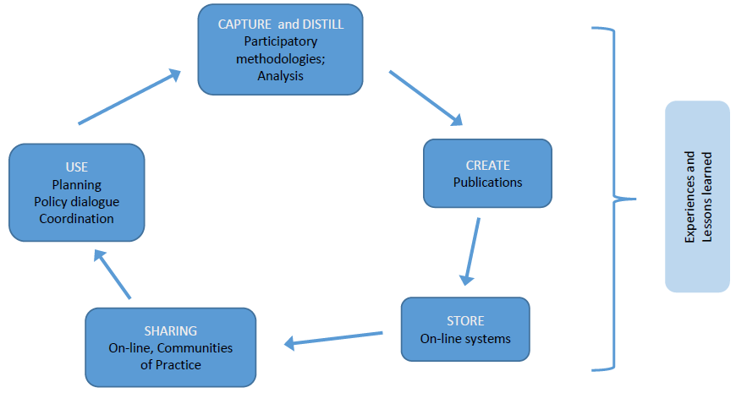

Knowledge management cuts across all areas of project activity, and to realize it, collaboration is essential. KM cuts across research, planning, practice, and learning. It supports organizational objectives through capacity development and depends on the project for information in order to keep the KM cycle active and strengthened, ultimately helping stakeholders make more informed decisions. The KM cycle, if resourced adequately, is reinforcing.
4.2. Objective of the KM strategy
To strengthen access to information and knowledge to support and influence local, national, regional and global policy dialogues on approaches to sustainable urban development and green touristic destinations for adoption.
4.3. Defining KM Strategy
Identification and Prioritization – Since the project will be operating at different levels – the governorate/municipality level and the tourism industry represented by the Egyptian Tourism Federation and Egyptian Hotel Association, and individual owners/operators of hotels & resorts in Sharm El-Sheikh – with a number of pilot scale projects in each and a diversity of stakeholders, there is a need to assess what their on-going knowledge needs are to determine targeted KM support. Identification and prioritization will be carried out by the PMU led by the Project Manager in close consultation with key stakeholders.
Engagement – Across the project area with a diversity of stakeholders, engagement will need to be targeted to specific groups to assess KM effectiveness. Strategic considerations will include:
- Incentivising use of knowledge management systems and products
- Incentivising the generation of knowledge sharing and products by stakeholders
Working S.M.A.R.T – Data quality will depend on getting the right data and ensuring that the data is accurate. A robust monitoring and evaluation plan will support this work.
Less is more – Development of a harmonized results reporting framework to improve the reporting capacity of the stakeholders.
To achieve its objective, the project’s KM Strategy will focus on 3 key areas:
4.3.1 Capacity Development
Capacity building in terms of embedding comprehensive monitoring and evaluation plans for activities will be critical to guide information capture and analysis in the development of knowledge and knowledge products – experience notes, lessons learned and best practices.
To improve the formulation of policies, strategies, and interventions in a sustainable manner, efforts will be made for the development of institutional capacity to generate knowledge solutions through a strategic use of technical assistance resources. Where there is limited local capacity in providing knowledge solutions the project will engage, whenever appropriate and feasible, local institutions for knowledge management activities to build their institutional capacity.
A training needs assessment and a training plan will be developed targeting national and municipal institutions, private sector and CSOs. A detailed training program and action plan will be designed in the first year, and the training program will be implemented throughout the project´s duration. In addition, a Sustainable City Capacity Scorecard will be developed in PY1 to track the improvement of the institutional capacities of the key institutions (and others that may be included during implementation) in planning, implementation and monitoring of urban, resilient, adaptive and sustainable growth. The Sustainable City Scorecard will be completed at mid-term and end of project as part of the project´s M&E (Outcome 4.2).
The specific services to be provided by the Project will be detailed, which may likely include short-term technical assistance and expertise for consultant-led trainings on:
- Institutional capacity building concerning development, management and implementation of sustainable development strategies and action plans at municipal level. Target group: mainly municipal/governorate staff.
- Training of public and private sector representatives on MRV methodologies for GHG and other emission reductions, in line with the SESSDS requirements and international standards
- Technical training activities for public officers/technical staff of utilities concerning design principles, technical specifications and selection criteria for energy & resource efficiency, renewable energy and waste management projects.
- Training activities for hotel staff (technical managers/FM, etc.) on conducting energy assessments/audits in their facilities and implement energy monitoring and management practices in line with international standards and norms (e.g. ISO 50001/50002), including best practices on resource efficiency measures for hotels
- Training activities for public officers and hotel managers/staff on green purchasing (criteria, tech specifications, selection of alternative products to e.g. single-use plastics)
This will entail exchanges regarding relevant previous and ongoing projects funded by the GEF and other donors (see Sections 2.2 The baseline scenario and 3.9 Coordination and partnerships), through exchanges with (former) project staff and government personnel involved, as well as from donors or development agencies, including the UNDP country office environment team due to its quality assurance role in past UNDP/GEF projects. Such trainings and exchanges will benefit from the knowledge products generated under previous projects (e.g. the UNDP-GEF rooftop PV project, and UNIDO GEF solar water heating projects). Useful knowledge products include technical specifications for the selected technology, results of case studies, list of recommended suppliers, design tools, etc. The project will follow up on advancements and commercialization of new technologies in other countries such as hybrid A/C systems than can be suitable for Sharm El-Sheikh. UNDP-GEF RTAs overseeing the project will provide relevant lessons and best practices available from the UNDP-GEF portfolio beyond Egypt.
4.3.2 Knowledge Products by the project
Developing demand-driven knowledge products to support information and knowledge sharing, will include flagship products for the project, such as:
- Training needs assessments, training plans and training materials
- MRV Platform
- Experience Notes and minutes from Technical Coordination Groups
- Lessons learnt by the project, including most notably documented results from the green investment pilot projects (incl. investment costs, payback period, technical feasibility for different introduced technologies, etc.) documented in annual and technical reports, brochures, digital albums, videos, etc.
- Peer-reviewed journal publications
These knowledge products will also capture the gender dimensions and present data in sex-disaggregated format wherever applicable.
Importantly, collaborations and partnerships will play a significant role in effectively operationalizing the KM strategy, and to maintain quality standards. Collaborations and partnerships will be defined in thematic areas by the PMU and subject matter specialists.
For quality assurance, the project’s Technical Team, Planning Team and other personnel will receive training on:
- Documenting lessons learned, best practice and success stories
- Research methodologies and M&E including capturing tacit and explicit knowledge, interviews, producing multi-media resources as determined by their on-going needs, and how to ensure gender is reflected in any knowledge products.
4.3.3 Knowledge Events organised by the project
Opportunities for enhancing knowledge dissemination, sharing and application will be actively explored through the conduct of and participation in meetings, workshops, conferences and similar events. Innovative pilot projects, lessons learned, and best practices will be showcased at these learning events to facilitate knowledge sharing.
Engagement and information and knowledge sharing events will include inter alia:
- The above-mentioned knowledge products on project lessons and results will be disseminated to the targeted stakeholders and beyond to promote replication and upscaling, through seminars to be held in collaboration with the Egyptian Hotel Association, Sharm El-Sheikh Investors Associations and/or Ministry of Tourism. Seminars can include exhibitions for suppliers to present their products in order to connect hotels with suppliers. Once technology is proven and there is large interest for replication, the project will stop providing co-finance and limit support to technical assistance. The successful technologies implemented in Sharm El Sheikh will be conveyed to other municipalities and hotels in Egypt working with the Ministry of Environment, the Green Tourism Unit of the Ministry of Tourism and Antiquities and the Egyptian Hotel Association.
- Public promotion of successes in green hotel practices in Sharm El Sheikh and public sector
- Biennial “Egyptian Green Tourism Award” ceremony and dissemination events
- Municipality/Governorate and Local Government roundtable meetings
- Technical Coordination Groups
- Knowledge fairs, roadshows, competitions, learning events
- Development and dissemination of news and publications
- Final Project Dissemination Conference
5) Knowledge Management implementation priorities
Priority 1: KM Strategy refined and endorsed by the Inception Workshop and approved by the Project Board. Recruitment of Communications and Knowledge Management Officer (refer to ToR in the Annex 7).
Priority 2: KM System development: People, Processes and Platforms
- 2.1 Development of research and analytical frameworks to guide and inform strategies of data, information and knowledge capture/analysis, and monitoring and evaluation for implementation at project localities initially. This will include the identification of thematic knowledge areas, and consistently, the skills thematic areas for networks database;
- 2.2 Development of the Online Community of Practice and information and knowledge sharing forum to include the set-up of project website and social media accounts;
Priority 3: Content Management: Identification and assignment of knowledge management activities to project staff, local and central government officials, private sector, NGOs and community level stakeholders. The value of editorial/creative content management cannot be overemphasized, since knowledge management will not succeed if there are no workers and managers whose primary duties involve gathering, editing and re/packaging knowledge.
Priority 4: Development of a KM monitoring and evaluation framework. Any amendments to the framework will be managed by the Communications and Knowledge Management Expert.
6) Risk management
Knowledge Management activities are an integral part of the project and will be supported through ongoing and pipelined technical advisory support. Closer coordination will also be made with local and central government and the Community of Practice to assess knowledge needs and mobilize project expertise, collaboration or partnerships to respond to District needs for knowledge solutions.
RISKS | RISK MITIGATION
- Dis-incentivisation of knowledge sharing – information monopolies for competitive advantage | Incorporate into work plan and partnerships
- Under-resourcing:  - Operational costs for data and information collection, publications, storage and dissemination  - Pipelined costs for technical assistance for capacity building in information capture and analysis for the development of knowledge products, publications | Develop a costed annual Communications and KM work plan
- No specific identification and accountabilities towards content developers/development | Incorporate into TORs and work plans
- Not sufficiently incentivised | Explore cost effective incentives and/or knowledge partnerships
- Lack of measuring impact | Develop a performance indicator framework for KM
- Behaviour change | Behaviour change strategy and monitoring and evaluation plan developed
7) Monitoring and evaluation
The project will develop a system for capturing and measuring KM access, sharing and use. Measurement data and analysis should be used to inform and calibrate the strategy as an indication of performance. At present, mechanisms that ensure the regular monitoring of tangible data on tourism impacts continue to be limited in Egypt. Yet, for the health and competitiveness of destinations like Sharm El Sheikh that rely on irreplaceable natural treasures such as its coastline and marine resources, monitoring mechanisms that generate regular insights into impacts empower stakeholders with tangible evidence in the management, preservation and maintenance efforts of the environment to which they are connected.
The progress of implementation of Knowledge Management activities may be monitored closely through the following indicators. The project will support the establishment of a MRV system at local level, which will provide regular, reliable and context-specific insights for the sustainable development of tourism in Sharm El Sheikh and in the region, and will consequently play a key role in the effective monitoring and implementation of the SESSDS and Action Plan.
Monitoring, reporting and verification will involve the systematic collection and analysis of information based on planned activities and set targets during the implementation of the urban sustainable development strategy and activities, where the data collected accords with a set of performance indicators relevant to the measurement of the progress made towards greening Sharm. A platform for Monitoring, Reporting and Verification (MRV) will be developed to guide and adapt the Sharm El-Sheikh urban infrastructure use and sustainable development plans over time.
The monitoring platform will be based on ongoing successful experiences and will monitor sustainable city indicators based on indicators developed by the Global Platform for Sustainable Cities (GPSC) as well as other indicators that may be identified specifically for the case of Sharm. Monitoring will include project relevant impact indicators (e.g. resource efficiency and energy use, sustainable transport, solid waste management and chemicals, biodiversity, GHG & UPOP emissions). In addition, management efficiency indicators related to integrated planning, transparency and citizen participation will be defined and monitored.

Annex 22: Initial Project Procurement Plan (Year 1)
The national Implementing Partner / Executing Agency shall, with support from UNDP, through the project management unit, update the procurement plan throughout the duration of the project at least annually by including contracts previously awarded. The procurement plan below is merely an indication and, due to the volatility of various costs and the necessity for adaptive management, is subject to change during implementation. As a result, there should be room for flexibility during project implementation.

Project Name: Enhancing Biodiversity Conservation and Sustainable Land and Natural Resource Management
Country: Green Sharm El-Sheikh | Implementing Partner: Ministry of Environment
Tentative Date of First Procurement: 01 April 2022 | Date of this Procurement Plan: 22 September 2021

1. Project Procurement Thresholds

The following UNDP procurement thresholds shall apply to procurement of goods, services and works:

Procurement method | Contract value | Type of requirement | Method of solicitation | Type of competition
Micro-purchasing | Below US $5,000 | Goods, services or simple works | Canvassing (by phone, internet, shopping, etc.) | Limited international or national
Request for quotation | US $5,000-$149,999 | Goods, services or simple works | Written request for quotation | Limited international or national
Invitation to bid | US $150,000 and above | Goods or works | Advertisement in international media | Open international
Request for proposal | US $150,000 and above | Services | Direct invitation or negotiation | Open international
Direct contracting | Any amount within permissible circumstances | Services, goods or works |  | None

2. Prior or Post Review

The following UNDP prior or post review requirements apply to the various procurement and consultant recruitment methods used for the project.

 | Level 1 (Country): | Level 2 (Regional): | Level 3 (HQ):
 | Contracts, Assets and Procurement Committee | Regional Advisory Committee on Procurement  (country offices only) | Advisory Committee on Procurement
Competitive procurement process
Any contract or series of contracts including amendments to be awarded to a vendor in a calendar year that in aggregate has a cumulative value: | Above US $50,000 (above US $100,000 for Individual Contracts) and up to the standard delegated procurement authority – Direct Review by CAP Chairperson  Above the standard delegated procurement authority and up to any increased delegated procurement authority – by CAP Committee | Above the delegated procurement authority and up to US $2 million (applies per year for Long-Term Agreements) | Country offices: above US $2 million (applies per year for Long-Term Agreements)
Direct contracting
Any contract or series of contracts, including amendments to be awarded to a vendor in a calendar year that in aggregate has a cumulative value: | Above US $50,000 and up to 50 percent of the standard delegated procurement authority – Direct Review by CAP Chairperson  Above 50 percent of the standard delegated procurement authority and up to 50 percent of any increased delegated procurement authority – by CAP Committee | Above 50 percent of the delegated procurement authority and up to US $2 million (applies per year for long-term agreements) | Headquarters units: above 50 percent of the delegated procurement authority  Country offices: above US $2 million (applies per year for long-term agreements)
Amendment of all contracts
Any amendment or series of amendments to a contract which, in aggregate, increases the contract value by 20 percent or the delegated procurement authority, whichever is less: | Above US $50,000 and up to the standard delegated procurement authority – Direct Review by CAP Chairperson.  Above the standard delegated procurement authority and up to the increased delegated procurement authority - by CAP Committee | Above the delegated procurement authority and up to US $2 million (applies per year for long-term agreements) | Country offices: above US $2 million (applies per year for long-term agreements)
Ex ante review
Ex ante review refers to the review of the procurement strategy roadmap prior to commencement of the procurement process for complex procurement actions with a value: | N/A | Above US $1 million and up to US $2 million (applies per year for long-term agreements) | Above US $2 million (applies per year for long- term agreements)
Notes:
1. The procurement support unit shall participate when requested in the committee review of ex ante submissions.
2. An ex ante review is not required if:
(a) The business unit has had a previous successful experience in the procurement of similar goods/services/works that was already subject to an ex ante review; or
(b) There is sufficient specific corporate guidance and templates on the procurement of the said goods/services.
3. Irrespective of the above, the procurement authority may submit the cases for ex ante review if significant risks are perceived.

No | General Description | Contract Value USD  Year 1  (cumulative) | Procurement Method | Procurement By | No of Contracts | Advertisement Date (quarter/year) | Implementation Start date (quarter/year) | Prior or Post review
Procurement Plan Table 1: Expected Goods and Non-Consulting Services under the GEF project “Green Sharm El-Sheikh” for Year 1
1 | One project vehicle | 37,000 | Request for quotation | IP | 1 | Q3/2021 | Q3/2021 | PRIOR
2 | Vehicle insurance. USD 1000/car/year * 6 years | 1,000 | Request for quotation | IP | 1 | Q3/2021 | Q3/2021 | PRIOR
3 | Vehicle maintenance. USD 2000/car/yr * 6 years | 2,000 | Request for quotation | IP | 1 | Q4/2021 | Q4/2021 | PRIOR
4 | Rent three flats, two offices in Cairo and Sharm and accommodation in Sharm for Technical Officers USD 1500/month*8 month in the first year | 12,000 | Request for quotation | IP | 3 | Q3/2021 | Q3/2021 | PRIOR
5 | (Laptop @USD 1000*7) + Printer @USD 600*2 + photocopier @USD 1500+ mobile phones @USD 300*7 + wifi router@USD 300 | 12,000 | Request for quotation | IP | 1 | Q3/2021 | Q3/2021 | PRIOR
6 | Office Furniture including 7 desks, 7 chairs, 4 cabinets, etc. | 12,000 | Request for Quotation | IP | 1 | Q3/2021 | Q3/2021 | PRIOR
Procurement Plan Table 2: Expected Work Contracts under the GEF project “Green Sharm El-Sheikh for Year 1
1 | National Consulting Firm to refine Sharm Sustainable Development Master Plan | 20,000 | Request for Proposal | IP | 1 | Q3/2021 | Q3/2021 | PRIOR
2 | Co-finance CCM pilot Projects | 20,000 | MOUs | IP | 1 | Q4/2021 | Q4/2021 | PRIOR
3 | National company to support design pilot installation of new technologies in PAs (e.g. anchoring systems, waste collection and disposal from boats and piers | 20,000 | Request for quotation | IP | 1 | Q4/2021 | Q4/2021 | PRIOR
Procurement Plan Table 3: Table 3: Expected Consultancy Services under Green Sharm El-Sheikh Project for Year 1
1 | National Project Manager USD 3700/month*10m in the first year | 37,000 | IC | IP | 1 | Q3/2021 | Q3/2021 | PRIOR
2 | Local Project Coordinator USD 2300/month *8 m in the first year | 18,400 | IC | IP | 1 | Q3/2021 | Q3/2021 | PRIOR
3 | BD/Gender Technical Officer USD 1600/month* 8 m in the first year | 12.800 | IC | IP | 1 | Q3/2021 | Q3/2021 | PRIOR
4 | Environmental Safeguards/CCM Technical Officer USD 1600/month* 8 m in the first year | 12,800 | IC | IP | 1 | Q3/2021 | Q3/2021 | PRIOR
5 | MRV/CCM Technical Officer USD 1600/months* 8m in the first year | 12,800 | IC | IP | 1 | Q3/2021 | Q3/2021 | PRIOR
6 | Communication/KM Officer (Cairo Office) USD 1300 /month* 6 m for the first year | 7,800 | IC | IP | 1 | Q4/2021 | Q4/2021 | PRIOR
7 | Admin/Finance/Procurement Officer (Cairo Office) USD 1300/month* 8 m in the first year | 10,400 | IC | IP | 1 | Q3/2021 | Q3/2021 | PRIOR
9 | Driver USD 700/month *6 m in the first year | 8,400 | IC | IP | 1 | Q3/2021 | Q3/2021 | PRIOR
10 | SEIA Consultants | 201,000 | IC | IP | 3 | Q3/2021 | Q3/2021
11 | CCM National Consultants | 10,000 | IC | IP | 3 | Q4/2021 | Q4/2021 | PRIOR
12 | BD National Consultant | 10,000 | IC | IP | 3 | Q4/2021 | Q4/2021 | PRIOR
14 | BD International Consultant | 8,000 | IC | IP | 1 | Q4/2021 | Q4/2021 | PRIOR

Annex 24: Background Report: Biodiversity and Protected Areas
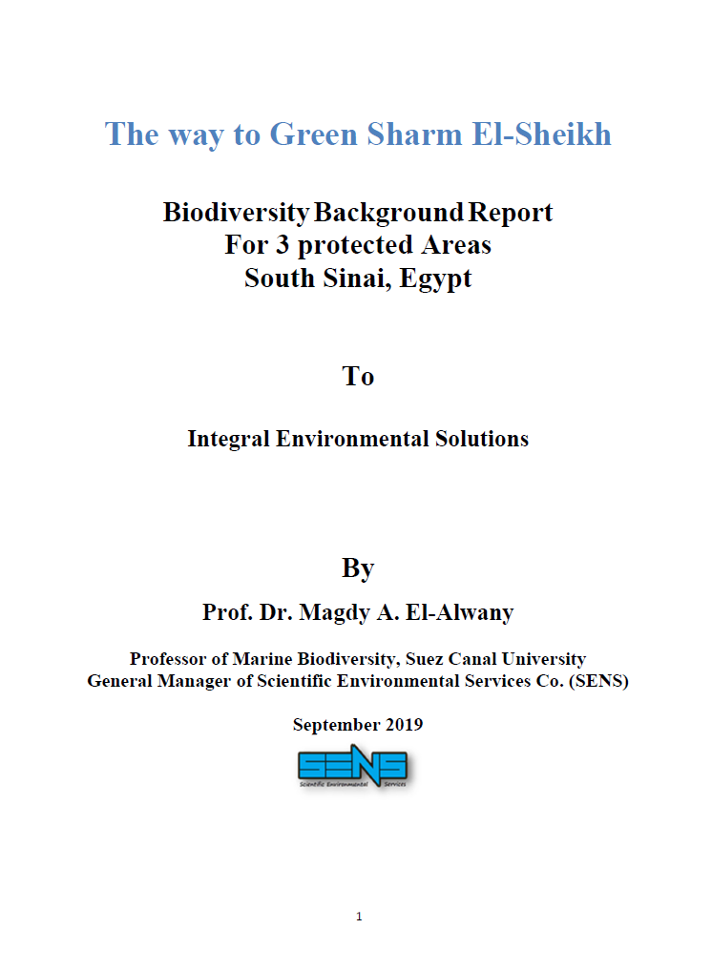

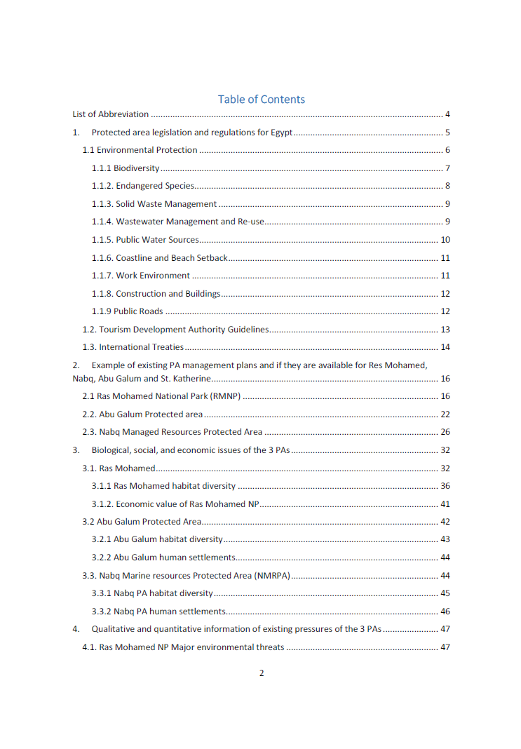
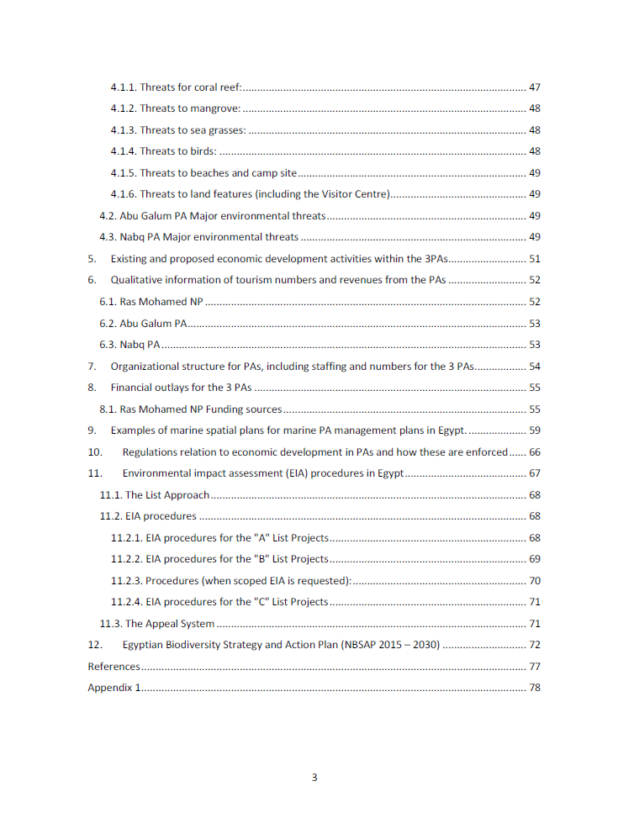
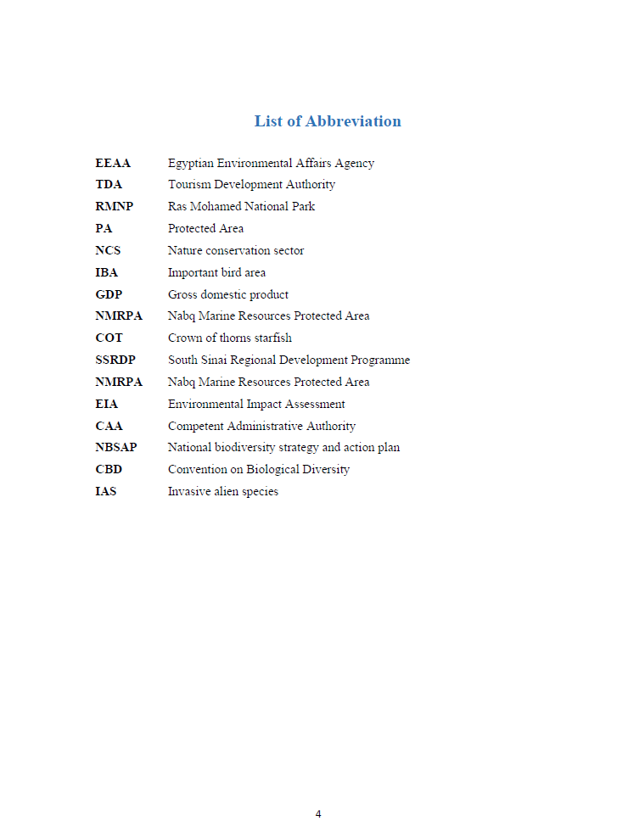
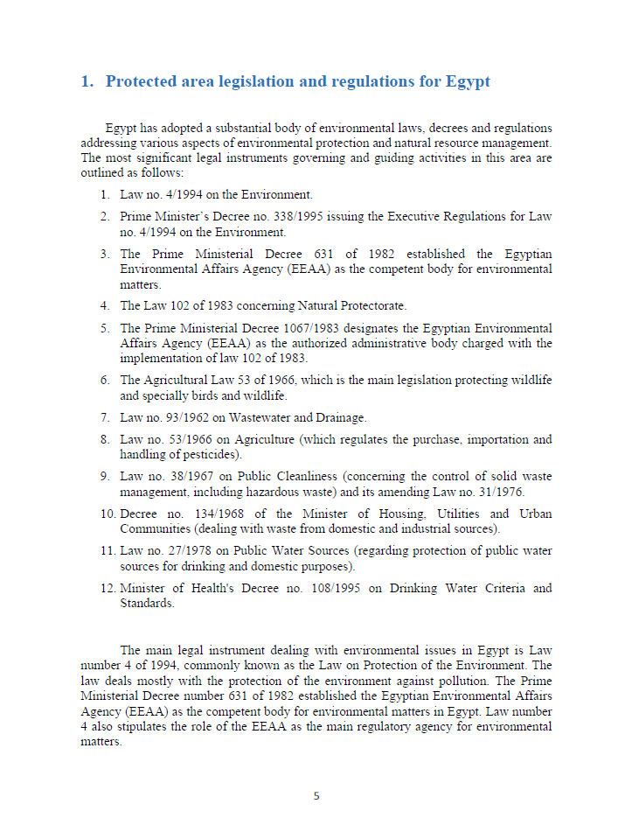
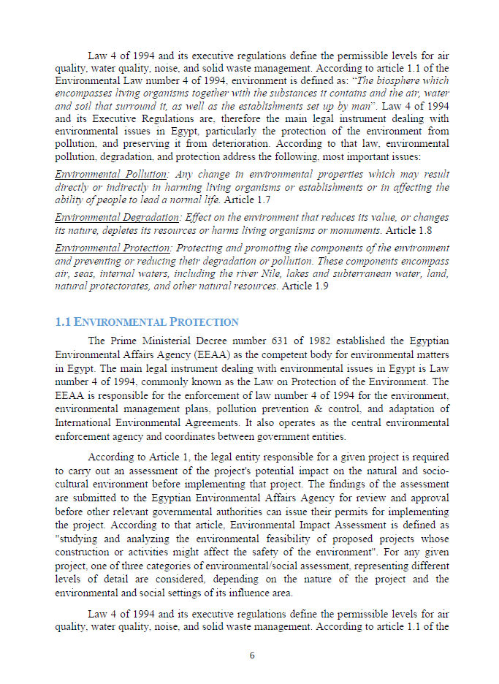
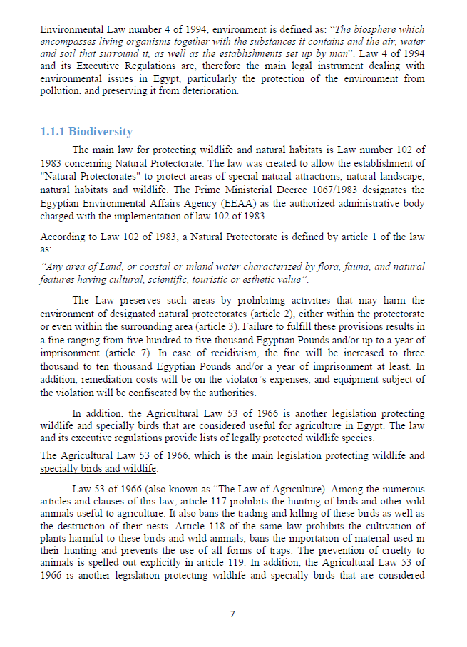
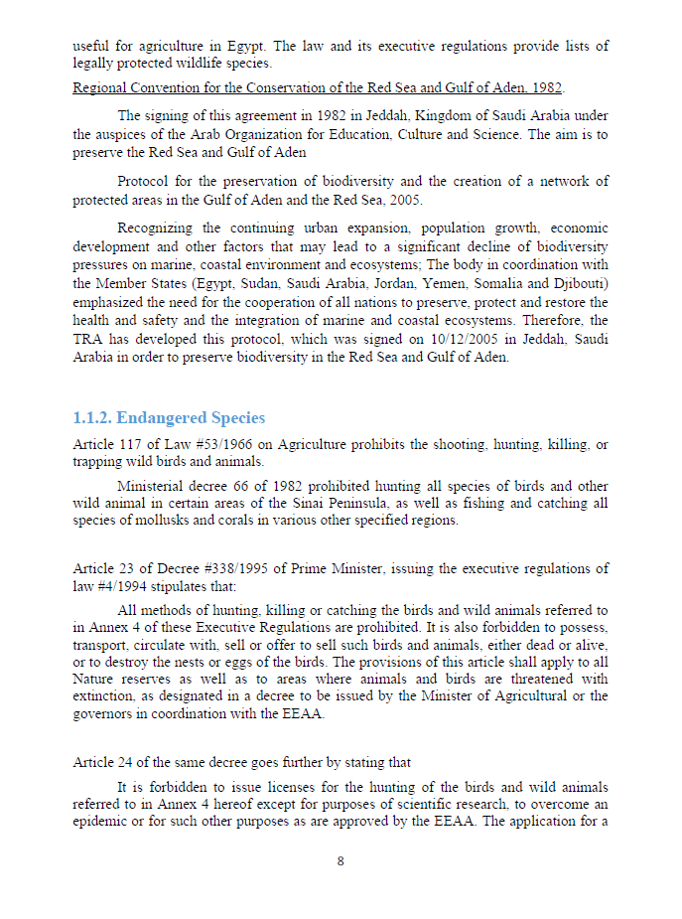
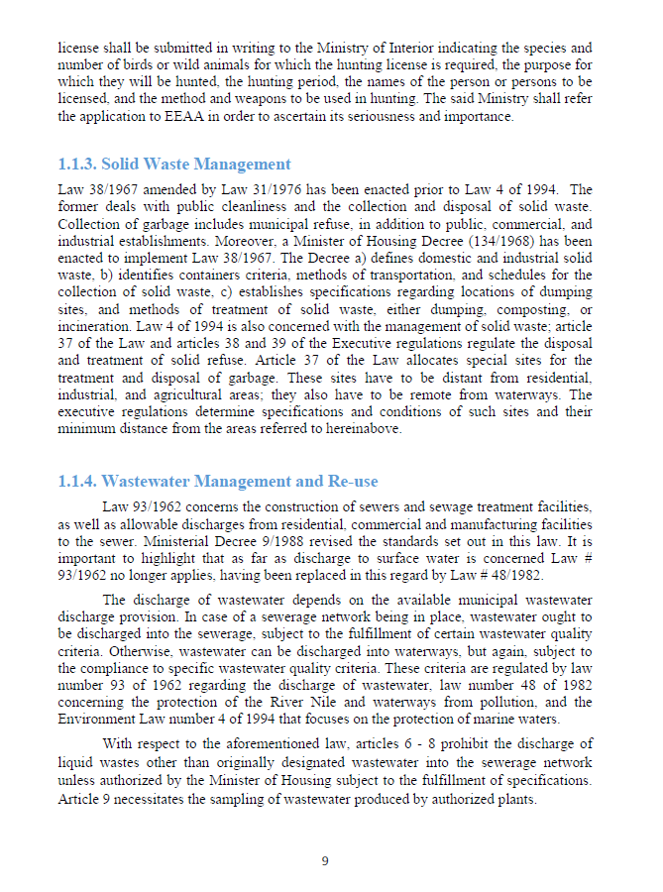
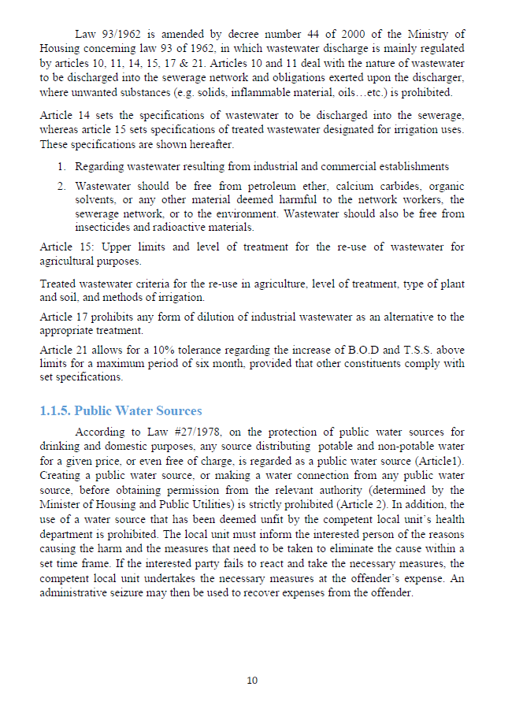
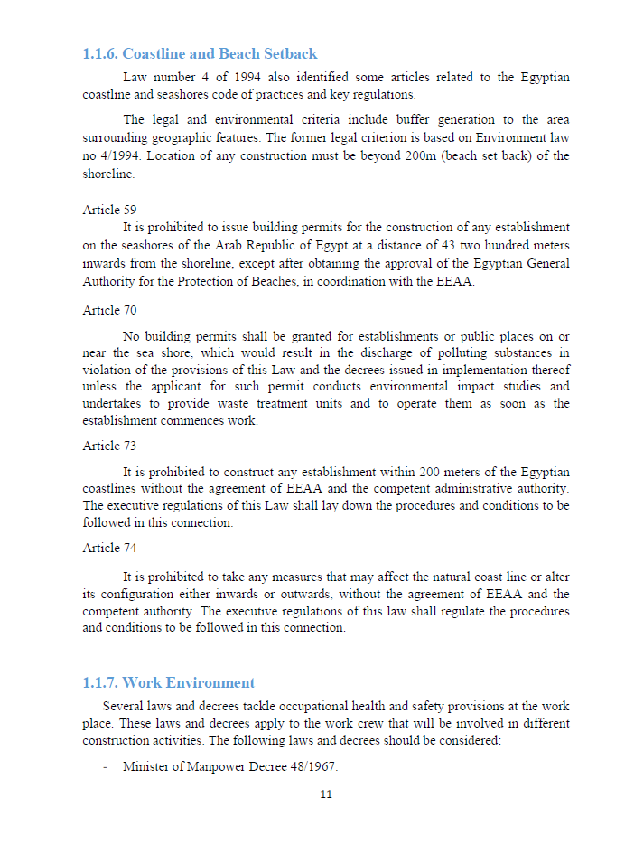
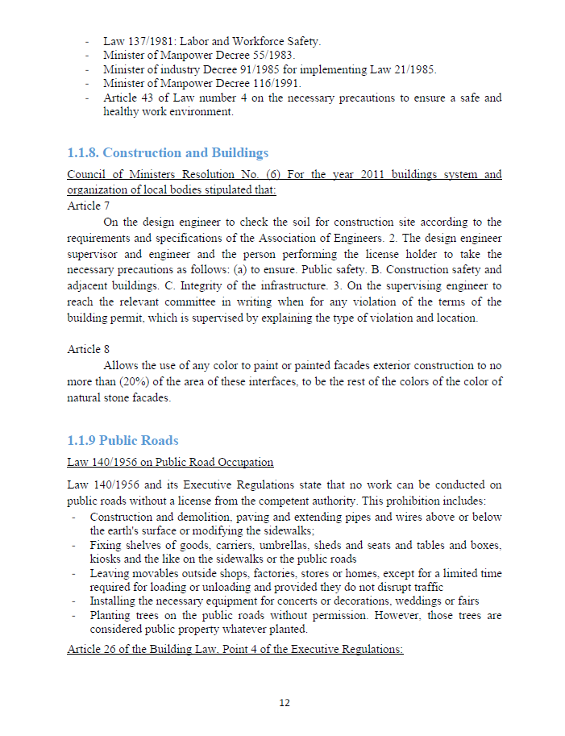

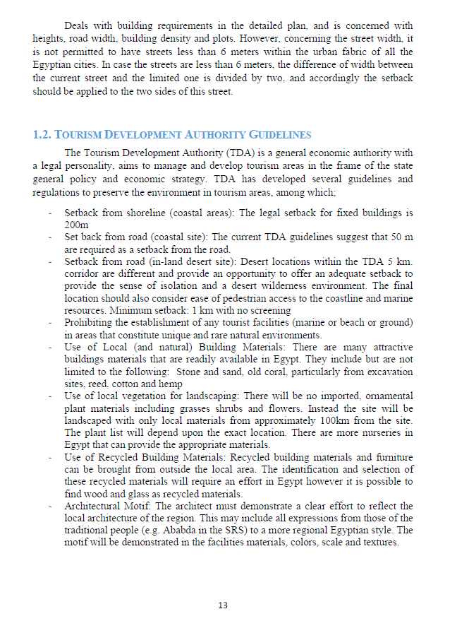
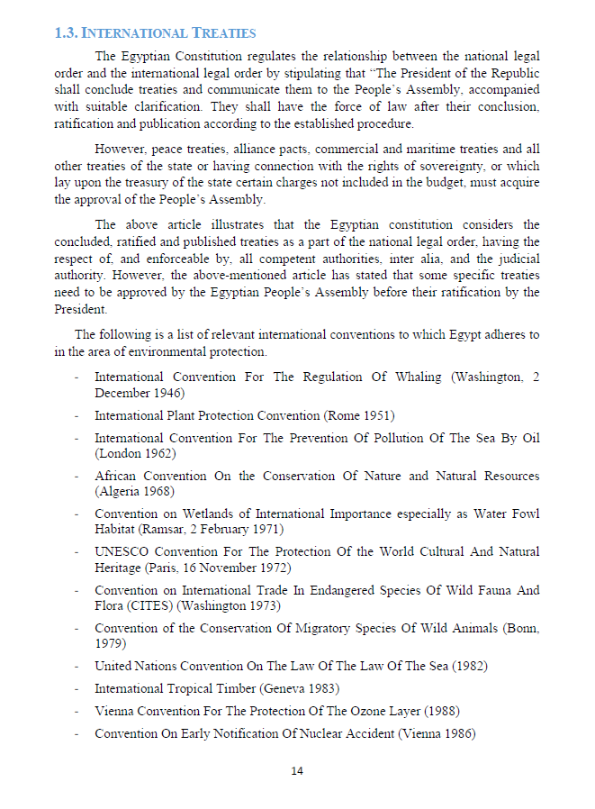


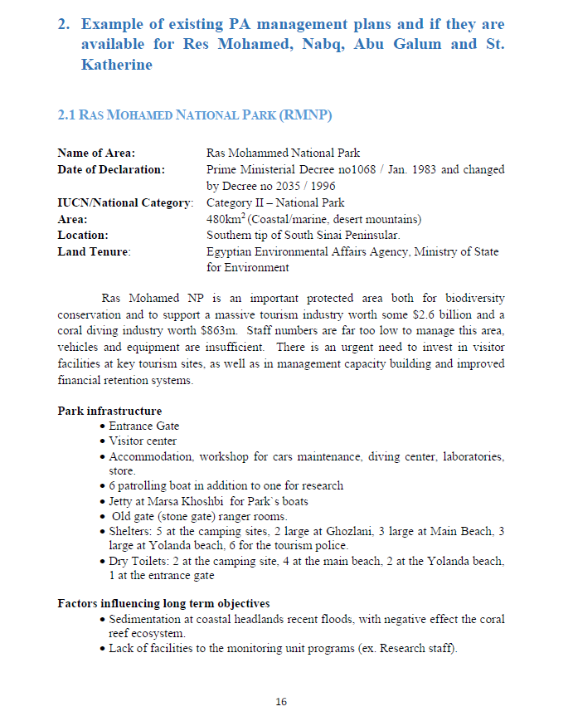

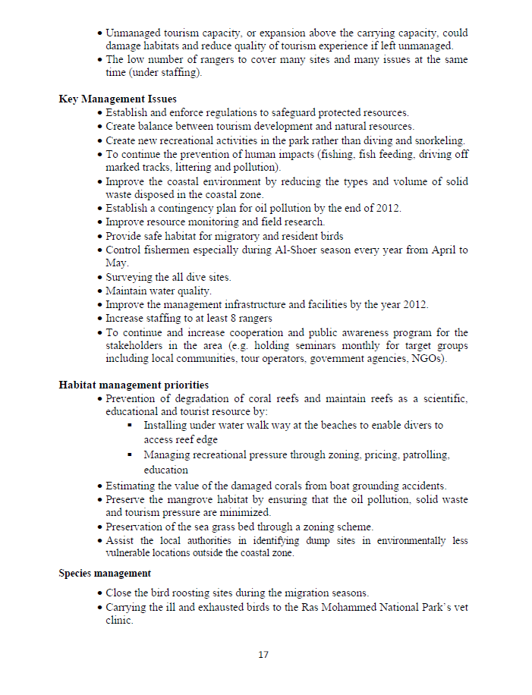

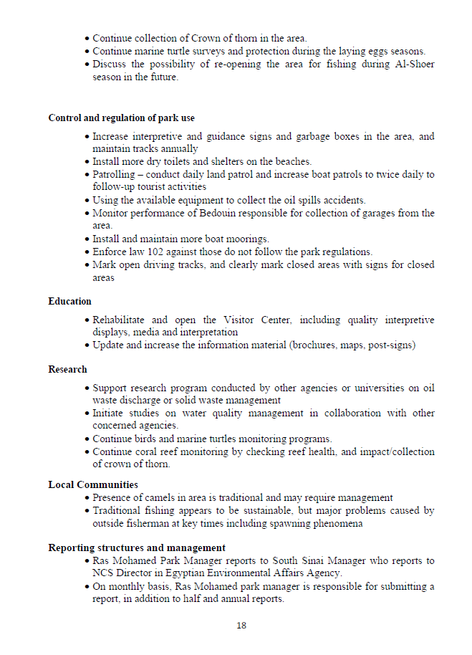
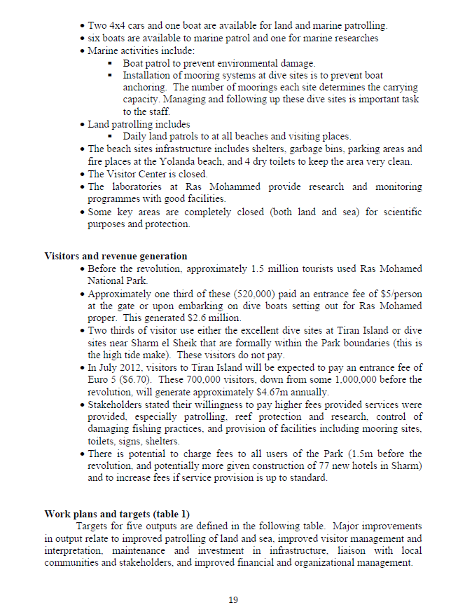
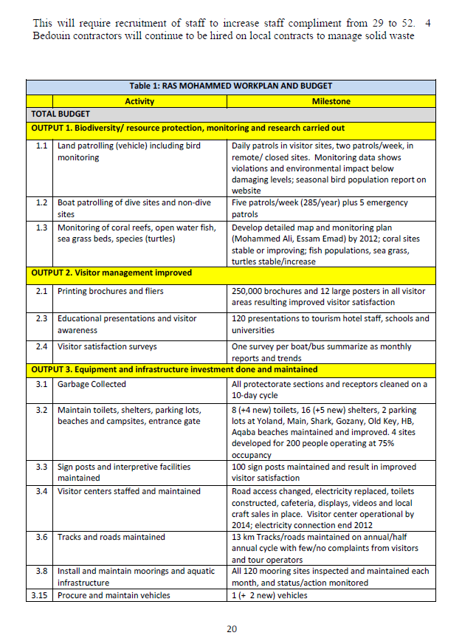
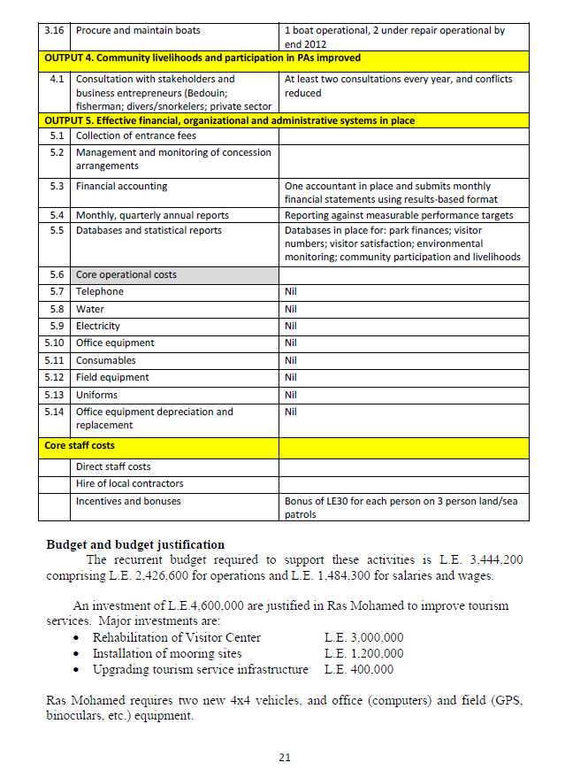
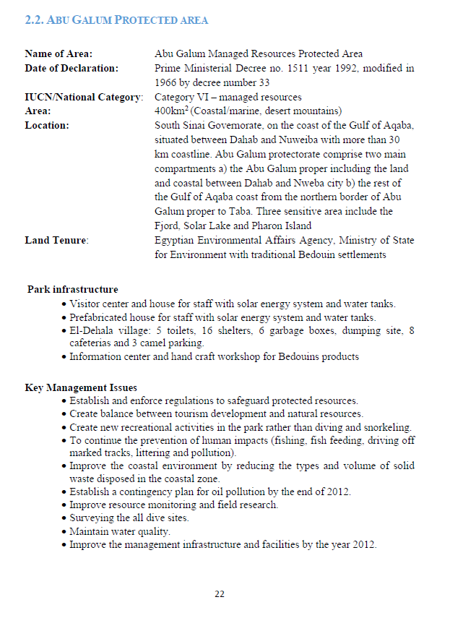

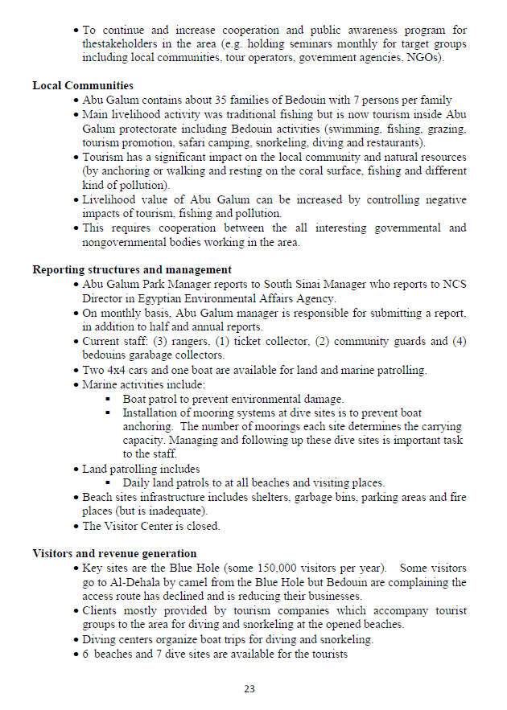
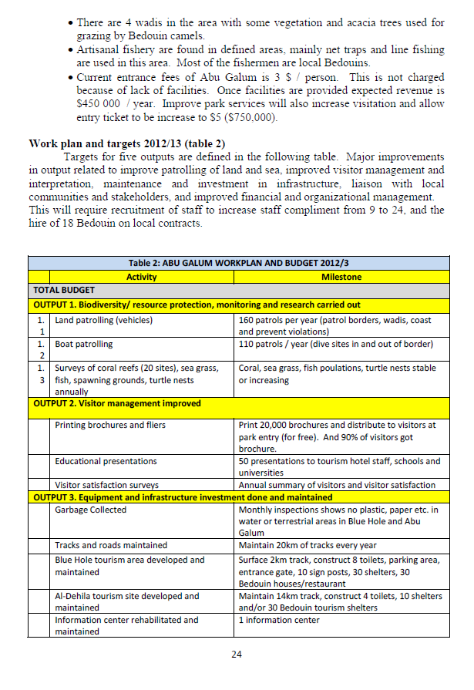
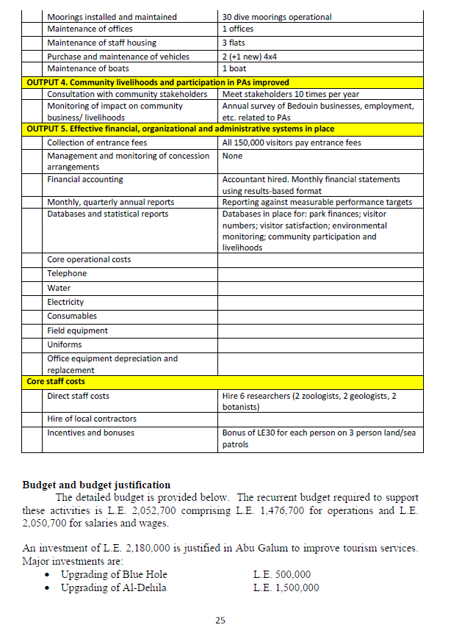
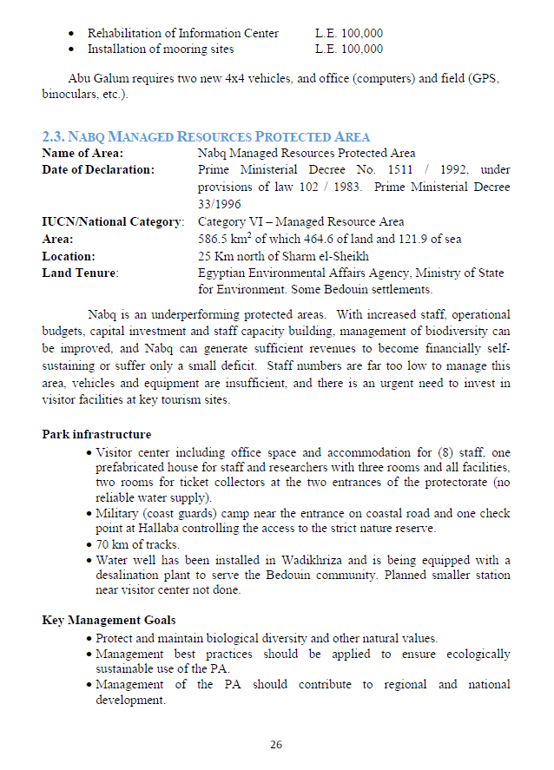
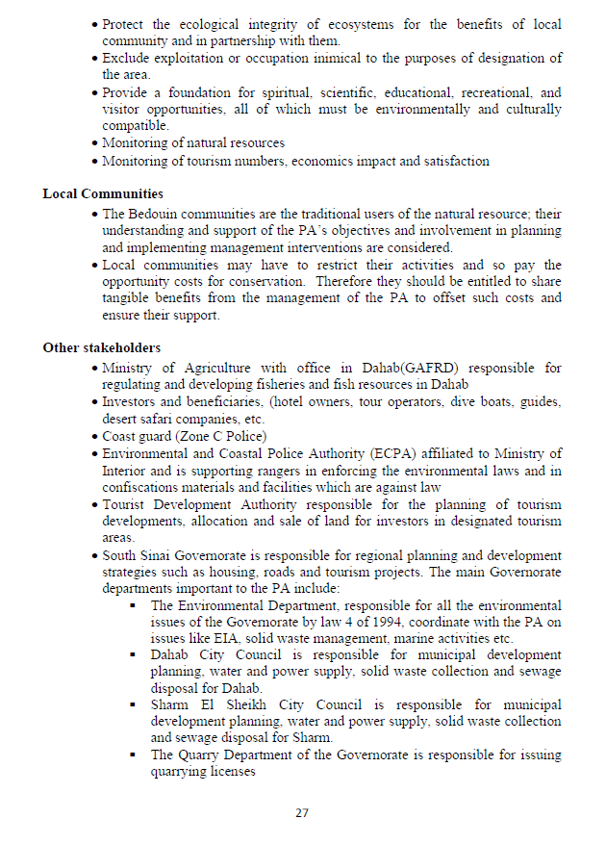
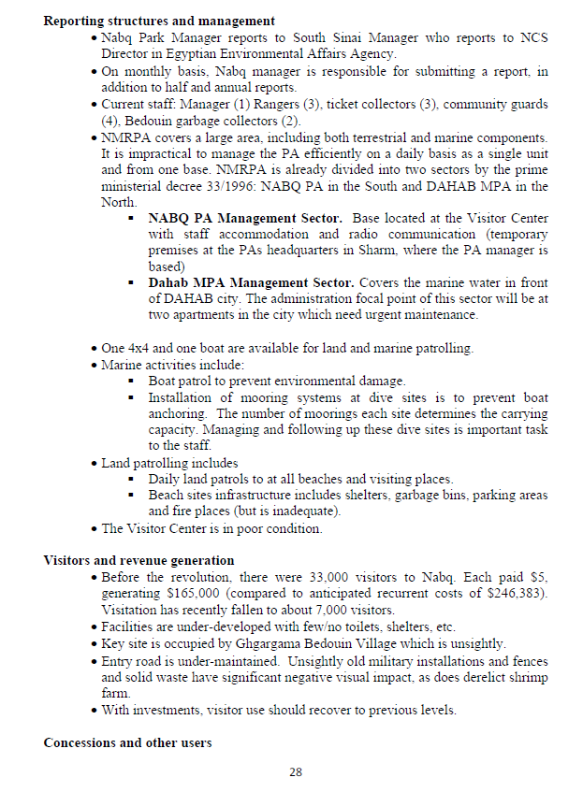

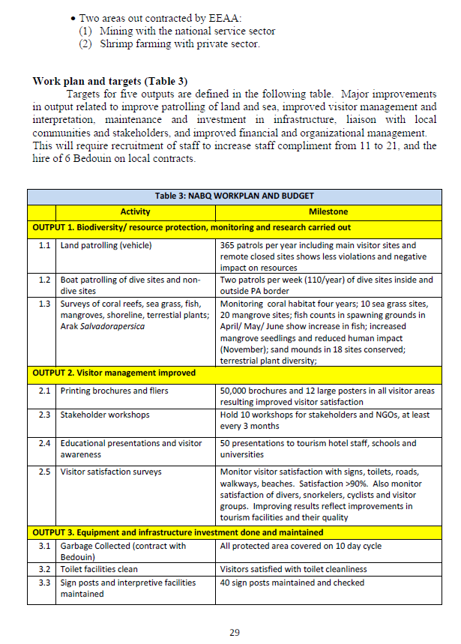
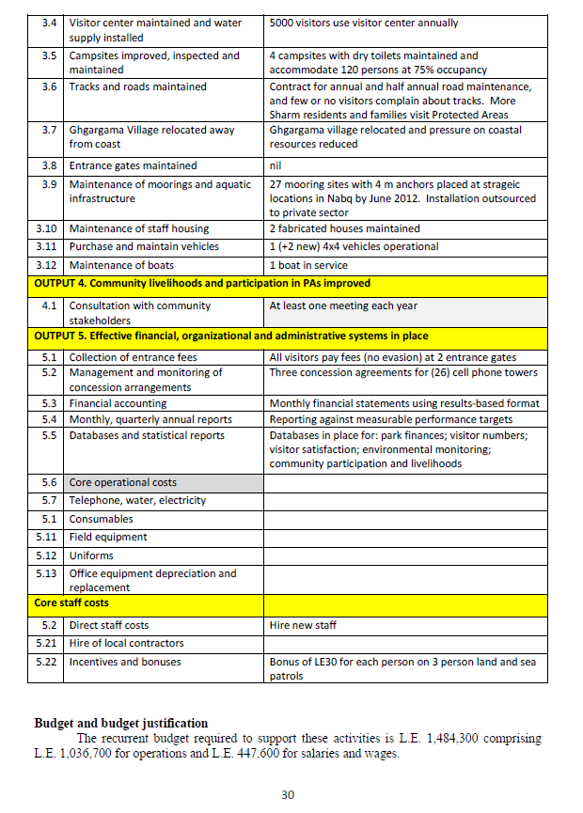

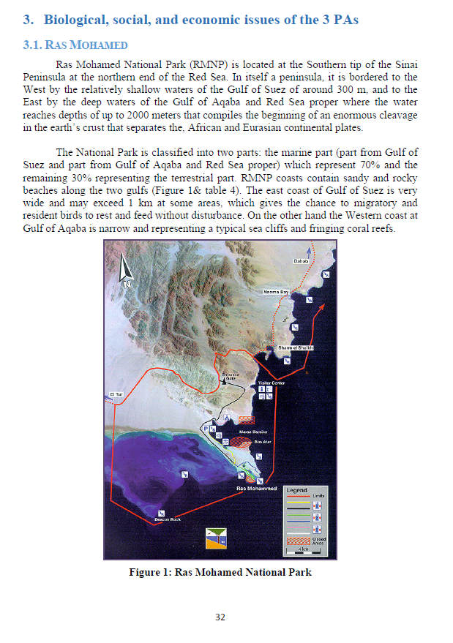
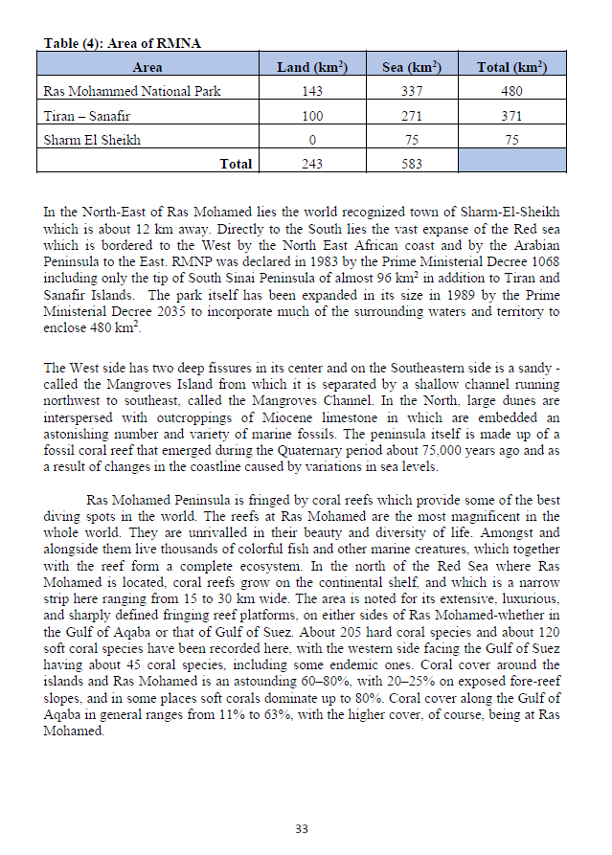
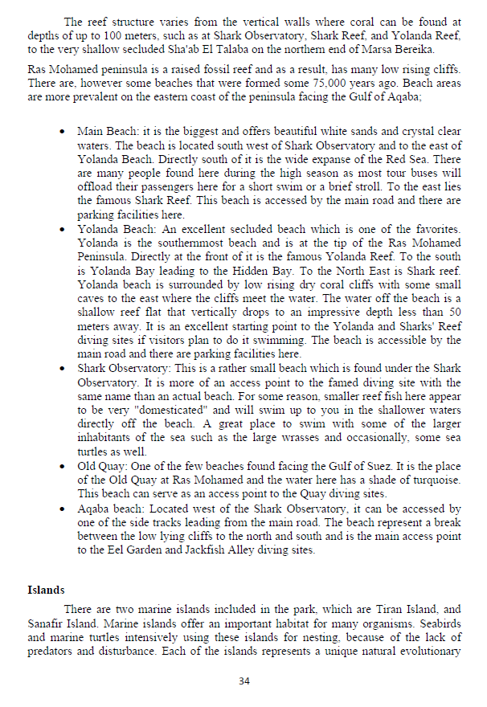

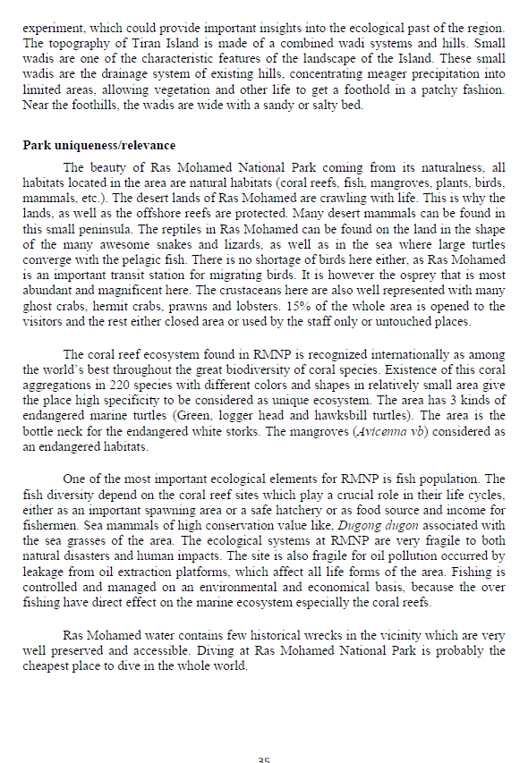
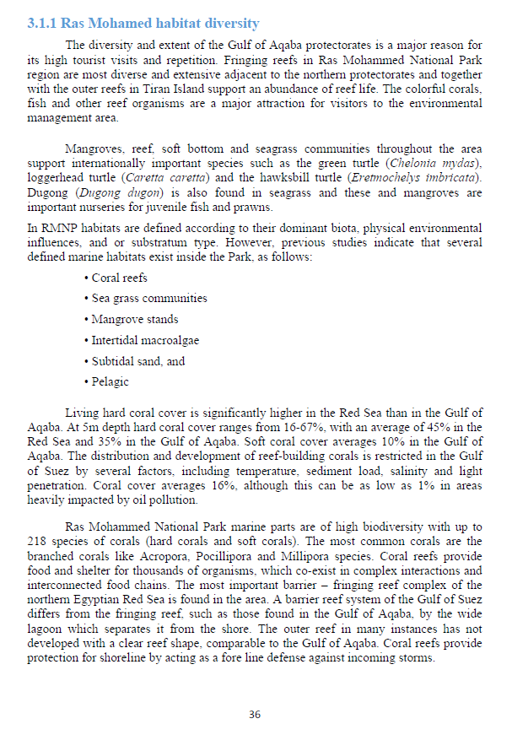

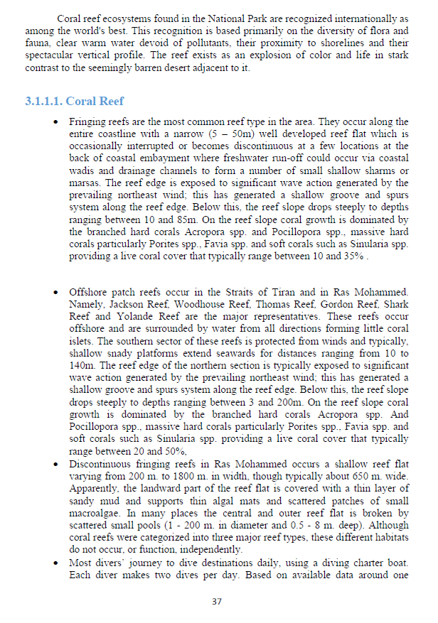
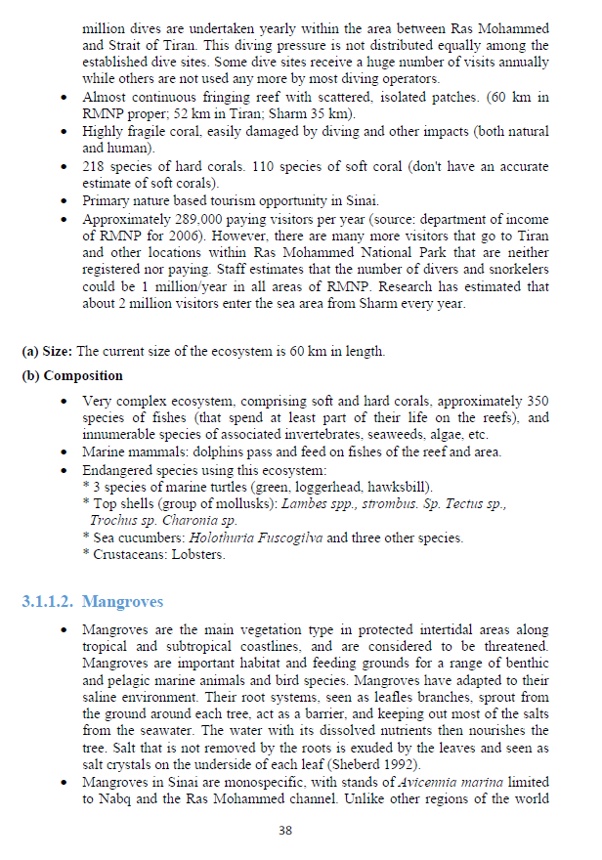

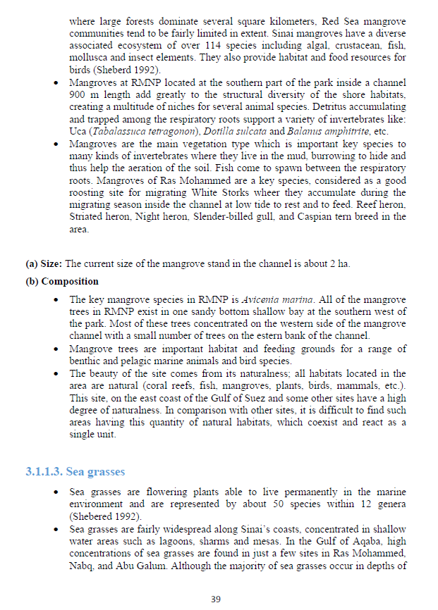
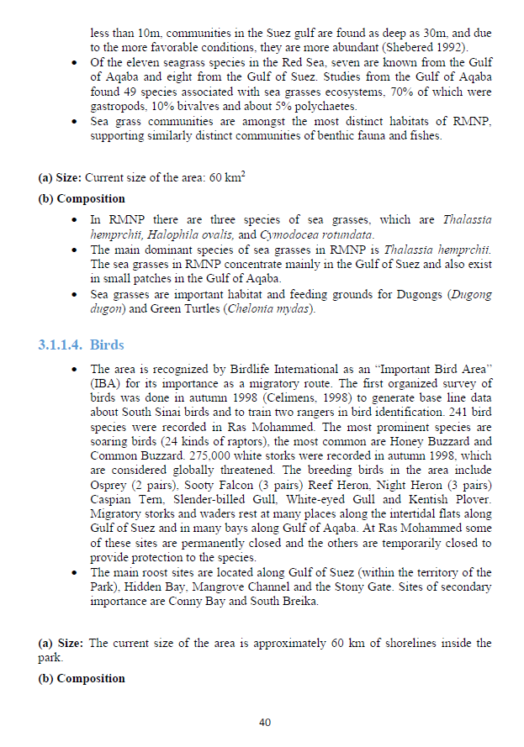
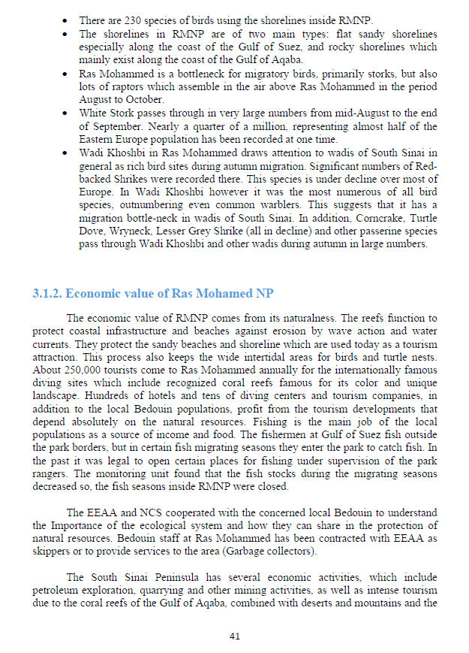

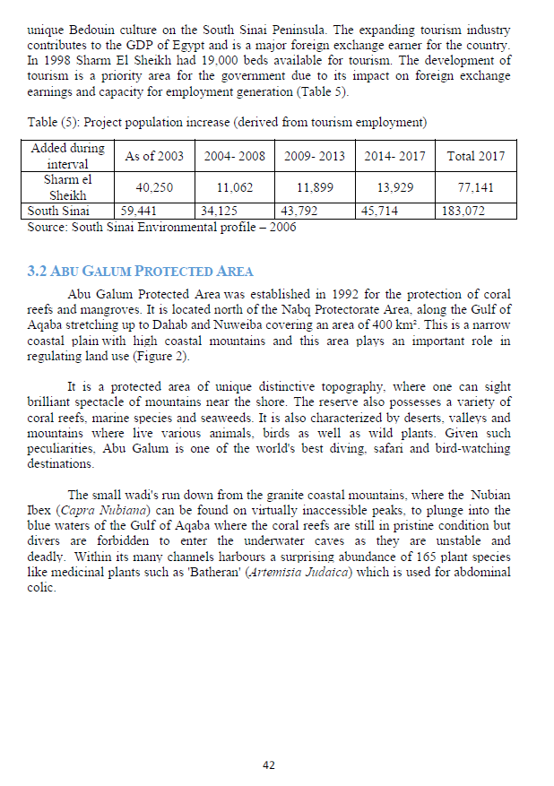

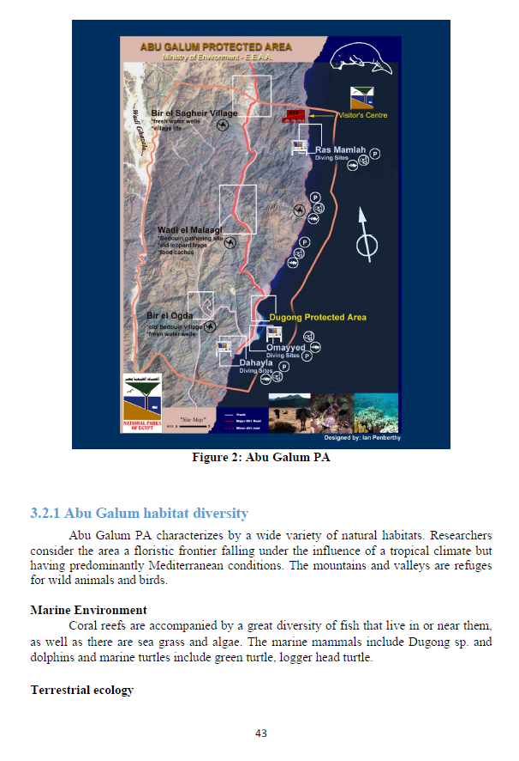
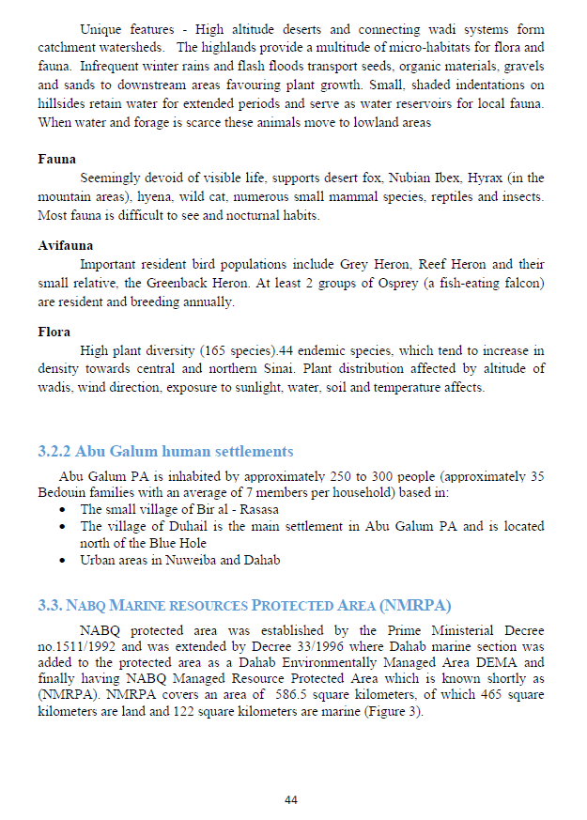

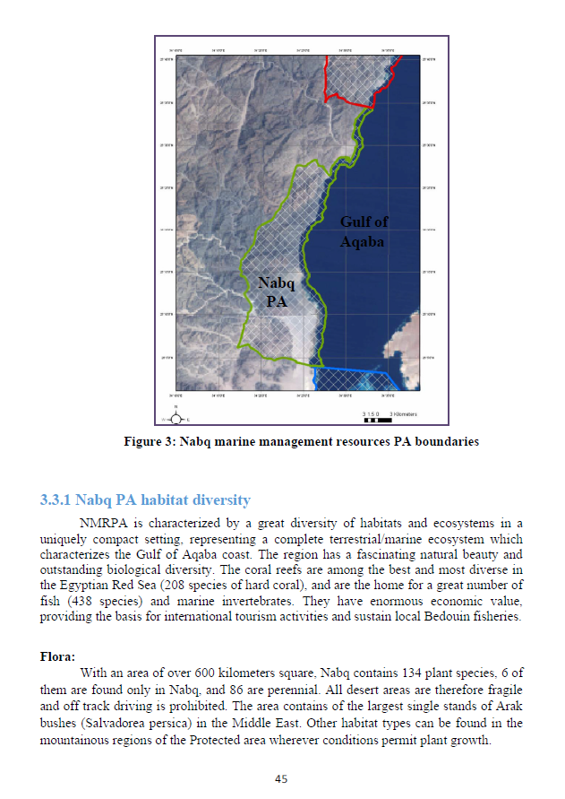
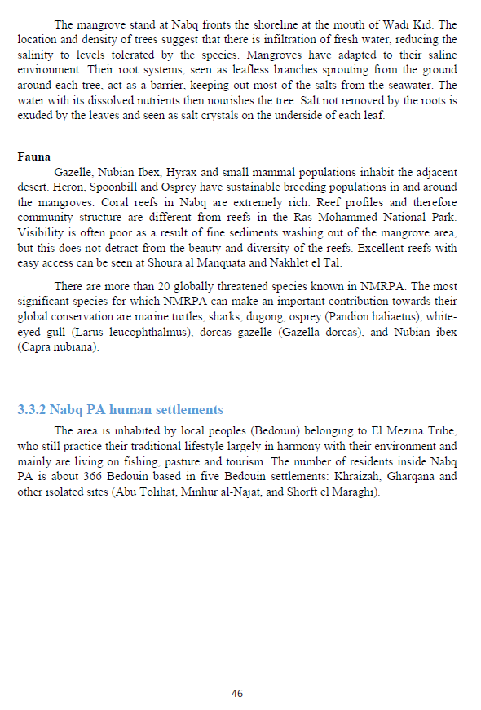
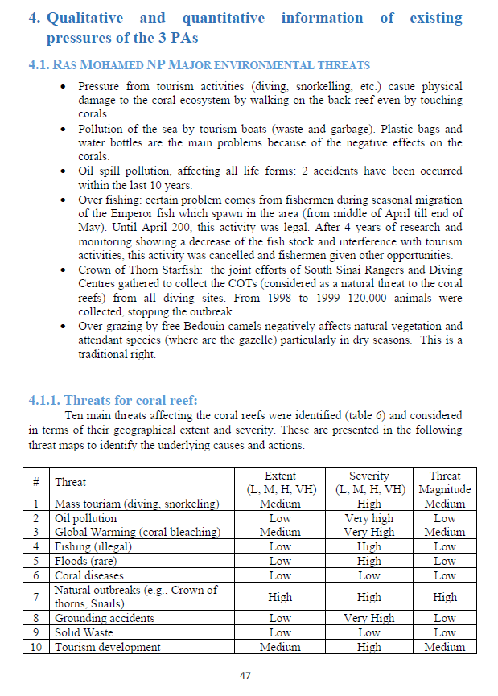

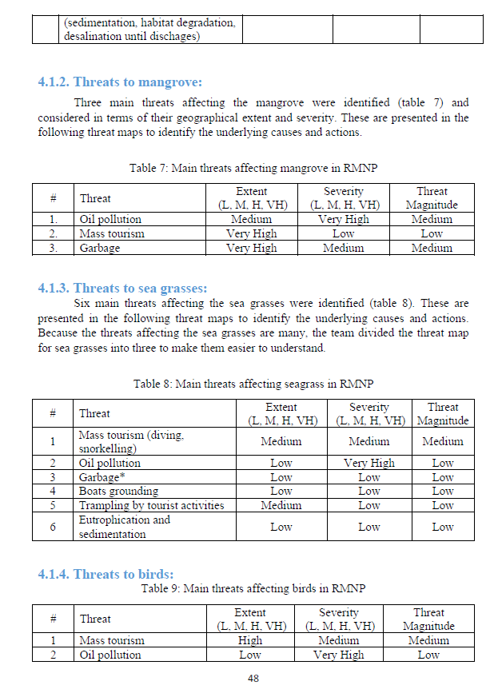
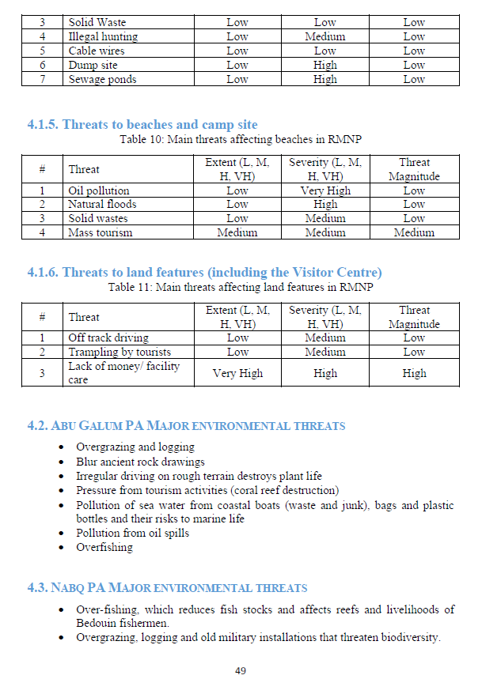
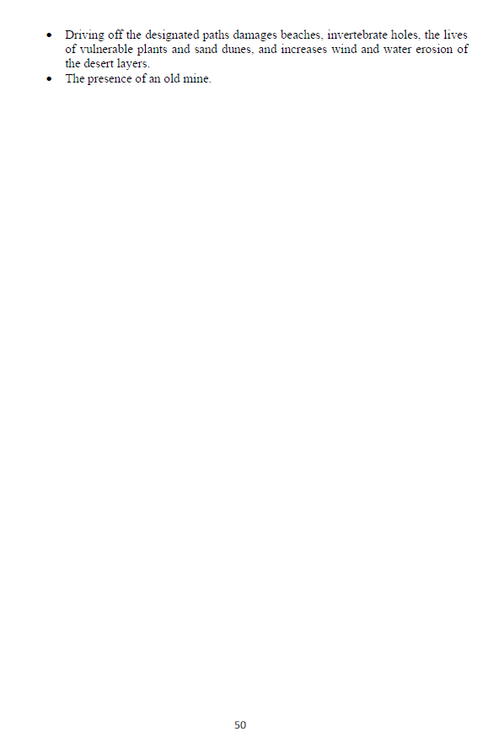

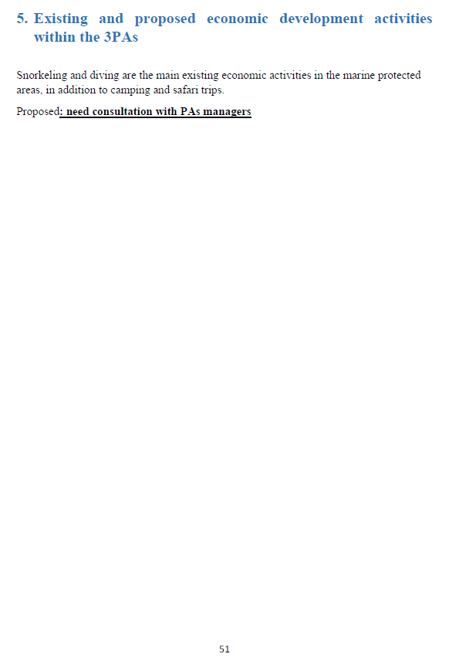

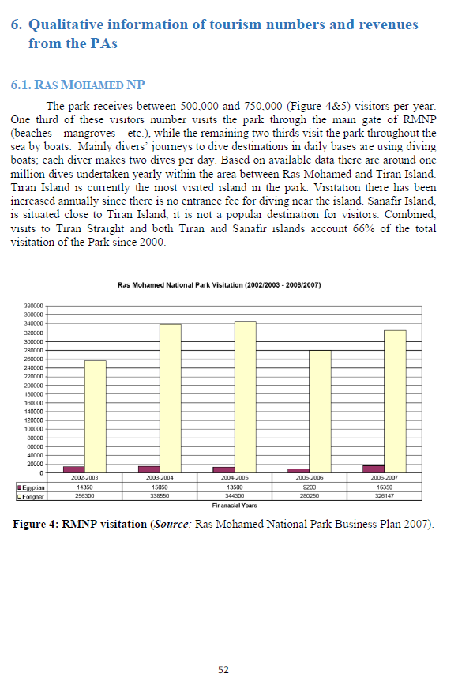

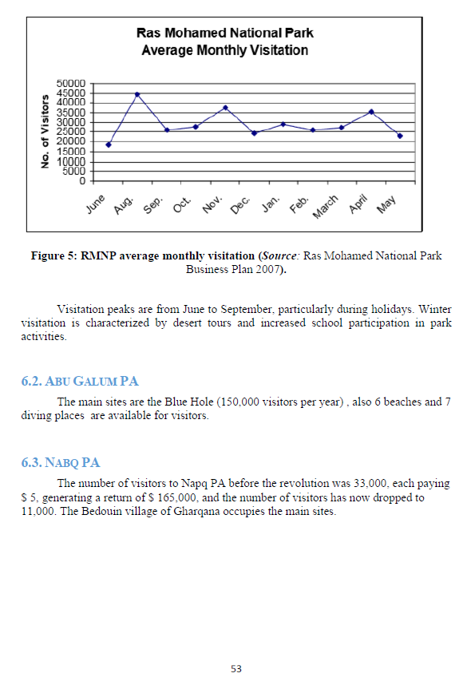

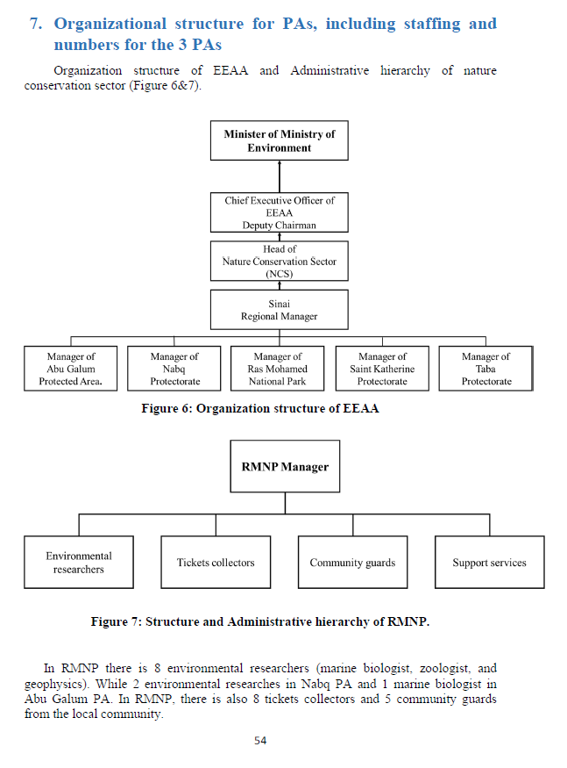

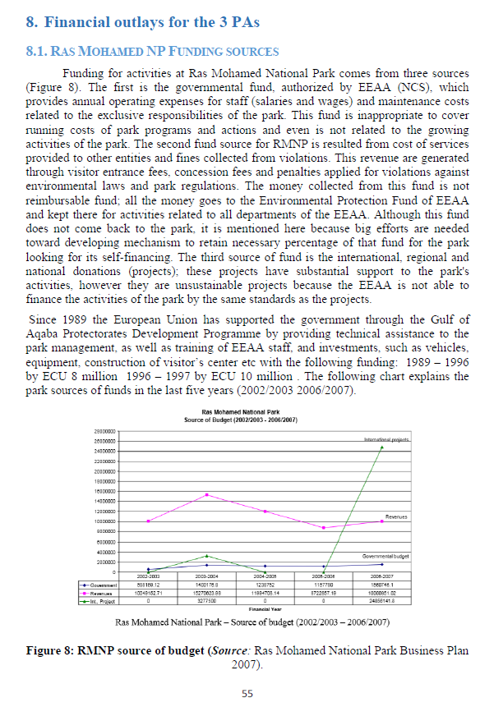
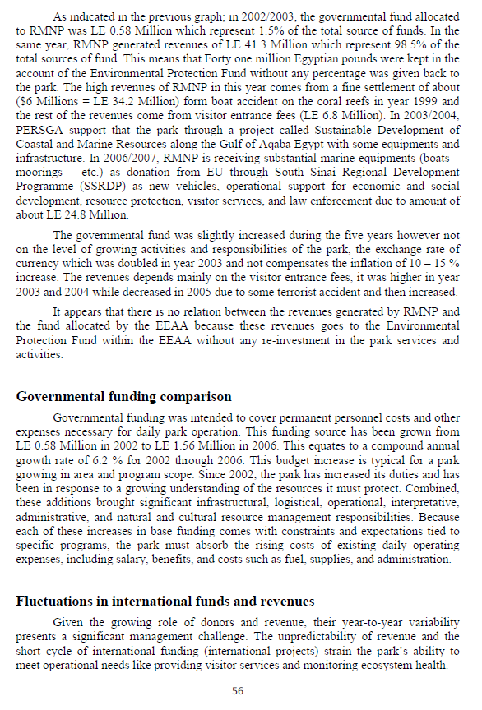

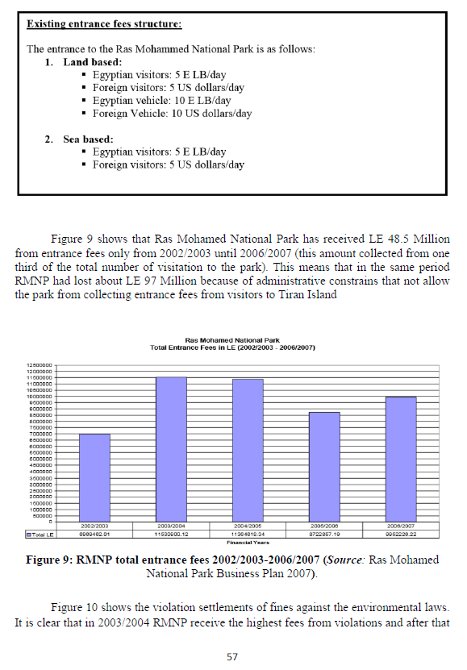
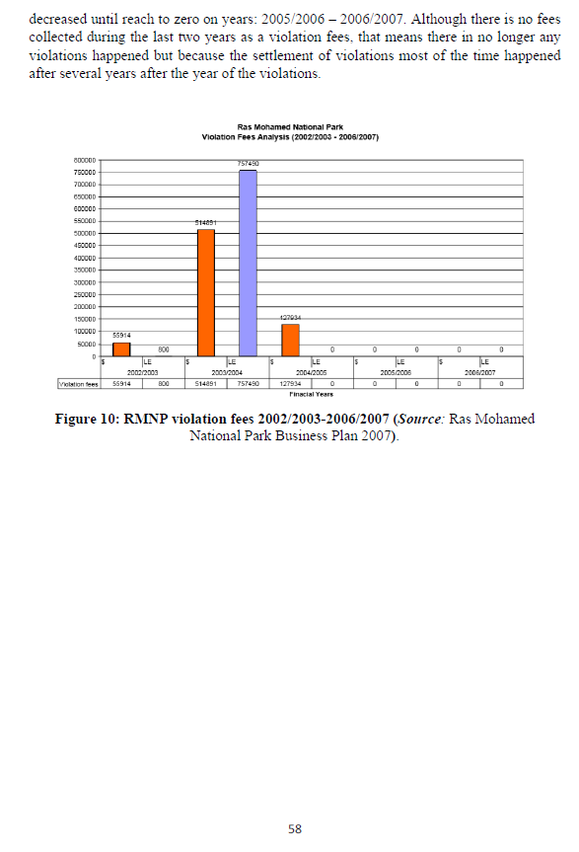

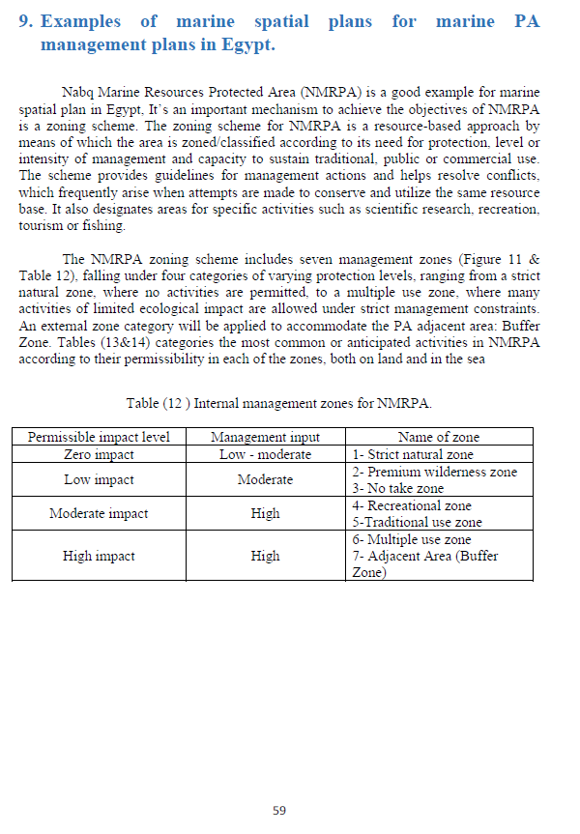

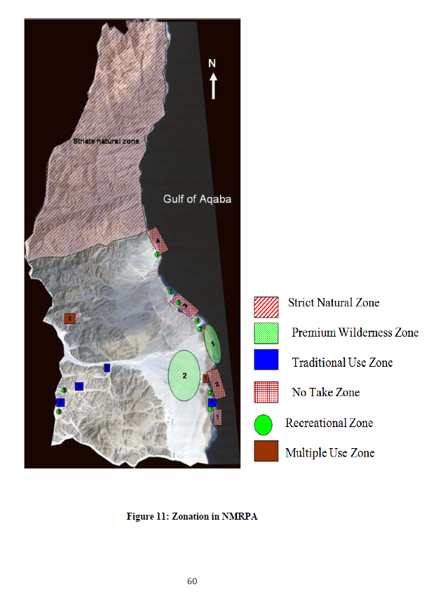

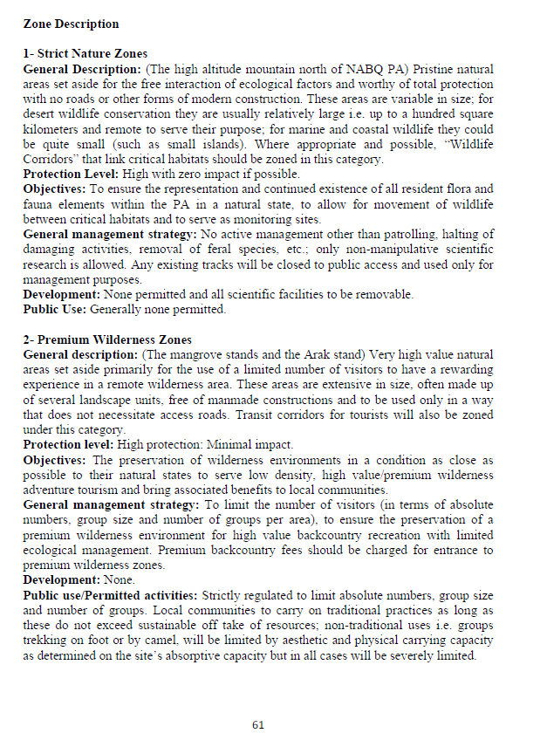

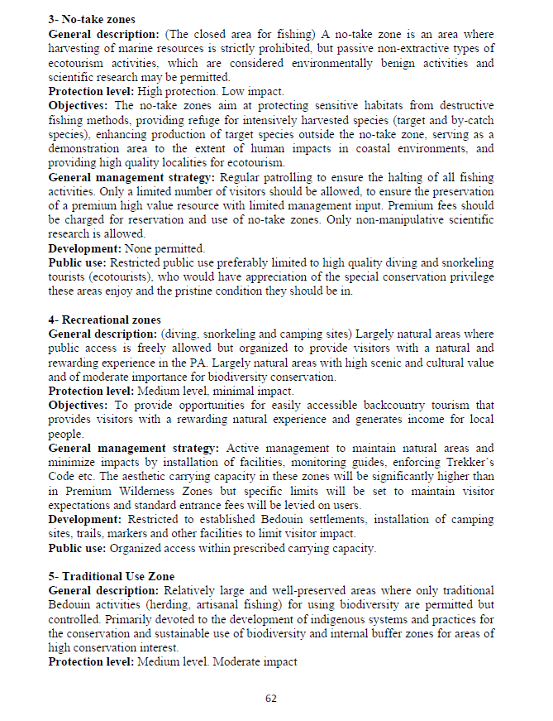

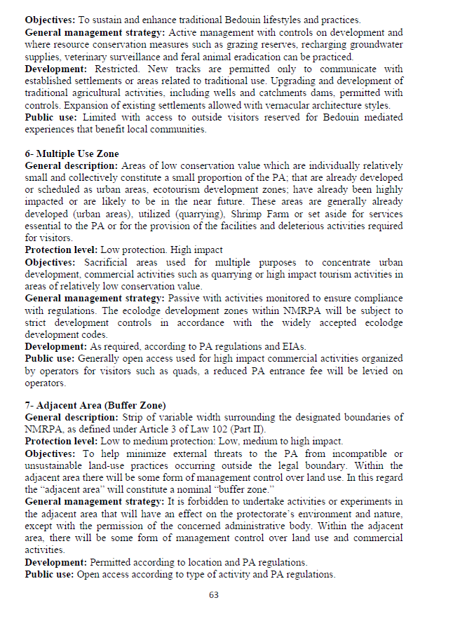
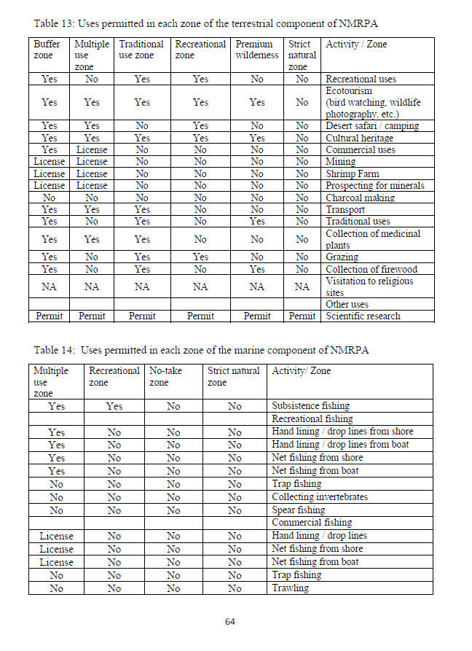
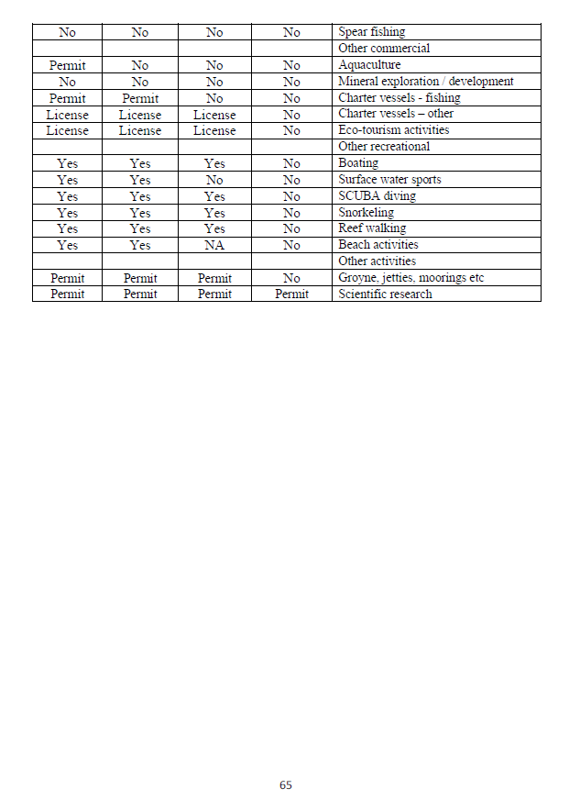

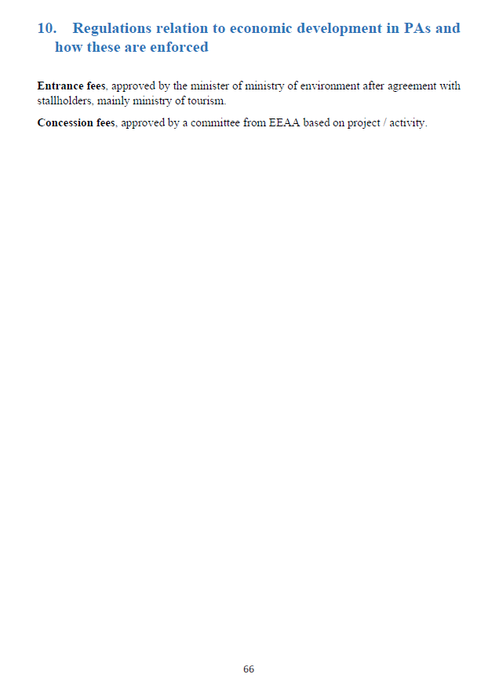

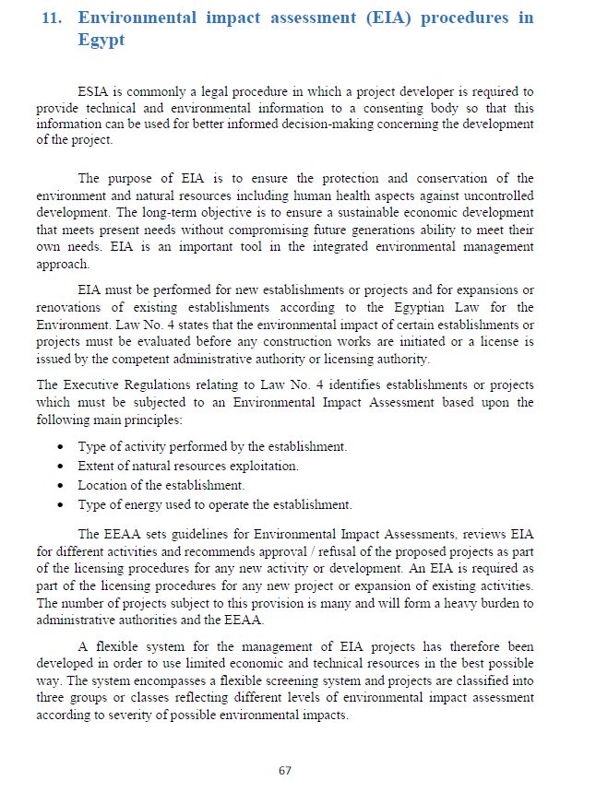

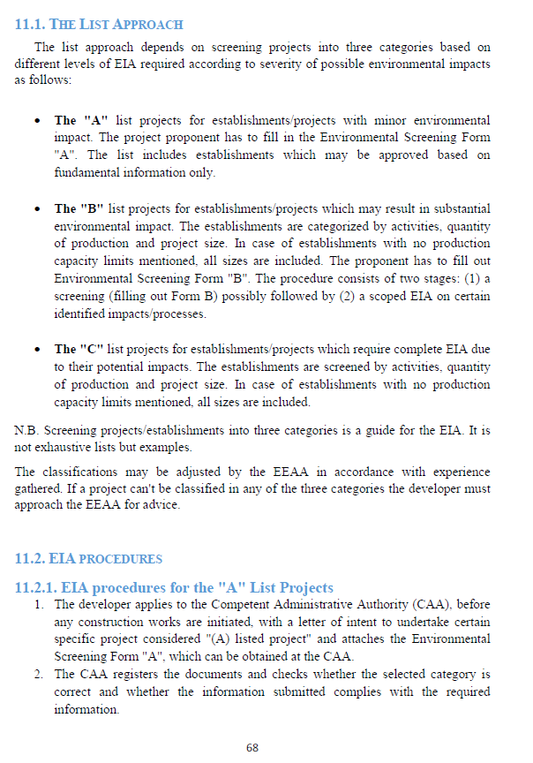

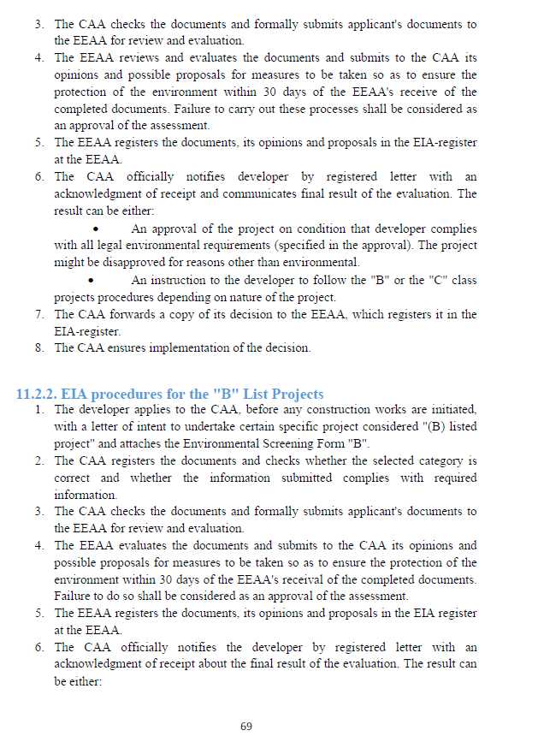

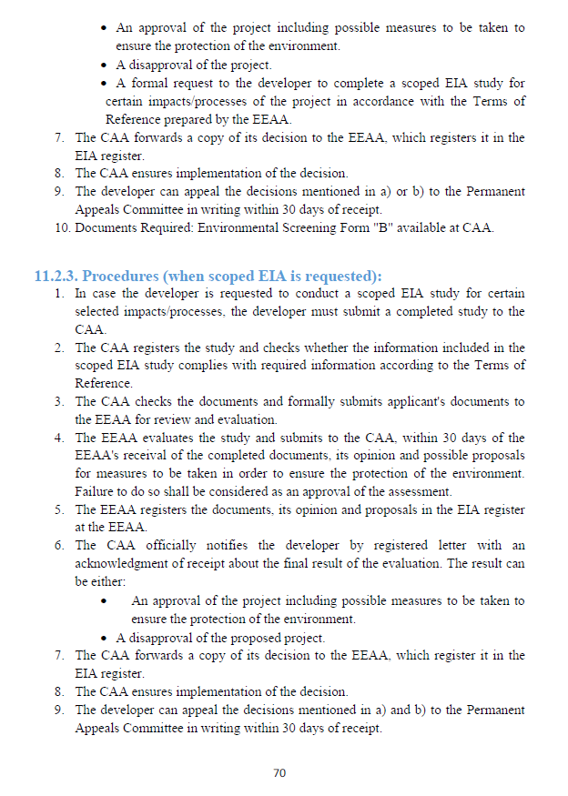
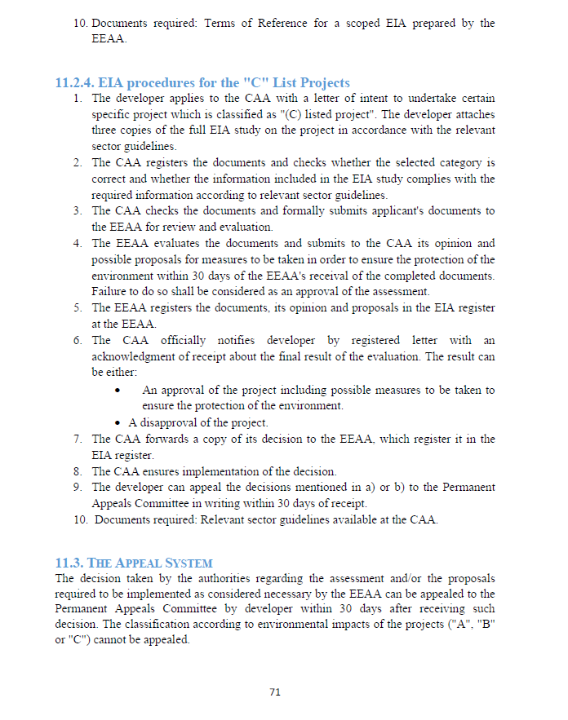

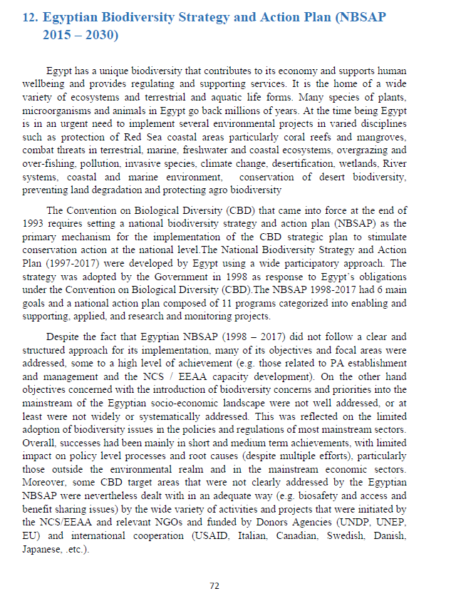
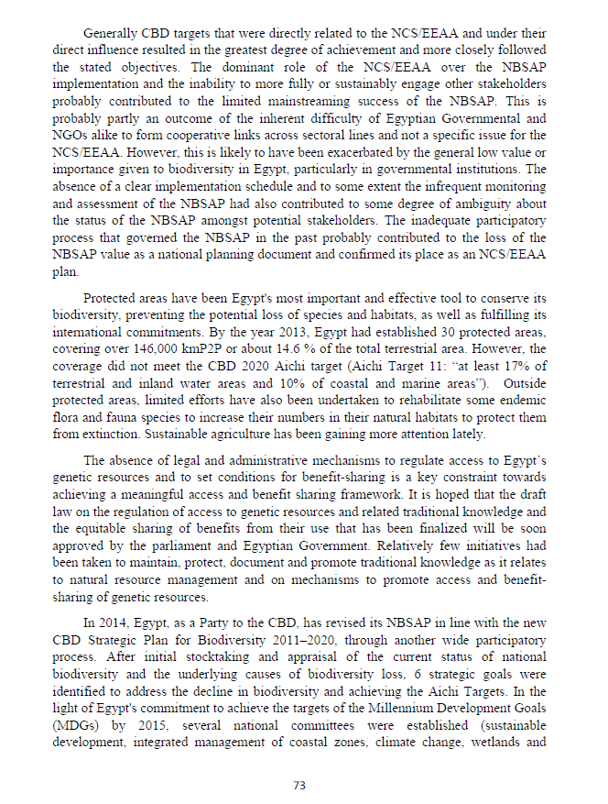
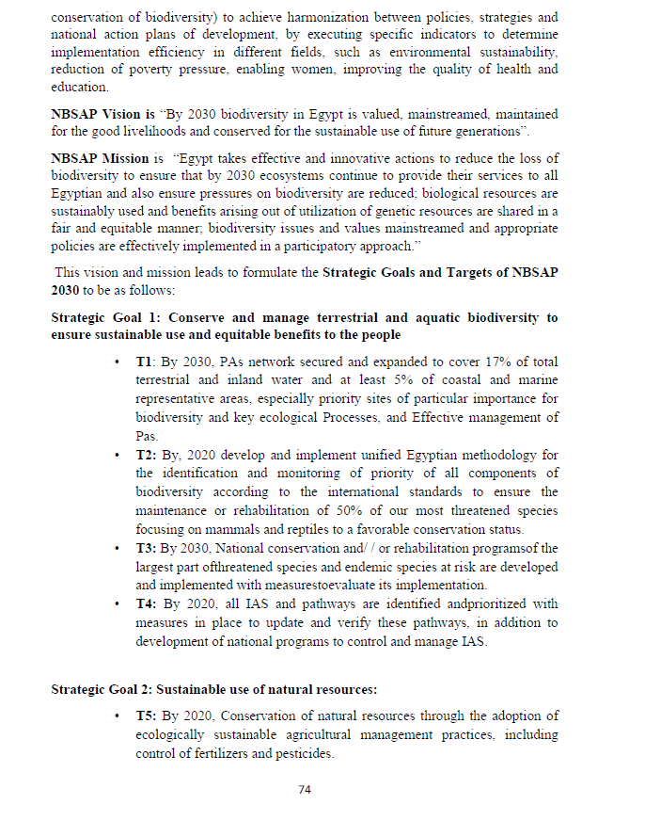
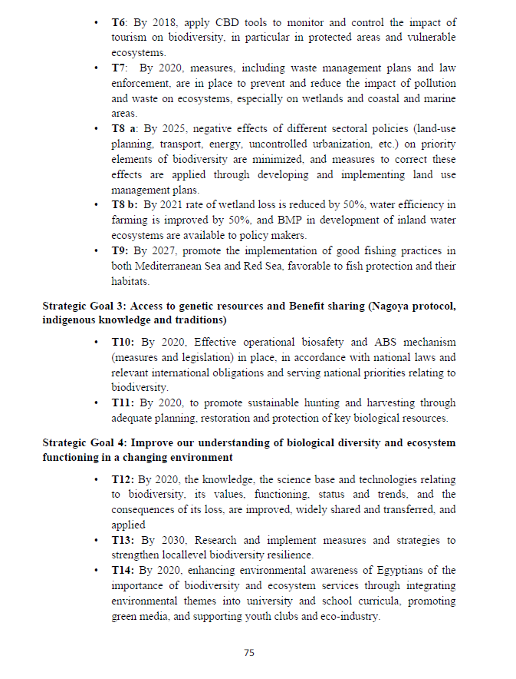

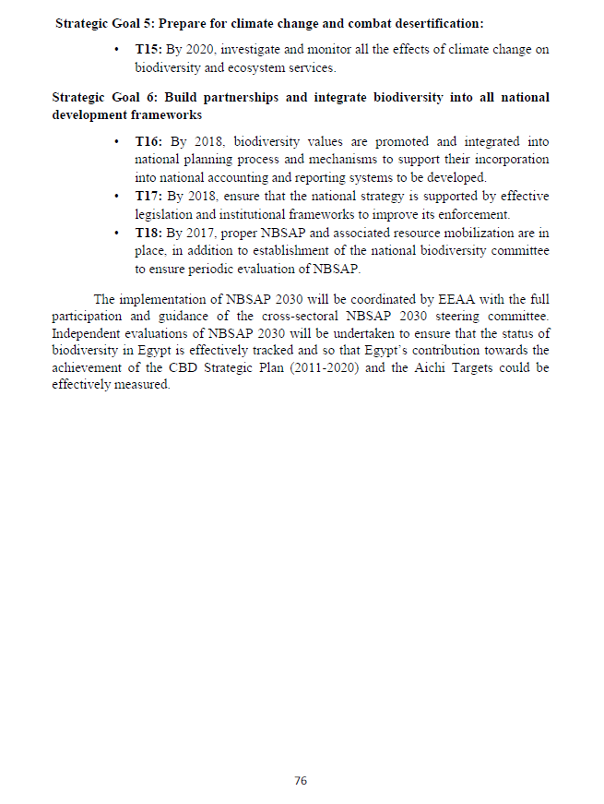

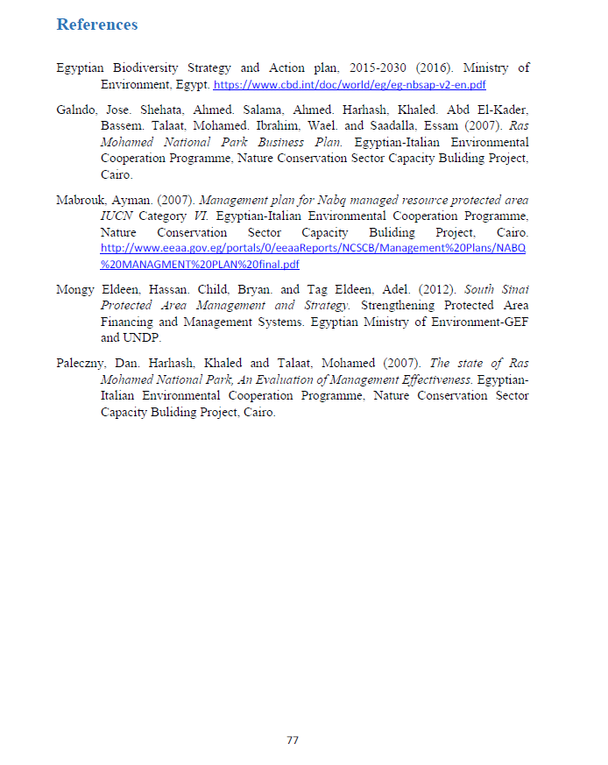



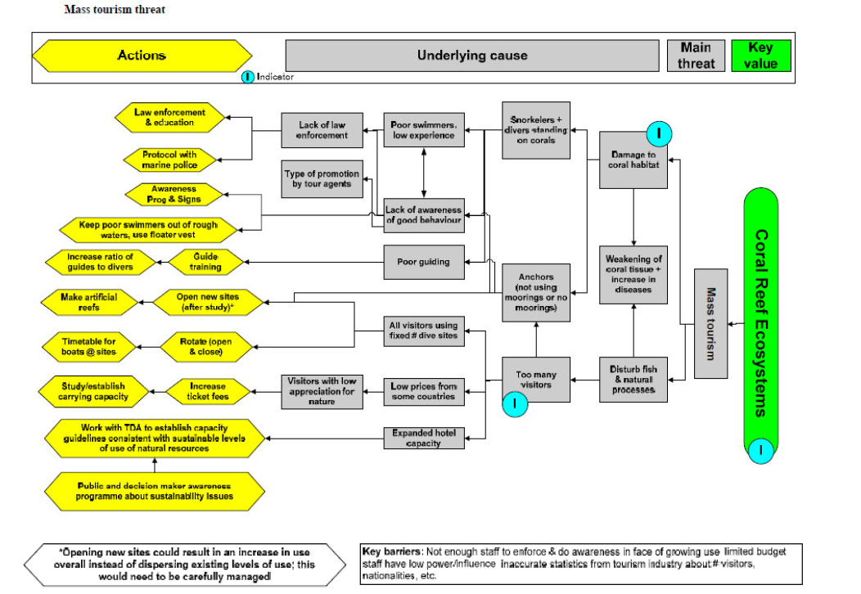

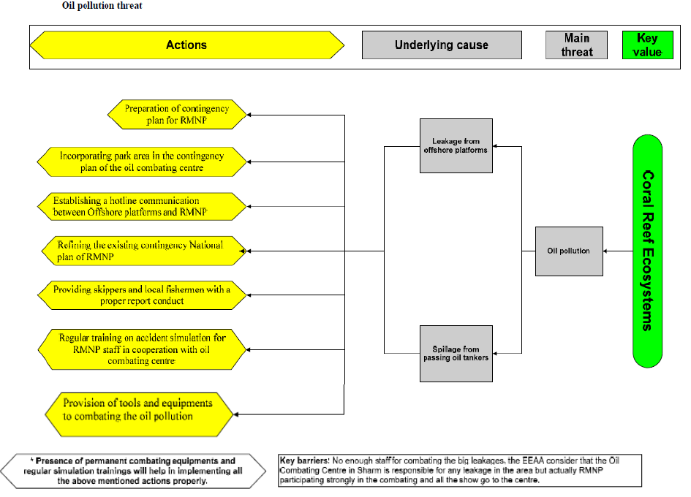
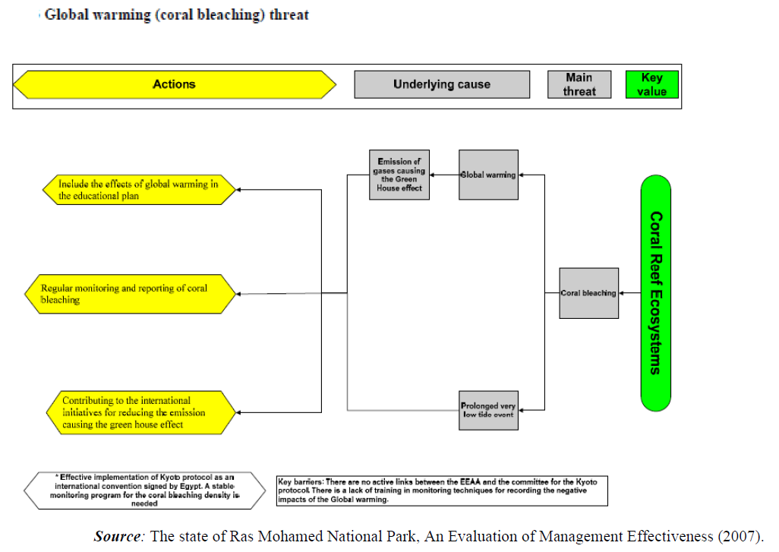

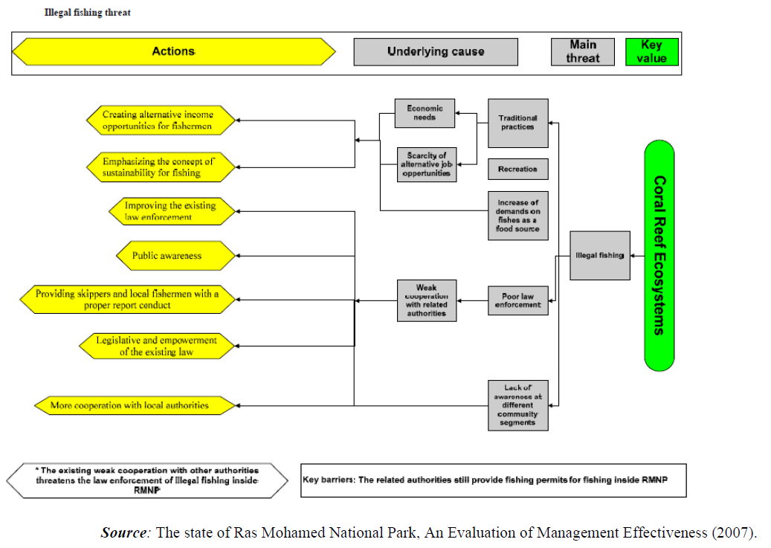

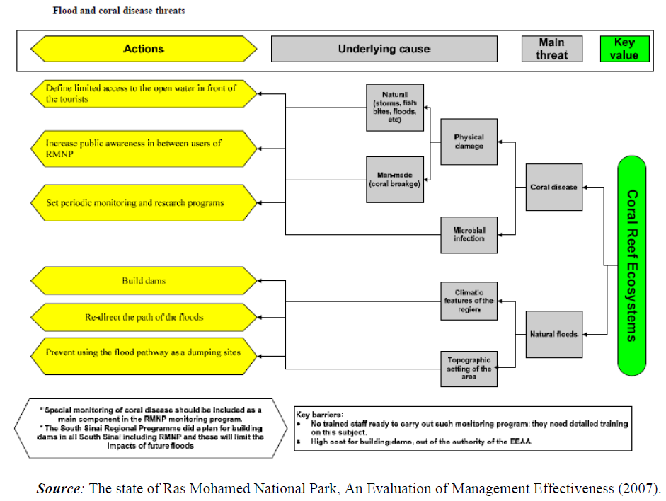

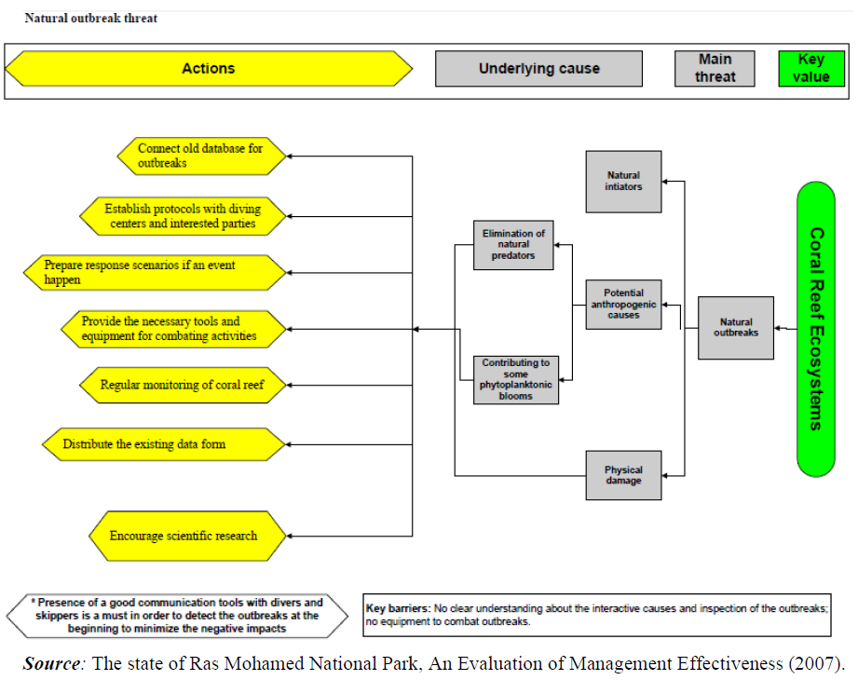

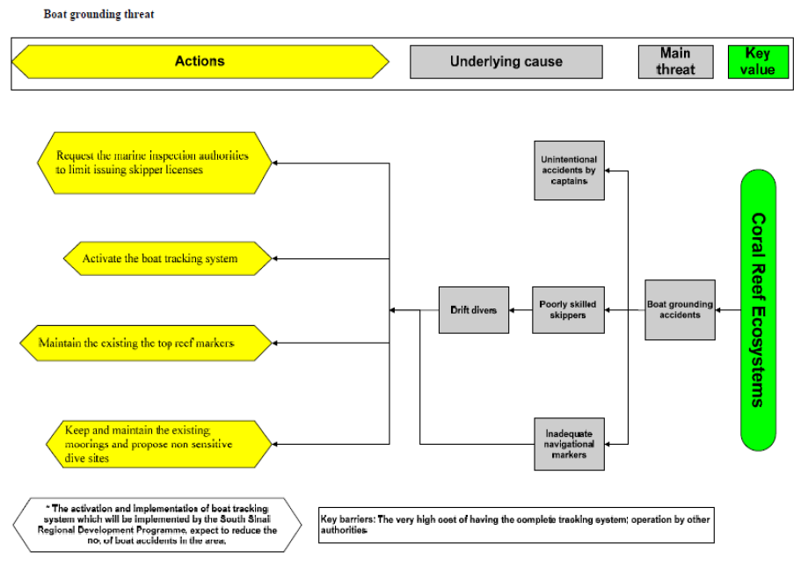
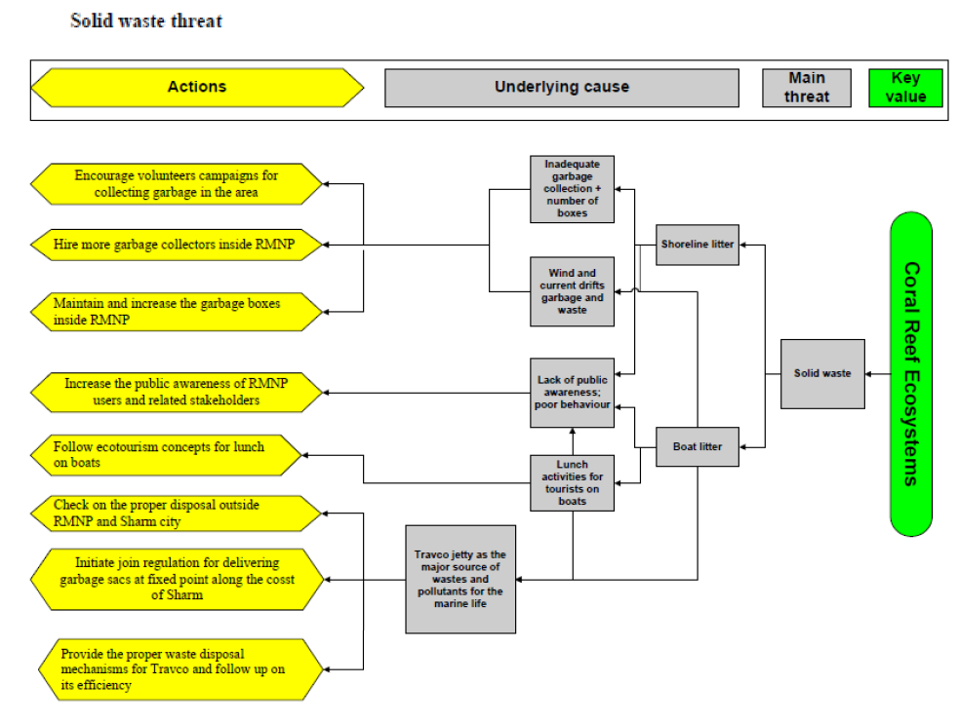

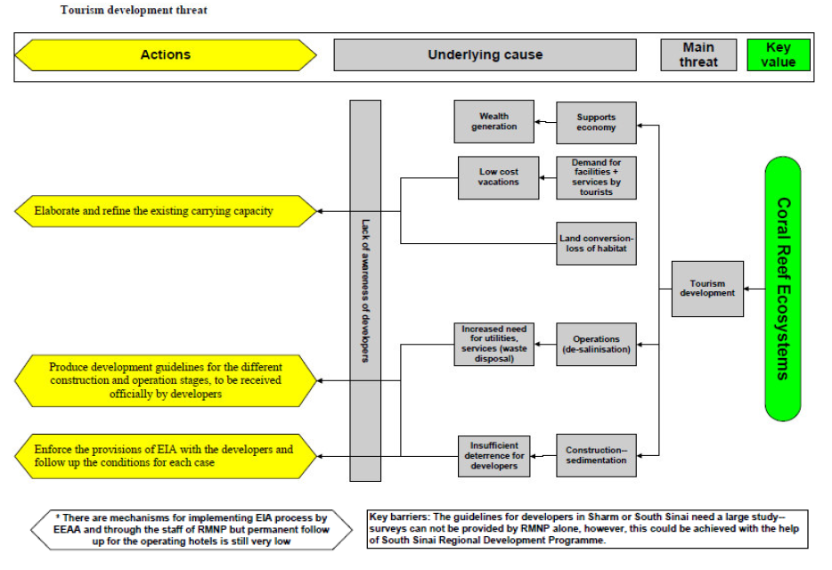

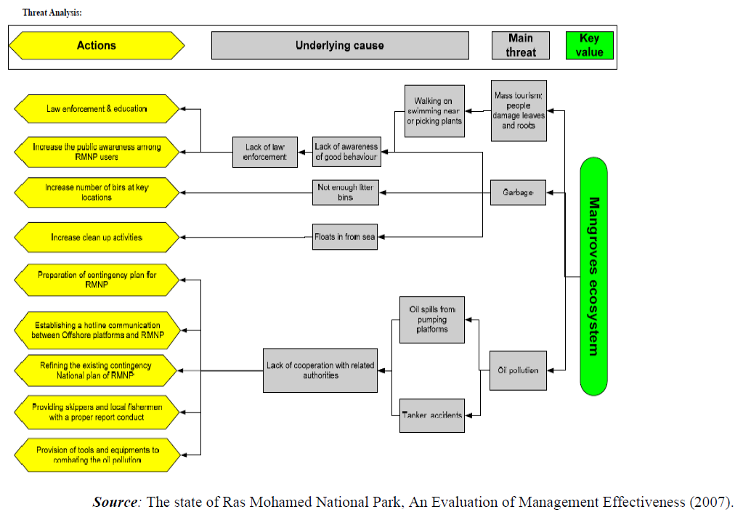

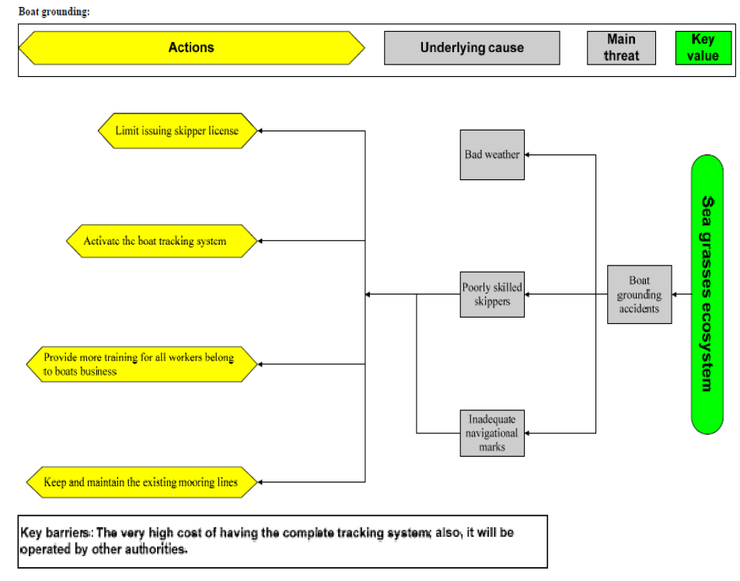

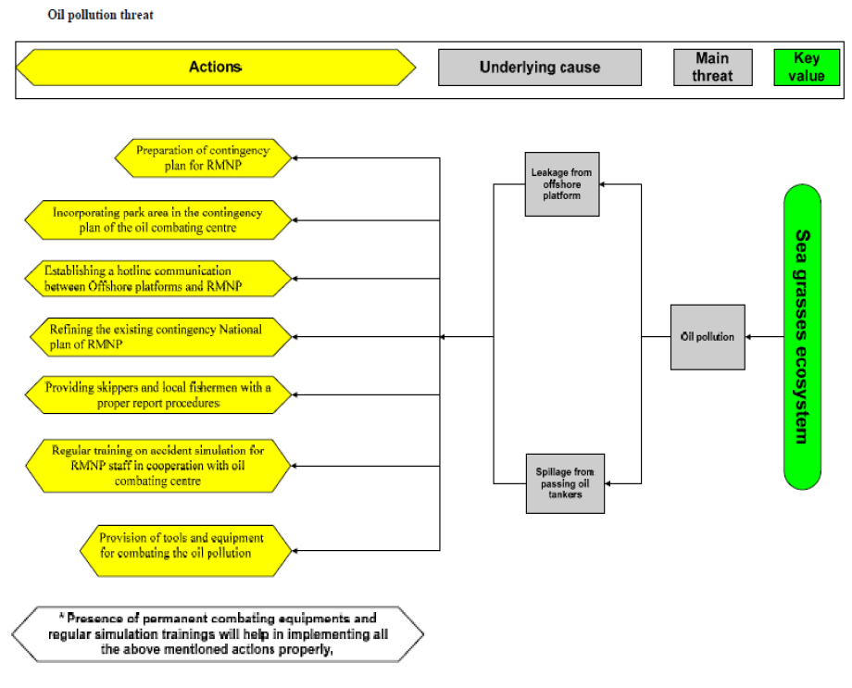

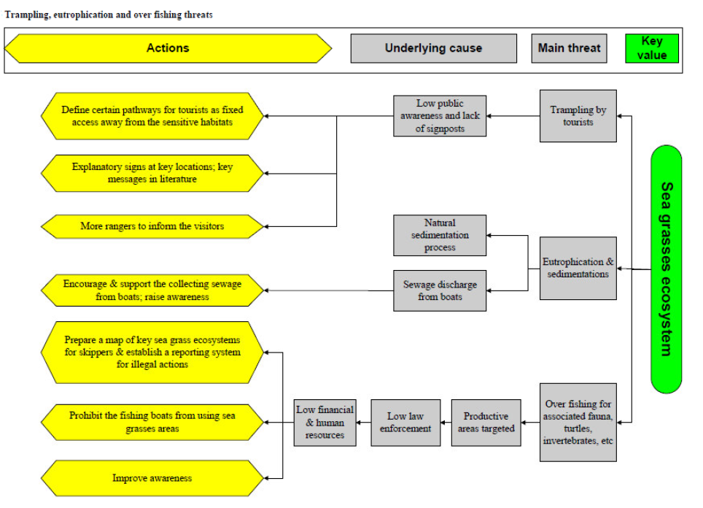

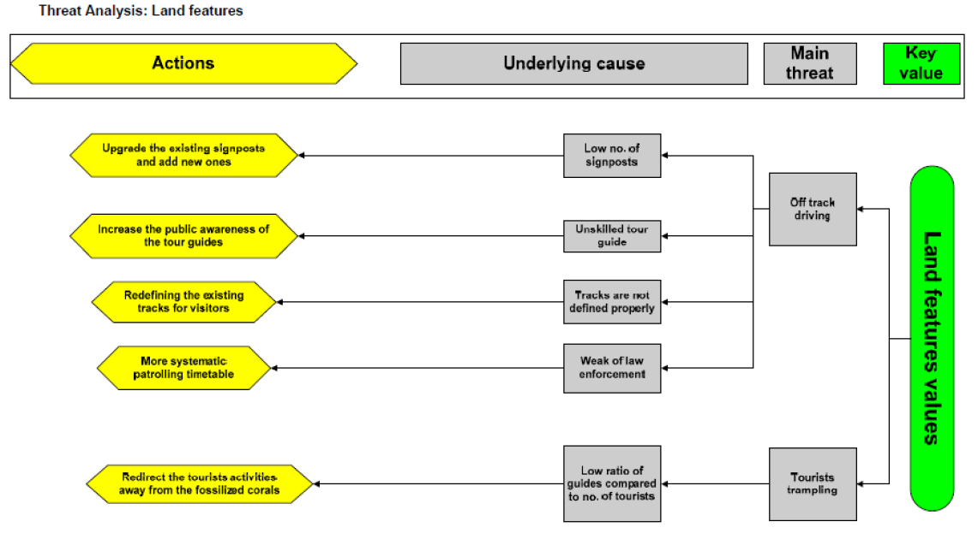

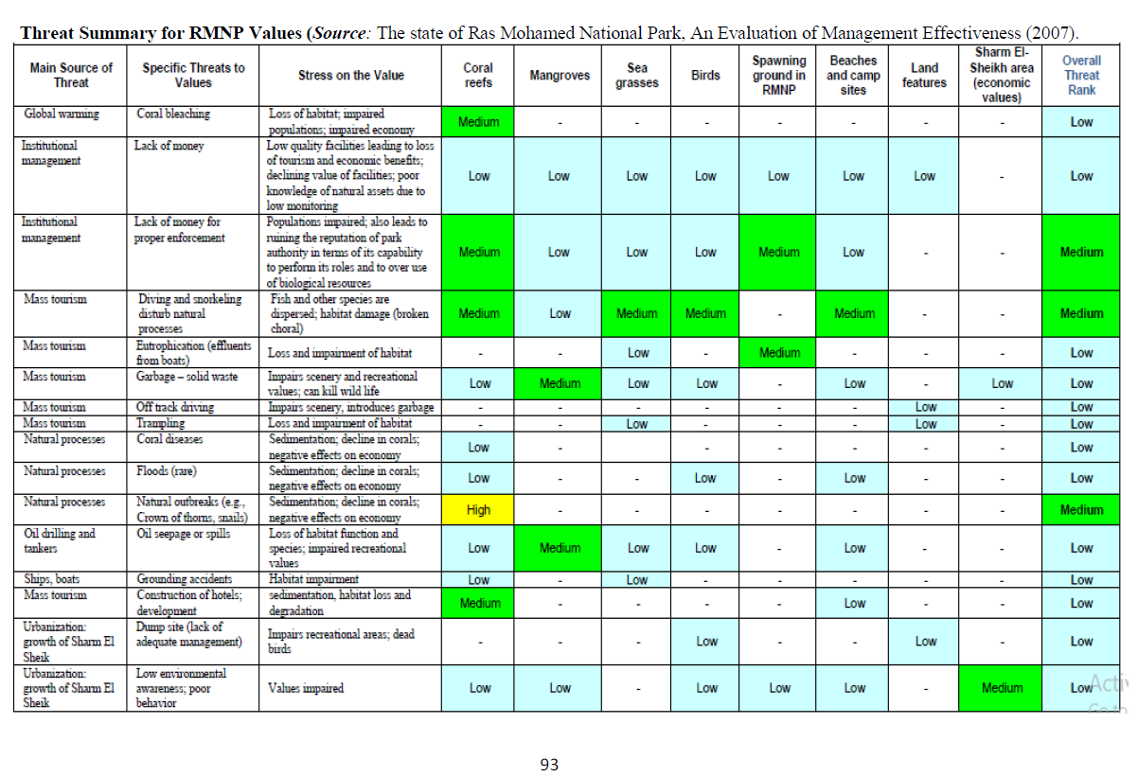
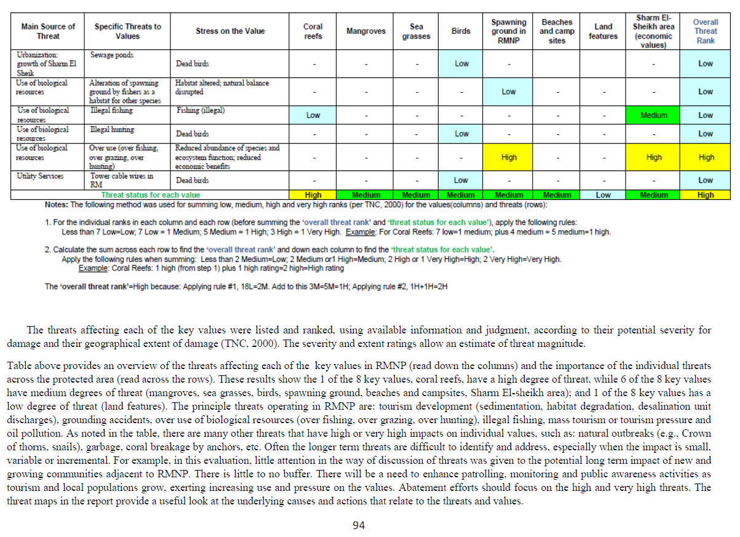

Annex 25: Background Report: Tourism and Energy
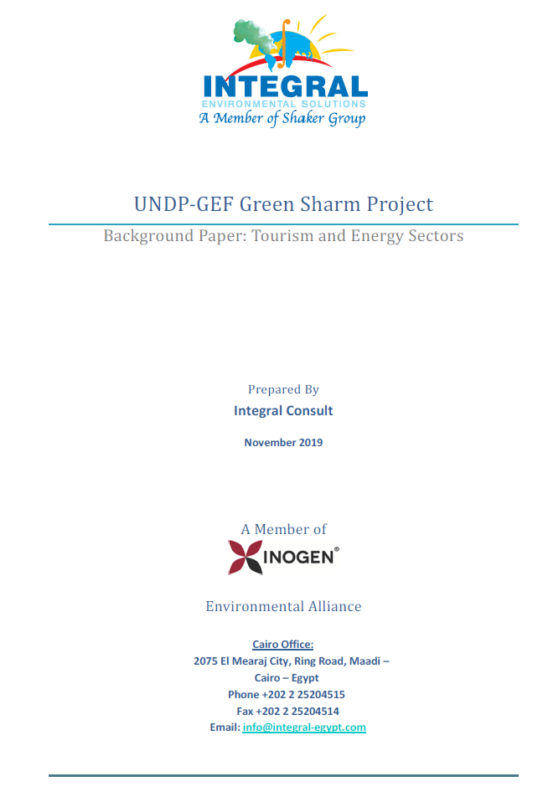
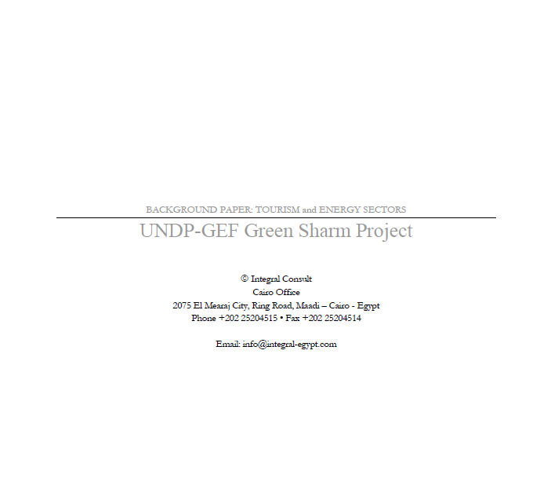

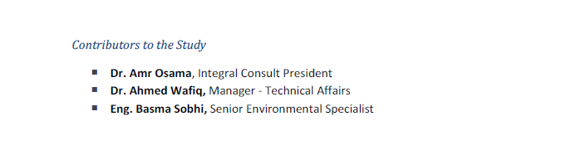

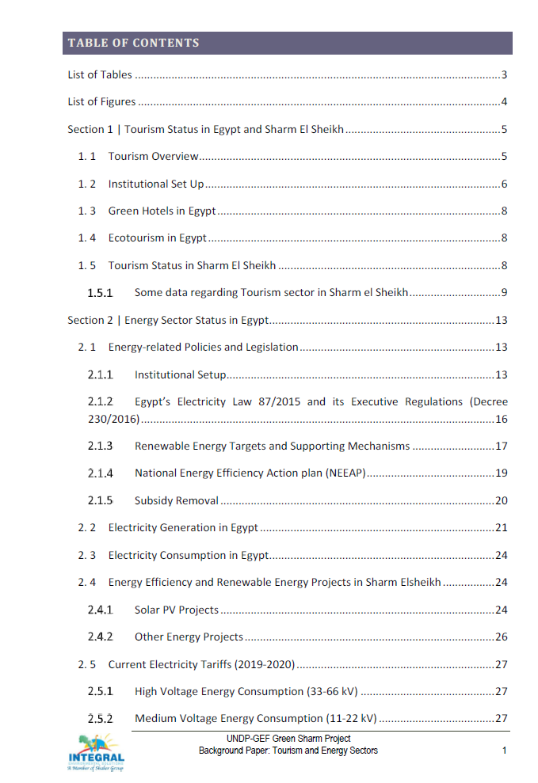

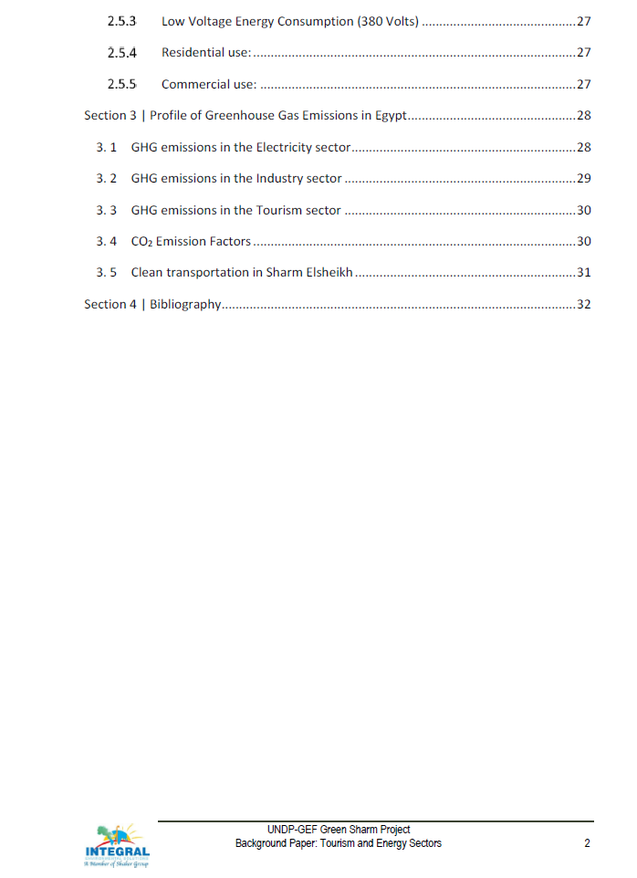

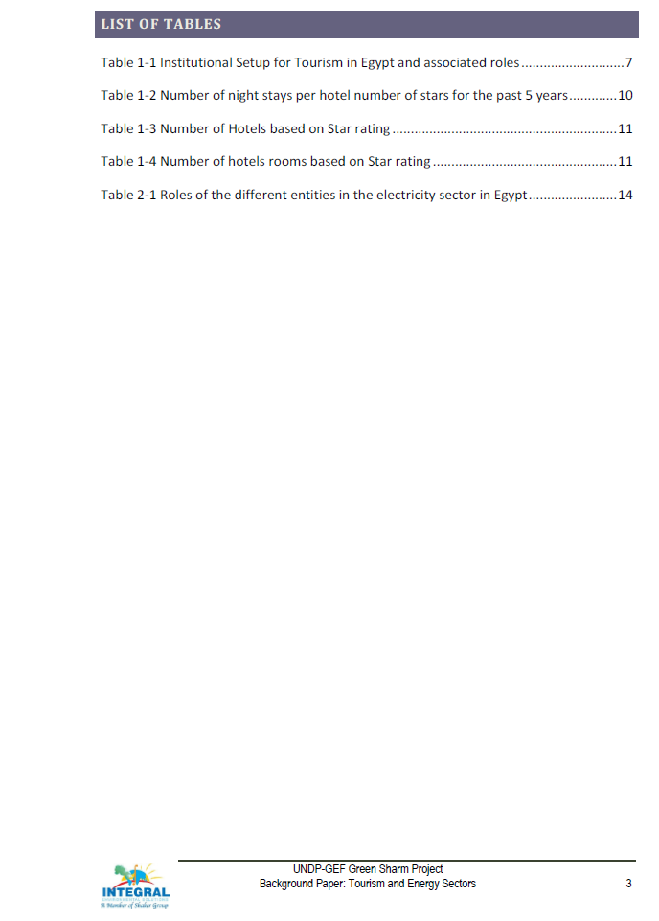

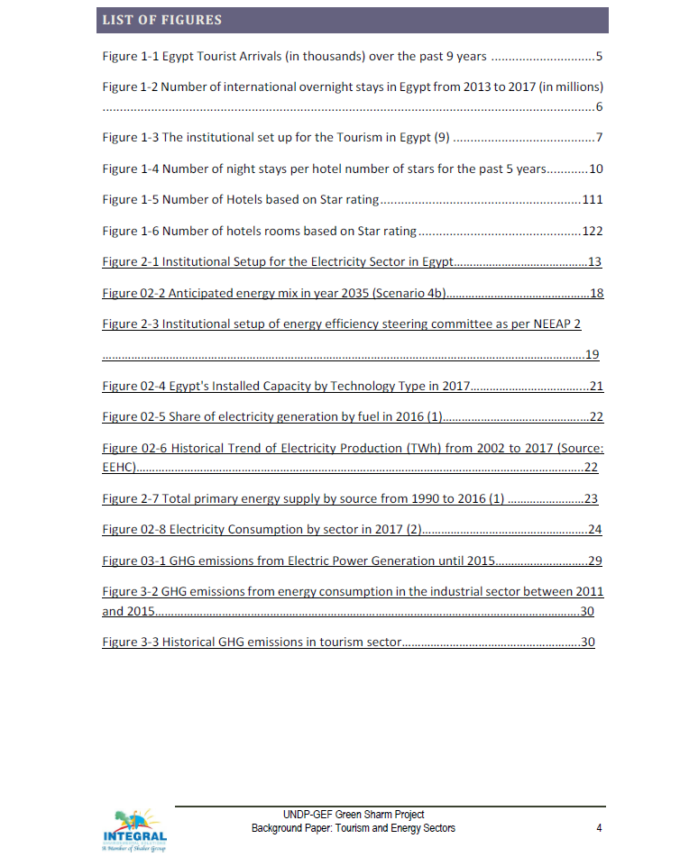

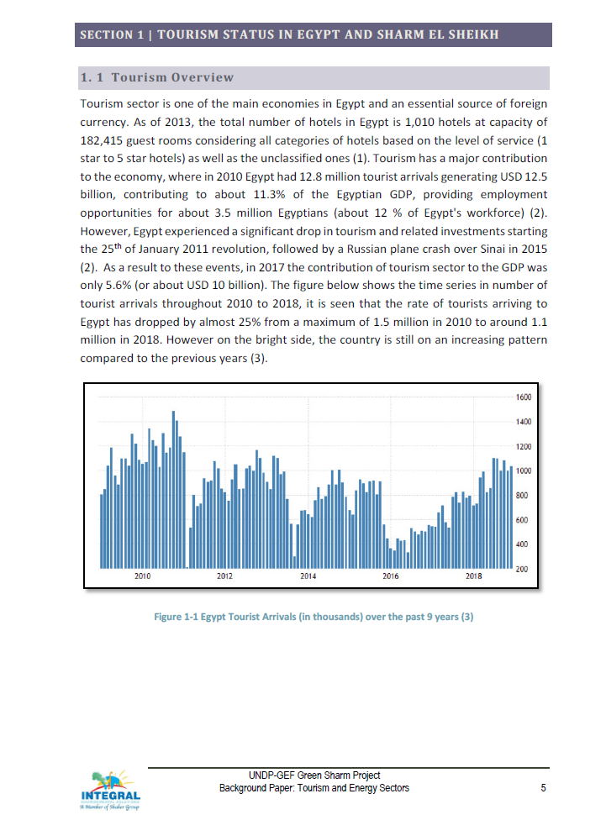
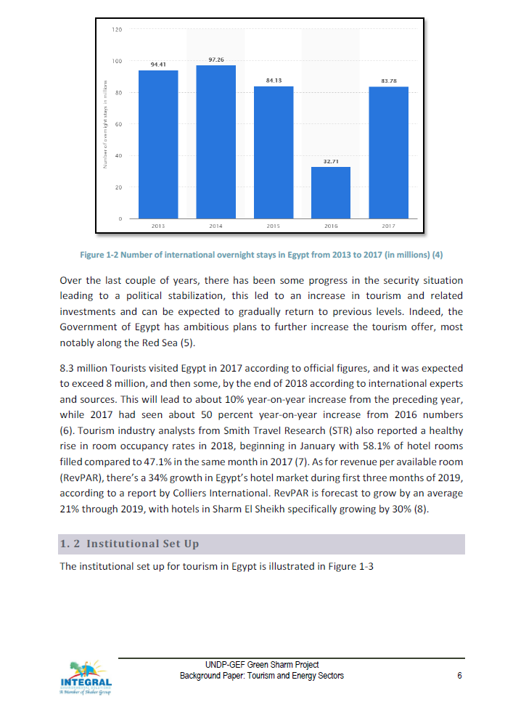
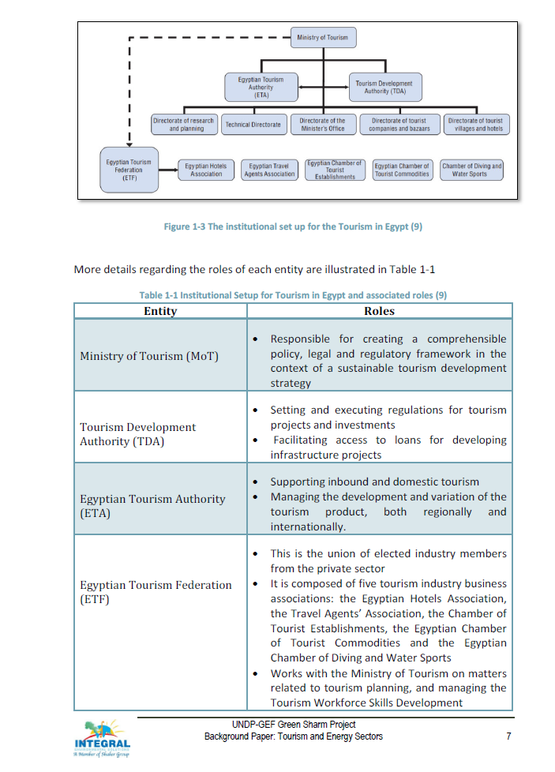
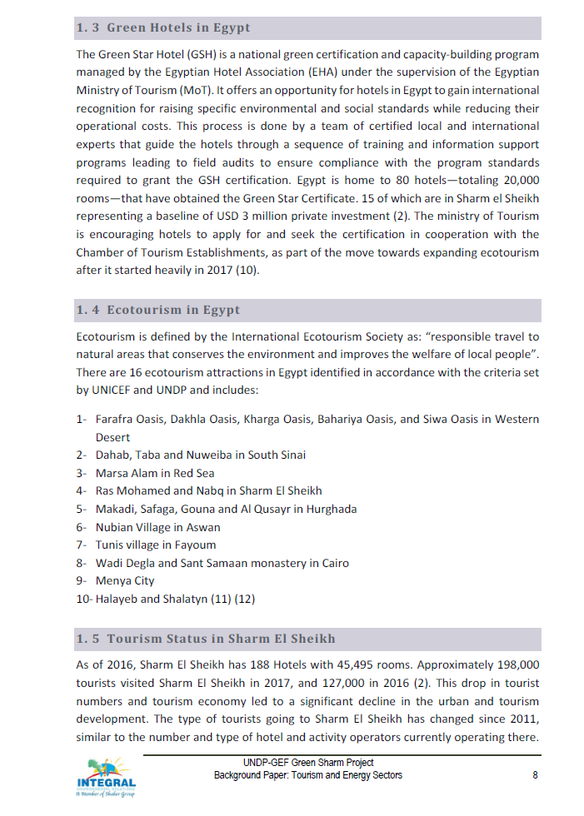
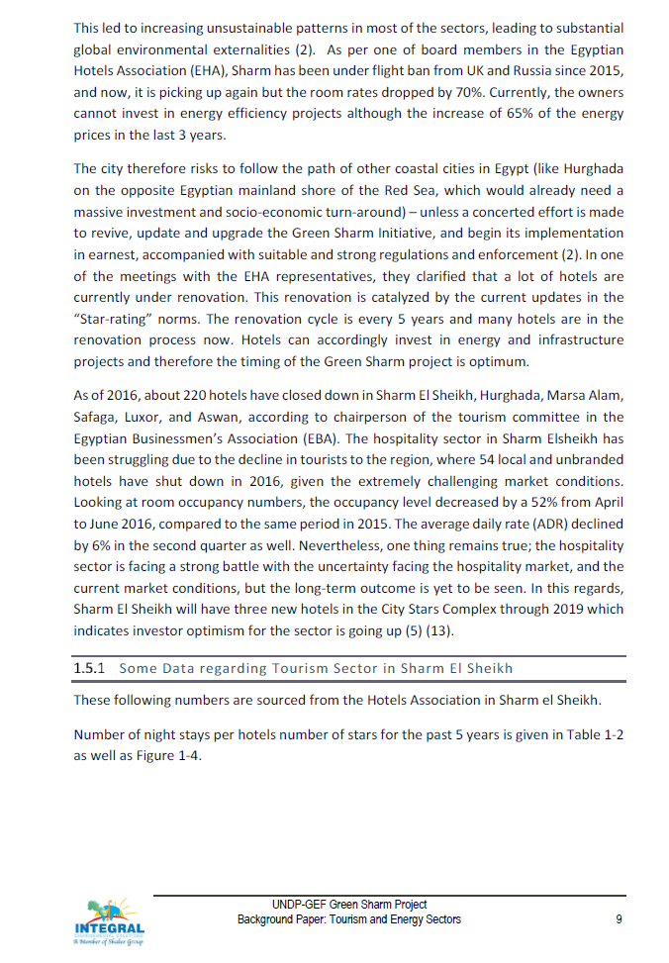
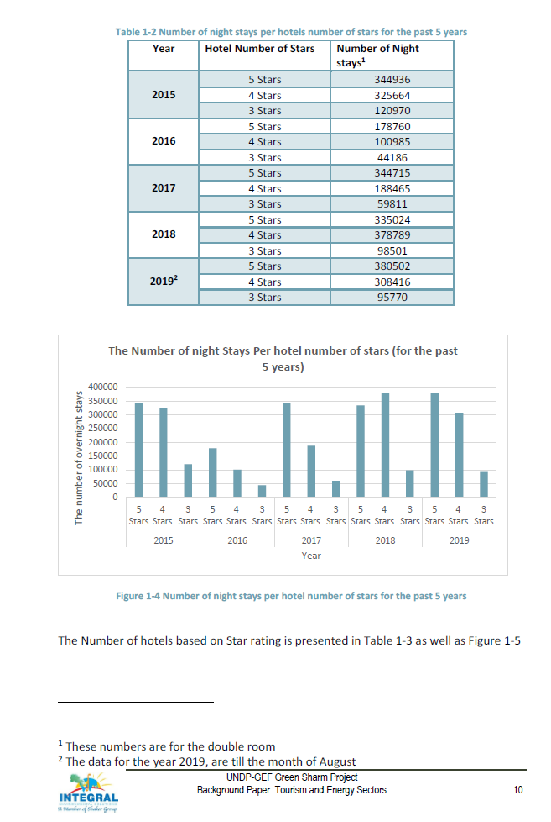
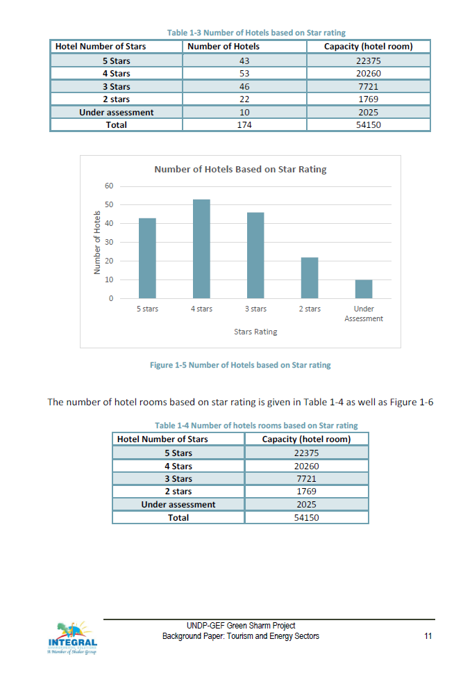
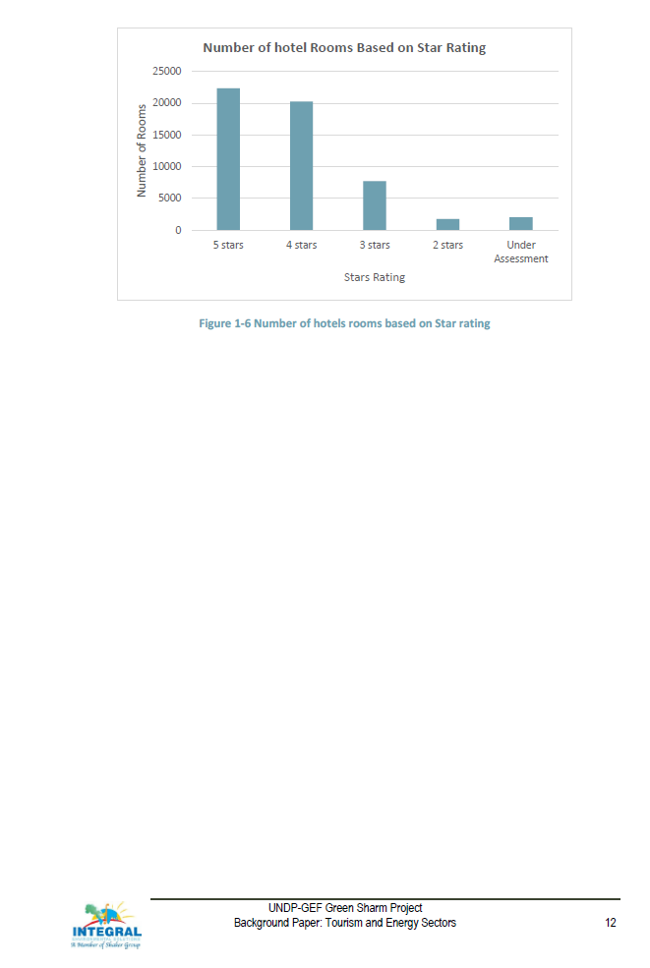
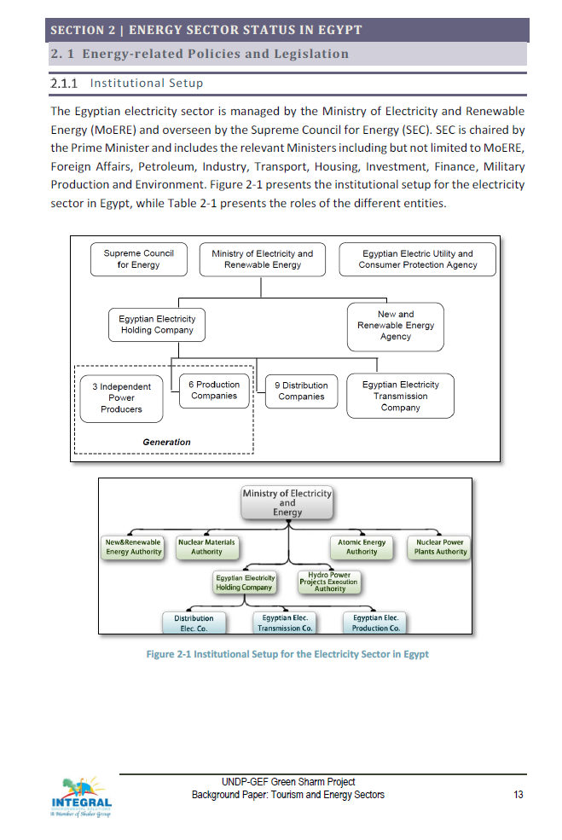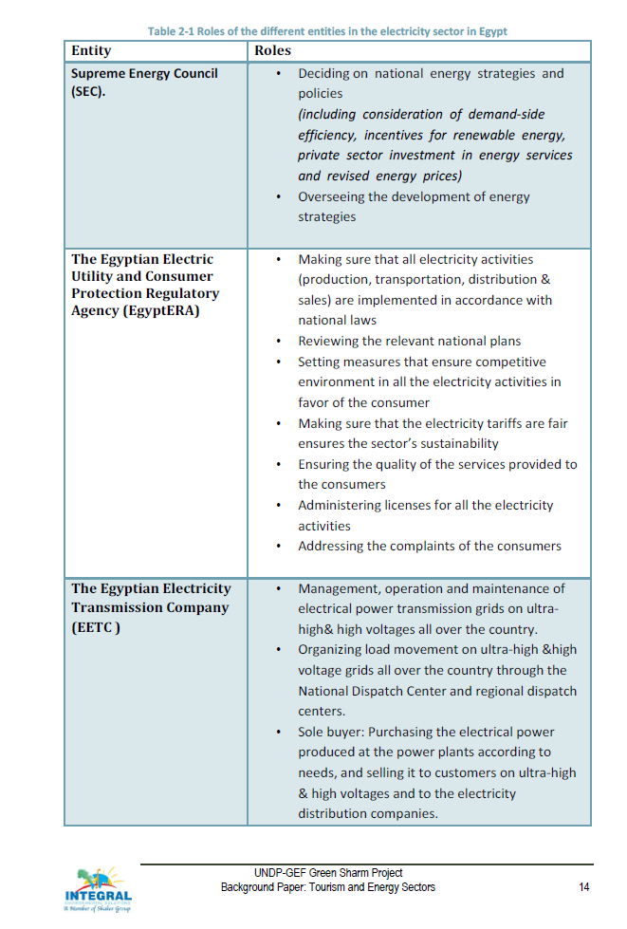
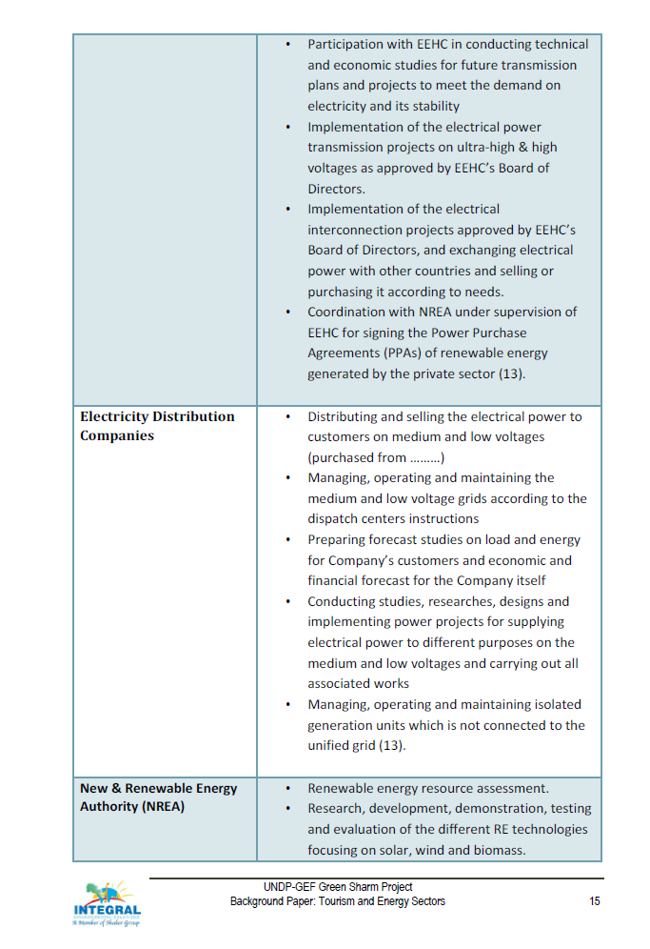
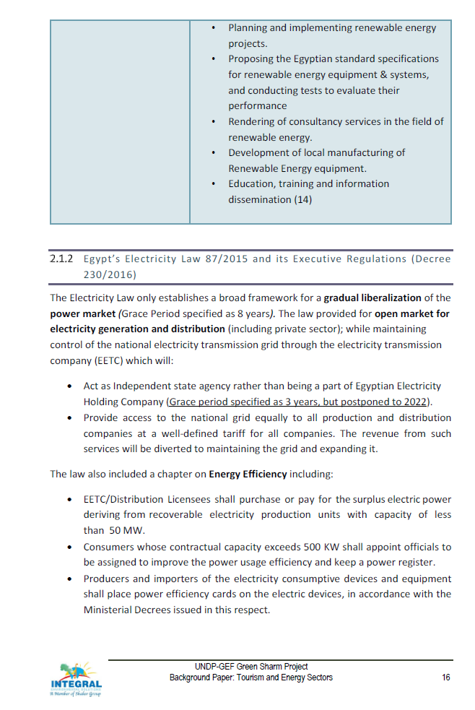
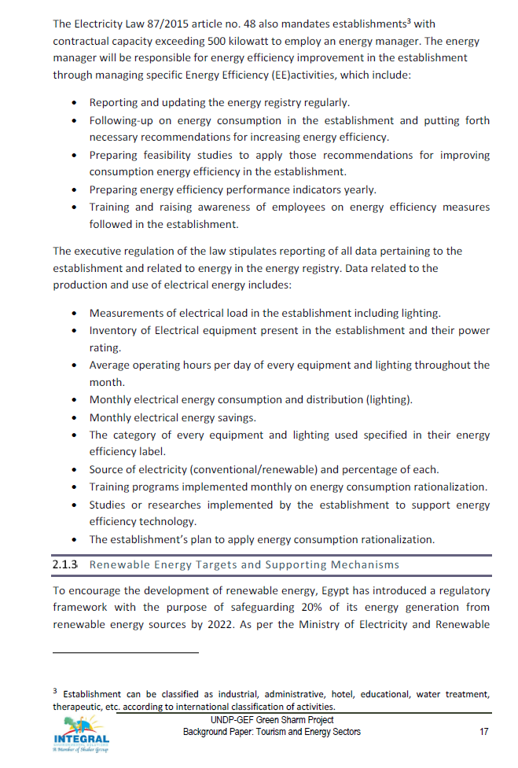
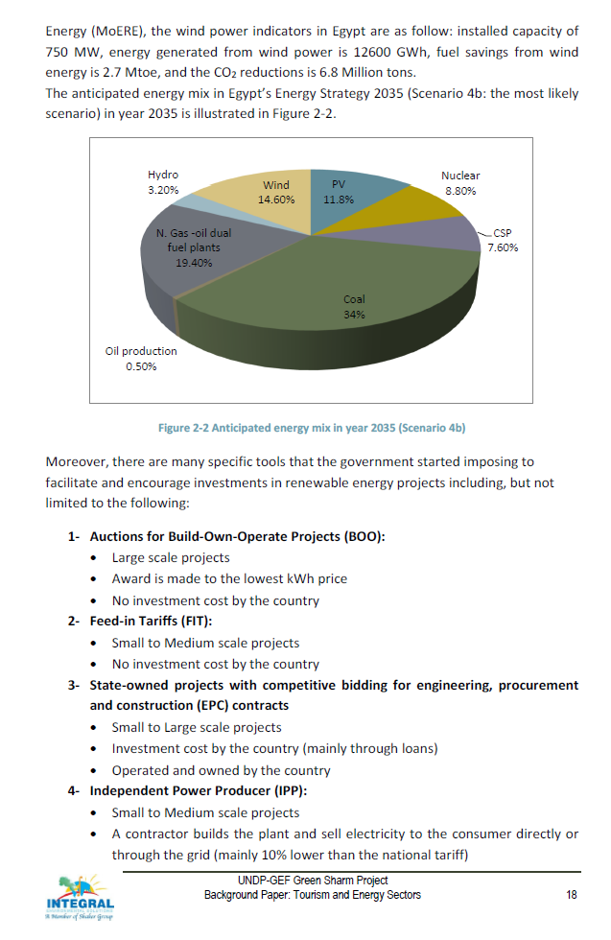
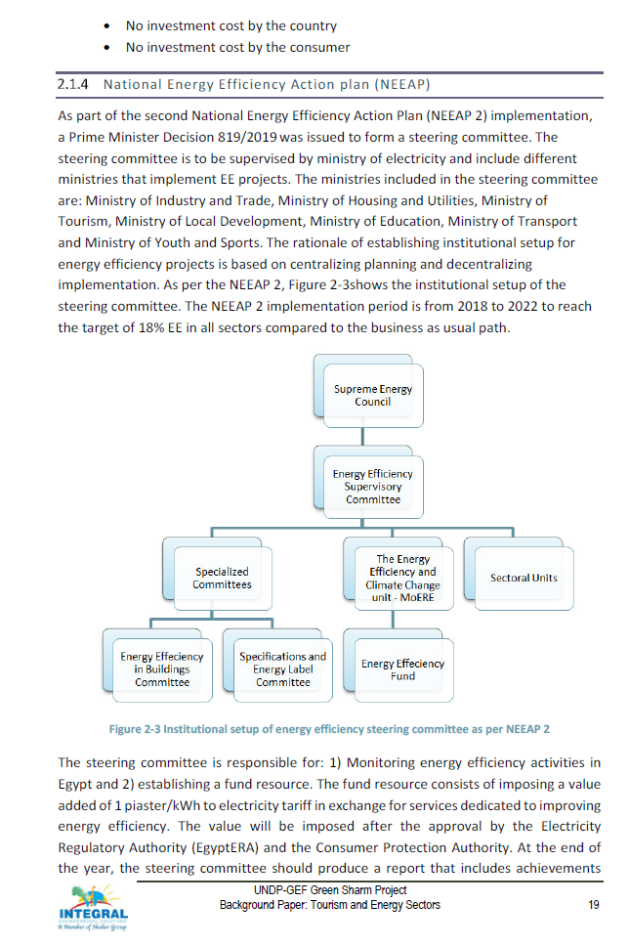
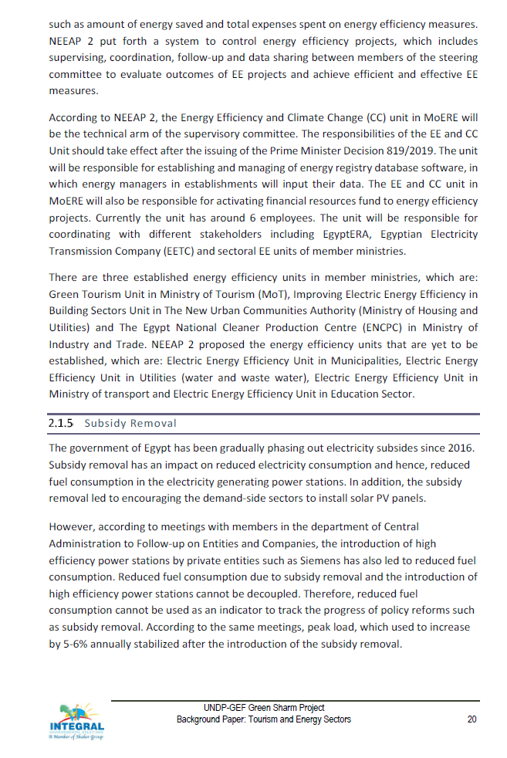
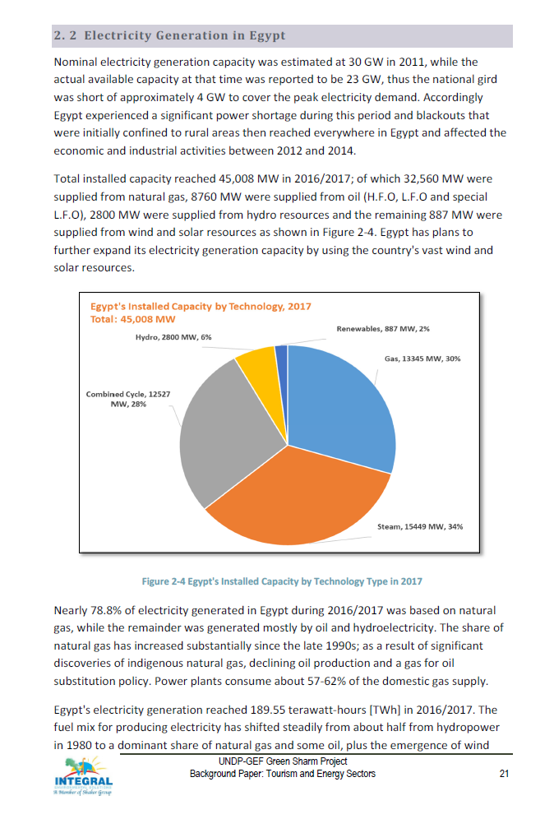
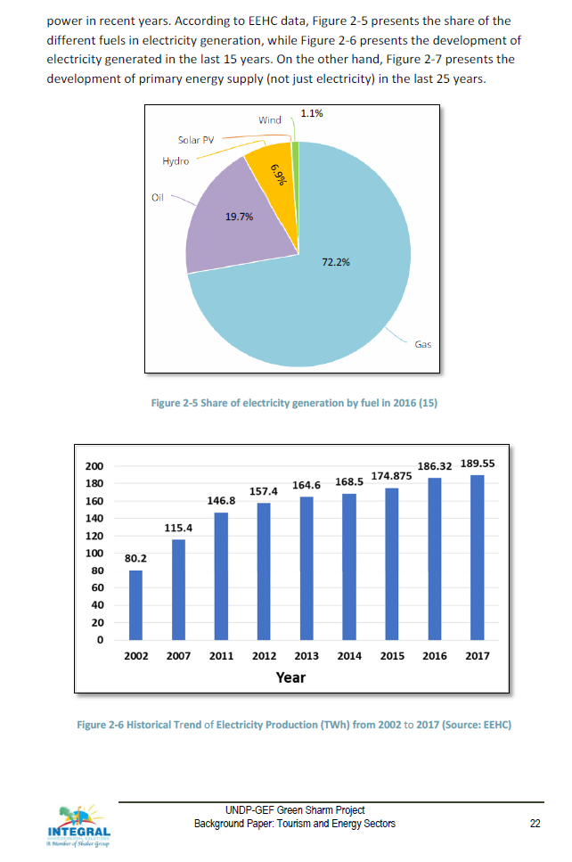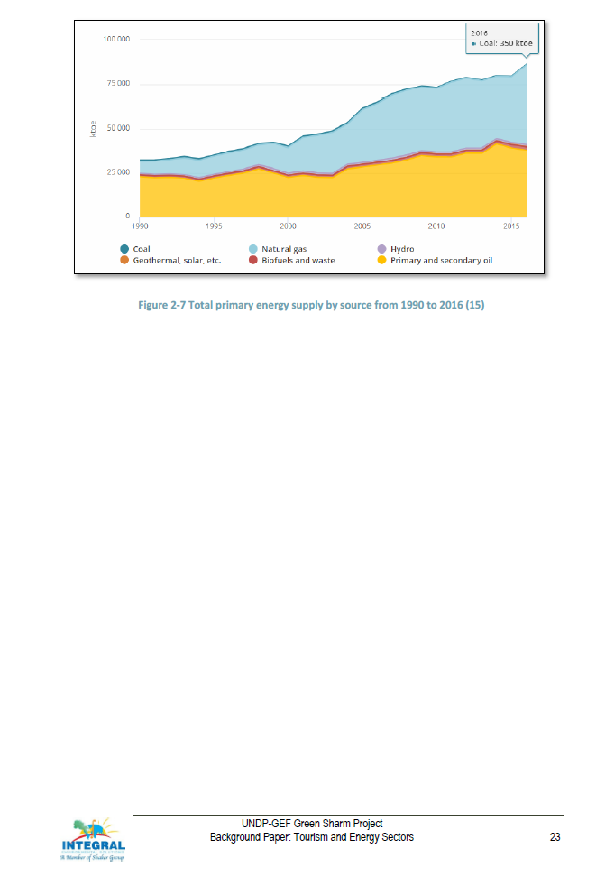
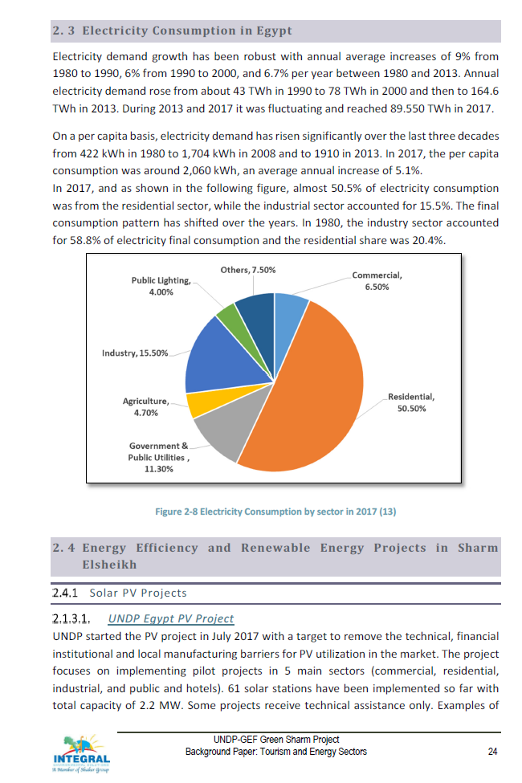
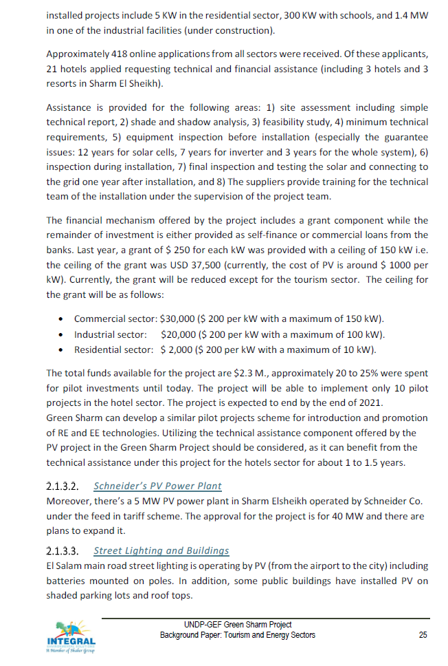
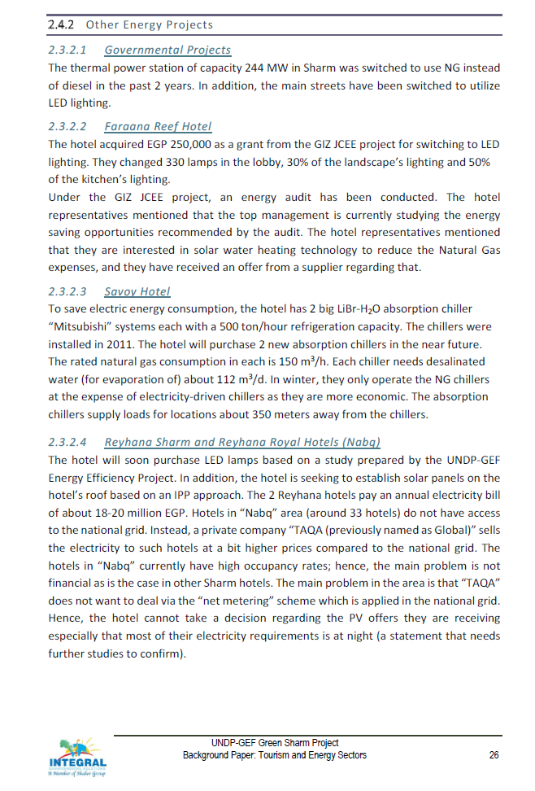
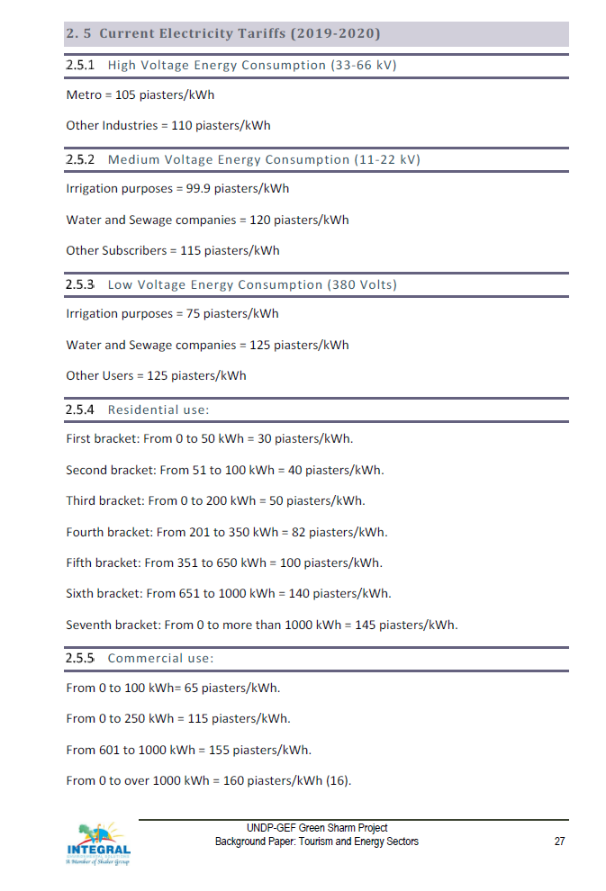
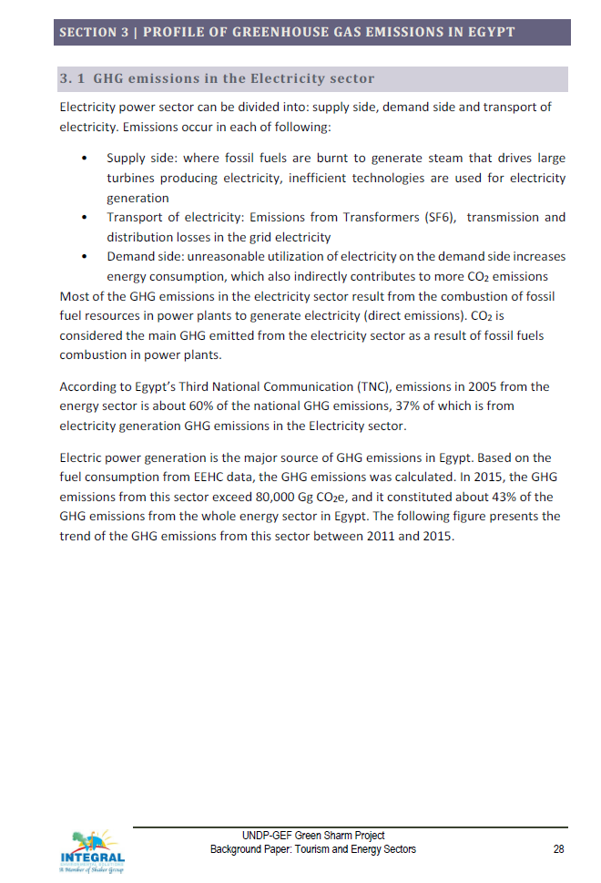
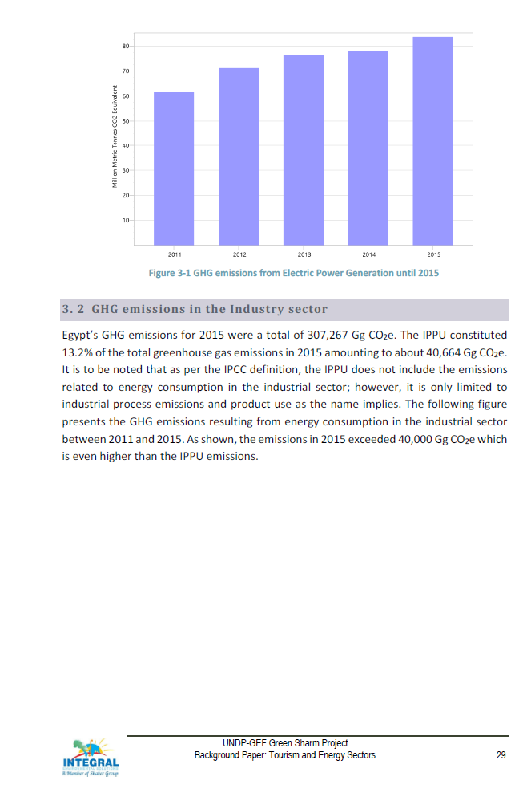
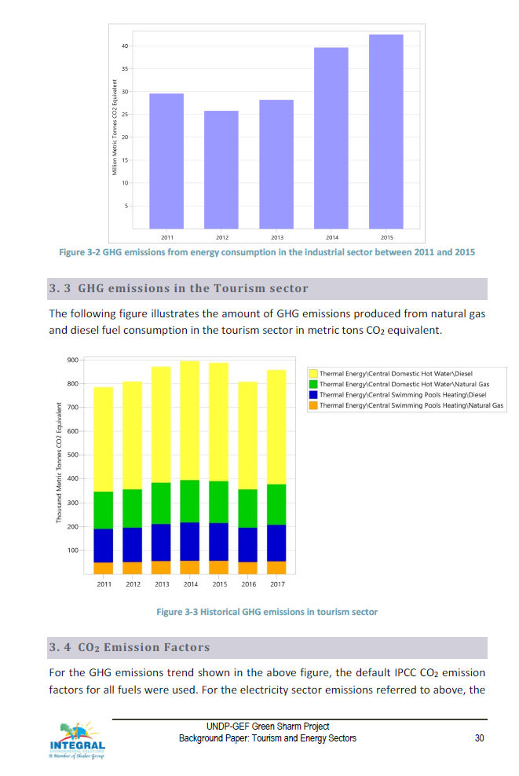
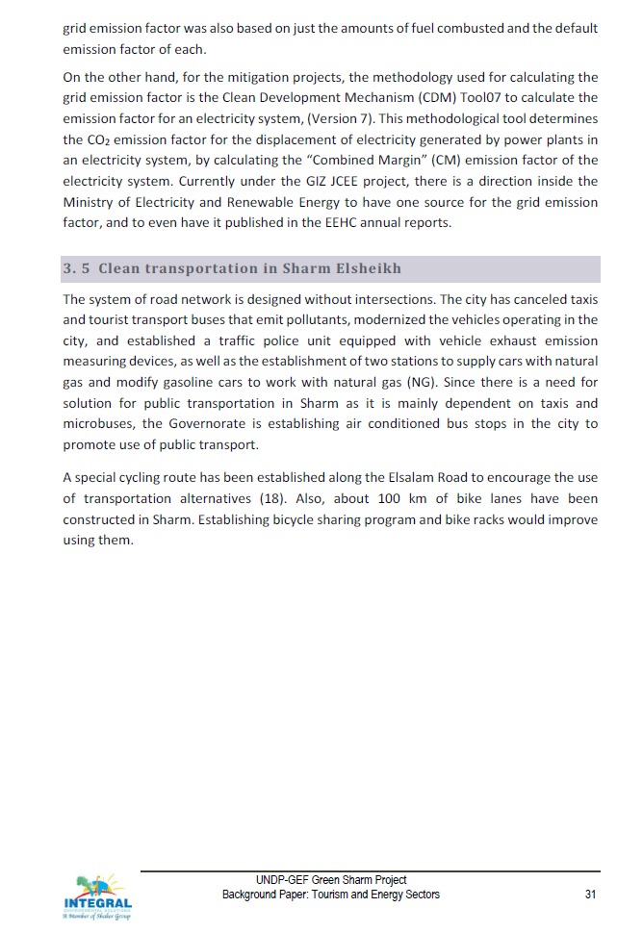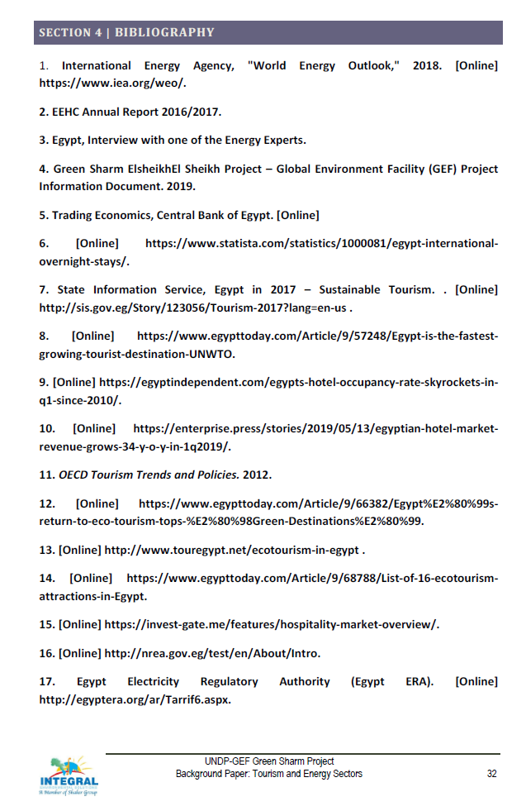
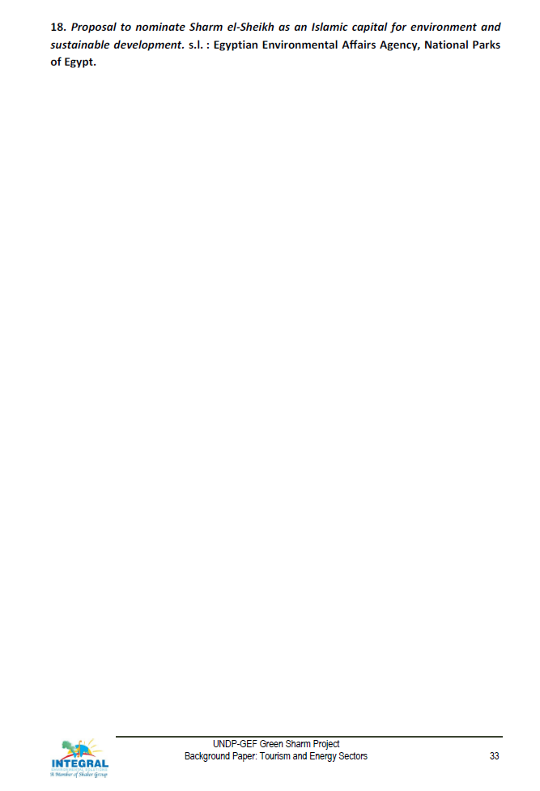

Annex 26: Background Report: Waste
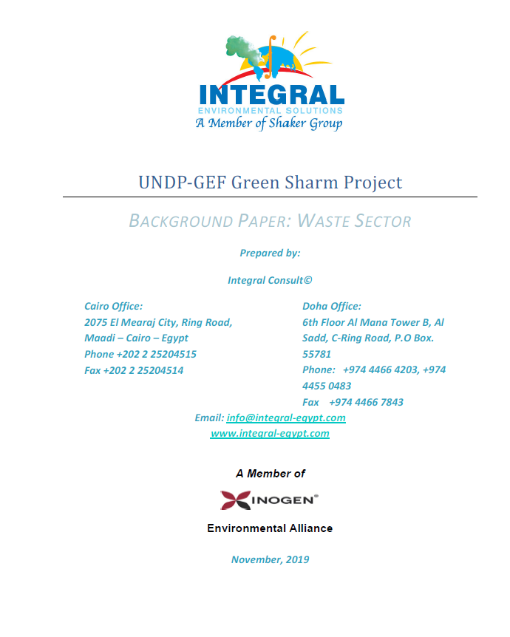
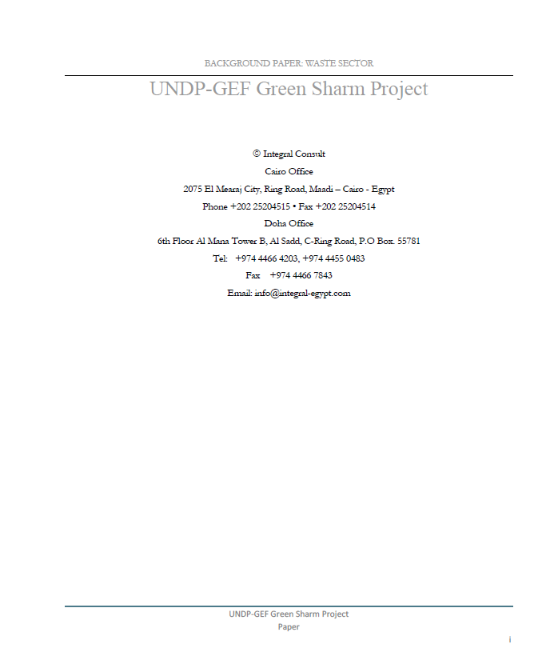

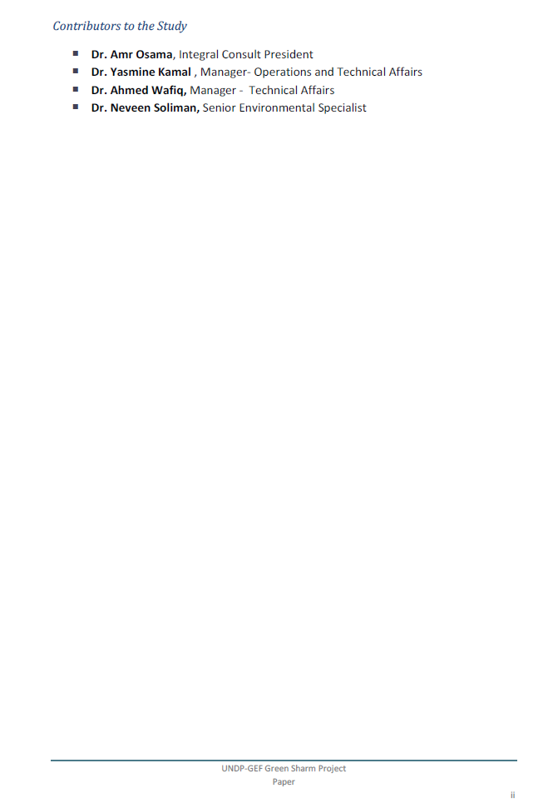
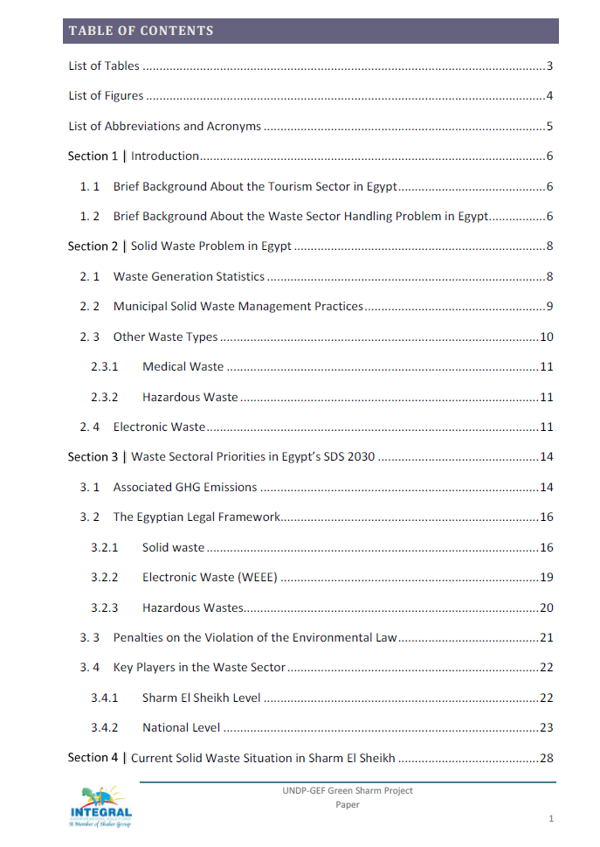
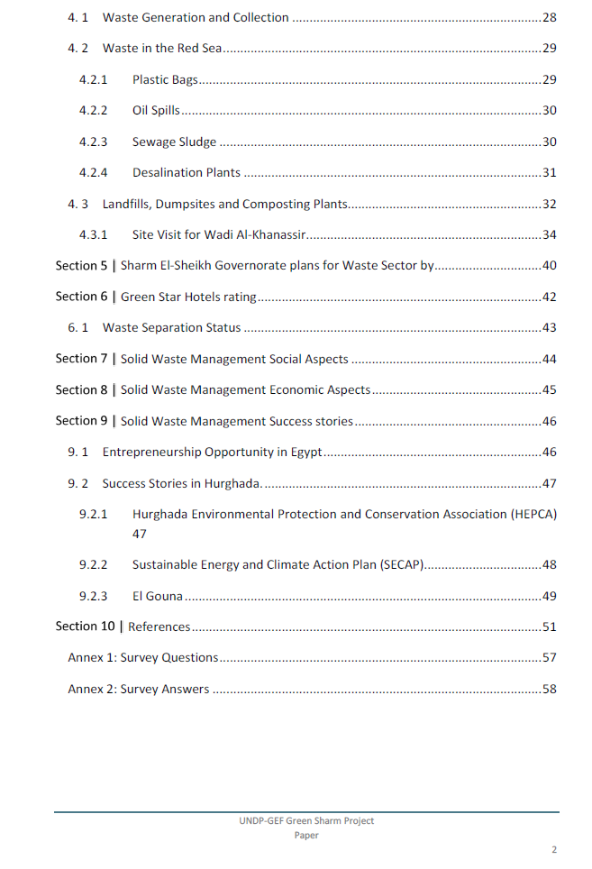
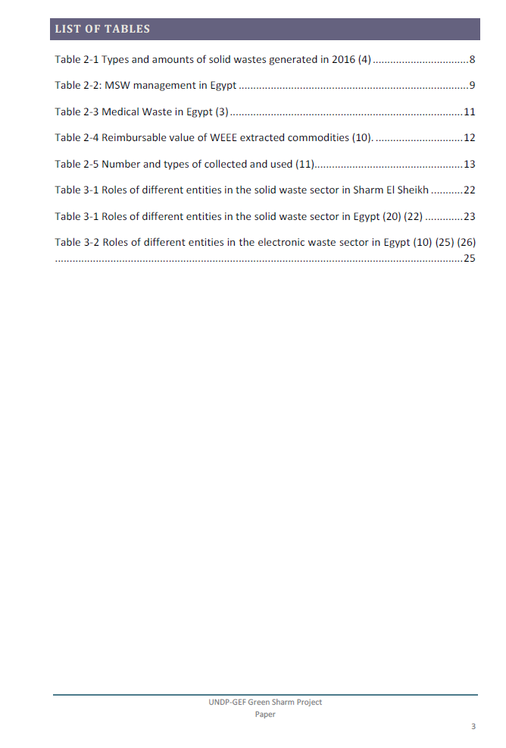
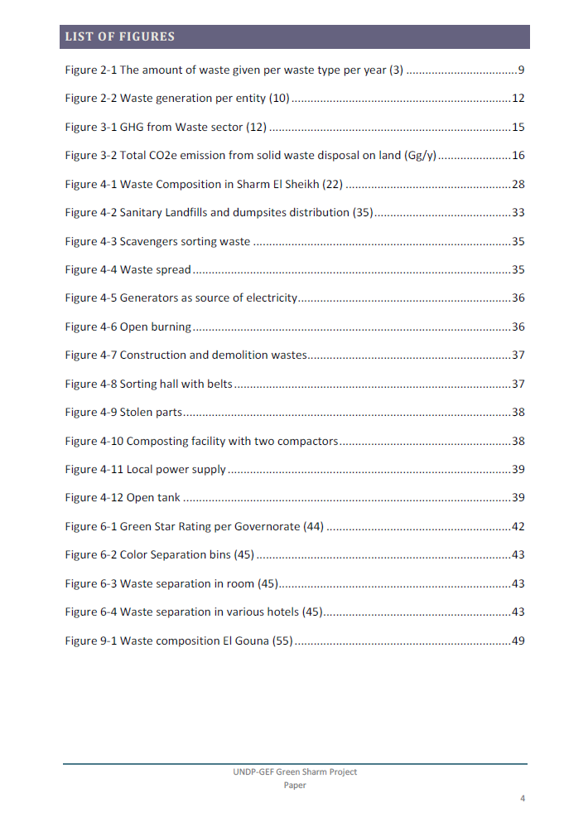
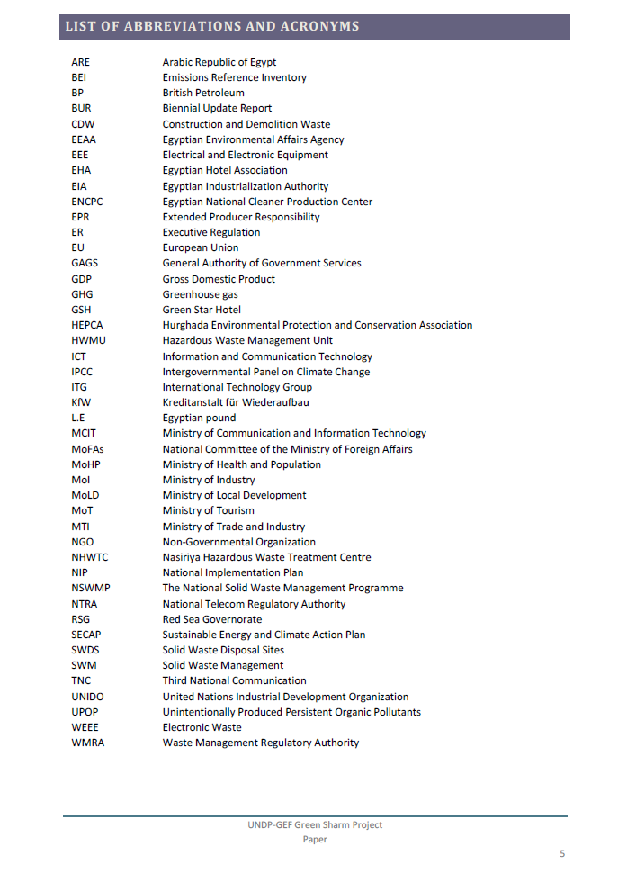
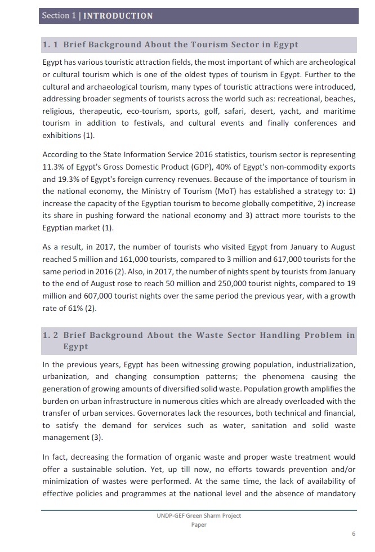
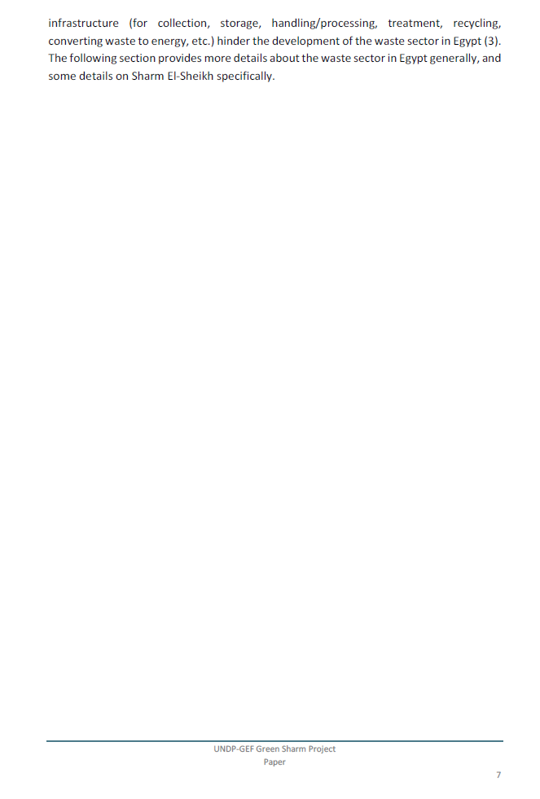
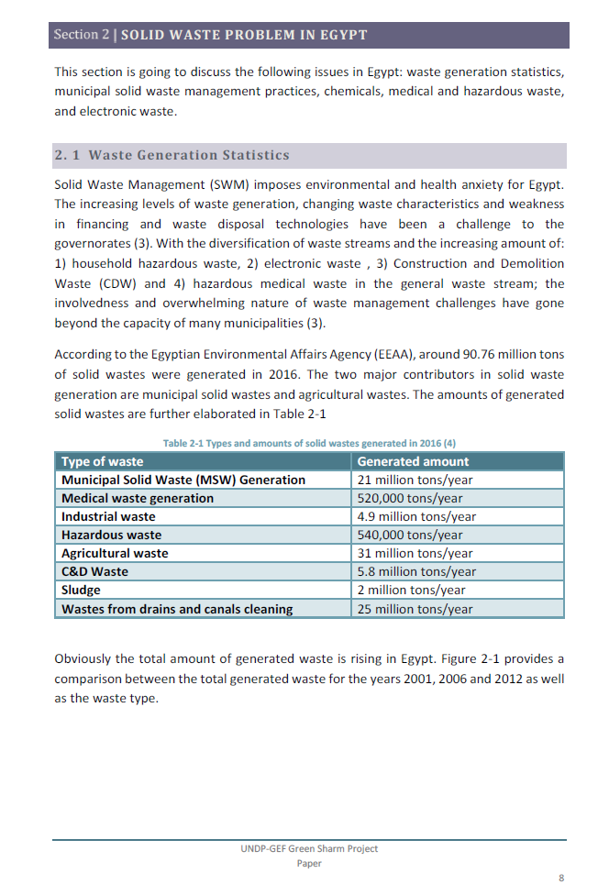
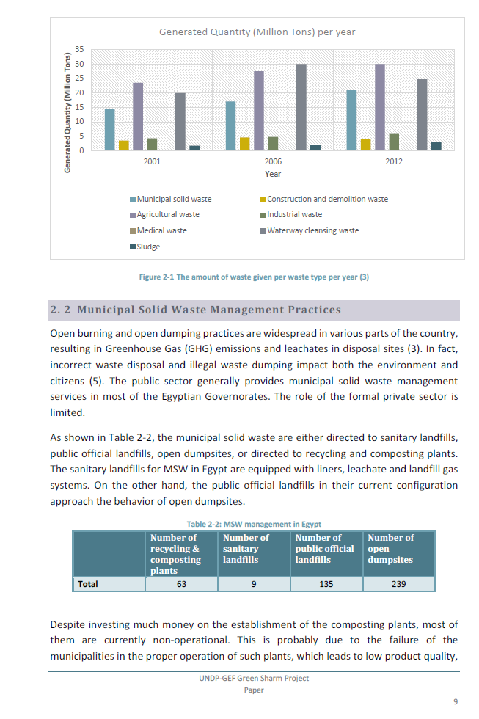
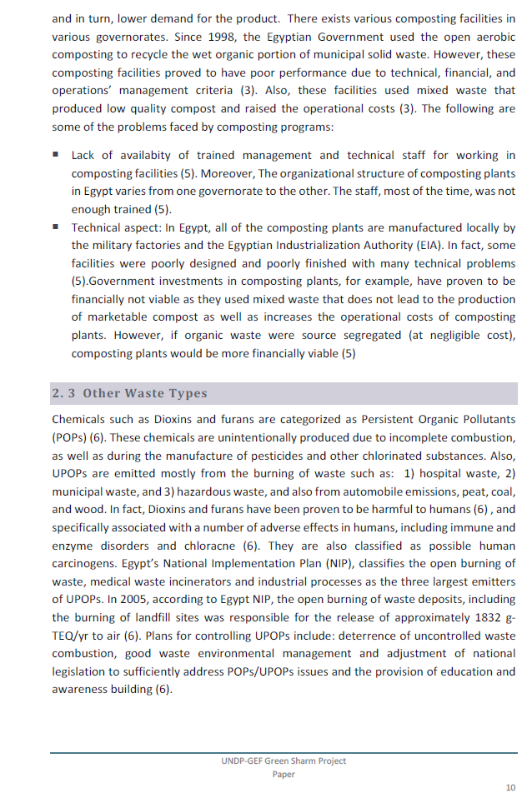
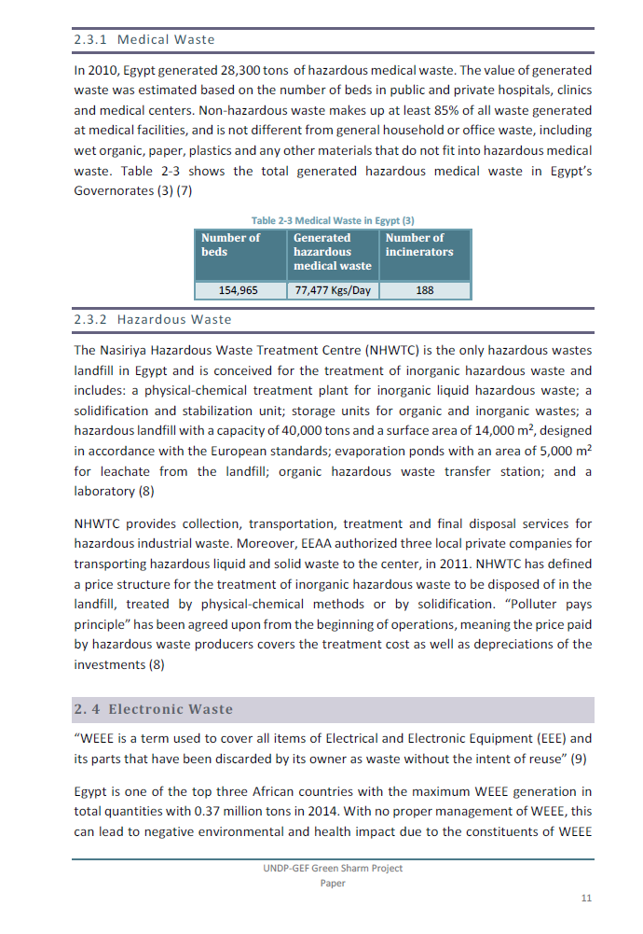
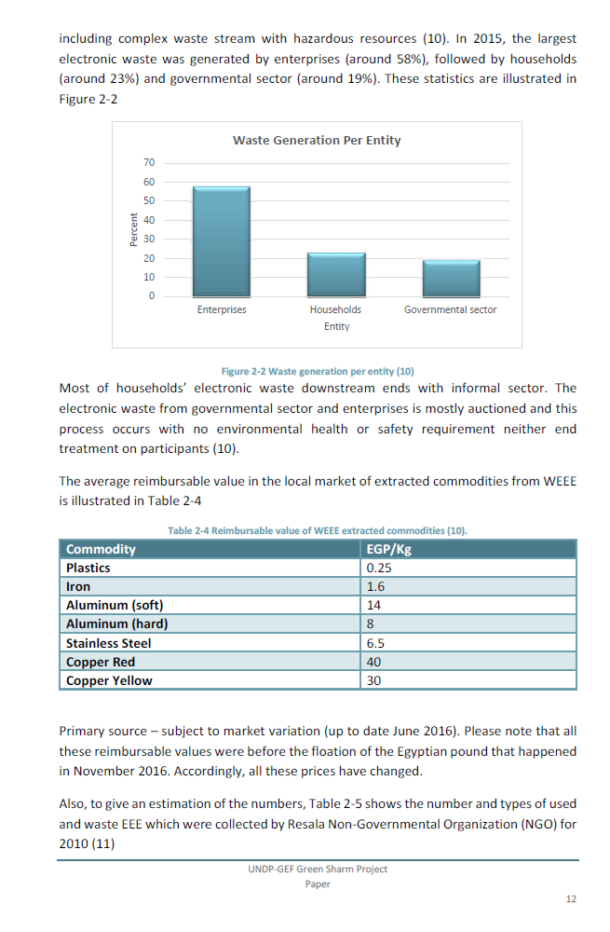
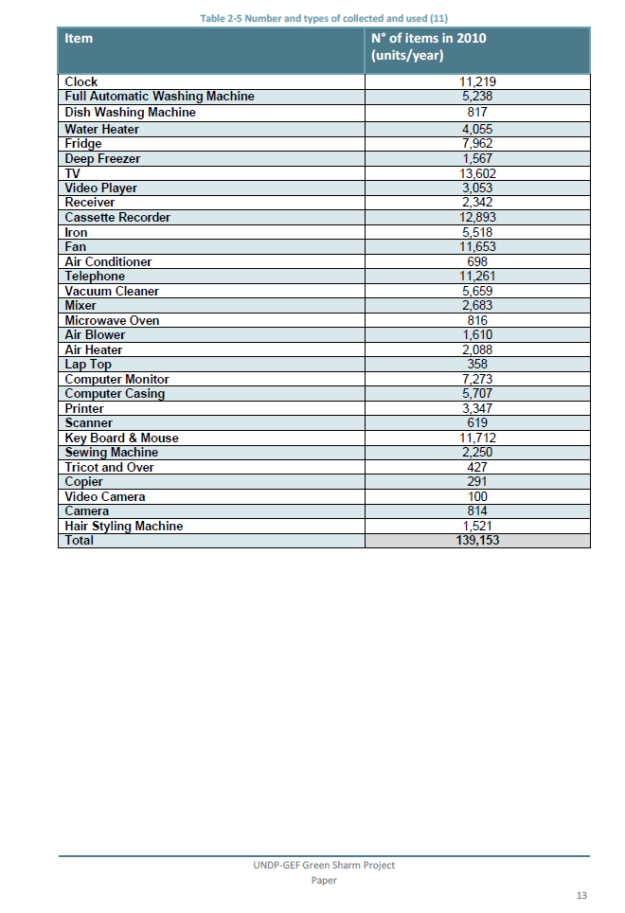
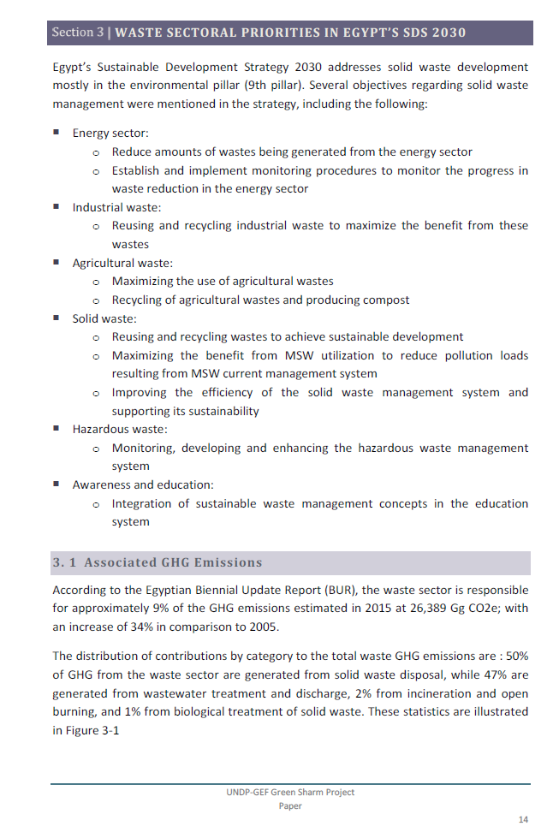
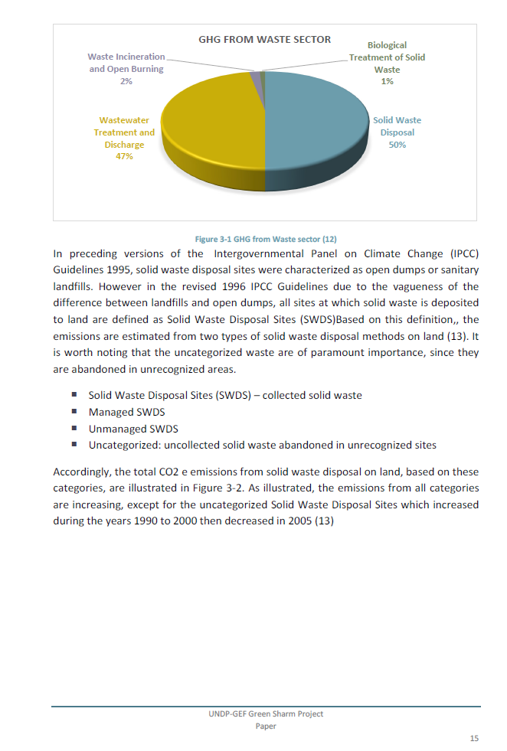
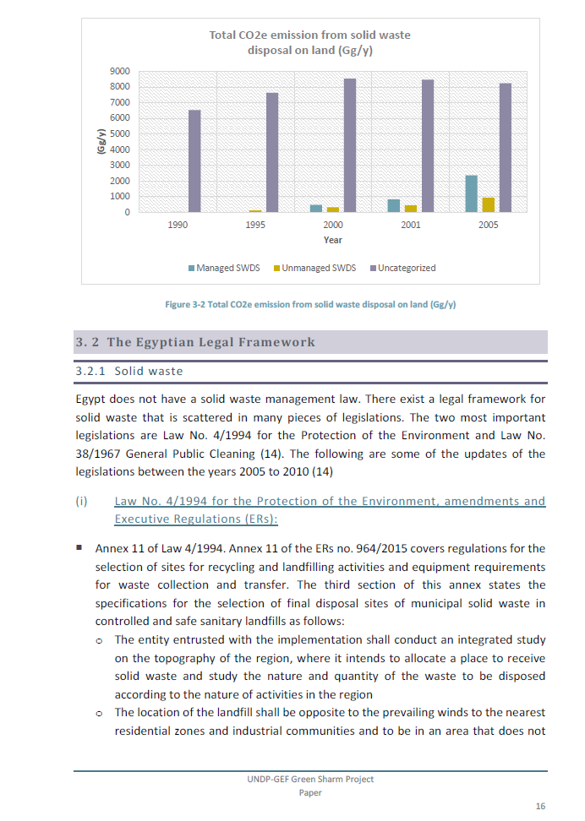
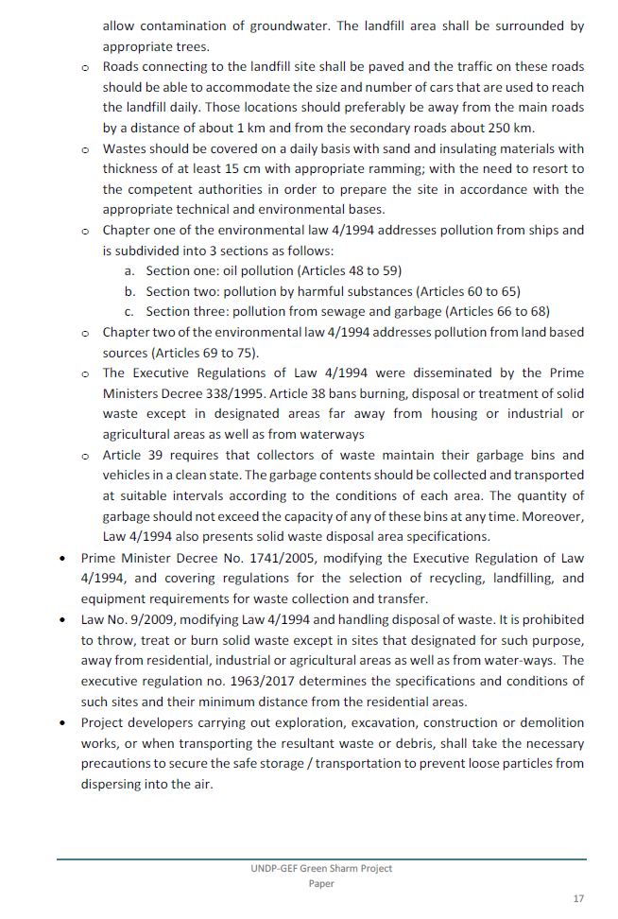
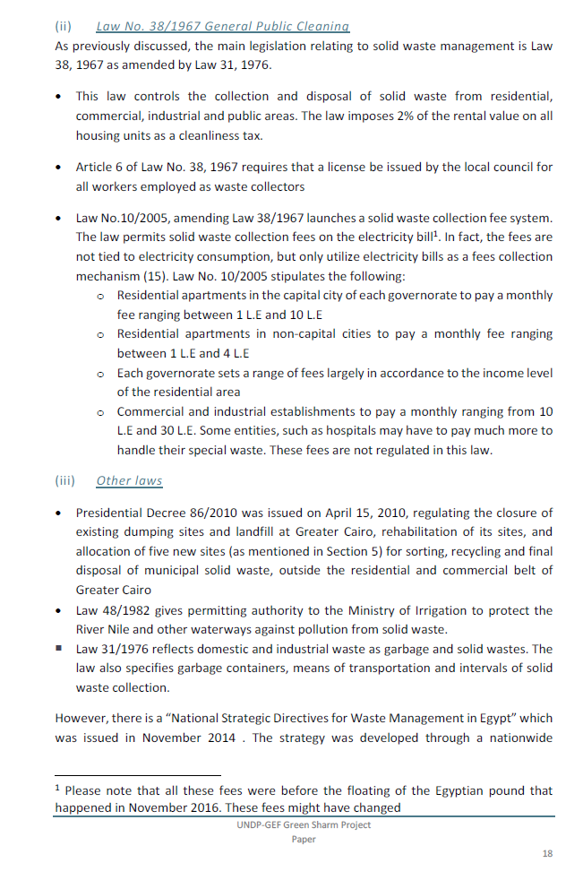
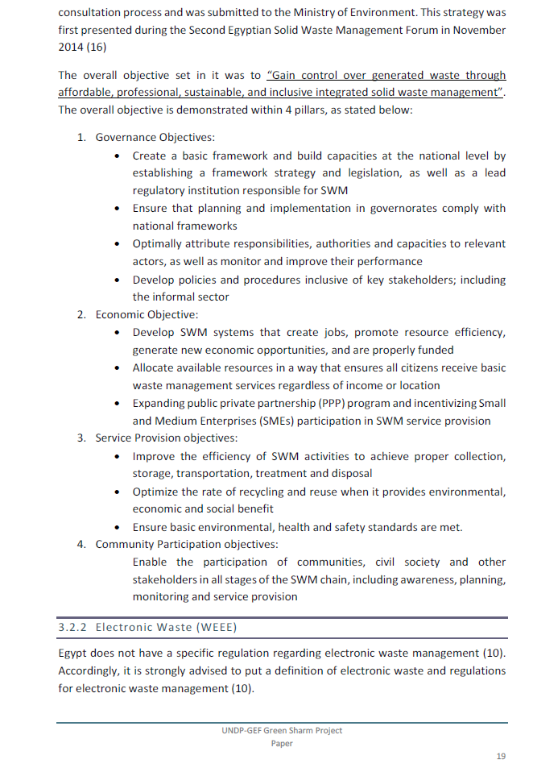
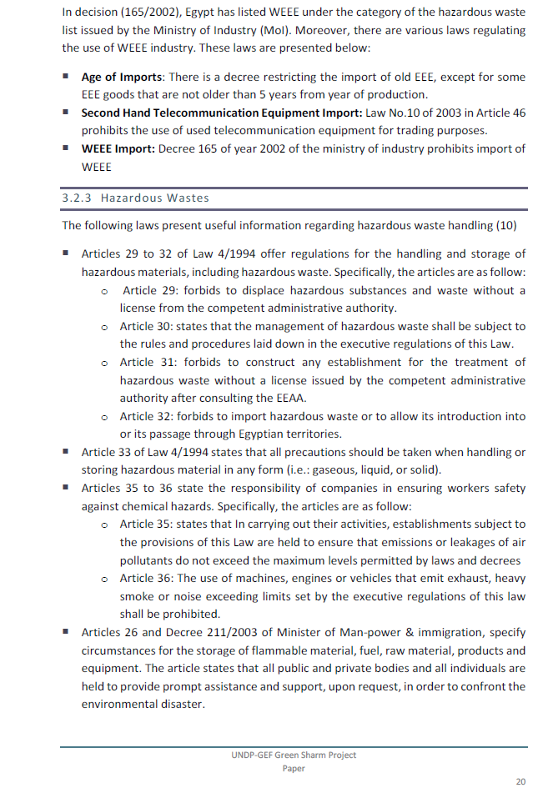
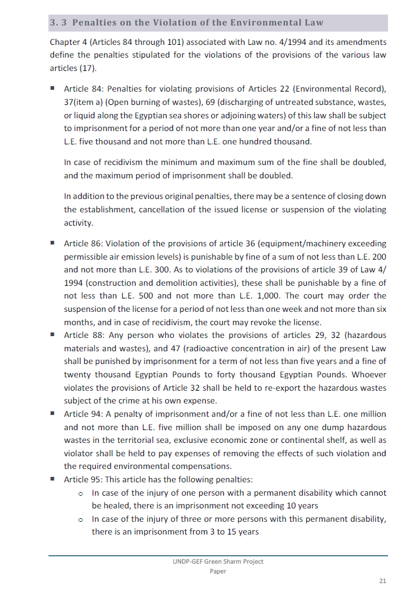
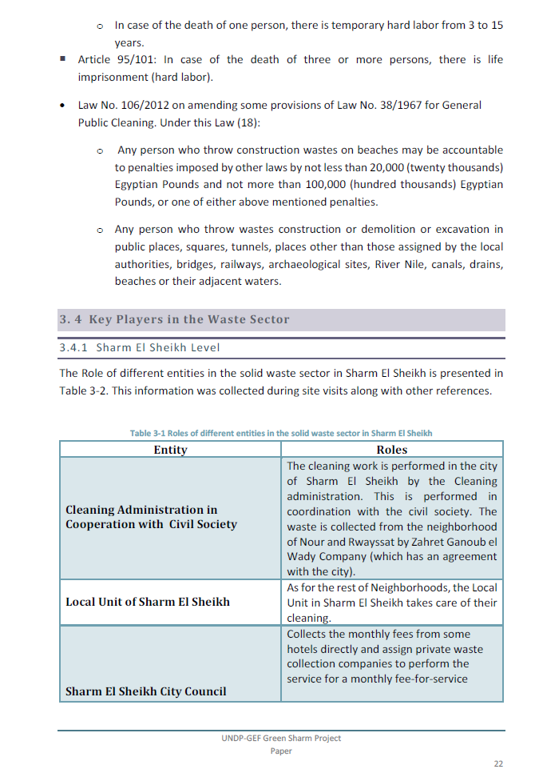
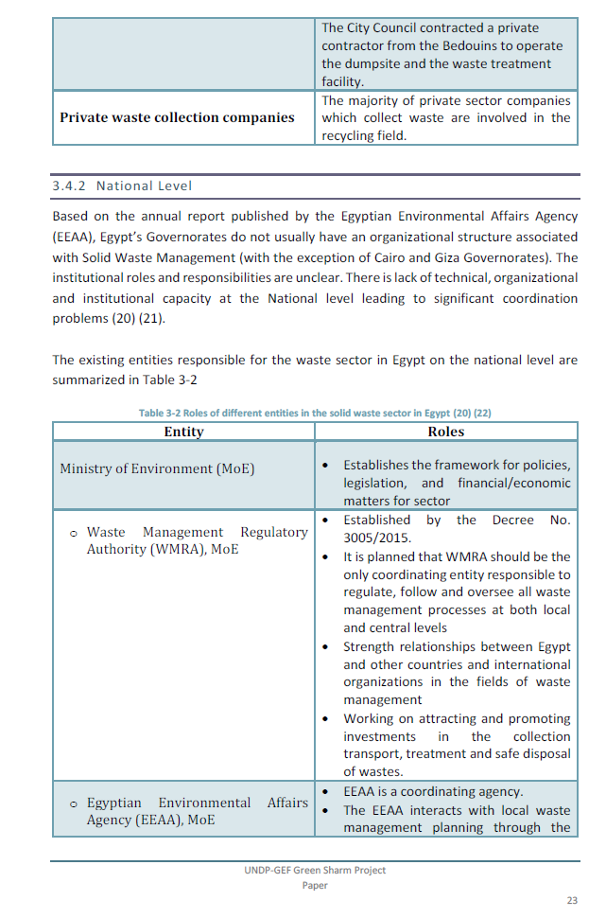
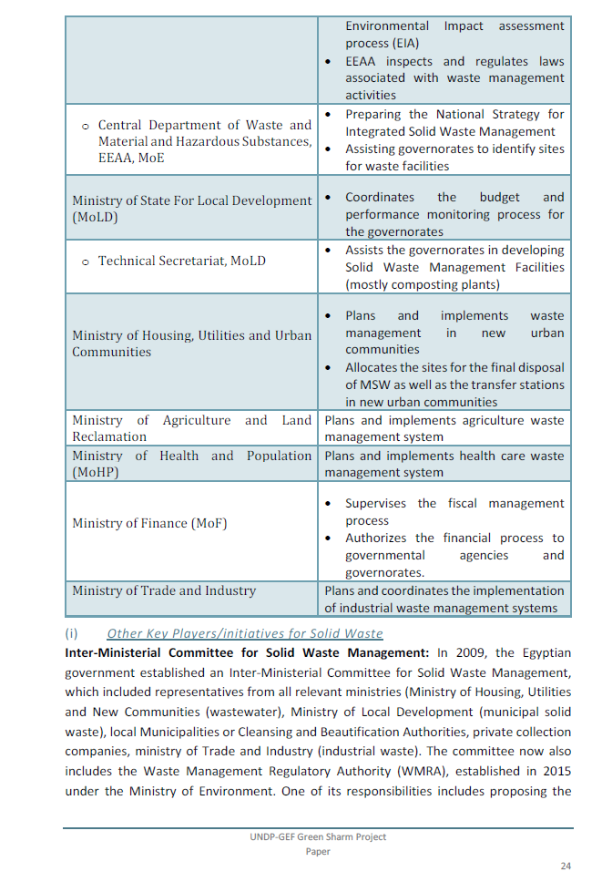
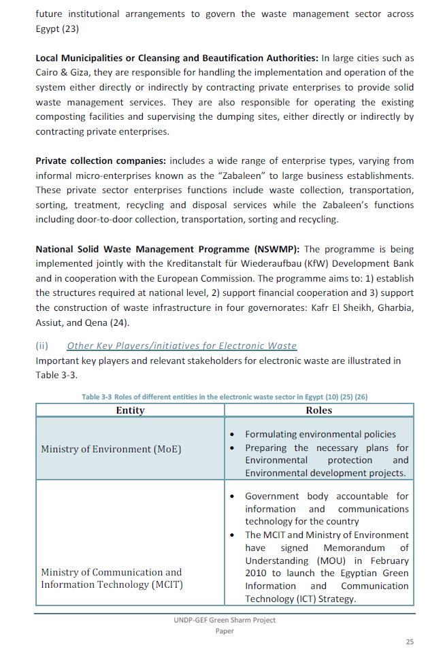
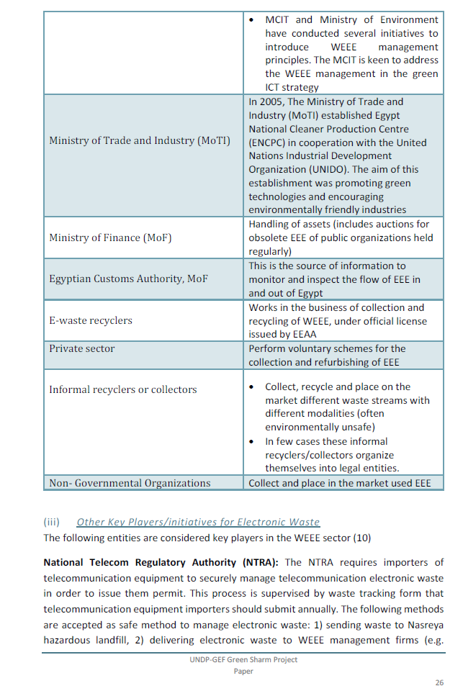
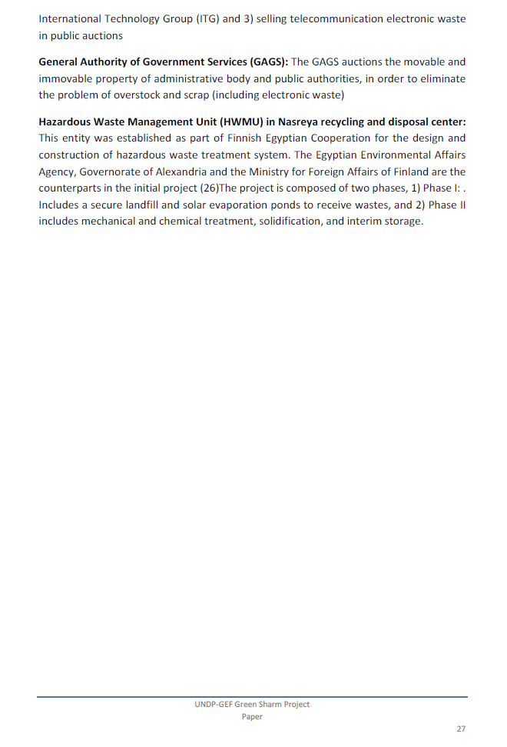
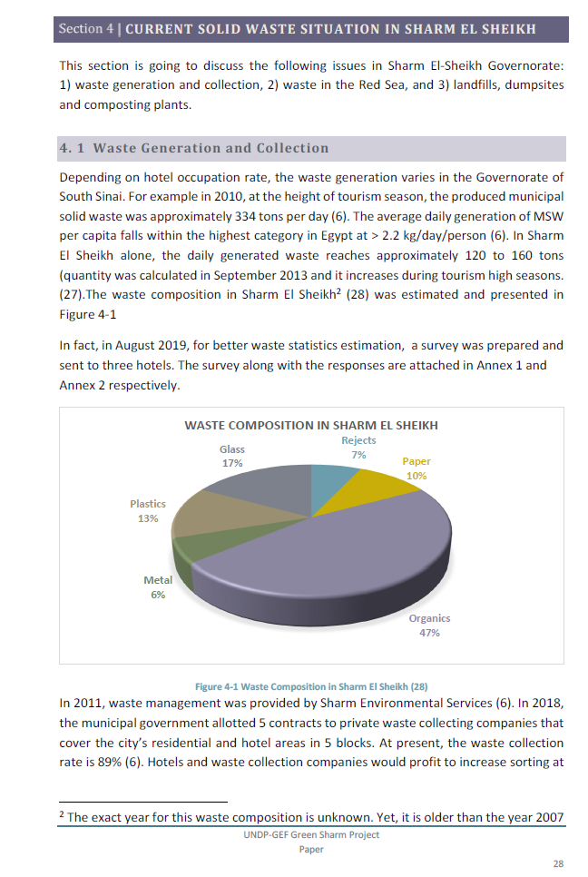
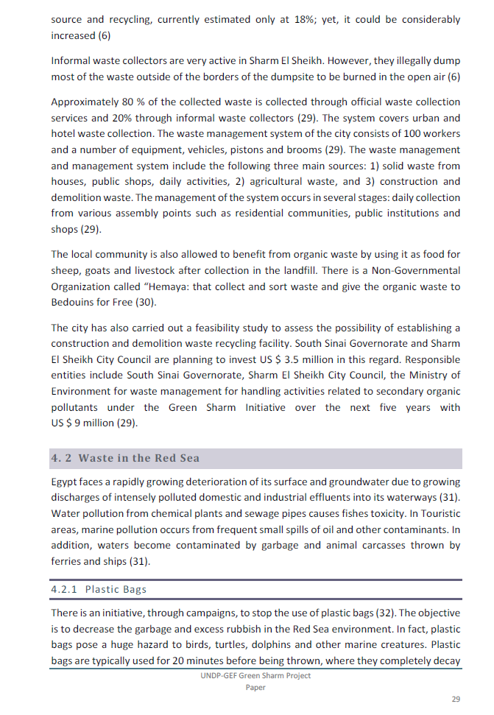
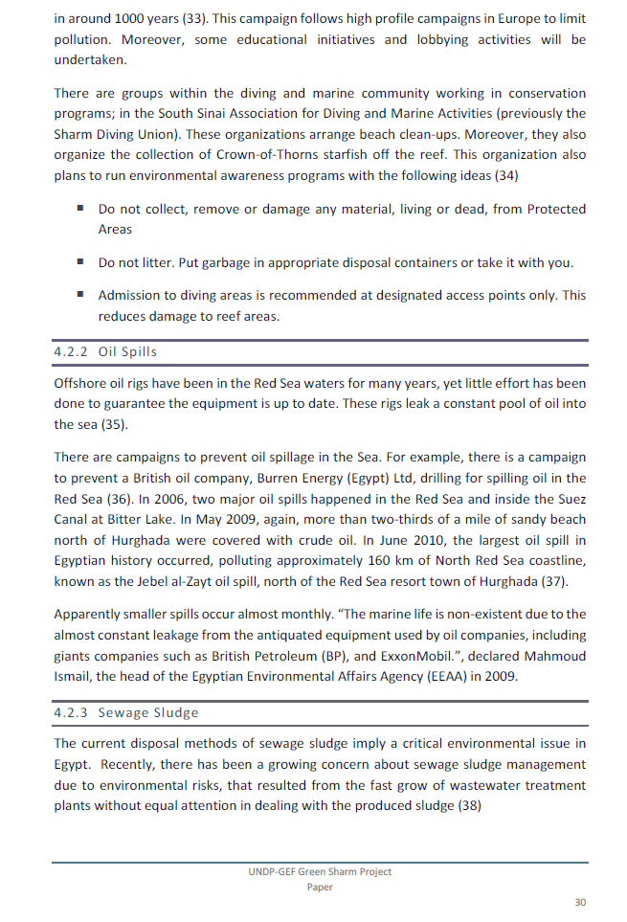
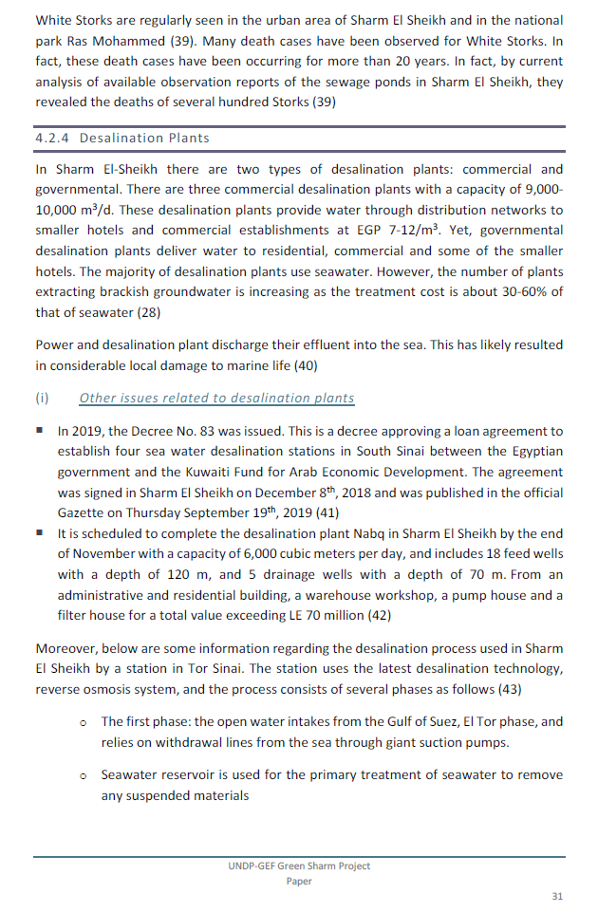
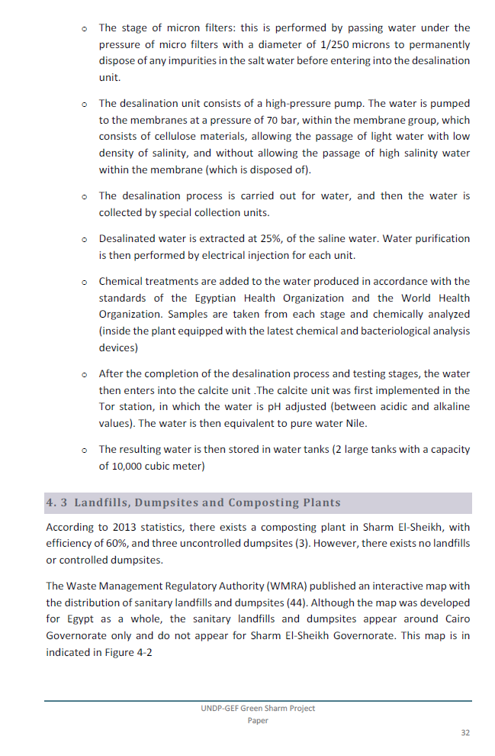
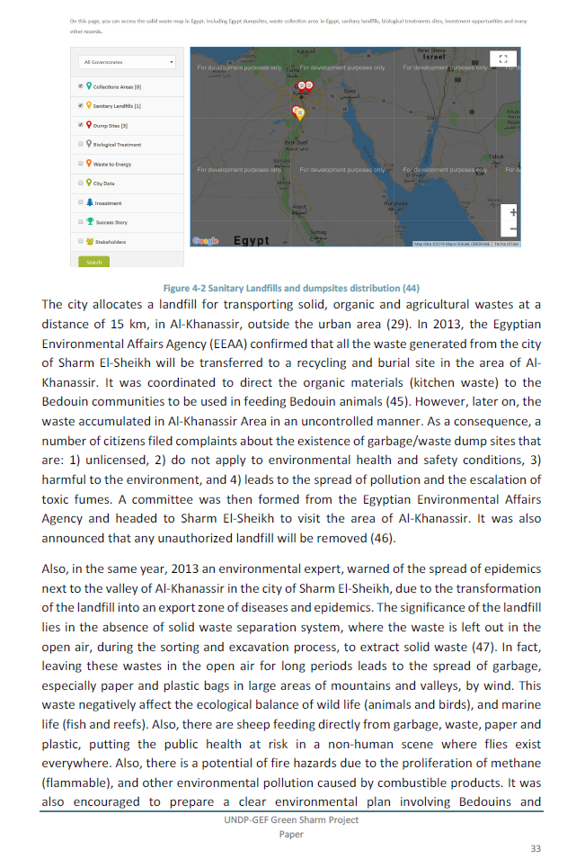
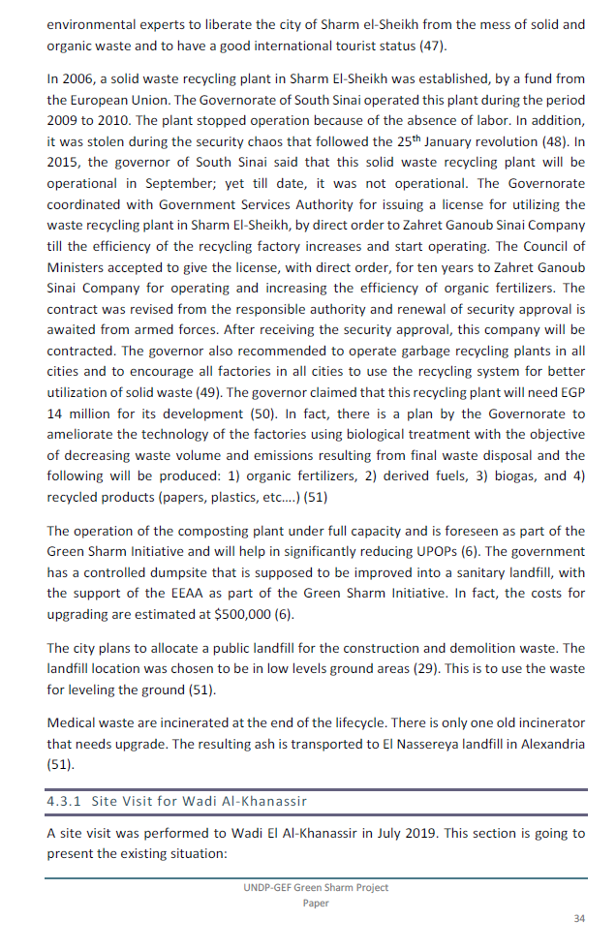
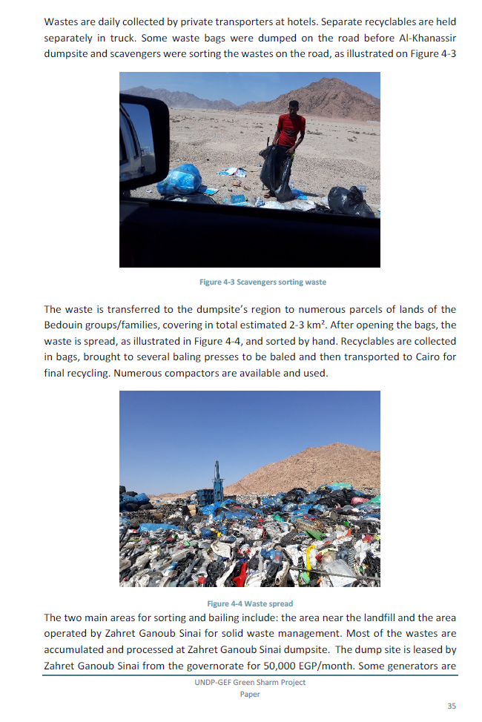
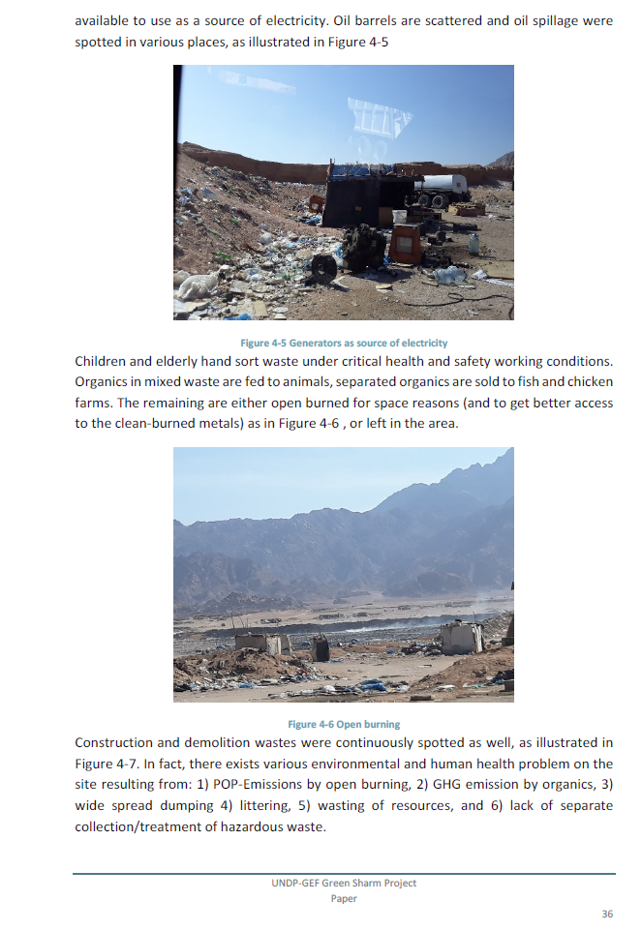
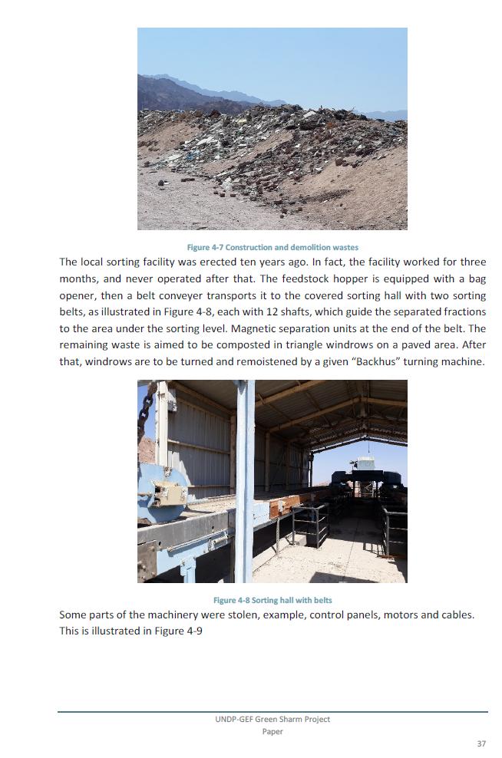
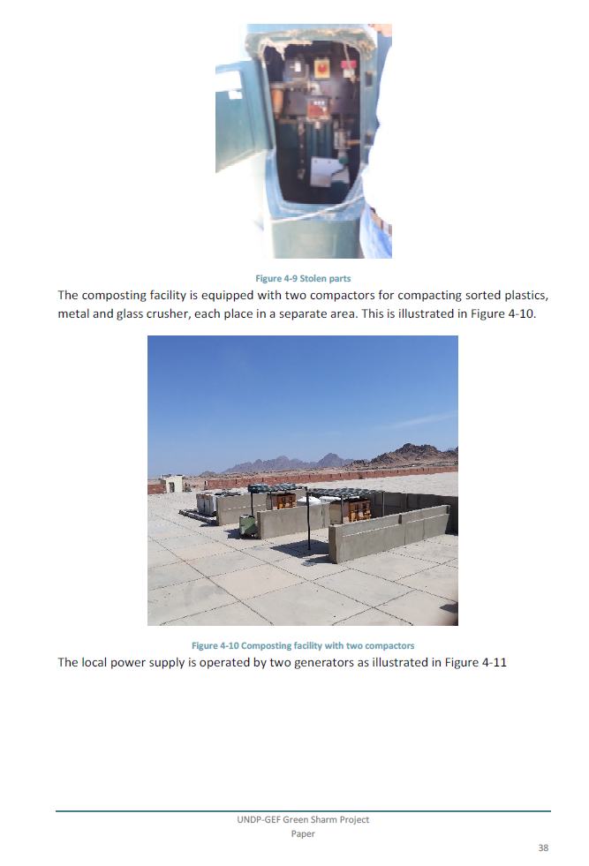
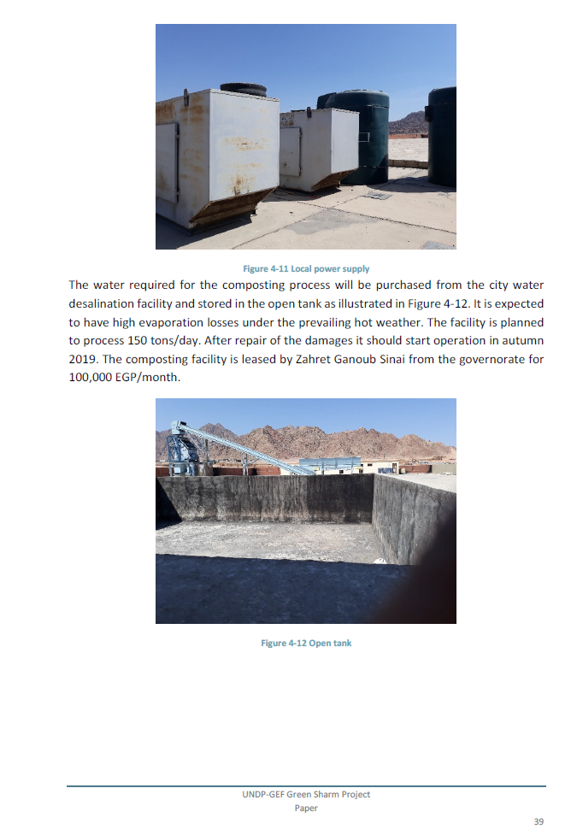
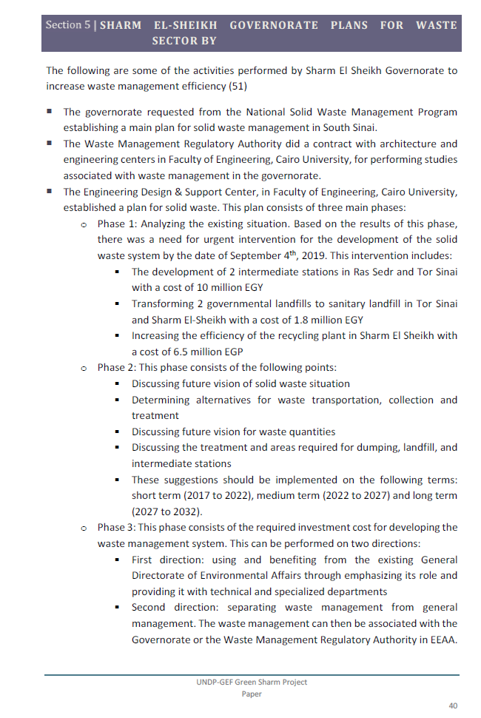
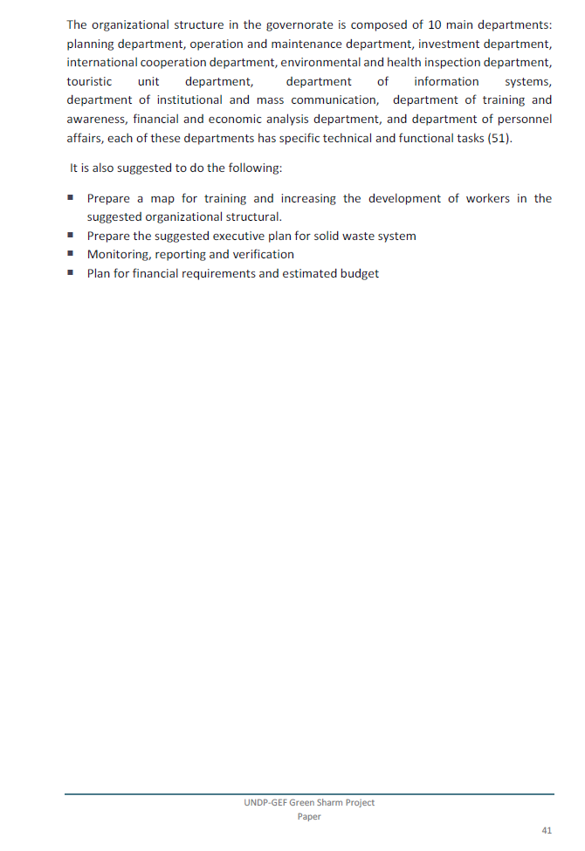
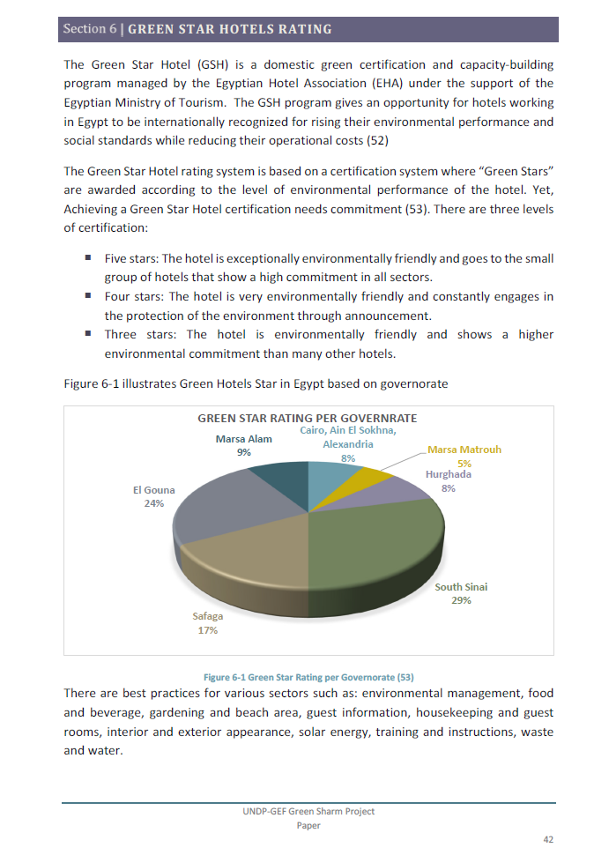
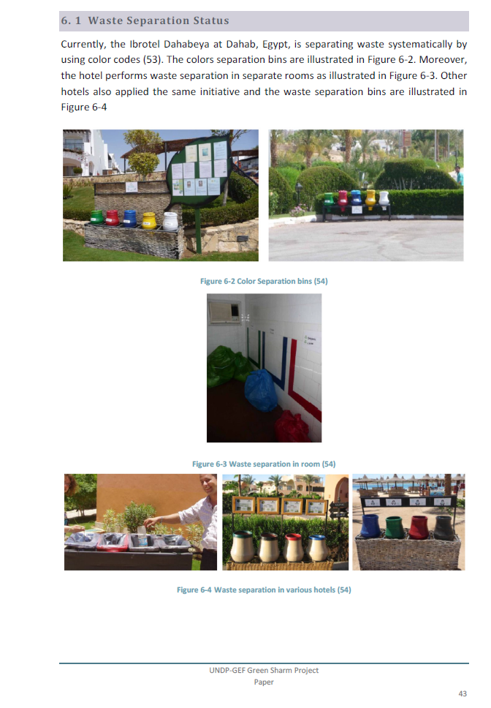
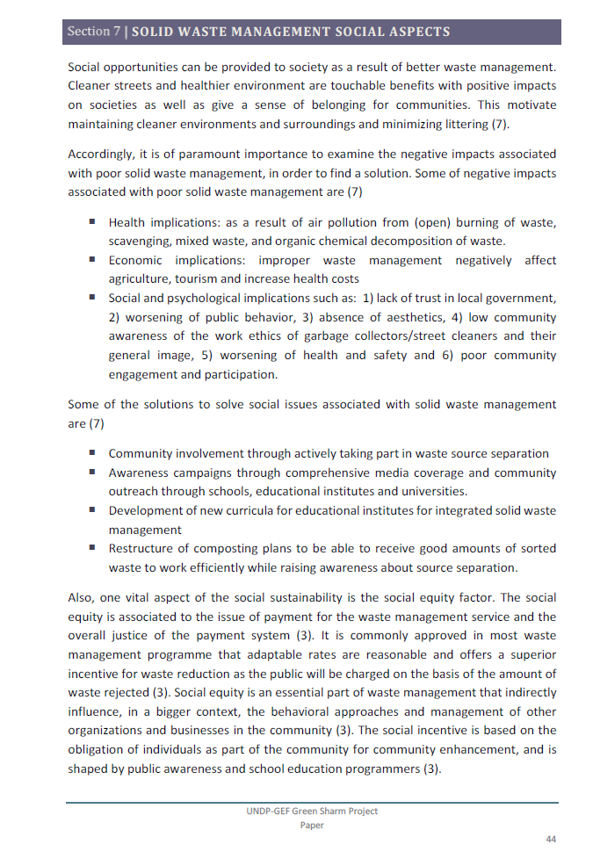
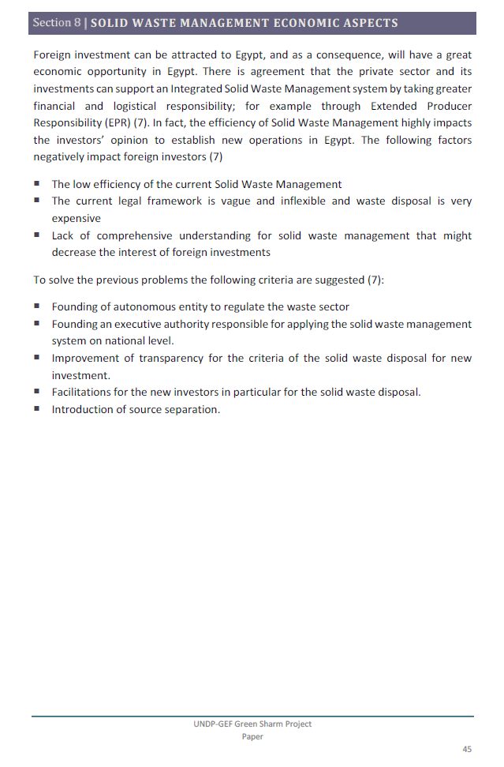
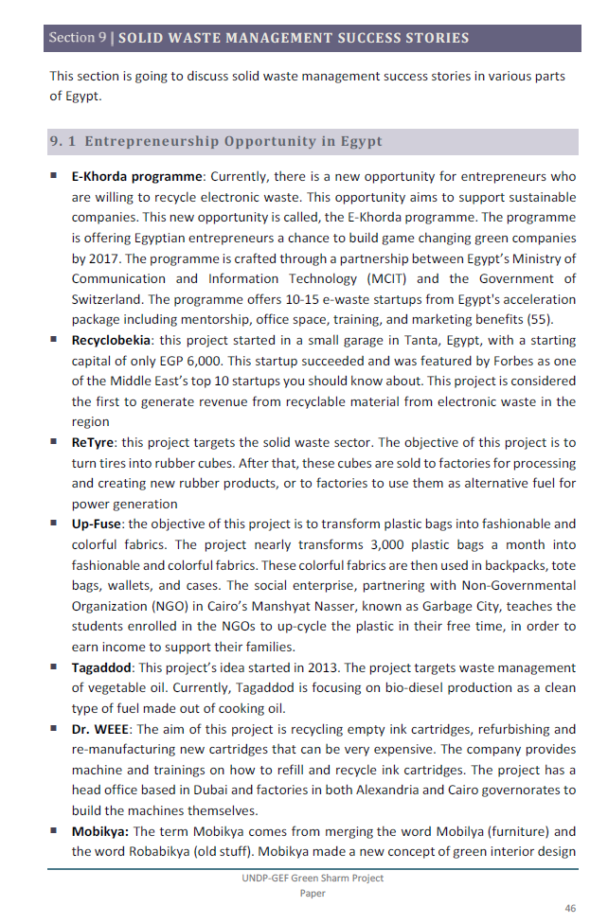
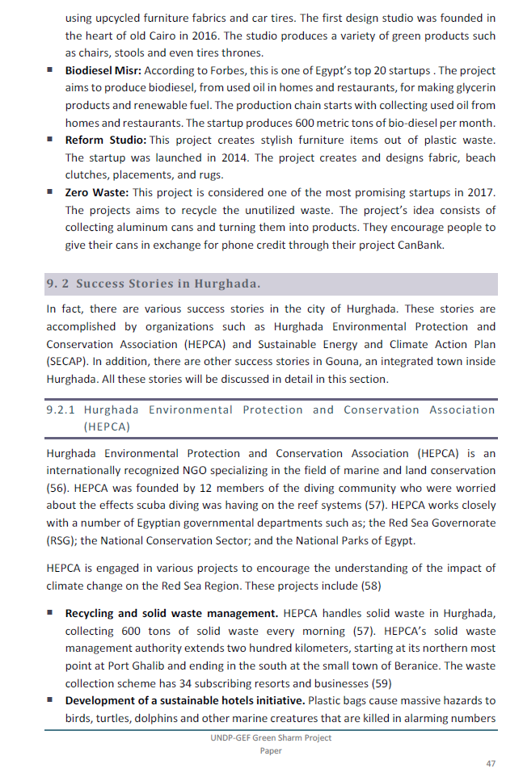
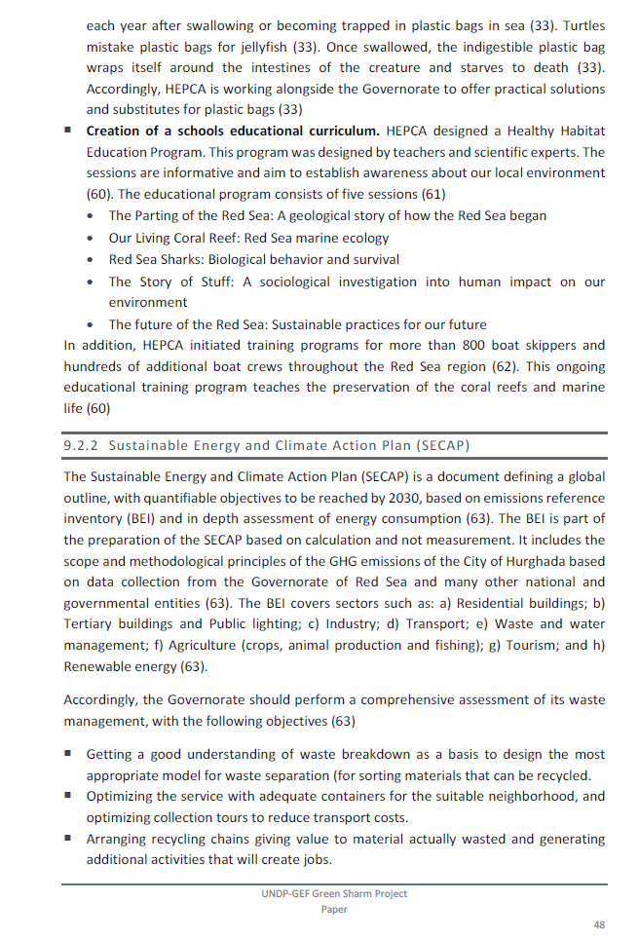
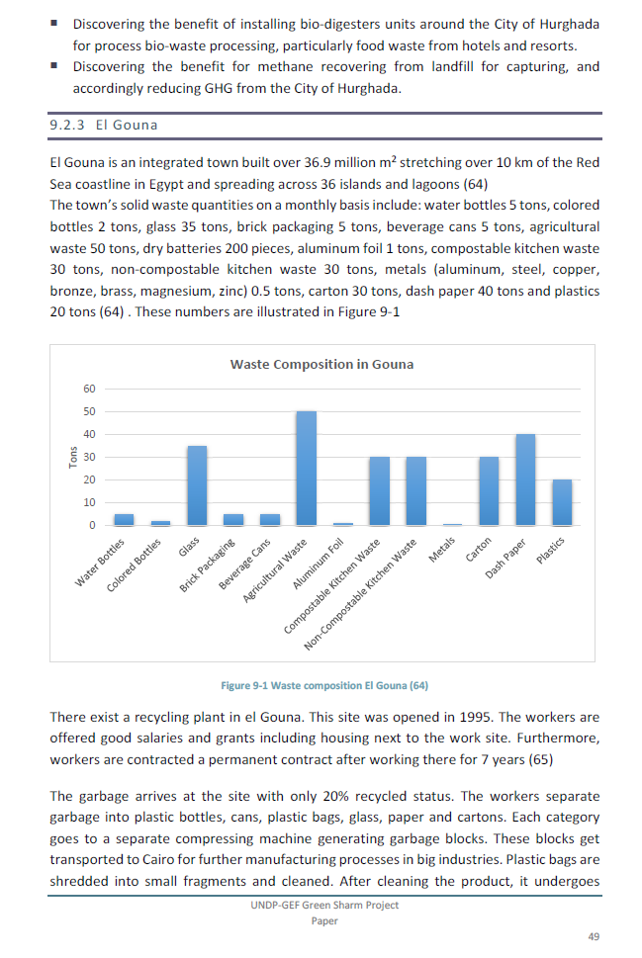
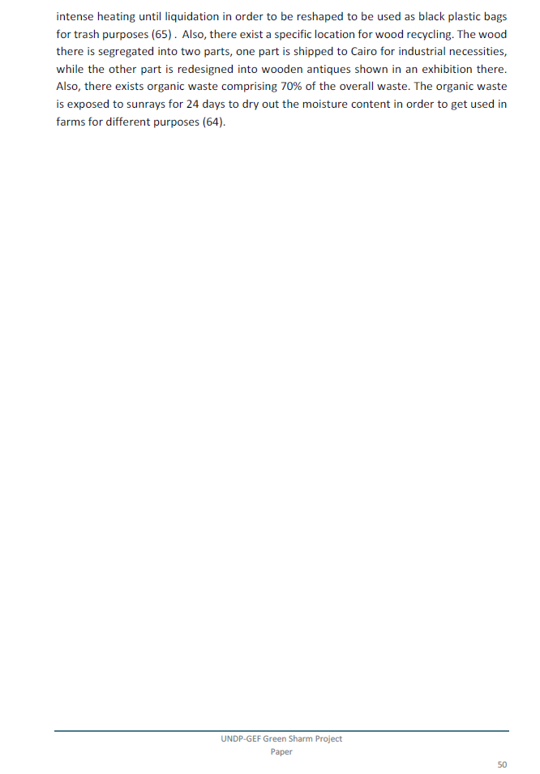
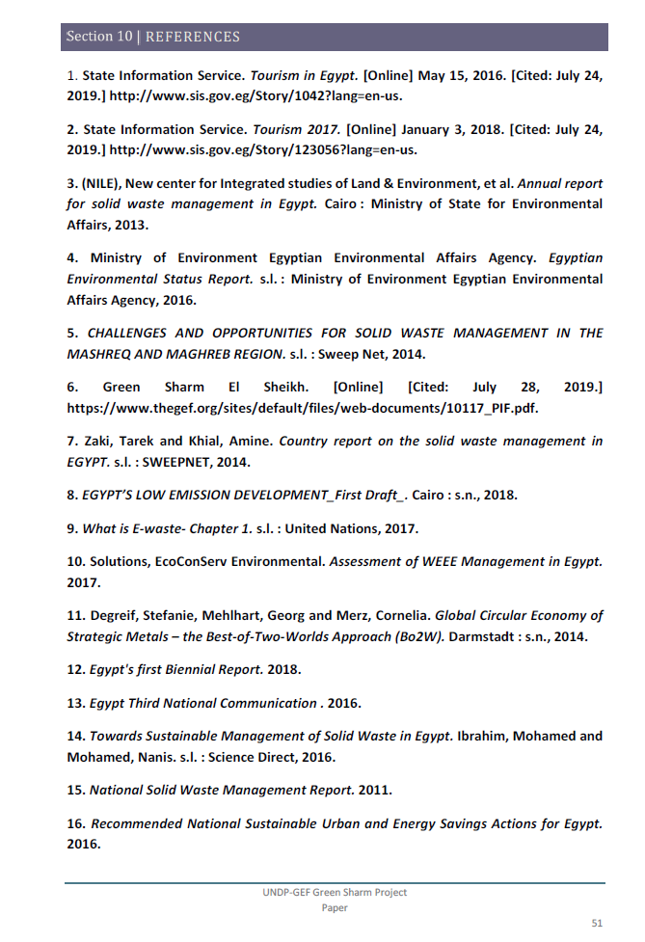
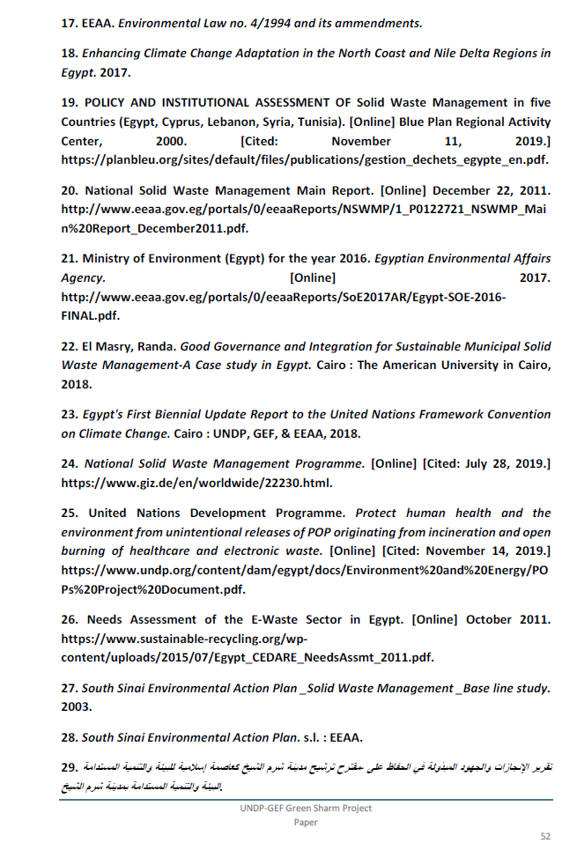
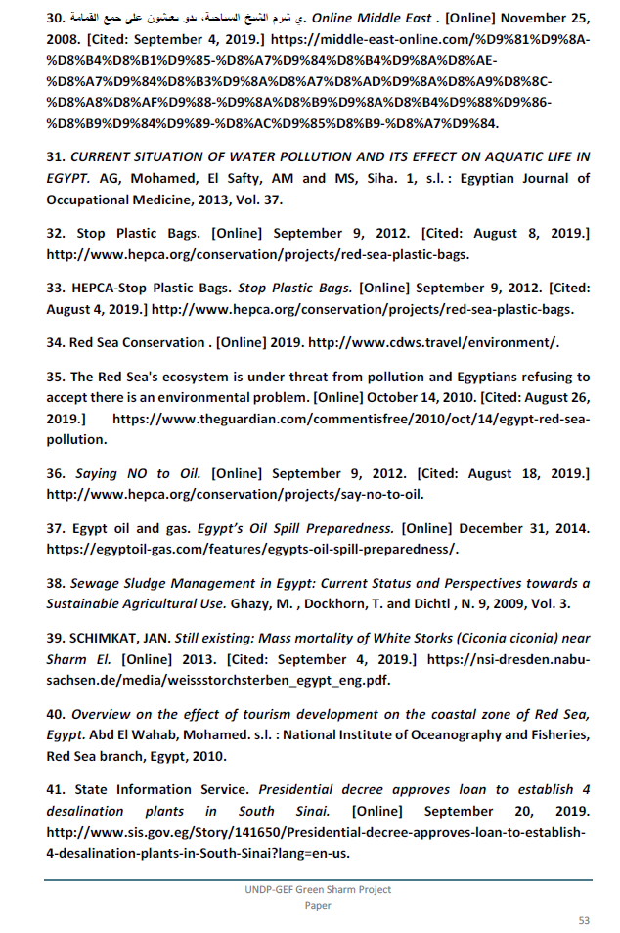
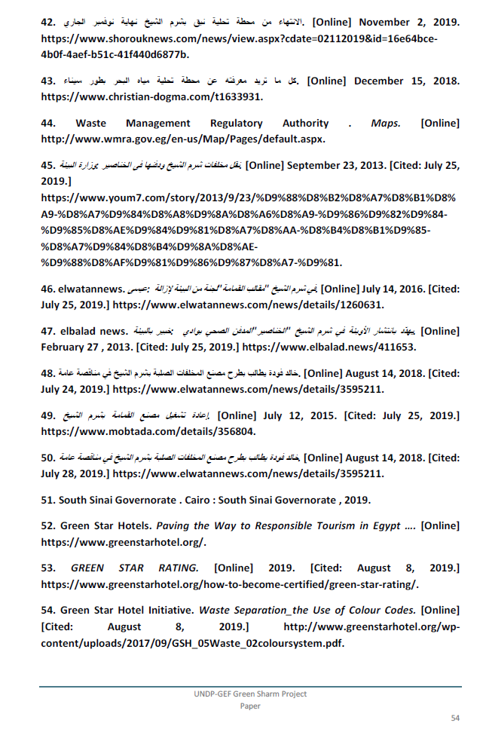
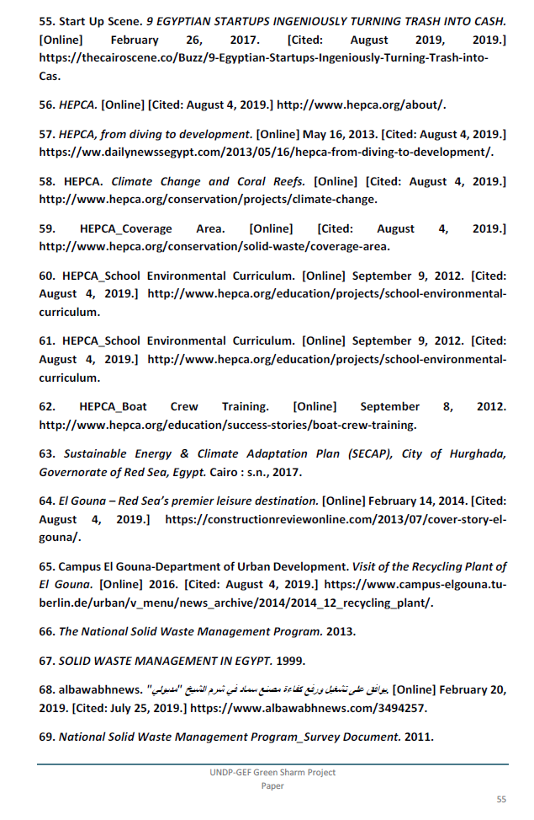
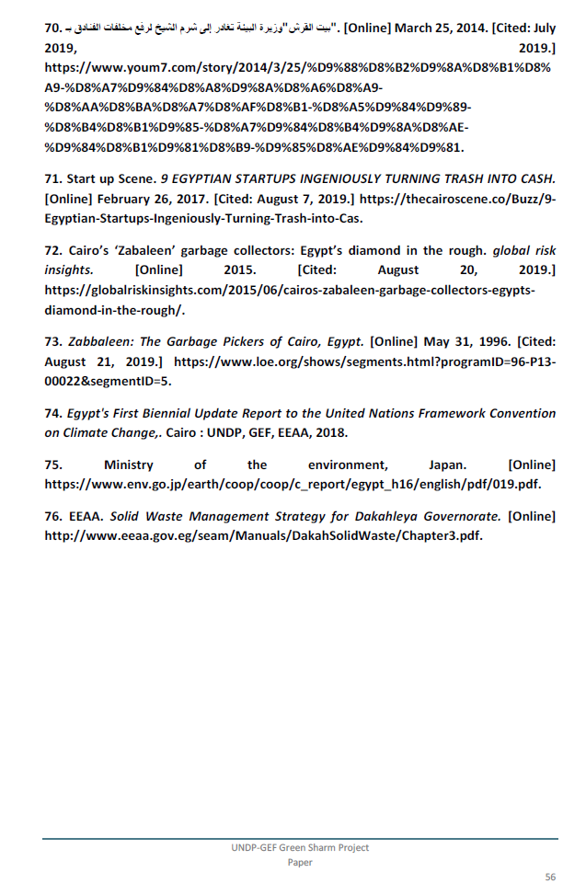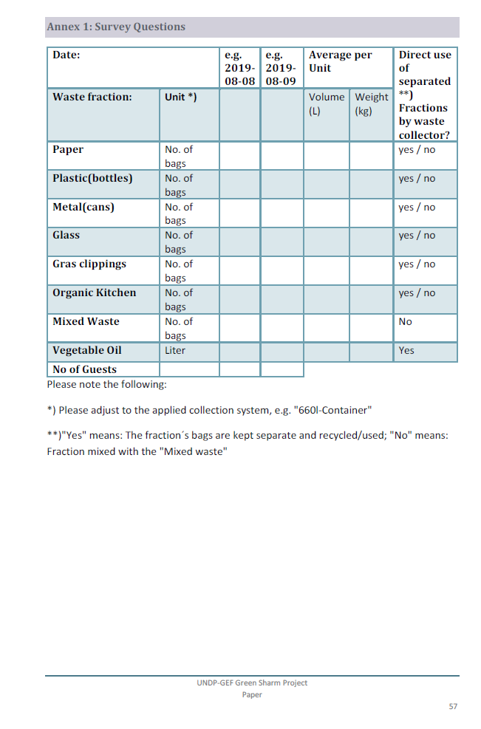
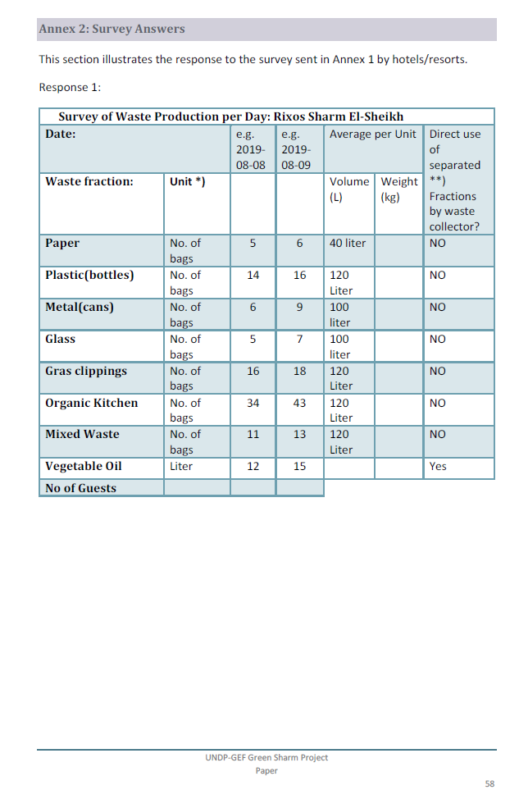
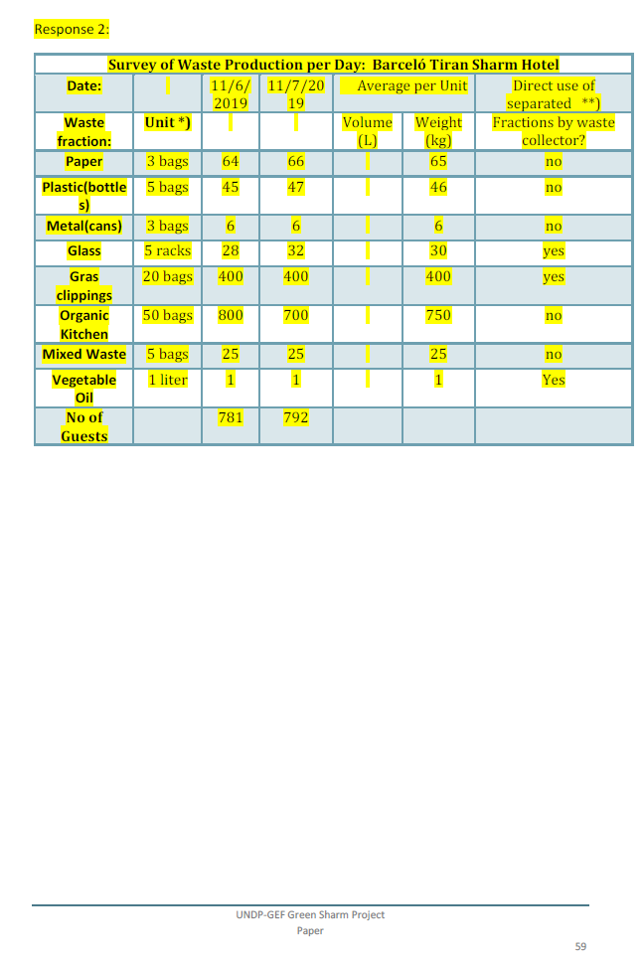
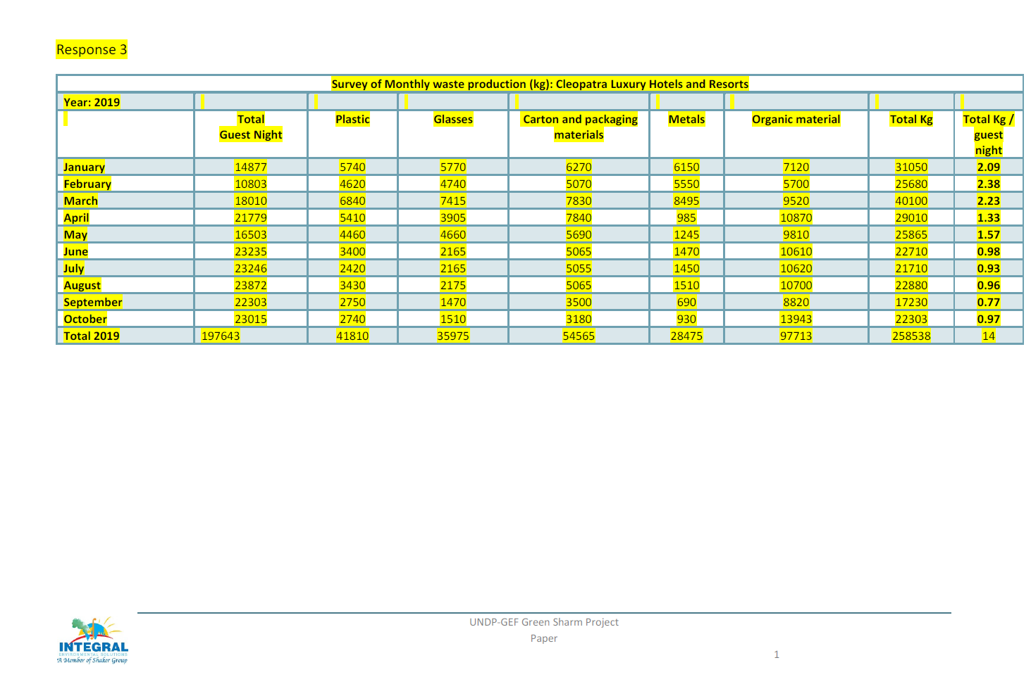

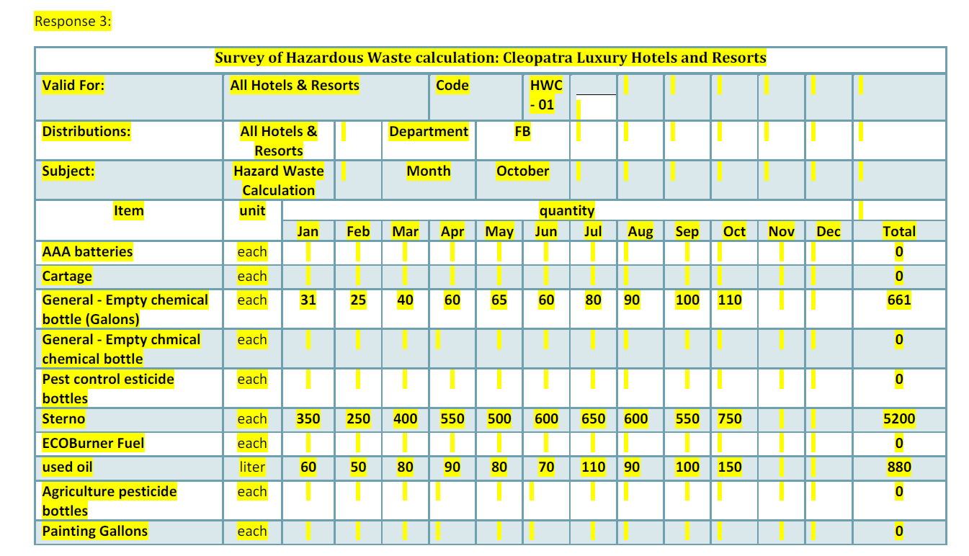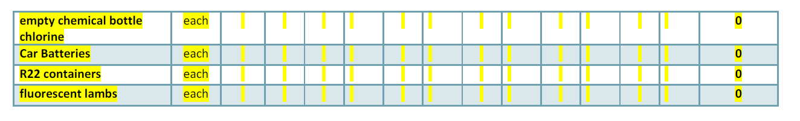

Annex 27: TBWP in GEF Budget Template
Expend Cat | Detailed Description | Component (USDeq.) |  |  |  |  |  |  | Total | Responsible Entity
Expend Cat | Detailed Description | Comp 1 | Comp 2 | Comp 3 | Comp 4 | Sub-Total | M&E | PMC | (USD eq.) | (Executing Entity receiving funds from the GEF Agency) [1]
Furniture/Equipment | 73400 Rental & Maint of Other Equip: vehicle fuel ($50/wk*52 weeks*1vehicle*6yrs) (30% of which under Component 1) | 4,680 |  |  |  | 4,680 |  |  | 4,680 | MOE
Furniture/Equipment | 73400 Rental & Maint of Other Equip: vehicle fuel ($50/wk*52 weeks*1vehicle*6yrs) (30% of which under Component 2) |  | 4,680 |  |  | 4,680 |  |  | 4,680 | MOE
Furniture/Equipment | 73400 Rental & Maint of Other Equip: vehicle fuel ($50/wk*52 weeks*1vehicle*6yrs) (30% of which under Component 3) |  |  | 4,680 |  | 4,680 |  |  | 4,680 | MOE
Furniture/Equipment | 73400 Rental & Maint of Other Equip: vehicle fuel ($50/wk*52 weeks*1vehicle*6yrs) (10% of which under Component 4) (50% KM / 50% M&E) |  |  |  | 780 | 780 | 780 |  | 1,560 | MOE
Furniture/Equipment | 72800 IT equipment: IT equipment for project staff – PCs, laptops, printers, etc. ($12,000) |  |  |  |  | 0 |  | 12,000 | 12,000 | MOE
Furniture/Equipment - Vehicle | 72200 Equipment and Furniture: 4x4 Vehicle Sharm El Sheikh ($37,000), 30% of which under Component 1 ($11,100) (see note at table end) | 11,100 |  |  |  | 11,100 |  |  | 11,100 | MOE
Furniture/Equipment - Vehicle | 72200 Equipment and Furniture: Purchase of monitoring/metering equipment for energy/emission monitoring ($15,000, allocated to output 2.1.1); 4x4 Vehicle Sharm El Sheikh ($37,000), 30% of which under Component 2 ($11,100) (see note at table end) |  | 26,100 |  |  | 26,100 |  |  | 26,100 | MOE
Furniture/Equipment - Vehicle | 72200 Equipment: Equipment related to income generation activities (e.g. craft making, eco-lodges, fishing boats, etc.) (3.4.2, $20,000); equipment/investments in PA management such as moorings, trails, interpretation facilities and signage, camp sites, etc., as based on management plans (3.1.1, $50,000); 4x4 Vehicle Sharm El Sheikh ($37,000), 30% of which under Component 3 ($11,100) (see note at table end) |  |  | 81,100 |  | 81,100 |  |  | 81,100 | MOE
Furniture/Equipment - Vehicle | 72200 Equipment and Furniture: 4x4 Vehicle Sharm El Sheikh ($37,000), 10% of which under Component 4 ($3,700) (see note at table end) (50% KM / 50% M&E) |  |  |  | 1,850 | 1,850 | 1,850 |  | 3,700 | MOE
Furniture/Equipment - Vehicle | 72200 Equipment and Furniture: Office equipment |  |  |  |  | 0 |  | 20,967 | 20,967 | MOE
Contractual Services – Individual | 71400 Contractual Services Ind: 5% PM ($13,125; please see TOR in Annex 7); 20% 4 Technical Officers (1*$26,250+3*$21,875=$91,875); 20% Comms & KM Officer ($21,875); 30% Driver ($13,125); $41,940 for ESIA/SESA/ESMP in Yr1 | 181,940 |  |  |  | 181,940 |  |  | 181,940 | MOE
Contractual Services – Individual | 71400 Contractual Services Ind: 50% PM ($131,250; please see TOR in Annex 7); 50% 4 Technical Officers (1*$65,625+3*$54,687.50=$229,687.50); 50% Comms & KM Officer ($54,687.50); 30% Driver ($13,125); $150,000 for ESIA/SESA/ESMP in Yr1 |  | 578,750 |  |  | 578,750 |  |  | 578,750 | MOE
Contractual Services – Individual | 71400 Contractual Services Ind: 20% PM ($52,500; please see TOR in Annex 7); 20% 4 Technical Officers (1*$26,250+3*$21,875=$91,875); 20% Comms & KM Officer ($21,875); 30% Driver ($13,125); CSs to provide technical support and training for income generation activities in output 3.4.2 ($22,500 divided equally between 6 yrs) |  |  | 201,875 |  | 201,875 |  |  | 201,875 | MOE
Contractual Services – Individual | 71400 Contractual Services Ind: 3% PM ($8,750); 10% 4 Technical Officers (1*$13,125+3*$10,937.50=$45,937.50); 10% Driver ($4,375); 10% Comms & KM Officer ($10,937.50; 50% KM / 50% M&E) |  |  |  | 35,000 | 35,000 | 35,000 |  | 70,000 | MOE
Contractual Services – Individual | 71400 Contractual Services Ind: 22% PM ($56,875; please see TOR in Annex 7); 100% Admin & Finance Assistant in Cairo ($87,500) |  |  |  |  | 0 |  | 144,375 | 144,375 | MOE
Contractual Services – Company | 72100 Contractual Services – Comp: (1.1.2 & 1.2.2) International TA to support the SESSDS development, incl. action plan and financing strategy ($100,000); (1.1.3) Development of a CO2 calculator (and/or other promotional tools) ($10,000); (1.2.1) 4 feasibility studies to be tendered out: (1) waste management + business plan ($80,000), (2) innovative RE + EE solutions ($80,000), (3) renewable energy desalination plants + EIA ($80,000), (4) transport & mobility ($40,000); (1.1.3) Dissemination and communication activities, incl. development/launching of marketing and branding strategy / campaign for green tourism ($60,000); (1.2.3) International TA for long-term financing scheme to increase the uptake of private sector investments in environmental technologies and biodiversity conservation ($75,480) | 525,480 |  |  |  | 525,480 |  |  | 525,480 | MOE
Contractual Services – Company | 72100 Contractual Services – Comp: Local/Intl. consultant firms to be contracted: Design, implementation, supervision company ($170,000), Cost sharing mechanism for pilot investments ($2,324,170) under outputs 2.2.1, 2.2.2, 2.2.3 and 2.3.1. |  | 2,494,170 |  |  | 2,494,170 |  |  | 2,494,170 | MOE
Contractual Services – Company | 72100 Contractual Services – Comp: (i) to support installation of new technologies and tools for threat management ($40,000, yr 1); (ii) to document best practices ($20,000, yr 1) and (iii) technical support and pilot installation of new technologies (e.g. anchoring systems, waste collection and disposal from boats and piers, etc.; $80,000 yrs 2 and 3 each and $40,000 yr 4 (3.1.1, subtotal $260,000); CSs to conduct inventory and define baselines for terrestrial and coastal areas of 3 PAs (3.3.1, $20,000, yr 1); to undertake monitoring of terrestrial, coastal and marine systems (3.3.2, $40,000 @ $8000 each yrs 2-6); NGO to support participatory planning in Gharqana village (3.4.1, $40,000 @ $8000 each yrs 2-6); NGO to support implementation of ecotourism and livelihood activities in Gharqana village (3.4.2, $40,000 @ $8000 each yrs 2-6); support to communities for income generation activities for activities on cost sharing basis that will be defined following the village participatory planning process in Year 1 (3.4.2, $197,897 @ $40,000 each yrs 2-5 + $37,897 yr 6); Produce electronic awareness related materials for hotel staff and visitors (output 3.5.2, $20,000, yr 1). |  |  | 617,897 |  | 617,897 |  |  | 617,897 | MOE
International Consultants | 71200 International Consultants: to set up MRV methodology (output 1.1.4) | 24,000 |  |  |  | 24,000 |  |  | 24,000 | MOE
International Consultants | 71200 International Consultants: EE and resource efficiency experts to support design/implementation of innovative pilot solutions in hotels (2.2.2, $80,000); Waste management experts providing expertise for conducting feasibilities, design, implementation support, monitoring (2.3.1, $88,000); |  | 168,000 |  |  | 168,000 |  |  | 168,000 | MOE
International Consultants | 71200 International Consultants: IC to provide new technologies for management of threats (e.g. new anchoring systems, waste management on boats and piers, etc.) allocated to output 3.1.1 |  |  | 40,000 |  | 40,000 |  |  | 40,000 | MOE
International Consultants | 71200 International Consultants: M&E: Mid-Term Review ($30,000) and Terminal Evaluation ($30,000) (4.1.1.) (100% M&E) |  |  |  |  | 0 | 60,000 |  | 60,000 | MOE
Local Consultants | 71300 Local short-term consultants: to do a legal/framework gap analysis and review of intl. best practice and prepare guidelines for local sustainable development planning (1.1.1, $15,000); to develop a green tourism marketing/branding strategy and action plan and continuous promotional activities (1.1.3, $27,500); to develop a MRV platform (1.2.2, $17,500); to support SESSDS financing strategy and long-term financing scheme to increase the uptake of private sector investments in environmental technologies and biodiversity conservation (1.2.3, $20,000) | 80,000 |  |  |  | 80,000 |  |  | 80,000 | MOE
Local Consultants | 71300 Local short-term Consultants: Hiring individual trainers for conducting trainings in public and private sector on sustainable strategies devt. planning, MRV, energy & resource efficiency, green purchasing, etc. (altogether 150 days incl. preparation; 2.1.1, $75,000); Feasibility studies and monitoring/supervision support for outputs 2.2.1 $50,000, 2.2.2 ($32,500), 2.2.3 ($25,000); Support and supervise local implementation of avoided GHG/UPOPs/MSW activities under 2.3.1 ($85,000) |  | 267,500 |  |  | 267,500 |  |  | 267,500 | MOE
Local Consultants | 71300 Local short-term Consultants: to facilitate consultations and assessment related to threat management (3.1.1, $14,000); to develop electronic system for management of visiting and permitting (4 weeks) and prepare of financing/resource mobilization and reinvestment strategies for 3 PAs (3.2.1, $47,500); to provide oversight for marine ecosystem monitoring in YR 2 and 4 (3.3.2, $20,000); to update Chamber of Hotels guidelines and support hotels with biodiversity-friendly hotel improvements (3.5.1 $10,000, 3.5.2 $15,000); to help develop electronic database and input baseline and monitoring data and training of staff for use of system in YR 2 and to evaluate and adjust operations in YR 4 (3.3.2, $9,000) |  |  | 115,500 |  | 115,500 |  |  | 115,500 | MOE
Local Consultants | 71300 Local short-term Consultants: M&E: Mid-Term Review ($10,000) and Terminal Evaluation ($10,000) (100% M&E) |  |  |  |  | 0 | 20,000 |  | 20,000 | MOE
Trainings, Workshops, Meetings | 75700 Workshops and meetings: Stakeholder consultation and capacity development meetings for inter-institutional development and coordination and to develop strategies and action plans, financing strategies, review measures continuously | 40,000 |  |  |  | 40,000 |  |  | 40,000 | MOE
Trainings, Workshops, Meetings | 75700 Workshops and meetings: Training workshops and stakeholder consultations (2.1.1) |  | 15,000 |  |  | 15,000 |  |  | 15,000 | MOE
Trainings, Workshops, Meetings | 75700 Workshops and meetings: Stakeholder consultations related to threat assessment options and implementation of new technologies and tools and training of junior biodiversity staff in Sharm El Sheikh PMU (3.1.1, $12,000); Workshops related to development of financing/resource mobilization strategies and development and application of guidelines for financing of PA activities (3.2.1, $6,000); Training workshops for terrestrial and coastal area assessment methodology (3.3.1, $4,000); YR 2 and 4 workshops to discuss management responses to monitoring results and YR 5 national workshop to discuss project learning (3.3.2, $6,000); Community workshops and meetings (with other stakeholders) to define community management interventions (3.4.1, $8,000); Stakeholder and training workshops related to development of income generation activities (3.4.2, $12,000); Workshops to training staff of new biodiversity-friendly hotel operations (3.5.1, $6,000); Annual workshops and training for hotel and enterprise staff on biodiversity-related aspects (3.5.2, $20,000). |  |  | 74,000 |  | 74,000 |  |  | 74,000 | MOE
Trainings, Workshops, Meetings | 75700 Workshops and meetings: M&E: Inception workshop and other M&E meetings (output 4.1.1, $10,000 + $10,000); KM: Final Project Dissemination Conference (output 4.1.2, $10,000); |  |  |  | 10,000 | 10,000 | 20,000 |  | 30,000 | MOE
Travel | 71600 Travel: Travel costs of PMU team, international and local consultants under Component 1 | 31,000 |  |  |  | 31,000 |  |  | 31,000 | MOE
Travel | 71600 Travel: Travel costs of PMU team, international and local consultants under Component 2 |  | 39,000 |  |  | 39,000 |  |  | 39,000 | MOE
Travel | 71600 Travel: Travel costs of PMU team, international and local consultants under Component 3 |  |  | 60,000 |  | 60,000 |  |  | 60,000 | MOE
Travel | 71600 Travel: Travel costs of PMU team, international and local consultants under Component 4 (50% KM / 50% M&E) |  |  |  | 17,070 | 17,070 | 17,070 |  | 34,140 | MOE
Office Supplies | 72500 Supplies: supplies, communications, maintenance of IT equipment |  |  |  |  | 0 |  | 10,500 | 10,500 | MOE
Other Operating Costs | 74500 Miscellaneous Expenses (Insurance): vehicle insurance ($1000/yr*1vehicle*6yrs) (10% of which under Component 1) | 1,800 |  |  |  | 1,800 |  |  | 1,800 | MOE
Other Operating Costs | 73100 Rental & Maintenance-Premises: Office rent in Cairo ($500/mth * 32 months) & Sharm El Sheikh ($1000/mth * 68 months) |  |  |  |  | 0 |  | 84,000 | 84,000 | MOE
Other Operating Costs | 74500 Miscellaneous Expenses (Insurance): vehicle insurance ($1000/yr*1vehicle*6yrs) (10% of which under Component 2) |  | 1,800 |  |  | 1,800 |  |  | 1,800 | MOE
Other Operating Costs | 74500 Miscellaneous Expenses (Insurance): vehicle insurance ($1000/yr*1vehicle*6yrs) (10% of which under Component 3) |  |  | 1,800 |  | 1,800 |  |  | 1,800 | MOE
Other Operating Costs | 74100 Professional services: M&E: Translation of MTR and TE to Arabic ($5,000) (100% M&E) |  |  |  |  | 0 | 5,000 |  | 5,000 | MOE
Other Operating Costs | 74500 Miscellaneous Expenses (Insurance): vehicle insurance ($1000/yr*1vehicle*6yrs) (10% of which under Component 4) (50% KM / 50% M&E) |  |  |  | 300 | 300 | 300 |  | 600 | MOE
Other Operating Costs | 74100 Professional services: auditing costs (6*$4000) |  |  |  |  | 0 |  | 24,000 | 24,000 | MOE
Grand Total |  | 900,000 | 3,595,000 | 1,196,852 | 65,000 | 5,756,852 | 160,000 | 295,842 | 6,212,694

Other evidence of government agreement may be accepted in lieu of a signature, unless the programme country government requires a signature.
All signatures to be provided within 25 days of GEF CEO endorsement
https://www.cia.gov/library/publications/the-world-factbook/geos/eg.html
https://tradingeconomics.com/egypt/government-budget
The designations employed and the presentation of material on this map do not imply the expression of any opinion whatsoever on the part of the Secretariat of the United Nations or UNDP concerning the legal status of any country, territory, city or area or its authorities, or concerning the delimitation of its frontiers or boundaries
http://population.city/egypt/port-said/
Source: IRENA: Renewable Energy Outlook Egypt 2018
http://www.rcreee.org/sites/default/files/afex_ee_2017.pdf
AF-Mercados EMI for European Bank for Reconstruction and Development, September 2013
Egyptian-German Joint Committee on Renewable Energy, Energy Efficiency and Environmental Protection: Energy Audit Report for Faraana Reef Resort, Sharm El Sheik, Egypt
(NILE), New center for Integrated studies of Land & Environment, et al. Annual report for solid waste management in Egypt. Cairo : Ministry of State for Environmental Affairs, 2013.
Zaki, Tarek and Khial, Amine. Country report on the solid waste management in EGYPT. s.l. : SWEEPNET, 2014.
Data from 13/11/2012
AF-Mercados EMI for European Bank, September 2013
http://www.rcreee.org/sites/default/files/afex_ee_2017.pdf
GOPP, UN-HABITAT. The National Urban Policy, March 2019 (PowerPoint presentation).
UN-HABITAT is supporting GOPP to develop strategic urban plans for 70 smaller cities
The Green Fins initiative aims to protect and conserve coral reefs through environmentally friendly guidelines that promote a sustainable diving and snorkelling industry. See also https://www.greenfins.net/
A multicriteria analysis (MCA) offers a way to identify the most feasible options with maximum impacts among projects that are not infrastructure investment-specific, or when conditions (e.g., resources, data, government requests, or capacity) dictate that an infrastructure assessment cannot be completed. It entails engaging stakeholders to score individual projects against a set of predetermined criteria, which can be weighed against each other to create a list of prioritized projects.
Brine is a by-product liquid stream with higher concentrations of most of the feed’s dissolved solids, some of the pre-treatment additives (residual amounts of coagulants, flocculants, and anti-scalants), organics, microbial contaminants and any particulates rejected by the reverse osmosis membranes.
Funded through dues collected from hotels.
following the “Monitoring Guidelines of Capacity Development in GEF Operations”
EMIS is promoted by UNDP in other projects/countries, e.g. see the case of Serbia: http://ems-undp.rs/en-us/Blog/ISEM
COOL ME - Scaling up sustainable COOLing in the Middle East
https://www.gstcouncil.org/gstc-criteria/
https://www.greenhotelier.org/
As the Government of Egypt has not signed or ratified the Minamata Convention on Mercury this project does not include any interventions related to mercury
By 2020, at the latest, biodiversity values have been integrated into national and local development and poverty reduction strategies and planning processes and are being incorporated into national accounting, as appropriate, and reporting systems
By 2020, at the latest, Governments, business and stakeholders at all levels have taken steps to achieve or have implemented plans for sustainable production and consumption and have kept the impacts of use of natural resources well within safe ecological limits.
By 2020, pollution, including from excess nutrients, has been brought to levels that are not detrimental to ecosystem function and biodiversity.
By 2015, the multiple anthropogenic pressures on coral reefs, and other vulnerable ecosystems impacted by climate change or ocean acidification are minimized, so as to maintain their integrity and functioning.
By 2020, the rate of loss of all natural habitats, including forests, is at least halved and where feasible brought close to zero, and degradation and fragmentation is significantly reduced.
By 2020 all fish and invertebrate stocks and aquatic plants are managed and harvested sustainably, legally and applying ecosystem based approaches, so that overfishing is avoided, recovery plans and measures are in place for all depleted species, fisheries have no significant adverse impacts on threatened species and vulnerable ecosystems and the impacts of fisheries on stocks, species and ecosystems are within safe ecological limits.
By 2020, ecosystems that provide essential services, including services related to water, and contribute to health, livelihoods and well-being, are restored and safeguarded, taking into account the needs of women, indigenous and local communities, and the poor and vulnerable.
By 2020, at the latest, the mobilization of financial resources for effectively implementing the Strategic Plan for Biodiversity 2011-2020 from all sources, and in accordance with the consolidated and agreed process in the Strategy for Resource Mobilization, should increase substantially from the current levels. This target will be subject to changes contingent to resource needs assessments to be developed and reported by Parties
Y. H. Ramzy, Sustainable tourism development in AlFayoum Oasis, Egypt
http://chm.pops.int/Implementation/NIPs/NIPTransmission/tabid/253/Default.aspx
https://panorama.solutions/en
Baseline, mid-term and end of project target levels must be expressed in the same neutral unit of analysis as the corresponding indicator. Baseline is the current/original status or condition and need to be quantified. The baseline must be established before the project document is submitted to the GEF for final approval. The baseline values will be used to measure the success of the project through implementation monitoring and evaluation.
Target is the change in the baseline value that will be achieved by the mid-term review and then again by the terminal evaluation.
Outcomes are medium term results that the project makes a contribution towards, and that are designed to help achieve the longer term objective. Achievement of outcomes will be influenced both by project outputs and additional factors that may be outside the direct control of the project.
Egypt’s Ministry of Environment has been working in recent years with the support of international partners to pave the way for mainstreaming green economy and sustainable consumption and production-related policies as tools to achieve sustainable development. The Sustainable Consumption and Production Action Plan (2016) and the Green Economy Work plan and Strategy (2010) were developed in line with Egypt’s 2030 Sustainable Development Strategy adopted by the Cabinet. The SESSDS will be built off and harmonized with existing national principles on resource efficiency, sustainable consumption and the green economy. In addition, there is a
Based on relative sensitivity for each of the 189 diving sites site calculated for each main criterion Habitats, Coral, Fishes and Exploitation and outbreak. Refer to Annex 20 for 2017 baseline of 189 sites
See https://www.thegef.org/gef/policies_guidelines
See http://www.undp.org/content/undp/en/home/operations/transparency/information_disclosurepolicy/
See https://www.thegef.org/gef/policies_guidelines
See https://popp.undp.org/_layouts/15/WopiFrame.aspx?sourcedoc=/UNDP_POPP_DOCUMENT_LIBRARY/Public/PPM_Project%20Management_Closing.docx&action=default.
Data collection methods should outline specific tools used to collect data and additional information as necessary to support monitoring. The PIR cannot be used as a source of verification.
In accordance with workplan, to be specified during project inception
Probability (P) based on 1-5 scale (1 = Not likely; 5 = Expected), Impact (I) based on 1-5 scale (1 = Low; 5 = Critical)
https://covid19.who.int/region/emro/country/eg/
EF Natural gas: 0.2kg CO2eq/kWh, EF electricity: 0.519 kg CO2eq/kWh
Source: Energy Audit Faraana Reef Hotel Sharm El-Sheikh (2019)
Source: Energy Audit Faraana Reef Hotel Sharm El-Sheikh (2019)
Not included potential savings from replacement of refrigerant
Sustainable Energy Opportunities at the Hotel Sector in Egypt (EBRD, 2013)
Energy Audit Faraana Reef Hotel Sharm El-Sheikh (JCEE/GIZ, 2019)
Source: Energy Audit Faraana Reef Hotel Sharm El-Sheikh (2019)
Default value based on CDM combined margin approach, from IGES database
Prohibited grounds of discrimination include race, ethnicity, sex, age, language, disability, sexual orientation, gender identity, religion, political or other opinion, national or social or geographical origin, property, birth or other status including as an indigenous person or as a member of a minority. References to “women and men” or similar is understood to include women and men, boys and girls, and other groups discriminated against based on their gender identities, such as transgender and transsexual people.
See the Convention on Biological Diversity and its Cartagena Protocol on Biosafety.
See the Convention on Biological Diversity and its Nagoya Protocol on access and benefit sharing from use of genetic resources.
Forced eviction is defined here as the permanent or temporary removal against their will of individuals, families or communities from the homes and/or land which they occupy, without the provision of, and access to, appropriate forms of legal or other protection. Forced evictions constitute gross violations of a range of internationally recognized human rights.
United Nations Development Reports: Table 5. Gender Inequality Index http://hdr.undp.org/en/composite/GII
Sensitivity and zoning plan of the Sharm El-Shiekh coral reefs through spatial multiple criteria analysis: Final Report (2017)

